FFA@CEBAF Working Group|Minutes

Meeting date | time 11/18/2022 | 11 AM EST | Meeting location https://jlab-org.zoomgov.com/j/1614898082?pwd=TnUzMS81M2sxbDZIbERJU01tYkJCQT09
 | Attendees  Alex B, Ryan, Alex C, Vasiliy, Dejan, Jay, Todd, Donish, Reza, Scott, Stephen, Kirsten, Randi, Kitty, Andrei
  Meeting called by | Alex B
  Type of meeting | Weekly Meeting
  Facilitator | Alex B
  Note taker | Ryan
  Timekeeper | Alex B

Intro Discussion
IPAC: Alex B will draft a whole collab submission. Deadline is December 7th.
https://www.ipac23.org/dates-and-deadlines/
Think about other IPAC submissions as well. Stephen put in 2 (1 for magnet design).
Reza - Injector part? Alex B – will be mentioned in general paper, but we could also add an abstract for that. Reza is sending one for positron part.

Agenda topics

Time allotted | 25 mins | Agenda topic M56/Path Length FFA Arcs | Presenter Dejan
- 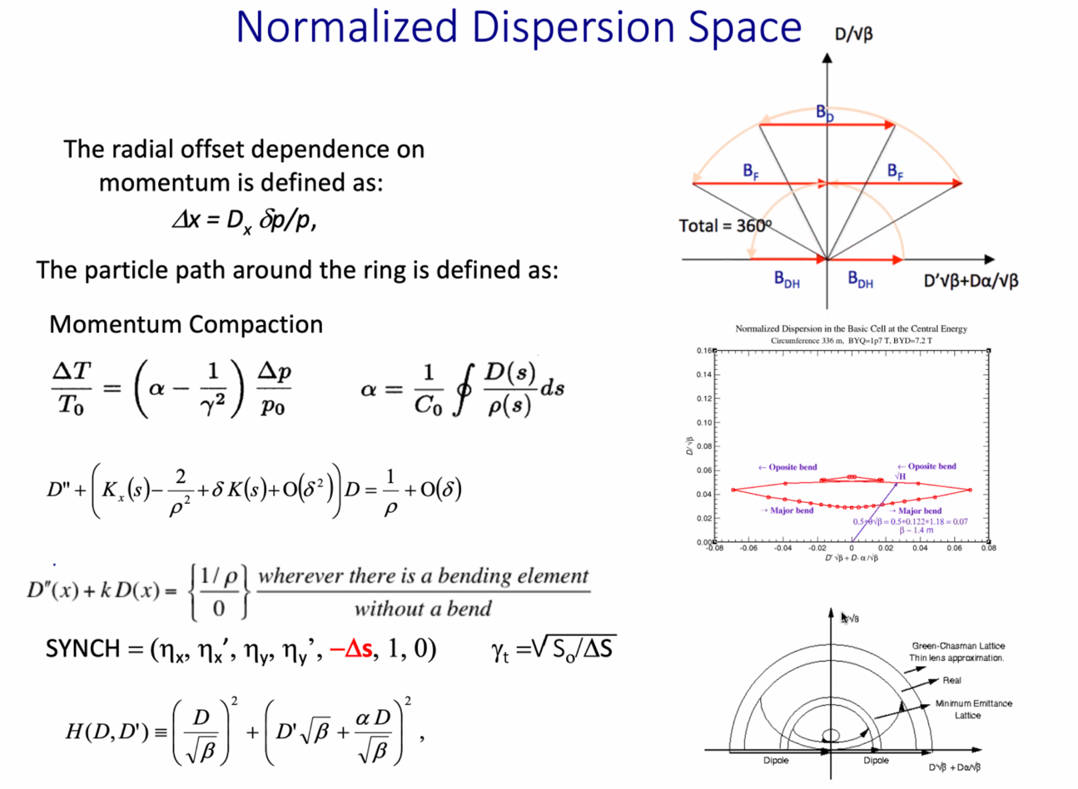
  - Alpha is momentum compaction here, not Twiss
  - T/To = how control longitudinal motion
  - Directly connected to splitter design and M56
- 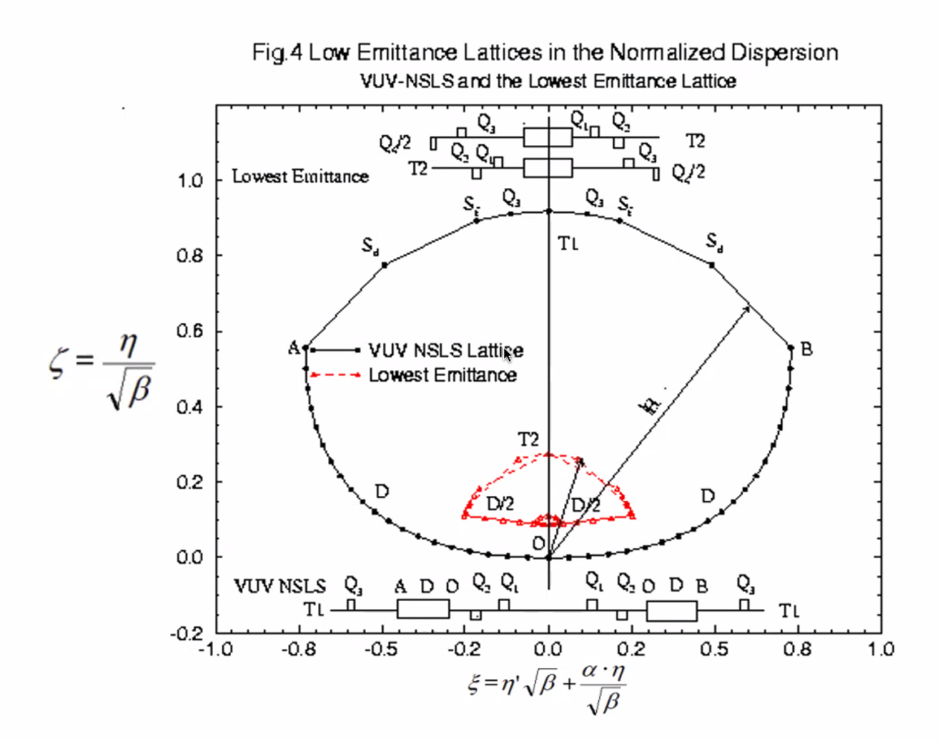
  - Everything positive
- 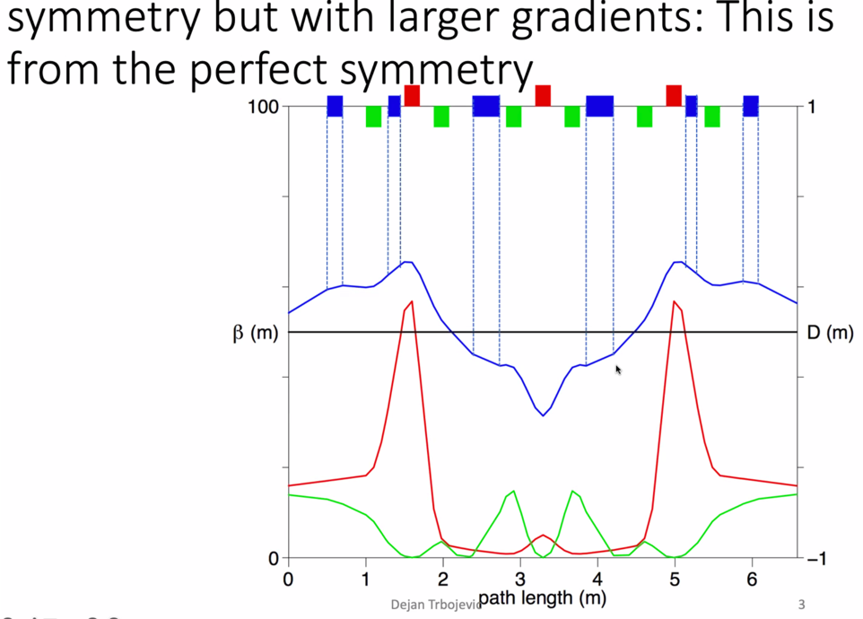
  - Negative dispersion in central dipoles (blue)
- 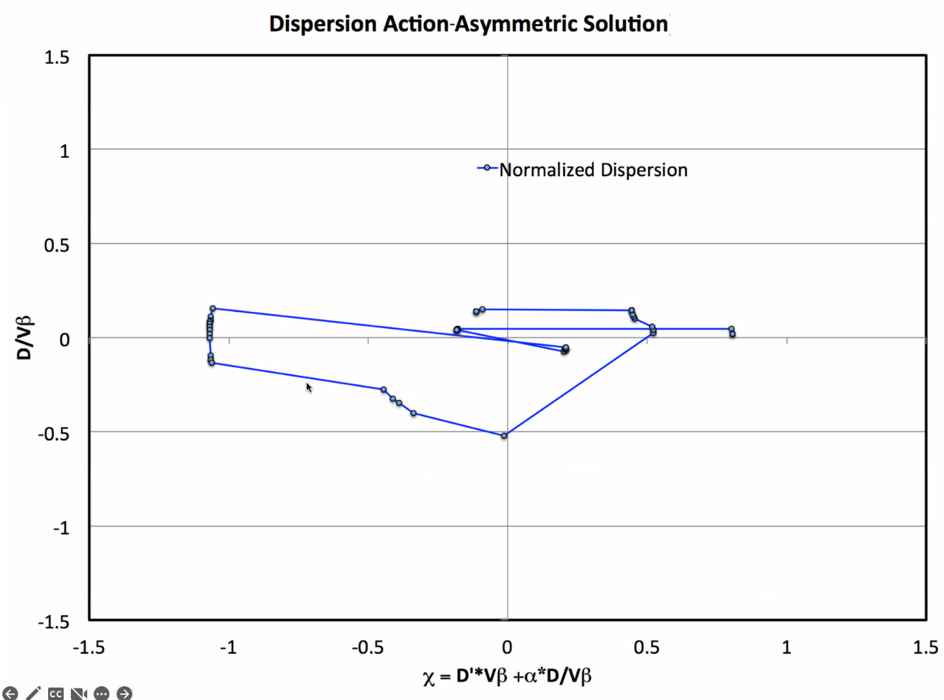
  - Are you getting negative or positive value? Track this to see what you’re doing.
- 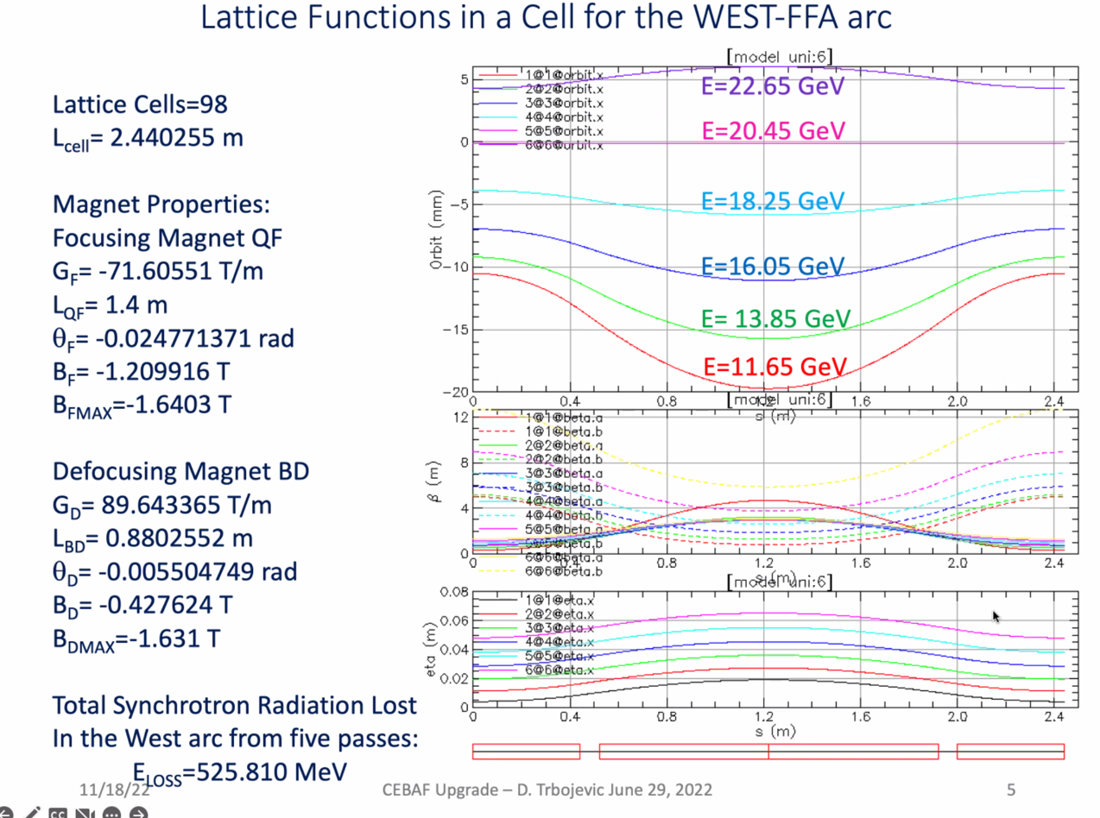
  - From June-ish
  - Almost all is positive dispersion – the integral divided by rho will generally be positive
  - Sometimes, you get parts that go negative – then the integral can become negative
    - This would change the splitter design
- 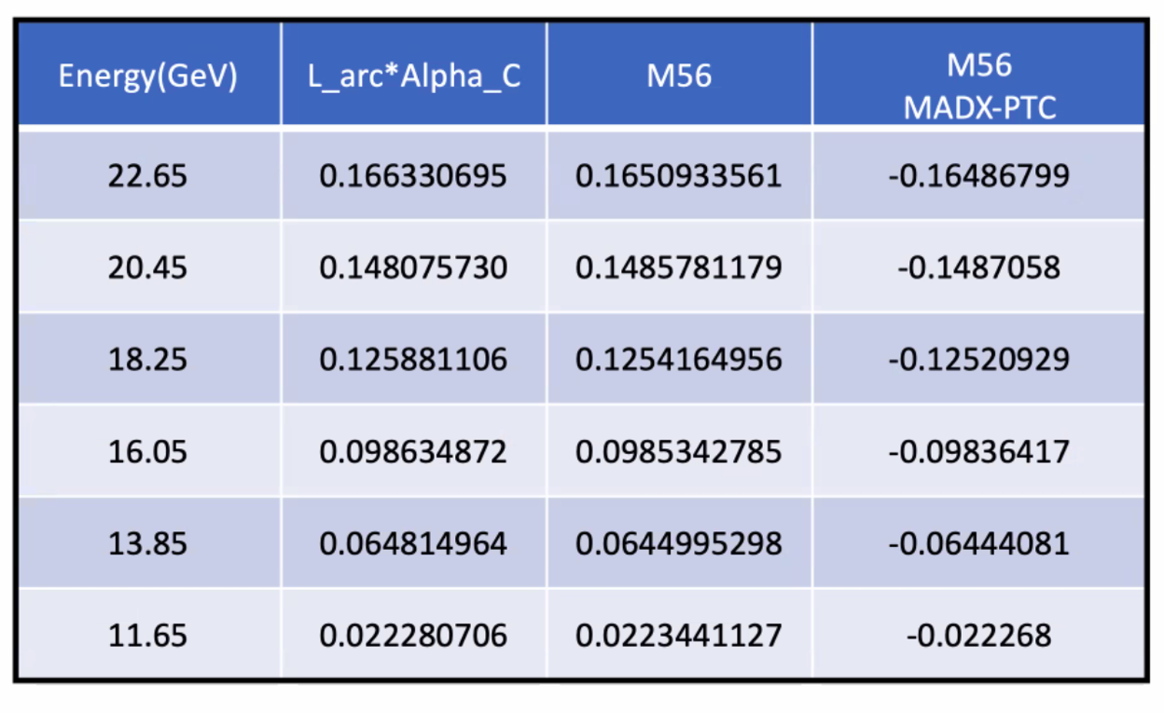
  - Didn’t take into account SR loss
  - M56 in meters here
  - Took whole lattice, put it in MADX-PTC, SYNCH, and BMAD
    - Pretty consistent between codes
  - MADX-PTC – it is negative due to definition vs. SYNCH code. (- delta-s)
    - Same thing happens in OptiM – likely due to a convention.
- You want these numbers correct in the splitters exactly (with opposite sign)
- Alex B – there will also be a small negative coming from the spreaders – so we need to make sure we take that into account as well.
  - The table is only the FFA contribution
- 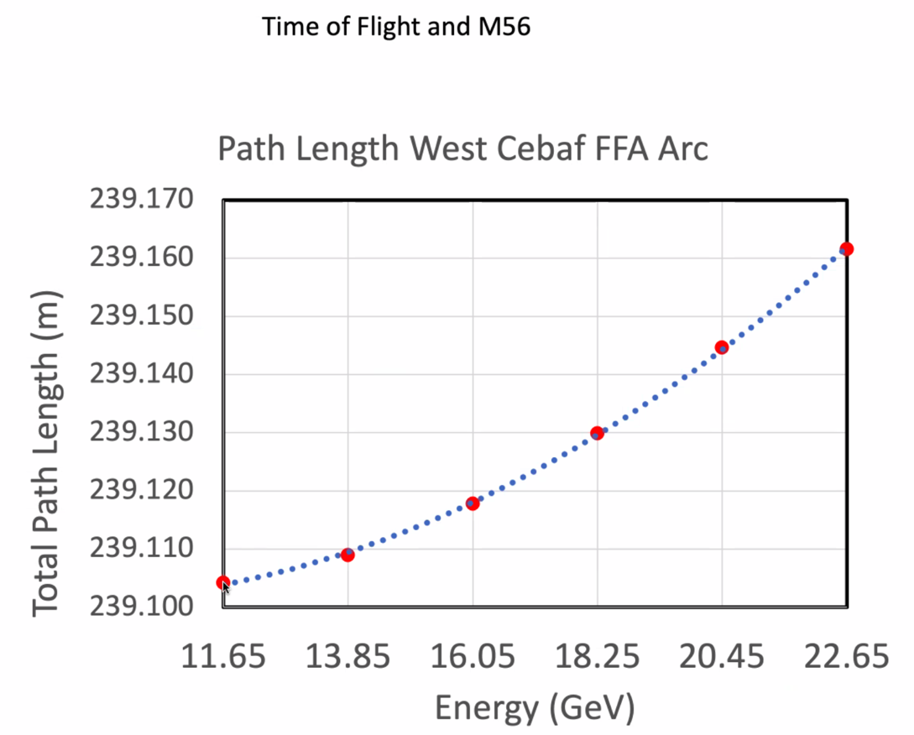
  - Need to be sure that this TOF is corrected as well.
- 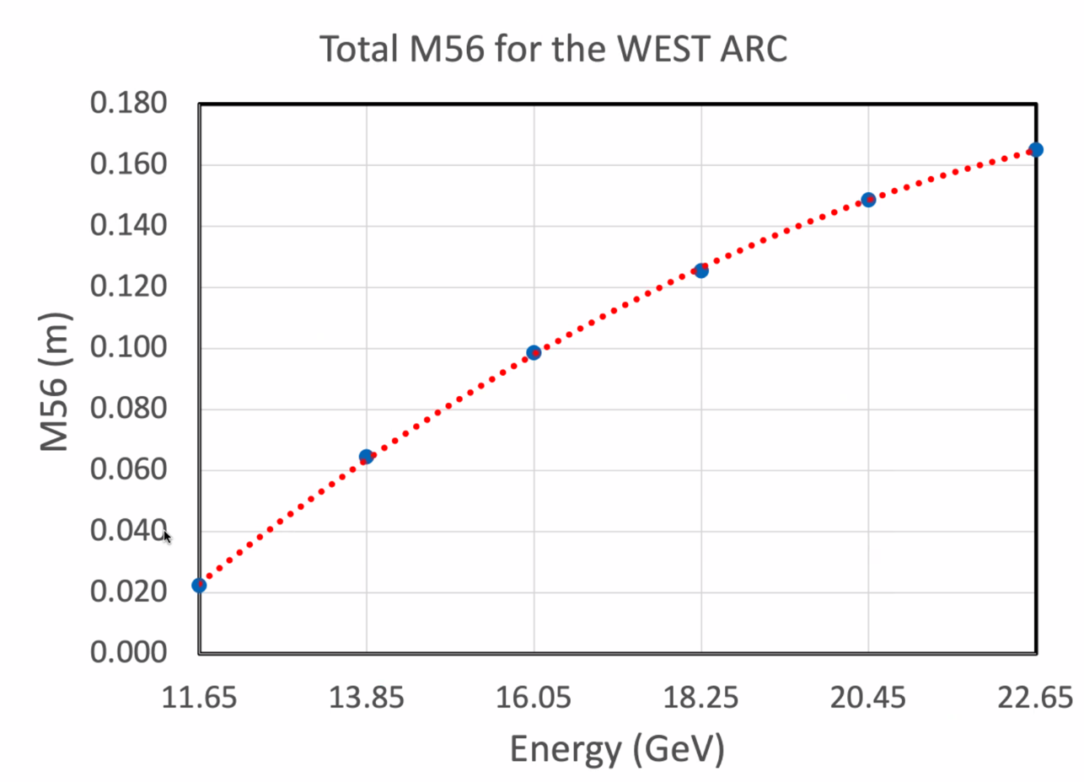
  - Be careful with sign
  - This is momentum compaction times circumference
- Jay – TOF is also important
  - 12 GeV moved magnets an integral number of wavelengths
- When design splitters, you have to fix the geometry for TOF first, and choose which bucket you’ll deal with.
  - Then M56 changes phases of quads
- Can juggle positive and negatives (zigzag)
  - First, try cancel TOF, then adjust phases by zigzag or other “bumps” to get dispersion integral correct.
- When you do the M56 calculation in BMAD, you have to do the whole lattice.
  - Fairly straightforward
Action items | Person responsible | Deadline

Time allotted | 25 mins | Agenda topic Adiabatic Arc | Presenter Vasiliy
- It’s no longer adiabatic! Simply not enough space, so use quick non-adiabatic match using just a few magnets.
- 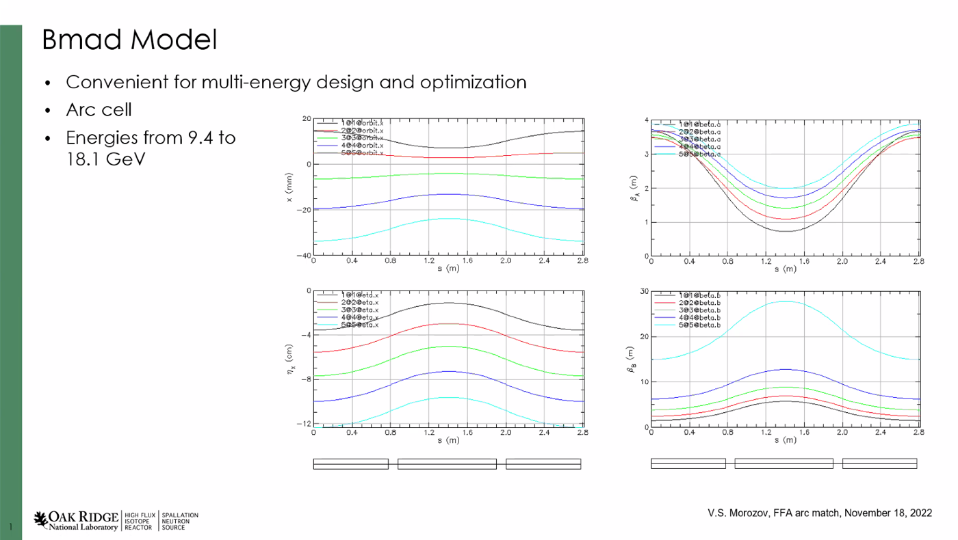
  - Extremely convenient to look at different energy optics
  - This is arc cell with multiple plasses
- 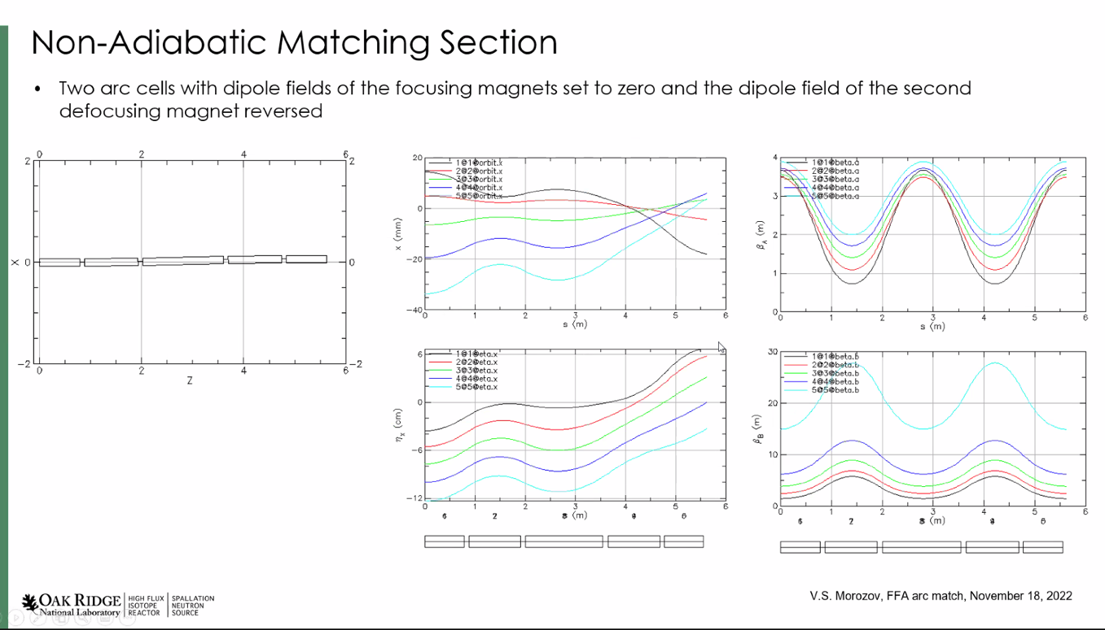
  - Min design is two s-bends
  - Two arc cells connected together, turned off dipole field in all focusing magnets
  - Flipped the polarity of the second
- 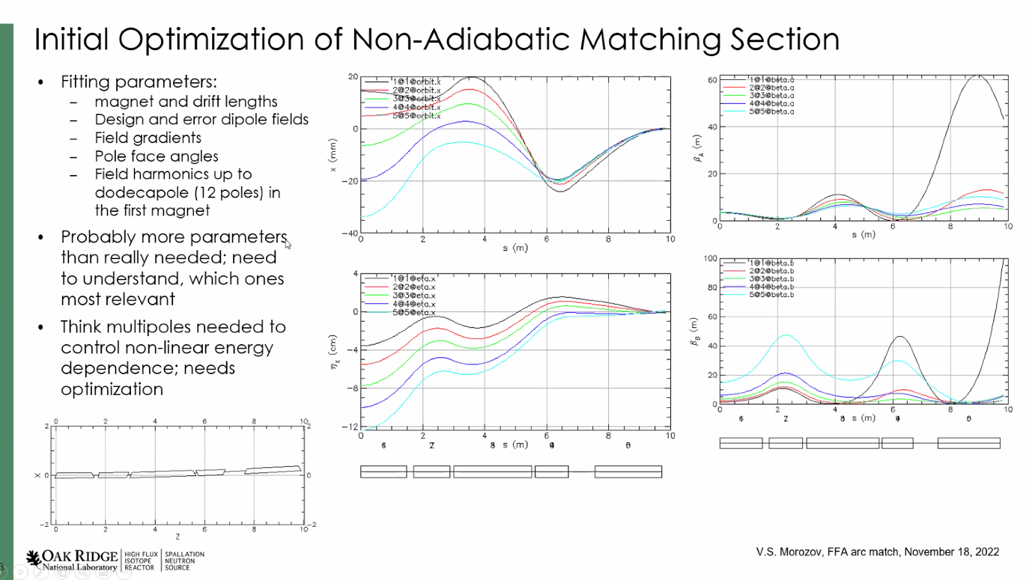
  - Optimized using the length of the magnets and drifts in between
  - Design and error dipole fields
    - Design controls the design orbit, error controls how far away from design
    - Varying both at the same time you can move things together
  - Design bending angle is changing if you vary them together
  - Varied gradients, etc…
  - May need nonlinear fields
    - Dispersion not linear function
- Can do it with linear fields for two selected orbits, but then the rest don’t work.
- Used more parameters than needed, so will look at getting rid of some.
- Lowest energy always the biggest problem – Dejan recommends adding weight to that.
  - Takes time to get the weights right, as well as step sizes.
- Orbits merge beautifully.
- Alex B – this is very compact! 10 m in s-coordinates
- Dejan – the first magnet has to be a quadrupole because it impacts the orbits differently for each energy.
  - Larger the offset would make a kick toward the middle
  - 1983 article presented previously.
- Scott – skip pole face angles – probably equivalent to doing something in the body, and it’s likely difficult to implement in reality.
  - Probably accomplishing a lot through nonlinearities.
- Stephen – you need dipole, nonlinear + nonlinear to match orbits. If you want Betas too, you’ll need more magnets.
- Vasiliy – getting the extra focusing terms from edge angles.
- Dejan only used gradient and bending in his fitting. Start where orbits are separated, and that magnet has to be a quad with very little dipole component.
- Advantage of BMAD – no other codes can fit multiple universes simultaneously.
  - Mad-X can do it, sort of. But harder and slower.
- Scott: should scan mismatch parameter as well at end.
- 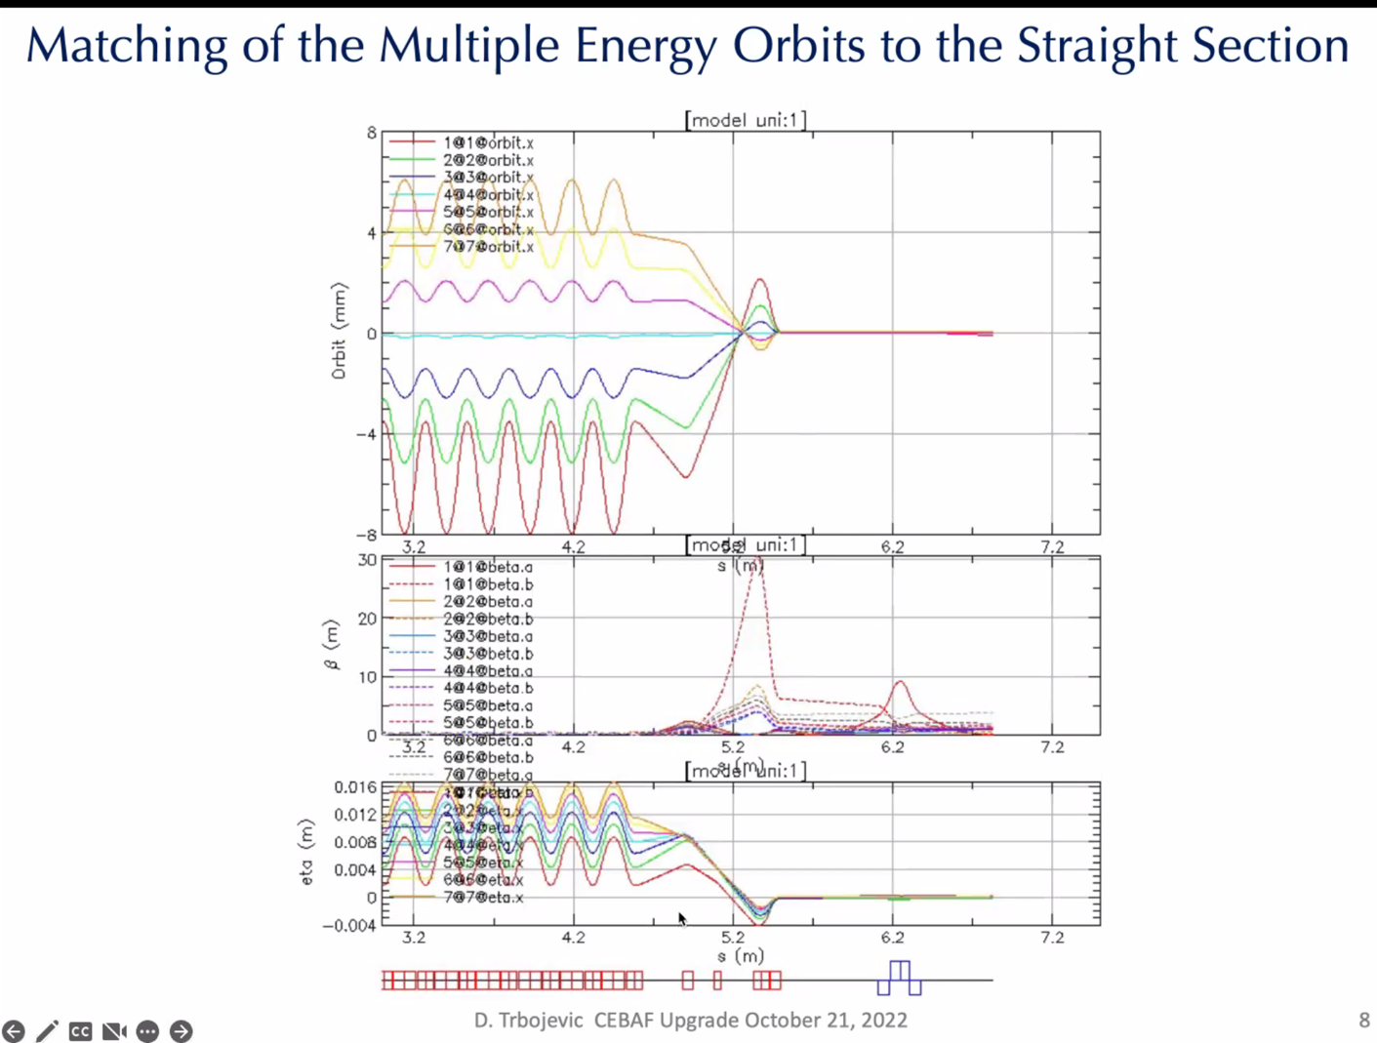
  - Dejan’s solution – 4-ish magnets
  - Orbits merged, one beta is going nuts
  - Slopes of Beta at end is 0
  - Dispersion is matched.
  - All linear magnets – only distance, gradient, and bending are adjusted.
 | Person responsible | Deadline

Time allotted | 10 mins | Agenda topic AOB | Presenter All
- Kirsten – SR radiation loss issue has been sorted out. More confident that next iteration of emittance budget will be more accurate.
- Stephen – uploaded something ~a month ago for comparison.
  - Made fake sector magnets similar to Dejan’s, then worked things out.
- Split rectangular magnet, shift it a bit so the beam doesn’t wander into a stronger field region.
  - Alex C has this for one arc
  - Stephen will check to see if offsets for other arc are there.
 | Person responsible | Deadline

Special notes

Pathway to Repository: https://jeffersonlab-my.sharepoint.com/:f:/g/personal/tristan_jlab_org/EqZ5MeS-nipCgPfZB5p0oS4B9Is67d3nQb9sLJI3Zyev9g

NO MEETING NEXT WEEK – HAPPY THANKSGIVING!

