FFA@CEBAF Working Group|Minutes

## Meeting date | time 12/02/2022 | 11 AM EST | Meeting location <https://jlab-org.zoomgov.com/j/1614898082?pwd=TnUzMS81M2sxbDZIbERJU01tYkJCQT09>

|  |  |  |  |  |  |  |  |  |  |  |  |
| --- | --- | --- | --- | --- | --- | --- | --- | --- | --- | --- | --- |
| |  |  | | --- | --- | | Meeting called by | Alex B | | Type of meeting | Weekly Meeting | | Facilitator | Alex B | | Note taker | Ryan | | Timekeeper | Alex B | | Attendees  Alex B, Ryan, Alex C, Scott, Dejan, Kirsten, Jay, Kitty, Randika, Andrei, Donish, Vasiliy, Stephen |

# Intro Discussion

New indico setup for IPAC, so don’t wait until the last minute to submit.

<https://ipac-docs.jacow.org/General/JACoWlogin/#your-jacow-account>

Please give comments on abstracts by Monday COB. They’re uploaded to the repository in the IPAC23 folder.

# Agenda topics

## Time allotted | 25 mins | Agenda topic SR Emittance Dilution | Presenter Kirsten

* Got lattice from Alex C, but couldn’t get the same sagittal offset.
* Alex C – no sagittal offsets b/c they are rectangular, and so get arc out of it
  + Basically copied offset values from Stephen’s values verbatim
* Kirsten: central 4 were not the same
* Beam tracking and rad integrals seem to agree (mostly) until last 2-3 passes
  + Tracking results probably more accurate
* Some explanation:
  + Both integrals and tracking last time were wrong.
  + Lattice changed
  + Bug reports fixed.
* 2E-3 was from 2 separate FFA arcs
* Previous presentation back in October(?) – radiation integrals said 1E-3 for energy spread
  + Problem with radiation integrals at that point, but not discovered yet
* Why drop?
  + Fewer FFA passes (8 down to 6)
  + Lower total energy
  + BMAD problems fixed
  + These numbers are likely more in the right ballpark than previously.
    - Probably won’t shift much, even after a more careful translation
* Are these numbers good enough?
* Scott: Stephen’s sagitta in the magnets helped to even out some of the problems.
  + New design reduced the peak field
* Dejan: Stephen found out that if you use the SBEND, you are more efficient in bending the electrons than in the RBEND.
  + Switched from RBEND to be as close as possible to SBEND, and moved the pieces radially in the RBEND to get as close as possible to the SBEND.
  + Hard to make the SBEND from the technology point of view
  + Hasn’t changed the lattice much, just rearranged the magnets so that the numbers came up close to what had before.
* Kirsten: numbers largely match Stephen’s – right ballpark.
* Total number of cells matters, but it’s a small difference.
  + 180 degree arc is likely a good place to do things now.
* Splitters will make it worse.
* If we assume 1E3 for energy spread, is that a good ballpark?
  + The problem is the high energy pass
  + Splitters will have larger radius of curvature overall, but will concentrate in dipoles. Will be a question of how low can we make the dipole fields?
  + If you want path length control in high energy splitter, you’ll need to bend backwards.
* Is there any energy loss from vertical bends in CEBAF?
  + Some
  + This is not taken into account in Kirsten’s model yet.
* Spreader dipoles: 1.4 Tesla roughly.
  + Should look at what the loss is in BMAD
* Ryan shows screen of highest pass in NE Spreader (OptiM):
  + 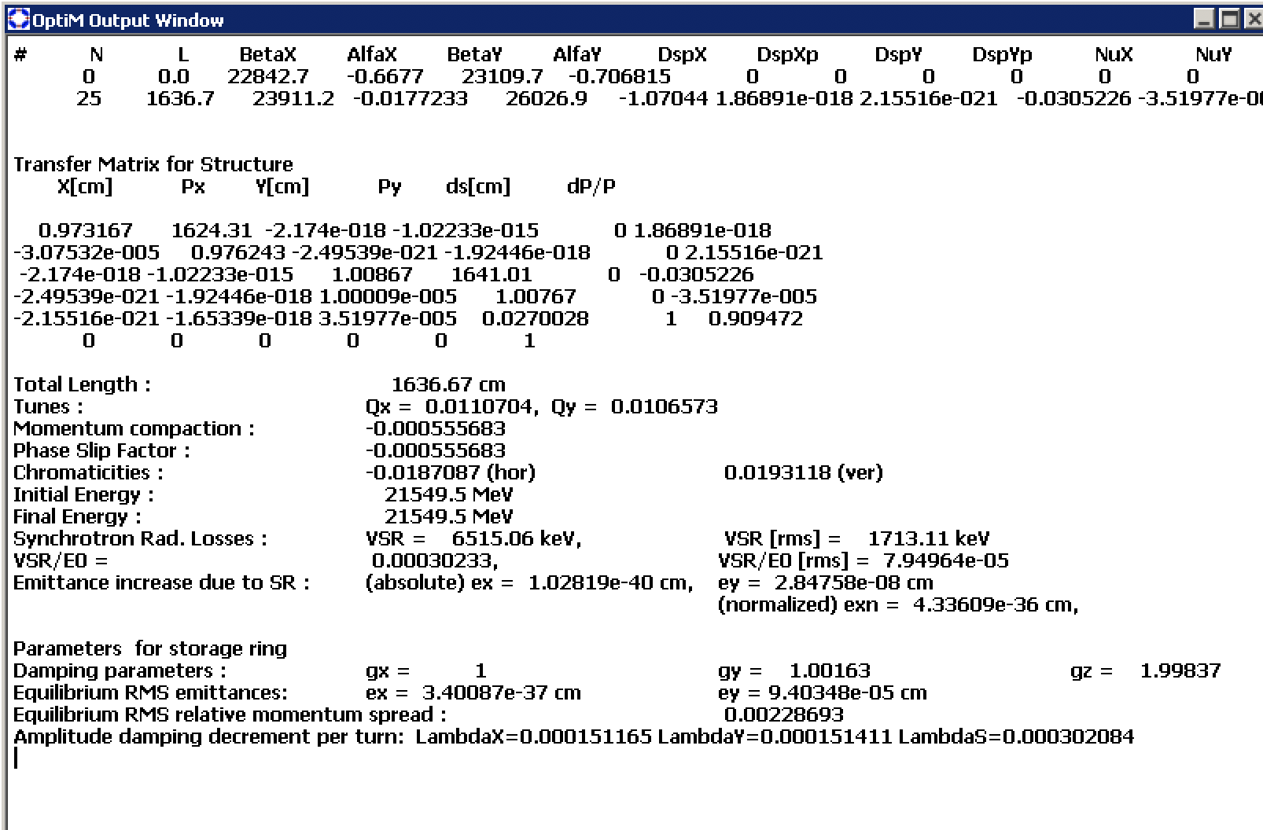

|  |  |  |
| --- | --- | --- |
| Action items | Person responsible | Deadline |
|  |  |  |
|  |  |  |

## Time allotted | 25 mins | Agenda topic IPAC Contributions | Presenter All

* We have 4 abstracts uploaded.
* Let’s all look, and give edit recommendations by Monday COB so we can make sure it’s all right.
* Alex B is doing the overall one:
  + 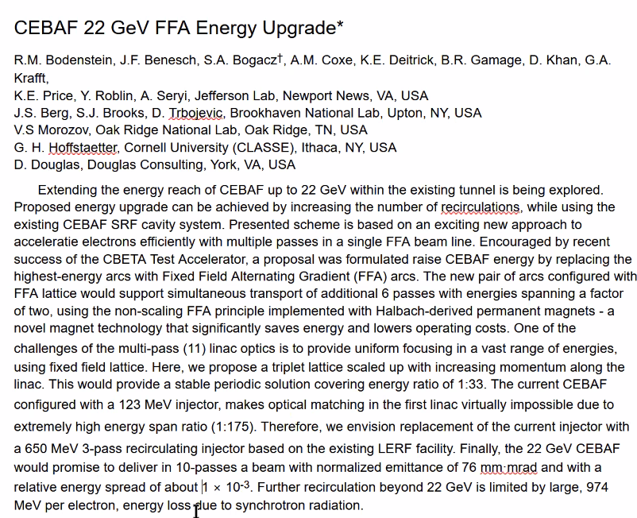
  + Included all collaborators
* Vasiliy will upload one for the non-adiabatic arc match. So the number goes up to 5.
* Alex Coxe:
  + 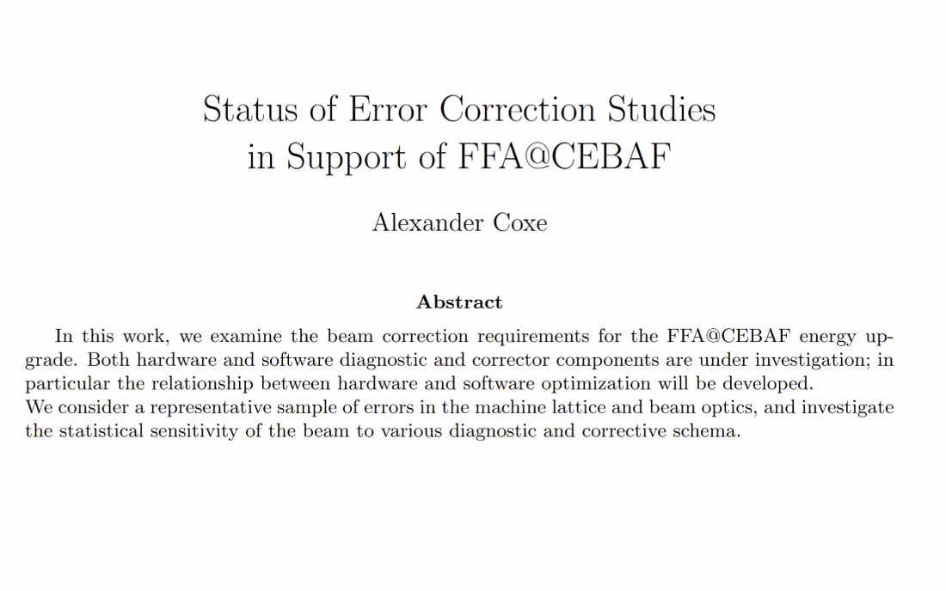
  + Not finished yet. Need to think of authors.
  + Will do Word document so people can edit.
  + Will expand it a bit. First draft was a little longer but overly specific. So this one is less specific, so took out some details. Will add a bit of text.
* Dejan asking Jay about the upcoming workshop:
  + It’s about the physics case, and an attempt to get more justifications for including a mention of FFA@CEBAF in the long range plan.
  + QCD straw votes came out, the CEBAF energy upgrade got about 40% for, 42% against
* APS April meeting has a satellite meeting about our 22 GeV upgrade.
* Ryan’s:
  + 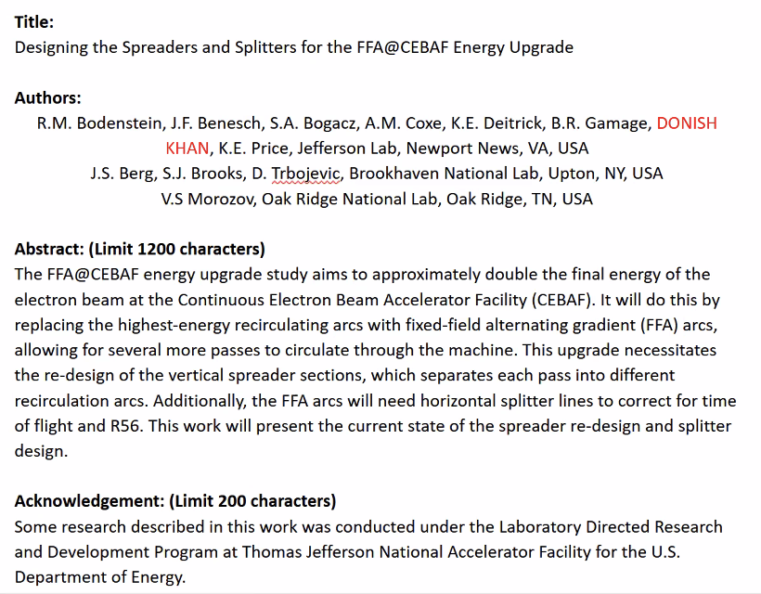
  + Donish – please check your name in everyone’s documents.
* Stephen’s:
  + 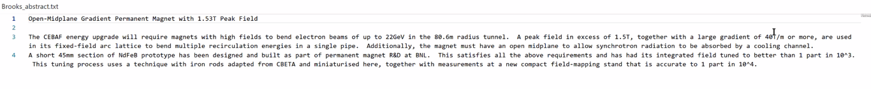

|  |  |  |
| --- | --- | --- |
|  | Person responsible | Deadline |
|  |  |  |
|  |  |  |

## Time allotted | 10 mins | Agenda topic AOB | Presenter All

* Vasiliy – think you can present the non-adiabatic this month?
  + Not ready to promise now, but will try
* Ryan – show spreader progress?
  + Sure – has EM arcs in a decent state, and some FFA arcs
    - Not merged yet, but can show some things.

|  |  |  |
| --- | --- | --- |
|  | Person responsible | Deadline |
|  |  |  |
|  |  |  |

## Special notes

Pathway to Repository: <https://jeffersonlab-my.sharepoint.com/:f:/g/personal/tristan_jlab_org/EqZ5MeS-nipCgPfZB5p0oS4B9Is67d3nQb9sLJI3Zyev9g>