FFA@CEBAF Working Group|Minutes

## Meeting date | time 12/09/2022 | 11 AM EST | Meeting location <https://jlab-org.zoomgov.com/j/1614898082?pwd=TnUzMS81M2sxbDZIbERJU01tYkJCQT09>

|  |  |  |  |  |  |  |  |  |  |  |  |
| --- | --- | --- | --- | --- | --- | --- | --- | --- | --- | --- | --- |
| |  |  | | --- | --- | | Meeting called by | Alex B | | Type of meeting | Weekly Meeting | | Facilitator | Alex B | | Note taker | Ryan, Alex C | | Timekeeper | Alex B | | Attendees  Alex B, Ryan, Alex C, Jay, Dejan, Kirsten, Kitty, Scott, Todd, Randika, Andrei, Stephen, Donish, Vasiliy |

# Intro Discussion

Thanks Alex C for taking notes while Ryan is speaking.

# Agenda topics

## Time allotted | 25 mins | Agenda topic Spreaders in BMAD | Presenter Ryan

* OptiM -> Bmad, not trivial
* Rewriting with patches, going one energy at a time
* It’s on the github for testing access
  + <https://github.com/RyanBodenstein/FFA_at_CEBAF/tree/main/Spreaders/BMAD/NE/Testing>
* A lot of it is geometry, tech note forthcoming
* Working on getting the optics looking right, mostly worked on closing dispersion
  + Passes 1, 3, 5, and 7 look similar
* Doing simulations with steel length is very convenient
* Getting the quads right for passes 5 and 7 took some work
  + Required an overlay to control the quadrupole pairs simultaneously
* Dispersion and dispersion prime close for all the EM passes, but it’s not perfect for the FFA pass
  + 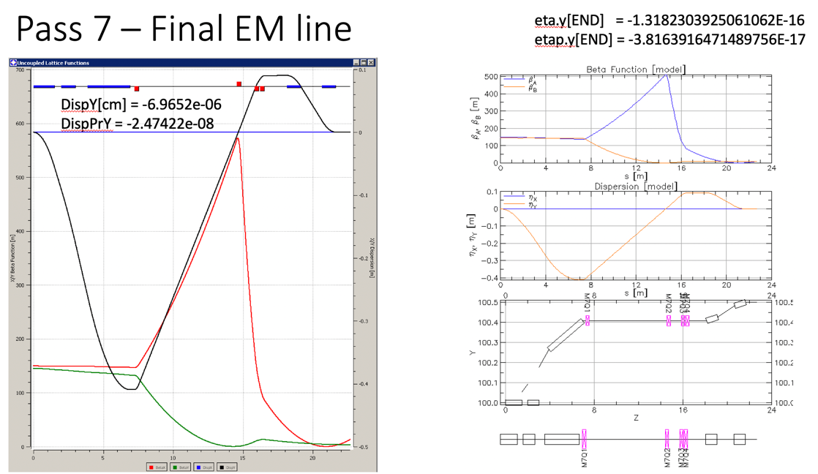
  + 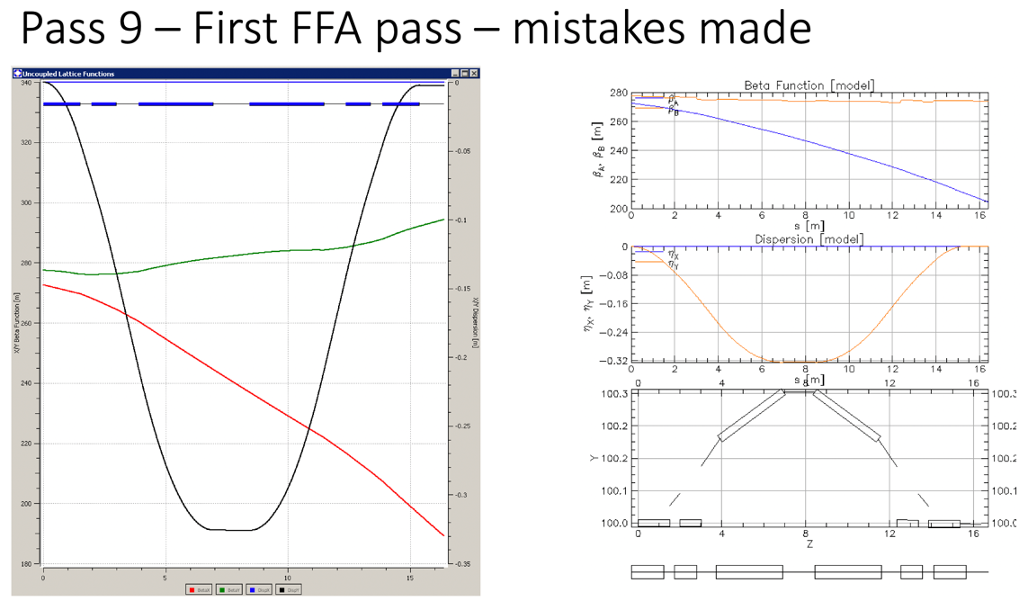
  + 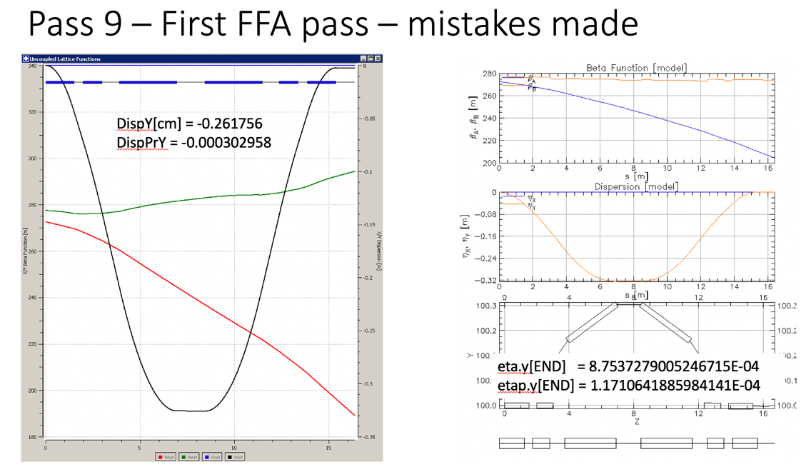
  + Scott says set the shared magnet for the FFA pass and make pass 7 work with it
  + Enforcing FFA symmetry important, but will cost the level of pass 7
  + Can you make magnet 3 have vertical edges? Set e0 and e1?
    - Can chamfer steel at entrance per Jay
    - Current magnets have close to vertical edges
    - If the steel is vertical, then all of the orbits should exit at 0 angle
  + Lots of discussion about that magnet 3
    - Making it fit, the entrance/exit angles, cutting off steel where not needed, etc…
  + Per Scott, want an ‘achromatic’ bend, makes all the passes come out level
  + FFA pass is more constructive to worry about first
  + Magnet 4 can’t be a perfect reflection of magnet 3, must be 7cm lower
  + Can we bump pass 7 out of the way so we can keep the mirror symmetry?
    - Scott suggests a septum to get 7 out of the way, costs some longitudinal space but solves all the problems, possibly put quad on created diagonal
    - Probably doesn’t fit? Very tight space
* Jay has a spreader tech note, steel is *very* tightly spaced
  + 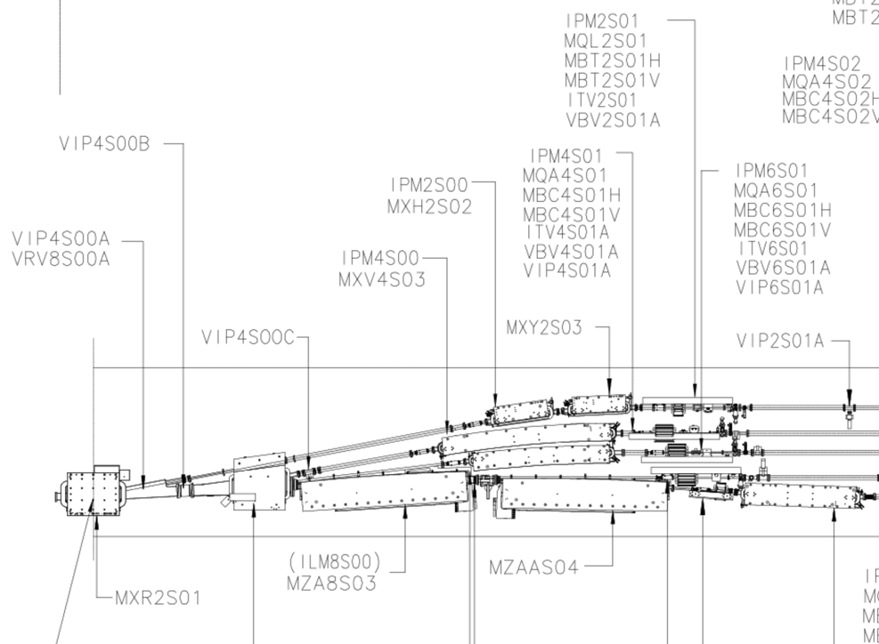
    - Current spreader layout
  + 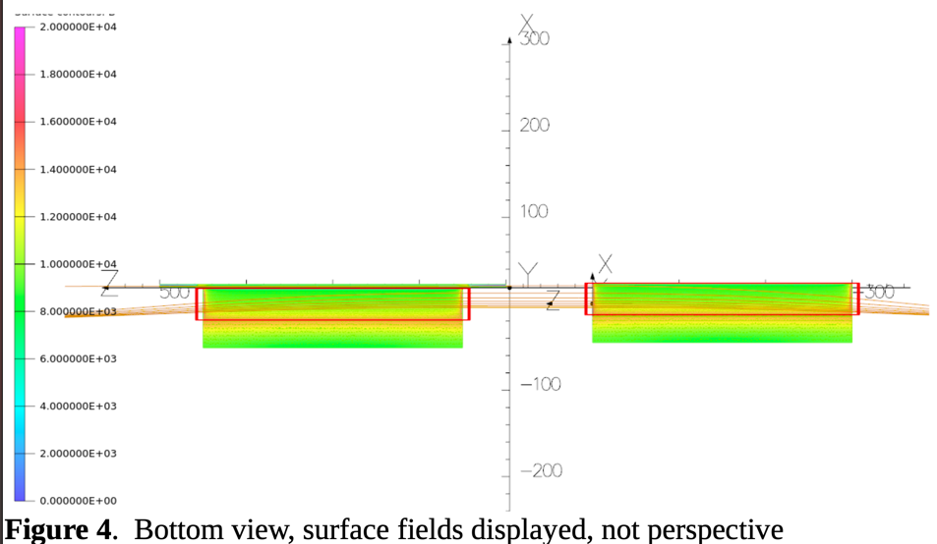
    - Beam travels left to right in this plot
  + 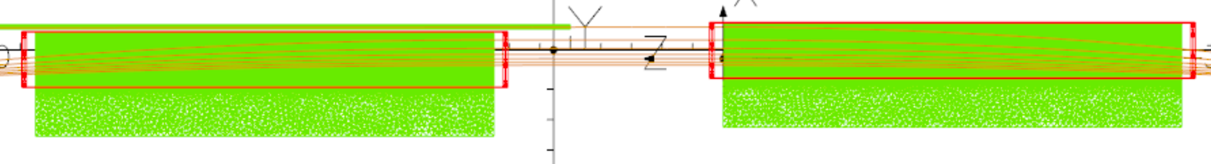
  + adding a quad is hard,
    - might be able to drop in a plate that adds a quad term like in a Lambertson,
  + Scott mentions this will add dipole terms too
    - Might be okay for only pass 7
* Need all the steel tubes for shielding
* What level of dispersion leakage is acceptable?
  + Realistically, there will be some anyway
  + We will need to be able to correct some level of this in the splitters
* Time to start remembering polarization preservation – easy to track, but adds two more degrees of freedom
* Dispersion should be zero entering the FFAs
* Todd comment:
  + Chase accepted EIC work – may not be highly available for a lot of side jobs.
* We need M56 and TOF numbers when they’re done
* Alex B: can we put in magnet sizes on plots?
  + Yes - Ryan will work on this. There’s a command to do it, but it requires knowing the magnet dimensions

|  |  |  |
| --- | --- | --- |
| Action items | Person responsible | Deadline |
|  |  |  |
|  |  |  |

## Time allotted | 25 mins | Agenda topic IPAC Contributions | Presenter All

* 5 abstracts submitted
* Gaining visability – hopeful for oral contribution
* Have overview and technical papers – great way for emerging projects
* Can see all abstracts with your name on them on the new JaCoW indico site
* Dejan: did we include the physicist’s opinions on this abstract?
  + No – no space.
* Todd: Can change abstracts later
  + Go to abstract book and for contributed orals selection
  + You can update the abstract to match the paper later

|  |  |  |
| --- | --- | --- |
|  | Person responsible | Deadline |
|  |  |  |
|  |  |  |

## Time allotted | 10 mins | Agenda topic AOB | Presenter All

* Visit to CEBAF?
  + Likely first week of April (shutdown) (April 6 and 7)
  + Will be “under the radar” a bit
  + Envision a 2 day retreat
  + Thursday have a tour, Friday have a follow-up session like a regular Friday meeting
* Todd: significant number of BNL people coming last week of January for another meeting
  + Scott: none of this group likely to come
  + Good to be aware of this.
* Next Friday is the final meeting of 2022
  + Will discuss non-adiabatic matching with Vasiliy

|  |  |  |
| --- | --- | --- |
|  | Person responsible | Deadline |
|  |  |  |
|  |  |  |

## Special notes

Pathway to Repository: <https://jeffersonlab-my.sharepoint.com/:f:/g/personal/tristan_jlab_org/EqZ5MeS-nipCgPfZB5p0oS4B9Is67d3nQb9sLJI3Zyev9g>