FFA@CEBAF Working Group|Minutes

## Meeting date | time 12/16/2022 | 11 AM EST | Meeting location <https://jlab-org.zoomgov.com/j/1614898082?pwd=TnUzMS81M2sxbDZIbERJU01tYkJCQT09>

|  |  |  |  |  |  |  |  |  |  |  |  |
| --- | --- | --- | --- | --- | --- | --- | --- | --- | --- | --- | --- |
| |  |  | | --- | --- | | Meeting called by | Alex B | | Type of meeting | Weekly Meeting | | Facilitator | Alex B | | Note taker | Ryan | | Timekeeper | Alex B | | Attendees  Alex B, Ryan, Alex C, Vasiliy, Todd, Kirsten, Stephen, Radika, Donish, Scott, Dejan, Jay, Andrei |

# Intro Discussion

Alex – updated LINAC optics uploaded to repository.

* Designed for FFA passes, matches in lower passes well, becomes drift in higher passes.
* Ryan added “extended” parts outside of the periodic sections
* Files in OptiM
* Splitters are the outstanding elements

# Agenda topics

## Time allotted | 25 mins | Agenda topic Non-adiabatic Arc | Presenter Vasiliy/Randika

* Randi removed multipole components, but can’t get down to zero
  + Not far, but not converging either
* Vasiliy’s slides:
  + 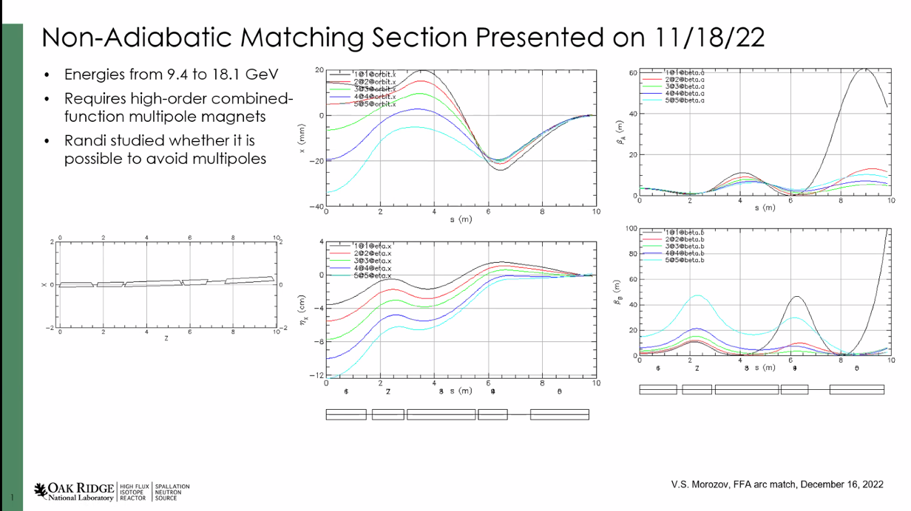
  + Dejan: the fitting takes a long, long time. Many variables, etc…
  + Last time, orbits and dispersion nicely suppressed, not perfect
  + Problem was that relied on high-order combined multipoles (12 poles!)
  + Played with pole face angles to improve things – not a big difference
* Split up tasks with Randi –
  + Randi to get rid of multipoles, if needed by adding extra cells
* Randika’s slides:
  + 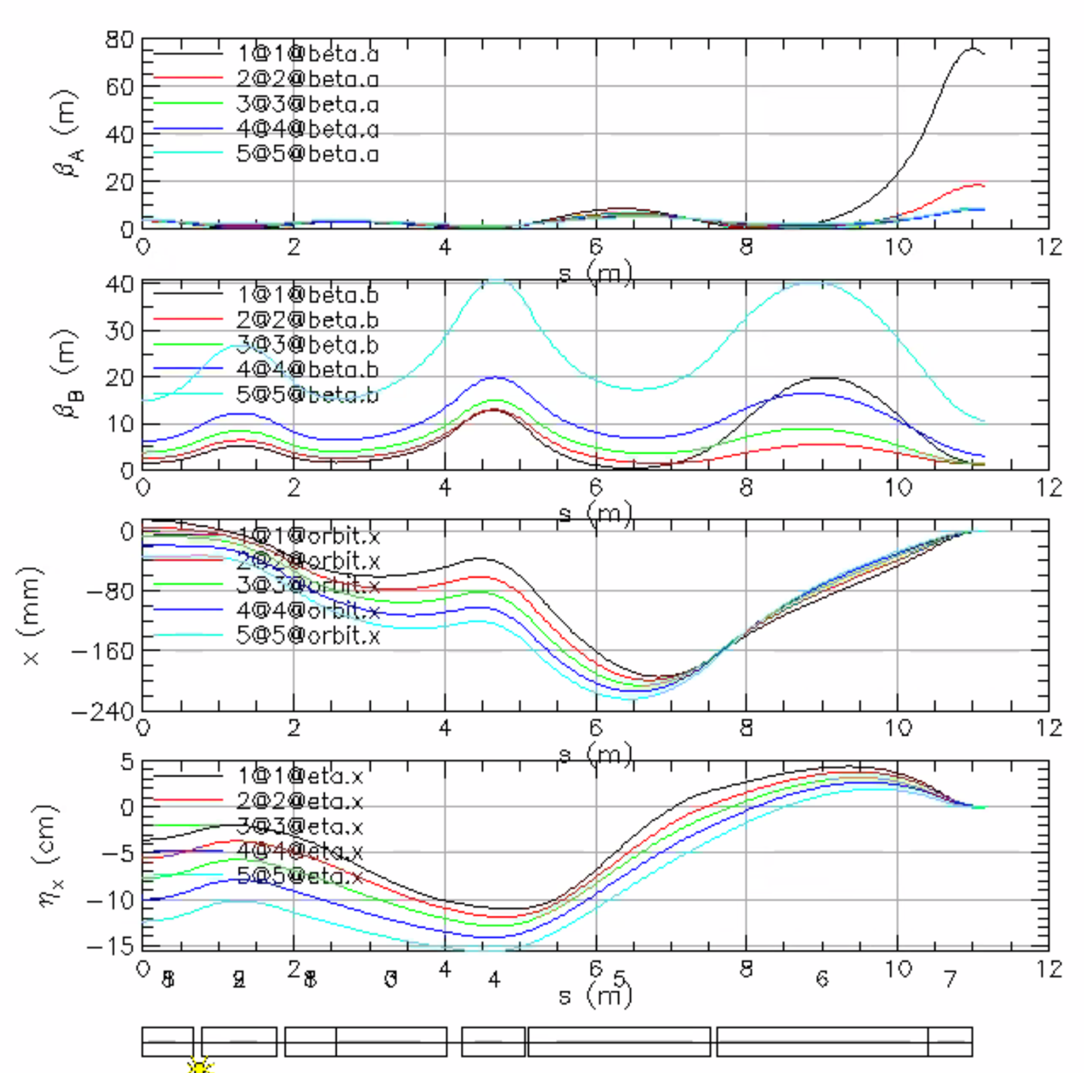
  + Removed the phases variable and most multipoles (except b1)
  + Dispersion and orbit are 0, but alphas are not
    - Working on zeroing alphas
  + This is only dipole and quadrupole moments
  + Dejan: last part of fitting, always found out it’s good to have a triplet
    - Try to divide the magnet before the last two pieces, put a drift between
    - Usually FDF or DFD
    - Bending is always negative in the last, and positive in the first
    - You’re very close, you just need a few more variables to get the alphas to be zero.
    - Looks very nice
    - Can maybe drop orbit down to 15-20 m
  + Vasiliy: alpha doesn’t HAVE to be zero.
    - Dejan: make the weighting much less than the other variables
      * Beta should have lowest weight
      * But limits in betas (maybe not higher than 40, but with low weight)
      * Takes a whole week of running for Dejan
      * Randi: using LMDIF seems to run well – it’s quicker because we’re close
* Dejan: latest run with 20 universes is taking forever
* Vasiliy: another alternative
  + From IPAC22 (Dejan’s)
  + 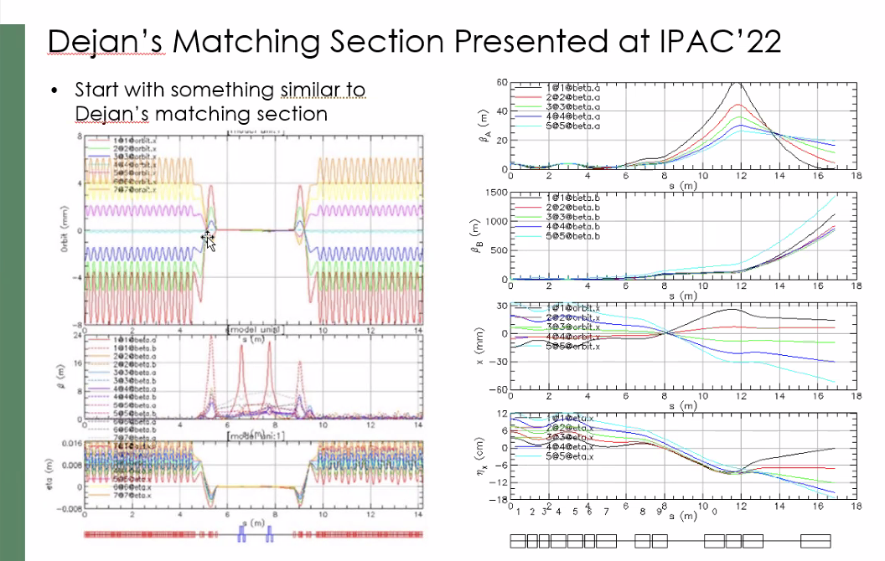
  + Bending is opposite way
  + Vasiliy tried to do this style with crossing, similar peaks, etc..
  + Dejan: last magnet in the triplet, try to vary it a bit. Lengths not same in Dejan’s solution
    - Frustrating to get final solution
  + Started with playing by hand with parameters
* 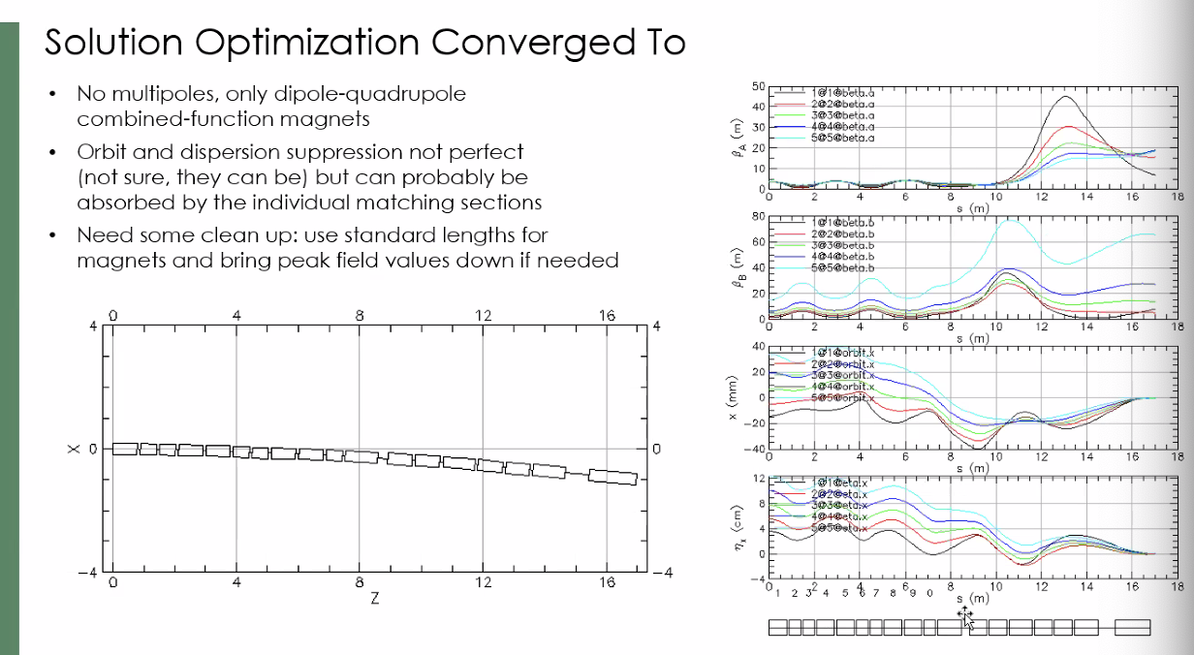
  + Just dipole and quad components
  + Not perfect yet, but probably OK b/c we can absorb in the individual matching sections
  + Alphas not perfectly 0, but close
  + Tradeoff between orbits, dispersion suppression, and beta control
* In Dejan’s case, large beta blow up
  + Vasiliy limited beta, and that could contribute to why different
* Orbit spread is reasonable, but a bit more work needed
  + Want to standardize magnet sizes
  + Some magnets at field limits, so may need to change lengths.
* Should we keep pushing? Or just use this?
  + Alex B: draw a line somewhere, but at some point we need to have something to use
  + Can always optimize more
  + At some point, declare a version for the time being.
* Kirsten: which version of the FFA cell are you using?
  + This is from Stephen’s lattice from the IPAC22 paper
    - There’s a more recent one
* Are you using 2 FFA or 1 FFA solution?
  + Using 2
  + The 1 FFA is from Dejan, then adjusted by Stephen and clarified by Alex C and Kirsten
* Kirsten/Alex C will upload the latest arcs after this meeting to make sure we’re all using the same lattice
  + This one is based upon the latest baseline
* What are the gradients in the new lattice?
  + Stephen did the offsetting, and adjusted gradients a bit, but not sure if that info is supplied
    - Didn’t push new lattices
* In January, will upload the latest version with practical magnets. Then Alex C/Kirsten can update in our BMAD files, and Vasiliy can use that.
* Alex C: let’s make a “baseline” folder in the repository, so we all work from the same.
* Maybe we use GitHub?
  + Scott and Ryan use github
* We don’t currently have a good way of saying “this is the lattice”
  + We get something from different people, then translate, etc…
* Only well-defined piece is the FFA arc – everything else is almost separate
* X.0 versioning problems
  + Problem is, people send X.0+epsilon
  + Scott prefers date codes
* Stephen made magnets into pseudo-SBENDs from Dejan’s design
  + Dejan: max field 1.6 T
  + Stephen, if that changes rapidly over a short space, that’s a problem
    - Reduced 76 cells
* 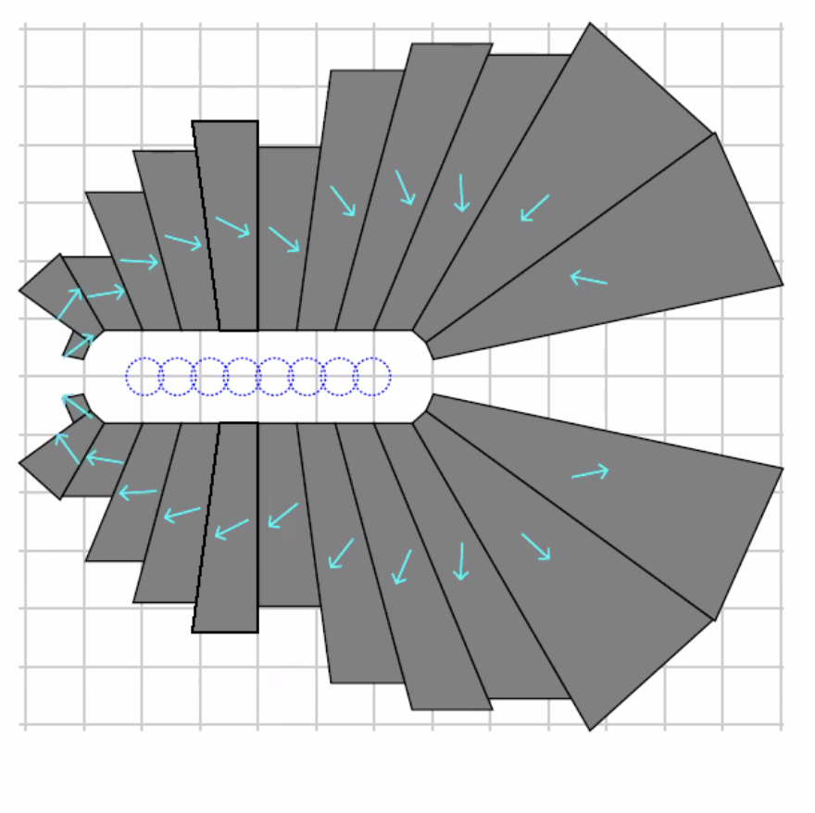
  + Optimized orbit excursion
  + This is the widest magnet (this is ~16 cm)
  + Minimized area of magnetic material
  + Dejan: magnet size went from 10-16 cm wide
    - Alex C: But less magnetic material
* Dejan: Suggest Vasiliy redo with new model
  + Get close manually, then let the program find it

|  |  |  |
| --- | --- | --- |
| Action items | Person responsible | Deadline |
|  |  |  |
|  |  |  |

## Time allotted | 25 mins | Agenda topic 2023 Outlook | Presenter All

* We need a bit more organization
  + Sharepoint vs github?
  + Ryan will organize a file structure that we can all agree upon for version control, etc…
    - Will present a document in January for approval of the group
    - Will use date codes, etc…
  + Need to define responsible parties for each section, so that we can confirm “baseline” version
* Dejan: Is it possible to re-submit FOA?
  + Alex B – there needs to be a few formal steps after NSAC
    - Put it on hold until after
* Dejan: visit?
  + April 6-7th.
  + Tour will be highlight
  + 2 day event with session
* Alex C: excited for the coming year, especially after the upcoming USPAS class.
  + Will get some early beta done for error studies
* Last meeting of the year: Happy Holidays!

|  |  |  |
| --- | --- | --- |
| Action Items | Person responsible | Deadline |
| Make document for file structure/organization | Ryan | End of Jan? |
|  |  |  |

## Special notes

Pathway to Repository: <https://jeffersonlab-my.sharepoint.com/:f:/g/personal/tristan_jlab_org/EqZ5MeS-nipCgPfZB5p0oS4B9Is67d3nQb9sLJI3Zyev9g>

HAPPY HOLIDAYS!