FFA@CEBAF Working Group|Minutes

## Meeting date | time 01/13/2023 | 11 AM EST | Meeting location <https://jlab-org.zoomgov.com/j/1614898082?pwd=TnUzMS81M2sxbDZIbERJU01tYkJCQT09>

|  |  |  |  |  |  |  |  |  |  |  |  |
| --- | --- | --- | --- | --- | --- | --- | --- | --- | --- | --- | --- |
| |  |  | | --- | --- | | Meeting called by | Alex B | | Type of meeting | Weekly Meeting | | Facilitator | Alex B | | Note taker | Ryan, Alex C | | Timekeeper | Alex B | | Attendees  Alex B, Ryan, Alex C, Vasiliy, Donish, Jay, Dejan, Stephen, Kirsten, Kitty, Scott, Todd, Randika |

# Intro Discussion

FOA vs. LRP –

* LRP scheduled to come out in August, so could try next year probably for FOA.
* Last vote was ~ 40% for, 43% against the upgrade
* Need to get word out to non-JLab user community
* Alex will present at APS meeting this April
* Lots of politics involved – many against projects that may “compete” with EIC
  + Need to present in a way that R&D is required before proposal
  + Future of the field
  + Need to stress that it doesn’t negatively impact EIC
* Problem is that they are essentially parallel in time – concerns that NP won’t be able to fund 3 labs simultaneously once EIC starts operating
* Need to make very strong case for continued fixed-target work with at least e+/e- at 11 GeV, but also at higher energies
  + Need user community to really push this toward the larger NP community and to congress

# Agenda topics

## Time allotted | 25 mins | Agenda topic Non-adiabatic Arc | Presenter Vasiliy/Randika

* There were two interesting approaches – are they converging?
* Revising parameters and making them practical
  + Magnet lengths, field strengths, etc…
* Will continue working and report more later
* Dejan: it takes up to 2-3 weeks of running on a laptop to get perfect matching
  + Not sure how much time it takes, but it takes a lot of effort
  + Was very close, but didn’t have alphas = 0, but going in right direction
    - Small enough is probably OK – can likely be absorbed
      * Dejan: no, they have to be 0 – then it’s easy to proceed
* Vasiliy – concerned with getting fields under control.
  + Do this slowly by changing magnet lengths but not mess up matching
* Must be careful with weighting and constraints
  + Need higher weight for Dx and Dx’ (and for y)

|  |  |  |
| --- | --- | --- |
| Action Items | Person responsible | Deadline |
|  |  |  |
|  |  |  |

## Time allotted | 25 mins | Agenda topic File Structure | Presenter Ryan

* Date stamp is useful, version stamp less simple
* Stephen mentions that the SharePoint has many other non-code items (presentations, images, etc…)
  + This isn’t what we’re organizing with the GitHub, but should be well-organized.
* Alex B thinks GitHub should be the primary tool, but if we can mirror to SharePoint, that will be ideal
  + Should be doable from a local computer (even drag and drop)
  + Should we remove old versions from Sharepoint?
    - Likely no, but use date stamps to indicate the right version
* Scott: Forks will likely be a great organizational tool
  + This can help with the date stamp organizational aspects as well – file names can remain the same, and the release folder will indicate when changes were made
* Owners of sections and codes must be assigned – they’ll have “final say” over if a new release is ready
  + Likely will be the person doing that section in that code
* Consensus: we need a “baseline” repository
* Jay: should we upload the TOSCA files?
  + Yes – at least the files needed to run. Perhaps the output files will need to be elsewhere
    - The GB size files may be a problem on GitHub
    - <https://docs.github.com/en/repositories/working-with-files/managing-large-files/about-large-files-on-github>
      * Seems that there’s a way to point to large files, but GitHub doesn’t store them
* The general organizational structure works, but the workflow will help more:
  + fork > branch > commit > pull request > release
    - Release will have a date stamp
    - Release notes can indicate what is changed in that release
* Documentation is important – can it be managed through GitHub?
* Syncing from different codes will prove to be difficult
  + If one code is iterated, then the same relevant code needs to be in sync with it
    - If out of sync, that needs to be documented as well
* Managing the iterative design may be complicated as well
  + Who is matching to who?
  + Example: Does the spreader need to match into the arcs, or do the arcs need to match into the spreader? How does this iterate?
* In the end, a “lattice overlord” is needed to oversee that all the pieces fit together.
* Copying screenshots of first draft below, but significant changes will be required, given today’s discussion.
* 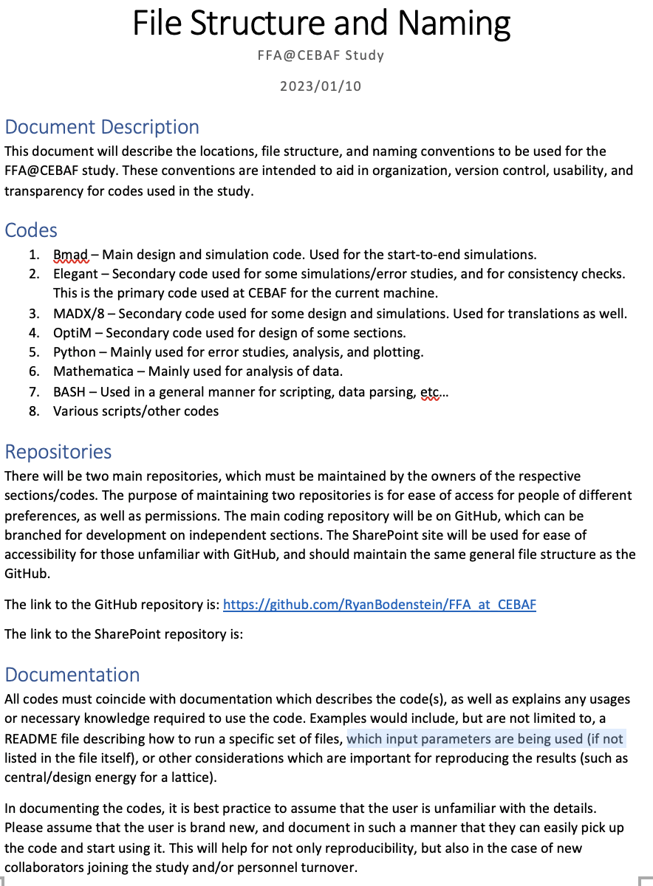
* 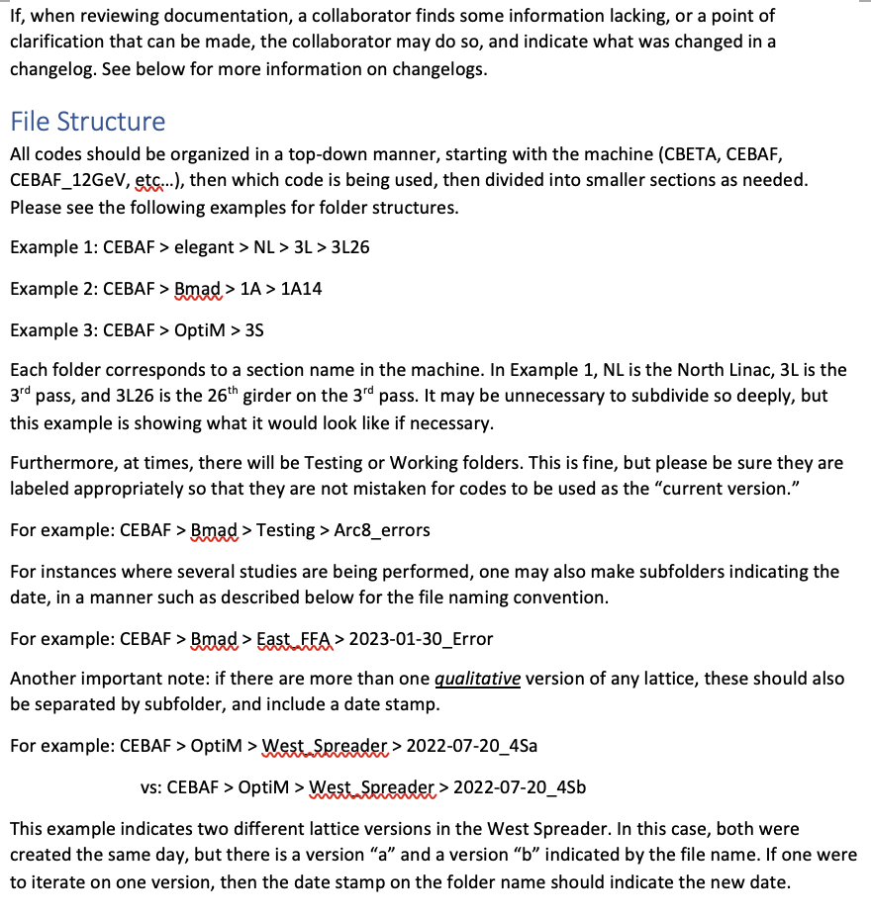
* 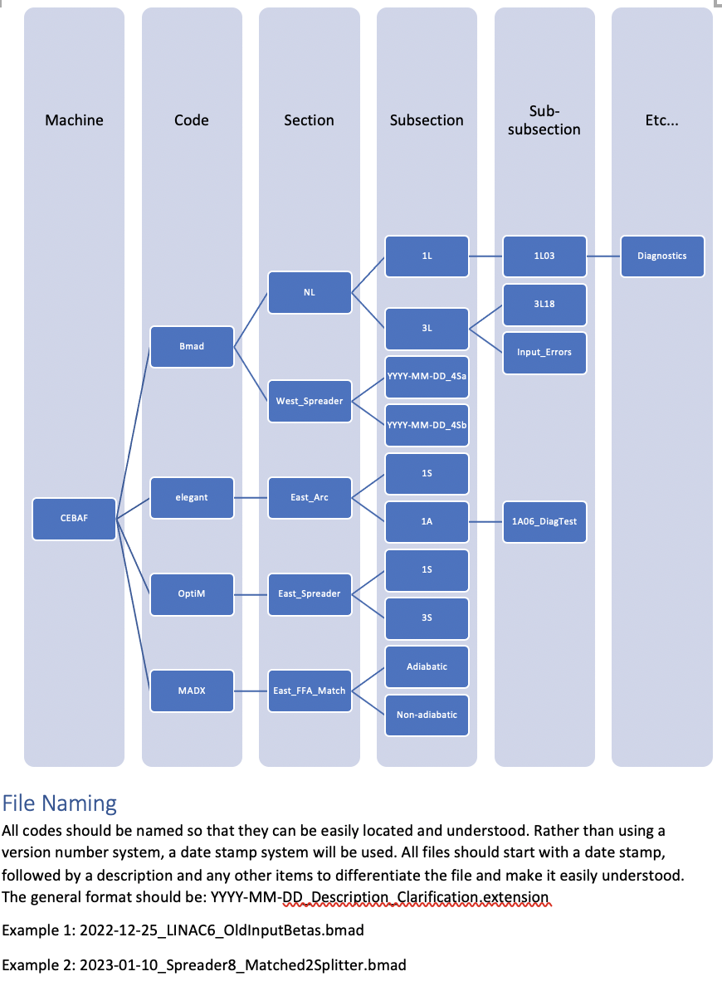
* 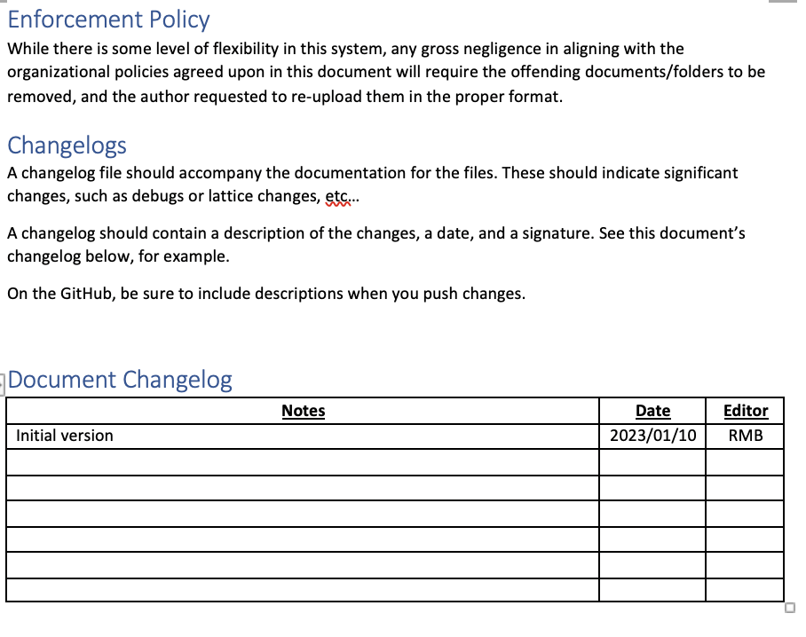

|  |  |  |
| --- | --- | --- |
| Action items | Person responsible | Deadline |
| Update the document and share for all | Ryan |  |
|  |  |  |

## Time allotted | 10 mins | Agenda topic AOB | Presenter All

|  |  |  |
| --- | --- | --- |
| Action Items | Person responsible | Deadline |
|  |  |  |
|  |  |  |

## Special notes

Pathway to Repository: <https://jeffersonlab-my.sharepoint.com/:f:/g/personal/tristan_jlab_org/EqZ5MeS-nipCgPfZB5p0oS4B9Is67d3nQb9sLJI3Zyev9g>