FFA@CEBAF Working Group|Minutes

## Meeting date | time 01/20/2023 | 11 AM EST | Meeting location <https://jlab-org.zoomgov.com/j/1614898082?pwd=TnUzMS81M2sxbDZIbERJU01tYkJCQT09>

|  |  |  |  |  |  |  |  |  |  |  |  |
| --- | --- | --- | --- | --- | --- | --- | --- | --- | --- | --- | --- |
| |  |  | | --- | --- | | Meeting called by | Alex B | | Type of meeting | Weekly Meeting | | Facilitator | Alex B | | Note taker | Ryan | | Timekeeper | Alex B | | Attendees  Alex B, Ryan, Alex C, Vasiliy, Donish, Stephen, Jay, Dejan, Todd, Kirsten, Randika, Scott, Kitty, Andrei |

# Intro Discussion

Alex C going to USPAS! Applicable to dissertation work.

Quick discussion about non-adiabatic merging (5 magnets in short longitudinal space)

# Agenda topics

## Time allotted | 25 mins | Agenda topic Non-adiabatic Arc | Presenter Vasiliy/Randika

* Not done yet, but getting there
* 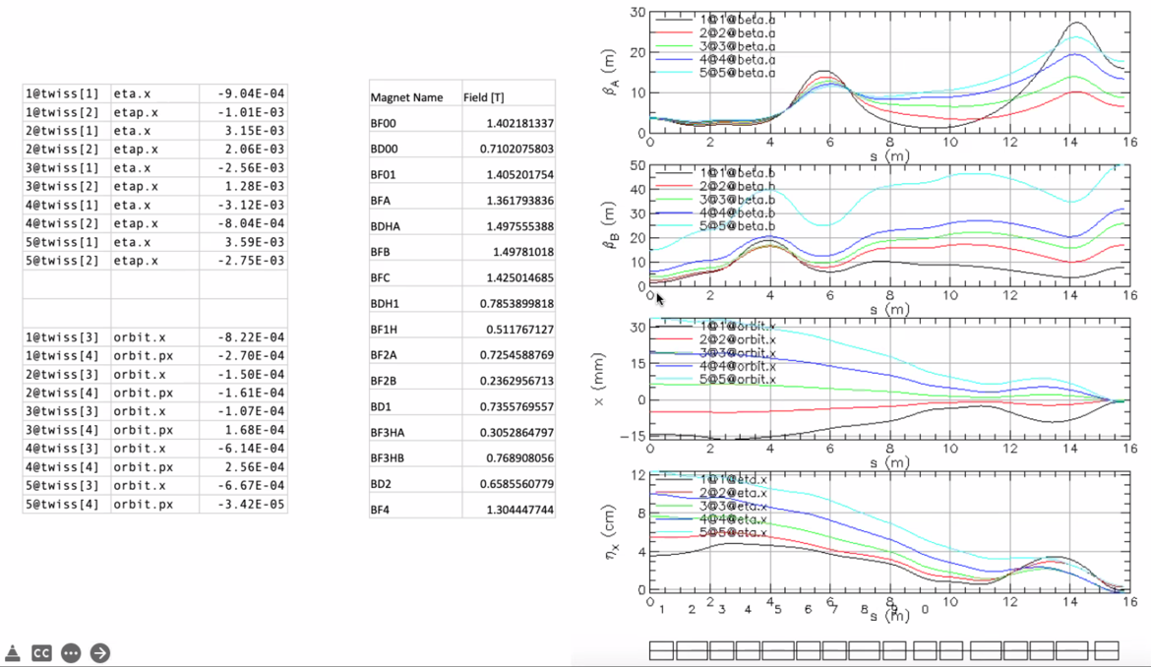
  + Alphas are close to zero, but not there yet – still working
* 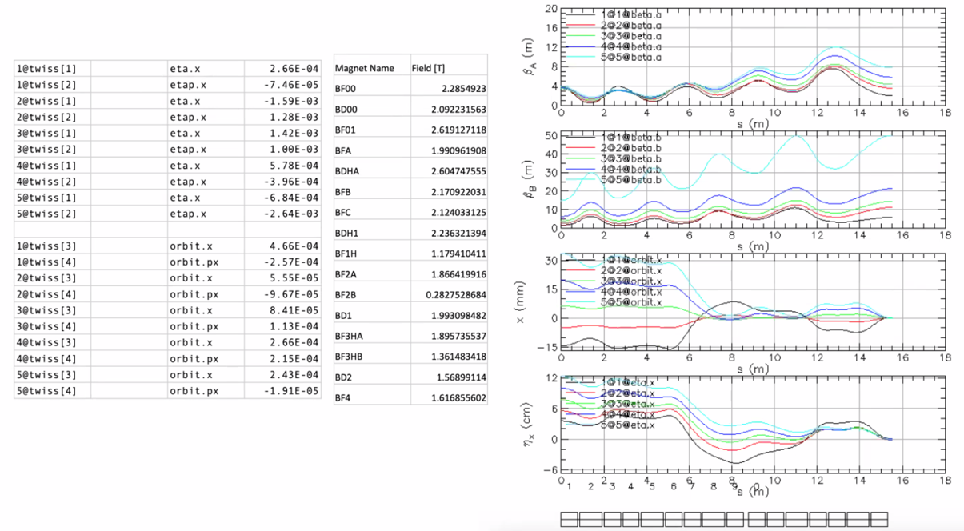
  + Dispersion and orbit lower, but alpha not right yet
* Dejan: push on length
  + Do we have a limit on the total length? No, we’re saving space. You can make them a little longer to reduce the field
    - Do this in small steps so you don’t lose what you already have.
  + One function went up: BetaB went up – this is normal
  + Alphas are very close to zero. It’s not very pretty, but it’s almost there.
  + Play a bit with the bending of the dipoles. If you use the last 3 magnets with the middle one bending one way, and the outside ones bending opposite to the middle, you may have to drive it yourself.
* Alex B: you dig in a bit deeper into the arcs, not just the last 5 magnets, but you modify some of the arc proper?
  + No, those are just added as a repeating section
* Dejan: let the distance between final triplet and previous magnets be a free parameter
  + This should be a variable
  + Different distances will blow up Beta, but that’s expected
  + You matched it, just make it prettier now
* Vasiliy: how hard make magnets of different lengths?
  + Not hard. Just add a little at a time.
  + 10% at a time? No, likely smaller than that. Maybe 5%.
* Dejan: what weight on Betas?
  + Just 1. Dispersion has high value
  + Best fitting for Dejan: put 100 for betas/alphas, orbits and dispersion at 1000 or 10000 if memory serves
* Vasiliy: how do you get field?
  + Assuming centered
  + Dejan: don’t make ratio larger than 1.6
  + Stephen: gradient aperture +/- 30-40 mm to hold all the beams
    - Only an option if using 2 splitters instead of 4 in the machine
    - If you have a splitter on each linac, you won’t need this. If you have one splitter, then the other side would look like this.
* Dejan: you can always add another magnet if you need more variables
  + Randika: thinking of reducing the number of magnets
    - Try to see if last 3 magnets have opposite signs
    - This is in the shared folder
* Stephen: how close is beta match?
  + Not matching for specific value
    - This makes it easier.
* If there’s a splitter, why are we putting them in?
  + Maybe cut last magnet in FFA to half, and take this as an input into the matching section into the linac
  + Or put this into the splitter
* All orbits are entering with 0 initial slopes
* Where is this section supposed to go?
  + FFA on left, right is splitter/recombiner
  + So why are we trying to make all the beams colinear?
    - Good question
* Dejan did this before b/c always needed a straight section for kickers, etc…j
  + Here, we don’t need that.
* Alex B: grey area
  + Depending on how well we do at merger at end of arc, we will have to weigh this.
* Dejan: started with adiabatic merging with larger distances between triplets, then figured out that it’s a waste of space. So we gave up on that. Then the word merging remained, Vasiliy found this 10 m solution.
  + We had a separating magnet coming from the splitters so that every orbit matches the FFA orbits
  + Stephen: We went from horizontal merge to the FFA, but first magnet was a half magnet
* Once separated, changing betas takes half the magnets
* Stephen: we should look at LINAC > spreader > splitter > FFA with half magnet at beginning.
  + This is interesting conceptually, but uncertain if this can/should be used in out project
  + Dejan: we could give up on the splitters on one side
    - But then need to match betas – more difficult
    - Match betas – easier to match than if beam always in same position.
* Alex B: we should do both simultaneously to see how things merge
* Magnets in splitters have much larger energies – not easy to make
* Vasiliy: two options:
  + Relax if going into spreaders/recombiners
  + Another version of this to match betas
* Dejan: depending on if we can do M56 and TOF with 1 or 2 sides
  + If we do it with 1 on each arc, then the other side can use this
  + Stephen: still need to match betas into linacs, and this could be hard
* We need a splitter line first. This is priority.
  + Ryan shows some dimensions:
    - 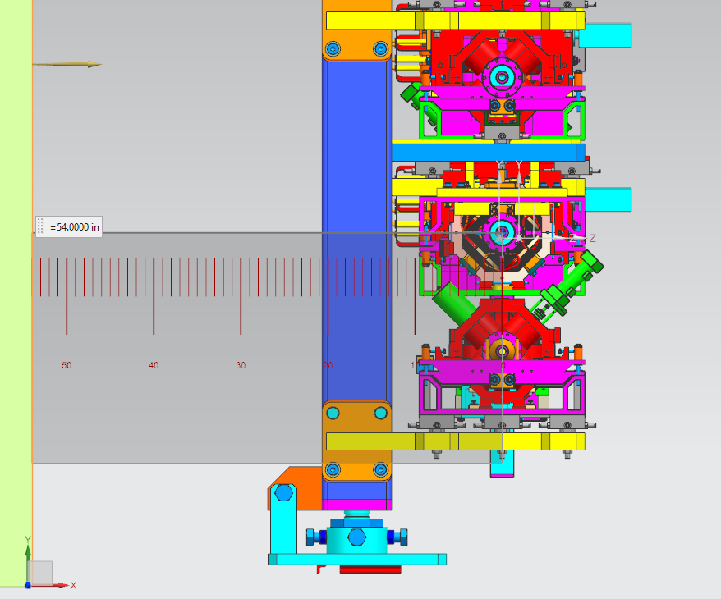
    - 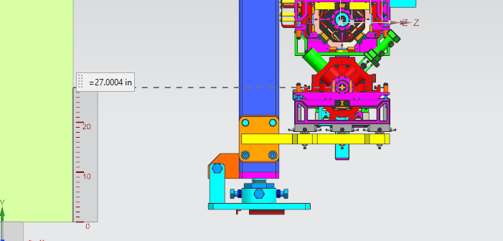
    - 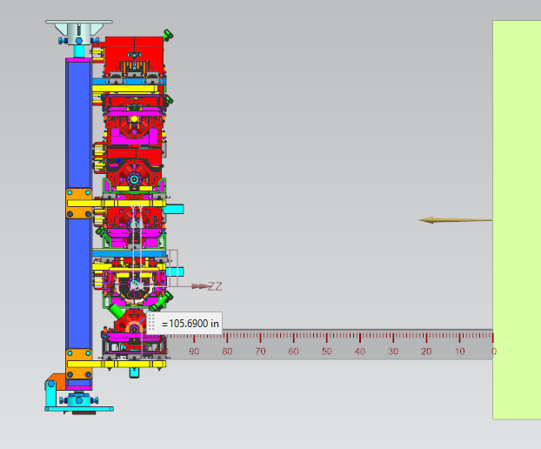
  + Jay: ask Drury or Humphry for how much space needed
  + We’re going to be geometrically constrained
    - First step, slap down 6 lines, then manipulate to get the right path length (or negotiate with engineers to shave walls/magnets).
    - We won’t have ideal bends for M56 correction
    - Get in beamlines, then TOF, then M56
    - Look at CBETA splitters, try to copy that into the space we have as best we can, then massage it from there.
* Dejan – M56 numbers were for HIS version, but this needs to be redone for the newest lattice.
  + Can do this in MADX in a minute
  + Kirsten: can get it from Bmad simulation no problem. But that’s for full arc, then you take out X number of magnets for splitter, have to recalculate, etc… become recursive
  + Dejan didn’t use the full 180 degrees

|  |  |  |
| --- | --- | --- |
| Action Items | Person responsible | Deadline |
|  |  |  |
|  |  |  |

## Time allotted | 25 mins | Agenda topic FFA Arc Errors | Presenter Alex C

* 
* How define sample space
* 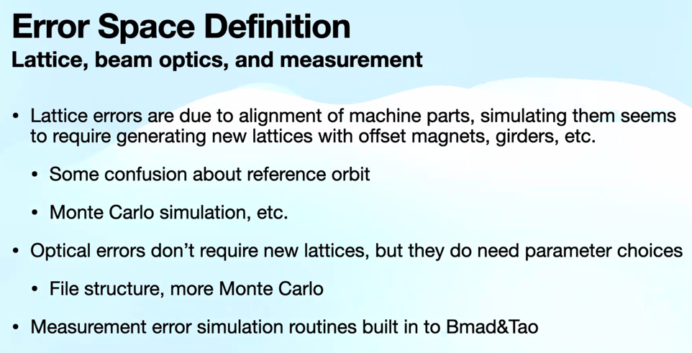
  + All starting optics are in separate file
  + Need to think more systematically on how to combine these together
  + Bmad and Tao have some built in measurement simulation routines
* 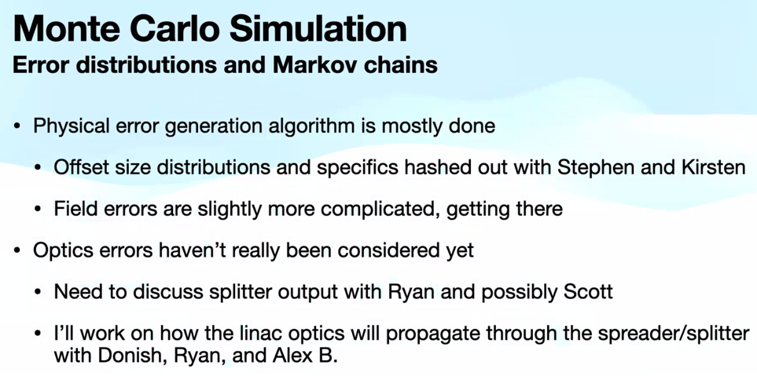
  + Need to discuss splitter output
  + How propagate linacs through the spreader/splitters
* 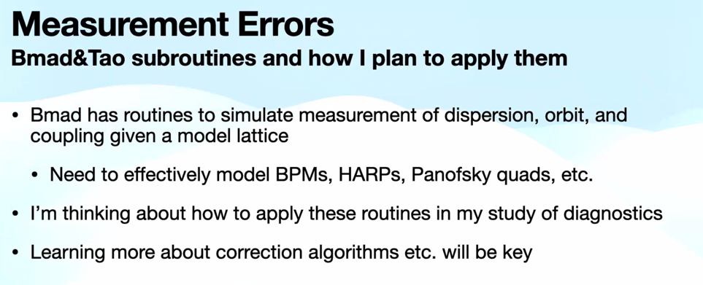
  + Still looking into how to make these things work
* 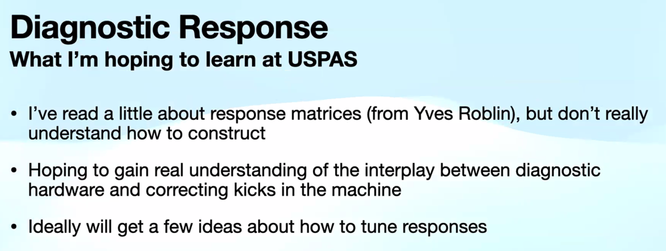
  + Not sure how to go from no response matrix to having one
* 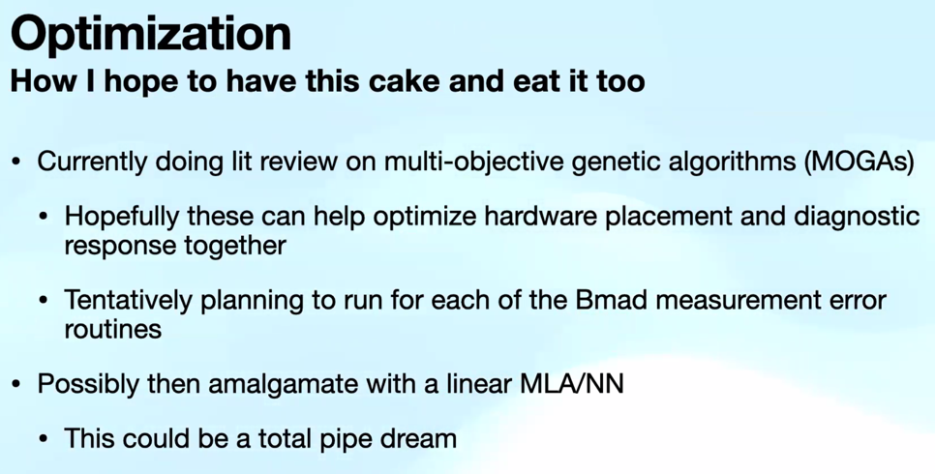
* Dejan: didn’t tell anything about results
  + You need to understand what are the limits on the quality of the magnets and the quality of the surveying. We had this problem running CBETA. Something like 2 or 3 magnets are misaligned.
  + Stephen was using results from every possible error to create the request for the mag field quality.
  + Alex C: I have MC simulation that can spit out as many error-filled lattices as needed. But want to be able to use the data from those statistics. Haven’t gotten to run 100K lattices yet, but am getting there.
* Jay: question – Halbach made estimates on fabrication errors for magnets. When you put them into SDDS subroutines – do you plan to get to that level (fabrication errors)? Klaus looked into this in great detail.
  + Yes, going to write it down.
  + Also want to see how these errors might add. Right now, the magnets are in 6 pieces. So see if non-uniform field error impacts things.
* Kirsten: how implement correction scheme?
  + PyTao? Do you have a solution, or just know it exists?
    - Know exists, but haven’t solved it yet. Trying to set up the dominoes, then knock them down.
  + Virtual machine from CBETA
    - This can break with BMAD updates.
* Donish: check out some of Dave Douglas’ studies for these errors.
* Dejan: Dave did another document for BNL as well.
* William Lou did a lot of this at CBETA

|  |  |  |
| --- | --- | --- |
| Action items | Person responsible | Deadline |
|  |  |  |
|  |  |  |

## Time allotted | 10 mins | Agenda topic AOB | Presenter All

* Dejan: Vasiliy/Randy did a very good job. This is useful if they take this only for the 2 possible areas to connect to the linac.
  + - If the other two are possible to correct M56 and TOF
  + Need to do splitters for 14 cm TOF correction
  + Start matching down to LINAC by making Betas merged
* Alex B: yes, push for splitters, come out of arcs with parallel orbits, then match to linac
* Vasiliy: things are more clear today.
* Dejan: We’re doing R&D. The FOAs are for R&D. Big mistake delaying for a year by not applying. Why not apply now?
  + Discussion on if we’re qualified to proceed. Once NSAC accepts this study, then we can try. But for now, we can’t assume a different result from last year.
  + Andrei: I don’t think we need to wait. There is interest.
  + Dejan: we need white paper ASAP
  + Andrei: the physicists are putting this together for the long range plan.
  + Pre-application due Feb 7 – can refresh these and resubmit.
  + Andrei: let’s try
  + Alex B: will contact Spata and see if we can do this.
    - FY2023 RESEARCH OPPORTUNITIES IN ACCELERATOR STEWARDSHIP AND ACCELERATOR DEVELOPMENT
    - FUNDING OPPORTUNITY ANNOUNCEMENT (FOA) NUMBER:
    - DE-FOA-0002951
    - <https://science.osti.gov/-/media/grants/pdf/foas/2023/SC_FOA_0002951.pdf>
      * Follow up email after says not the right link. See email exchange for more info.
  + Andrei: white paper will be published, but not yet.
    - Next week there’s a small workshop here about it. We’re gaining momentum.
    - Jay: Hall C futures on Arxiv

|  |  |  |
| --- | --- | --- |
| Action Items | Person responsible | Deadline |
|  |  |  |
|  |  |  |

## Special notes

Pathway to Repository: <https://jeffersonlab-my.sharepoint.com/:f:/g/personal/tristan_jlab_org/EqZ5MeS-nipCgPfZB5p0oS4B9Is67d3nQb9sLJI3Zyev9g>