FFA@CEBAF Working Group|Minutes

## Meeting date | time 01/27/2023 | 11 AM EST | Meeting location <https://jlab-org.zoomgov.com/j/1614898082?pwd=TnUzMS81M2sxbDZIbERJU01tYkJCQT09>

|  |  |  |  |  |  |  |  |  |  |  |  |
| --- | --- | --- | --- | --- | --- | --- | --- | --- | --- | --- | --- |
| |  |  | | --- | --- | | Meeting called by | Alex B | | Type of meeting | Weekly Meeting | | Facilitator | Alex B | | Note taker | Ryan, Donish, Kirsten | | Timekeeper | Alex B | | Attendees  Alex B, Ryan, Donish, Scott, Dejan, Stephen, Kirsten, Jay, Vasiliy, Reza, Vasiliy, |

# Intro Discussion

EIC discussion.

Eduard coming to JLab as Director of Operations! Eberhardt recommended FFA for 12 GeV decades ago! Back then, the magnets and the technology and techniques not ready yet. Maybe Eduard will come to our meeting? TBD

Brief trip down memory lane.

FFA@CEBAF retreat first week of April (Thursday and Friday the 6th and 7th). Will require registration.

# Agenda topics

## Time allotted | 25 mins | Agenda topic Splitters | Presenter Scott

* Should feel very familiar, you’ve seen the first part.
* 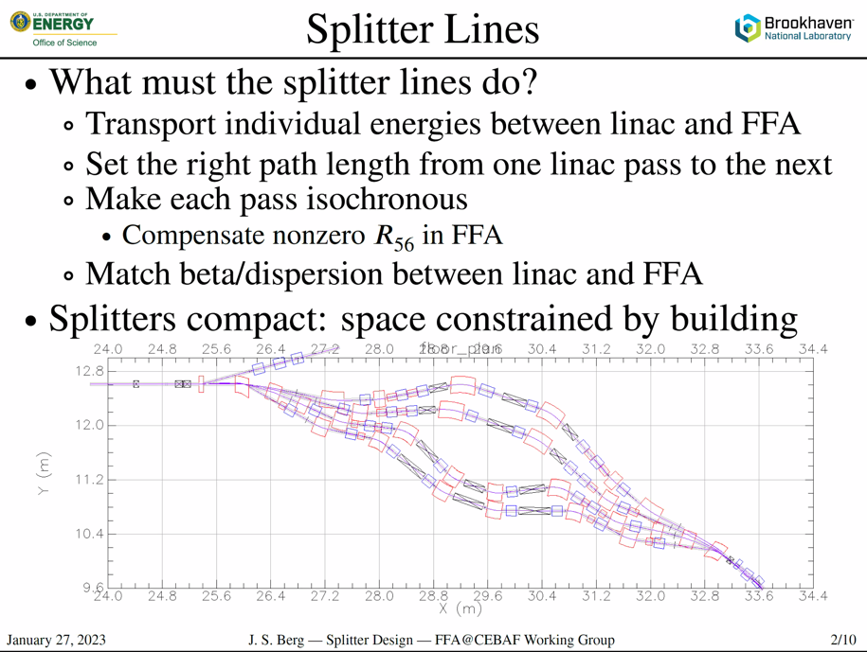
  + Beam from linac to arc, separate for each energy
  + Make sure the path length is correct (some number of wavelengths)
  + Want isochronous, or known non-zero R56
  + Match
* Will need to be very compact, again.
* 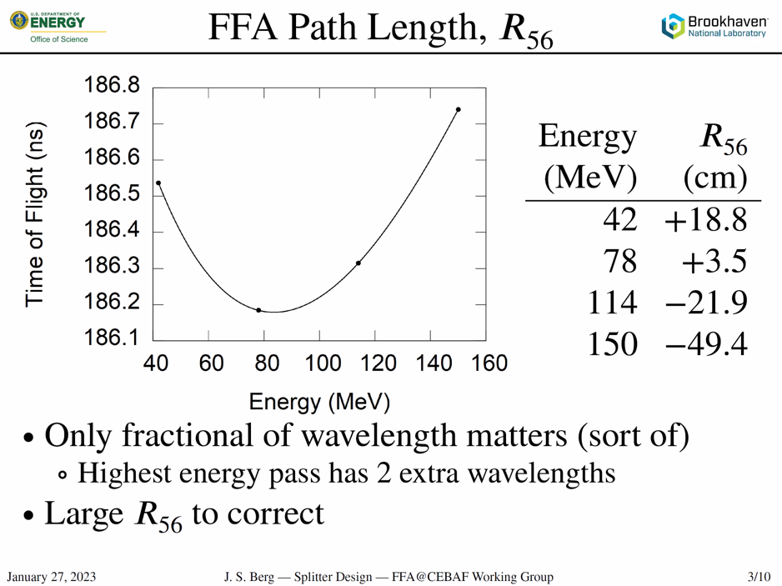
  + Not the same for each pass, so clean it up
  + CBETA highest E pass had 2 extra wavelengths due to geometry
  + R56 in CBETA shown – those are very large numbers
* 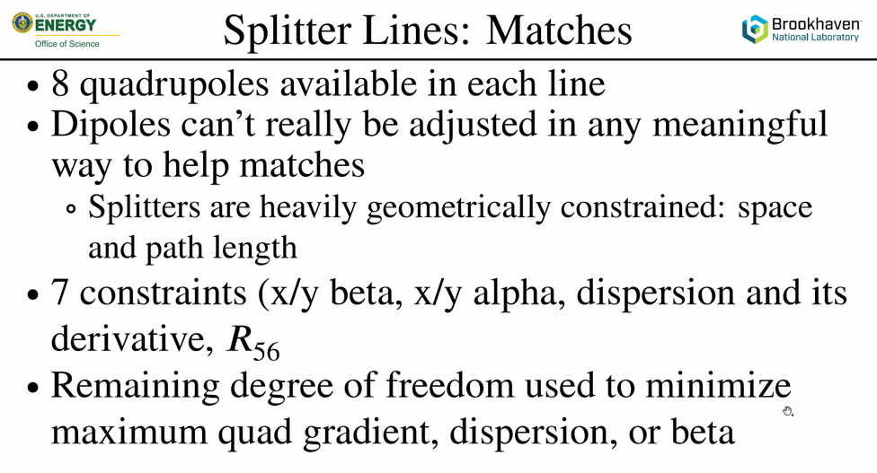
  + Kind of stuck with dipole arrangement, quads squeezed in where could fit
  + 8 quads gives 1 DOF b/c 7 constraints
* 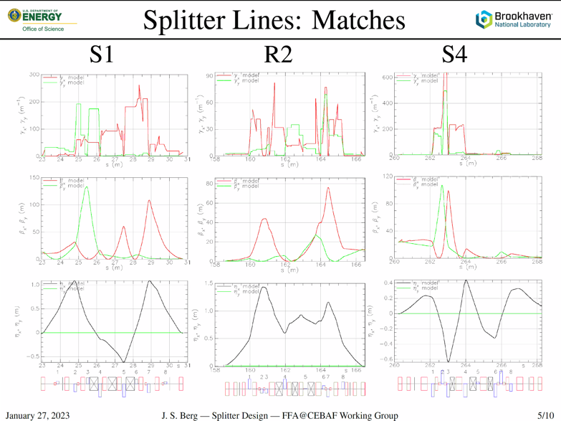
  + 3 examples, all “bad”
  + Plot gamma b/c related to natural chromaticity
    - 100 per 4 meters /(4Pi) about 30 – bad (S1)
    - R2 ok
* Brute force/desperation matching. Basically, dropped a bunch of quads/dipoles and said “go”
  + Kept having to create wrong-sign R56, then correct that as well
* 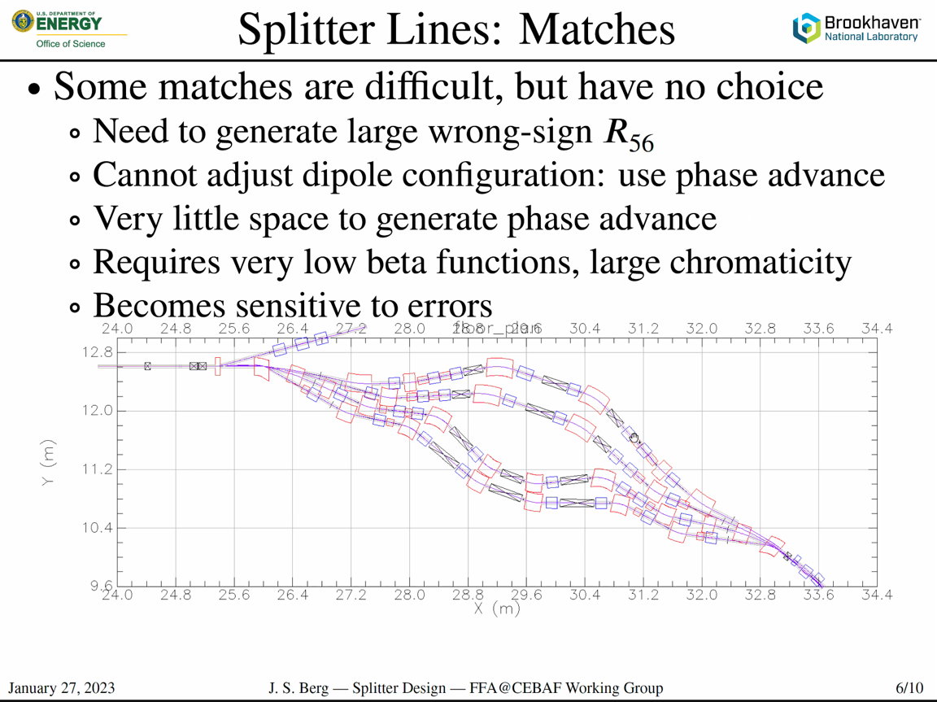
  + Very little space to create phase advance, which is what gives you independence. If you have 4 quads and only 10-degrees of PA between then, basically the same quad.
  + Cranked down Betas to create phase advance. This is a bad way to do it b/c they create chromaticity as well. But there was no choice here. When the beta coming out of the linac is 20 m or some large number, you can’t make a FODO
  + Very sensitive to errors
* 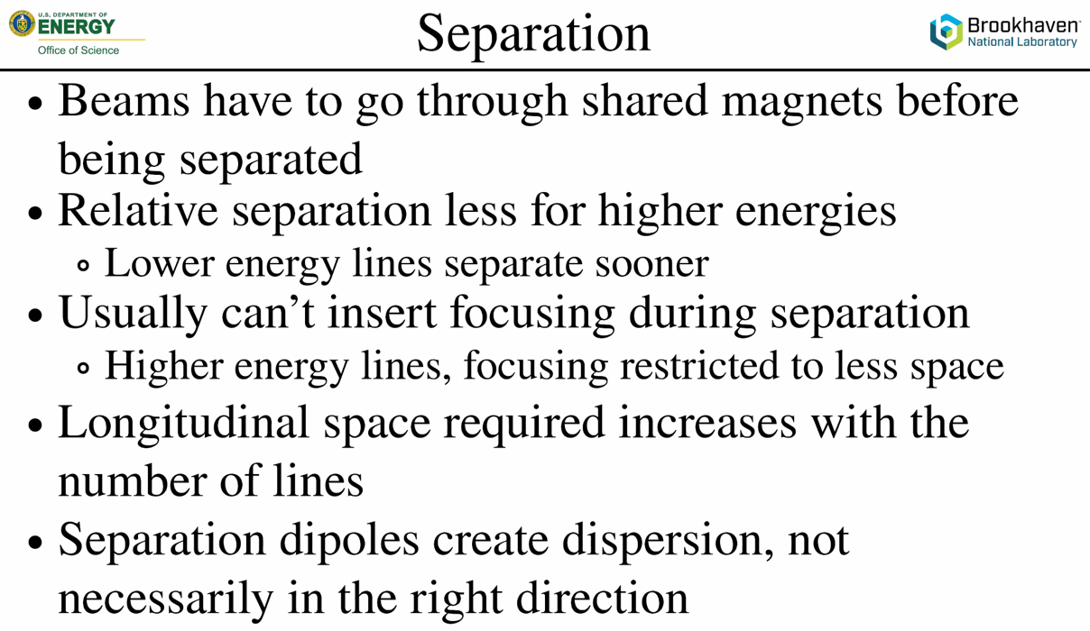
  + We have smaller energy range
  + Usually, can’t put in focusing during separation (can sneak some in)
  + For each separation, you need more longitudinal space
  + Low E lines can afford the space more
  + High E lines need larger magnets, etc…
  + You need dispersion for R56, but it’s not always the RIGHT one
* 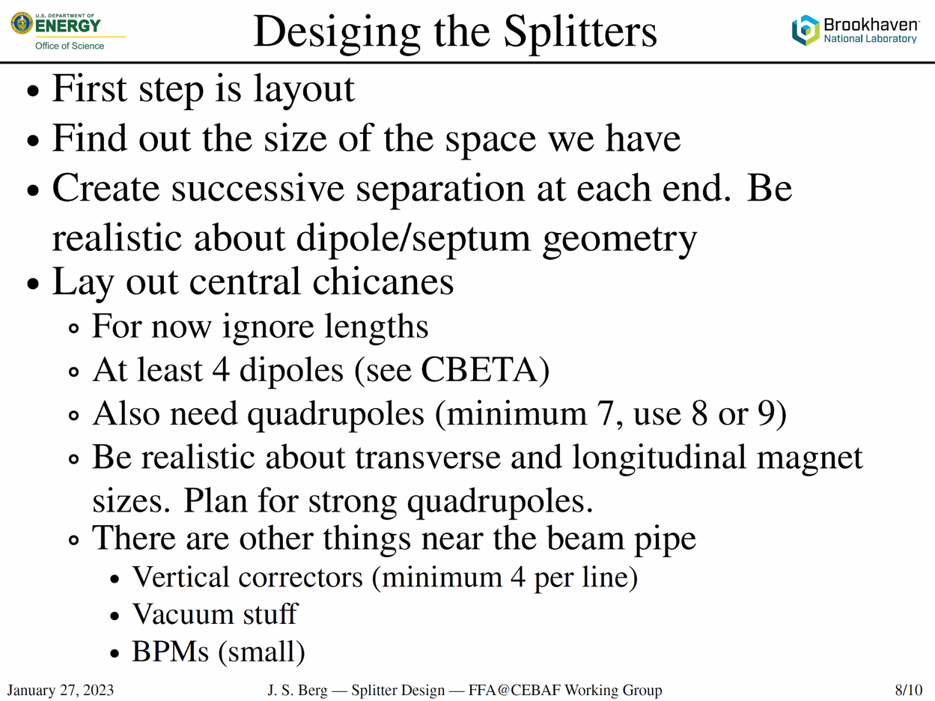
  + Get a bunch of magnets into the box
    - Only worry about what the magnets do in a very broad sense
  + This is a space problem.
  + After separation, put in the chicanes. Don’t worry about what they’re doing yet. Just get enough magnets in there.
  + CBETA has 4-dipole chicane, after matching. This is sort of minimum.
  + Will need minimum of 7 quads. DO NOT RUN THE MINIMUM.
    - 8 or 9 without correcting vertical dispersion
    - Add 2 more if we need to correct vertical dispersion
  + Be realistic about sizes
  + Plan for strong quads. Assume 90-120 phase advance with spacing you have on the magnets. Need to have very strong quads. This will give sizes. Need transverse and longitudinal sizes.
    - CBETA needed a “long quad”
  + Don’t forget “other” items. Correctors (min 4 per line), BPMs, valves, pumps, etc…
* So, get it all in the box, “does it still fit?”
* 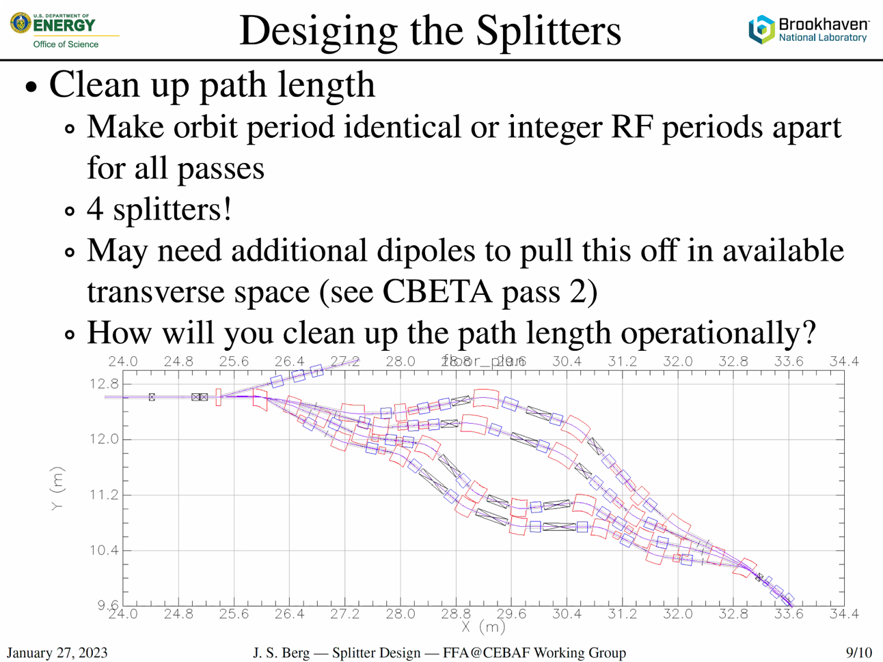
  + First make N chicanes (6 for us)
  + Path length is spread over 4 splitters (if we use all 4 corners). So some can be left to “other corners” to correct
  + Alex B: When you try to get path length different in chicane, the contribution from going through magnet is minimal. Most comes from angled straight sections?
    - Yes
  + How clean up pathlength in OPS in the machine?
    - Long black boxes in CBETA are used for pathlength correction (sliding joints) – worked very badly.
      * Took up quad space
      * Operationally problematic
      * Advantage: you can keep the beam on axis of beamline (in principle)
      * You could instead steer the beam to do the correction.
    - Steering beam downside: if you try to fix up your match, you’ve steered the beam, so you have to fix that as well. Adjusting dipoles as fixing quads, etc…
    - Advantages in controlling mechanically, but also costs to doing it. So put that in the planning and think about how to do it
      * Kirsten: might not be so bad at CEBAF since sliding joints not as close to RF. But CEBAF RF is cranky.
* 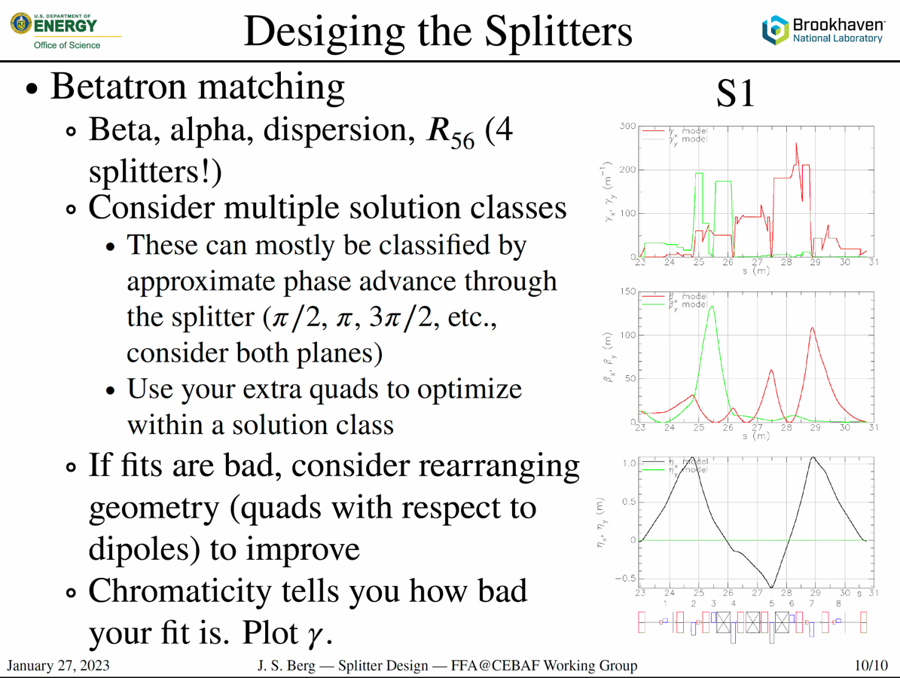
  + Remember, corrections can take place in 4 splitters
  + Solution class: let’s say I have 8 quads, 1 DOF, swing it and maintain match. Things will change as match, but limited to how much the solution can change. What limits this is ROUGHLY the phase advance (usually a multiple of Pi/2). Not an exact number at all.
  + Let’s say you start with Beta match, get other Twiss, then try to get R56. You’ll find that the Twiss have “locked you in” to a class. There’s a range of R56 you’ll be able to get in that class, and that’s it. Won’t be able to change it?
    - Don’t give up, but reset match to something completely different. Can’t continuously vary, but really jump to something new. Change quad polarities, etc…
  + Continuous changes only used in a single solution class
    - Sometimes, you’ll get something horrible, but then you can start changing things to improve it. This can lead to a good solution
  + Consider rearranging geometry (quads WRT dipoles may need to change). Maybe dispersion fit is problematic, for example.
    - Phase advance between dipoles can change that way.
  + Chromaticity tells you how bad your fit is. Keep plotting gamma!! Keep gamma small. Take integral, divide by 4Pi, should be “a few” not like “30”
    - Alex B: can we use sextupoles?
      * Yes, BUT, using chromaticity b/c it tells you how strong your focusing was, and what problems to expect.
      * When correcting Chromaticity, correcting beta. Many higher-order terms come into play. Avoid the source, b/c you can’t fix it with a reasonable scheme.
      * Even if you had an independent arc with independent powered sextupoles, still couldn’t correct. Message: FIX THE SOURCE
* Dejan: get real numbers for TOF and R56 (just momentum comp times overall length)
  + Comes out in any code
  + When you know the first numbers, the first thing to do is to look at the geometry to correct TOF
  + Look at normalized dispersion space to see where dipoles should be to get right sign to correct momentum compaction
    - Positive or negative from arc
  + When design betas, should not go to 100 m, they should be low numbers to reduce chromaticity.
* 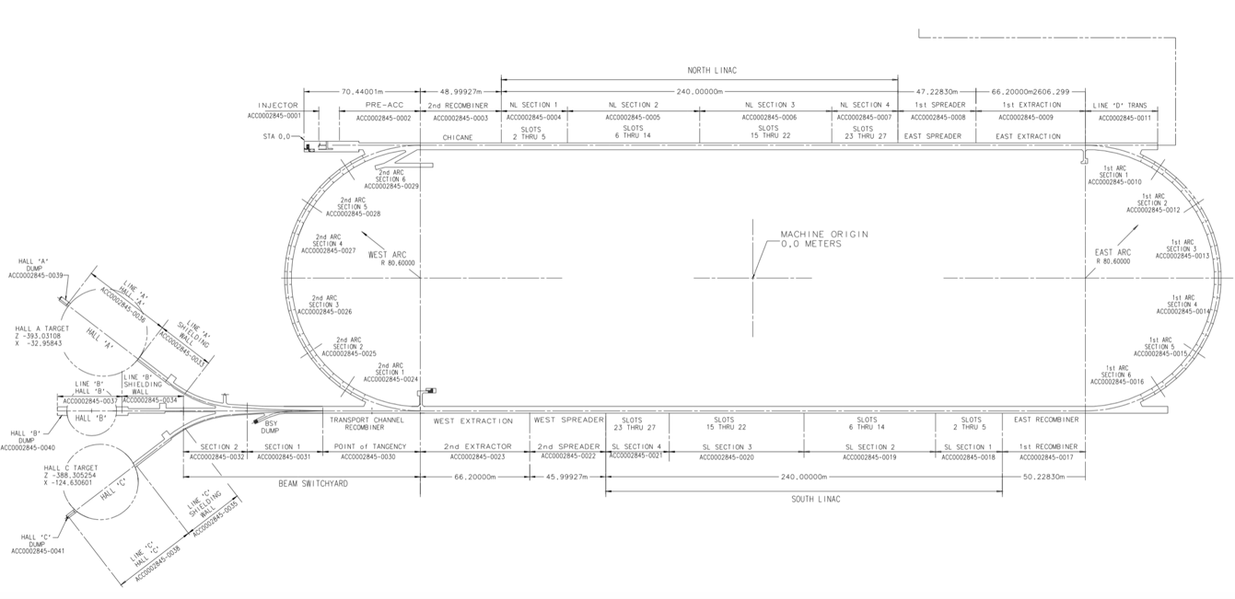
* 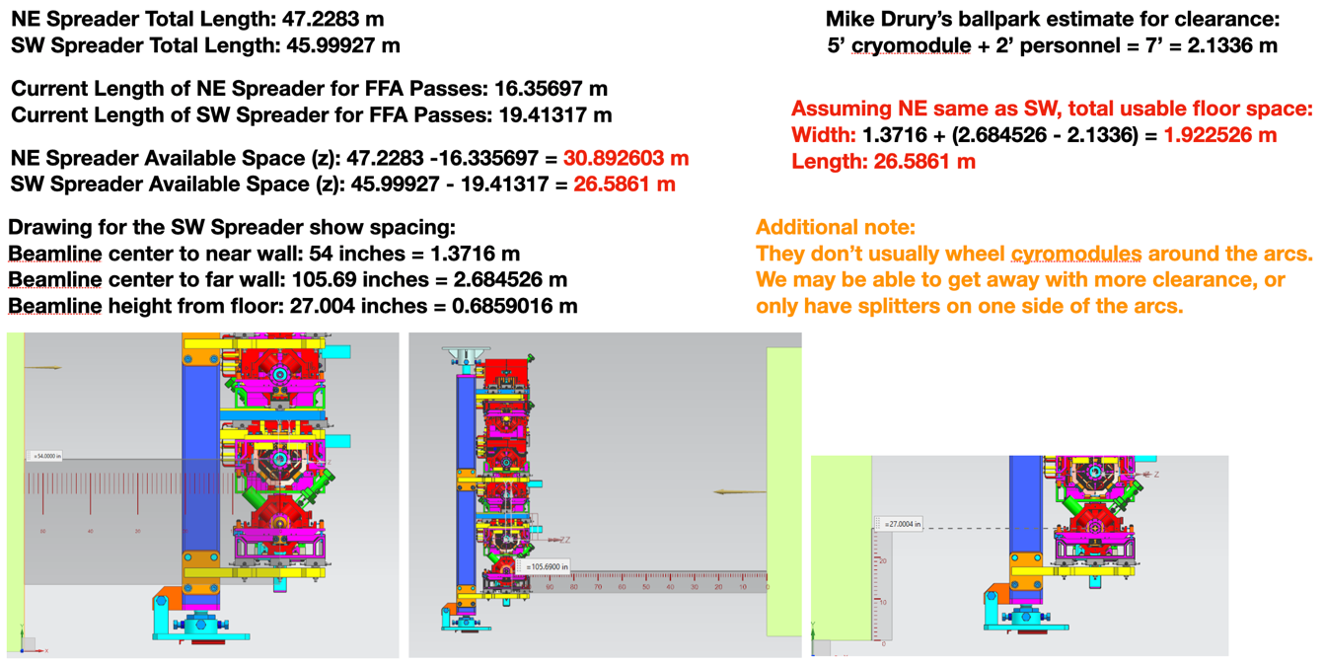
  + 47, 46 m in spreader lengths. Current length for ne, sw: 31, 26 m. Usable space: < 2 m x 26.5 m.
  + Cryomodules can have 2 entrance locations if we get rid of the spectrometer near the beginning of the NL. This would allow more space for splitters, if the other corners use the non-adiabatic transition Vasiliy and Randy are working on.
* 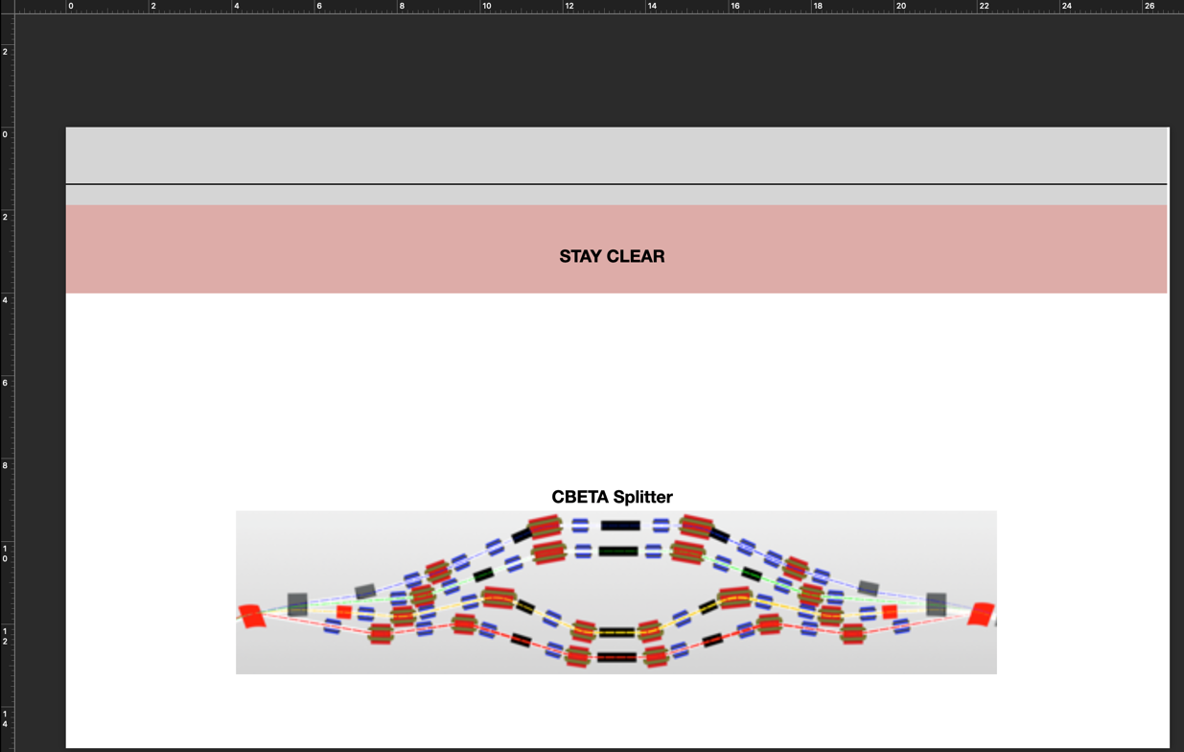
  + Ballpark, 10 m space needed at CBETA
* 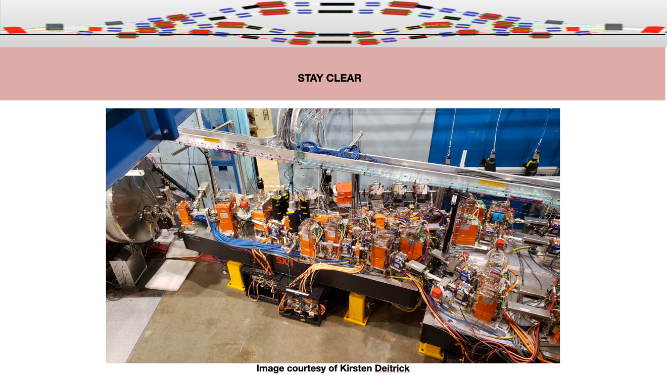
  + Ballpark of 2 m transverse needed at CBETA with small magnets
* We’ll need much larger magnets.
* 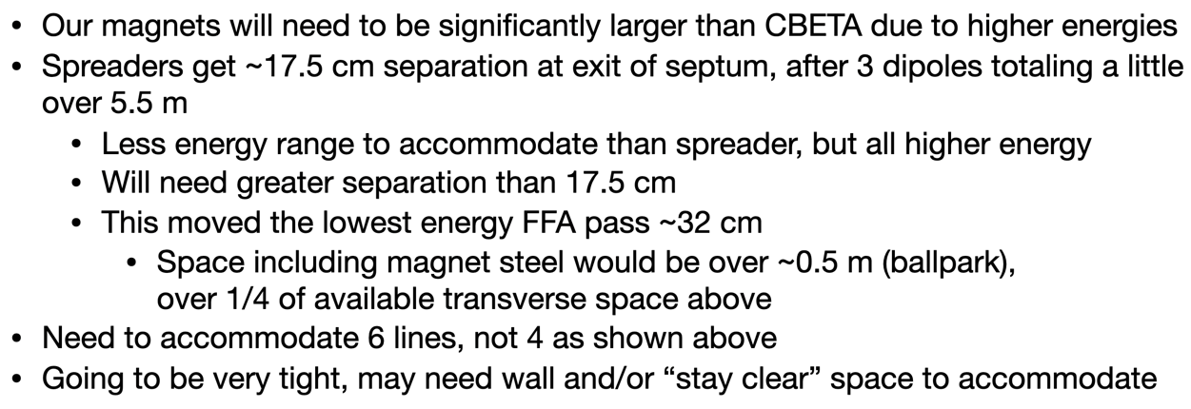
  + Stephen comments order of magnitude [length]^2 transverse offset, [length]^3 path length
* Alex Comments on Spreader:
  + 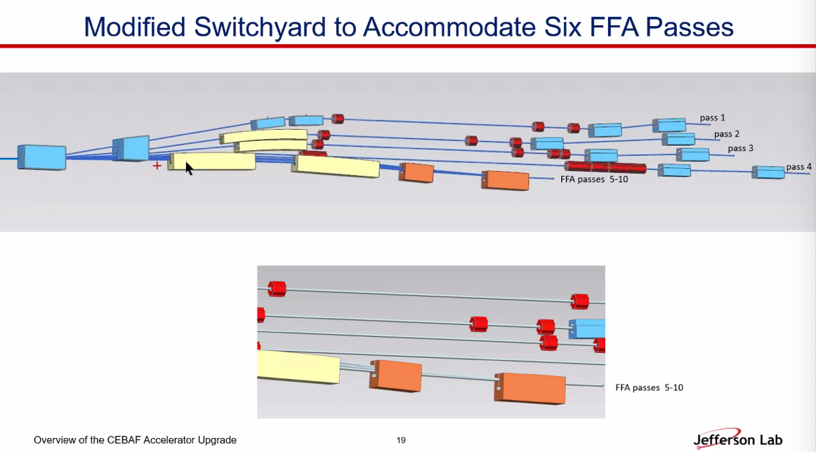
    - Dispersion will be suppressed
    - Knowing betas at linac, we could have a starting beta at the end.
  + Stephen: order of magnitude, could use more longitudinal space
* Dejan: for 12 cm pathlength, need radial offset of chicane should be 42 cm. Not too bad at all. Path length correction may not be difficult.
  + Scott: primary source of pathlength direction is primarily from angles in chicane
  + Path length correction from length of chicane WRT straight line. That’s the difference in path length. 42 cm offset WRT central line.
* Scott: questions about options:
  + Could imagine that the splitters extend into the arc?
  + To what extent is the building structure compatible with taking it along the ceiling?
    - Jay: it’s not. Convective coolers, lights, fire suppression, 650 MeV lattice will be along the ceiling.
    - Scott: not rolling, craning. Raise over the splitters. Is there enough structural strength in the ceiling?
      * Jay: yes.
      * Scott: could steal some space at cost of adding a crane system over splitters
        + Or putting in rails/ramp to be ~1 m off the floor.
* Jay: what algorithms are used within MADX for moving things around?
  + Scott: I could give a talk on this all by itself. Basically, found 1 solution, have 1 DOF (convenient for this process). Idea was that you have the solution, can now find local tangent vector of changing quad strengths. 7 contraints, 8 variables. What’s the tangent vector for 7x8 matrix? Find null space of matrix: that’s the direction you can go. Make one step in that null space. Repeat (find the new null space). Code would “trace the line” for hours and hours at a time. It would often find ridiculous solutions, sometimes would crash. But sometimes it would loop back and find something reasonable. B/c so non-linear, had to go step-by-step, you had to find the solution in the null space each time. Keep going in one direction and the other and see what came out. Would look at the plot (magnet strengths, betas, etc…). Find the solution where you’re in the lower left corner (small beta small mag strength).
    - 10s of 1000s of different solutions. Chose one based on best behavior.
    - This only scans in 1 solution class. So you then have to make a new solution space and try again.
    - Wrote custom code for this.
  + Jay shows Karmarkar’s algorithm
    - simplex both used for shimming mri magnets.
    - Maybe consult with someone that does this for a living (RProject.org ?) could be useful here.

|  |  |  |
| --- | --- | --- |
| Action Items | Person responsible | Deadline |
|  |  |  |
|  |  |  |

## Time allotted | 25 mins | Agenda topic GitHub | Presenter Ryan

* Will send out some info in preparation of next week.

|  |  |  |
| --- | --- | --- |
| Action items | Person responsible | Deadline |
|  |  |  |
|  |  |  |

## Time allotted | 10 mins | Agenda topic AOB | Presenter All

* FFA@CEBAF retreat/workshop first week of April (Thursday and Friday the 6th and 7th). Will require registration, but no fee.
  + Jay organize tour on Thursday
  + Friday, we could have our normal discussions
* How organize the agenda? Would be good to set up subjects ahead of time.
  + Each of us should have some goal to present something at the meeting.
* Need overview of where we are, where we’re heading, etc…
* Scott: instead of having a bunch of talks, would be good if we can turn it into a working meeting. A real workshop. Try to do some work on various issues. Trying to avoid filled agenda.
  + Dejan: we should have subjects laid out
  + Scott: yes, but we don’t all have to be in the same room at the same time either.
    - Stephen: for example maybe we only have 3 people working on splitters together, not everyone needs to be there.
    - Maybe have initial discussion, then break out as needed.
* Alex: let’s say maybe Thursday morning, sit together, decide what we want/need to attack. Then go see CEBAF. Then Friday, whole day to discuss, break out, etc…
* Scott: Dejan, on our end, we need to decide who will/will not get approved for travel.
  + Direct flights, cheap trip overall.
  + By invitation only
* Alex will send out invitations soon.

|  |  |  |
| --- | --- | --- |
| Action Items | Person responsible | Deadline |
|  |  |  |
|  |  |  |

## Special notes

Pathway to Repository: <https://jeffersonlab-my.sharepoint.com/:f:/g/personal/tristan_jlab_org/EqZ5MeS-nipCgPfZB5p0oS4B9Is67d3nQb9sLJI3Zyev9g>