FFA@CEBAF Working Group|Minutes

## Meeting date | time 02/03/2023 | 11 AM EST | Meeting location <https://jlab-org.zoomgov.com/j/1614898082?pwd=TnUzMS81M2sxbDZIbERJU01tYkJCQT09>

|  |  |  |  |  |  |  |  |  |  |  |  |
| --- | --- | --- | --- | --- | --- | --- | --- | --- | --- | --- | --- |
| |  |  | | --- | --- | | Meeting called by | Alex B | | Type of meeting | Weekly Meeting | | Facilitator | Alex B | | Note taker | Ryan | | Timekeeper | Alex B | | Attendees  Alex B, Ryan, Scott, Randika, Kirsten, Donish, Jay, |

# Intro Discussion

# Agenda topics

## Time allotted | 25 mins | Agenda topic GitHub | Presenter Ryan

* Quick review of options:
* Branch vs Fork workflow
  + Feature Branch:
    - 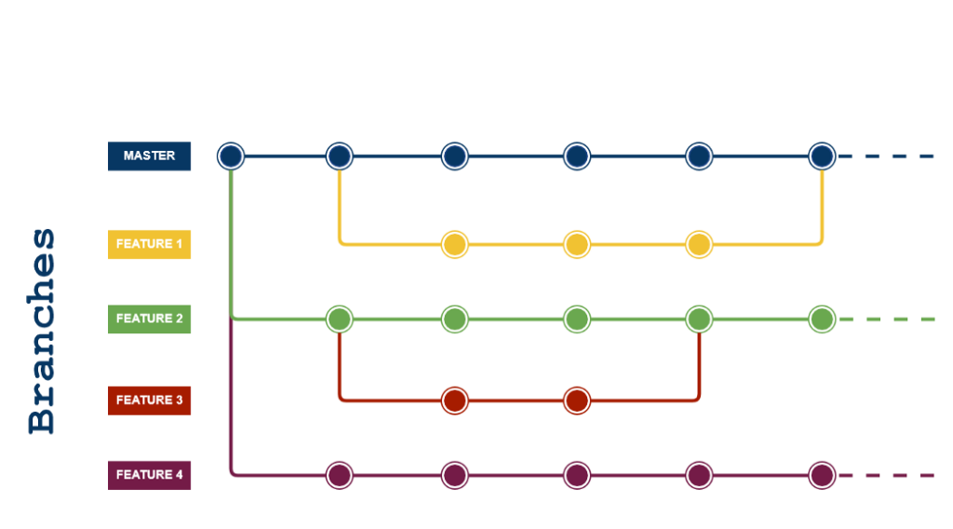
  + Git Flow:
    - 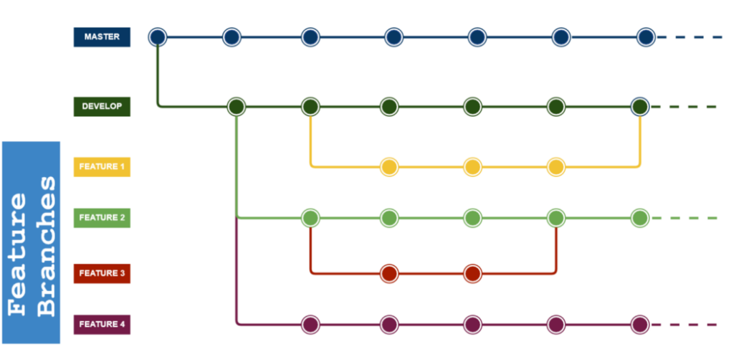
  + Fork:
    - 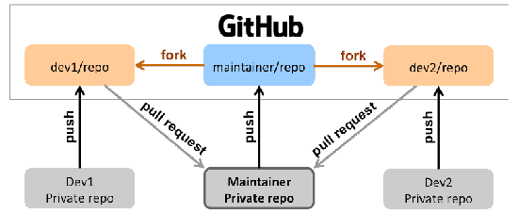
* Created a test repository so we can learn the features and try it out:
  + <https://github.com/RyanBodenstein/Structure_Test>
  + If you want to try branching, Ryan will have to invite you after you make an account
* Quick tutorial:
  + Step 1 – make an account and install
  + 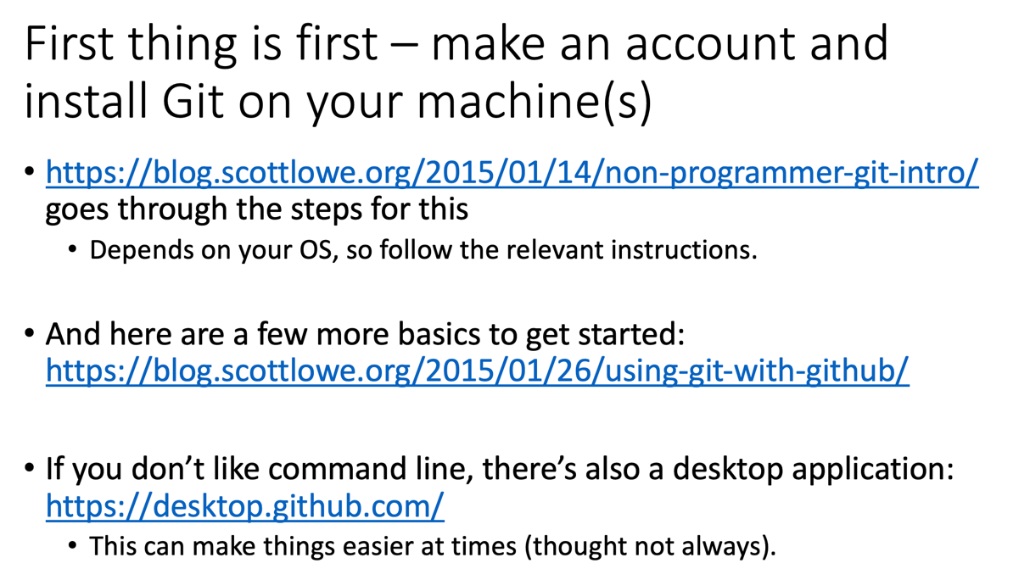
* Go through slides from today for resources and a series of screen shots showing some of the basics.
* Once you’ve tested things out and are comfortable, please vote for your preference:
  + <https://forms.gle/3gRjhUvPs6CZWGTB8>
  + This way, I can start organizing it properly.

|  |  |  |
| --- | --- | --- |
| Action Items | Person responsible | Deadline |
|  |  |  |
|  |  |  |

## Time allotted | 10 mins | Agenda topic AOB | Presenter All

* Jay is looking into hall lines again
* Ryan spoke with Harry about clearances
  + 44 inches required for personnel access – this would be the best we can do
    - Jay corrects – there are some cases where 36 inches is allowed
* Cryomodules won’t need to go through, but the forklift may, and other carts, etc…, so the dimensions are being iterated upon
  + With the 7 foot clearance requirement, it’s likely too tight:
  + 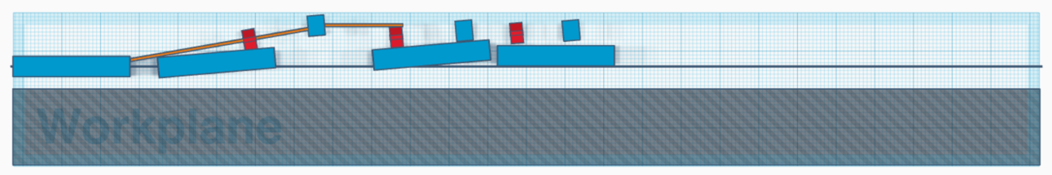

|  |  |  |
| --- | --- | --- |
| Action Items | Person responsible | Deadline |
|  |  |  |
|  |  |  |

## Special notes

Pathway to Repository: <https://jeffersonlab-my.sharepoint.com/:f:/g/personal/tristan_jlab_org/EqZ5MeS-nipCgPfZB5p0oS4B9Is67d3nQb9sLJI3Zyev9g>