FFA@CEBAF Working Group|Minutes

## Meeting date | time 02/10/2023 | 11 AM EST | Meeting location <https://jlab-org.zoomgov.com/j/1614898082?pwd=TnUzMS81M2sxbDZIbERJU01tYkJCQT09>

|  |  |  |  |  |  |  |  |  |  |  |  |
| --- | --- | --- | --- | --- | --- | --- | --- | --- | --- | --- | --- |
| |  |  | | --- | --- | | Meeting called by | Alex B | | Type of meeting | Weekly Meeting | | Facilitator | Alex B | | Note taker | Ryan, Alex C | | Timekeeper | Alex B | | Attendees  Alex B, Ryan, Alex C, Scott, Todd, Vasiliy, Randy, Donish, Andrei, Kirsten, Kitty, Jay |

# Intro Discussion

Brief talk about Optics On Call at JLab. Crisis mode.

Finalizing “retreat” – can hopefully register next week. No stiff agenda, but make it discussions and spontaneous presentations, etc… (morning of Thursday and tour). Tour will be several hours. Friday will be work/discussions/etc…

Alex C back from USPAS – was a great class (measurement and controls w/ Zimmerman and Minty)!

# Agenda topics

## Time allotted | 25 mins | Agenda topic Hall Lines | Presenter Jay

* Looking at beam transport and magnet designs in Hall Lines.
* Sent around tech notes – please read.
* 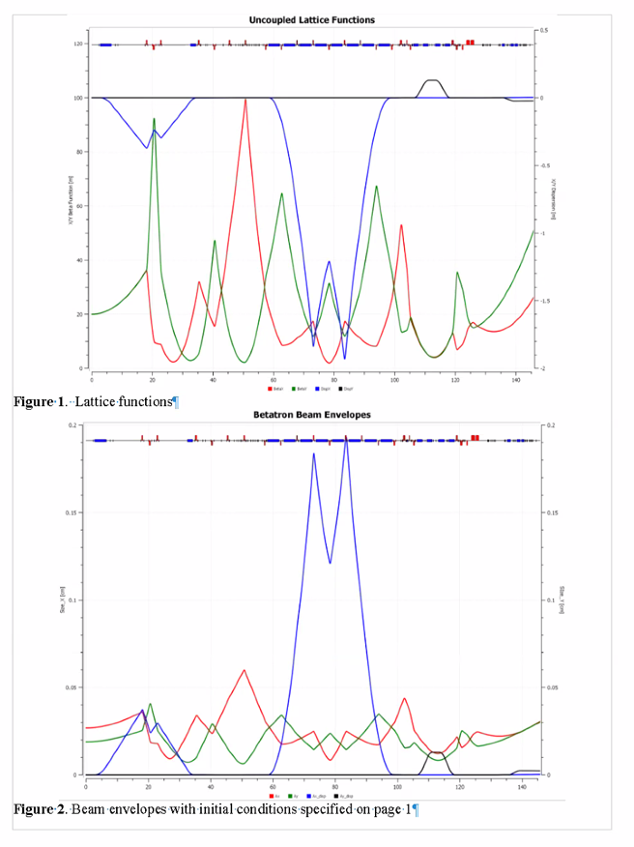
  + 1.9 m peak dispersion
  + Longer Lambertson on left. Compton chicane is 180 cm dipoles
  + Two stronger quads (from Moller polarimeter)
  + Beam envelope with initial conditions specified in note.
    - 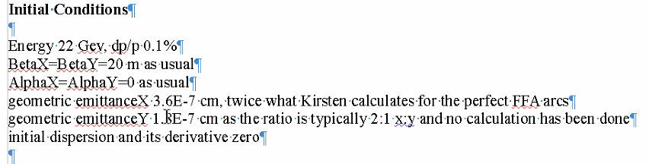
* 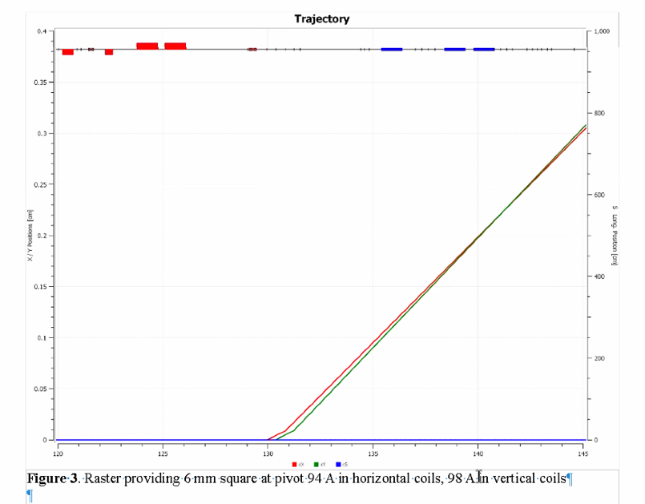
  + 4 raster coils (~100 Amps in each)
* 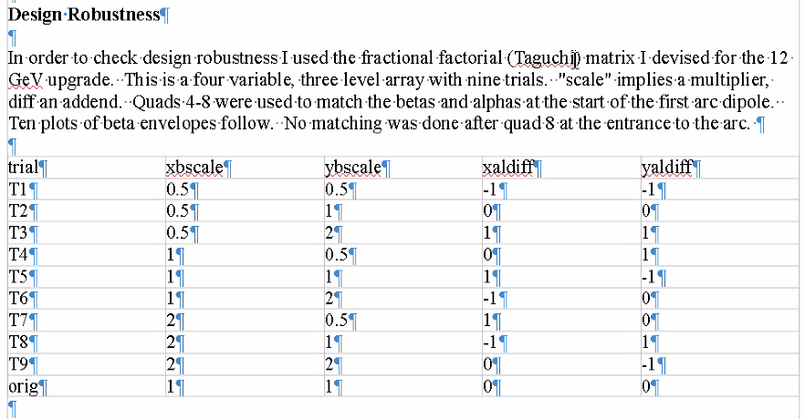
  + First level interactions and some cross coupling
  + Reasonable subset to look at to see if we can match with a variety of conditions
    - Beta either half or twice the nominal, etc…
* 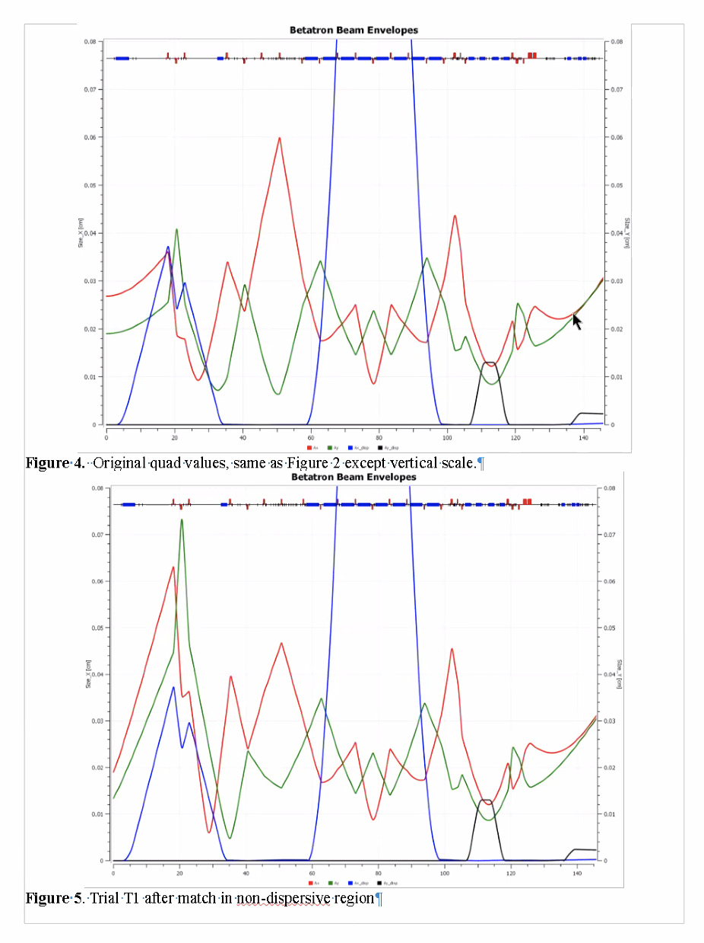
  + Changed alphas and betas from original to check for robustness. Q8 used for matching
  + Once you get out of arc into Compton chicane, adjusting the 5 upstream quads in non-dispersive region can restore optics.
* All 9 trials show same, even with large differences in the front end. End is fine.
* Design is viable. OptiM file has details.
* 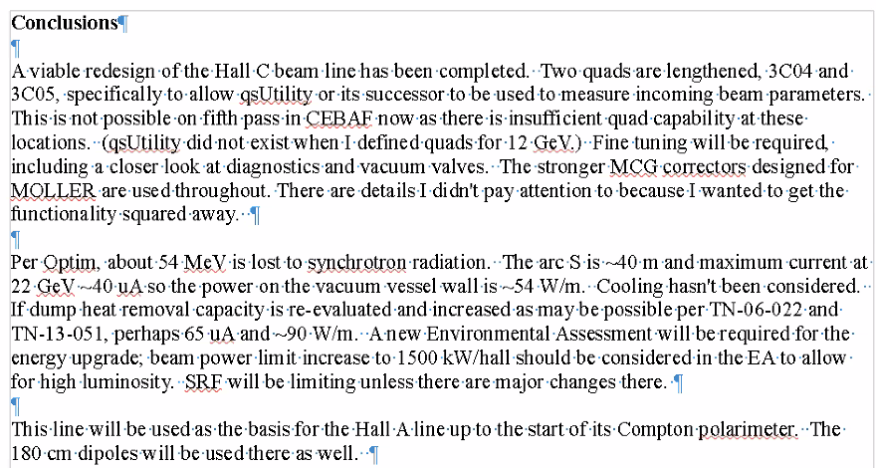
  + qsUtility – vary quad and look at beam size on wire scanner downstream. Use that to determine Twiss of beam.
  + Didn’t exist for 12 GeV for quad strength definition.
  + Making sure longer quads are placed at 4 and 5 to make sure there’s enough strength to get parabolas, assuming input parameters not wrong.
  + About 54 MeV SR loss.
  + May be possible to increase the current, will need new environmental assessment.
* Will mirror this for Hall A
* Note: center plate thicker in Lambertson to keep field in center plate down to just 2 T. Fair amount of field penetration still present.
  + Better than present Hall B
  + 24 mm thick in new Lambertson.
* End of the line: short vertical chicane (2 cm now, go to 2.62 cm).
* Arc dipoles – made sure didn’t hit tunnel wall. May need shorter BPM assemblies
* Dispersion moved, so harps should be moved (and can’t fit where they are now anyway)
* Interferometers important for hypernuclear studies – need to know energy spread
  + Part of Hall C future program – need to know 100 keV level energy spread.
* Emittance dilution – roughly twice of FFA arcs
  + Meters of dispersion here, rather than cm in FFA arcs
* Yves has an optics he uses in higher passes of Hall A w/ 2.2 m dispersion
  + Hard to get good spot size with that
* Jay using single peak optics (4 m dispersion) – dp/p
  + 22 mm beam pipe (ID) – need the quad strength
* Curly H function
* So many other constraints in hall lines, can’t control. Good to know the number.
* Existing dipoles are 3 m, these are 380 cm + 11 cm of coils on each end. No room to cut and add more coils.
* Given need for big conductor, can’t subdivide dipoles and make DBA, etc…
* Good to see rastering as well. Checked at 6 mm square (largest used is 5 mm).
* 6-10% head room on some magnets.
* Scott: If you’re worried about dispersion amplitude, you can:
  + Spread dipoles more (if can)
  + Change quad polarity to be more tightly focusing (but will require more quad strength)
* Jay: can shrink some places to get longer quads, but not a lot of space to play with. (52 cm to 60 cm roughly for longest quads).
* 8 dipoles in middle encompass the 45 degree bend in tunnel. They are VERY close to wall.
* Lambertson separates beams, goes through triplet, nulls dispersion at dipole, matching section to deal with variations coming from CEBAF, then the bend, then matching into Compton polarimeter, then triplet for Moller polarimeter and matching
  + In between, correctors, harp, safety, beam stop, BCMs, BPMs, FFB correctors
* Scott: could imagine trying to play some games with possibly using the tunnel width in an ugly fashion to get a configuration that is closer to a nicer dispersion suppression.
  + Radius of tunnel less than 80 m, and have to get the magnets around the bend, so played the game a bit.
* Alex B: you looked at the resilience of design for mismatch – this is important operationally.
  + 10 years ago, you did the same check. It works like a charm!
  + Could make improvements based on this, within limits of real estate
  + Jay: look at spreadsheet with orbit information for what we have now, as well as new design.
    - OptiM file show what drifts measure in length
    - Dipoles and quads only have steel length
      * Need to allow for 5 cm on each end and 11 cm on each end for quads and dipoles, respectively
      * Also need to have cooling and bellows as well
      * Drifts include a lot of this
* Let’s put all the recent tech notes into a folder on the shared drive.
* Will do Hall A. Will be same up to chicane
* Hall B has vertical ramp – dipoles will need changing
  + Bend, two triplets, bend (not DBA)
  + Couldn’t convince management to rearrange existing dipoles and quads to get lower fields and have 1.5 m of dispersion so we could see what the energy is doing. Will do this here.
  + Reason quads are 52 cm b/c needed for this
    - If we need to go to 60 cm, can look into it

|  |  |  |
| --- | --- | --- |
| Action Items | Person responsible | Deadline |
|  |  |  |
|  |  |  |

## Time allotted | 25 mins | Agenda topic Spreader/Splitter | Presenter Ryan

* Ryan has hiccups with keynote – oops. Will convert to PowerPoint.
* Spreaders – all EM passes done
  + Must use “run lmdif” command to make them work.
  + Ryan spoke to Kirsten, and will learn to export optimized files so that running the optimizer isn’t necessary.
* 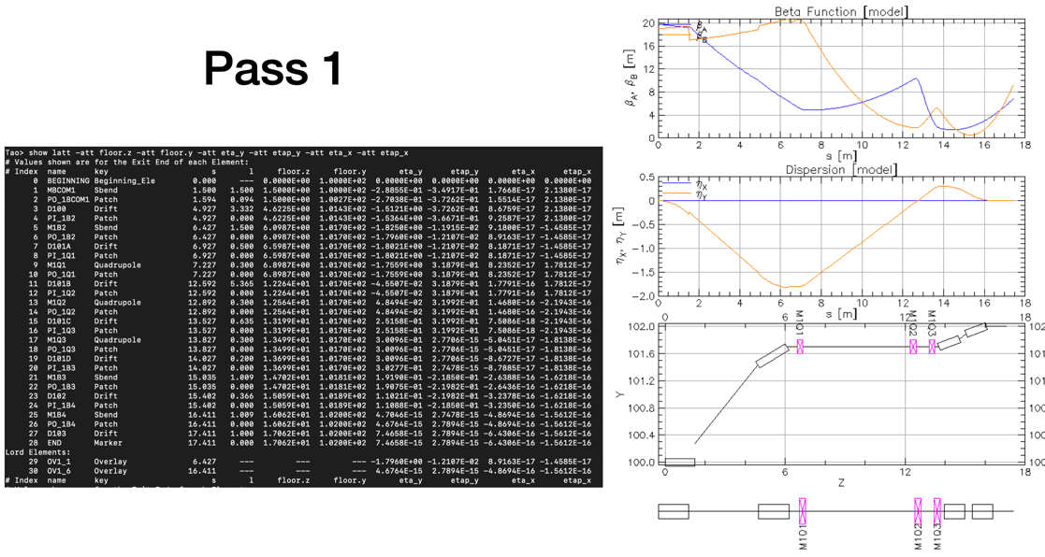
* 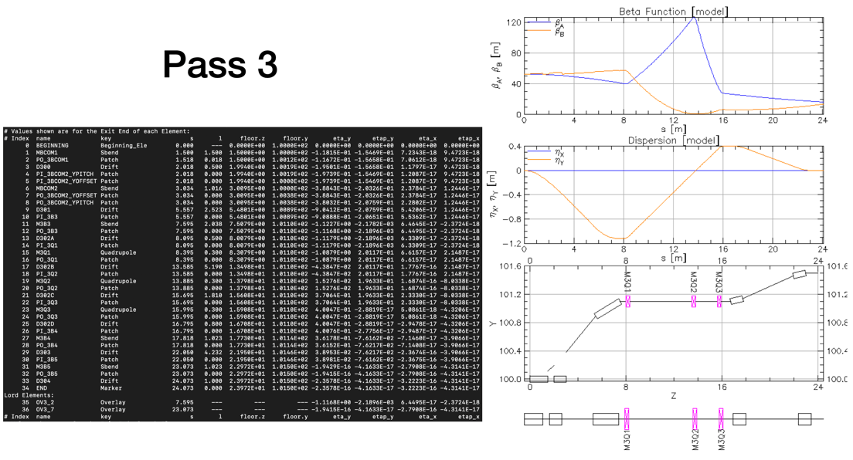
* 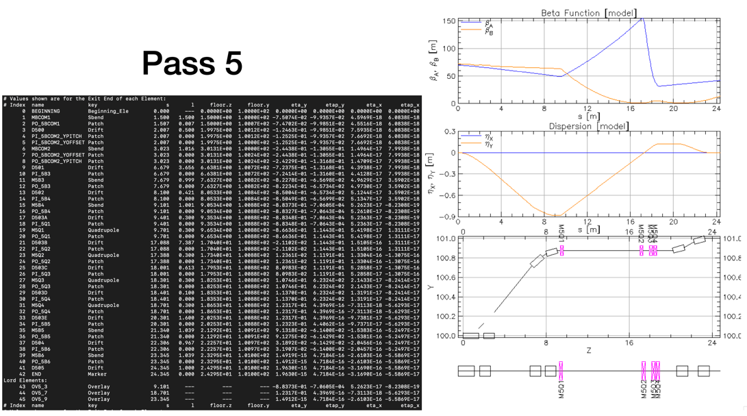
* 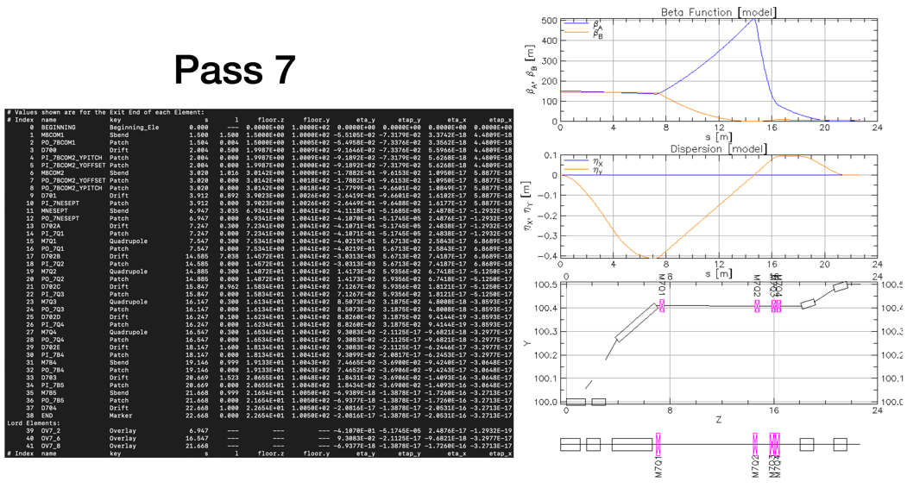
* 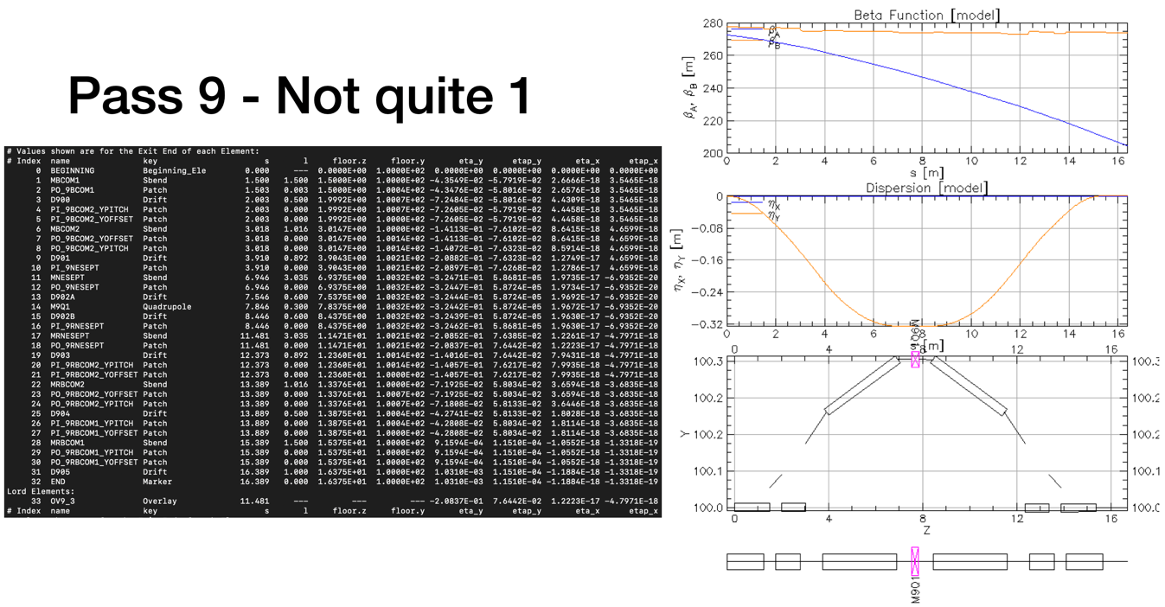
  + Here – quad is off. Geometry close to right, but not quite right. Almost
* 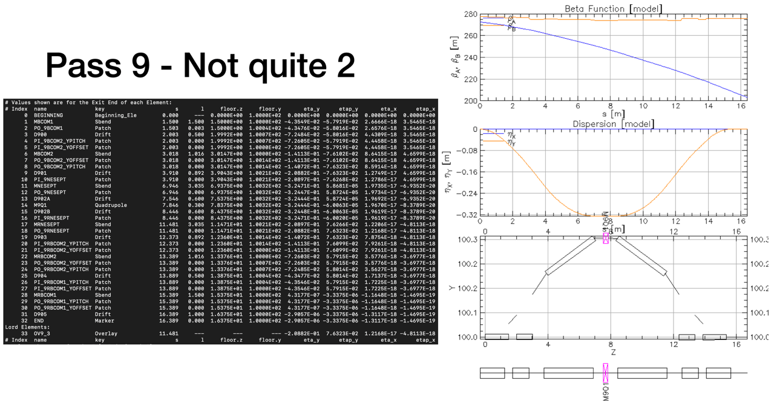
  + Here, quad turned on. Improves dispersion, but still problems with geometry, so more needed.
* Ryan will talk to Scott next week – thinks he’s working in circles or missing something.
* Splitters – not a lot of space transversely. Maybe enough longitudinally, but magnets are going to have to be large.
* 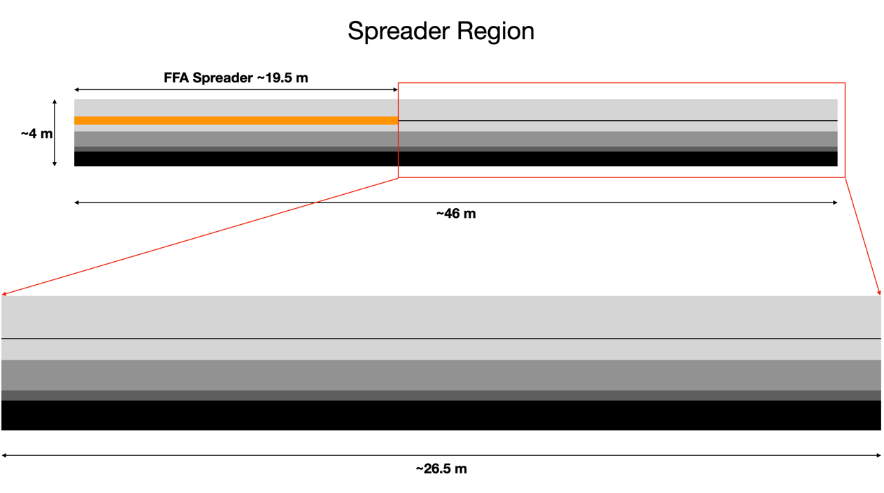
* Perhaps use some of extraction line? We don’t know how we are extracting yet.
* 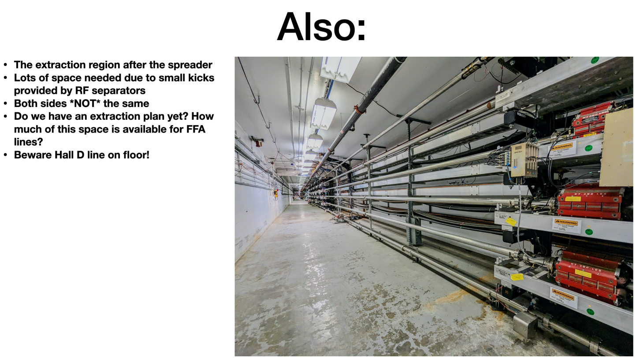
  + Need to figure out which halls are getting which energies? How are we extracting, and to where?
  + This area is very hard to get helium – no access buildings now.
  + This would mean that superconducting separator will need to be conductively cooled.
* Fast magnetic kicker is not fast enough, so will need RF separators
* 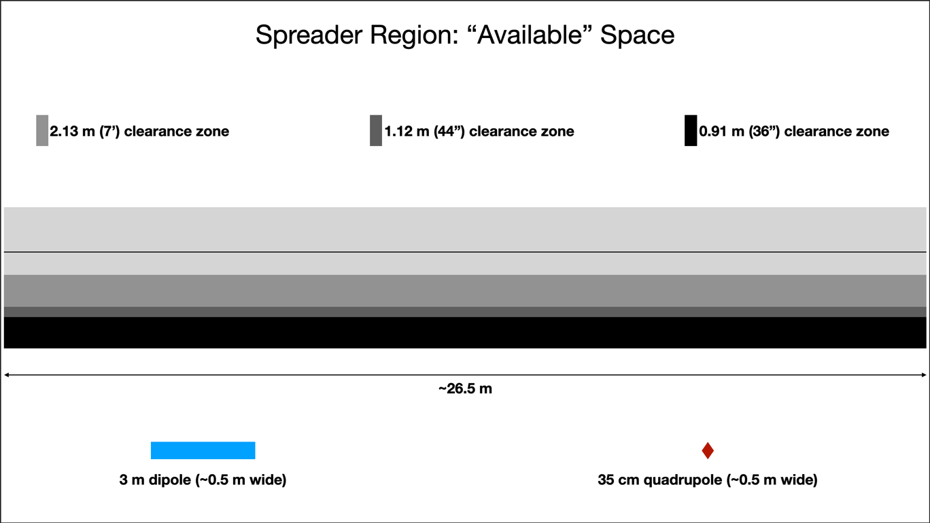

|  |  |  |
| --- | --- | --- |
| Action Items | Person responsible | Deadline |
|  |  |  |
|  |  |  |

## Time allotted | 10 mins | Agenda topic AOB | Presenter All

|  |  |  |
| --- | --- | --- |
| Action Items | Person responsible | Deadline |
|  |  |  |
|  |  |  |

## Special notes

Pathway to Repository: <https://jeffersonlab-my.sharepoint.com/:f:/g/personal/tristan_jlab_org/EqZ5MeS-nipCgPfZB5p0oS4B9Is67d3nQb9sLJI3Zyev9g>

NO MEETING NEXT WEEK!