FFA@CEBAF Working Group|Minutes

## Meeting date | time 02/24/2023 | 11 AM EST | Meeting location <https://jlab-org.zoomgov.com/j/1614898082?pwd=TnUzMS81M2sxbDZIbERJU01tYkJCQT09>

|  |  |  |  |  |  |  |  |  |  |  |  |
| --- | --- | --- | --- | --- | --- | --- | --- | --- | --- | --- | --- |
| |  |  | | --- | --- | | Meeting called by | Alex B | | Type of meeting | Weekly Meeting | | Facilitator | Alex B | | Note taker | Ryan | | Timekeeper | Alex B | | Attendees  Alex B, Ryan, Alex C, Donish, Kirsten, Scott, Kitty, Jay, Andrei, Todd, Vasiliy, Randika, Stephen |

# Intro Discussion

Skiing and running!

Retreat is April 6 and 7th. Registration link coming soon with instructions, etc…

March 8 and 9th – JLab Accelerator Advisory Committee Meeting.

# Agenda topics

## Time allotted | 25 mins | Agenda topic EM Arcs | Presenter Donish

* Donish started a few months ago. Looking into new optics around EM arcs, new spreaders, and new linac optics.
* 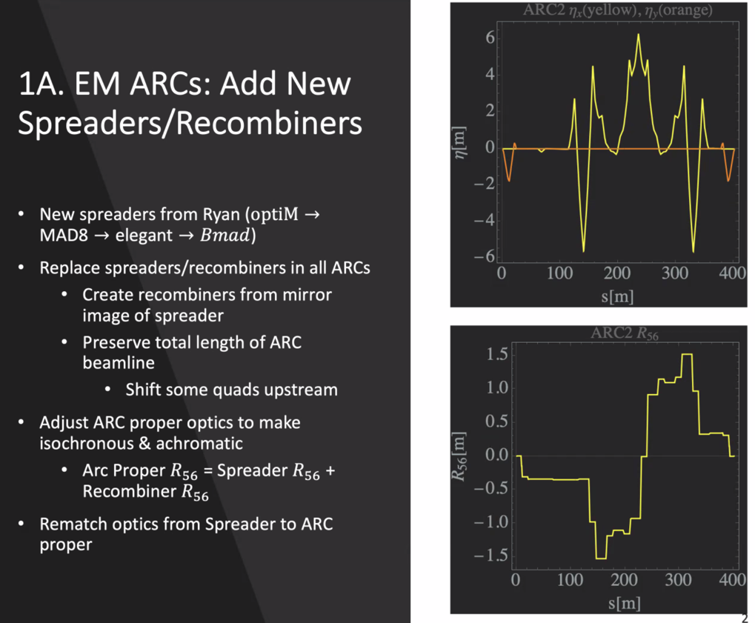
  + Using OptiM versions, will update as the spreaders update
  + Mainly uses elegant
  + Made mirror image of spreaders to make recombiners
  + Preserved total length, so moved items around/cut items as needed.
    - Shorter ones, add drifts
    - Longer ones, shift quads
  + Adjust arc proper to make isochronous and achromatic
  + Top plot – dispersion (for ARC2) for both planes
  + Bottom Plot – R56 goes 0 to 0
  + Rematch from spreader to arc proper
    - Outgoing Twiss not same as old spreaders. Used matching section after the spreader to rematch the new spreader Twiss into the arc proper (for all 8 arcs)
* 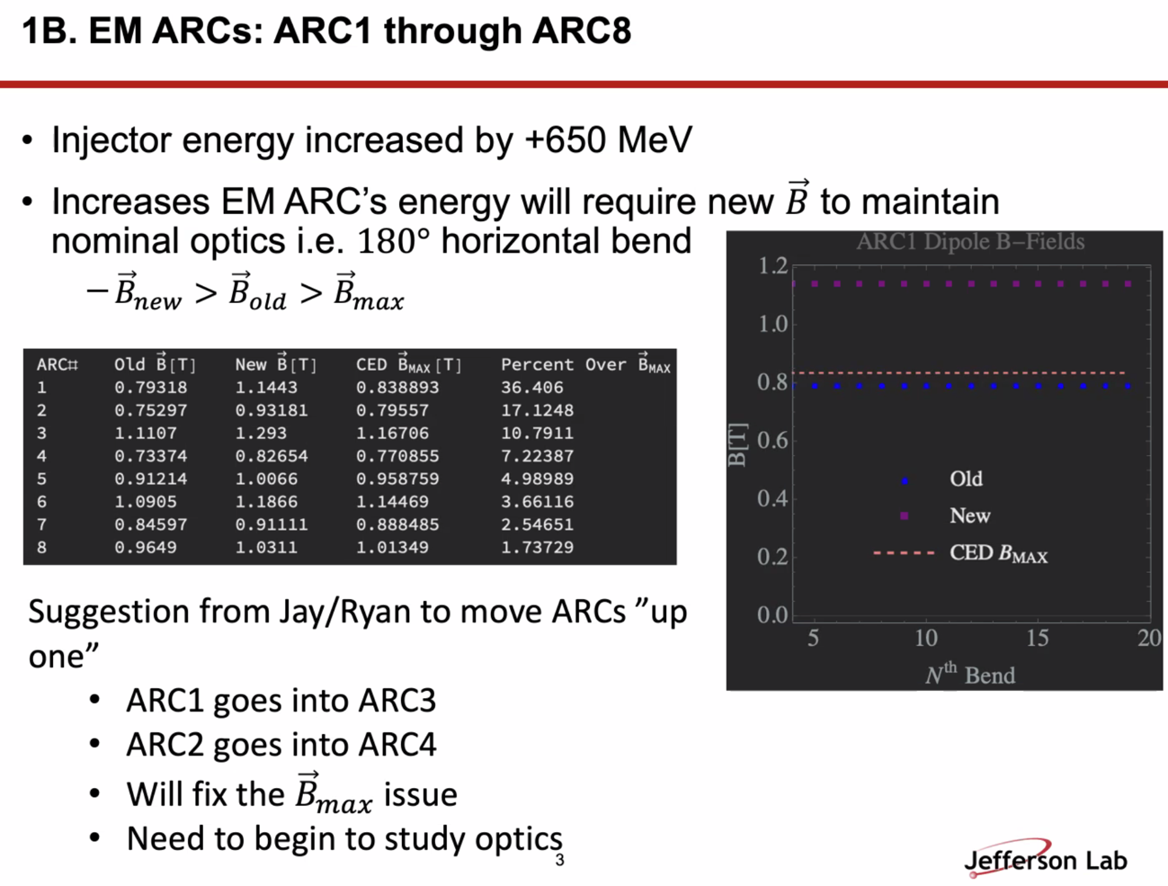
  + Current dipoles too weak to handle the higher energies from the new 650 MeV injector
  + Old B is from 12 GeV version – New is what is now needed.
  + “Move up” all of the arc magnets.
  + Alex B: this is what we used for the costing exercise. Essentially “downshifting” and use the higher arcs magnets for the lower.
  + Jay: in terms of being able to understand energy aperture, etc…, suggest you use the 4 m 4 period dispersion optics everywhere instead of the 7 m dispersion optics in 1 and 2.
    - Like the 5-pass energy recovery (Isurumali) design.
    - We’ve run this way as well
    - CED might have low-dispersion version for Arc1 and Arc2
    - Jay: Just use the existing Arc3-Arc10 optics (4 super-period, 4 m dispersion)
      * Alex: synch light monitors?
      * The also provided 75% more dispersion for energy locks
      * We’ve run with 4 m dispersion on the hall lines
    - Tight spots with energy offsets with energy locks (even with 30 Hz), we’ll run into losses in Arcs1&2
    - For Donish: Basically, take Arc 3 optics and maintain it in Arc1 – so this will make it easier, just scale.
* 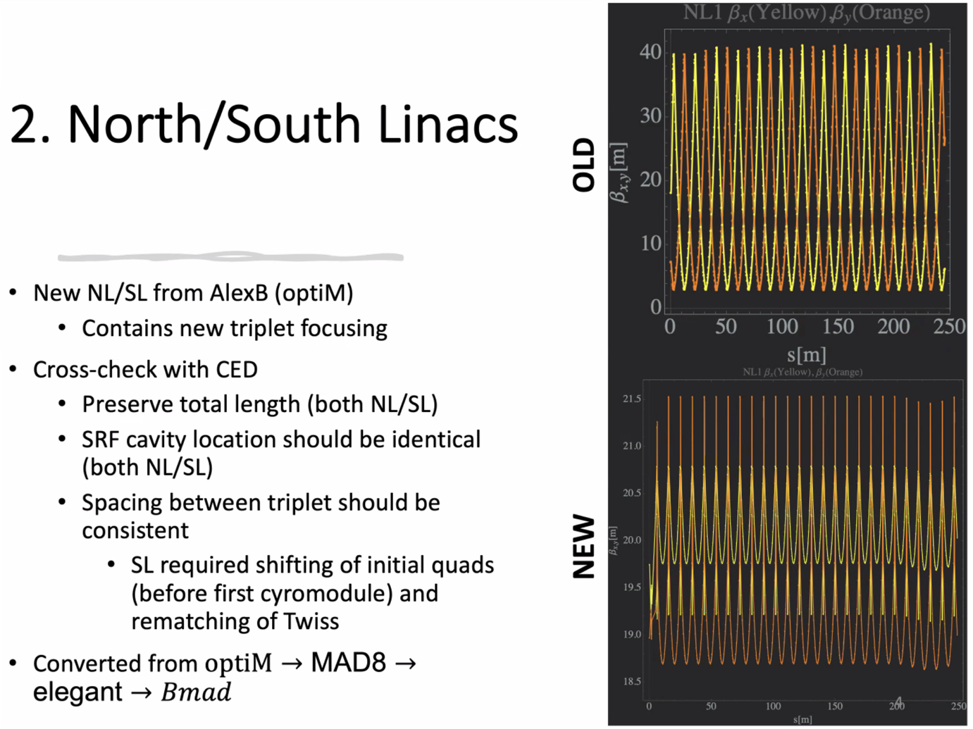
  + Top is old NL betas, bottom is new optics
  + Went through and corrected the positions and overall lengths
    - Everything spot on with CED now.
  + Most work in elegant, translates to BMAD after
    - Jay: C100s are longer, so gaps are smaller at end of linacs
    - 1L07 also has 70 cm cavities and is 30 cm longer than old cryomodules
      * CED has correct dimensions
      * 30 cm less space for triplets (so only ~80 cm for total extend of triplets)
      * Corrector packs are nested by 1L07 – girders are shorter by those 11 modules
        + Spacing from steel to steel is 80-90 cm range
    - Alex B: if there’s issues with space at the end, we can adjust the magnets as needed
      * Jay: diagnostics can be within the triplets
      * Alex B: assumed same length for triplets all across.
  + Final design will need to take into account engineering, diagnostics, etc…
* In mathematica, defined location of all cavities and all triplet groups, and could shift the triplets up or downstream in the linac. Optimized to make sure all the triplets are spaced correctly, and not overlapping with the cavities, etc…
* 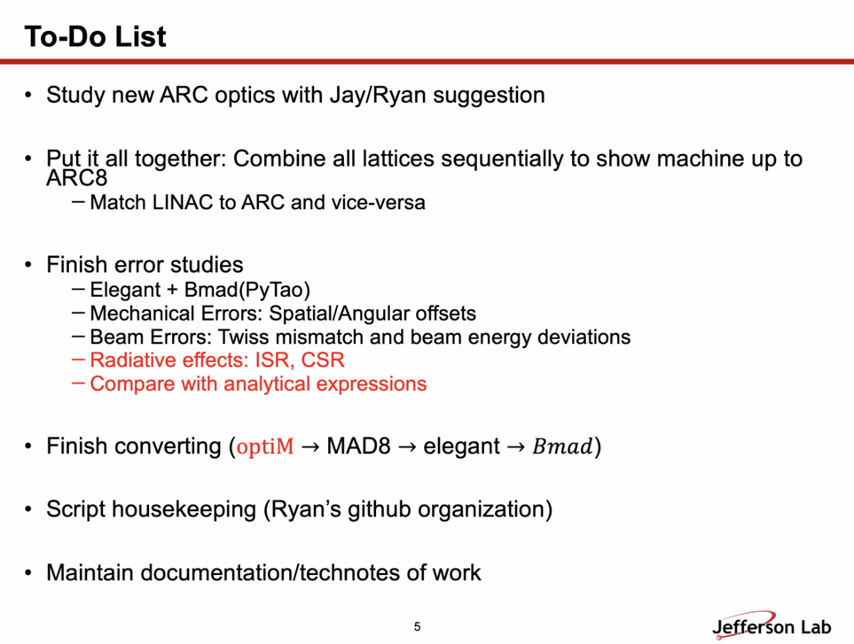
  + Has the ARC files written, but needs to run them
  + Working on combining them all so we can run through the EM parts of CEBAF
  + Working on error studies in both elegant and Bmad
    - Red items are things that haven’t been included yet, but would like to include
    - Wants to compare data with analytical expressions
  + Want to have a perfect beamline in all codes whenever possible. So far, have perfect 1-to-1 with elegant and Bmad, close with OptiM and elegant (needs a bit of work still).
  + Housekeeping: want to make sure everything is aligned across codes, etc…
    - Need to reorganize a bit and clean files so that they are useable
  + Documentation: making sure everything is written down clearly so we can all go through the work together
    - Alex C: “Please and thank you!”
* Alex B: idea of having different platforms (codes) is extremely useful
  + About the linac: focusing effect (end fields) coming from cavities is proportional to cavity gradient. Significant contribution at lower energies especially. R-S method for cavity focusing.
    - Implemented in elegant
* Jay: comment: Designed correctors back in 2020 (TN-20-039) thinking about triplet focusing in the linacs. The pricing was outrageous.
  + In error studies, think about how much Bdl one needs, look at tech note and see if 13 cm version has enough, or if we need to come up with a longer version that still fits
* Jay question: Transverse kick in original CEBAF cavities is included? Does it balance out in linac? Balances theoretically if all the gradients are right. So a lot of the steering is likely do to unbalance
  + Alex B: additional steering etc… is taken into account by correctors.
  + Jay: transverse kick is ~7% of gradient – need to find out what the number really is (talk to Haipeng Wang)
    - Look at how the gradient is distributed in the linacs right now and see how much extra corrector strength needed to take into account the kicks from RF cavities on top of other errrors.
      * Look at the current machine, see what gradients are there now, and see if this is a problem for the upgrade or not.
    - Donish: will start up errors again in a week or so, will follow up with Jay to get a better idea (after reading TN).
* Donish: have the files in OptiM, elegant, and BMAD – they’re all taking into account the cavity focusing.
* Scott: Back when showed the arc1 optics dispersion:
  + Looked, gut said that those optics are not first choice.
  + Jay: This is what is in arcs 1 and 2 now, higher arcs have 4 super periods with 4 m peak dispersion
  + Scott: to create something like this is unpleasant (focusing)
    - Jay: this was mostly for the energy locks, and at this point may be counter-productive. Trying to convince the B-Team that we should switch it now.
    - Alex B: would be worth checking now
* Kirsten: How much is a problem is CSR right now in CEBAF?
  + Not at all (we’re not compact enough to have a large impact)
  + The FEL had some concerns, but it wasn’t significant either.
* Scott: question on dipoles/arcs switch:
  + Each arc has dipoles that are different lengths. Different number of cells?
    - Yes, different lengths, different periods, etc…
* Alex B:
  + 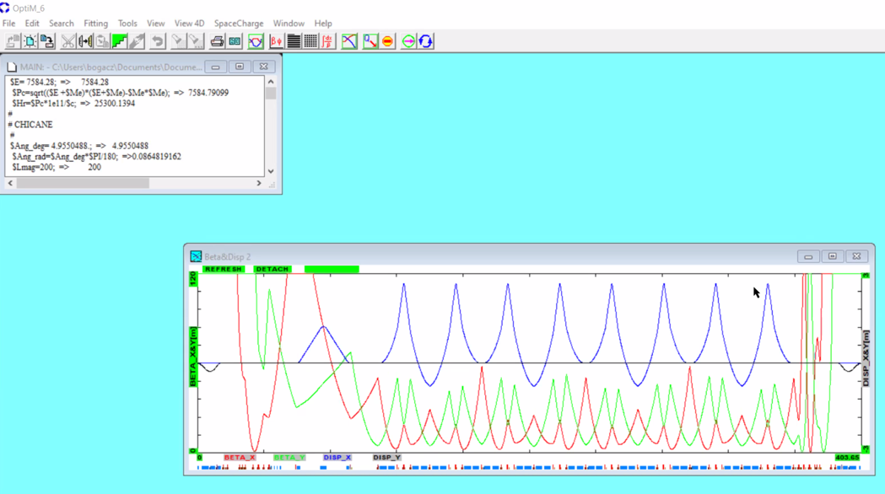
* Ryan:
  + 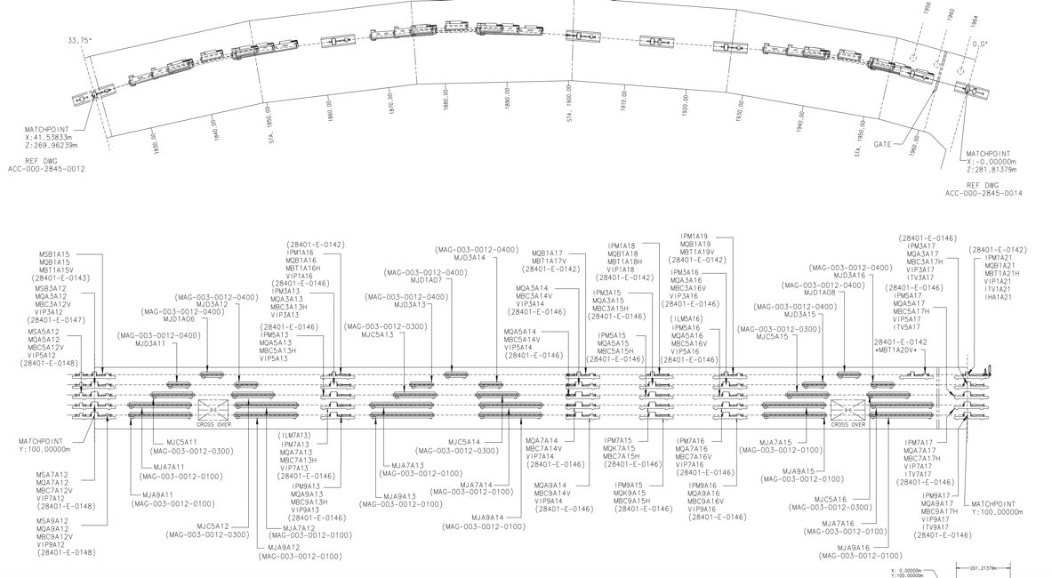

|  |  |  |
| --- | --- | --- |
| Action Items | Person responsible | Deadline |
|  |  |  |
|  |  |  |

## Time allotted | 25 mins | Agenda topic Emittance Dilution | Presenter Kirsten

* Will go next time.

|  |  |  |
| --- | --- | --- |
| Action Items | Person responsible | Deadline |
|  |  |  |
|  |  |  |

## Time allotted | 10 mins | Agenda topic AOB | Presenter All

* Andrei: postitive update with DOE discussion
  + 10 days ago, David Dean had discussion, and all way positive
  + Last week, preparing for lab budget management meeting, the budget (for FY25), we included a proposed scenario to add $3M/year for upgrade research. That was positively viewed. This is both positrons and FFA.
  + Dean will increase LDRD funding for upgrade work.
  + DOE FOA next year said our work would be good for this (assuming it all fits in the long range plan, etc…).

|  |  |  |
| --- | --- | --- |
| Action Items | Person responsible | Deadline |
|  |  |  |
|  |  |  |

## Special notes

Pathway to Repository: <https://jeffersonlab-my.sharepoint.com/:f:/g/personal/tristan_jlab_org/EqZ5MeS-nipCgPfZB5p0oS4B9Is67d3nQb9sLJI3Zyev9g>