FFA@CEBAF Working Group|Minutes

## Meeting date | time 03/03/2023 | 11 AM EST | Meeting location <https://jlab-org.zoomgov.com/j/1614898082?pwd=TnUzMS81M2sxbDZIbERJU01tYkJCQT09>

|  |  |  |  |  |  |  |  |  |  |  |  |
| --- | --- | --- | --- | --- | --- | --- | --- | --- | --- | --- | --- |
| |  |  | | --- | --- | | Meeting called by | Alex B | | Type of meeting | Weekly Meeting | | Facilitator | Alex B | | Note taker | Ryan | | Timekeeper | Alex B | | Attendees  Alex B, Ryan, Dejan, Reza, Kirsten, Kitty, Scott, Donish, Jay, Vasiliy, Stephen, Randika, |

# Intro Discussion

Retreat discussion: tour timing

* Start at 9AM or afternoon for tour?
* Flights (Breeze vs Delta vs ?)

# Agenda topics

## Time allotted | 25 mins | Agenda topic Emittance Dilution | Presenter Kirsten

* Not a lot of numbers, but there’s a lot of confusion.
* Should have been easy, but got weird.
* 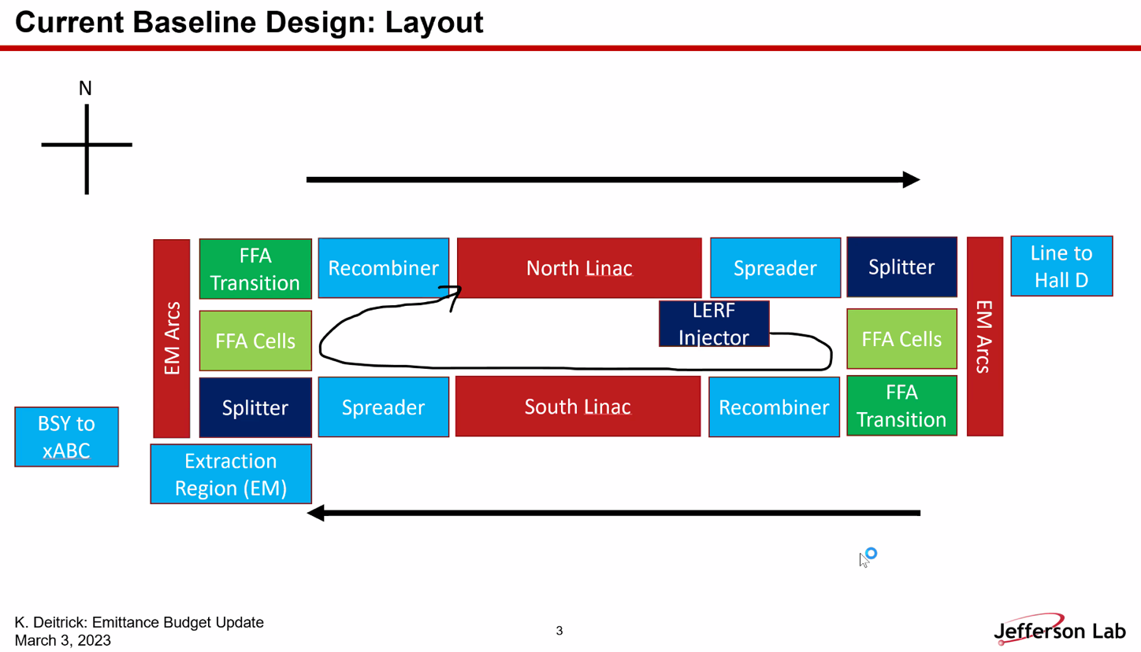
  + Block diagram of our baseline
* 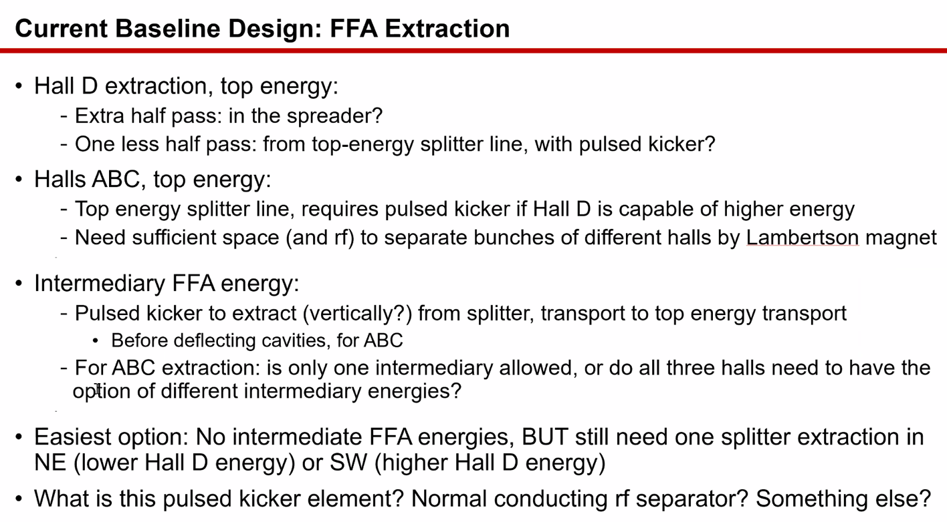
  + We have promised intermediate FFA extraction (Jay)
  + Bypass line for CBETA was investigated previously
    - There is more vertical room to do that
  + Can only extract in splitters
    - Can’t turn on a magnet and leave it unless all halls get same FFA energy
      * Jay: that’s arguable
      * Pulsed kicker element would allow Hall D to remain in, but if not pulsed, then Hall D will get half a pass less
* Were intermediate energies promised for all halls?
  + Yes.
* Extraction – really need to start looking at this now instead of later. Even if we don’t have beamlines, we need to clarify which beams can be delivered.
* Reza: in order to separate D from ABC, you need 750 MHz
  + 1/750 separation from A/B/C – half of CEBAF frequency
  + If you want to do that anywhere in the line, this is what it takes.
  + You *could* separate at 499 or 500 MHz and send 1 beam out – that’s what they do for lower passes
    - Need 750 for higher still
* Jay: assumed Hall D would go away, but in Europe, they expressed they are still interested.
* If we have intermediate FFA extraction anyway, Hall D won’t be the problem (Kirsten)
* Jay: they’ll just have to live with what we can do.
* So what can we aim for with extraction?
* 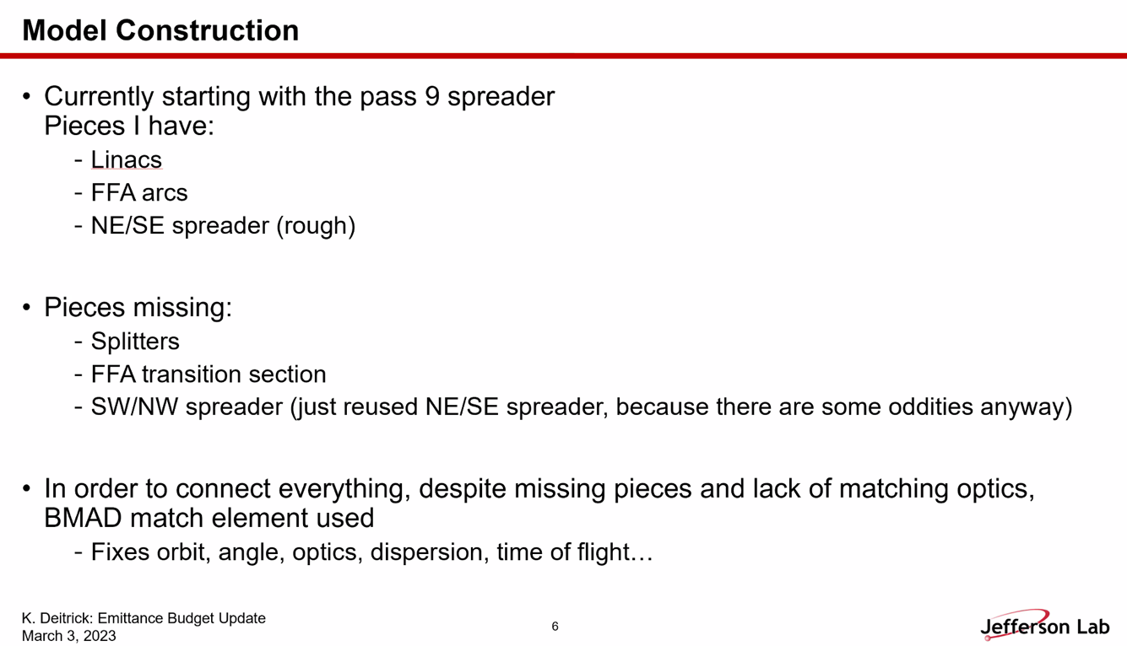
  + Calculation ends up being a bit back of the envelope
  + Lacking a few elements, so using the “MATCH” element in BMAD.
    - If beam particles no longer exactly match your single particle matrix tracking (as is often the case after introducing radiation), MATCH stops working unless you re-initialize
  + Broken into chunks to do calculations
* 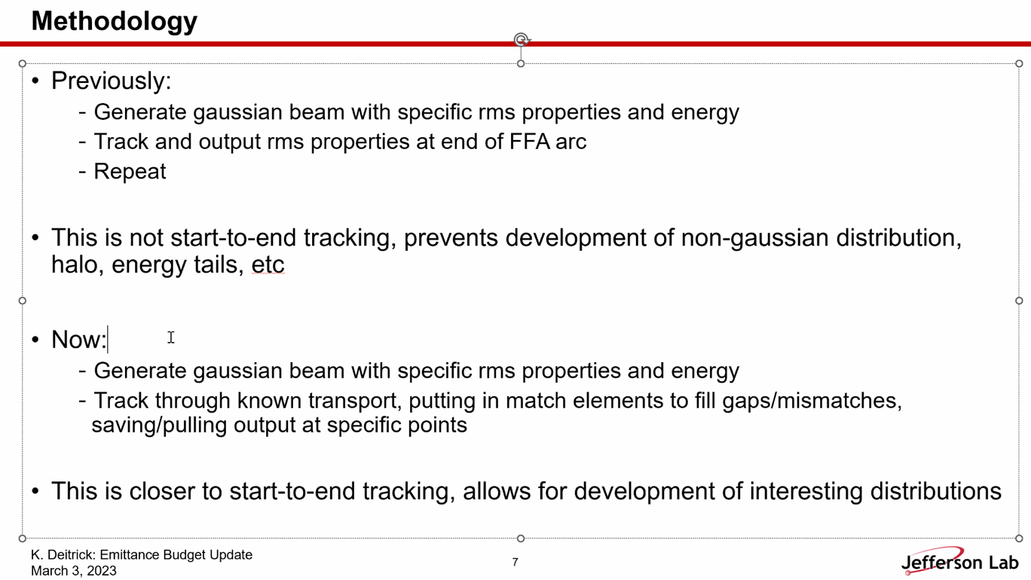
  + Previous studies forced beam to be gaussian, but the MATCH element should not require that (in theory)
* 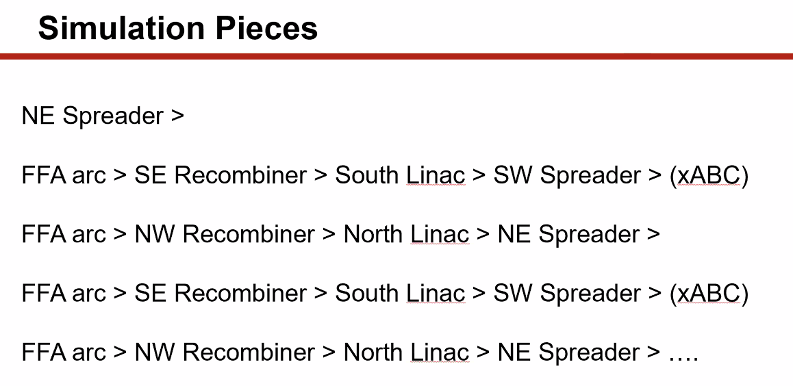
  + Scott: MATCH makes linear transformation from one end to the other. *Should* do what you want.
    - Kirsten: it does, as long as the distribution isn’t mangled by SR
    - Scott: if you have horrific tails, then the linear map application may make it look ugly.
* 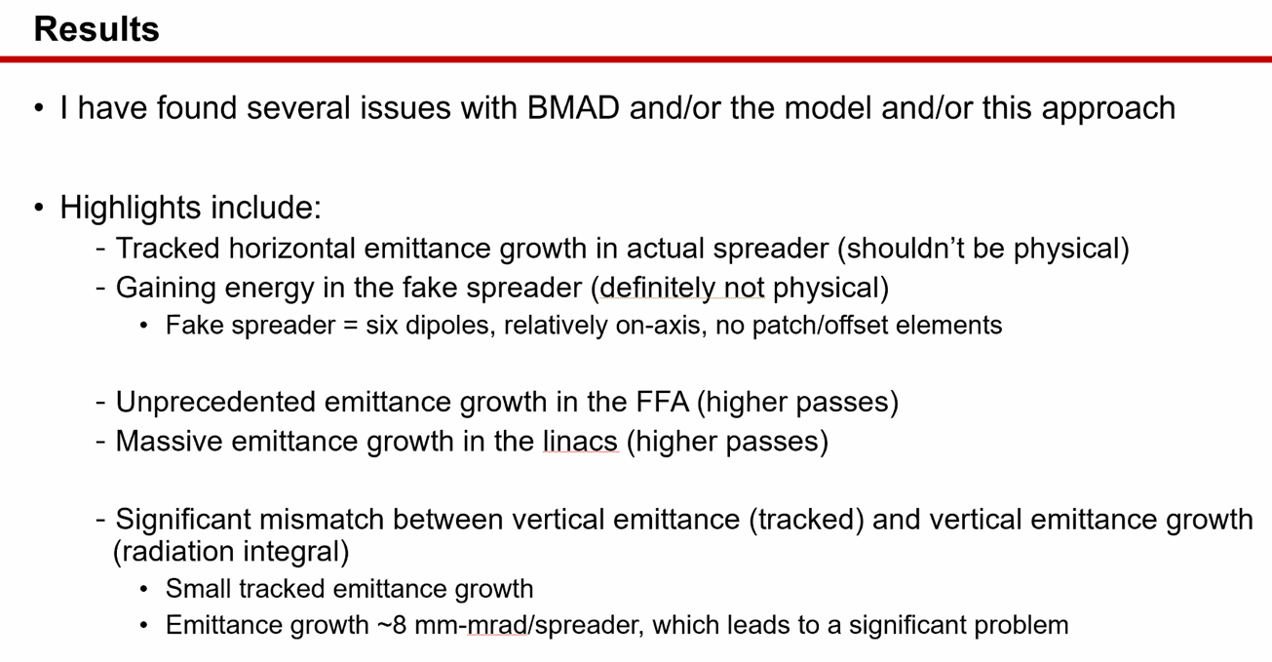
  + Somehow, making emittance growth horizontally in purely vertical spreaders.
  + Gaining energy in “fake” spreader
    - Scott: what’s happening to the reference energy? Is it going down b/c of average calculation of SR whereas the particle energy isn’t going down as fast?
    - Kirsten: Pass 3, beam gained 14 MeV
      * Scott: check that it’s *actually* gaining that. Look at particle energy instead of the e0.
    - Could be that it’s not on the particles
    - Scott: might be (guess) that the particles are also losing energy, just not as much as the reference particle.
  + After pass 3, saw more horizontal emittance growth than previous studies. Much more than before.
  + Saw ~10% horizontal emittance growth in linacs – shouldn’t happen
  + Big difference b/w tracking beam and using radiation integrals
* 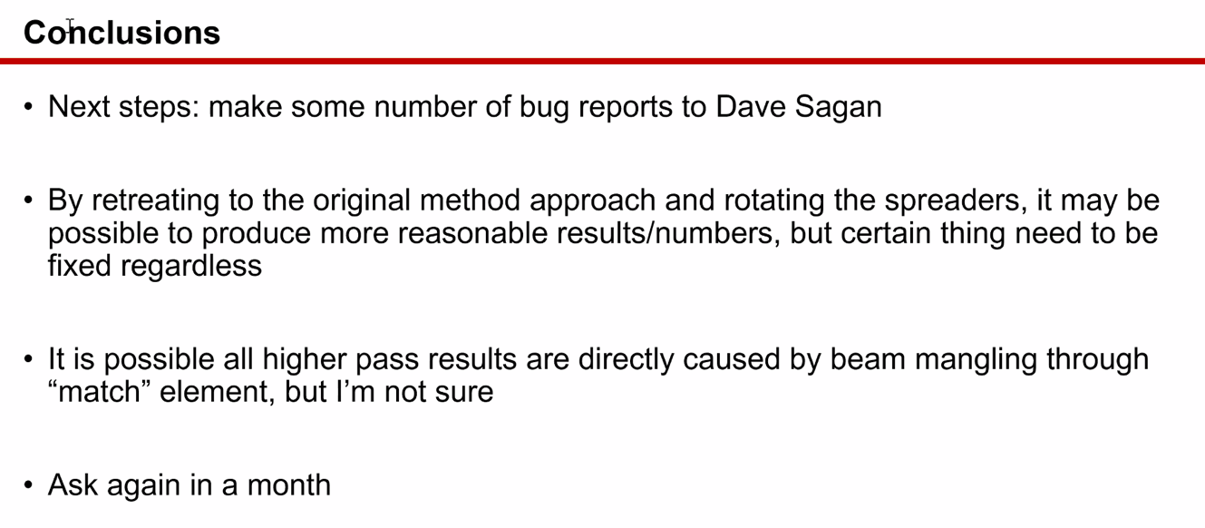
  + Need to address these issues before recalculating.
  + Best case: emittance is the same as previously
  + Worst case: horizontal is much larger and vertical will be massive
  + Likely: horizontal likely in the ballpark, but there may be pretty significant vertical emittance
    - If take the “fake” spreader and turn it sideways, still get roughly the same as with radiation growth – pretty marked increase
* Alex B: one way to gauge, in elegant or OptiM, they calculate the integrals
  + Kirsten: can try to make sure that they are making the same integrals as BMAD
* 200 mm-mrad normalized vertical emittance growth if numbers to be trusted
  + Seems hard to believe (and worrisome)
* Kirsten: I’ll check with elegant
  + Either BMAD has integral or tracking problem, or things are way worse than we thought.
* Alex B: good plan.
  + OptiM has a transfer matrix option
* Kirsten: could do this the hard way by making little patches of chicanes and matching sections
  + They wouldn’t be realistic
  + MATCH is quicker
* Alex B – if you want to do Twiss matching, then the matrix matching is pretty straightforward. 6x6 can be harder
* Kirsten: probably some vertical growth, just not sure how much. Ask in a month or so after bug reports.
* Might be a vertical db_field problem
  + Can you use total field? Maybe.
  + Can/will test with simple magnets to see.

|  |  |  |
| --- | --- | --- |
| Action Items | Person responsible | Deadline |
|  |  |  |
|  |  |  |

## Time allotted | 25 mins | Agenda topic Non-adiabatic Match | Presenter Vasiliy/Randy

* Met with Ryan and Randy and discussed next steps:
* Dispersion and orbit offset under control. Need another section to match to linac
* Randy – no time to look yet.
* 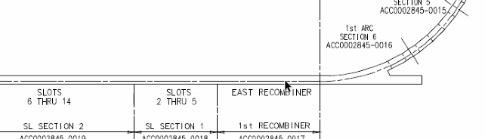
  + Everything at linac height
* 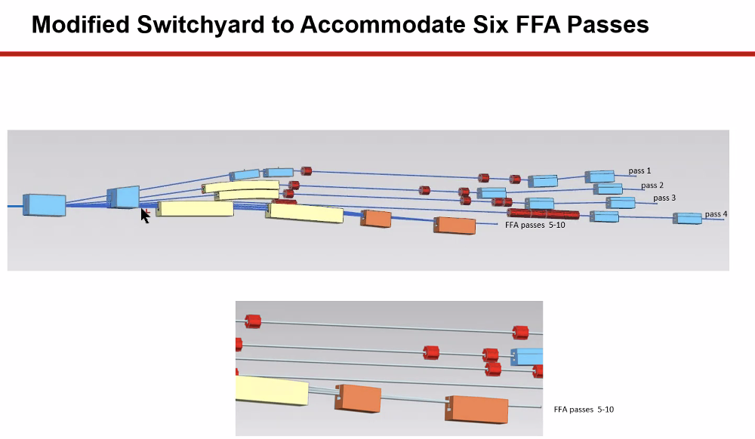
* 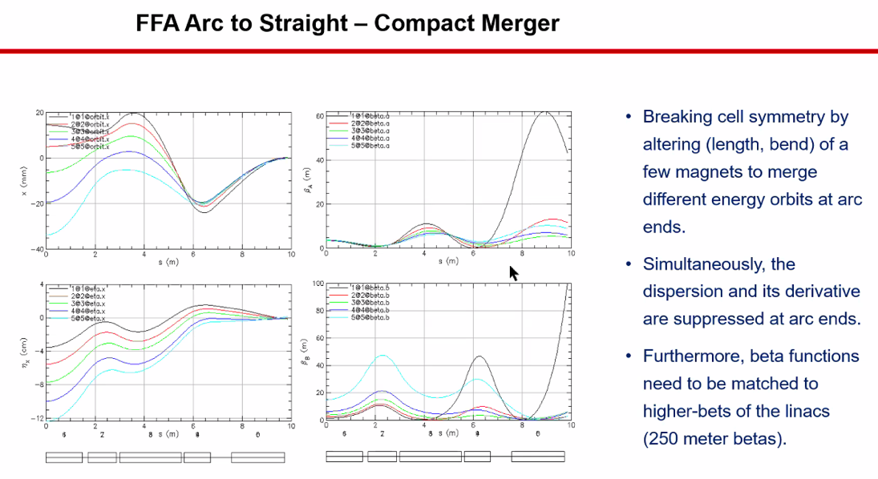
  + From last time, but Randy already has something better
    - Betas now look much better now.
  + Dejan: betas need a lot of downstream work
  + Vasiliy – yes, so we’ll go from this section to a matching section that matches betas to linac/recombiner
* Dejan – this is a long process, but it works beautifully

|  |  |  |
| --- | --- | --- |
| Action Items | Person responsible | Deadline |
|  |  |  |
|  |  |  |

## Time allotted | 10 mins | Agenda topic AOB | Presenter All

* Initial “fit the pieces in the box” for splitter:
  + 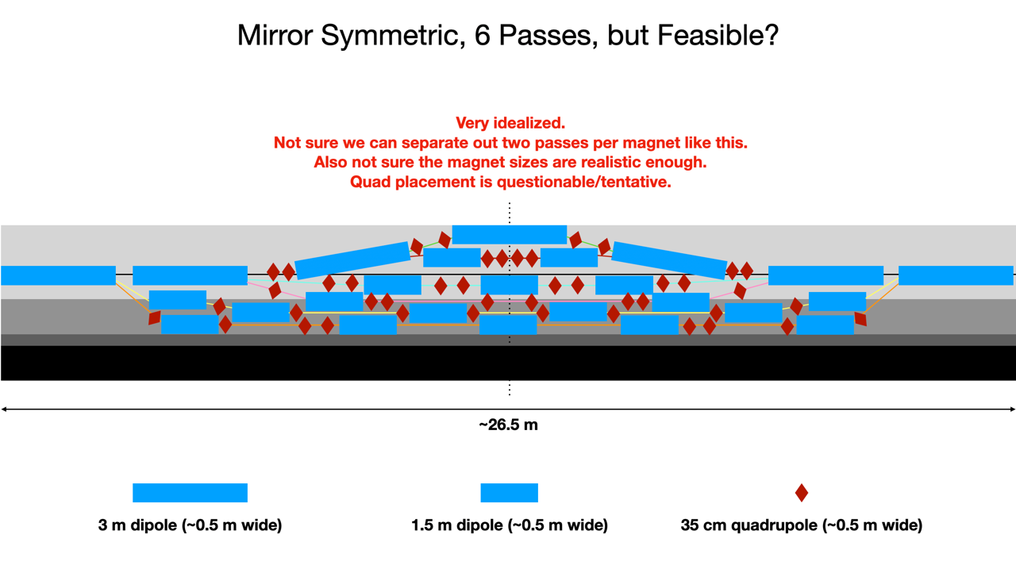

|  |  |  |
| --- | --- | --- |
| Action Items | Person responsible | Deadline |
|  |  |  |
|  |  |  |

## Special notes

Pathway to Repository: <https://jeffersonlab-my.sharepoint.com/:f:/g/personal/tristan_jlab_org/EqZ5MeS-nipCgPfZB5p0oS4B9Is67d3nQb9sLJI3Zyev9g>