FFA@CEBAF Working Group|Minutes

## Meeting date | time 03/10/2023 | 11 AM EST | Meeting location <https://jlab-org.zoomgov.com/j/1614898082?pwd=TnUzMS81M2sxbDZIbERJU01tYkJCQT09>

|  |  |  |  |  |  |  |  |  |  |  |  |
| --- | --- | --- | --- | --- | --- | --- | --- | --- | --- | --- | --- |
| |  |  | | --- | --- | | Meeting called by | Alex B | | Type of meeting | Weekly Meeting | | Facilitator | Alex B | | Note taker | Ryan, Alex C | | Timekeeper | Alex B | | Attendees  Alex B, Ryan, Alex C, Dejan, Kitty, Donish, Randy, Stephen, Reza, Jay, Kirsten, Vasiliy, Scott |

# Intro Discussion

Just coming out of JLAAC: great committee reviewing. Many in person. Whole program was excellent.

We responded to last year’s recommendations, and they’re writing up the new ones.

Oliver: discussed current at CBETA vs CEBAF. Should start thinking about beam tests during retreat. Get $3M in R&D money. Get Stephen’s prototype tested with beam?

* Could we install that at JLAB? We’d need a way to mount it.
* When we have a full cell, we could test it too.
* $3M for whole R&D project at JLab. Upgrade + Positrons are high priority.
  + Chatter: much more resources needed
* Sustainability is huge right now: Oliver asked about this

Bottom line: we need to test real magnets and show that they work.

# Agenda topics

## Time allotted | 25 mins | Agenda topic Matching Section | Presenter Randy/Vasiliy

* Had several meetings withVasiliy, Randy, and Ryan to update matching sections to latest designs.
* Number of passes changed, energies changed, matching conditions changed
* BMAD now computes Betas differently than a week ago. Used to be normalized to offset value, now normalized to reference momentum.
  + Check your betas
  + Vasiliy was plotting beam size for off-momentum beam for periodic solution. Had an error. While fixing, Sagan decided to no longer normalize the transfer matrix. Normalize to reference momentum. If you change ref momentum, but keep relative offsets the same, it’ll look different.
    - Dejan: I always run 5 codes: MADX, BMAD, SYNCH (sp?), etc… and compare
      * When run PTC, has normalized beta functions, but it’s ok. Just have to know what the code does. Is it normalized or not?
    - Need a 1+delta now compared to previously
    - Must be careful on emittance definition
    - Ryan: is this documented?
      * No, but wasn’t before
    - Scott: essentially, where this is coming from: if you were to look at the transfer matrix and compare it to a numerical differentiation, you’d find that they didn’t agree (if you did it about a nonzero pz). Sagan put in the 1+delta into the transfer matrix and now calculates betas from that. Now it’s more consistent. This is likely the “right way to do it.”
      * Dejan: these differences come from how Scott vs. Dejan does the work. Scott makes different universes per energy, Dejan uses a reference energy.
    - Difference with PTC vs Twiss?
      * Vasiliy uses PTC usually in MADX (both cases)
    - Scott: tried to get consistent and correct behavior in MADX in PTC and Twiss. Should be ok now.
* 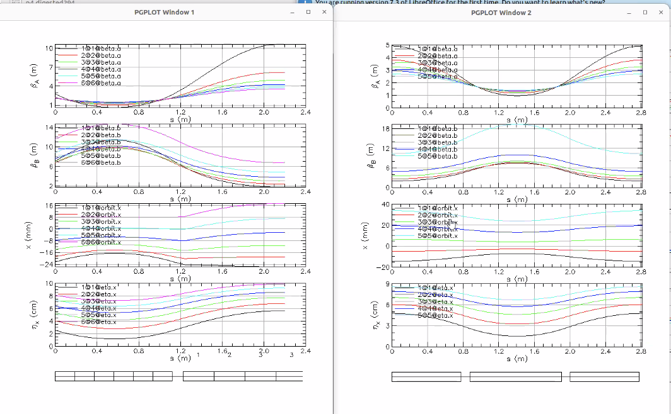
  + Output from arcs not same as from Alex C’s. Left side is Alex’s, right side is Randy’s.
  + Comparing references “by eye” – so don’t weigh these pictures heavily
  + Why split into 6 pieces?
    - In construction, some pieces will be offset by a few mm. There will be a lot of smaller longitudinal pieces.
    - It will likely be constructed similarly to this.
  + Why is bend implemented as a pitch?
    - Putting bend in magnet of FFA is a “fools errand” (Stephen)
    - Scott: if you think about how we’re going to place magnets on the floor, the F axes will be parallel to each other. The D axes will be parallel to each other. The F and D won’t be parallel to each other. So we’re laying out WRT axes layouts. It changes coordinates.
  + Shouldn’t be RBEND?
    - They are, in reality.
    - It’s about edge angles – changes for each beam, etc…
* 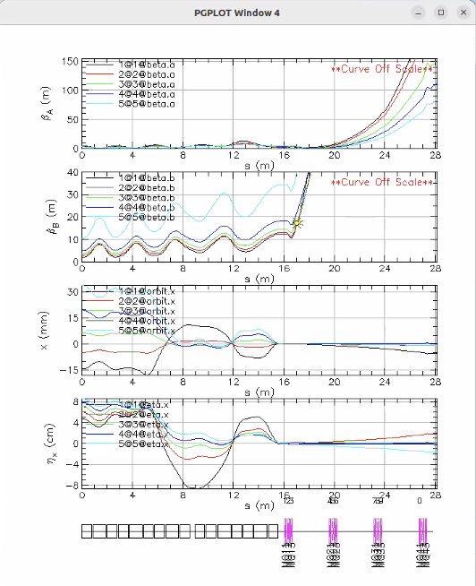
  + Not pretty. Going back and trying again.
  + Adding in 6th pass.
  + Matching triplets into recombiner, then linac
  + Relaxing some constraints on the left side and use the right side for that.
    - Focusing on orbits and dispersion on left
* Using the github version. (DEC 22 scaled)
* Alex C: there are two version in lattice. DECEMBER is scaled appropriately. Not the earlier.
* Dejan: previously, we used the adiabatic approach. We aren’t doing this anymore, and is saves space.
* Alex C: just updated BMAD – beta functions on github arcs are no longer periodic. They changed due to reference difference. Will change these.
  + Multiply initial conditions by 1+delta
  + Each pass, initial optics specified.
  + Close orbit doesn’t work with radiation on.
    - Using open orbit. Just need to rerun. Simple fix.
* Kirsten – curious if seeing this problem as well.

|  |  |  |
| --- | --- | --- |
| Action Items | Person responsible | Deadline |
|  |  |  |
|  |  |  |

## Time allotted | 25 mins | Agenda topic Splitters | Presenter Ryan

* Ryan presents first take of splitters
* 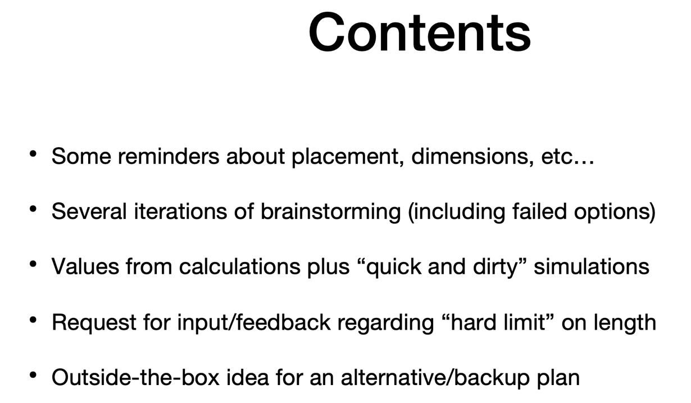
* Shows several iterations:
  + 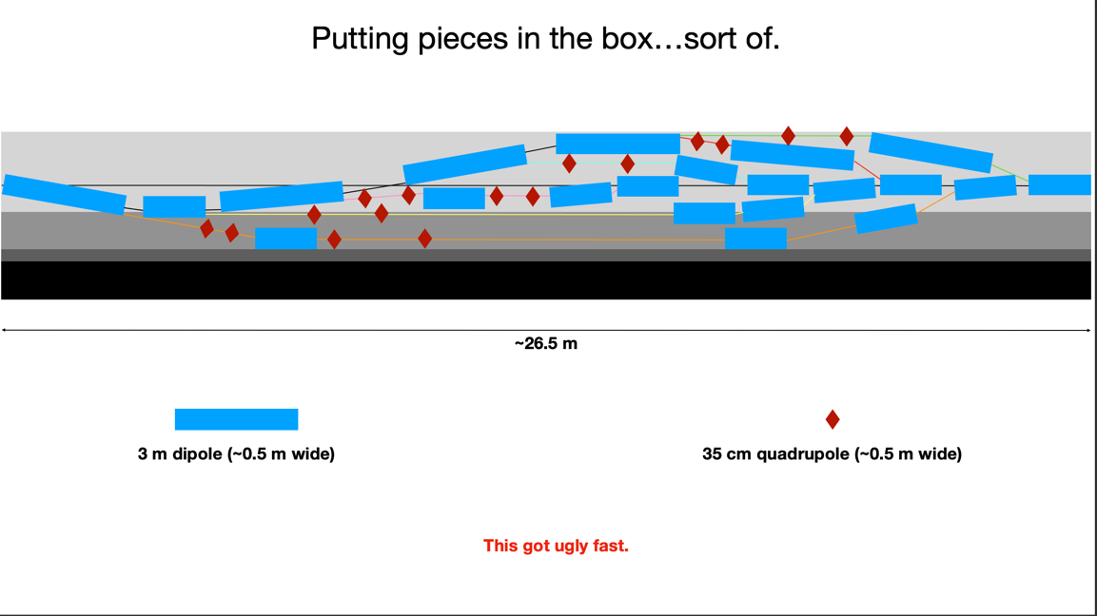
  + 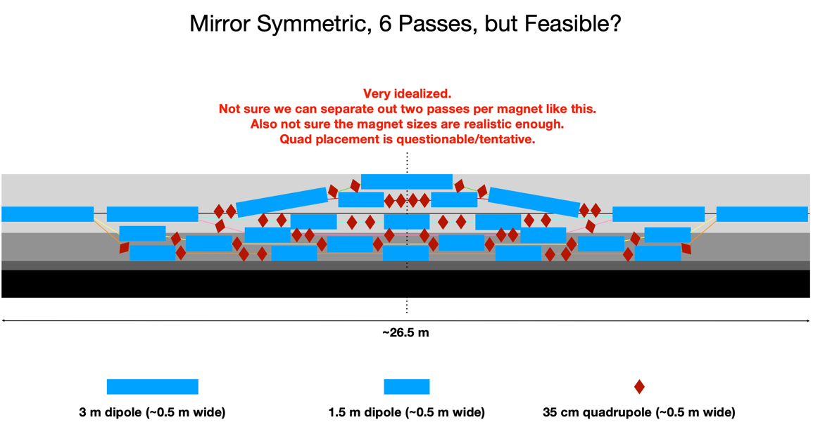
    - Cannot share quads
  + 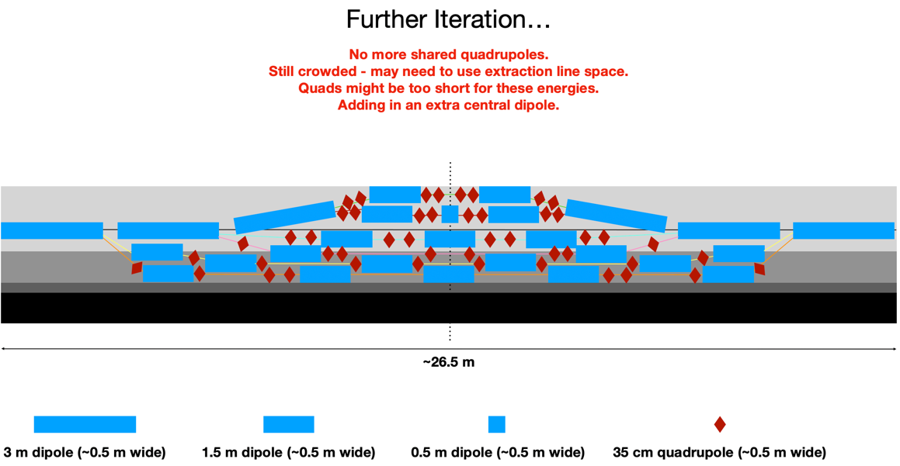
    - Expanding to 53 cm quads makes it too crowded, so looking for more space
* Expanding into the extraction region:
  + 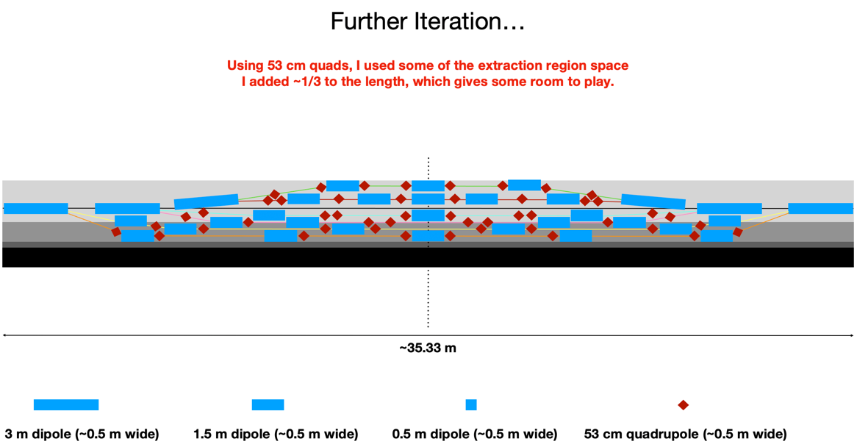
    - Added ~1/3 to the length to make these all fit
    - Stephen: can we add maybe 75% permanent magnets to save space?
      * Maybe – might be required.
* All above is just graphical. Plugging into BMAD for “quick and dirty” simulations gets out real values.
  + 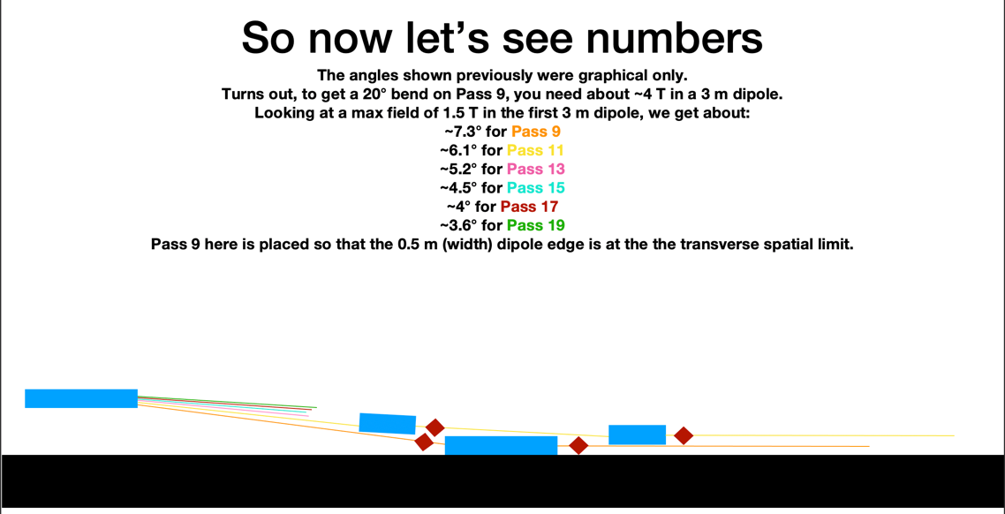
    - Scott: first magnet can maybe be stronger, ~1.8 T
    - First shared magnet could be a big push if stronger
    - Maybe fewer magnets transversely?
* A few notes from Scott in the chat:
  + Good idea for the dipoles.
  + If the required number of magnets don't fit into the room, then we're screwed anyhow.
  + It will only get worse from there.
  + The first dipole can be significantly larger; you could push things toward 1.8 T.
  + J Scott Berg to Everyone (11:46 AM)
  + When you only have a couple dipoles transversely, you have room for a return yoke, etc.
  + That may have an unpleasant impact on the optics, but it may be worth trying.
* Two “quick and dirty” BMAD attempts:
  + 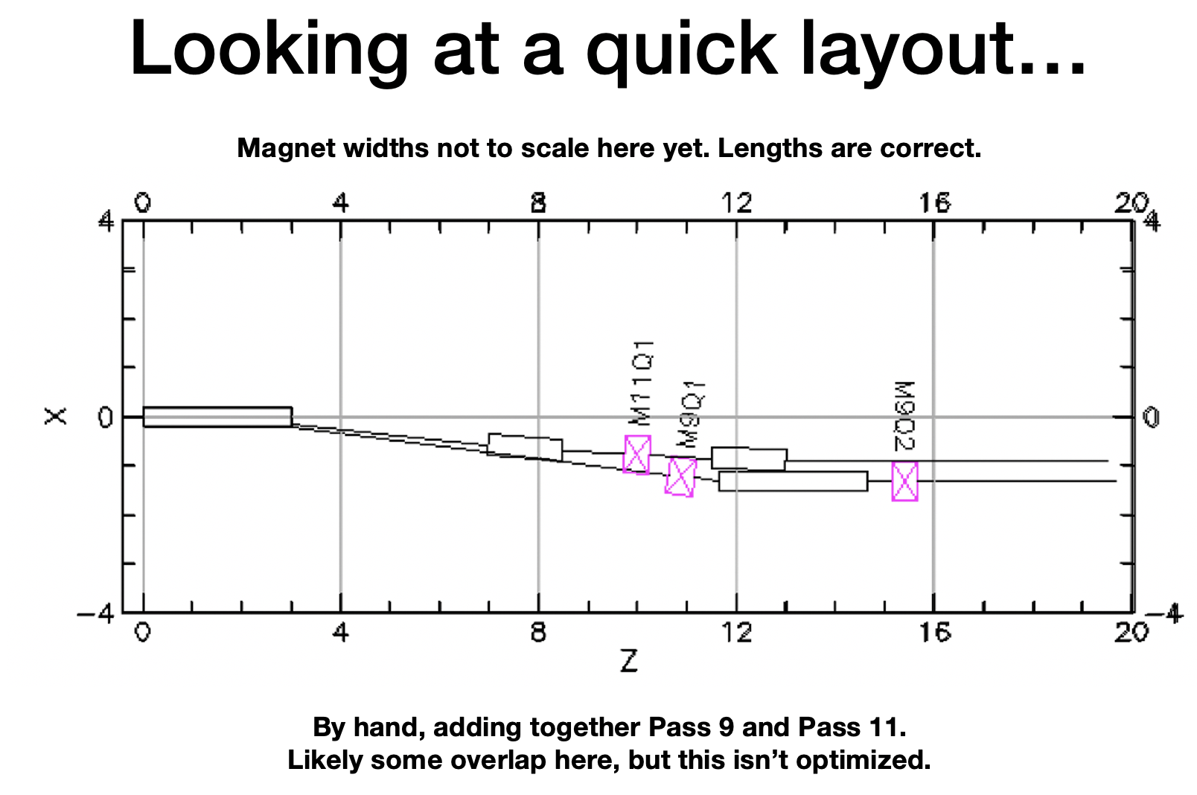
  + 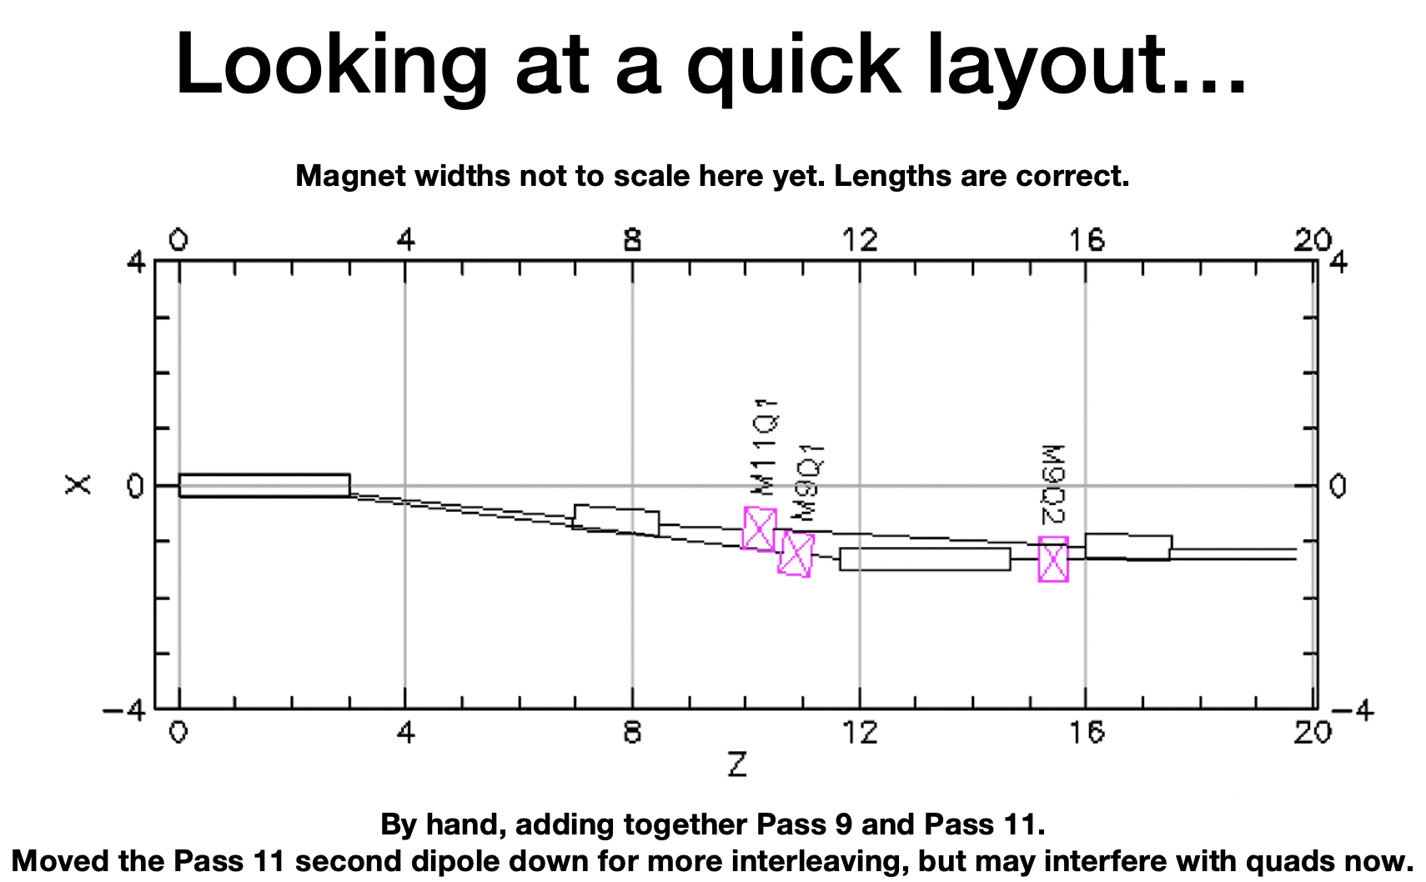
* How much space can we *really* use?
  + 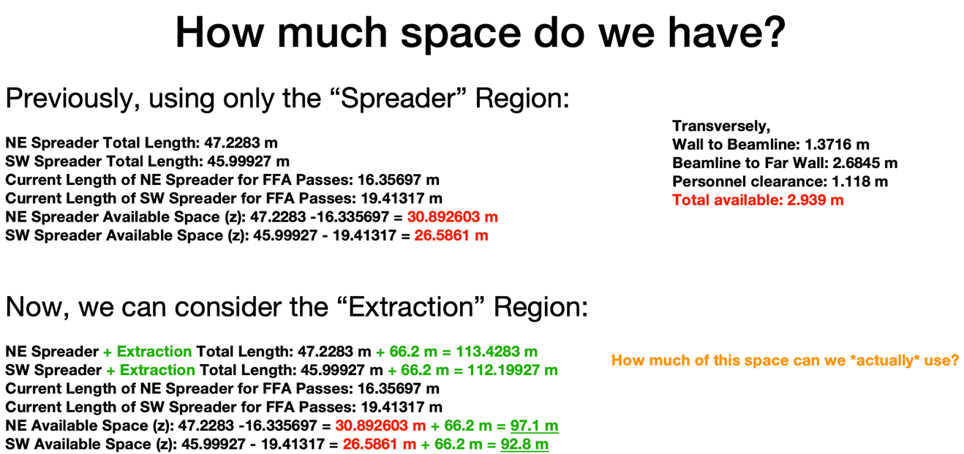
  + 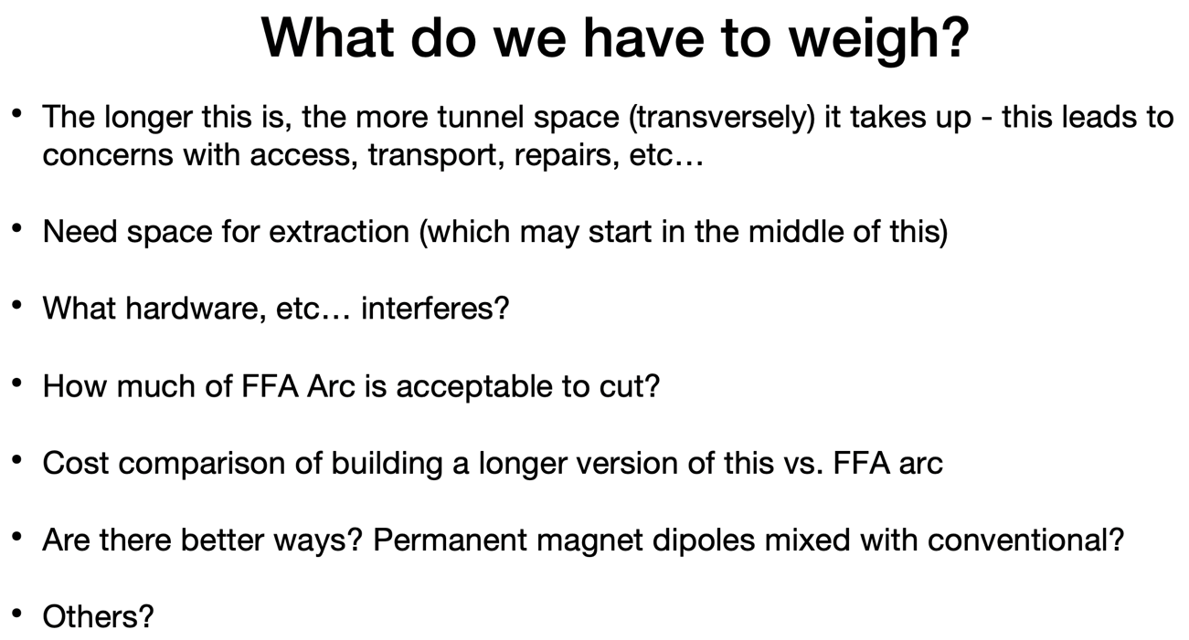
* Proposed alternative/backup: moving the splitter to the middle of the FFA arc:
  + 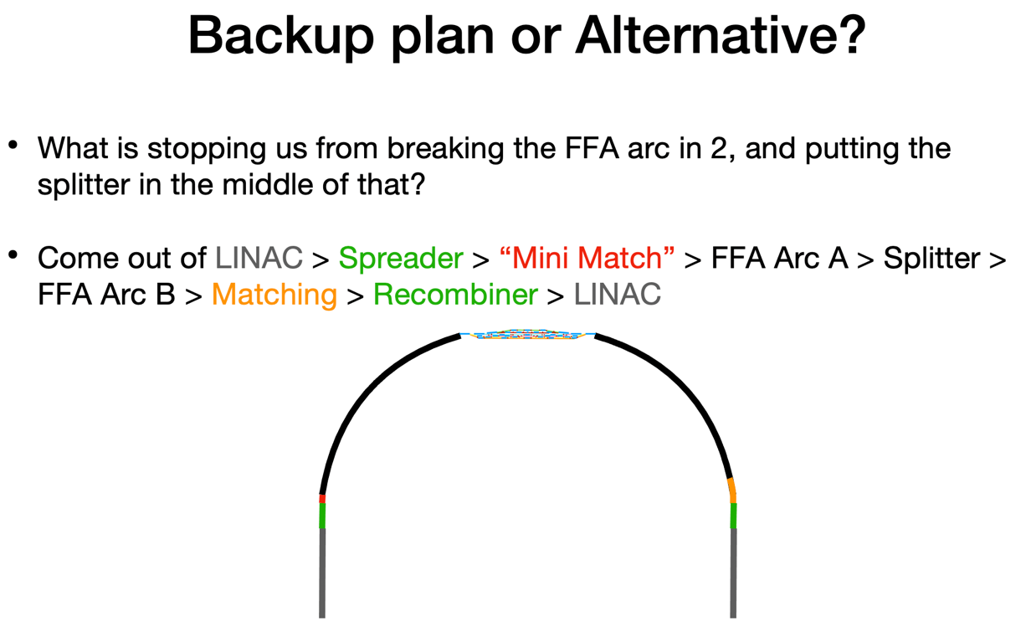
    - The flatness would impact the overall geometry of the arc
      * Ryan: I just didn’t bend the photo, it would be bent
    - Scott not afraid of curve
      * Halfway is a long way without vacuum ports
  + 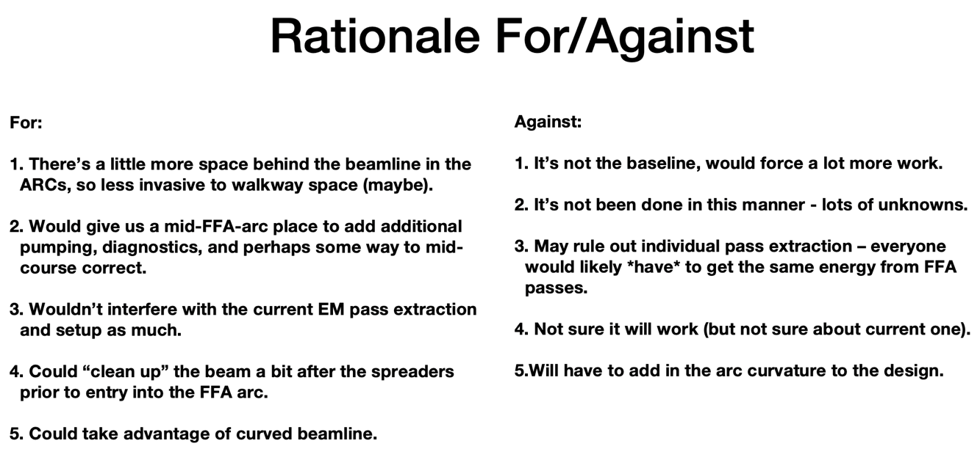
    - Scott: how confident are we that we can match beta/dispersion in transitions?
      * Not confident 2 splitters is enough
      * Need extraction
  + Kirsten: this opens up SOMETHING for extraction
  + Overall, this idea might be worth investigating
    - Will look at both in parallel
  + Primary reason to not use immediately after spreader is space
* Remember: KISS (Keep It Simple Stupid)
* Well into overtime, so Ryan will continue this next time.

|  |  |  |
| --- | --- | --- |
| Action Items | Person responsible | Deadline |
|  |  |  |
|  |  |  |

## Time allotted | 10 mins | Agenda topic AOB | Presenter All

|  |  |  |
| --- | --- | --- |
| Action Items | Person responsible | Deadline |
|  |  |  |
|  |  |  |

## Special notes

Pathway to Repository: <https://jeffersonlab-my.sharepoint.com/:f:/g/personal/tristan_jlab_org/EqZ5MeS-nipCgPfZB5p0oS4B9Is67d3nQb9sLJI3Zyev9g>