FFA@CEBAF Working Group|Minutes

## Meeting date | time 03/17/2023 | 11 AM EST | Meeting location <https://jlab-org.zoomgov.com/j/1614898082?pwd=TnUzMS81M2sxbDZIbERJU01tYkJCQT09>

|  |  |  |  |  |  |  |  |  |  |  |  |
| --- | --- | --- | --- | --- | --- | --- | --- | --- | --- | --- | --- |
| |  |  | | --- | --- | | Meeting called by | Alex B | | Type of meeting | Weekly Meeting | | Facilitator | Alex B | | Note taker | Ryan, Alex C | | Timekeeper | Alex B | | Attendees  Alex B, Ryan, Alex C, Andrei, Jay, Kirsten, Donish, Stephen, Kitty, Scott, Dejan, Randy, |

# Intro Discussion

IPAC, weather

# Agenda topics

## Time allotted | 25 mins | Agenda topic LDRD24 | Presenter All

* Following JLAAC discussion (below in AOB), Ryan shares initial brainstorming idea:
  + 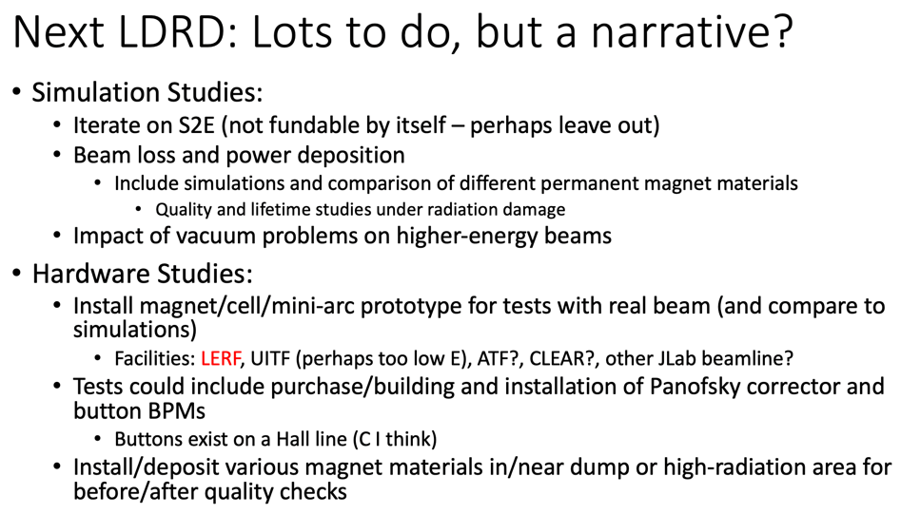
  + 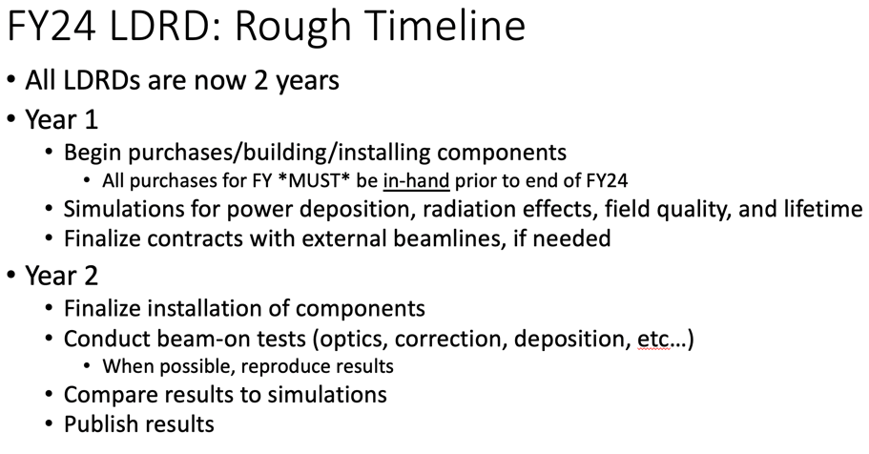
  + 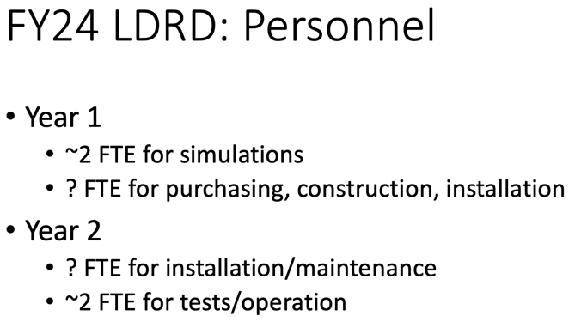
  + 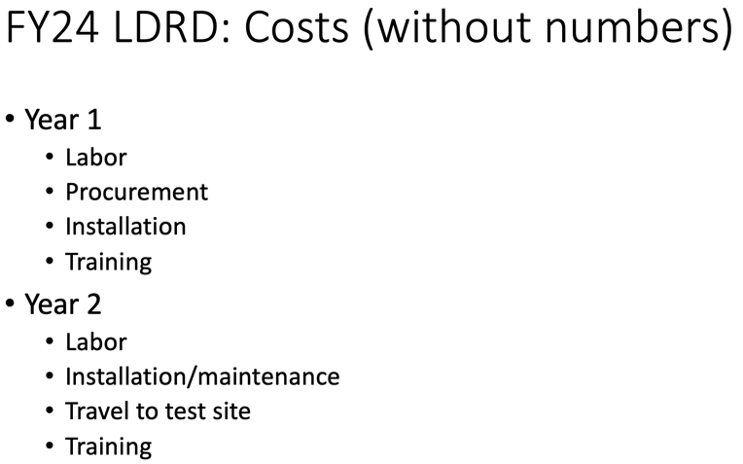
* Stephen: Is it possible to spend LDRD funds at other labs?
  + Would be useful for him to make magnets for testing
  + Ryan *thinks* it’s possible if made as a procurement – TBD
  + JLab would be a good place to test b/c it’s the right type of radiation
* Alex B: we can discuss more at the retreat
* Scott, how much effort is allowed on simulation work without LDRD?
  + Andrei: there will be an FOA coming next year – will cover efforts at BNL and JLab
    - NP funding can support JLab effort, unsure about BNL
    - Will talk to Director to make sure BNL efforts are supported
  + Scott: mostly concerned with, can the JLab staff continue to work on this as their day job?
    - Kirsten: EIC is my main job, this is just a small task.
  + Andrei: we are squeezing out some effort, but eventually we’ll need (FY25) to ramp up.
  + Alex B: at some point, this will become a project?
* Dejan: leader of small group doing interesting stuff (Scott and Stephen). A lot of money will be moved to EIC
  + There’s less and less enthusiasm about R&D due to budget
  + Working on proton therapy
  + CEBAF Upgrade
* Scott: that’s a separate issue to a certain extent. But for a visible participation for those at BNL, we will need an account number.
  + Email is one thing, but coming over, scheduling meetings, etc… will become a problem next year.
  + WE NEED to make sure JLab people have a code for their efforts.

|  |  |  |
| --- | --- | --- |
| Action Items | Person responsible | Deadline |
|  |  |  |
|  |  |  |

## Time allotted | 25 mins | Agenda topic Splitters | Presenter Ryan

* Pushing through with some iterations in BMAD, based on input from Jay with new magnet designs
  + Jay is looking at a 380 cm dipole that can go up to ~1.8 T. Says 3 m should be about the same, and cooling would be easier
    - They are 50 cm X 50 cm, so they fit in the simulations nicely
* 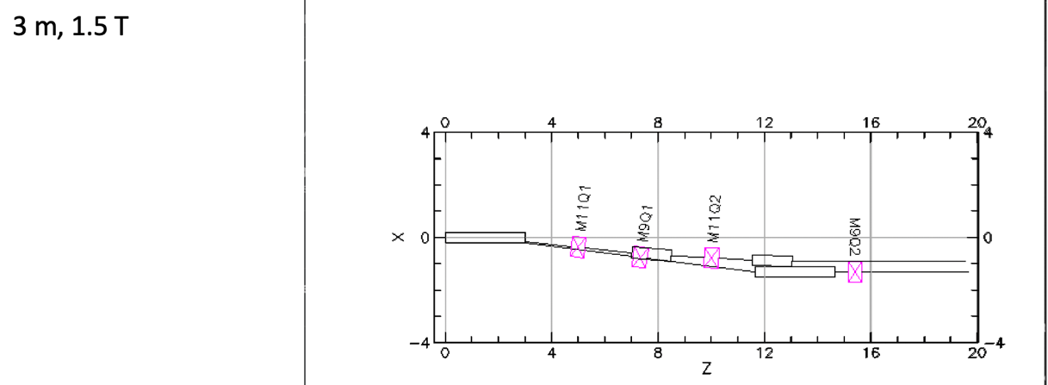
* 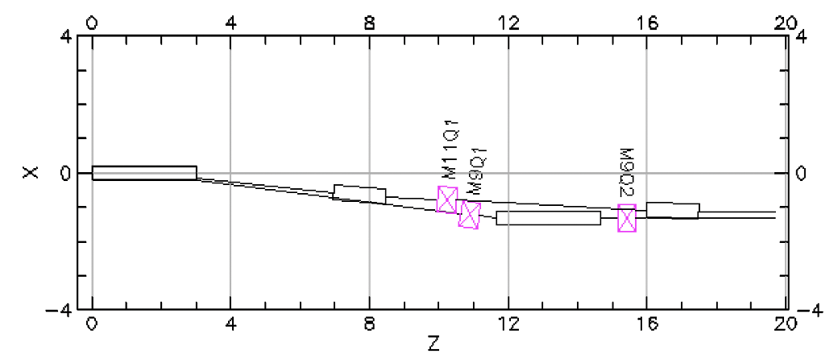
* 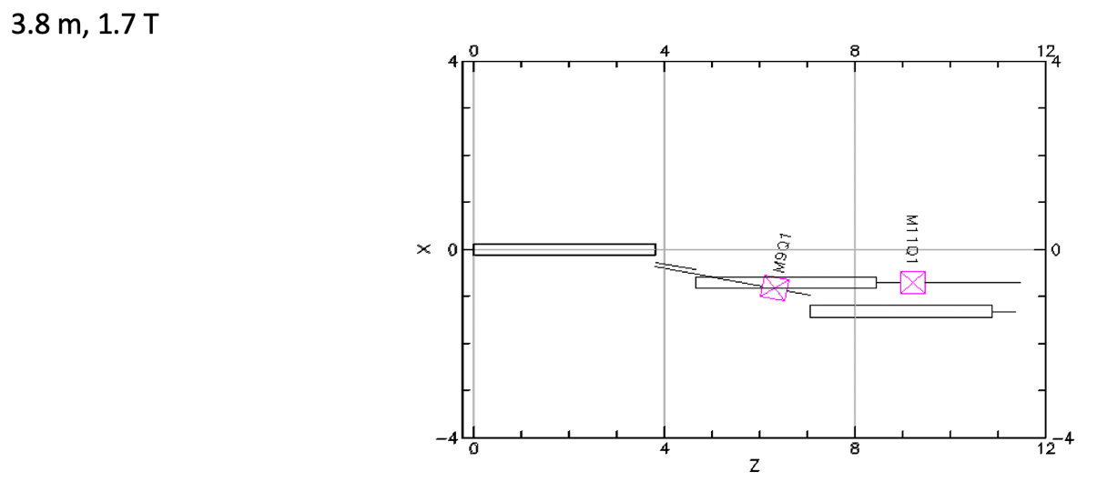
* 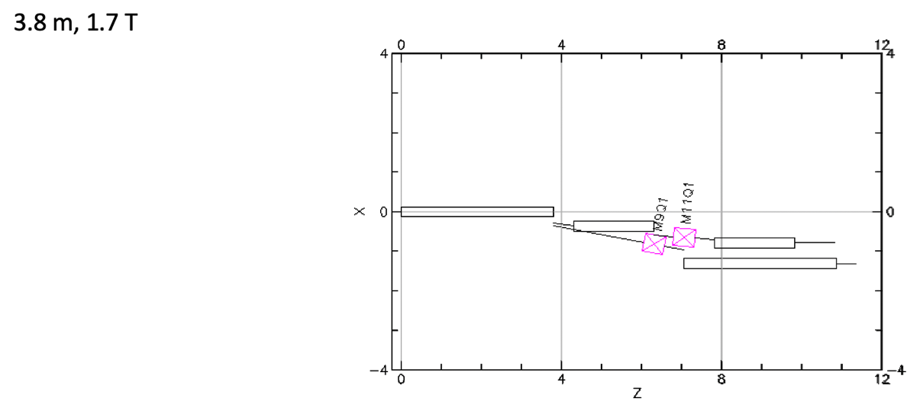
* 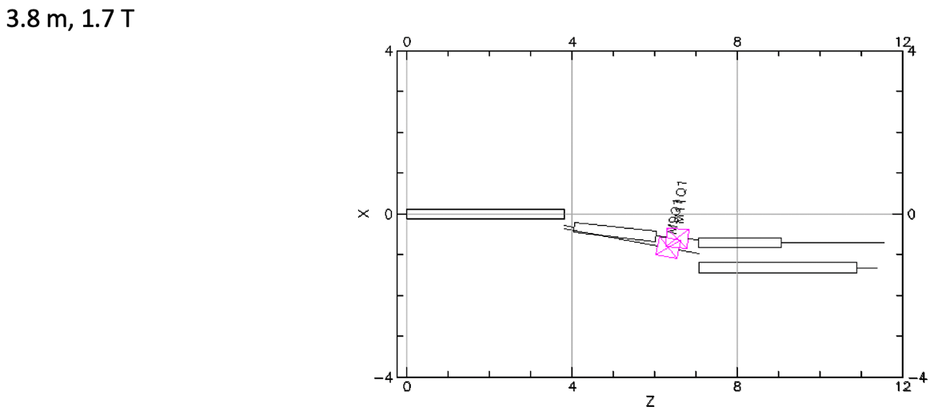
* 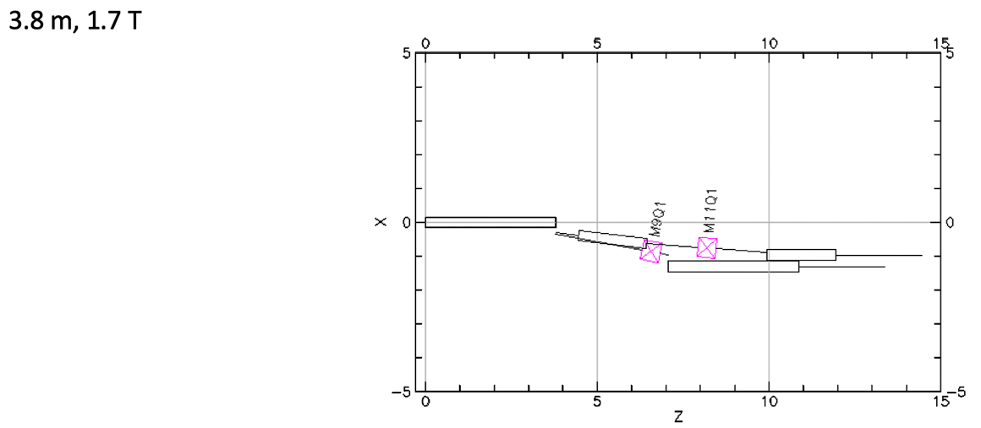
* Alex B: you can show proper magnet sizes in BMAD?
  + Kirsten – yes, even each magnet can be customized
* So far, the best geometry layouts use a smaller field/bend angle. Will continue iterating
* Ryan is working with graphical layouts, then putting them into BMAD to do the simulations
  + Iterating in BMAD after, not more graphically
* Ryan also showed failed attempt at mid-arc splitter:
  + 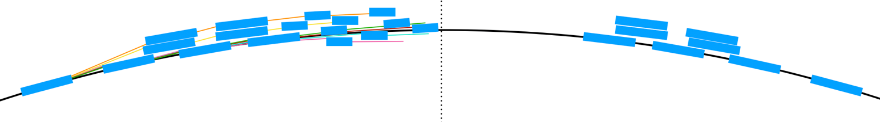
    - Will look at re-ordering. This effort was a failure
* Alex B: 8 quads per line should be enough to match everything
  + Scott – 7 is the minimum, but you’ll regret not having 8
* Alex B: So let’s start looking at optics
  + Scott – geometry, then path length, then optics
* Dejan disagrees with order of design. Is of the opinion that one should start with M56 and TOF correction first
  + Scott mentions that geometry tends to be the hardest part
* Jay mentions that the fields outside of the magnets are non-trivial at 5 cm outside the steel
* Discussion about using some permanent magnets (smaller transversely) so help fit in the magnets
  + Also discussion about using non-traditional magnet setups to help
  + Ryan says trying to start simple, and add in complexity if/when needed
* Dejan mentions extraction
  + Ryan spoke to Doug, says they do not need each hall to get different passes. This simplifies extraction
    - May lean toward putting splitter mid-arc – TBD
* Scott: you’ll use 6 quads to match, giving two more to get a range of available R56 values. To get others, you’ll need to shift things in ways that may not work, or may make other things worse.
* Dejan: Alex B has worked a lot with M56, and will be a good resource
  + Alex B: and Donish has worked with pathlength chicanes a lot too!

|  |  |  |
| --- | --- | --- |
| Action Items | Person responsible | Deadline |
|  |  |  |
|  |  |  |

## Time allotted | 10 mins | Agenda topic AOB | Presenter All

* JLAAC preliminary response report.
  + 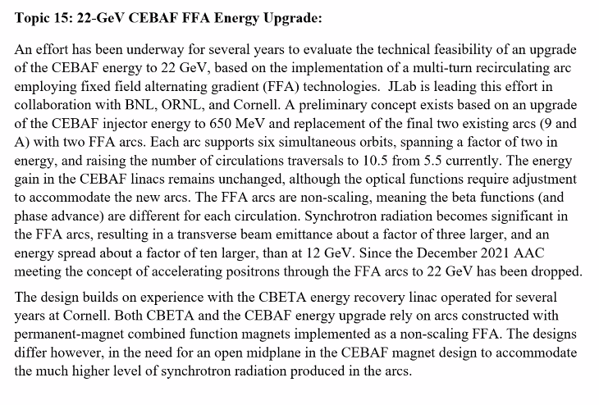
    - We’re extending the technology from CBETA, so we need to actually test this.
    - Much higher E at CEBAF
    - Current at CBETA is ~40 mA for single pass (70 uA for single pass)
    - Power: we are ~3 orders of magnitude higher
  + 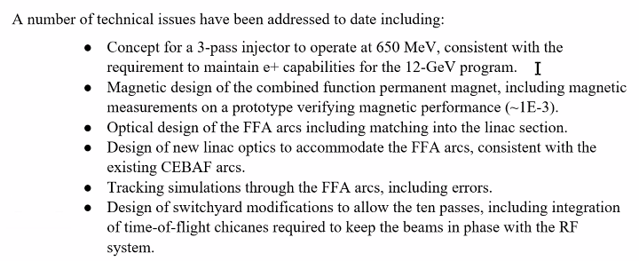
  + 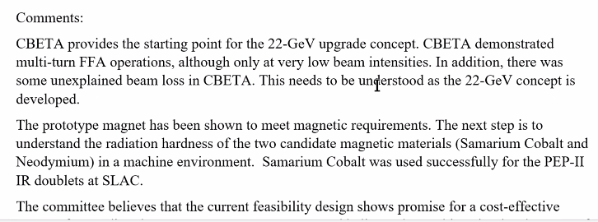
  + 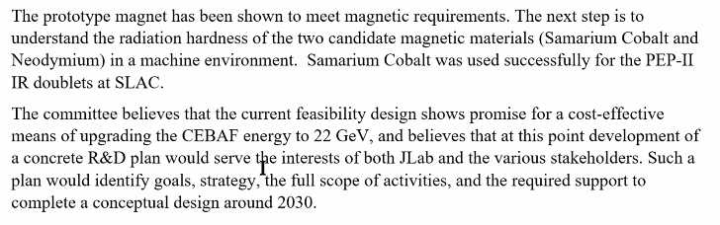
* Reminder: retreat in ~ 3 weeks. Please register, etc…
  + Alex B will set up a folder for administrative purposes.
  + Wednesday before the retreat, if you have a presentation, please upload what you have
  + Scott: planning-wise, travel is being done at JLab for guests. Haven’t heard back yet.
    - Tristan is working on it
  + Scott: from my point of view, my time would be best spent having a good amount of time with Ryan/Kirsten/Alex C to help out with details.
    - Will leave Sat morning so have full Friday
  + Alex B: LDRD discussion would be good to have viewgraphs.
  + Dejan wants to present something
  + Can stay in ResFac
  + Alex C volunteered to drive people from Norfolk
  + Vasiliy is coming
  + Scott has problem arriving day earlier, but Dejan and Stephen can arrive day before
  + Tour around noonish on Thursday
* Alex B: next week, lots of events here at the lab, no meeting next Friday
  + 
* Next meeting (2 weeks), Donish will present

|  |  |  |
| --- | --- | --- |
| Action Items | Person responsible | Deadline |
|  |  |  |
|  |  |  |

## Special notes

Pathway to Repository: <https://jeffersonlab-my.sharepoint.com/:f:/g/personal/tristan_jlab_org/EqZ5MeS-nipCgPfZB5p0oS4B9Is67d3nQb9sLJI3Zyev9g>

NO MEETING NEXT WEEK.