FFA@CEBAF Working Group|Minutes

## Meeting date | time 03/31/2023 | 11 AM EST | Meeting location <https://jlab-org.zoomgov.com/j/1614898082?pwd=TnUzMS81M2sxbDZIbERJU01tYkJCQT09>

|  |  |  |  |  |  |  |  |  |  |  |  |
| --- | --- | --- | --- | --- | --- | --- | --- | --- | --- | --- | --- |
| |  |  | | --- | --- | | Meeting called by | Alex B | | Type of meeting | Weekly Meeting | | Facilitator | Alex B | | Note taker | Ryan | | Timekeeper | Alex B | | Attendees  Alex B, Ryan, Alex C, Donish, Kirsten, Todd, Stephen, Randika, Jay, Spata, Kitty, Scott, Andrei, Vasiliy, |

# Intro Discussion

Ryan gave mini-talk to HBCU, etc… for DEIA outreach.

Alex B helped select some of the REU/SULI students for the summer

Kirsten in LERF as PD

# Agenda topics

## Time allotted | 25 mins | Agenda topic EM Arcs/Machine | Presenter Donish

* Good but short update
* Last time:
  + 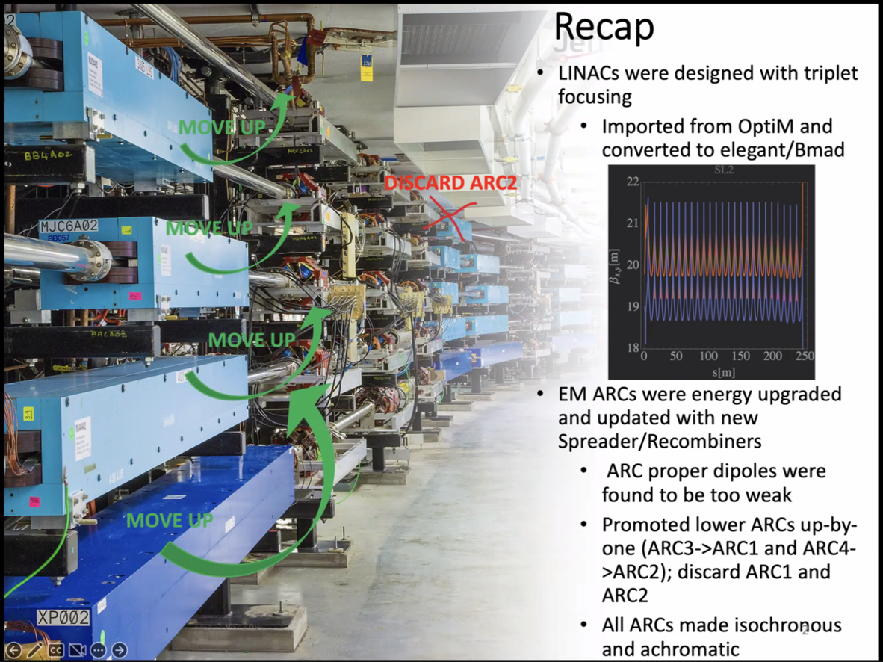
    - Optim > elegant + Bmad
    - Arc proper dipoles were too weak – move up the arcs and optics.
* 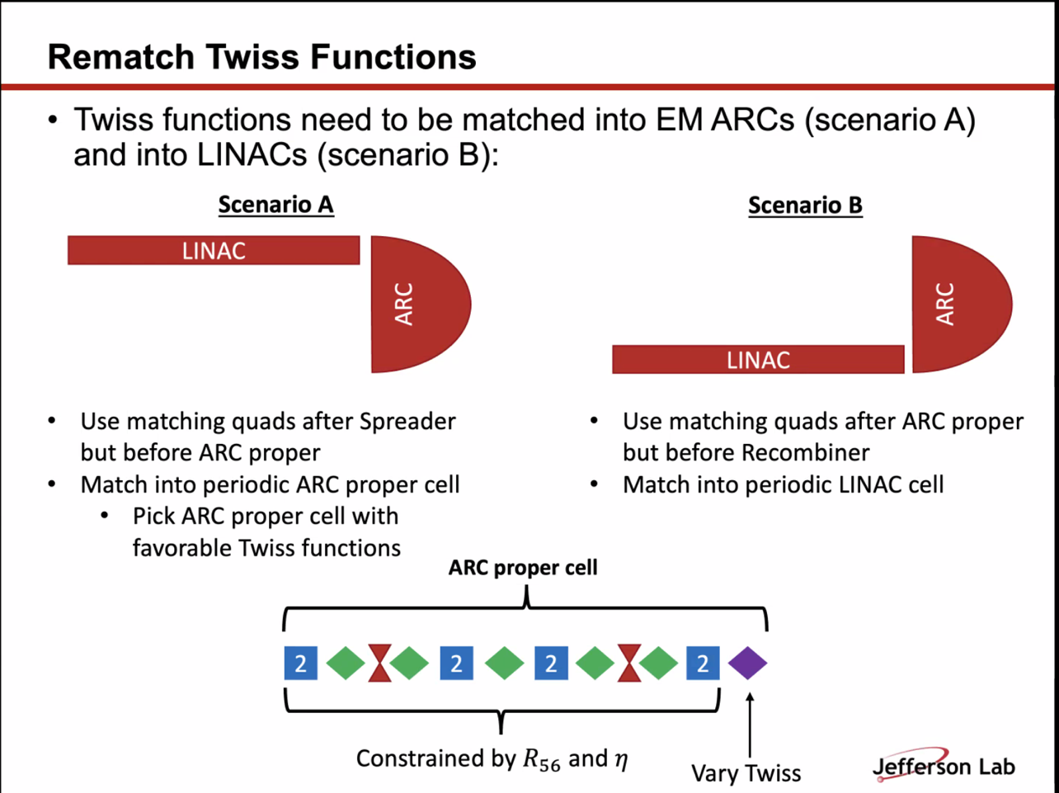
  + Blue are bends, triplet, bends, etc…
  + Periodic cell has 8 bends and 6 quads
    - Quads in the bends are constrained by R56 and dispersion
    - To make it isochronous, have to match the R56 with spreader and recombiner section
    - Cell needs to be achromatic as well
    - One lone quad that you can vary the Twiss with – that bit of freedom gives a lot of wiggle room for matching
* 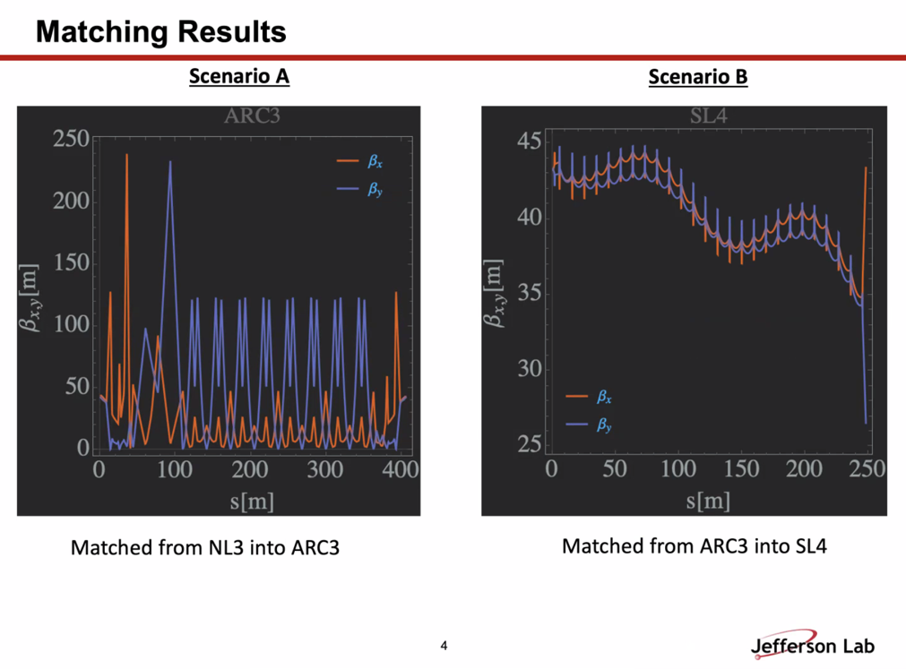
* 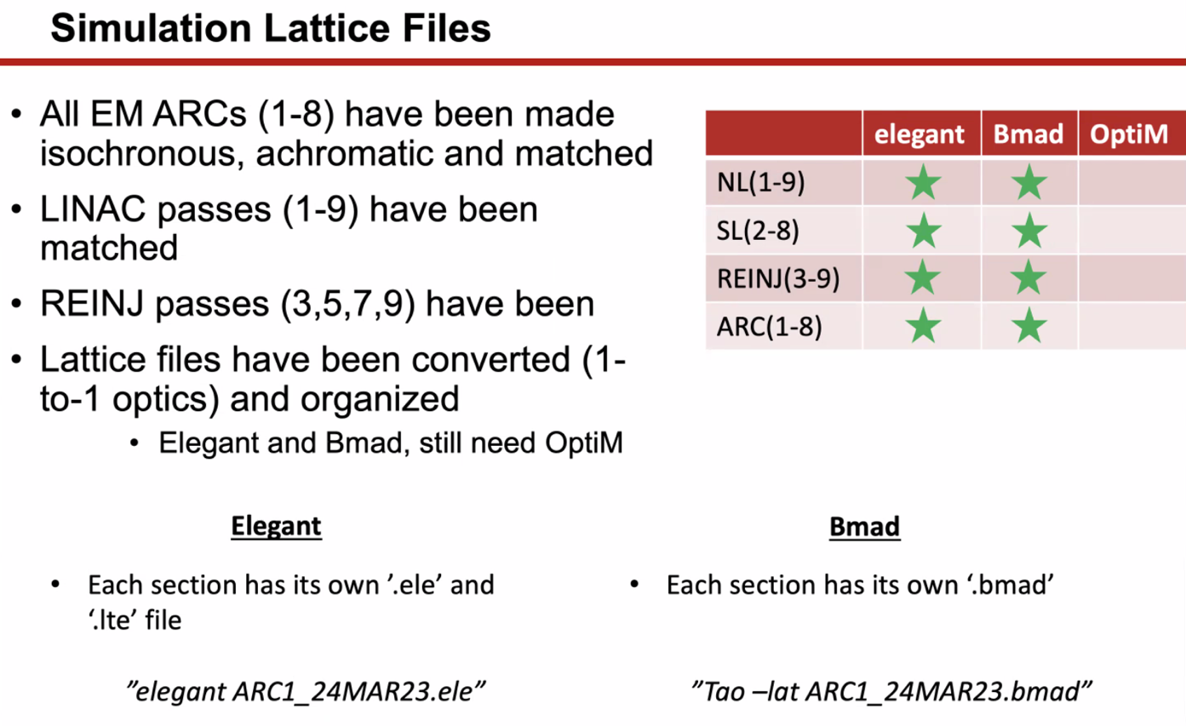
  + Still converting to OptiM
* 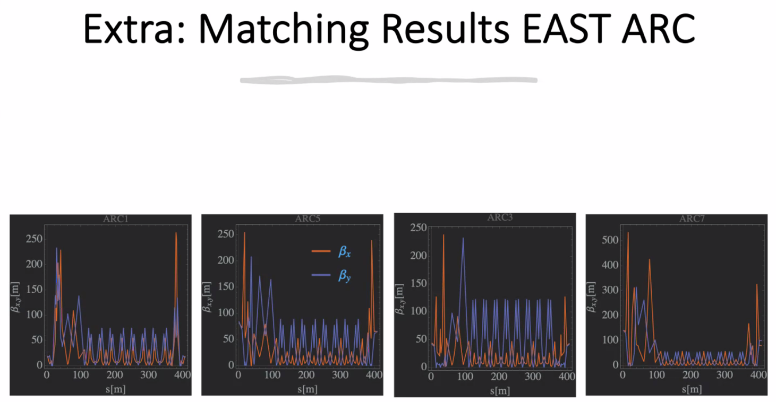
  + Alex B: I see the beta functions impacted by linac optics. You managed to cap them at a decent level. In the spreader, there’s only a few quads, so we have no way to really cap beta functions easily. But you managed to do it well.
    - Donish: exactly. There’s a massive spike right after spreader
      * That matching quad in the arc proper cell is what helped play with the spikes around the spreaders
    - Alex B: this is relatively new optics that you’re playing with as well. We didn’t have this flexibility before
      * Recently, the people who run the machine liked this and are deciding to adopt it.
* Going to give all these files to everyone. Will check in with Ryan to make sure the naming is correct, etc… will put it on the github soon.
* 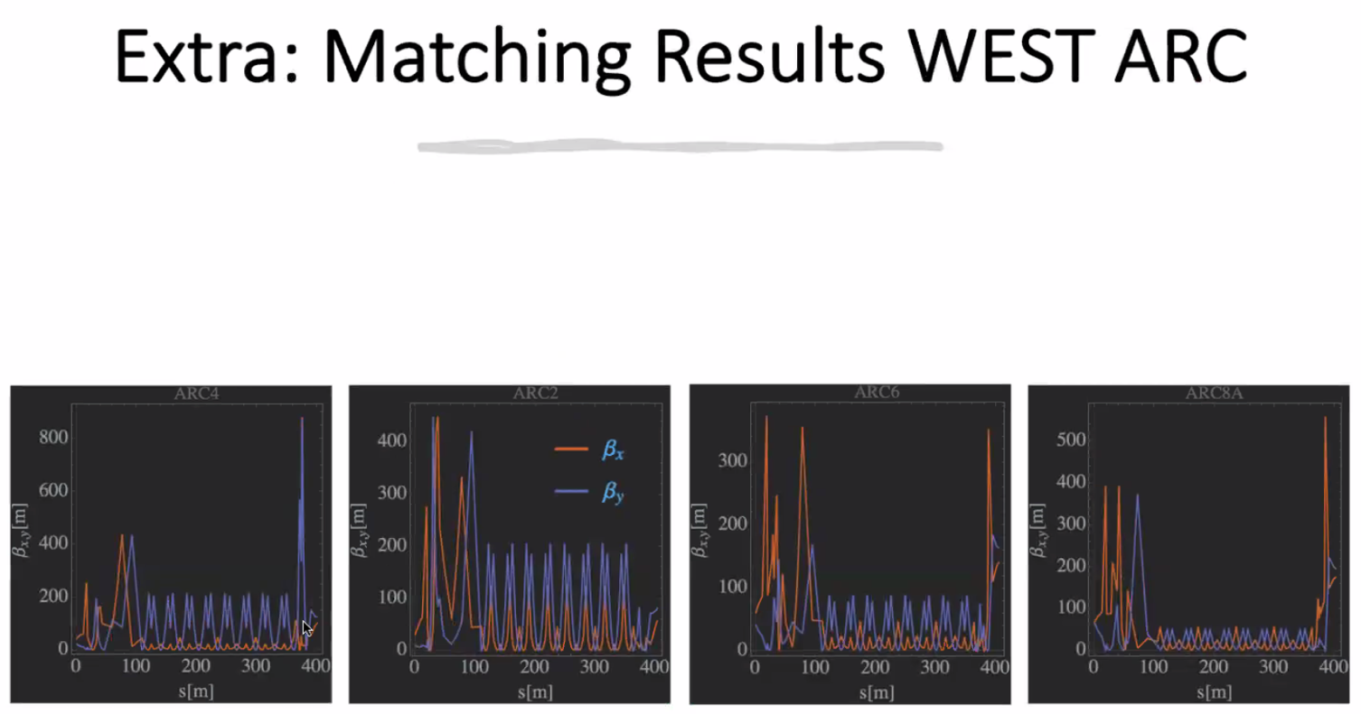
  + One spike in Arc to maybe look at more
  + Scott: what’s the emittance look like?
    - Kirsten, roughly 2:1 or 3:1
    - Alex B: beam won’t be round
* Donish: when I do the error studies and including radiation effects, can do a bit more optimization in arcs to try to dampen emittance growth if there’s any wiggle room there
  + Alex B: yes, in FFA arcs, everything is smooth and curly-H is tiny. But in the EM arcs it’s different. And the Spreaders make it hard.
  + Jay: varying step ratio in spreaders can reduce the betas
    - Ryan can always check and update if needed
    - Alex B: look at the bipolar distribution – tells ratio
      * Middle quad gives some flexibility to even things out, but the distribution of focusing between 1st and 3rd quad are defined by steps, as Jay said.
* Alex B: so we have most of EM machine done. So now we have the FFA passes to work on.
  + Have FFA arc, end pieces that Randy/Vasiliy are working on, and splitter, that will be the “first cut” optics for start-to-end simulations.
* Donish: I have the files, need to get them on the github. Will upload after checking.

|  |  |  |
| --- | --- | --- |
| Action Items | Person responsible | Deadline |
|  |  |  |
|  |  |  |

## Time allotted | 10 mins | Agenda topic AOB | Presenter All

* Retreat Registration:
  + 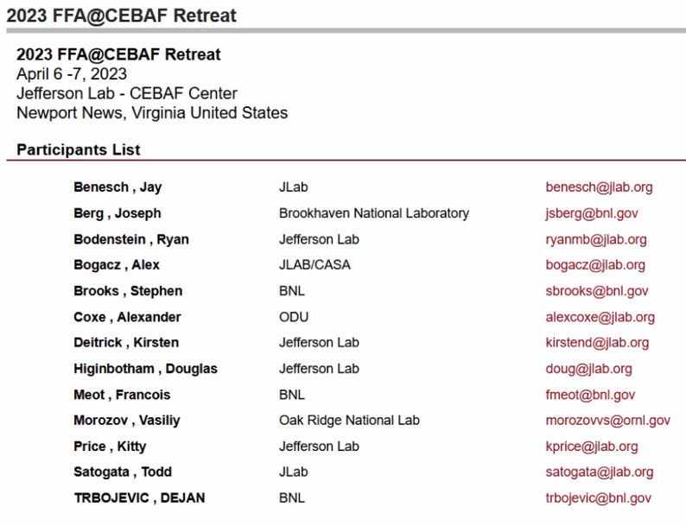
* In the presentations folder, there’s a sub-folder to upload talks if you want for the retreat.
* JLAAC Report:
  + 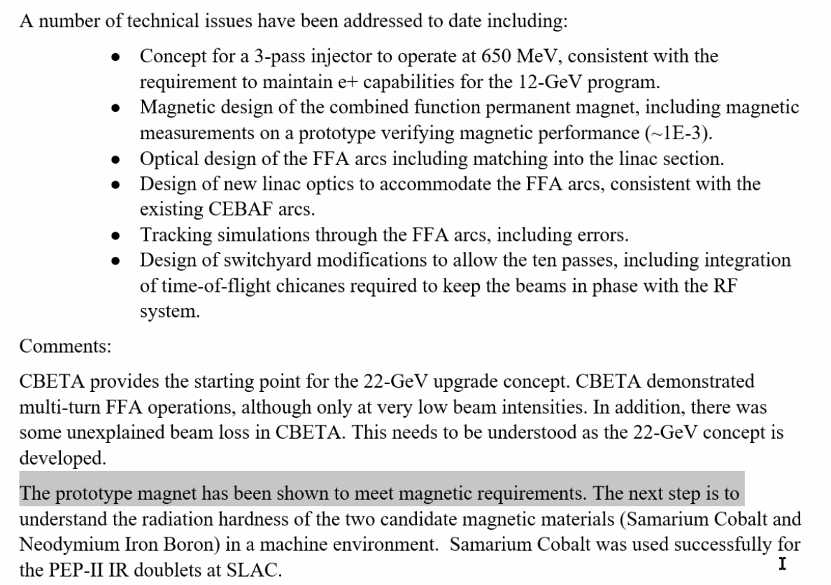
  + 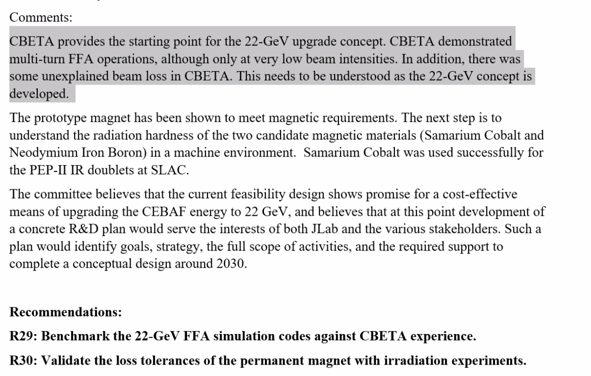
    - Post-mortem of why CBETA was losing beam
      * Stephen: they were in the slitters and not the FFA
      * Scott: we have to be a little careful about that statement, because while it’s true, the FFA beamline was part of the transport that got us to that point, so we need to be cautious.
        + Stephen: it was low level. Could still be something else going on, but in the FFA line itself, the radiation levels were tolerable
        + Scott: yes. The problem is that the beam goes into the splitter lines, which do not have the acceptance that the FFA arcs have. Primarily down to matching
        + Kirsten: Bulk of loss was during circulation. We had no control or insight over optics. Lots of flying blind that wouldn’t happen in CEBAF. Bulk was in R2D (?) cell in pass 7.
    - Alex B: could compile a few bullets to show how things weren’t so drastic as the statement makes out.
      * Kirsten: main problem – we didn’t have the time and ability to do the optics matching, and when you’re decelerating you’re flying blind. We’re not decelerating in CEBAF FFA. And the other optics problems we didn’t have the time to correct.
    - Scott: if you really want to address R29, we need to turn CBETA back on.
    - Alex B: if the three of you who ran CBETA could help to explain to the committee and address to this comment (R29) it would be useful.
      * Scott – 2 suggested direction:
        + 1. Turn back on CBETA and try to drill down on the optics. What has happening?
        + 2. One of the weaknesses of CBETA is that we didn’t have a good way of doing optics measurements in the splitter line. We had passable measurements, but didn’t have solid measurement of what the optics looks like. Could argue that we could make this a requirement for splitter lines (easier said than done). Screens were where they were b/c that’s where they fit, not ideal locations.
      * Kirsten: Some places you could quad scan. In other places, didn’t go through the beam waist (plus dispersion problem). Scott’s right: here’s why we think we had them, here’s how we think we can avoid them in CEBAF.
      * Alex B: yes, I think that’s a good way to address R29. We don’t want to simulate CBETA again.
        + Scott: we can simulate it again, but it’s not the same as the real machine. The CBETA lattice in SVN almost runs – something wrong with RF timing. Seems to mostly impact deceleration run. There’s a bit of work to be done to see what changed in BMAD, but otherwise it mostly runs.
    - Stephen: this is likely also something to do with stray fields.
      * Scott: I wouldn’t consider them to be the primary source, but they are there. Matches were sensitive and highly chromatic. We’d really need to drill down. But without the machine actually running, it would be very hard to do.
    - Kirsten: and septum misalignment
      * We’ll also have better insights into the optics and therefore control. We won’t fly blind.
    - Scott: only accelerating helps
      * We need to be able to measure beam distribution instead of just position
* Jay shares tech note about BSY
  + Can put 50 cm in and not touch the Hall C line
  + 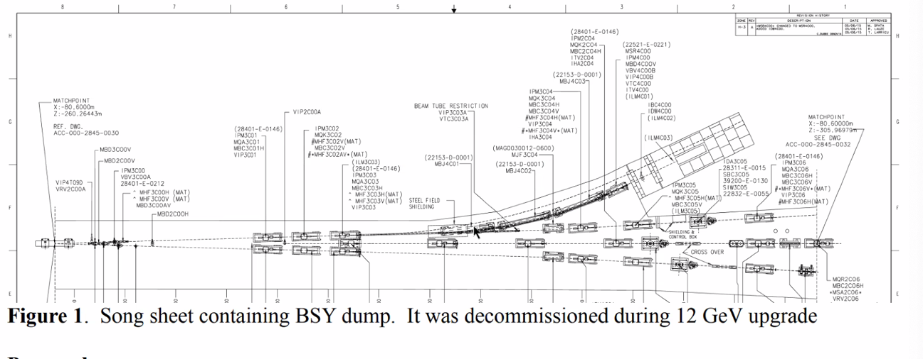
  + 2.8 m cell will fit (it’s a 3 m dipole right now)
  + Can go up to 11 GeV and anything lower, as long as you get the right power supplies for the dipoles
  + One cell will cost? Stephen thinks a few hundred $K
    - If you only have a few hundred thousand, we could scale down the magnets for lower E.
  + The line now does 6.6 GeV and maybe up to 8.8 GeV
    - If we can do 2-6 GeV good
  + Probably a couple hundred K to recommission and make usable
  + Likely ~$2M for the whole setup (labor, parts, install, recommission, etc…)
* LERF?
  + Low E, and not very available in the upcoming few years.
* Spata: not a lot of long drifts. Maybe transport recombiner, but it would be difficult.
  + LERF: positron group are trying to make an implementation plan to meet their needs. Trying to interleave meaningful work with other stuff.
    - Limited to (only 1 cryomodule installed right now) maybe 100 MeV ish.

|  |  |  |
| --- | --- | --- |
| Action Items | Person responsible | Deadline |
|  |  |  |
|  |  |  |

## Special notes

Pathway to Repository: <https://jeffersonlab-my.sharepoint.com/:f:/g/personal/tristan_jlab_org/EqZ5MeS-nipCgPfZB5p0oS4B9Is67d3nQb9sLJI3Zyev9g>