FFA@CEBAF Working Group|Minutes

## Meeting date | time 04/21/2023 | 11 AM EST | Meeting location <https://jlab-org.zoomgov.com/j/1614898082?pwd=TnUzMS81M2sxbDZIbERJU01tYkJCQT09>

|  |  |  |  |  |  |  |  |  |  |  |  |
| --- | --- | --- | --- | --- | --- | --- | --- | --- | --- | --- | --- |
| |  |  | | --- | --- | | Meeting called by | Alex B | | Type of meeting | Weekly Meeting | | Facilitator | Alex B | | Note taker | Ryan | | Timekeeper | Alex B | | Attendees  Alex B, Ryan, Dejan, Reza, Alex C, Donish, Kirsten, Randy, Kitty, Andrei, Stephen, Jay, Vasiliy, |

# Intro Discussion

Discussion of Gamma factory talk(s). Alex B was at APS meeting in MN.

# Agenda topics

## Time allotted | 25 mins | Agenda topic IPAC23 Updates | Presenter Alex

* Go through abstract count for IPAC23. Added folder so we can upload and review.
* Kirsten is taking our “main” status update paper/poster.
  + It’s coming well. Tracking down a few odds and ends.
  + Anyone have a CEBAF layout with only 1 FFA layout and only 1 TOF chicane indicated?
    - Can use one from Alex B’s recent talks (JLAAC, etc…)
  + Kirsten doesn’t have any more FFA-related posters, just other topics
* Stephen has 1 FFA@CEBAF paper (and one other FFA poster, but not for CEBAF)
  + Has a CEBAF magnet prototype one, just uploaded to shared folder
* Ryan has one on the spreaders and splitters
* Alex C has one on FFA error studies – will send
* Vasiliy has one on FFAs – Ryan will stand on it
  + 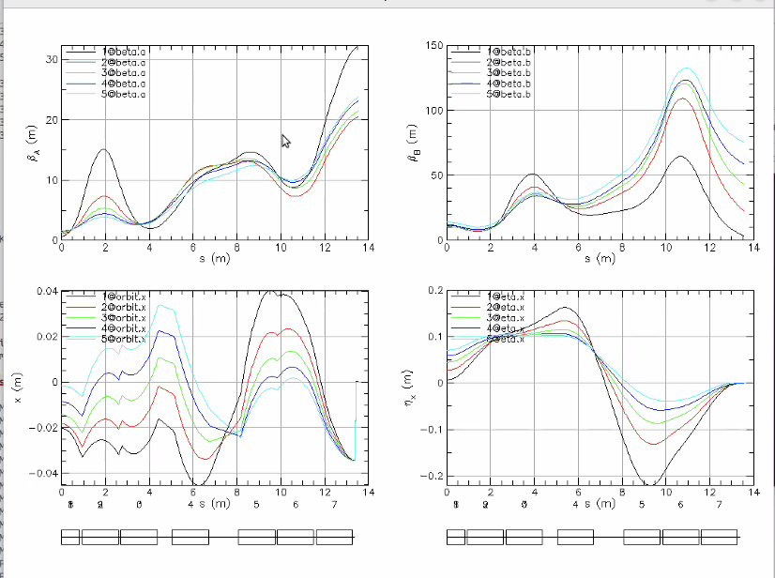
  + Best merge so far. Started with Dejan’s idea: use a dogleg to suppress the orbits and dispersion.
  + Greatest challenge with that approach is that the order of dispersion as a function of energy is opposite in a FODO cell than in a dogleg
  + Flipped order of dispersion, start counting by 0.
  + In a FODO cell, highest energy has largest dispersion. Opposite in dogleg
  + From current status, need to match betas – not successful so far, but getting there.
    - Optimum solution is when betas are large in LINACs with 0-ish slope in the middle
  + Half paper on high-power accelerator as well
* Randy’s update:
  + 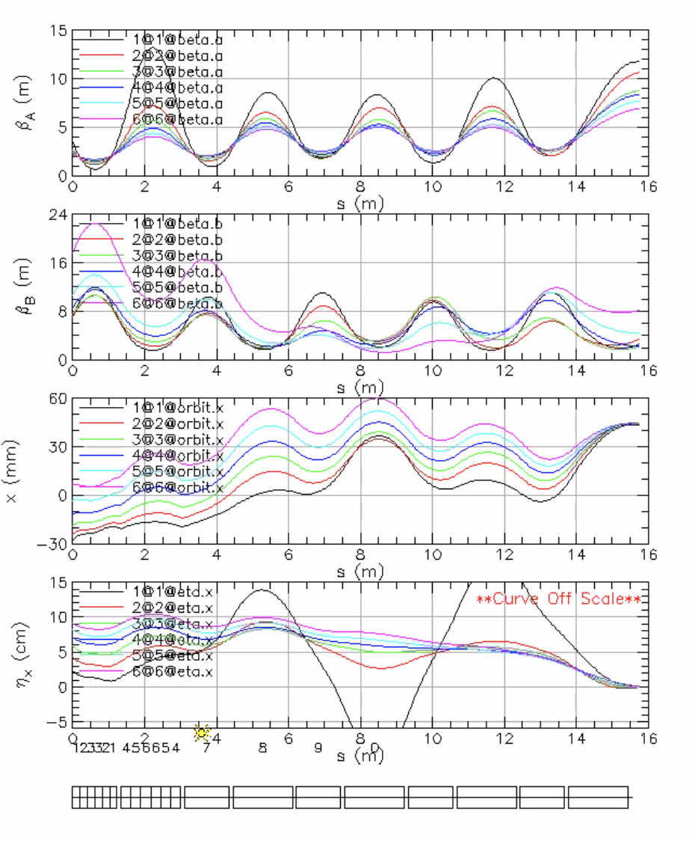
    - Starts in FFA arc, and merging. Still trying to suppress dispersion, but overall size isn’t concerning.
    - Still beta matching, etc…
    - Beta matching will be in a section following what is shown
    - Dejan: this reminds me of the other solution changing cell length – will send
  + Vasiliy: Impossible to make every orbit and dispersion exactly 0.
    - Dejan – not impossible, may need to add magnets
* Scott is going to IPAC for other work, but will help Stephen with posters
* Indicate presenters on IPAC website

|  |  |  |
| --- | --- | --- |
| Action Items | Person responsible | Deadline |
|  |  |  |
|  |  |  |

## Time allotted | 25 mins | Agenda topic Extraction | Presenter Reza

* Since Reza designed our extraction system, wanted to hear from Reza how we might be able to extract.
* In principle, can keep lower, EM pass extraction the same. But the question is, can we extract the FFA passes?
* Horizontal Splitters in NE and SW
* Highest E beam to D?
* Reza: Although I’m not on the papers mentions, have a positron paper at IPAC. Start electrons from LERF, up to 650 MeV, etc…
* Found out in middle of discussion that everyone has different opinions. So where are we?
* 
* 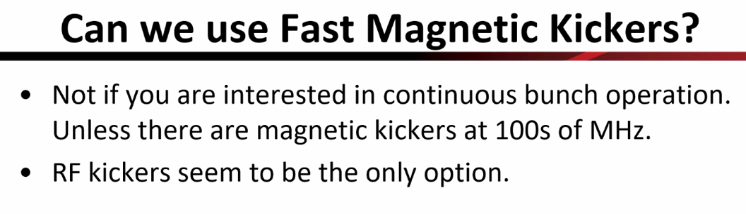
* 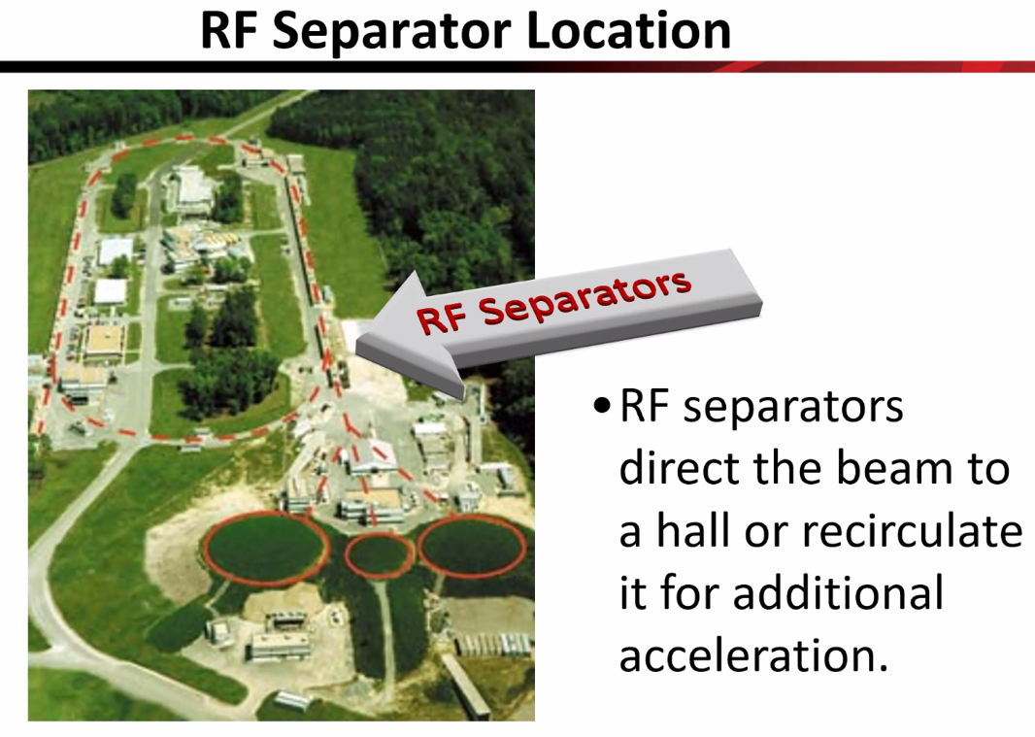
* 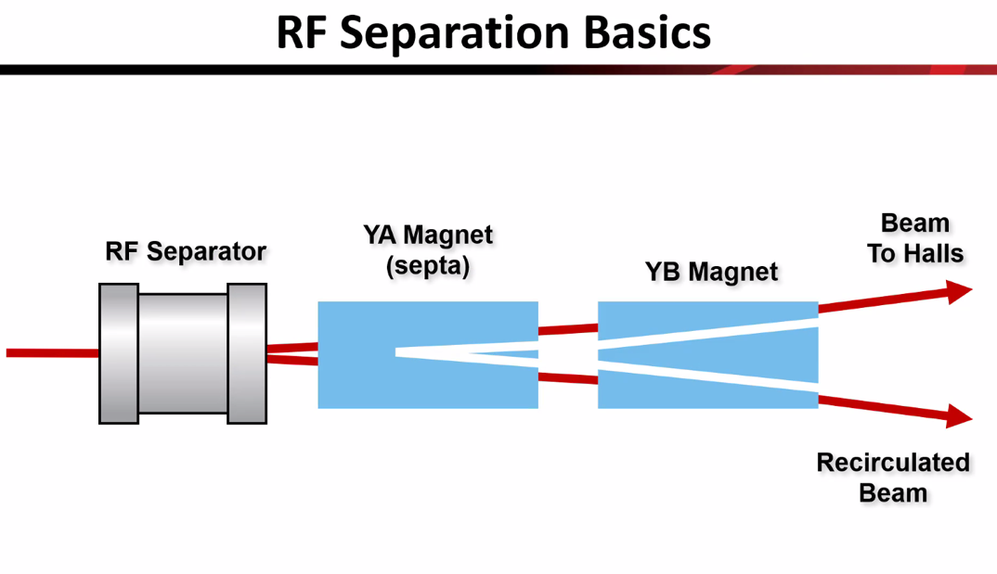
* 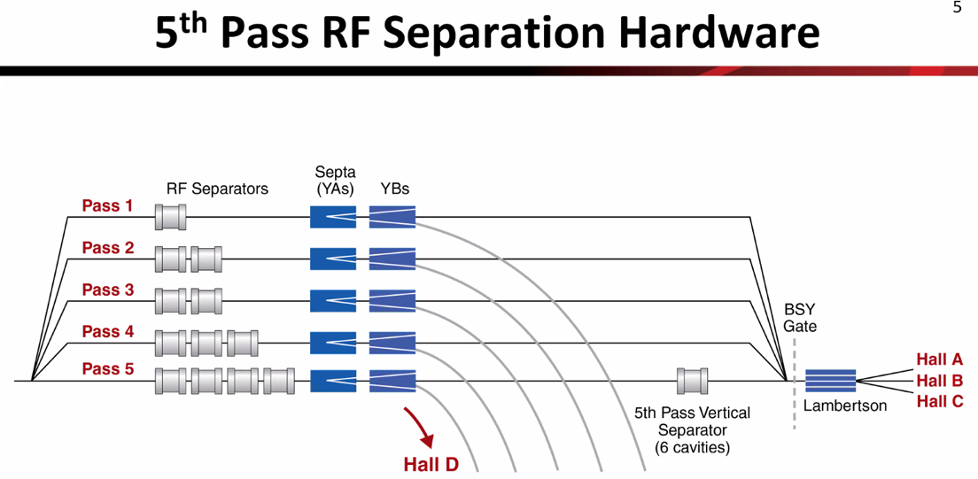
* 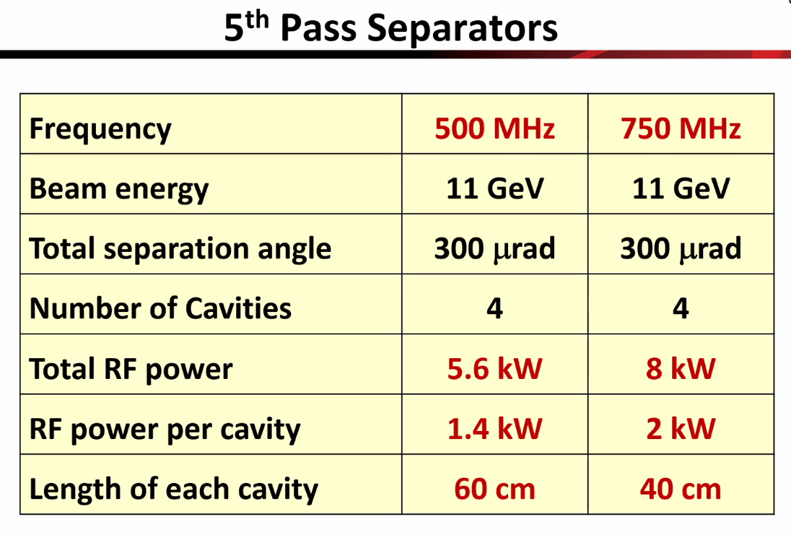
* 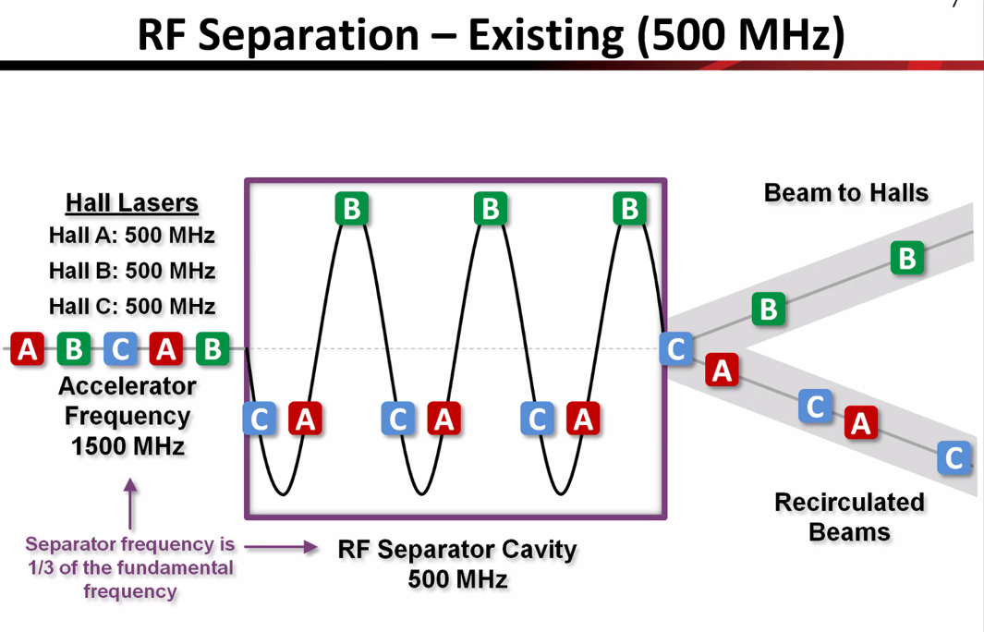
* 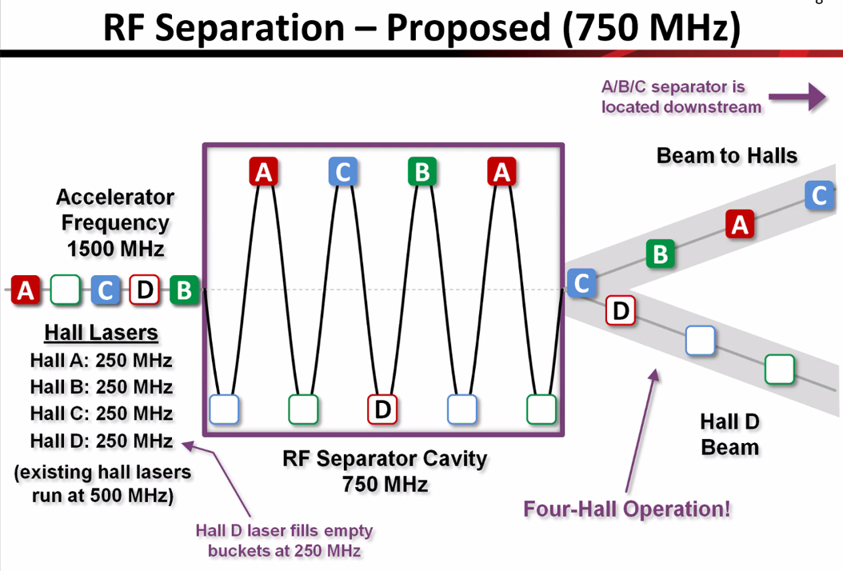
* 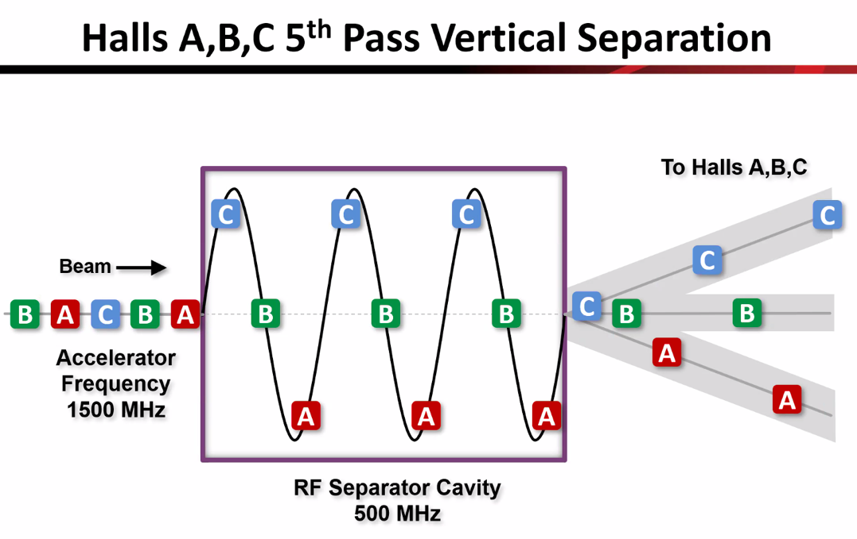
* Question from Kirsten: the only pass that can do multiple to delivery to halls is 5th pass? Yes, that’s correct for now. Only 5th pass can go to multiple halls simultaneously
* 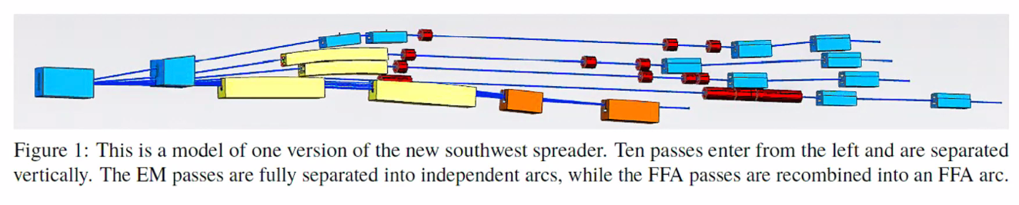
  + If you want lower E passes, we can stay the same
* 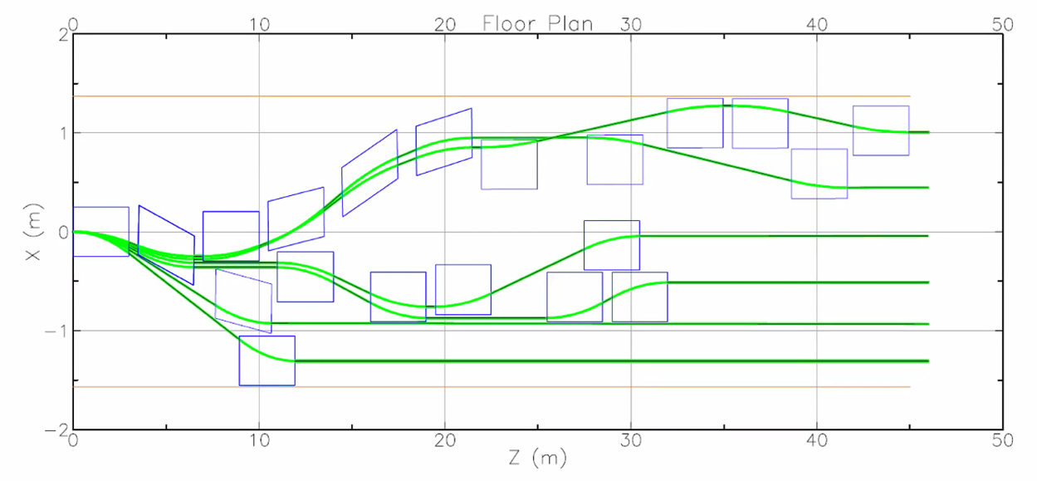
  + This is horizontal
  + One thing is that we can think of kicking here out of the plane
* 1. Let’s say halls want beam with a middle energy (say 2nd FFA pass). Can we get that out?
* 2. You get the beam out, and now you have A/B/C and want to separate D out. Do you want A/B/C to go to higher E? If D asks for 12 GeV and the others want 22 GeV, can we pull D out only without impacting A/B/C?
* 3. If you get to the full E, can you separate the 3 beams from A/B/C and D? Maybe it’s easier to do this
  + May not have the room for this, though
* Alex B: Can we start kicking in the center of the splitter with cavities?
  + Reza: let’s say they want the beam from the x=0 plot.
* Dejan – probably need a sliding magnet, then the rest of the energies will not be available
  + - You’d need more cavities to get the kicks as well
    - Additional, very serious problem from experiments POV: do they really need the different energies in same run to be able to compare? How quickly do they need to change energies?
* If you have a vertical magnet that is “always off” until you turn it on for separation vertically
* Hall D can’t’ take <12 GeV
* Can we send beam which has not gone through all 6 FFA passes? Can we do it by kicking in the splitter?
* Can maybe do the Spreader separation with a movable septum
* The current separation depends on where on the phase the beams sit. If you make a path length change equal to say ¼ of the wavelength, that beam won’t go through the zero crossing anymore. It will sit at a place you can’t kick. That requires about 5 cm addition
* Can we add/subtract the path length in the splitter for the extracted pass?
  + Likely not, it takes a lot to get a ¼ wave correction in that space
* What about Hall D?
  + Hard to extract after. Possible?
* Kirsten: if you put the splitter lines in the middle of the arc, instead of the straight section, will that work?
* Alex B: if we extract 18 GeV to A/B/C, and then we can get a half pass to D.
* Possible to go to A/B/C at higher E? Can only do it in separate lines. (Dejan)
  + If D extracts 12, we can’t get back to them with 20 at the same time.
* We currently spend ~4 hours to change passes now in CEBAF
* Will need to upgrade all hall lines
* Alex B: Copper RF separator cavities are quite outdated with low gradient. Maybe we can get a brand-new design?
  + Reza: put out a design in a conference paper
  + Consisted of 2 rods on each end (all fields on those rods). Not sure if anyone has anything better/more concentrated since then.
  + If we go superconducting, same design but doesn’t get hot
    - No cryo in that area
  + Suba had a thesis on something like this (one SRF dipole cavity instead of current setup)
    - Problem is, there’s no cryo in that area
  + Can probably push the tech a bit, but it’s something to be worked on
* If we kick the beam out of the plane (vertically) – we cannot then put it back, right?
  + Not if we’re kicking out magnetically. *MAYBE* if we kick with RF
* Please note that RF kickers kick all the passes, so they separate the orbits as well.
* If D needs top energy, then A/B/C won’t get beam.
* If you have highest-pass beam, how get to hall D?
  + If RF separate D in the NE corner, then other halls can get beam (half pass higher or more).
* Lots to talk about still, but this was a good start.
* We will add comments into the general IPAC paper about this brainstorming.

|  |  |  |
| --- | --- | --- |
| Action Items | Person responsible | Deadline |
|  |  |  |
|  |  |  |

## Time allotted | 10 mins | Agenda topic AOB | Presenter All

|  |  |  |
| --- | --- | --- |
| Action Items | Person responsible | Deadline |
|  |  |  |
|  |  |  |

## Special notes

Pathway to Repository: <https://jeffersonlab-my.sharepoint.com/:f:/g/personal/tristan_jlab_org/EqZ5MeS-nipCgPfZB5p0oS4B9Is67d3nQb9sLJI3Zyev9g>