FFA@CEBAF Working Group|Minutes

Meeting date | time 04/28/2023 | 11 AM EST | Meeting location https://jlab-org.zoomgov.com/j/1614898082?pwd=TnUzMS81M2sxbDZIbERJU01tYkJCQT09
 | Attendees  Alex B, Ryan, Dejan, Scott, Alex C, Kitty, Randika, Edy, Donish, Todd, Andrei, Stephen, Vasiliy, Jay, Reza
  Meeting called by | Alex B
  Type of meeting | Weekly Meeting
  Facilitator | Alex B
  Note taker | Ryan
  Timekeeper | Alex B

Intro Discussion
IPAC discussions: Scott, Ryan, Kirsten, Todd going from FFA crew.
Please upload/review papers in the shared folder. Everything is due on the 3rd.

Agenda topics

Time allotted | 5 mins | Agenda topic Welcome to Edy | Presenter Alex
- Edith “Edy” Nissen – member of Alex’s group here at JLab in CASA
- Lots of experience (beam-beam, gear-shifting, etc…)
- Was senior fellow at CERN, etc…
- Postdoc at JLab, then CERN, then Staff at JLab
- CEBAF OPS, collider synchronization at Swedish lab, etc…
Action Items | Person responsible | Deadline

Time allotted | 25 mins | Agenda topic S2E 4-Pass CEBAF | Presenter Donish
- 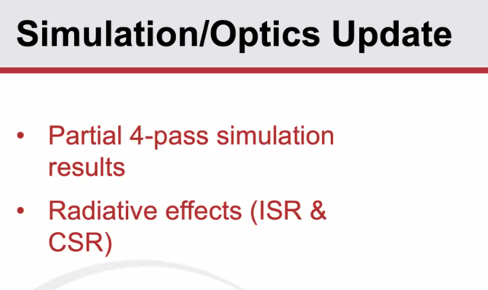
  - Still WIP – but sharing progress
- Want to discuss radiative effects
- 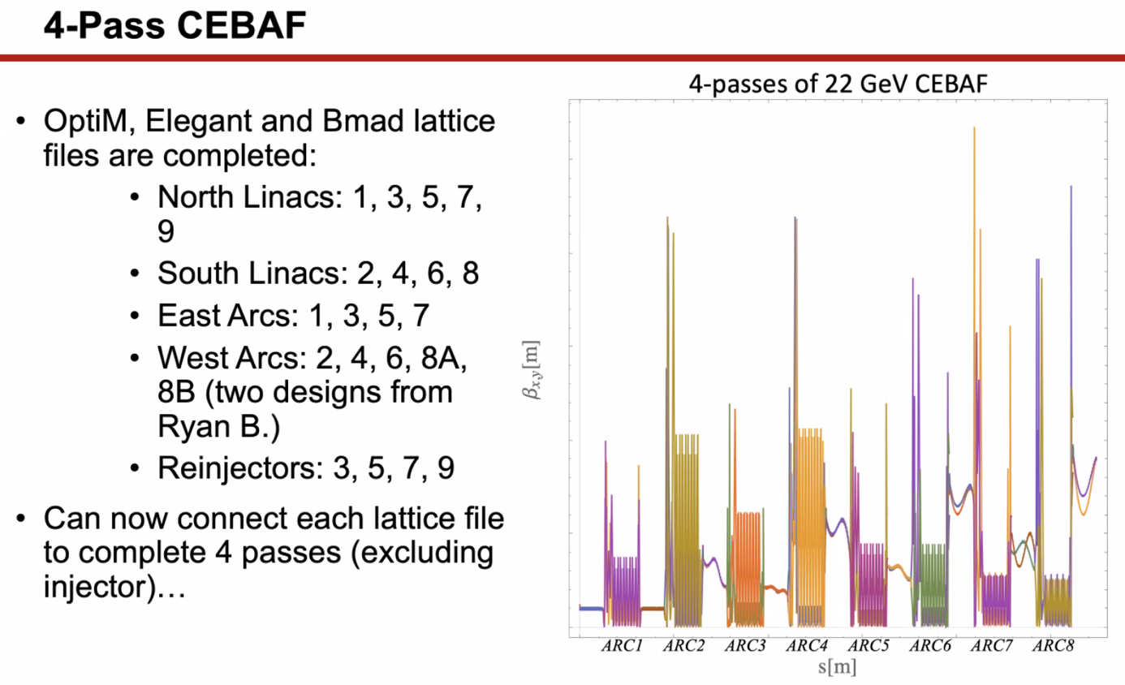
  - Still need to upload to GitHub, but they’ll be uploaded soon
  - Plot on right shows betas through all 4 passes
  - Decreased beta spike in Arc 4
  - Vertical Scale: max should be around ~500 m
    - Was 700-800 m before
- 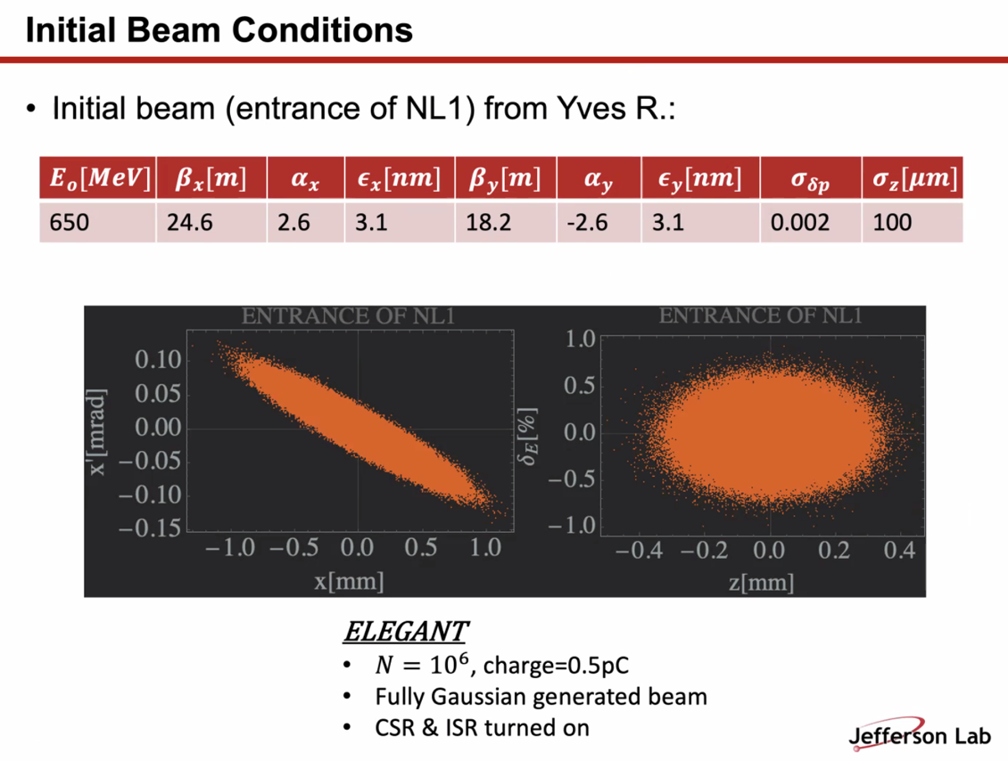
  - Estimated starting beam parameters
  - 1M particles
  - CSR/ISR turned on for all elements
- 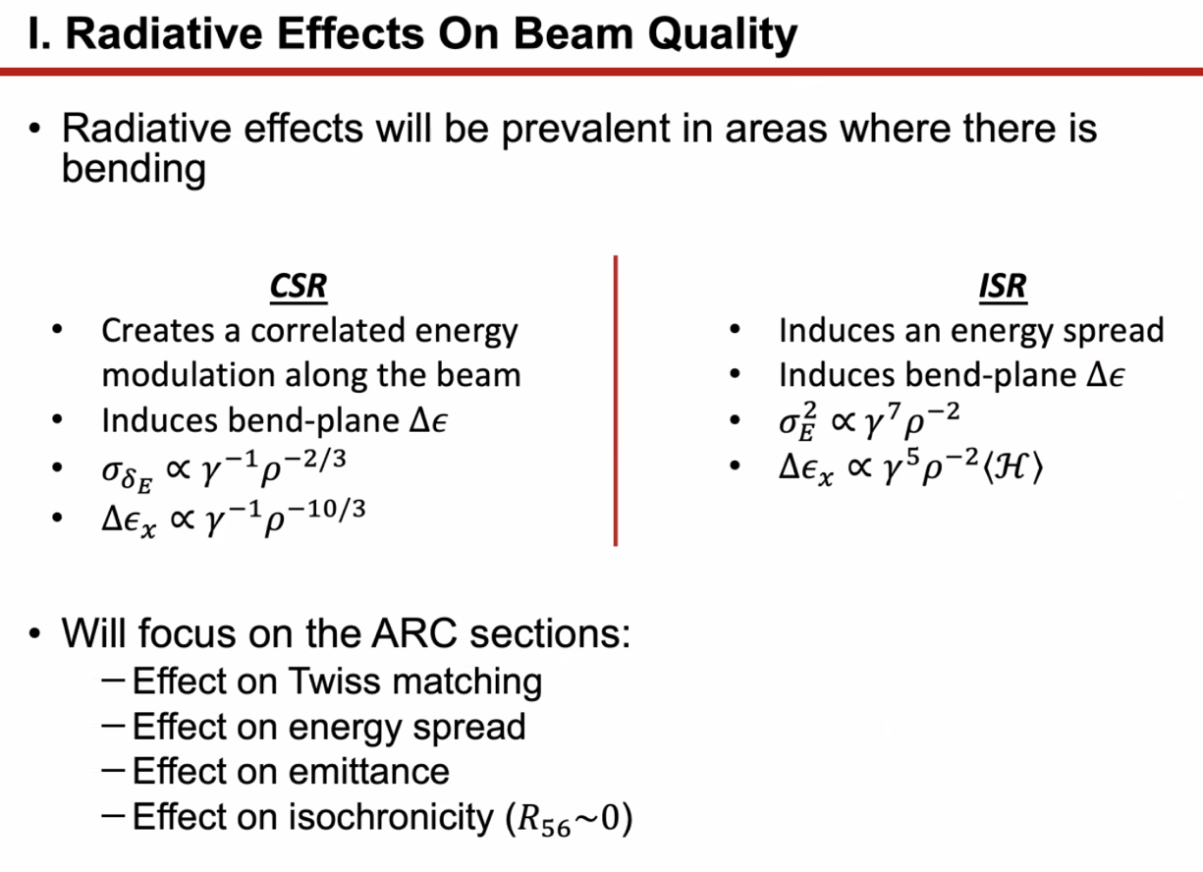
  - Proportional to bunch length – so when short, you get a lot more CSR
  - ISR – increases emittance growth and energy spread – heavily dependent on E of beam
- 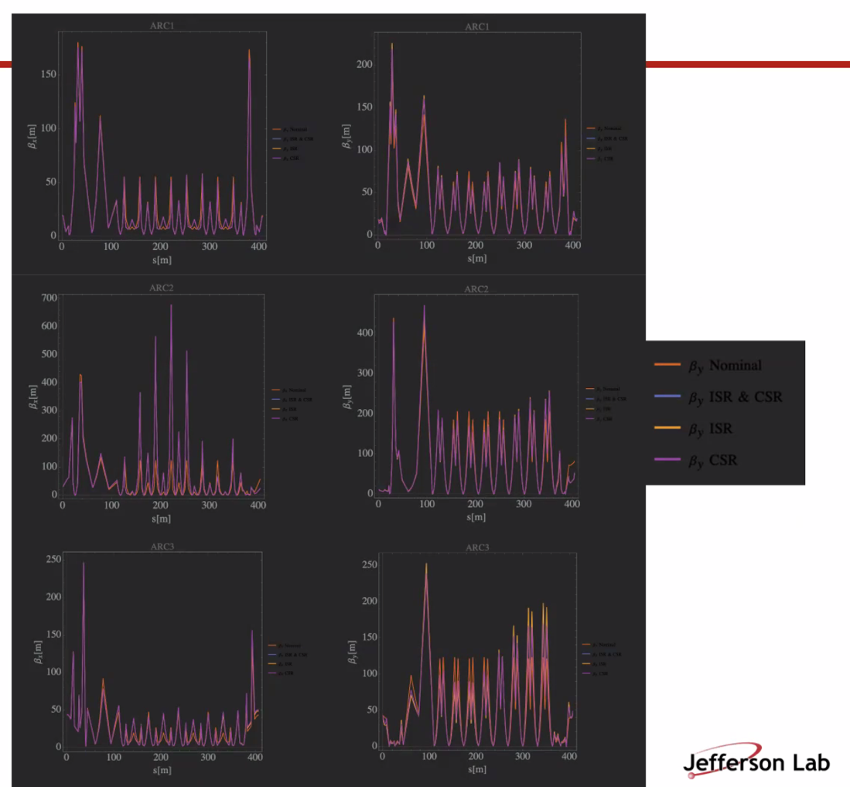
  - Beta X and Y through each ARC
  - 4 lines in each: betax and betay nominal, with ISR and CSR, then just ISR and just CSR
  - Not horrible – a bit of mismatch mostly at ends in first 3 arcs
  - These are not S2E – these are performed modularly (just this section)
- 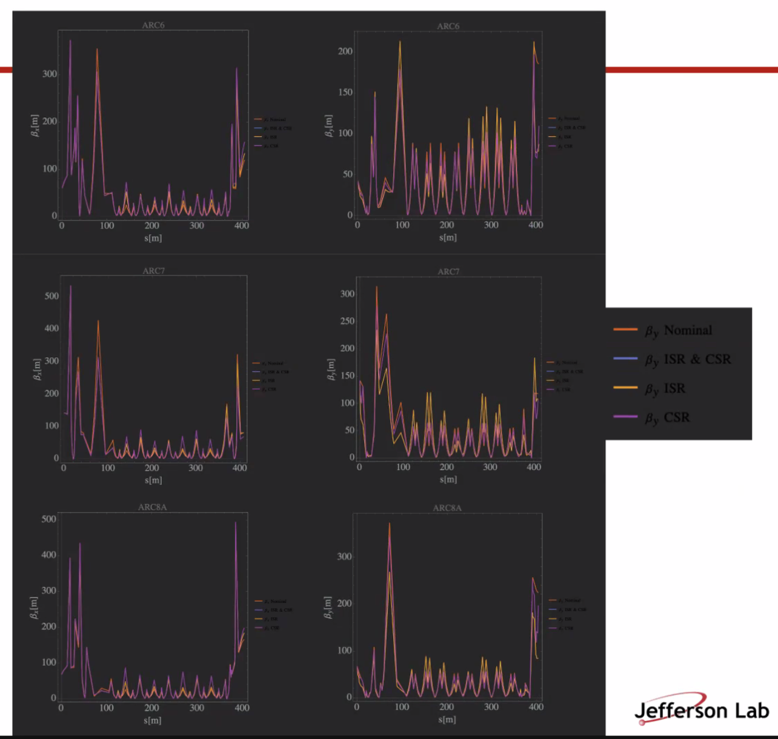
  - Latter arcs are seeing more effects from SR, but not horrible
- 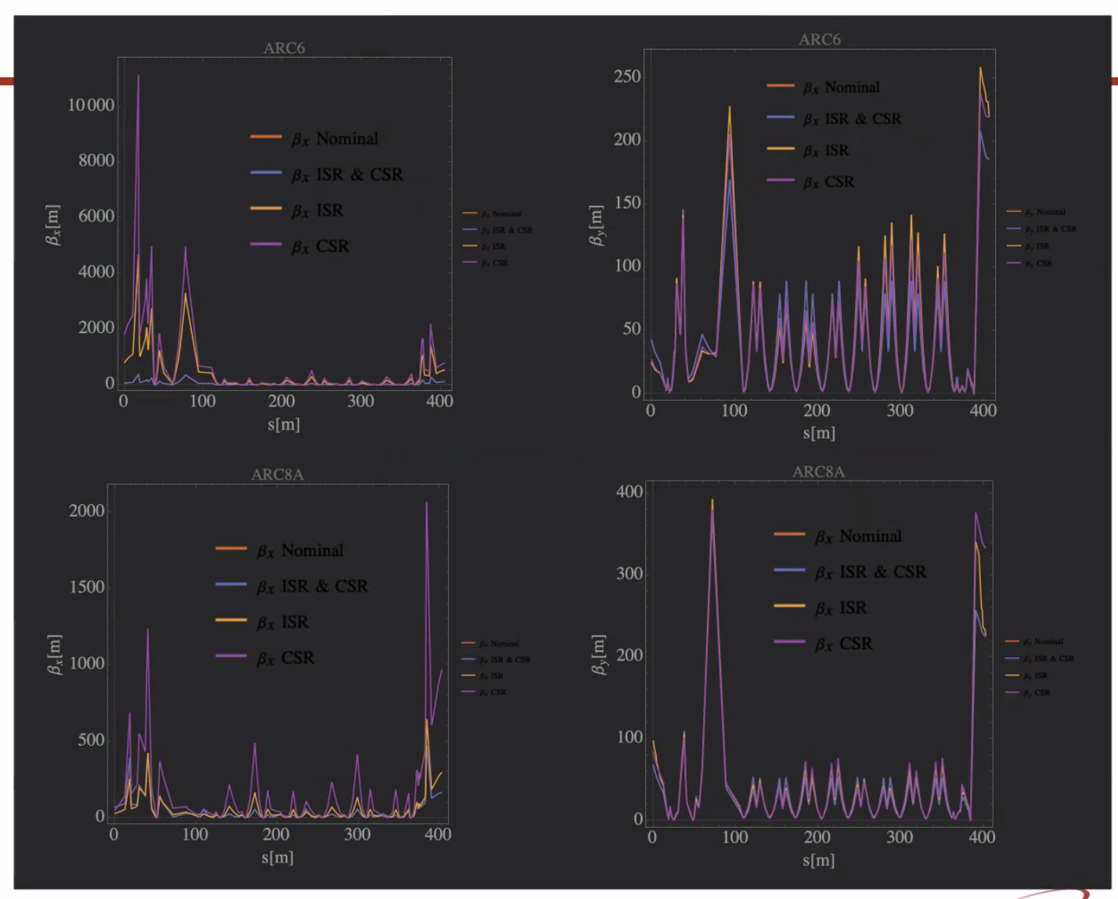
  - This is S2E version – mismatch gets bad when done as S2E instead of modular
  - These are the worst plots to demonstrate how bad it gets
  - No rematching at any exits/entrances to sections, so mismatch persists
    - No correction applied to this either, so this is simply what happens from ISR/CSR
  - Since no correction, seems like these could be corrected if we “keep up with it”
- Dejan: do you have any dispersion pictures?
  - Not on hand, but can get it.
- Alex B: one pass is fairly representative of reality (Arc1 and 2 with linacs in between)
- Reza: how much is due to mismatch, and how much due to no correction to energy?
  - Energy lock could solve some of this?
  - Good question: have to look into it and see where these mismatches are coming from
- Dejan: have the effect of SR loss and it’s not included in E balance at all?
  - In elegant, can turn on/off SR
  - Turning off, get nominal (above)
  - What bothers me: SR loss, at the end of one arc, you have lost energy, and that needs to get taken into account as it goes into the linac
    - Elegant does that
- Scott: you’re basically pushing a distribution through there
  - What’s not happened is a tapering down of the quad gradients and dipoles to correct for the expected average energy loss going down the line
    - Alex B: This is also not done in CEBAF – we don’t mitigate by scaling quads, etc…
    - Basically, correct with last few quads in line
- Dejan: when you get back on LINAC, you have to correct so you’re in the right spot of the RF wave
  - Jay: we use 9 quads for that in the recombiner, and we have dipole correctors to correct for the small amount of loss (~40 MeV)
- Dejan: add quads to make M56 = 0 by making oscillations of dispersion functions
  - Donish: Emittance growth scalable with optics
- Comment/Question from Donish: if dispersion is oscillating and integrates to 0 at end of arc, how are we taking into account the R56 from spreaders/recombiners/splitters?
  - Alex B: we balance this by having negative R56 in Spreaders/Recominers, and using some magnets in the arcs to help restore the balance – leverage in horizontal plane
- Dejan: we were discussing the value of the dispersion function will go to half of what it is now
  - Maybe we need more quads? But you have triplets throughout the arcs, so maybe 2.5 m goes down to 1.2 m and goes +/-
  - 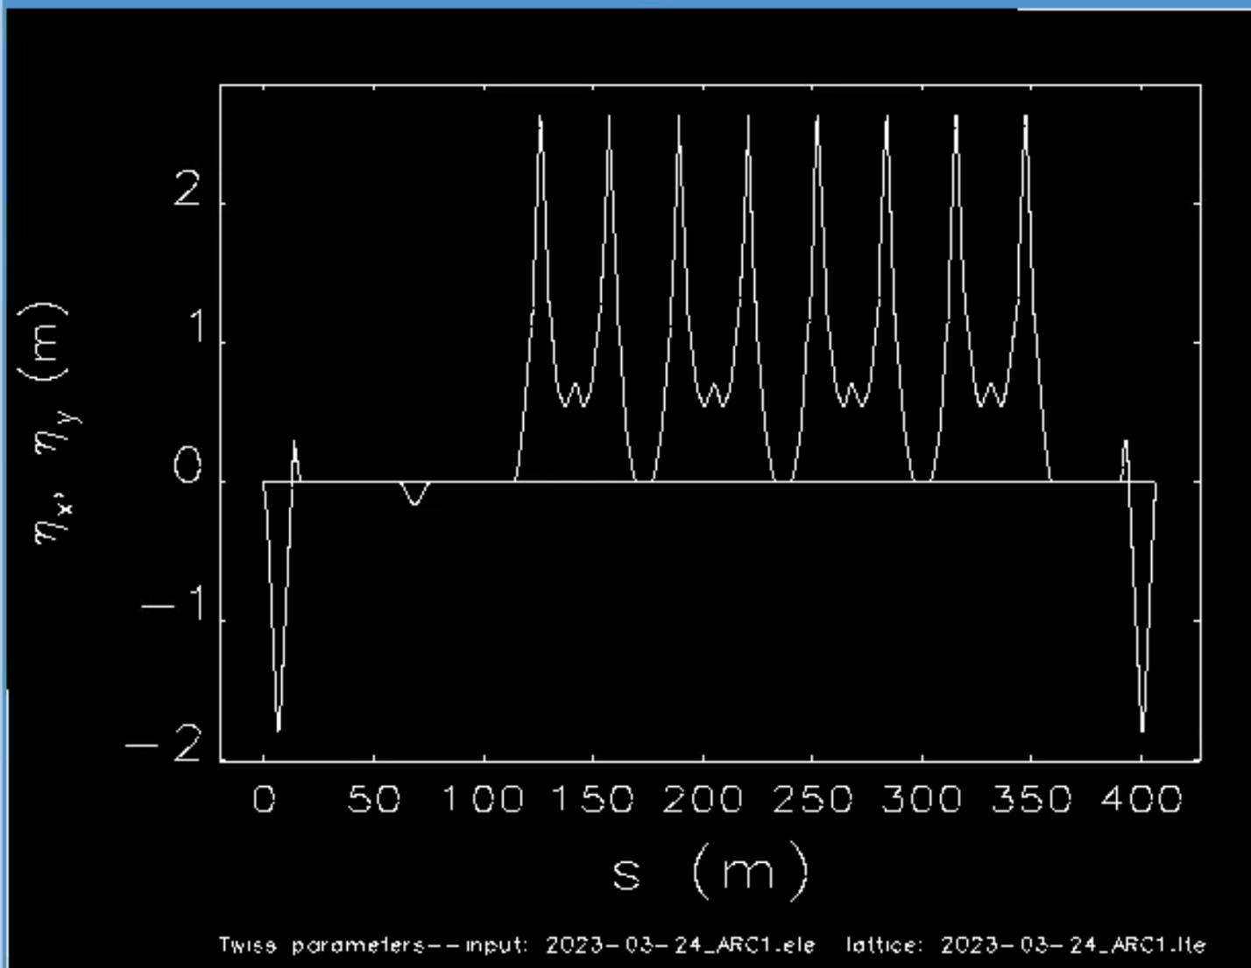
    - Donish shows dispersion in Arc1
    - Dejan: if get dispersion down to 1.2 m, will be improvement
    - Alex B: not really aiming to minimize dispersion too heavily
    - Ryan: don’t we need some level of dispersion for diagnostics as well?
- When put in corrections, will have new results
- 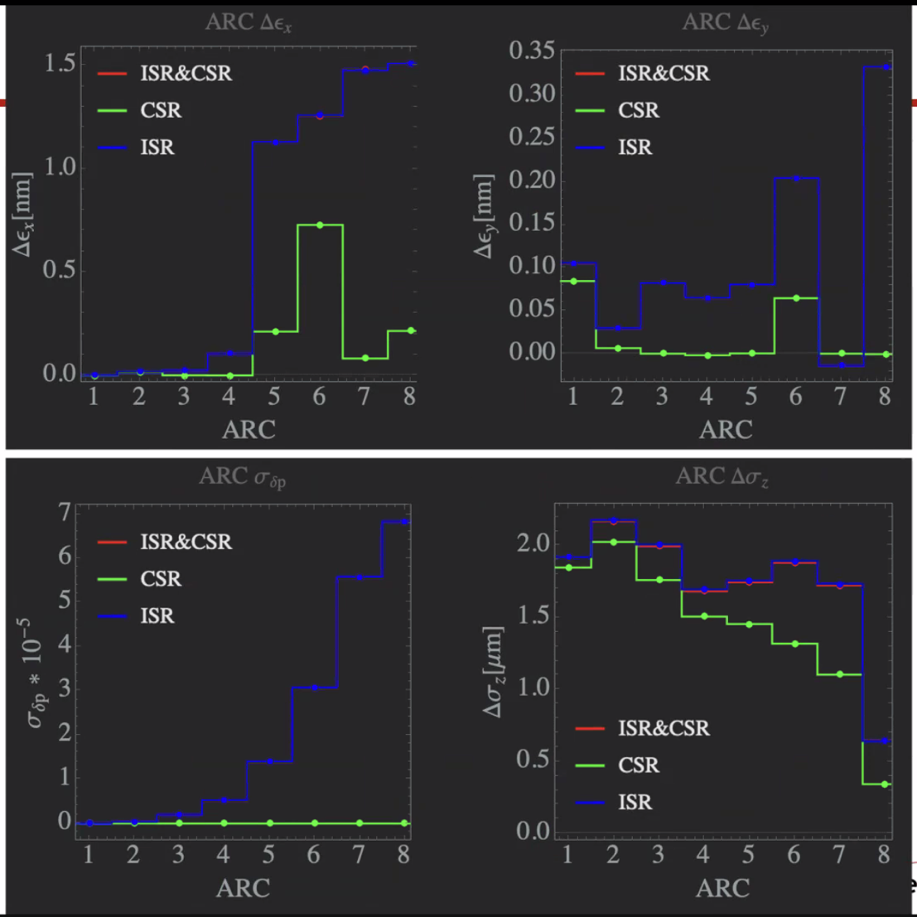
  - Induced energy spread (also from uncorrected machine)
  - ISR completely dominant over CSR (as expected)
  - Bottom right plot – change in bunch length to show change in isoch. Condition
    - Not huge
  - Values will likely change with corrections, especially change in emittance
- Alex B: there’s not a large, but present energy loss. In terms of betas, coming with wrong energy, it’ll mess up Twiss significantly
  - Uncorrected simulation will make the error significant
  - Read Reza’s mind
- There needs to be correction. Just hasn’t had a chance to do it yet.
- FEL had ~50X higher current, and we saw longitudinal distortions. But never seen it in CEBAF.
- Reza: so if you only have CSR, does that mean you’re bunching as you go along?
  - Yes. There should be energy correlation
  - If you increase energy as you go along, it washes out
  - Microbunching structure buried in E spread
- 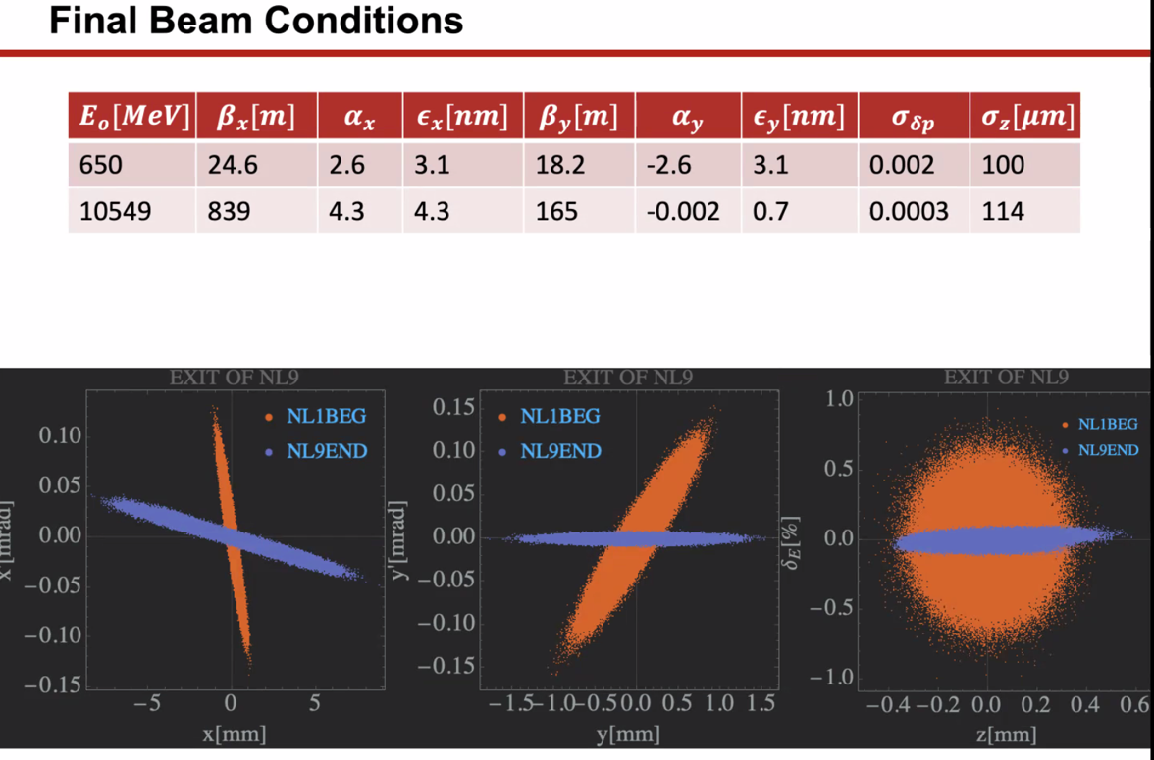
  - Correction needs to occur.
  - Compare initial to final
  - Orange is input beam, purple is final
- Since we can run off-crest, we can provide a chirp, and get some longitudinal compression
- Scott: seeing nothing from longitudinal POV that’s concerning
  - Will need to look at BBU
- Dejan: if you make the ellipses overlay, you can get the sigmas to align better
- Scott: energy spread is dominated by radiation
  - Run nominal calculation with Bmad or whatever, what’s expected? Are we seeing significant differences with radiation (growth above nominal)
- Dejan: suggest to team – use this study and hook it to control system and you can have prediction and measurements, and you can tune by hand the alpha and get results immediately. They call this “machine learning”
  - Connected to control system would be great
- 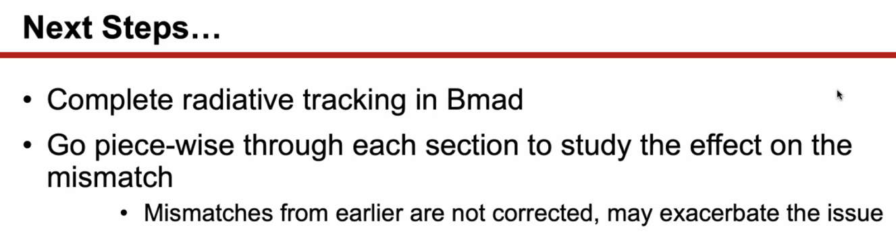
  - Ryan – try to make sure we correct where the machine really makes the corrections
    - Also, as you do these studies in sections, you can then connect adjacent pieces to make sure they work together
  - Alex B – after 1 pass, can restore everything
- Lattice files will go into correction studies as well
- Jay: all the quads in Arc 1 and 2 now – they’ll be surplus, so we can use them if needed (weak but useable)
- Jay – would be nice to rationalize number system so dipoles and quads are numbered differently
Action Items | Person responsible | Deadline

Time allotted | 25 mins | Agenda topic Extraction | Presenter Jay
- In the BSY, we used to extract having a C-magnet off the Hall C line to pull the beam into the BSY
- Could we do this in the splitters to extract downward
- As Ryan and Doug said, can pull D off a half turn early
- Use a C-dipole in each splitter line (unpowered until you want to extract). Power it to extract, then have a wide vacuum system with thick wall so you can get beam to extraction chicane and get it to the 5th pass transport recombiner line
  - Don’t worry about TOF b/c not going into linac again.
- Ryan missed a bit here…apologies
- Jay says can kick left to do it
- Ryan mentions kicking down
- Ryan can try to make drawings so we can see what we’re talking about.
Action Items | Person responsible | Deadline

Time allotted | 5 mins | Agenda topic AOB | Presenter All
- 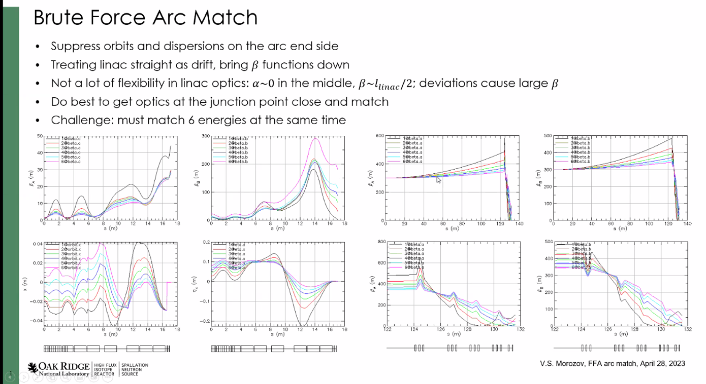
  - Vasiliy – suppress orbits and dispersion at arc end, and hit linac at straight section
  - Starting at center of LINAC, treat it as a drift, in fact, we don’t have a lot of freedom in terms of parameters in center of linac
- 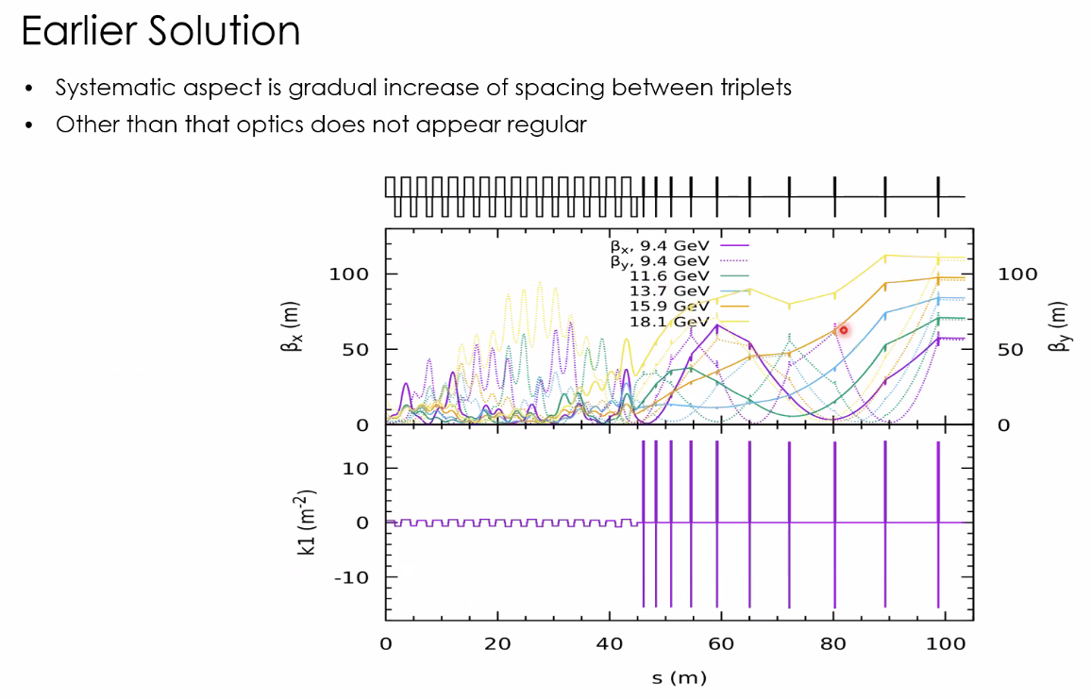
  - Took a lot of space to bring betas down
- 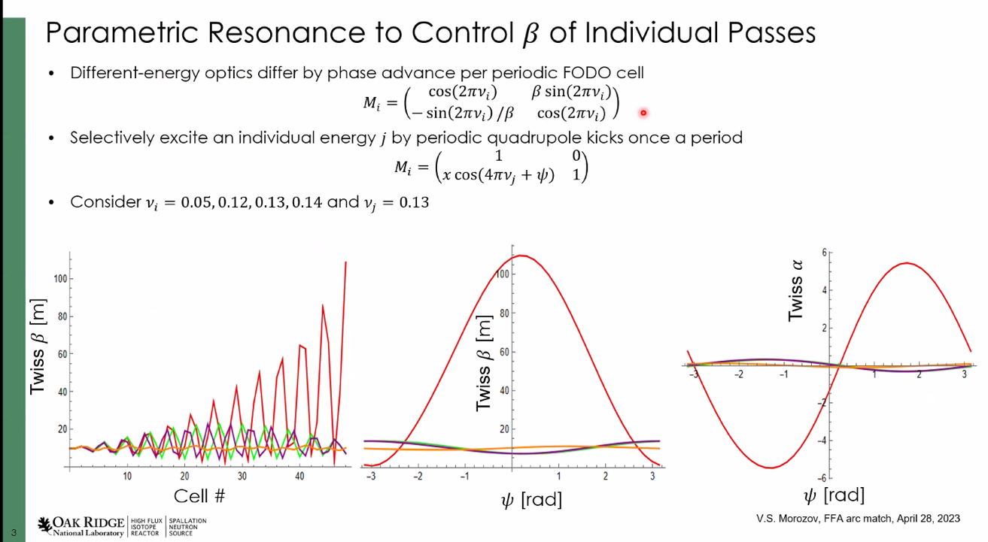
  - Ignore dispersion and only one plane
  - Each energy slightly different Beta – but all have different phase advance per unit cell
    - Could we use that to get orthogonal knobs working on individual energies – could excite a resonance (at any betatron tune)
    - Modulate (apply kick) at end of each period that is periodic with betatron phase advance
  - Stephen: did this with dipole kicks
    - In CBETA, could correct every pass
    - What suggesting, instead of with dipoles, do it with quads at specific phases
  - It works if you have enough space, but you have to cancel out the effect on other beams
  - Not a dead end, and it’s a good way of thinking about it.
Action Items | Person responsible | Deadline

Special notes

Pathway to Repository: https://jeffersonlab-my.sharepoint.com/:f:/g/personal/tristan_jlab_org/EqZ5MeS-nipCgPfZB5p0oS4B9Is67d3nQb9sLJI3Zyev9g

