FFA@CEBAF Working Group|Minutes

## Meeting date | time 05/19/2023 | 11 AM EST | Meeting location <https://jlab-org.zoomgov.com/j/1614898082?pwd=TnUzMS81M2sxbDZIbERJU01tYkJCQT09>

|  |  |  |  |  |  |  |  |  |  |  |  |
| --- | --- | --- | --- | --- | --- | --- | --- | --- | --- | --- | --- |
| |  |  | | --- | --- | | Meeting called by | Alex B | | Type of meeting | Weekly Meeting | | Facilitator | Alex B | | Note taker | Ryan | | Timekeeper | Alex B | | Attendees  Alex B, Ryan, Donish, Dejan, Edy, Vasiliy, Stephen |

# Intro Discussion

Discussion of old mentors for Alex B and Dejan. Scott cannot attend due to Muon meeting. End of month, having a muon collab meeting.

Todd in Europe for travel.

# Agenda topics

## Time allotted | 25 mins | Agenda topic Splitters - FMC Optics | Presenter Alex

* 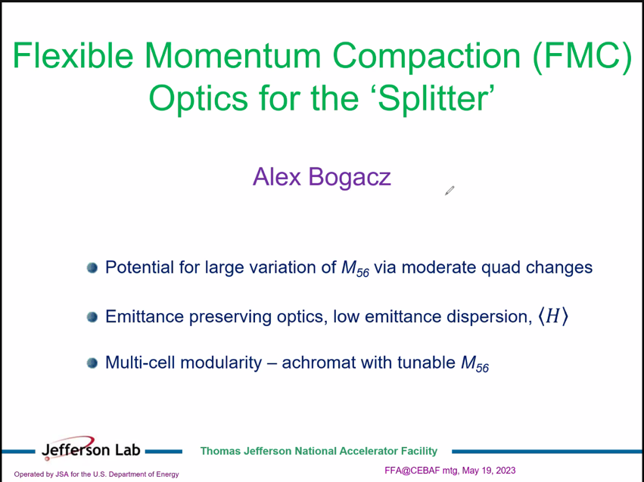
* Revival of idea for flexible momentum optics in splitters
* Dejan was the person who first proposed this style of optics ~30 years ago. Dave Douglas then picked it up – singlet/triplet alternating focusing
* Have to be very careful not to exceed the suppressed emittance preservation – expand “loftier” optics
* M56 can be adjusted quite strongly with moderate quad changes
* Emittance preservation is the key feature – central element
  + Start here, then morph it into something that will get us from Point A to Point B
* Multi-cell modularity by building zig-zag or chicane
  + Orthogonal tunability
* 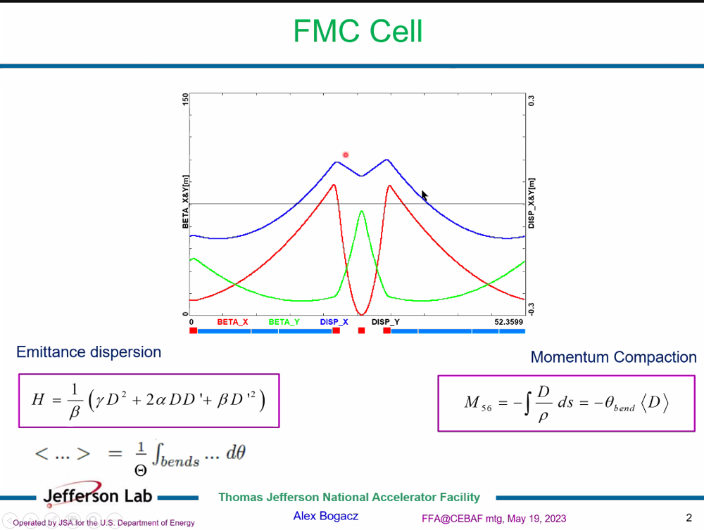
  + Explored for LHeC about 10 years ago – 3 pass ERL
  + Collider, so very strict emittance dilution requirements
  + High luminosity collider
  + 1 km radius of arcs
  + Singlet, bends, triplet, bends
  + Area under curve is proportional to M56
  + H – average of this is what matters
    - Want a small dispersion and also smooth beta
    - Only matters over bends due to averaging, so “violent change” in triplet is ok
* 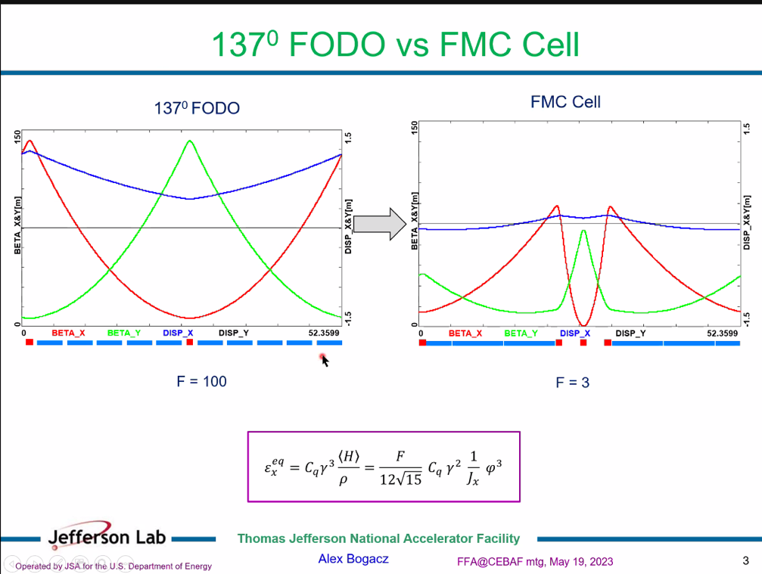
  + 137-degree FODO gives lowest emittance dispersion
  + If you build a ring, that’s equilibrium emittance
  + F is form factor, depending if FODO, DBA, etc…
    - ~30X lower in FMC
* 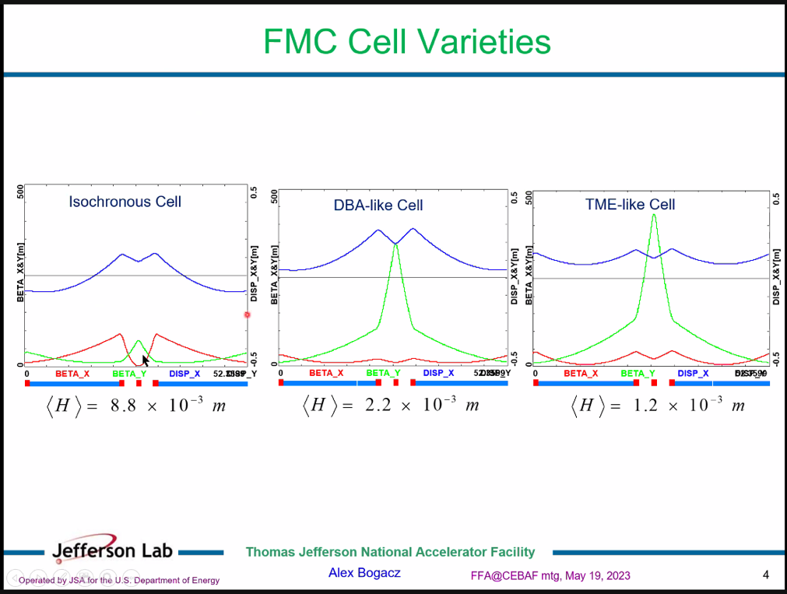
  + TME = theoretical minimum emittance
    - Very chromatic behavior
    - Phase advance higher than 180 degrees – in second stability region
* 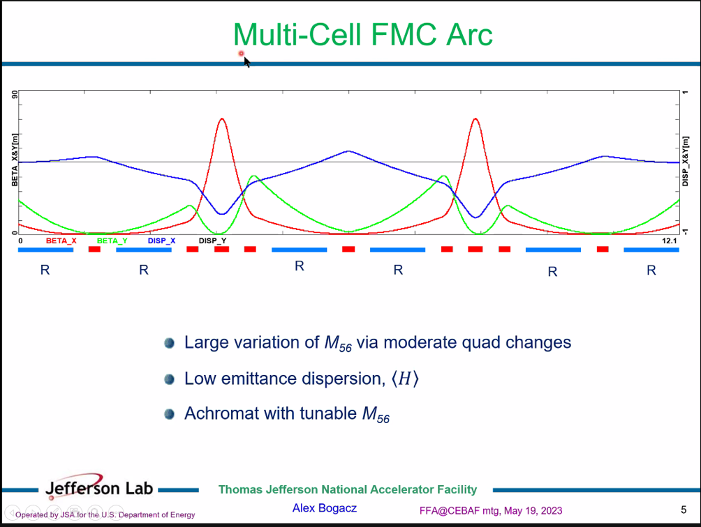
  + Let’s say you want a chicane with minimum 6 bends, achromatic. Keep dispersion low
  + Cell, half cell, another cell
  + More elaborate for splitter, can easily slip additional cells here
  + Adjusting two quads, change overall shape of dispersion to get more negative or positive, depending on needs
  + Remains achromatic
  + Small emittance dispersion – average only includes the bends (remember)
  + All bends are bending in the same direction – not what we want
* 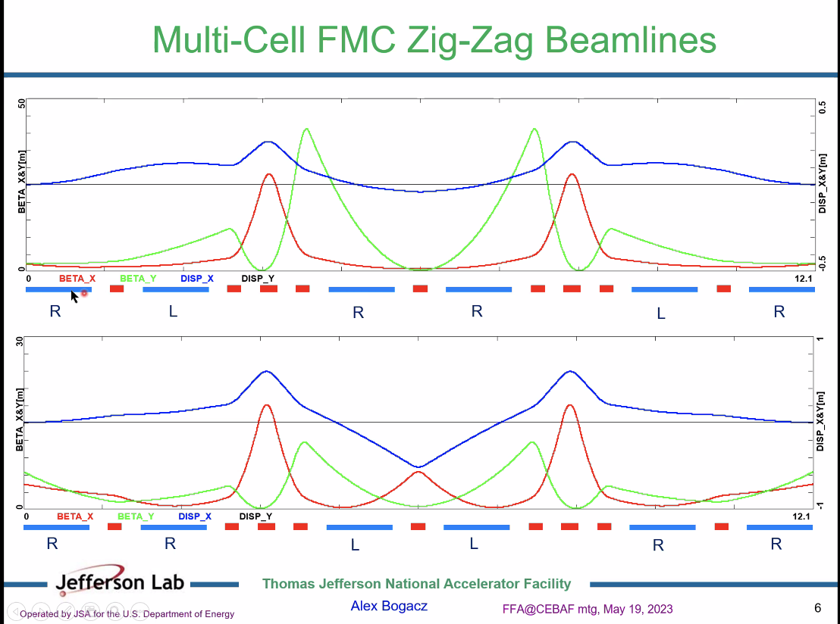
  + Bend R – right, L – left
  + Still achromatic, still preserves emittance, momentum compaction
  + Can still apply to Ryan’s layout – has all the amenities
* 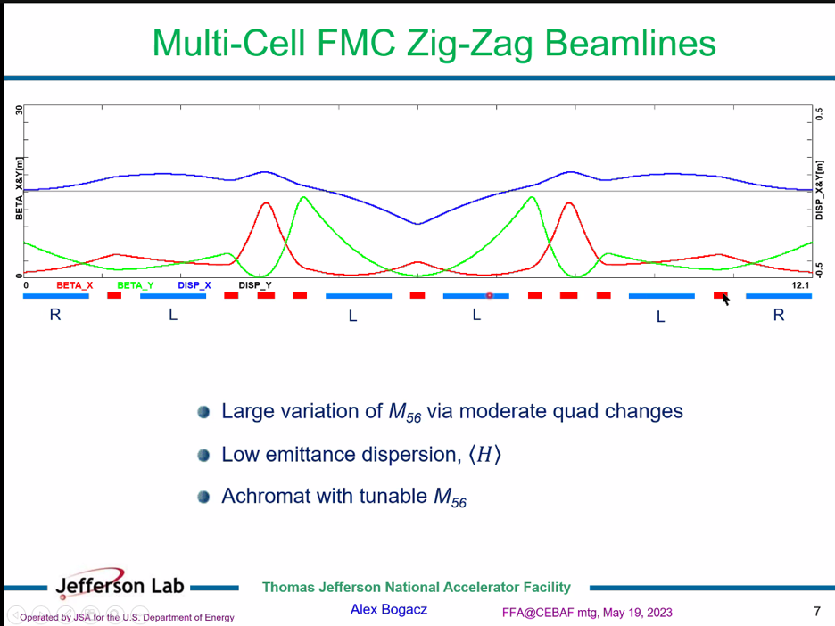
  + Magnet orientation changes the optics, but still achromatic, low Emit Disp
  + Nice blueprint for those splitters
  + Obviously it’s idealized – assuming same bending for all magnets, etc…
* Can expand in increments of 4 bending magnets
* Old idea, but very applicable
* Had experience with LHeC, paid lots of attention to ARCs, but spreaders and recombiners weren’t very flexibles – contribution from spreader/recombiner was much higher than entire arc
  + Kevin Andre (CERN student) redid the spreaders with similar optics to this
* Donish did some exploratory studies to see how this would “jive” with actual optics
* Dejan: only one comment – would be very useful for everyone working here with us to always use normalized dispersion space to see where vectors of dipoles are so you can visualize what you’re doing
  + Take out values of dispersion and get sqrt(H) as you draw dipoles of vectors
* Donish – can you please send that paper out so I can read it?
  + It’s in SY Lee’s book. There’s a chapter where he put this stuff in there.
* Edy – these lattices lead to nonlinear dispersions (perhaps not relevant here?)
  + Alex B – I remember for LHeC, it’s a collider. You’re right. At the end of the day, we’d need to see what sort of chromatic effects
    - Second order effects can cancel
  + When working on JLEIC booster, these lead to a lot of hard optics/aberrations to cancel
  + Alex B – yes, D’’ needs to be checked
* Dejan: Problem with higher order dispersion corrected with additional sextupoles in specific places
  + Journal paper with SY Lee, Dejan years ago. Will find it
  + Vectors published in EPAC 1990
* When doing lattices for cooling channels, that was a different regime though
* Vasiliy went to 5th/6th order of chromatic effects
* Dejan – when looking at chromatic effects, you have these amplitude tune shifts by sextupoles, then you have to minimize three parameters, need specific phase differences to cancel second order, etc…

|  |  |  |
| --- | --- | --- |
| Action Items | Person responsible | Deadline |
|  |  |  |
|  |  |  |

## Time allotted | 25 mins | Agenda topic Splitters – Exp. Design | Presenter Donish

* Unfortunately, had computer issues this week – not enough time to put a beamline together and complete a simulation.
* Alex B: comment on what doing?
* No slides, but can pop up the things spoken about on Monday
* 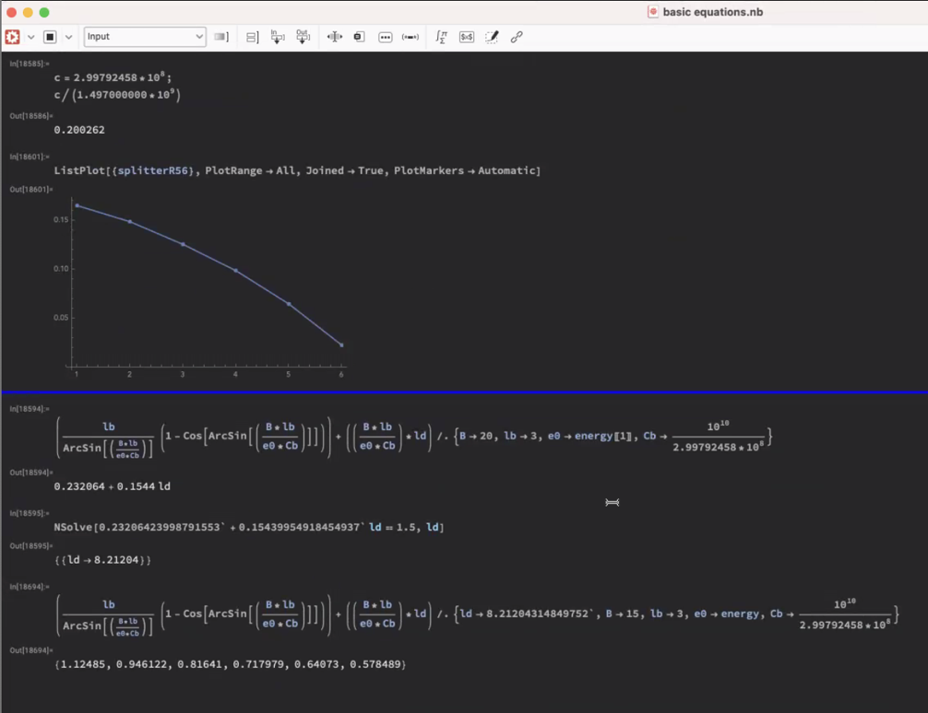
  + Splitting the beam is actually the hard part
  + Looked into calculating for the different energies what the separation of the beams would be through a single bend
  + From Ryan’s designs – we’ll need a lot of dipoles and spreading of the beam
  + This calc uses 1.5 T dipole (3 m) and 8 m drift length after dipole
    - 8 m from distance to hitting first wall after bend
  + Transverse spacing in between beams shown at bottom
  + Small spread across beams, especially with a single dipole
  + Wanted to understand space constraints – need more dipoles to be places strategically
    - Could use more quads to increase dispersion
* 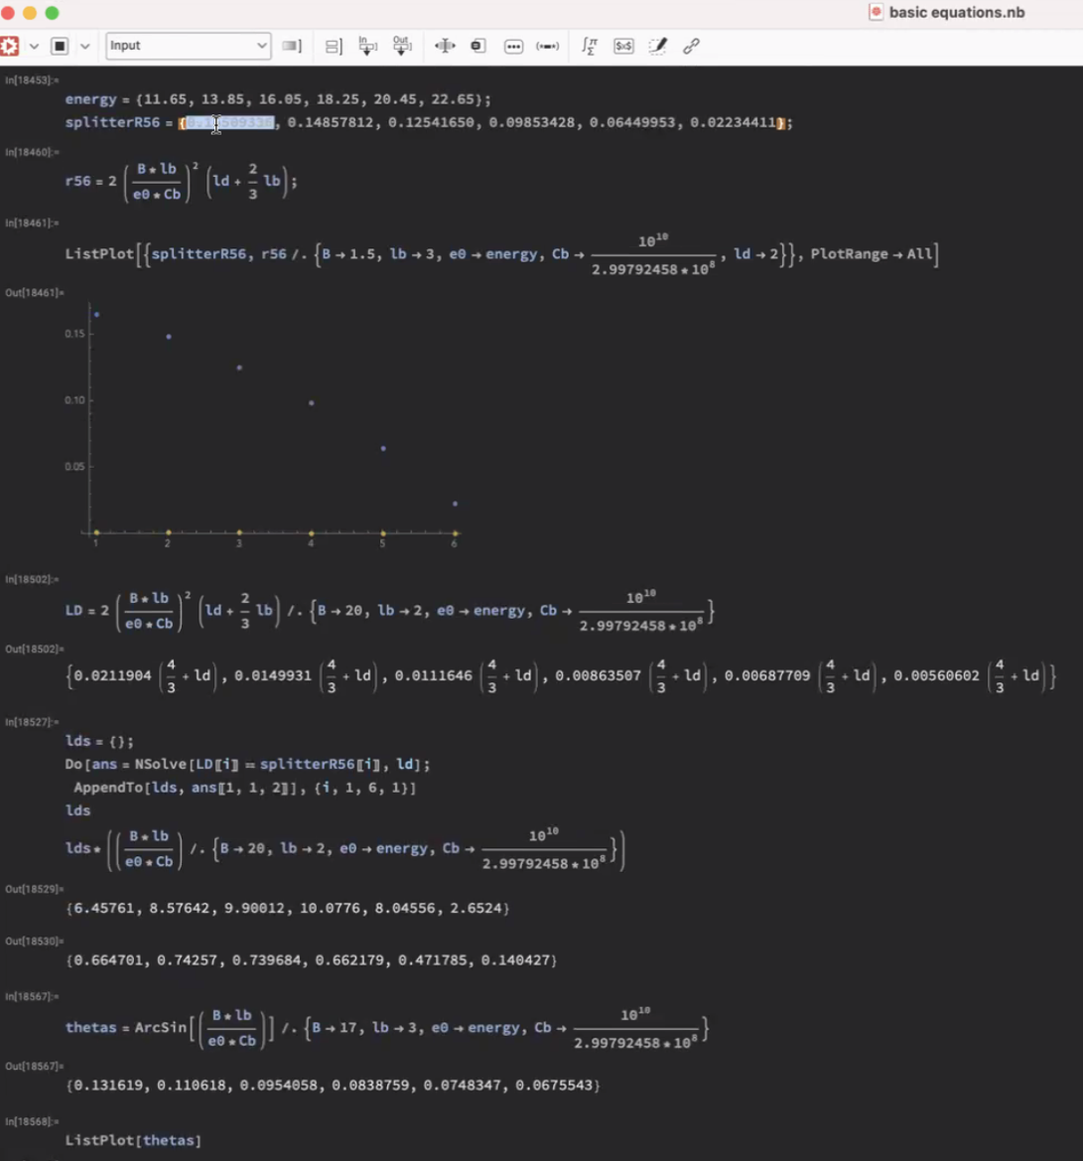
  + These are based on Dejan’s work – this assumes a 4 dipole chicane
  + This is a first order calculation (4 dipole chicane) – will most likely not work for our splitter geometry
  + Gives idea of real estate and landscape we’re working in
  + Shows next steps
* Dejan: I was missing a lot of values in my estimates.
  + It was not reaching the value we needed to cancel
* Alex B – this is a nice scoping study. Approaching from a more practical standpoint
* 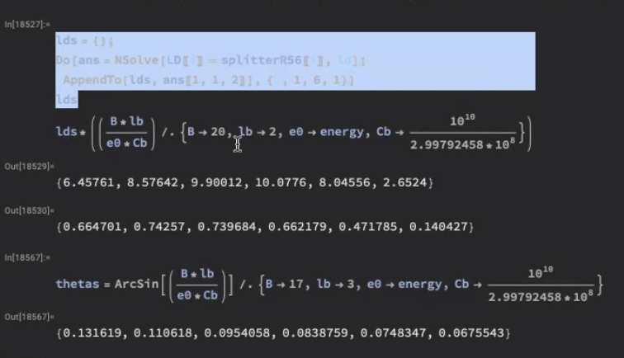
  + This is also to get a guage
* 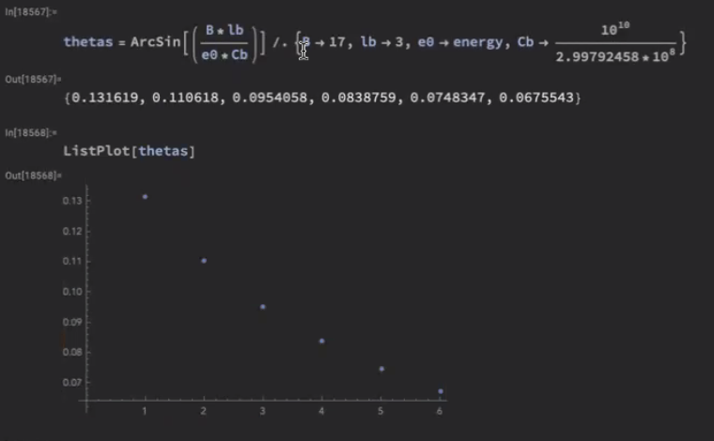
  + Theta of dipole with 1.7 T magnetic field to see how it scales
  + It would be easier if it was linear – but that’s clearly not the case
  + Parabolic nature to it
  + Can’t scale optics from one arc to the other
* 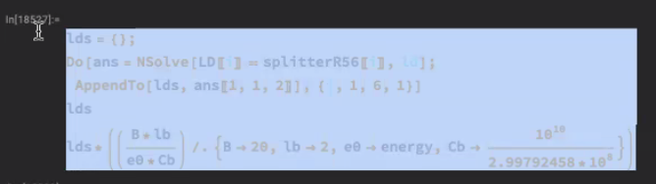
  + Space requirements for 4 bend chicane (start basic)
    - Where does this fail in terms of achieving the goals with the splitter
  + Can start fixing those problems once you see where they fail
* Next step: incorporating FMC lattices inside the chicanes
  + In linacs, you don’t have a lot of quads in them, and can’t control optics well
  + So next would have been adding in quads and FMC
* Alex started with 6 bend chicanes – in reality will have larger number of beamlines
* Dejan: look at Stephen’s presentation from the retreat
  + Much smaller values needed (after Vasiliy pointed things out)
  + Take WRT highest not lowest E
* Stephen: splitters can only make orbits longer – look at range
  + Not sure how relates to M56 though
* Dejan: first, need to correct TOF – problem was, needed more distance between main line and dipoles
  + When Stephen presented with Vasiliy’s idea, it wasn’t as much as Dejan thought.
* Donish: TOF variability is to correct for injection into the proceeding RF cavity, right?
  + Yes
  + Then you can in increase drift in areas of eta prime = 0
    - So if there’s a symmetry point where eta’ = 0, increase distance for TOF correction
* Dejan: Only way to change R56 is to change the lattice we have
  + Moment you change the FODO into something different where the dispersion is oscillating, this reduces the request in the splitters
    - But then other effects (SR for example)

|  |  |  |
| --- | --- | --- |
| Action Items | Person responsible | Deadline |
|  |  |  |
|  |  |  |

## Time allotted | 10 mins | Agenda topic AOB | Presenter All

* Piece of good news: JLab and BNL agreement finalized – starts June 1. Initiated by Andrei after retreat. Spata completed the bureaucratic part and crafted the agreement. 30% Stephen, Scott 10%, Dejan 5% - $242K for first year.
* We’ll start the FOA in the spring. It’ll be “in a can,” but we’ll need to modernize.

|  |  |  |
| --- | --- | --- |
| Action Items | Person responsible | Deadline |
|  |  |  |
|  |  |  |

## Special notes

Pathway to Repository: <https://jeffersonlab-my.sharepoint.com/:f:/g/personal/tristan_jlab_org/EqZ5MeS-nipCgPfZB5p0oS4B9Is67d3nQb9sLJI3Zyev9g>