FFA@CEBAF Working Group|Minutes

## Meeting date | time 06/02/2023 | 11 AM EST | Meeting location <https://jlab-org.zoomgov.com/j/1614898082?pwd=TnUzMS81M2sxbDZIbERJU01tYkJCQT09>

|  |  |  |  |  |  |  |  |  |  |  |  |
| --- | --- | --- | --- | --- | --- | --- | --- | --- | --- | --- | --- |
| |  |  | | --- | --- | | Meeting called by | Alex B | | Type of meeting | Weekly Meeting | | Facilitator | Alex B | | Note taker | Ryan | | Timekeeper | Alex B | | Attendees  Alex B, Ryan, Alex C, Annika, Scott, Dejan, Reza, Kirsten, Edy, Jay, Donish, Kitty, Randy, Todd, Stephen, Vasiliy |

# Intro Discussion

Quick introduction to Annika, our REU summer student, who will be working with Alex Coxe and Ryan (and Kirsten/Donish as needed).

# Agenda topics

## Time allotted | 25 mins | Agenda topic Emittance Evolution | Presenter Kirsten

* New approach, but new problems
* Solved many approach problems, the results are another issue
* 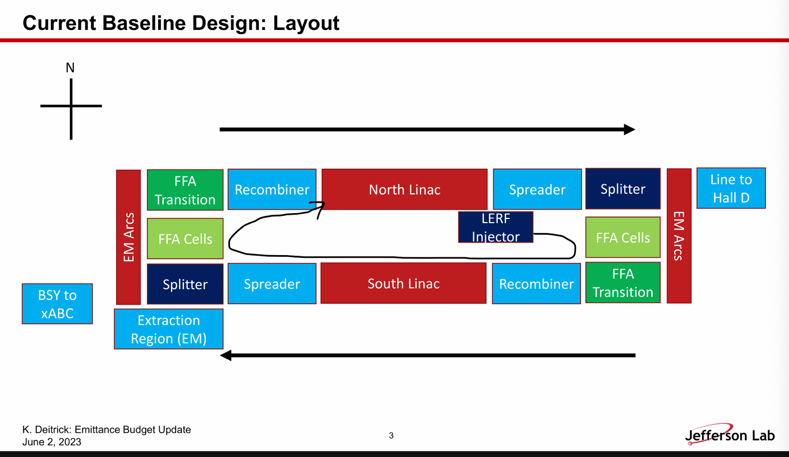
* 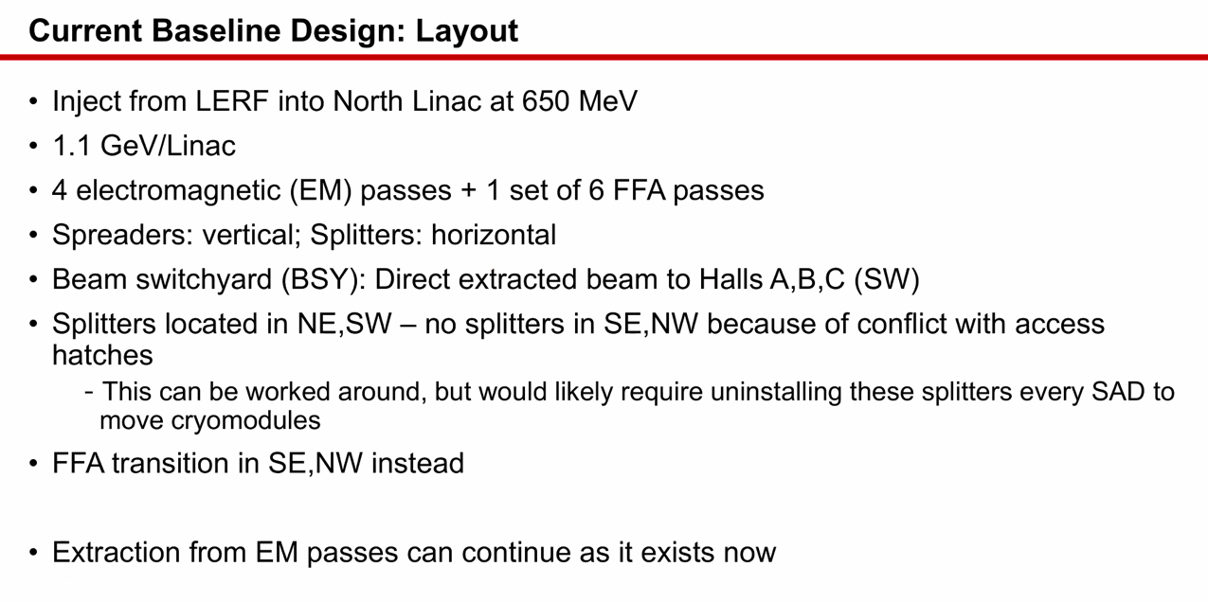
* 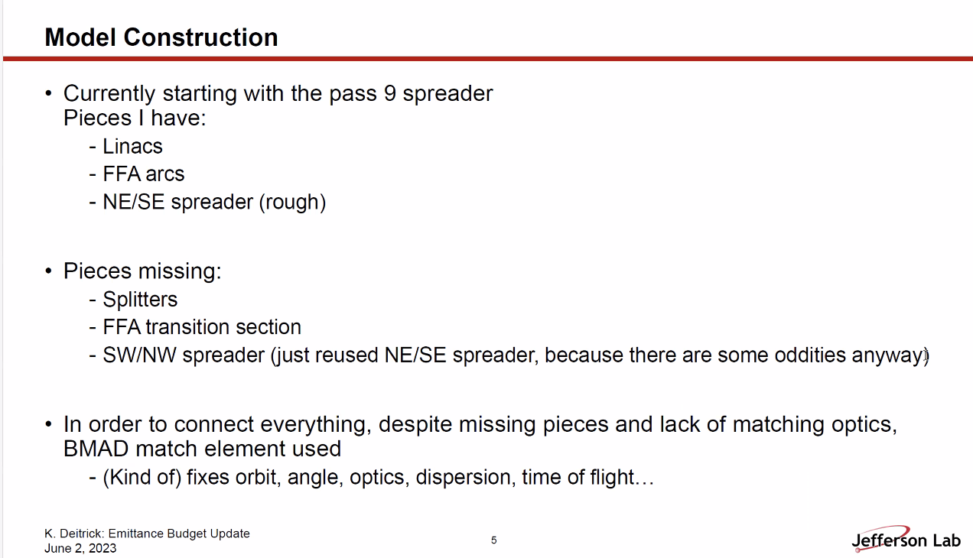
  + Have enough results to get some conclusions
  + Use Transfer matrices (“match” element in Bmad) for missing sections
    - Calculates based on the matrix calc that Bmad runs
    - If you’re at a spot in the lattice and you think the Twiss are at some value, but the particles DON’T have that, you won’t get what you desire
      * In general, as you start from an injected particle distribution (with same Twiss, etc…) and track particles, the numbers start to diverge between matrix and particle tracking
  + Nothing went horribly wrong, didn’t lose lots of particles, betas behaved appropriately in the FFA arc
  + Scott – assume you track to point where you get a match, then look at distribution just before match, then set incoming match
    - Double the match parameter?
    - Scott – MATCH is thin transfer matrix – you don’t WANT them
      * Right, we don’t want them
    - Scott – a MATCH element in a lattice is a non-physical thing.
      * Kirsten – yes, this is stopgap while we make pieces fit
  + THIS IS ONLY LOOSELY CONNECTED TO REALITY IN THE BROADEST OF STROKES.
* 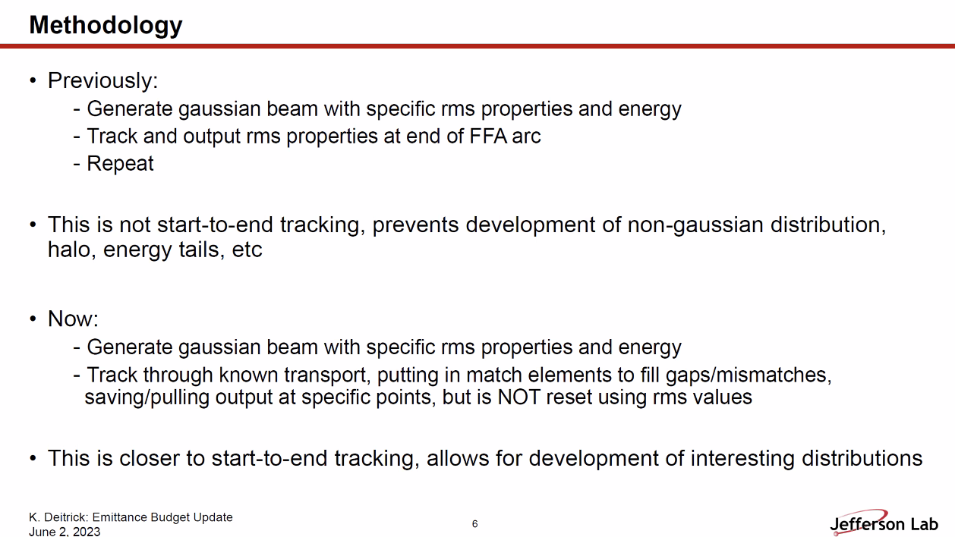
* RYAN HAD COMPUTER ISSUES, MISSED A FEW POINTS HERE. They were details about where MATCH elements are, etc…
* 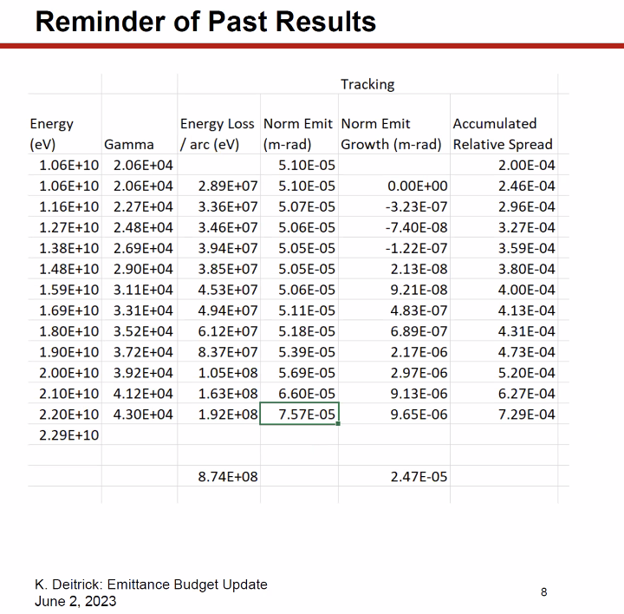
* 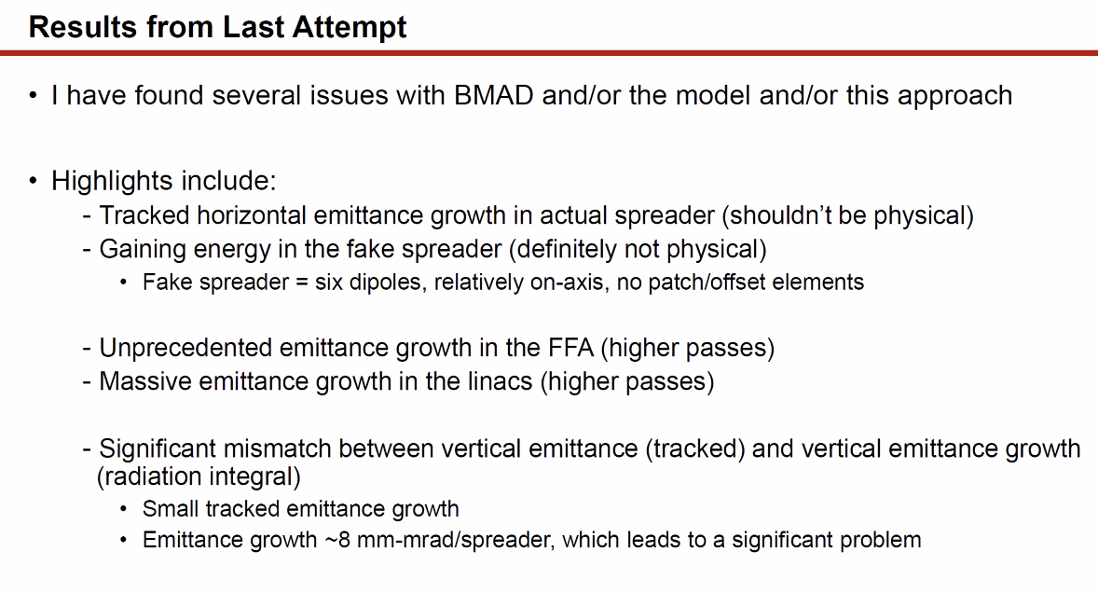
  + Review of last time. Things are fixed/problems reduced with Bmad
* 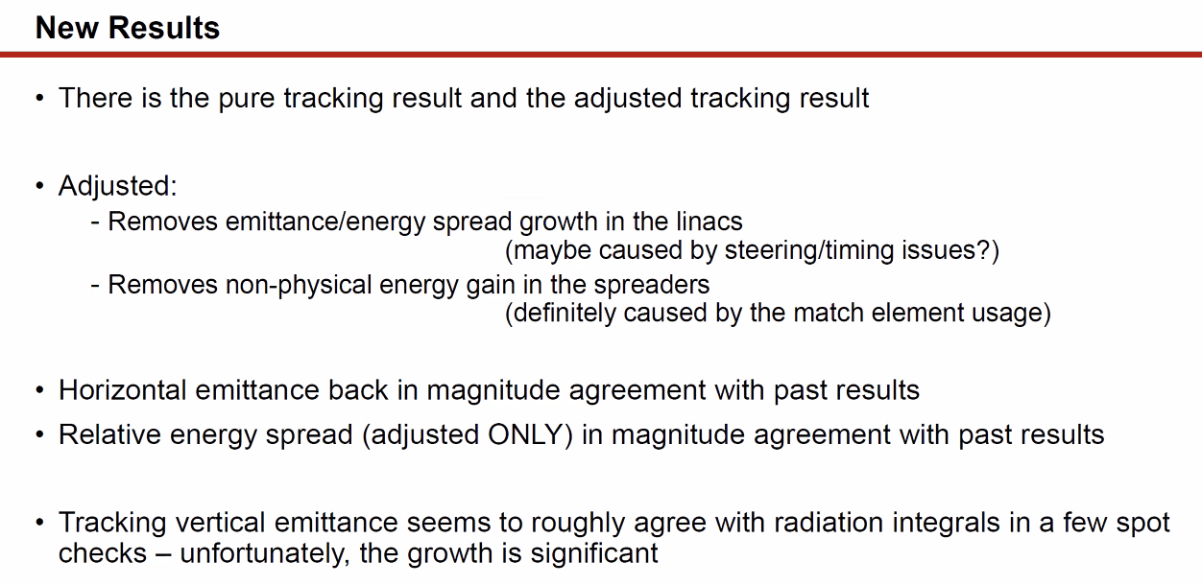
  + Have a spreadsheet for this as well, but can’t present easily during meeting
  + “Pure” tracking vs adjusted described
  + Energy spread is very clearly because timing mismatch/mis-steered, etc… - running “off crest” sometimes
    - Likely not a physical result
    - Can you force this? (Time patches are your friend – Scott)
  + Thought had auto-phase, but not so
  + Did not set time phase
  + If lose energy by FFA, then go through spreader/recombiner – match element restores all the energy lost in FFA
    - Likely missed some small nuance of the code
  + Reza – what is the bunch length assuming in this before going into linacs? Because if you’re off crest, the bunch length will kill you, but if you set it to zero you don’t care.
    - Can’t have 0 bunch length b/c Bmad doesn’t like this (warnings pop up)
    - Likely set to 1 mm RMS
      * Alex B - 90 micrometers is nominal RMS bunch length (from Geoff’s recent 12 GeV paper)
  + Horizontal Emittance is similar to last results.
    - Pure tracking result (Hall D assumed half pass up): Normalized 94 mm mrad
    - Adjusted: 83 mm mrad
    - Previous: 75 mm mrad
    - Alex B – analytic formula gives about 65 mm mrad
      * From December (radiation integrals) – got 70 mm mrad
  + Relative energy spread (only adjusted version) into Hall D
    - 6E-4
    - Seems low
    - Highly reassuring: there was no significant emittance growth in spreaders
      * Maybe underestimating
    - Check numbers in spreadsheet when uploaded
  + Jay – vertical emittance in machine is much larger (2-3 X factor) in real machine than in elegant models
* Vertical Emittance in Hall D
  + Current number (assuming not gaining vertical emit in linacs) ~200 mm mrad (normalized) with the adjusted, and about 230 mm mrad with the “pure” method
    - Jay – right now, horizontal is about 2X vertical in Hall D
      * Can’t see how you can get vertical being vertical 2X horizontal due to so much SR
    - Alex B – if you check analytic, there’s some scaling with gamma
* Here’s the problem as far as can tell:
  + Not a significant difference in emittance growth between lowest and highest E in spreaders (2-3)
  + However, going through FFA, the emit growth is very different between low E and high E sides.
* 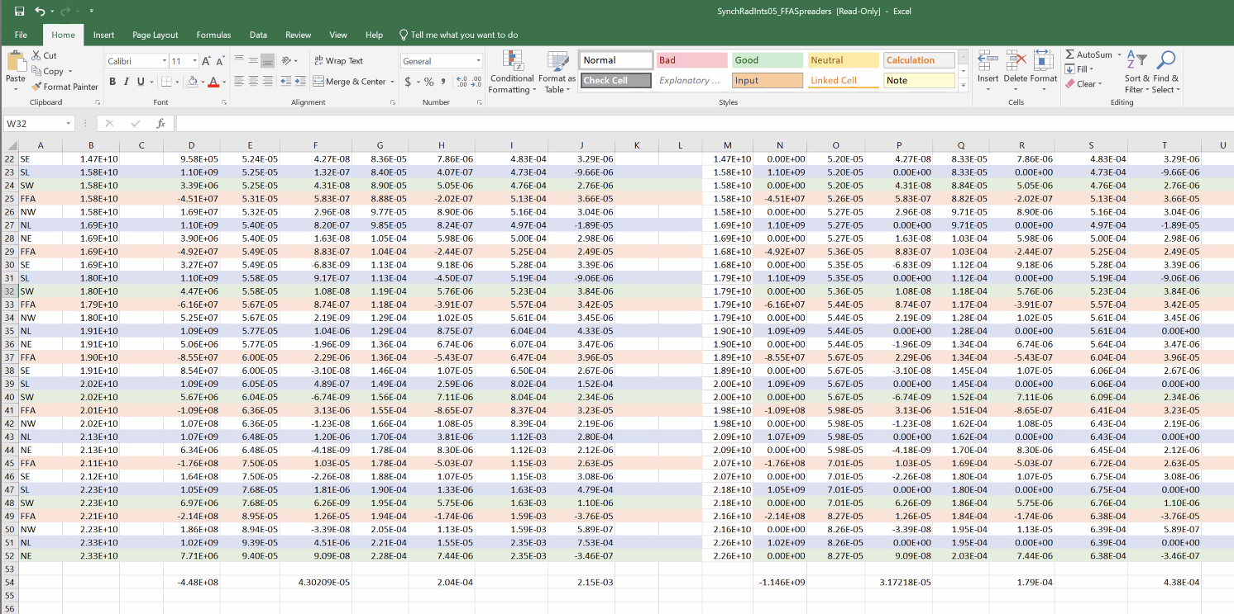
  + Vertical emittance is on a sort of linear increase as you “make laps”
  + The horizontal emittance seems to grow more exponentially
* 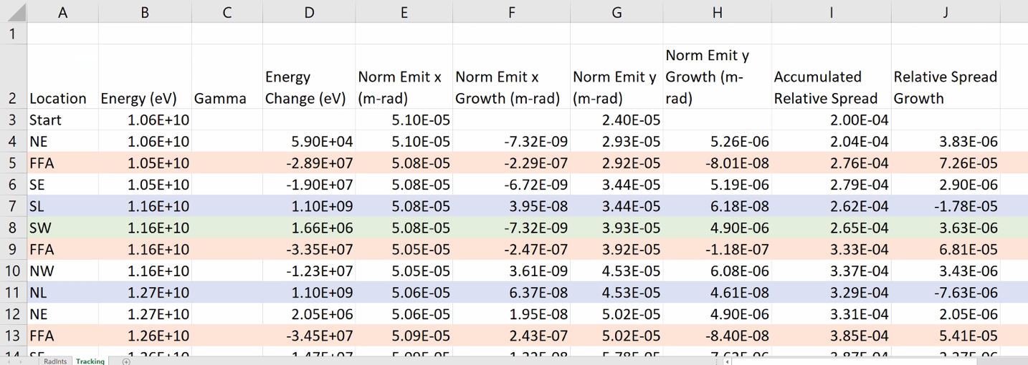
  + About half as much vertical as horizontal – spits out values at end of listed element
  + Green – could possibly kick beam out there
  + Got through ~1.5 laps, and horizontal emittance doesn’t change much (but every time you go around arc, you have pair of spreaders, each giving about 8
* Scott – one thing bothering = statistics (use more particles)
  + Getting negative values at some lower energies also concerning. But with the amount of bending, you’d expect some radiation happening here. May be that you need better statistics
  + Kirsten – only using 10K particles right now for time
  + This is Bmad reported emittance (not calculating self)
  + Looking at radiation integrals – normalized growth on order of 0.01 for a while
* Stephen – if it’s the same at every turn in spreaders/recombiners, and not in relation to energy, could there be something odd happening (like you’re not going through the center?) in the spreaders?
  + Kirsten – reason I don’t think there’s an offset problem is b/c paying attention to orbit to use the MATCH element
  + Vertical offset/trajectory is never significantly large
  + 3 quads + dipoles in dogleg
* Analytically, get similar number to when tracking particles
* Are spreaders spitting out radiation at a bad number? Could it be at a bad part of the beta?
  + 100 m beta instead of 10s of m
* Dejan – just take integrals (show radiation integrals)
  + Kirsten – have, and they don’t significantly disagree
  + But how can they be negative?
* Jay – brought up 22 GeV in OptiM (unnormalized) 2.3E-8 cm
  + Normalized is 11 microns
    - Sort of on par with what Kirsten is seeing with tracking and radiation integrals
* All the numbers are pretty much aligning, but they’re higher than we wanted/expected
* Alex B – the curly H function over dipoles is a good figure of merit
  + If you do it over the chicanes and arcs, and look at dispersion as well, it could be comparable to whole 180 degree arc
  + Dispersion of ~2 m in spreader (if memory serves) could be problem?
* Kirsten – have two different results of getting radiation, and they agree with OptiM, feeling that even if the numbers aren’t exact, they’re likely a good first approximation.
* Alex B – the good news is that we’re packing those contributions into a different plane. So even if we’re getting different numbers in a different plane, we just get a “round beam.”
* Alex B – next scary spot – the “blank spot” of the splitters. If we don’t pay attention to the “optics” of the splitters, may get a very huge horizontal emittance dilution which overshadows the other numbers. So we have to do this carefully.
  + Kirsten – this may be an excellent example of how they may destroy our horizontal emittance
* Also, is this a vertical emittance we can live with, or do we need to iterate on this (despite limited flexibility, this is hard)?
  + Optics can be tackled – there’s been no efforts into making a low emittance lattice
* Dejan – the problem we have (I remember) – Ryan took the end of the existing linac to make the spreaders
  + Ryan – there is limited rematching capability, but there’s either a 1 or 3 quad match
    - Donish played with some of the matching to get the beam through
  + Could play with LINAC optics a bit, at end
* Scott – putting quads at end of LINAC, having energy problems
  + Will likely have to take the hit, at least in EM passes
  + Numbers aren’t horrendous
  + Splitter may be where we can correct, maybe
  + Come out of spreaders (up and down) – now only have FFA beam (for higher passes)
* Dejan – what about adjusting triplets in linac so that we can minimize betas into the spreaders
  + Scott – because of the energy factor, you need to make the linac a drift for higher passes. Can make small adjustments, but that’s it
* Scott – here’s what happens in the splitter (worried about horizontal)
  + Going in with curly-H=0, no problem with first dipole. But it’ll grow really fast. If you can come into the splitter matched differently, you can reduce that curly-H
    - So add in a matching section between spreader and splitter
  + Alex B – curly-H is a variation of beta, but we can manipulate alpha coming out of the spreader, that might help
  + Scott – simplistically at least, when you go into a dipole you have no curly-H. It’s proportional to beta at the dipole. So knock down the beta before the splitters, after the spreader to reduce betas (and therefore smaller curly-H and reducing emittance growth in splitter)
  + Alex B – if we can launch into spreader with smaller beta after the linac, it might help.
    - Jay – no, look at the numbers:
    - 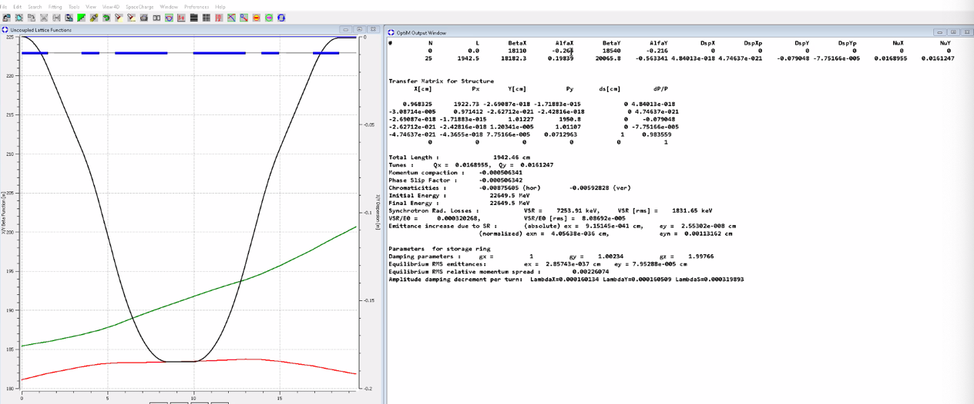
      * Getting the slope of the green line will be quite hard
    - 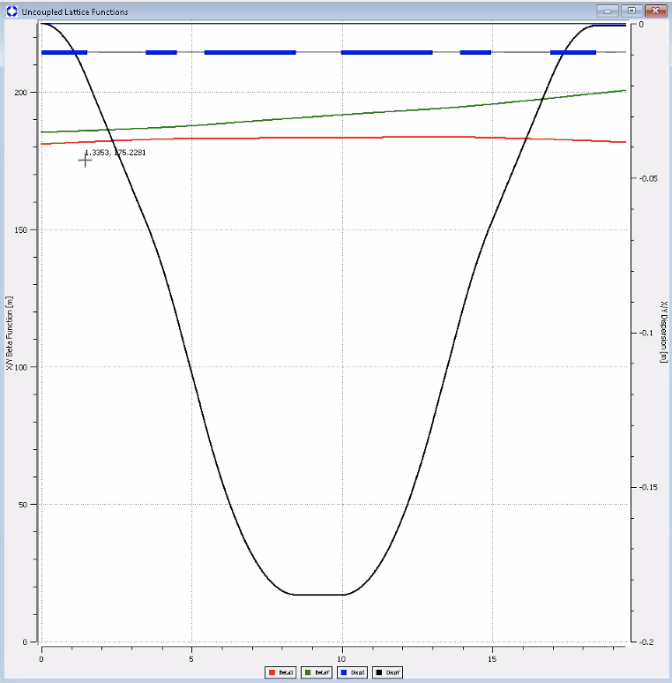
      * Changed scales
      * Number = -0.216
  + Scott – limited on improving curly-H through there. It’s modest in the grand scheme.
    - The first bit of curly-H you generate, only thing that matters is beta.
  + Probably can’t make much improvement in vertical plane.
  + Kirsten – will have emittance growth in splitters. You may not get all the optics match and low E in the splitters. If anyone wants to play with the linac optics, but Kirsten is more concerned about the splitters
    - Will also look into Randy/Vasiliy’s transition lattice, but don’t expect a large impact (likely moderate growth).
    - Vertical is bigger than we’d like, but not going to kill us
* Kirsten – anyone following up with users about energy vs. flexibility?
  + Jay – I intend to ask the question at the user’s group meeting (this month)

|  |  |  |
| --- | --- | --- |
| Action Items | Person responsible | Deadline |
|  |  |  |
|  |  |  |

## Time allotted | 25 mins | Agenda topic Non-iso Arcs Discussion | Presenter All

* Ran overtime, so next time.

|  |  |  |
| --- | --- | --- |
| Action Items | Person responsible | Deadline |
|  |  |  |
|  |  |  |

## Time allotted | 10 mins | Agenda topic AOB | Presenter All

|  |  |  |
| --- | --- | --- |
| Action Items | Person responsible | Deadline |
|  |  |  |
|  |  |  |

## Special notes

Pathway to Repository: <https://jeffersonlab-my.sharepoint.com/:f:/g/personal/tristan_jlab_org/EqZ5MeS-nipCgPfZB5p0oS4B9Is67d3nQb9sLJI3Zyev9g>