FFA@CEBAF Working Group|Minutes

Meeting date | time 06/09/2023 | 11 AM EST | Meeting location https://jlab-org.zoomgov.com/j/1614898082?pwd=TnUzMS81M2sxbDZIbERJU01tYkJCQT09
 | Attendees  Alex B, Ryan, Dejan, Edy, Alex C, Annika, Jay, Vasiliy, Stephen, Scott, Kirsten, Donish, Randy
  Meeting called by | Alex B
  Type of meeting | Weekly Meeting
  Facilitator | Alex B
  Note taker | Ryan
  Timekeeper | Alex B

Intro Discussion
Discussion of the Canadian smoke. Impacting travel, etc…
FFA School shaping up nicely for workshop. Stephen is working on organizing this.
Discussion on FFA workshop schedule. Invitations needed, conveners needed. Maybe 1 day dedicated to CEBAF? (Opening talks, etc…) Alex B is looking for some sponsors as well.
SBIR?

Agenda topics

Time allotted | 25 mins | Agenda topic Transition Design | Presenter Randy/Vasiliy
- 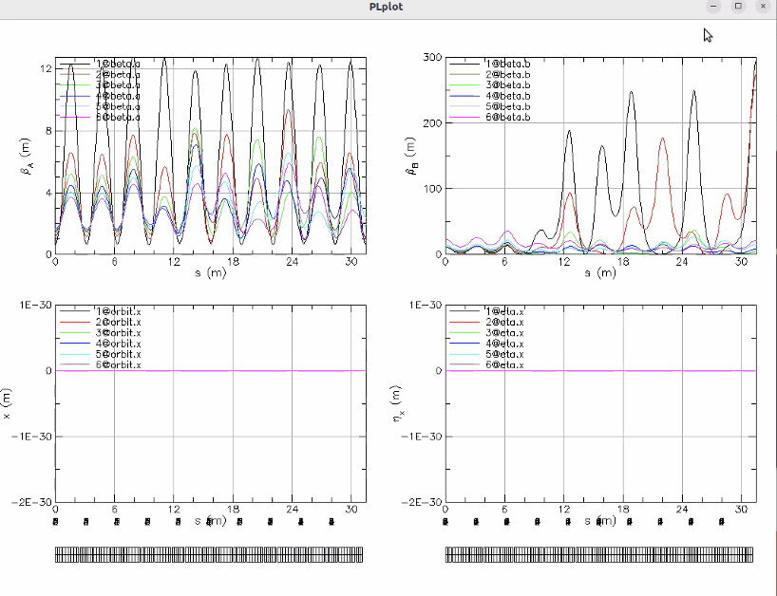
  - Parametric resonance
  - Started with lowest E, 10 cells, 30 m
  - Excite beta of lowest E (set to 300 m) and alpha = 0
    - Next energy up, can independently excite beta
  - Now have 2 energies at a 300 m with 0 alpha without too much horizontal perturbation
  - Beta tune gets lower at higher E, so see less peaks at higher passes
  - Couldn’t get 6th pass at the same time (skipped intermediate)
    - For this mechanism to work, you want several betatron oscillations
    - First pass makes ~2.5 oscillations, highest only makes ~1/3 of an oscillation
  - So likely, we need a few oscillations to make this work
  - We’d need this 180 m to make this work – so only option to accommodate this is to start the excitation in the arc
- Dejan: do you know the method from CERN how he excites the whole arc at CERN with two quads (one up one down) and uses the wave for the betatron and dispersion functions
  - He uses 90 degree phase advance
  - Did you think about doing something similar here? Have two quads induce the wave with 1 energy, then do the same thing somewhere else with the next energy (depending where the phase is)
    - Maybe not 90-degrees, maybe something else works?
  - Find 90 degrees for one energy, do two kicks. Then 90 degrees for another energy and do to more kicks
- This is still “the way to go” but need to start in the arc
  - Would have to be in the FFA arc, using the Panofsky quads to induce the kicks
- Dejan, what about if we start doing this in the linacs?
  - Alex B – higher energies would be the problem
- Stephen: doing this in the FFA is interesting
  - Beta might run into chromaticity problems
  - But beam is small physically, so to first order increasing betas in the FFA isn’t a problem
- 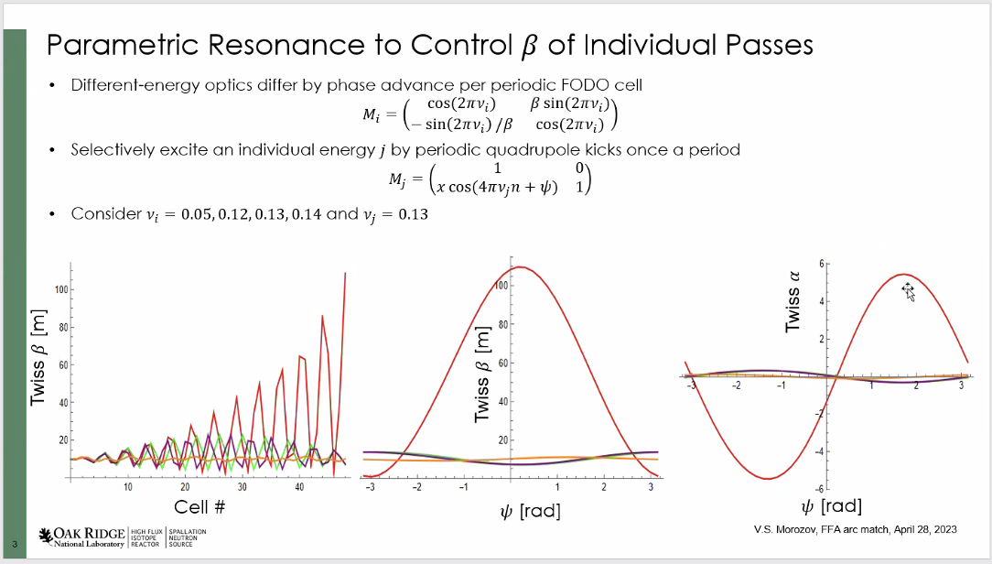
  - Like this approach b/c it works well for two lowest energies
  - 60 cells would be into the arc
- Ryan – would this impact our diagnostics in the FFA arcs? Would we need extra correctors?
  - Vasiliy – think this may not impact the correction, since it will be a spatial variation (not variation in time
- Need to keep phase advance constant – difference in phases for each pass is what allows us to do this
- Dejan - Maybe for high E, very strong phase, low E have low phase?
- Stephen – if you put in energy spread, you may have chromaticity problems
  - Not particularly optimistic that this will work for the arcs
  - Beta might have strong energy dependence as well – might find there’s a difference in what beta ends up at
- Dejan - In interaction region of colliders, there’s no dispersion in straight sections, but a very high chromatic effect from high focusing to IP
  - Vasiliy – this is the case no matter what we do
- Scott – we’re facing the chromatic effects everywhere, not just in the FFA. Chromaticity in betas – we have no knobs to match anyway
  - I think Vasiliy hit the nail on the head here in some sense. You need to be able to produce significant phase advance for all the energies to be able to pull off this match for all the energies.
  - That means more cells, meaning more length. Not a lot of ways to get around that fact.
  - If we could get the matches, willing to throw chromaticity under the bus
  - Hope we can pull off full range of TOF and R56 in two splitters (though prefer 4 splitters)
    - Need “to be proven” that we can do this, before we decide to go this route
- Vasiliy – want to play with this approach some more, using more cells, as well as bending cells (using the arc)
  - May validate Stephen’s point. Maybe chromaticity kills all
- Scott – we know from CBETA, once you got beta matched to what is in FFA, you can take care of the dispersion match with a reasonable number of cells
- Dejan – let’s go back to discuss with Alex B – when I put triplets in linacs, got ~300 m beta with ~0.01 tunes.
  - Lowest E, beta ~10 m with tune of 0.3
  - Why did we give up on this?
  - Alex B – that was the strongly focusing optics. You’re right, we started with very high phase advance per cell (~140 degrees). It was strong enough so when we went to the 11th pass in the linac, we still had enough phase advance to still get a periodic solution
    - With a flat envelope
    - Recall it being much lower (90 m?)
  - Why did we give this up?
    - We thought this was a smaller value than the drift linac, but across the 6 passes, there’s a large variation of beta functions between passes 5-11. About 50 m -100 m in those passes.
    - Back then, Vasiliy included that somehow, that variation of the beta functions for the different passes is undesirable for matching into the FFA
- At 12 GeV, the x/y betas were ~100 m (in the file looking at)
  - At 22 they go to 200 m.
  - Does this help Vasiliy with his matching? He’d have the range from 100 to 200 m in the energies in the relevant range. Maybe this helps?
- Alex B – the top energy the strong phase advance, could get periodic solution with max beta ~100 m.
  - The feature of the optics, the lower passes the beta went down gradually
  - Across the 6 passes going into the FFA arcs, it was a large variation (about a factor of 2)
    - Thought this isn’t a good thing.
    - Maybe we need to revisit?
- Ryan – how will this impact the rest of the machines optics? Spreaders, splitters, FFA arc?
- 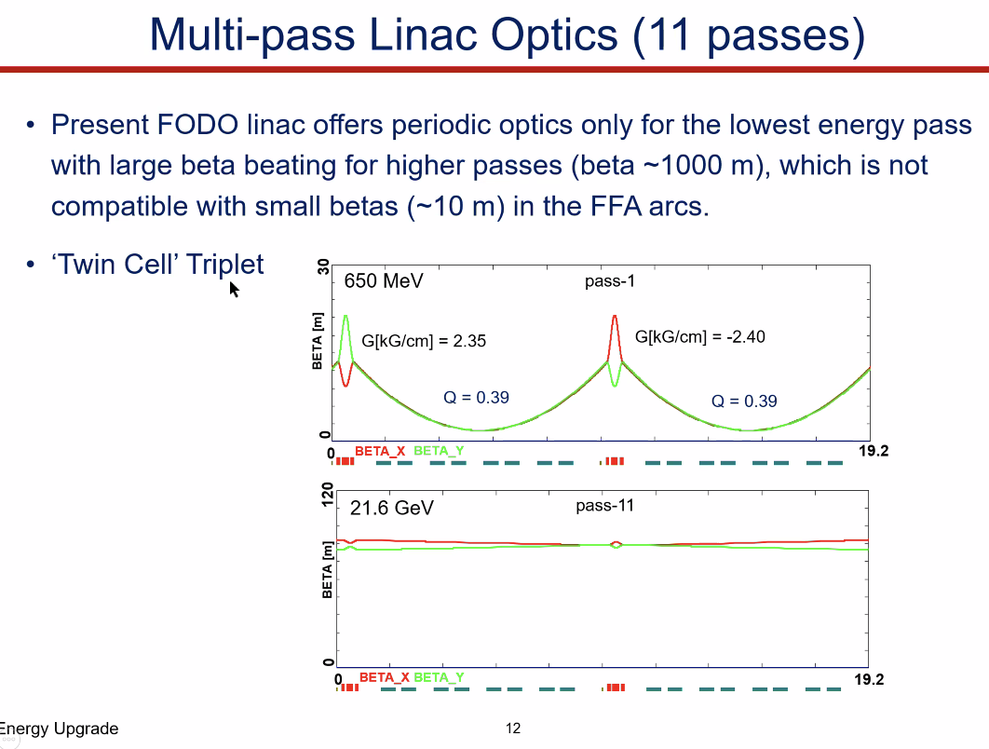
  - Strong focusing linac
  - Very strong tune (about 140 degrees of phase advance)
  - Reverse triplets (alternating)
  - Pass 11, we can still get relatively flat with little phase advance
- 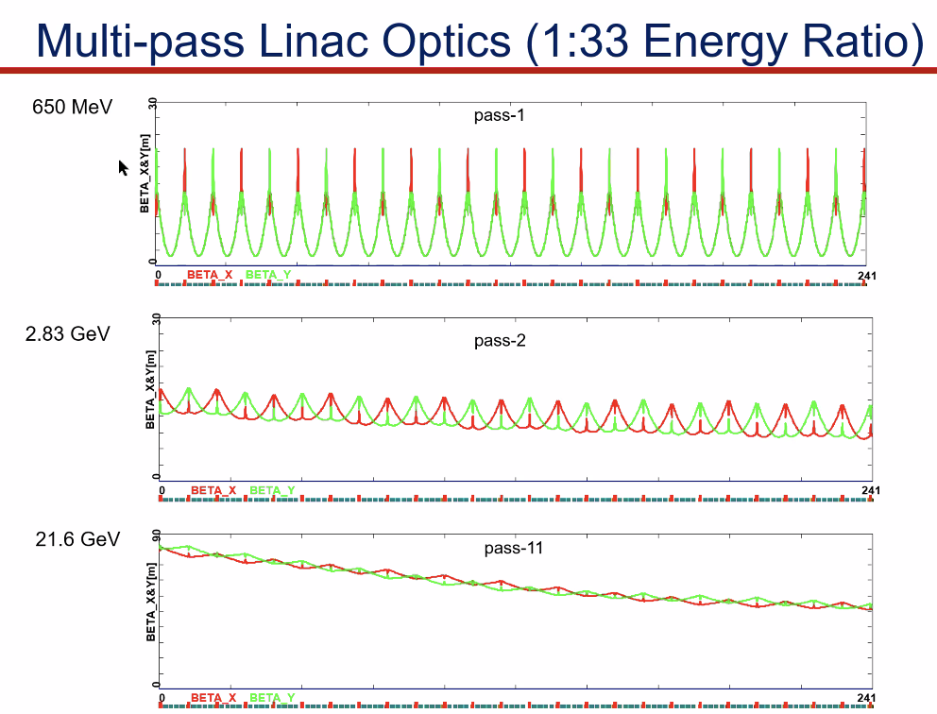
  - At the end, there will be a spread of beta functions (maybe a factor of 2ish)
  - If we can live with that, then maybe?
  - Betas are much smaller in this version. Weakly focusing (starting around 30 degrees), pass 5 gives parabolic with beta ~200 m
- So do we want strong or weak focusing?
- With the existing 4 lines, can we match this into the spreaders/EM arcs/recombiners?
- Can we revisit?
  - Vasiliy – Lowering the betas, the smaller the chromaticity will be
- We should check to see if this helps or not
- Alex B – let me rehash this. It’s not fully in the github, but we have the configuration, so we can revisit if needed.
- Could do plane-independent tune
- Strong triplet is triplet at low E, then like a FODO at higher E.
- 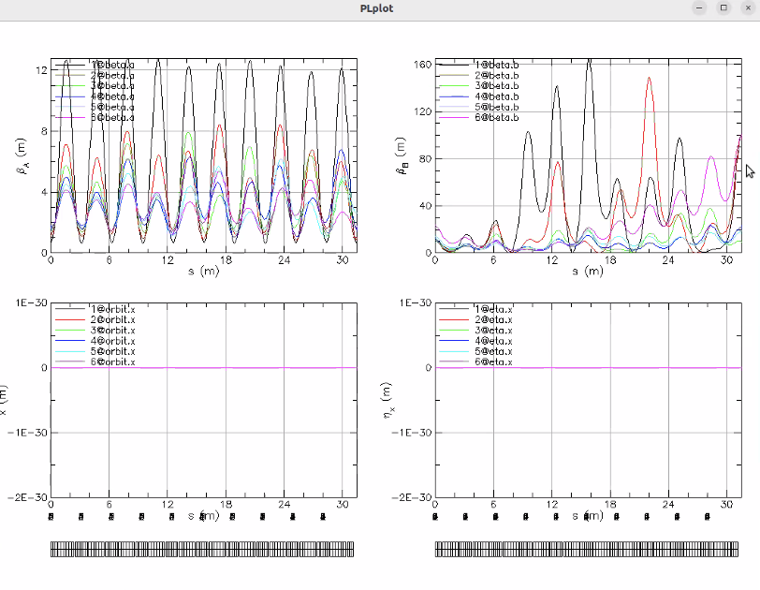
  - Set starting beta at 100 m
  - Focus on purple line, not a full oscillation. Can’t make alpha 0, but still small
  - Ryan – we’re not matching to the same betas if we change the linacs, so above needs to change
- Vasiliy re-reruns:
  - 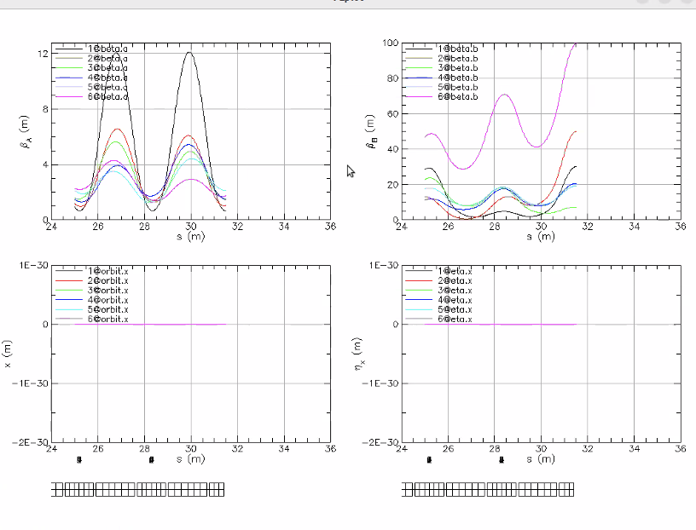
    - Not bad. Rematched each to a more appropriate beta on exit
  - 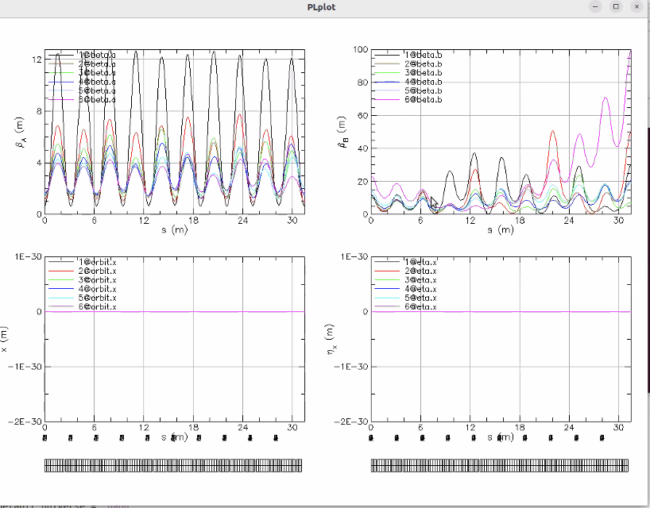
    - Chromaticity a bit better
- Alex B will re-visit the linacs
  - CEBAF is 120-degrees per cell now
  - Periodic solution is only for lowest pass in each linac right now
    - We have beta beating and end up with 200-300 m
    - Discussed with Yves before to make periodic for all passes
- Scott – to check on alternating triplets
  - There IS going to be a resonance in there – so we should make sure we don’t cross a quarter resonance
  - It should be a nice, well-behaved diagram, but worth checking
  - Worried that, due to various changes in machine, if we end up on the quarter, it won’t be good. A small resonance is easy to dodge.

Action Items | Person responsible | Deadline

Time allotted | 25 mins | Agenda topic Non-iso Arcs Discussion | Presenter All
- Jay asking about flexibility in allowing a range of energies (1 GeV and 1.1 GeV per pass)
  - Maybe we don’t have that full flexibility?
  - That’s part of why 1 FFA instead of 2 FFAs
- Do we want discreet energies?
- Edy – perhaps we run off-crest? (non-isochronous arcs)
  - Alex B – thought about this with 5-pass ER experiment. Wanted some compression before deceleration
- Scott – Think there are a couple of issues here.
  - How worried are with about BBU? How does the longitudinal impact this?
  - Tricky part – still have set of R56 to do whatever different thing we want. Still need R56 control in splitters
    - May be able to put them into a “natural” range from the system…maybe
  - Have to remember that the splitter lines are not naturally going to give you a 0 R56. They’re naturally going to give you a set of values, depending on the lines themselves (geometry mainly)
  - Not saying “forget the idea”
  - Saying – 1. Do BBU simulations first to make sure we can operate this way
    - 2. What will we naturally generate in the system and see if we can still get what we want.
- Alex B – BBU not a huge problem at low current
  - Jay – some cryomodules shows some (started around 30 uA in second pass)
  - Ilkyoung’s dissertation was on this
  - Saw onset of BBU (with one sick cryomodule)
  - Recalling the studies after: we have a few cavities that are close
  - Alex B – looking at fundamental equations, that threshold is “above us”
- Scott – if you do extreme things with longitudinal dynamics, it may impact other things.
- Multipass BBU – we charted up to 5 pass, but higher not done
- Dejan – 5 examples of running ERLs off crest. So why not at CEBAF?
  - Alex B – we can. ER experiment looked into it
    - Did extended studies. Gustavo Perez did some of this for his PhD thesis (longitudinal gymnastics to get this done)
      - Ran all arcs with nonzero momentum compaction and different gang phase for each pass in the linacs
  - Dejan - Running on crest is non-linear. Off crest is linear
    - Scott – no, we’re not going that far off crest. This is a huge energy spread, so it’s a small amount off crest
      - If you’re too far off crest – hard to manage the amount of synch oscillations you’re making
      - If you think about EM arcs in CEBAF, they’re designed to be isochronous (but with flexibility)
        - With CEBAF FFA arcs, the issue is that there are a lot of cells (particularly at higher E), the net result is that you get significant R56 (10s of cm probably). That’s a fairly large number
- Alex B – that flexibility opens opportunity – maybe we don’t need to make FFA arcs isochronous?
  - Compensate in linac by running slightly off crest?
  - Scott – worthwhile to explore. Just look into BBU and sensible manipulations
  - Alex B – a few degrees, you can get a quarter wave synchrotron rotation easily
  - Scott – would be dangerous if quarter per pass
  - Alex B – if you do half wave rotation – swap head/tail of bunch
- Scott – muon RLA danger – making huge synchrotron tune, and b/c need to stay close to crest to control slope, you have to worry about RF bucket breakup with high
- 2.2 cm – 16.5 cm R56 compensation in 1 arc (not pair)
Action Items | Person responsible | Deadline

Time allotted | 10 mins | Agenda topic AOB | Presenter All

Action Items | Person responsible | Deadline

Special notes

Pathway to Repository: https://jeffersonlab-my.sharepoint.com/:f:/g/personal/tristan_jlab_org/EqZ5MeS-nipCgPfZB5p0oS4B9Is67d3nQb9sLJI3Zyev9g

