FFA@CEBAF Working Group|Minutes

## Meeting date | time 06/16/2023 | 11 AM EST | Meeting location <https://jlab-org.zoomgov.com/j/1614898082?pwd=TnUzMS81M2sxbDZIbERJU01tYkJCQT09>

|  |  |  |  |  |  |  |  |  |  |  |  |
| --- | --- | --- | --- | --- | --- | --- | --- | --- | --- | --- | --- |
| |  |  | | --- | --- | | Meeting called by | Alex B | | Type of meeting | Weekly Meeting | | Facilitator | Alex B | | Note taker | Ryan | | Timekeeper | Alex B | | Attendees  Alex B, Ryan, Annika, Alex C, Dejan, Todd, Randy, Stephen, Vasiliy, Kirsten, Donish, Scott, Reza |

# Intro Discussion

LDRD discussion. Due dates, etc…

Juneteenth on Monday – no work.

# Agenda topics

## Time allotted | 25 mins | Agenda topic Strong Focusing LINAC | Presenter Alex B

* About 2 years ago, used strongly-focusing optics. When Vasiliy tried to match with FFA arcs, it seemed to make things difficult due to variation of beta functions
  + This caused us to look at weakly focusing triplet optics. Tight control through pass 5, then FFA passes had similar betas.
* 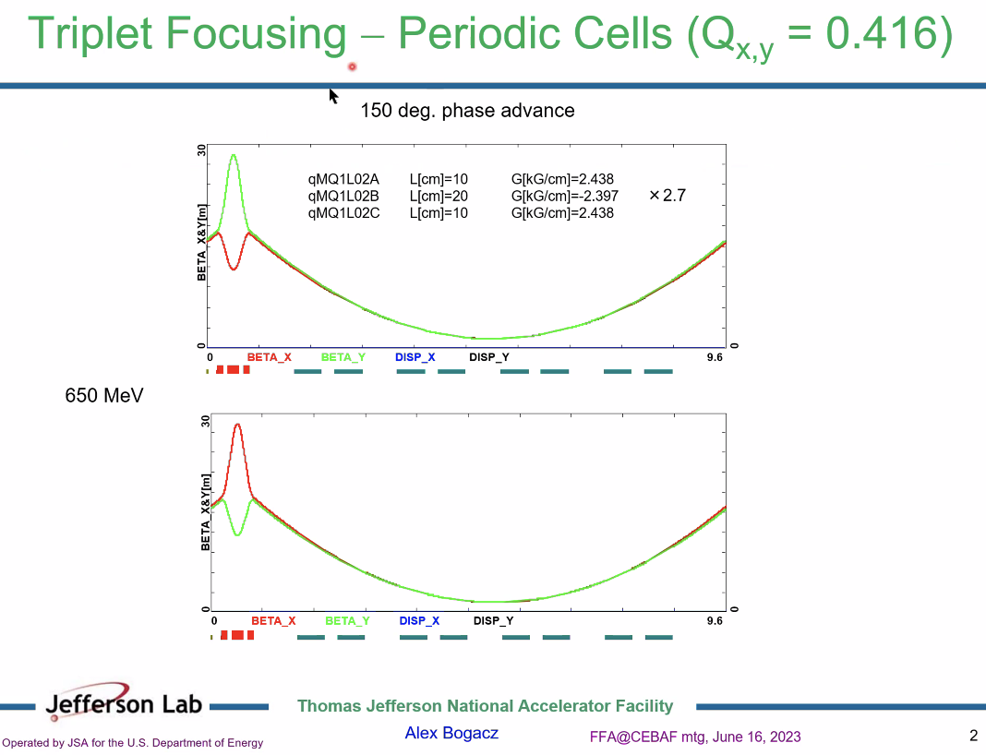
  + 150-degree phase advance (from Q=0.4)
  + 9.6 m period in linac
  + 8 cavities in cryomodule
  + Triplet replaces single quads (FODO)
  + Factor of 34 to get to higher E
  + 1.1 GeV needs 2.7x stronger quads at end
  + Bottom plot is reverse
  + Combine these ideas to make FODO-like at higher passes
* 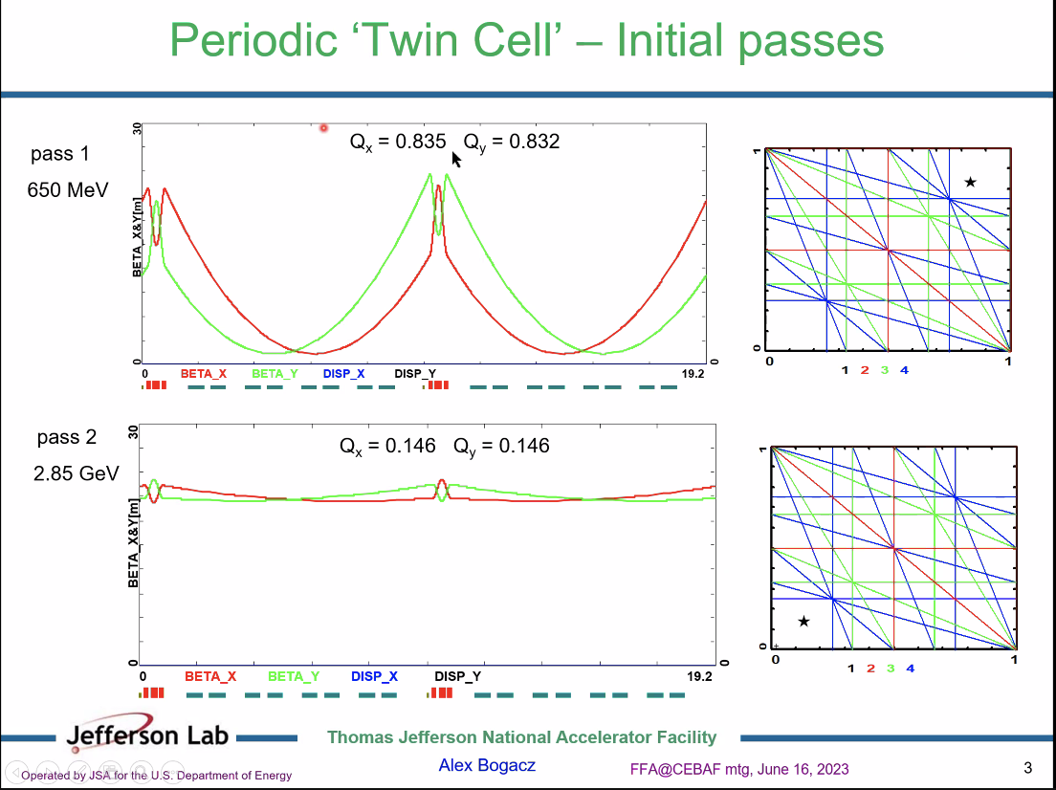
  + The horizontal tune is slightly higher than vertical tune
  + 4th order resonances shown on the right
  + Repeat this structure 14 times in one linac
  + Pass 2 starts at 2.85 GeV (2 linacs)
  + Same scale on plots – see the betas are “squashed” a bit – already looking FODO-like a bit
  + No worries about ¼ resonances
* 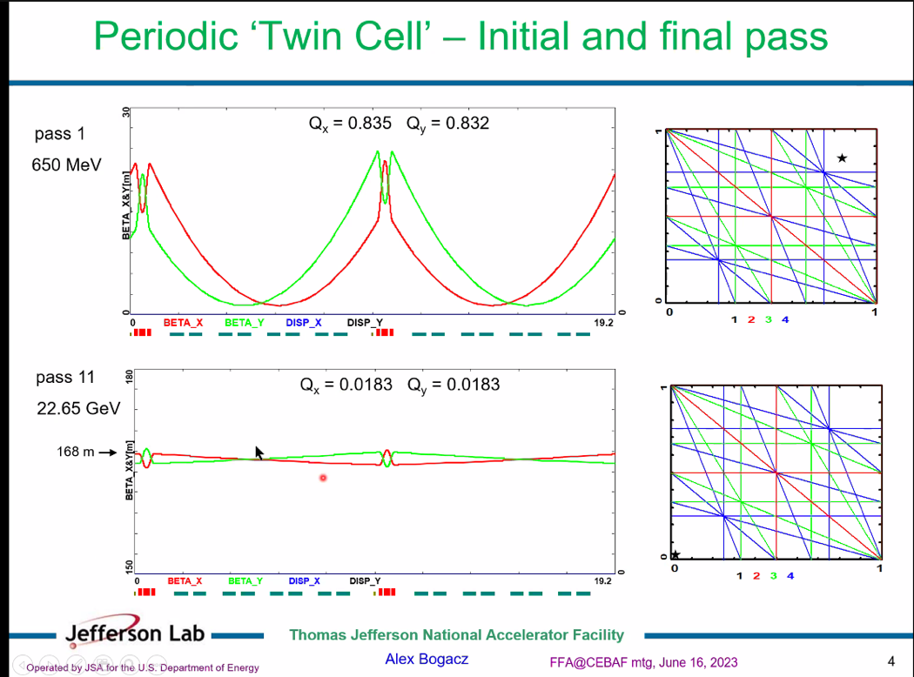
  + Scale changed
  + FODO-like structure persists
* 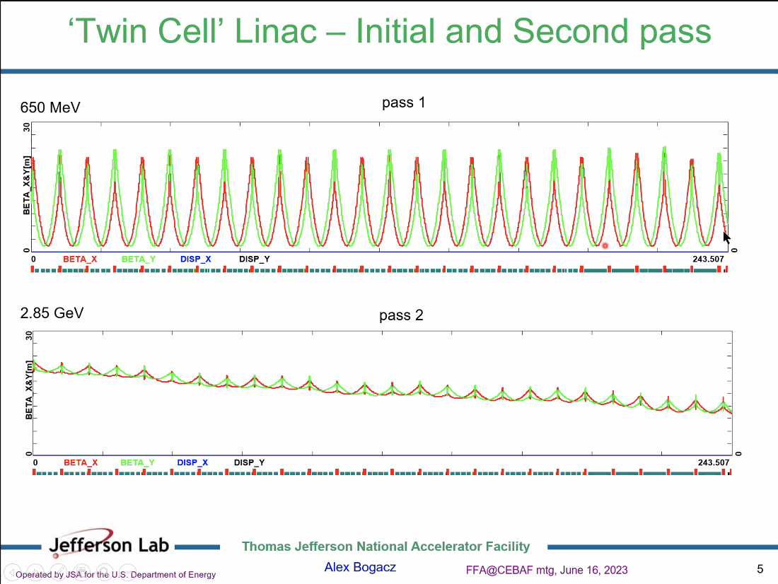
  + Scale with momentum for quad strengths through LINAC
  + Due to linac focusing, see beta decrease
  + Last cryomodules are C-100s
* 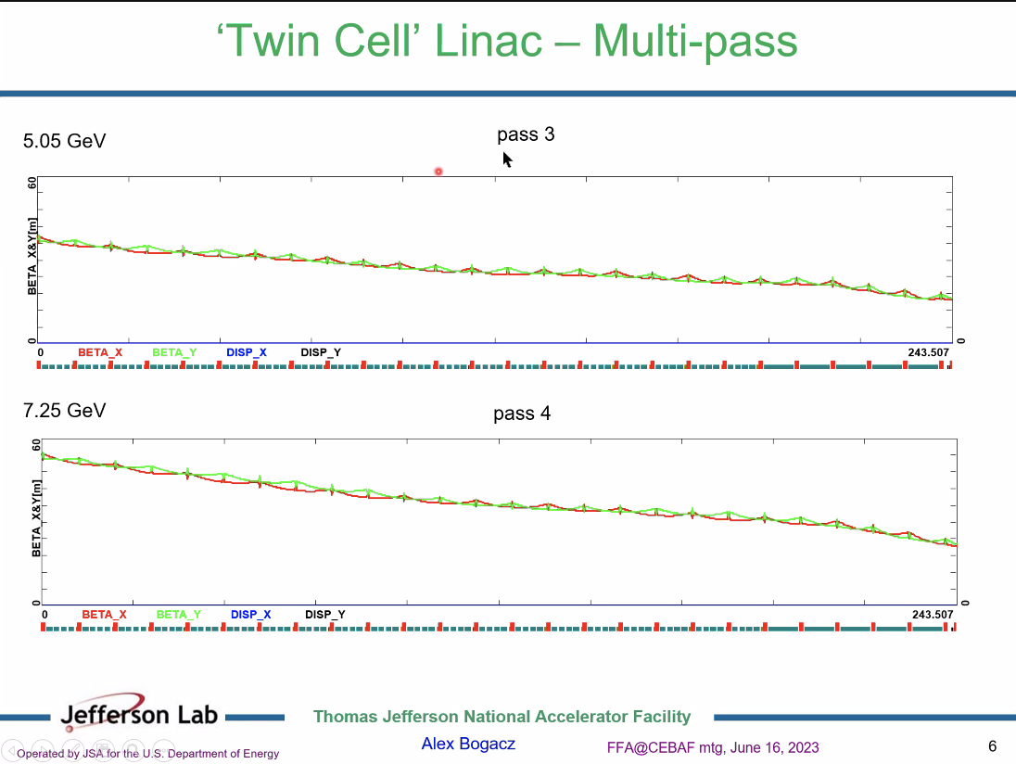
  + Still manageable beta values
* 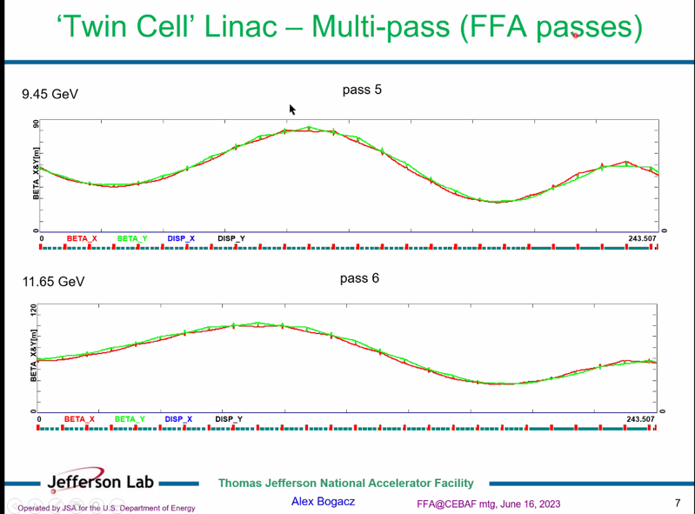
  + This is where FFA passes start
  + Another trick – can use beta beating that is there initially, so place nodes at the ends
    - Basically play with initial Twiss
* 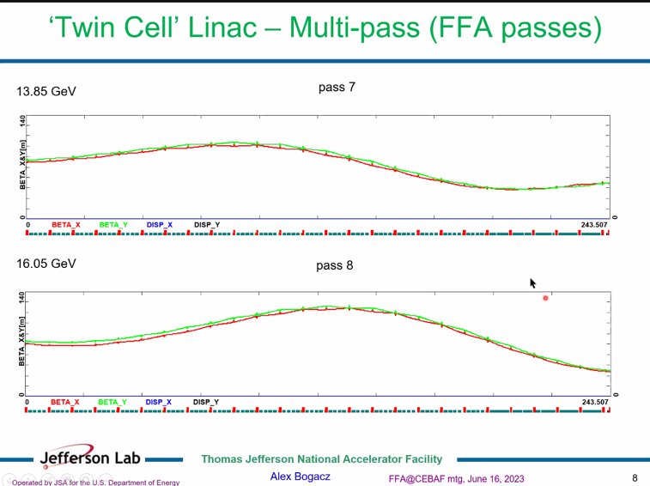
* 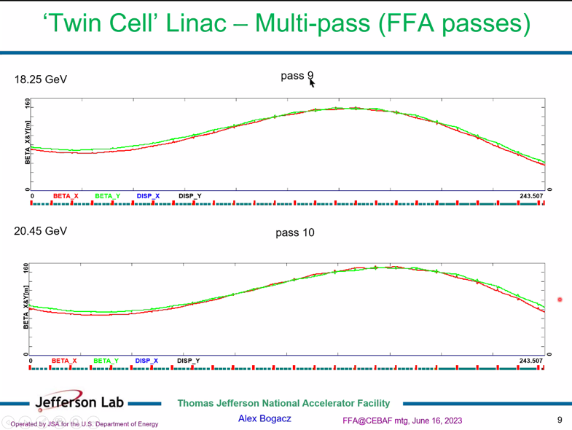
* 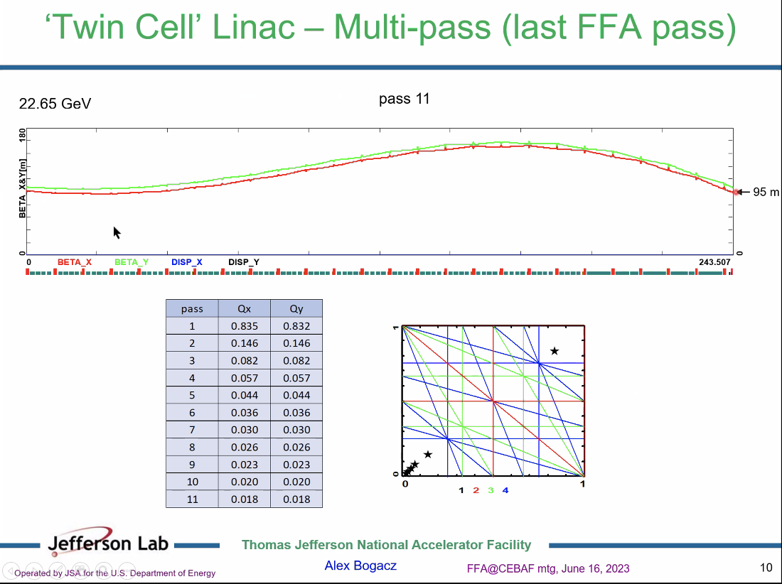
  + Betas well within control of CEBAF
  + This is definitely something to keep in mind and revisit
  + Variation from ~60-95 m in final betas
  + Tunes away from resonances
* 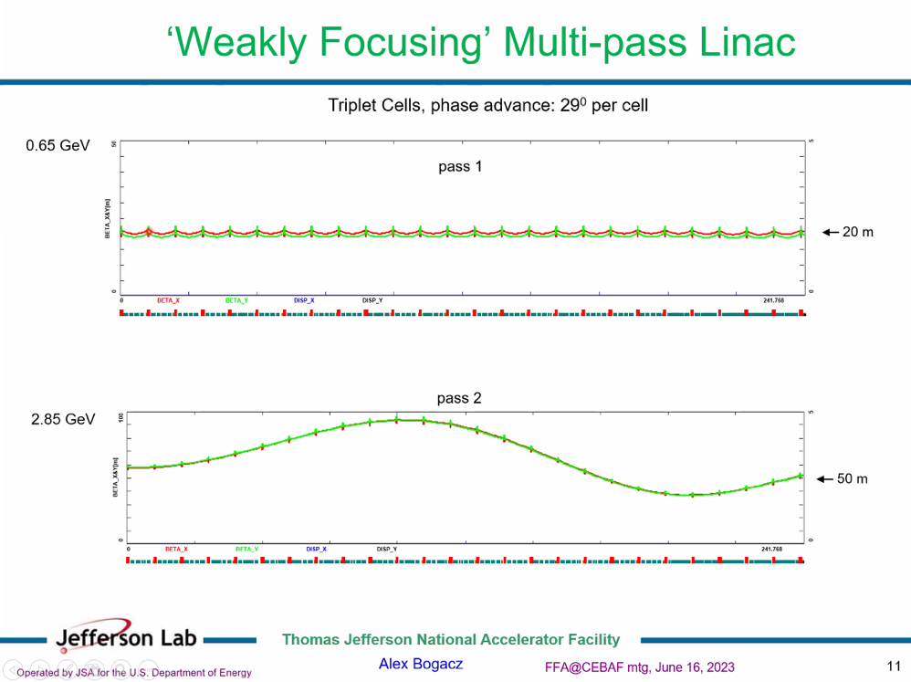
  + This is what we currently have
* 29 degrees chosen so that pass 5 (first ffa pass) morphs into drift linac
* 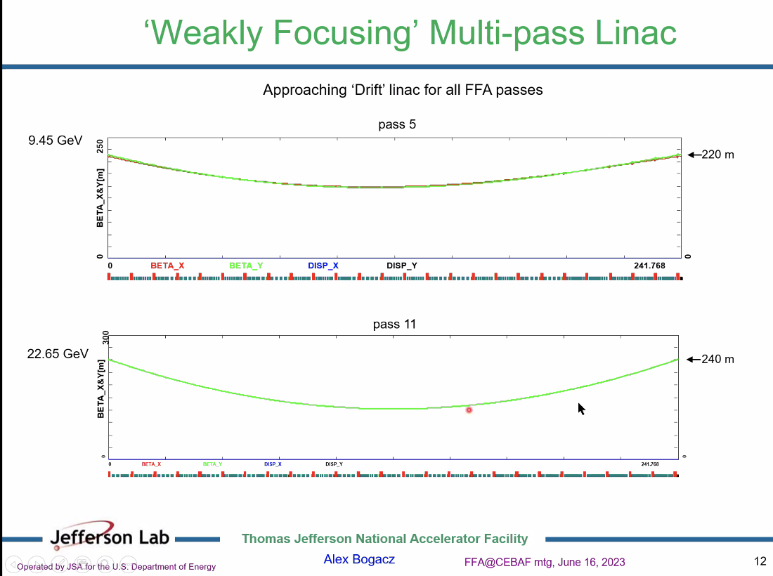
* Dejan – let’s suppose we have splitters on every side of the linac (which we don’t like) and we start with the initial conditions described (95 m) – then we have no problems using the quadrupoles in the splitters to get this further down
  + Ryan – If we have 4 splitters, then the merger isn’t needed. If we have 2 splitters, then we need the mergers. The splitters match on one side, and the transition on the other, downstream side, of the ffa arc
  + Kirsten – You go linac, spreader, splitter, FFA, transition, recombiner, linac
    - Do you have enough flexibility to match?
    - We haven’t gotten that far in the design
    - My understanding matches Ryan’s – you either have 2 splitters with transitions, or you have 4 splitters
  + Dejan – we couldn’t match from splitter into arc, so used half magnet so disp and disp’ = 0.
    - When we start running the machine, there’s a serious trouble to match, but we managed
  + It would be easier to match the betas from the splitters to the values in the splitters with different quads for each line
* Vasiliy – my understanding was the same as Kirsten’s and Ryan’s
  + Come out of FFA arc, in single beamline, bring all orbits and dispersion down to zero, then continue to match betas
  + So if we bring dispersion and orbit to zero, in order to separate them into separate lines, we’d have to re-introduce spread again.
    - But we can do that right after an FFA cell
* Scott – Vasiliy is basically right here. Either you do everything in this, or you do a splitter. A mixture is the worst of both worlds.
  + The dispersion match in these splitter lines is sometimes a pain, but in reality, the dispersion match is basically a 0 disp to nearly 0 disp match anyway. You’re not changing that by removing it
  + Tough part of the transition is changing the betas, because it requires real estate
  + If you can make it work (disp and betas), then you do it, otherwise do the splitter. Don’t mix.
* For first arc (east arc) we’ll have splitter, no merger, then FFA, then merger and no splitter
  + This is the current baseline (if we can make it)
  + No redundancy
  + It’s either splitter or merger
* Scott – I continue to be skeptical that using the adiabatic merge is the effective way to do it, but it would be good if it works
  + Assuming 2 splitters can get the changes we need.
* Alex B – going back to linac
  + Vasiliy - This solution makes me hopeful
* Ryan – this changes what we match INTO, but not what’s coming into the merger section. That’s defined by the FFA lattice
* Dejan – I prefer lower betas at end of linac
* Vasiliy – makes a huge diference
* Alex B – so there’s a solution that can work
  + We should probably split this and have two flavors in the codes
  + Could maybe adjust current Bmad linac files by using stronger quads instead of full redesign
* Do we use Lcavities in Bmad?
  + Yes
* Vasility - As you accelerate, the angular spread shrinks and the beta grows – it’s not a drift
* Donish – Alex, send files, and I can update them, and we can upload to github
* Donish tangent – one idea for organization
  + We have github and sharepoint, we could also make a JLab website where it keeps the documents
    - Make it easy to DL, etc…
    - Caveat – they’d need to VPN into the JLab network, so might be hard for outsiders
    - Scott – let’s avoid firewalls
  + Kirsten – the ERL work is often on dropbox.

|  |  |  |
| --- | --- | --- |
| Action Items | Person responsible | Deadline |
|  |  |  |
|  |  |  |

## Time allotted | 25 mins | Agenda topic LDRD FY24 | Presenter Ryan

* 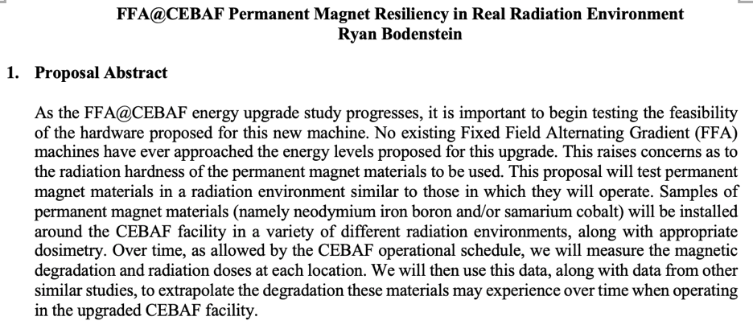
* Essentially, take permanent magnet samples, place them in the tunnel with dosimetry, and measure the demagnetization as they are dosed.
* 2 year LDRD, $529K total to be requested
* Everyone send Title ideas to Ryan

|  |  |  |
| --- | --- | --- |
| Action Items | Person responsible | Deadline |
|  |  |  |
|  |  |  |

## Time allotted | 10 mins | Agenda topic AOB | Presenter All

* Dejan – looking at splitter design, looking at order of magnitude of betas, dispersion, length
  + M56 was only half the value needed for the full arc
  + Max value of disp is only 60 cm (not 1 m)
  + Max value of beta is 50 m
  + Disp is all negative
  + Put all that into folder – someone should look at example (retreat folder)
* 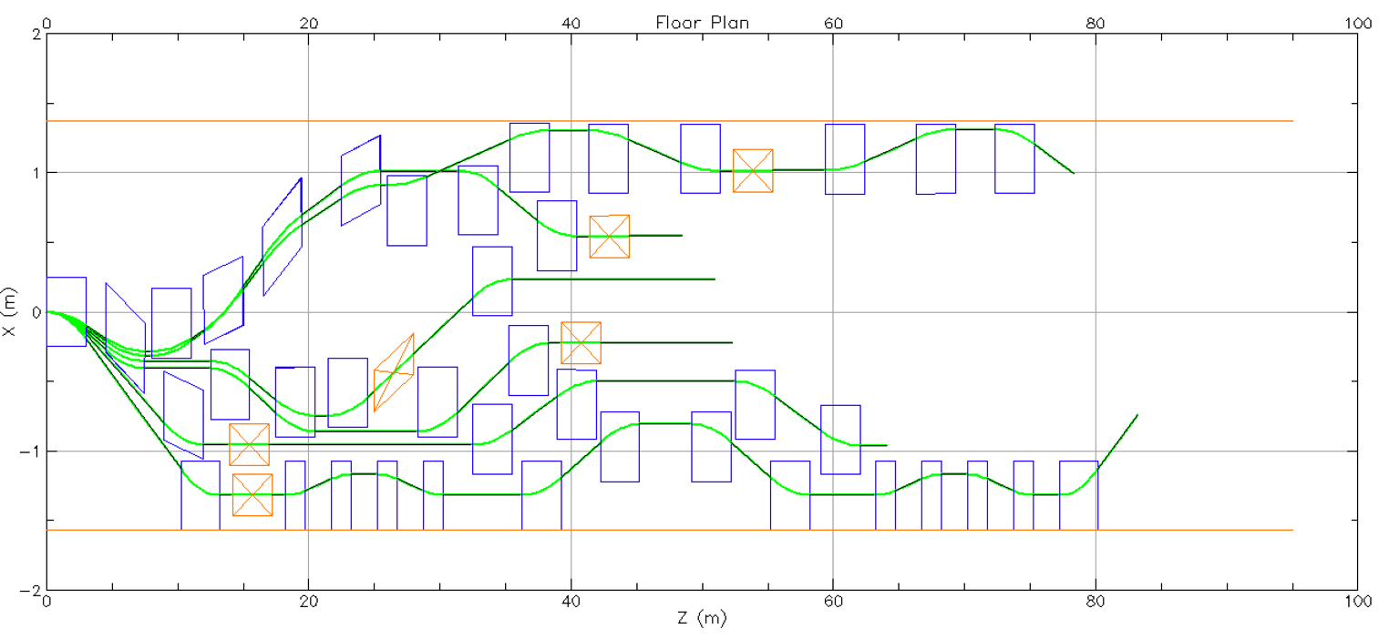
* Ryan shows current status (above) of geometry (with possible extraction points)
  + Bmad floorplan with orbits shown
  + Still need to close all the orbits and get all the geometry to work, then can add optics in.
  + It’s incredibly tight, and we need to make sure we can close this, get the geometric layout for all 6 lines, adjust for path length, and then add optics to see what fits
  + Top orange line is wall, bottom is personnel limitation
  + Separating the 6 lines takes a lot of space. Would be much shorter with only 5 passes.
* Dejan - Ryan isn’t far from geometry
* 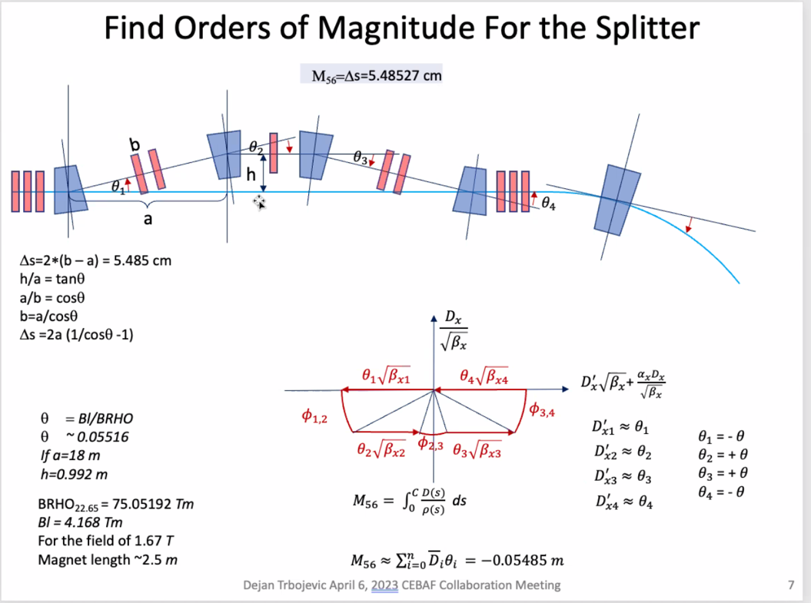
* 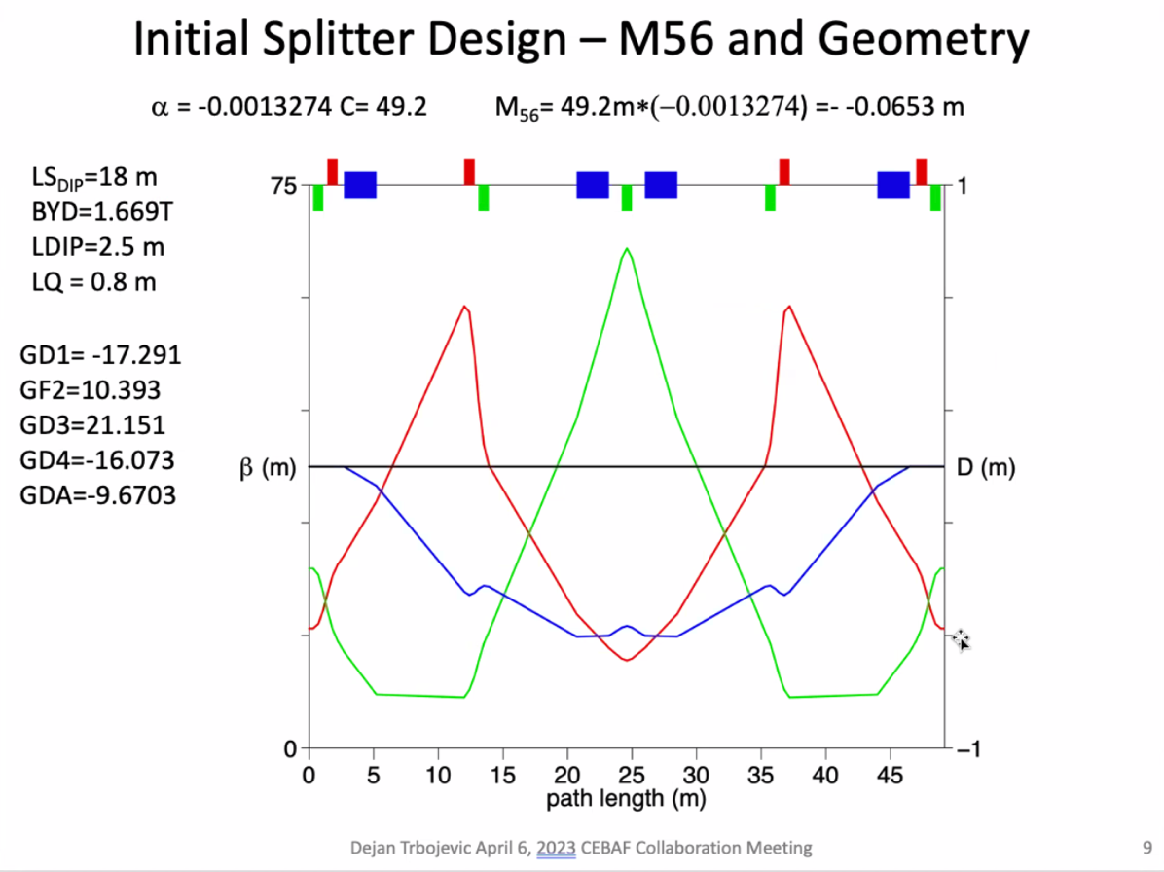
* These are the values of the elements that we’re dealing with. We’ll probably need permanent magnets with open aperture, so everywhere you’ll have bending, you’ll get SR
* Have initial layout from Ryan (almost)
* Dejan – I suggest that Ryan puts this into code, to see if it fits
  + Ryan – Will do, once close geometry for 6 lines to make sure they fit

|  |  |  |
| --- | --- | --- |
| Action Items | Person responsible | Deadline |
|  |  |  |
|  |  |  |

## Special notes

Pathway to Repository: <https://jeffersonlab-my.sharepoint.com/:f:/g/personal/tristan_jlab_org/EqZ5MeS-nipCgPfZB5p0oS4B9Is67d3nQb9sLJI3Zyev9g>

NO MEETINGS FOR TWO WEEKS!! Reconvene after 4th of July.