FFA@CEBAF Working Group|Minutes

## Meeting date | time 08/04/2023 | 11 AM EST | Meeting location <https://jlab-org.zoomgov.com/j/1614898082?pwd=TnUzMS81M2sxbDZIbERJU01tYkJCQT09>

|  |  |  |  |  |  |  |  |  |  |  |  |
| --- | --- | --- | --- | --- | --- | --- | --- | --- | --- | --- | --- |
| |  |  | | --- | --- | | Meeting called by | Alex B | | Type of meeting | Weekly Meeting | | Facilitator | Alex B | | Note taker | Ryan | | Timekeeper | Alex B | | Attendees  Alex B, Ryan, Annika, Alex C, Scott, Edy, Donish, Stephen, Dejan, Todd, Randy, Kitty, Reza, Vasiliy |

# Intro Discussion

* 24 people registered for the FFA Workshop
  + Scott is registered, but not 100% going
    - Hoping to talk in the beam dynamics session, a bit thin
    - A bit thin on Japanese colleagues

# Agenda topics

## Time allotted | 25 mins | Agenda topic FFA Correction | Presenter Annika/Alex C

* 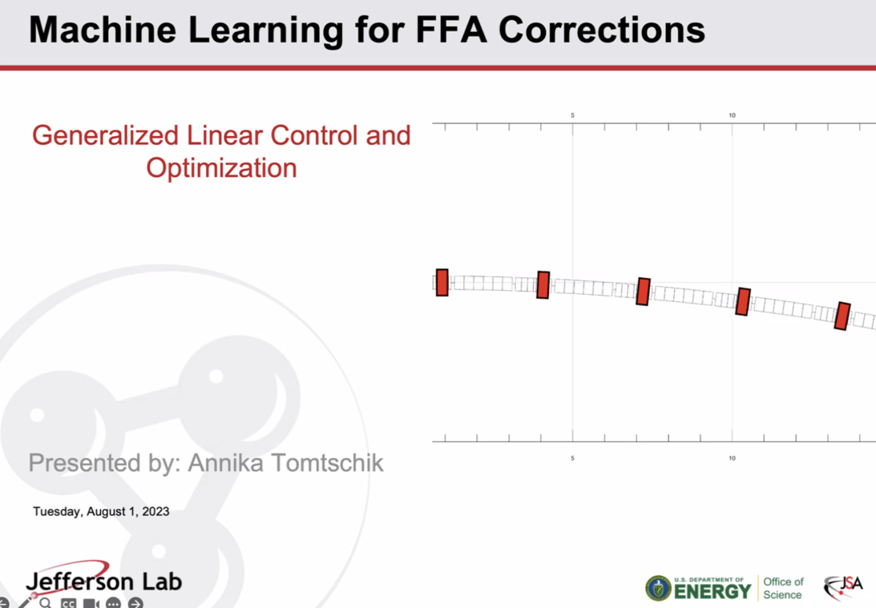
* 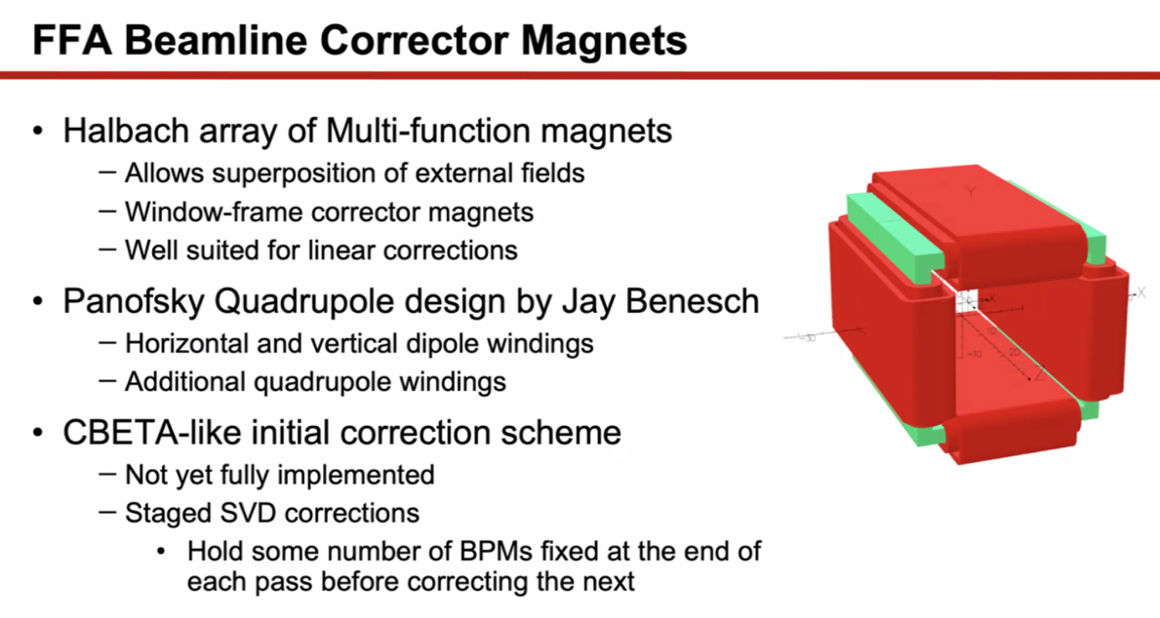
* 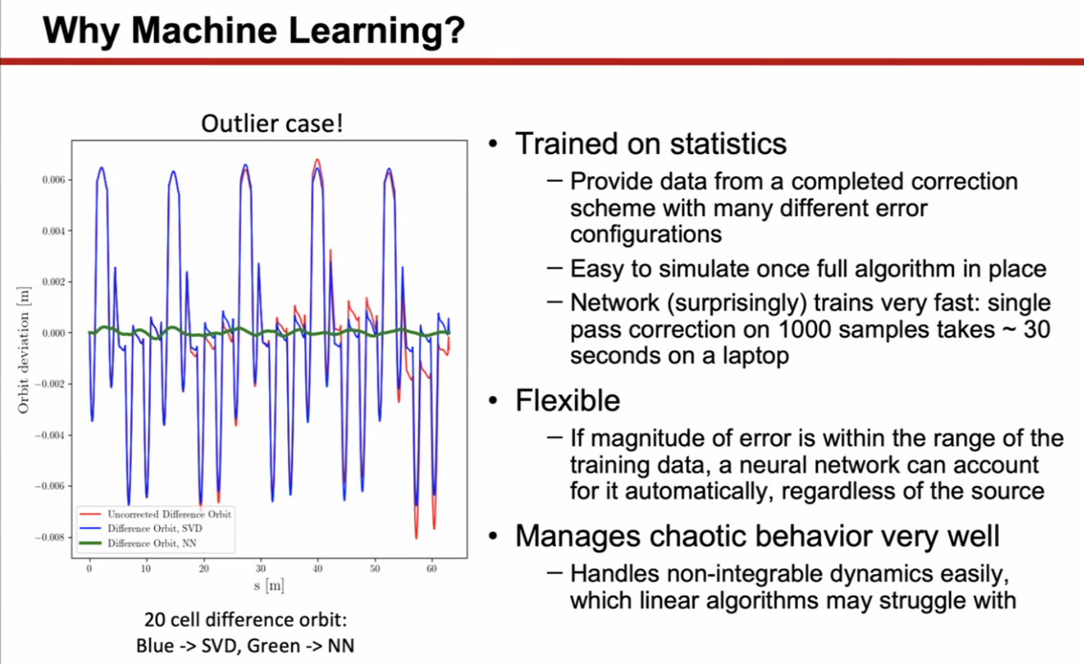
  + This case is an outlier – not a usual case, but shows that NN can be more reliable than SVD at times.
  + NN trained on data, so more flexible
* 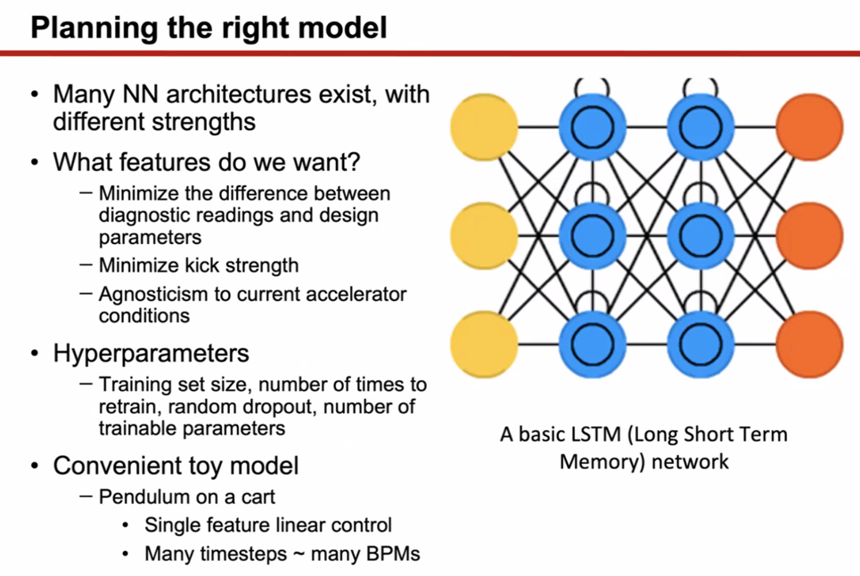
  + Testing the NN architectures was Annika’s project
* 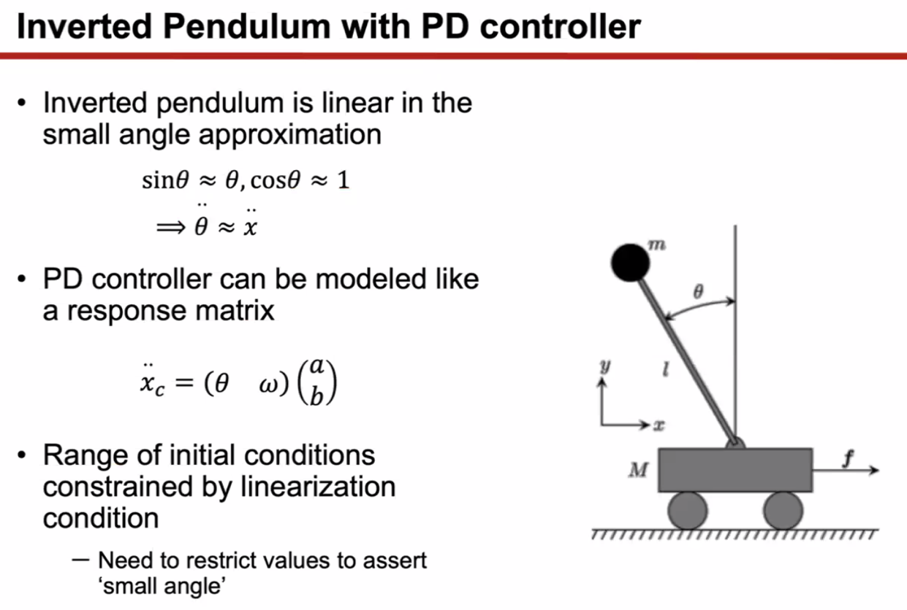
  + Mirrored linear accelerator behavior better with this model
  + Constrained the initial conditions with the linearization conditions – so can use small angle
* 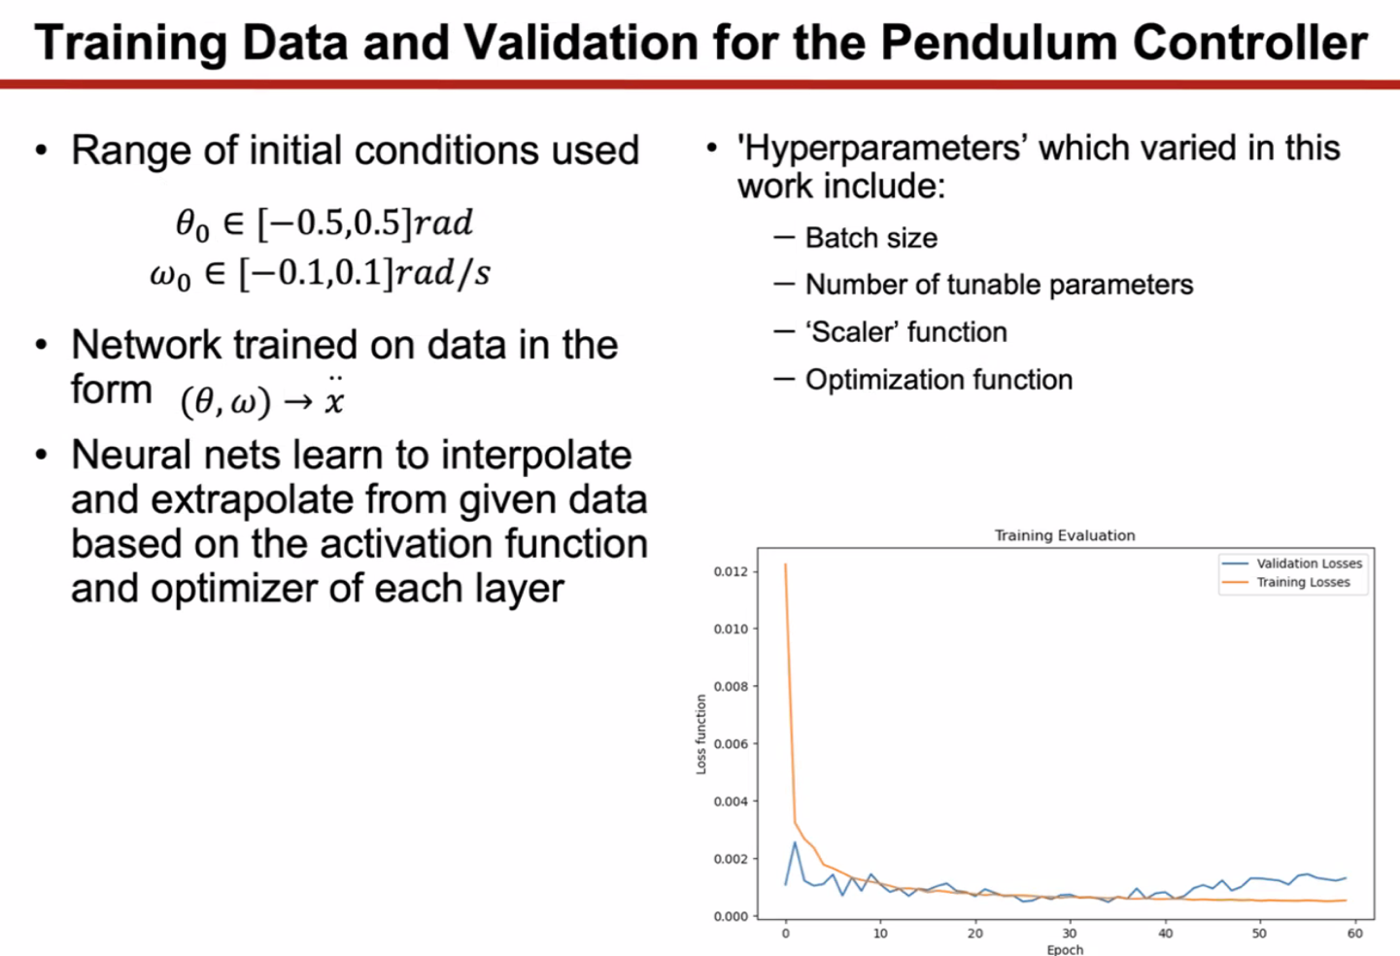
  + Typical pendulum sample with validation losses (training losses)
    - Overcorrected
* 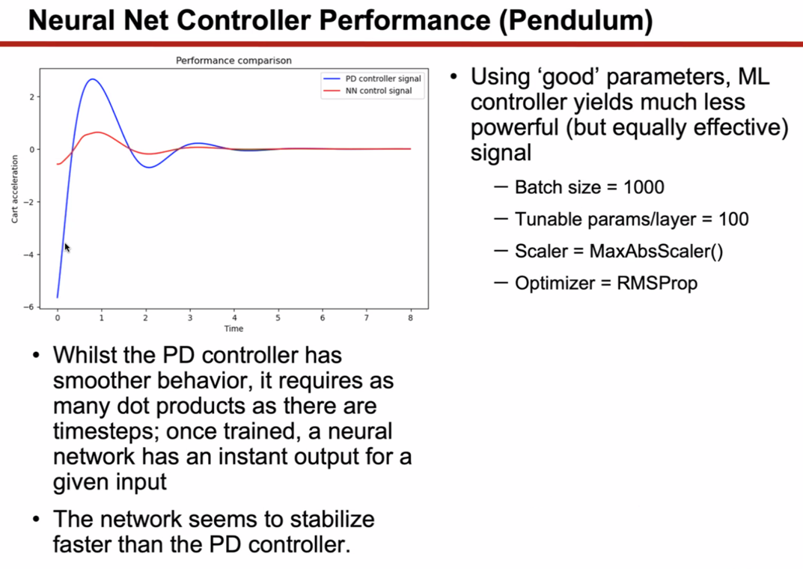
  + NN corrected faster but less smooth
* 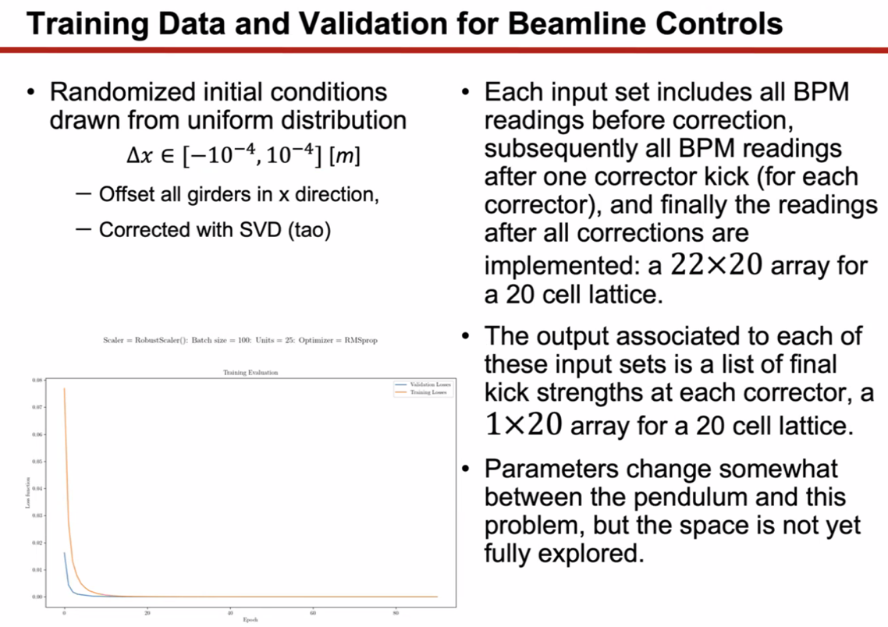
  + This is for accelerator, not pendulum
  + Training and validation losses – converged more smoothly and faster
  + No overcorrection
  + Parameters – batch sizes smaller, etc…
* 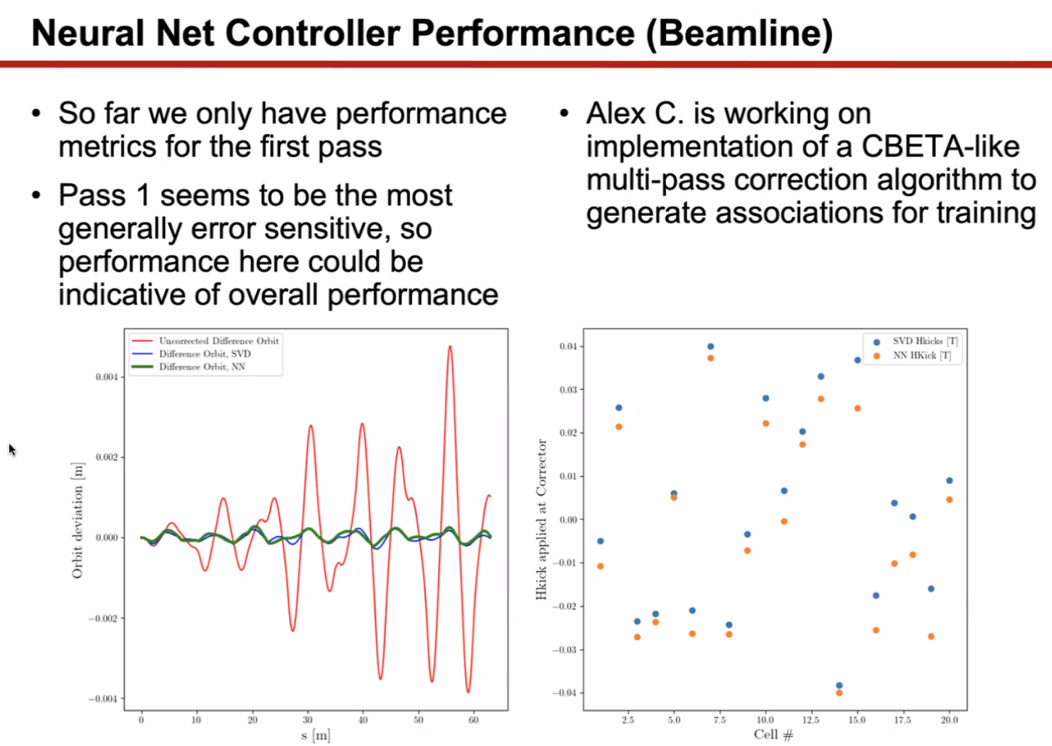
  + More typical case – SVD and NN give very similar results
  + Kick strengths are about 1% different between SVD and NN – this is roughly what is expected
* Not multipass yet!
* 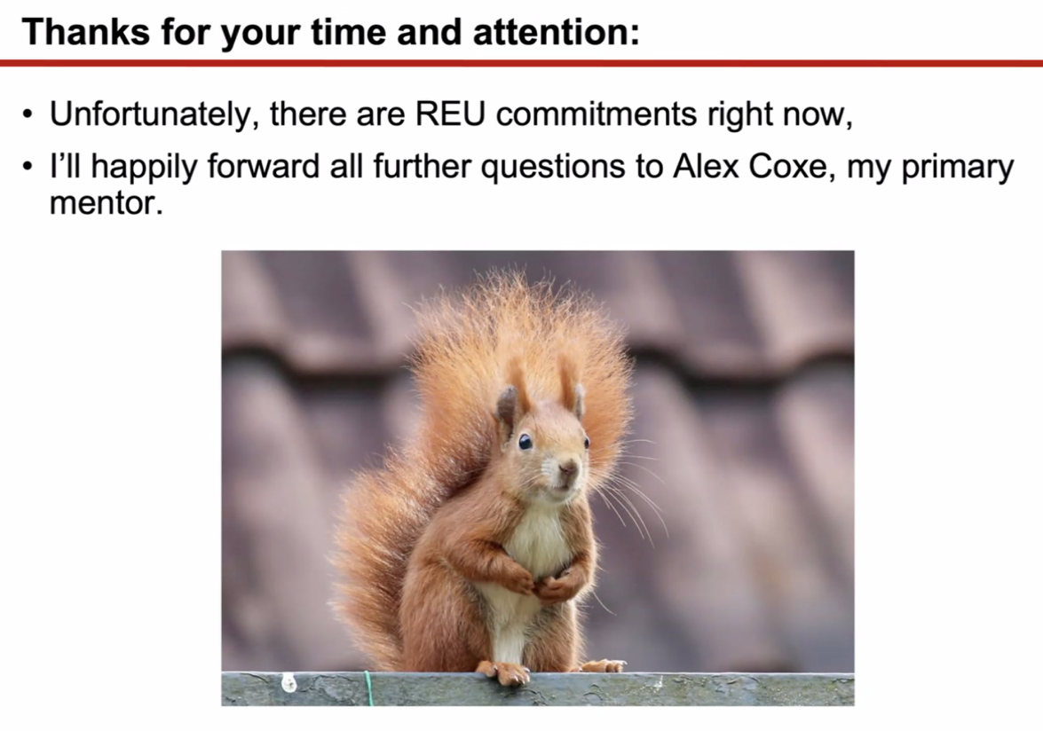
* Alex B – good idea to start with pendulum.
* Alex C – did some basic particle tracking in Bmad, just offset the girders by some amount
  + Have been looking at training data a lot, and that impacts things a lot.
* Reza – I also like the pendulum
* Alex/Todd/Dejan – was used as a demonstrator at Fermilab
  + Proton mining – to google
  + Crystal halo cleaning
* Dejan – we built it and installed it in the tunnel (first)
  + Russians brought crystals from St. Petersburg (bent crystals)

|  |  |  |
| --- | --- | --- |
| Action Items | Person responsible | Deadline |
|  |  |  |
|  |  |  |

## Time allotted | 25 mins | Agenda topic Strong Triplet LINACs | Presenter Alex B

* 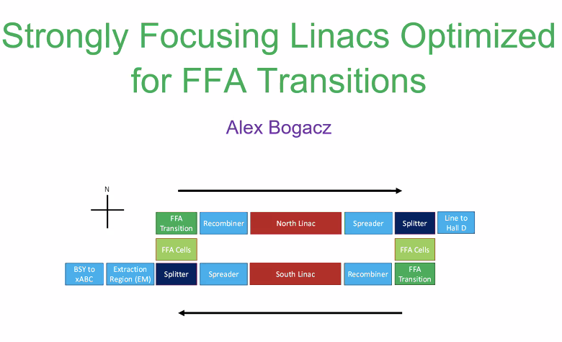
  + A few weeks ago, Vasiliy presented update with FFA transition
  + Kirsten’s block diagram
* We are looking at strongly focusing linac optics – did some optimizations looking at Betas inside the linac to balance things around, and for higher passes, have relatively small betas and things under control.
* Heard from Vasiliy that, when he looks at FFA transitions (at the end of each FFA arc)
  + Very challenging transition
* Recombiners in between – need optimized betas going into recombiners
* Optimize so that the transition can go into the recombiners and linacs
* 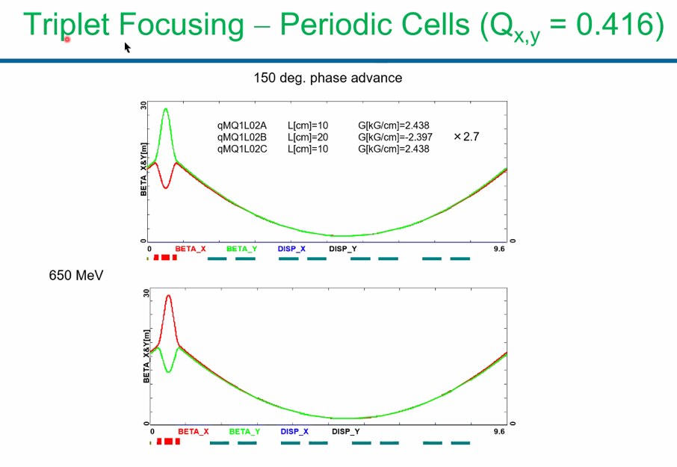
  + 1 cryomodule, 4 RF cavities, and 1 triplet per cell
  + 150 degree phase advance per cell
  + Scale quads as you progress through linac
  + Use “twin cells”: +-+ then -+- in successive cells
    - Enhances the stability
* 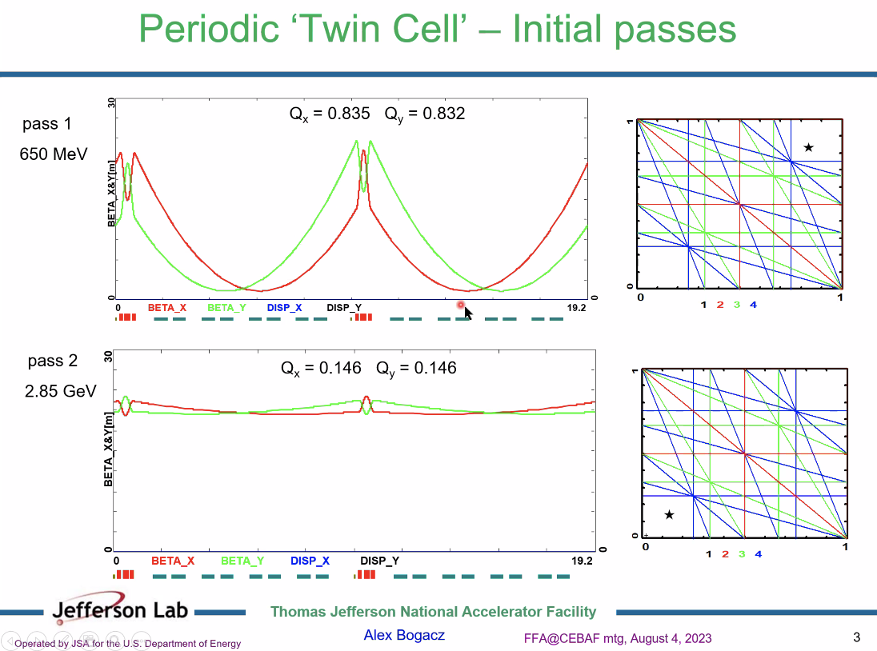
  + At pass 1, tune is upper right corner, but at pass 2, it’s in the lower left corner
  + Not on any resonances
  + Start getting FODO-like behavior as passes increase due to twin cells
* Scott: b/c of the energy ratio – no matter what you do, it’s basically the same
  + Really only the first pass that anything matters for, b/c once you’re in higher passes, you’re taking what you get
* Dejan – look at betas – it’s only 30 m (but only 2nd pass)
* 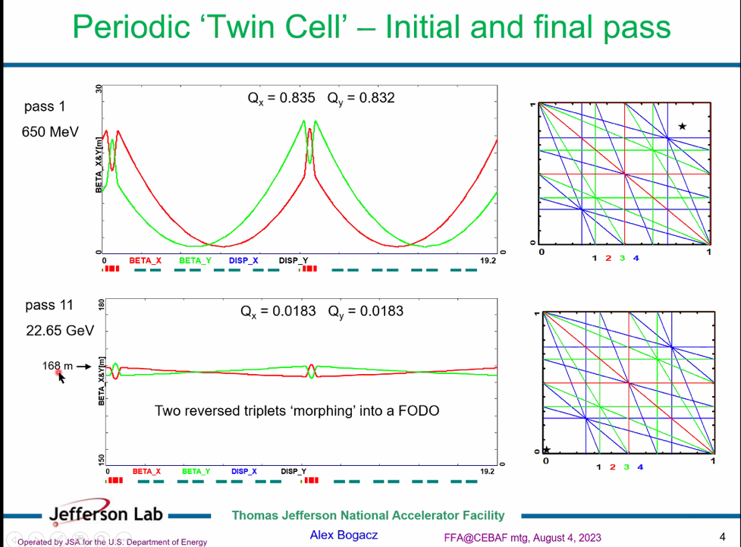
  + This is pass 11 – get 168 m beta
  + Dejan – I got 80 m at 22 GeV – I’ll pull out the files
  + This is only the periodic solution but it’ll get muh lower at the end
* 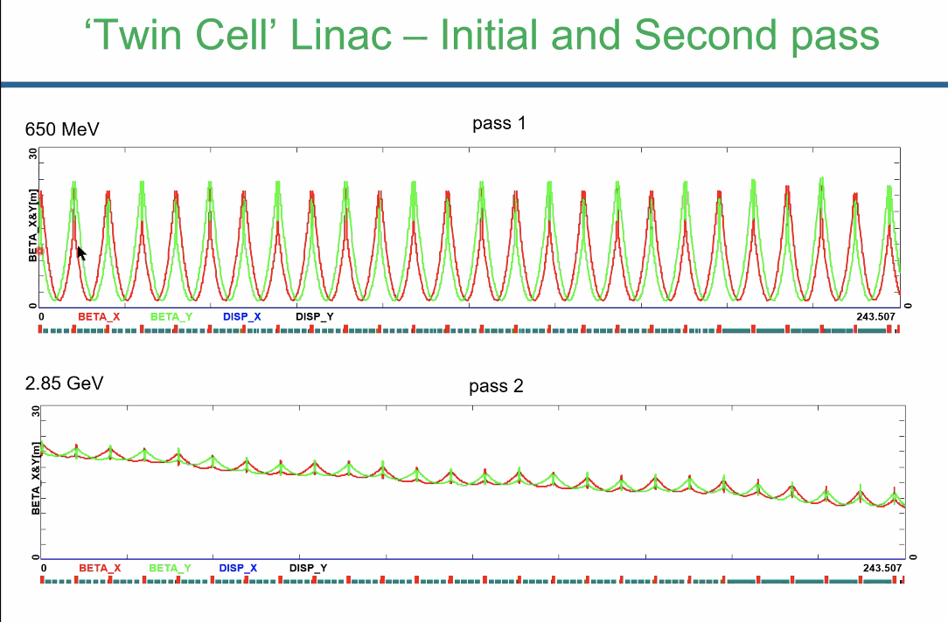
  + Lowest pass maintain periodic solution
  + Beta functions are small in pass 2
* 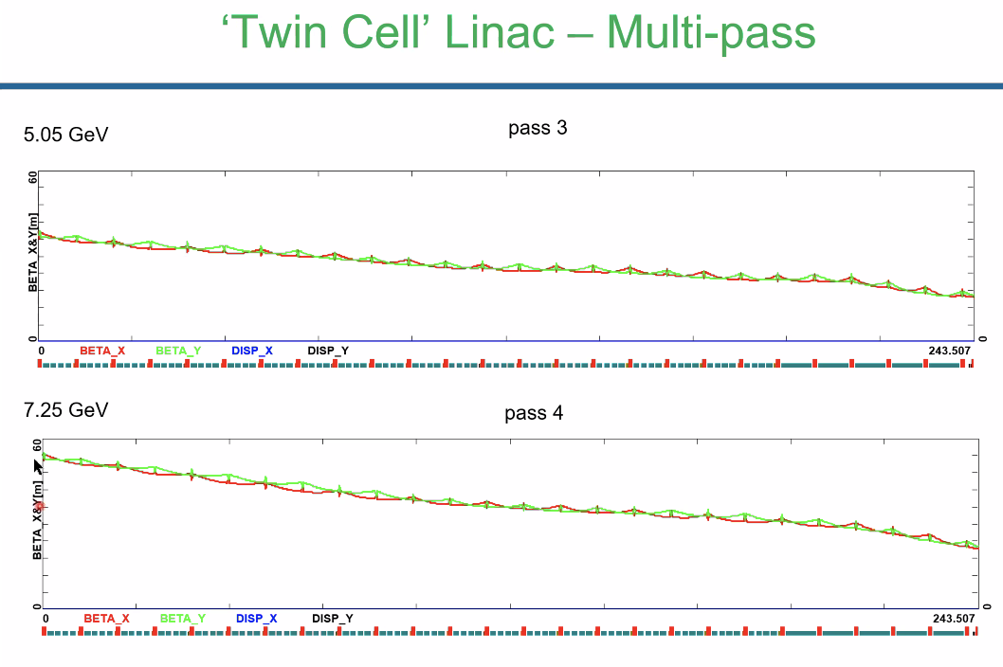
  + This is easily matchable to spreaders
* Now, we have to look at the FFA passes – what will be the optics when we append the recombiner and spreaders on each side
* 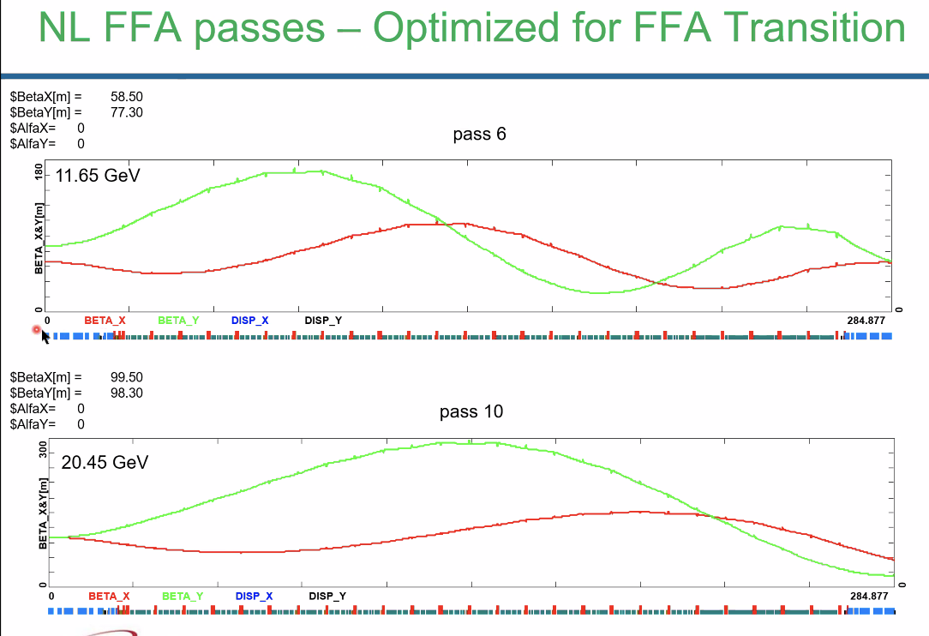
  + These include the recombiners and spreaders
  + Betas shown above, and alphas are 0
* These are based on the github spreaders/recombiners
* Optimized so alphas are 0 into recombiners, and betas are under 100 m
* 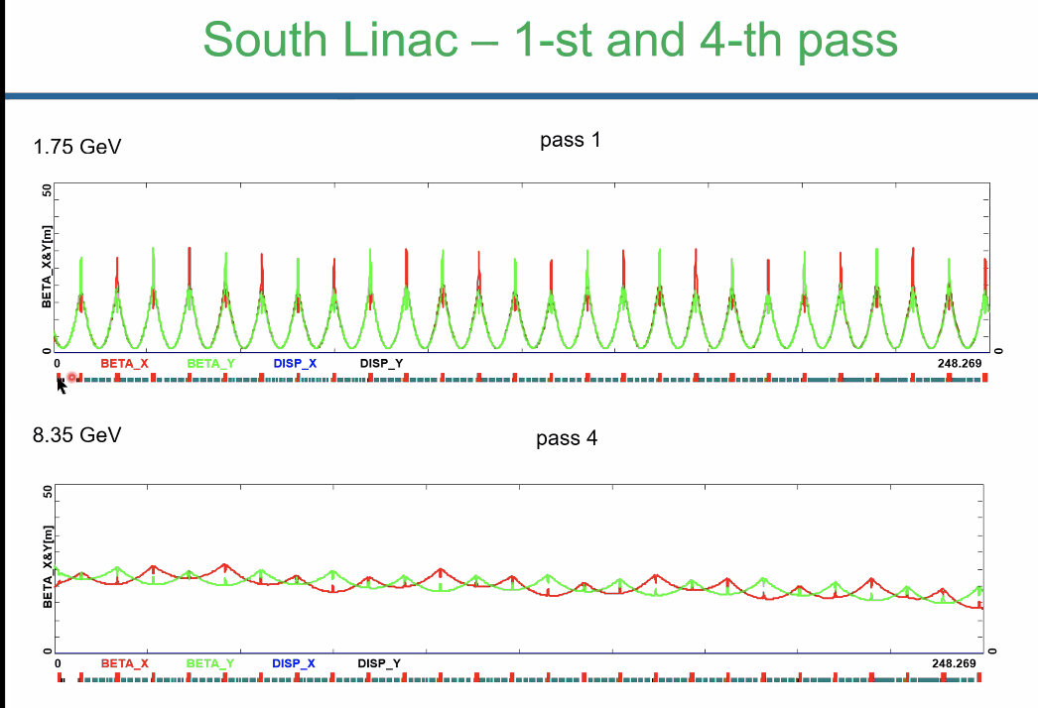
  + Same idea for SL
* 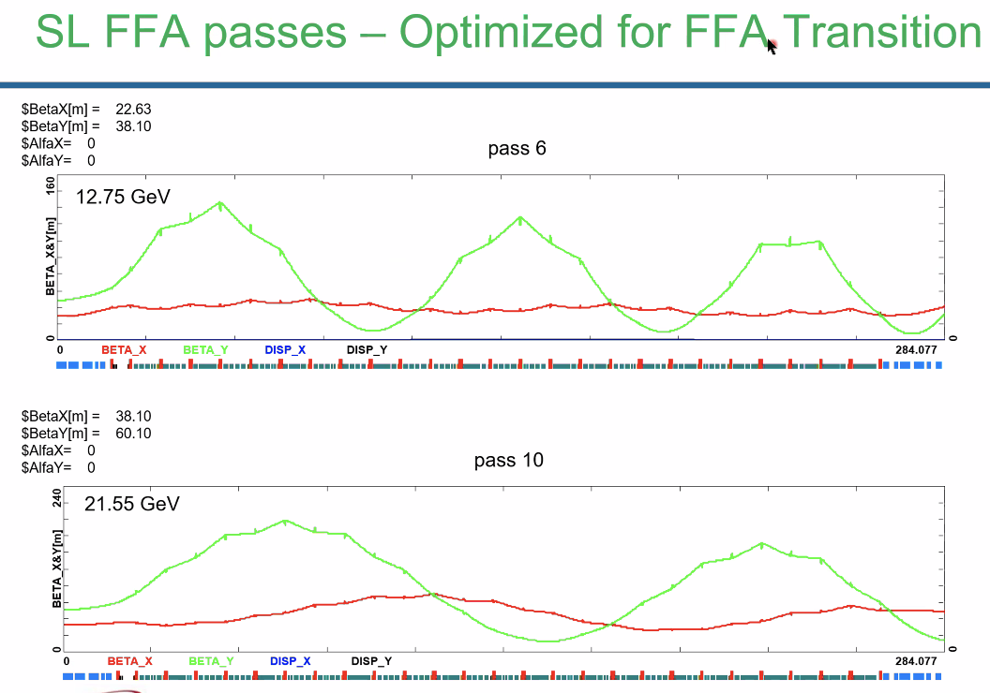
* So betas are much lower – the linacs are no longer “drifts”, but the betas are all manageable throughout
* 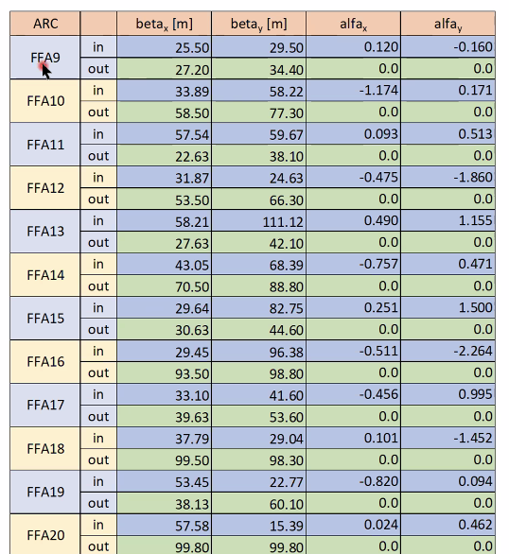
  + 6 FFA arcs on East Side – everything beyond the spreaders
  + Odds are east, Evens are west
  + Alphas are all 0 on output of arcs
  + Blue goes into spreaders
  + Alphas into splitters are nonzero, but they aren’t outrageously steep
* Will post presentation and spreadsheet
* “Treat 0s with grain of salt” – it was an optimization target. But they don’t have to be. There’s a level of flexibility
* Alex B likes the diagram b/c it helps us to navigate.
  + We’ll need to modify pieces as we go.
* Reza – you’re highest value for beta is FFA13. Does that mean anything, or is that just a different part of the sign wave?
  + Due to forcing things on the upstream side, the downstream side didn’t end up on the node, but more of the maximum of the beat
* Dejan – there’s a small problem here. I look at the exercises from long ago, and I was wrong – the max at 22 GeV was 190 m in the triplet configuration.
  + What bothers Dejan, no matter what we do, we have to get out via the vertical spreaders. Can the betas be smaller after that?
  + Alex B – those are included here. It’s a drift for the FFA passes
  + Dejan – let’s say we come out of the linac with alpha 0, then you have the vertical spreader
* No longer keeping a periodic, flat solution, because it constrains the ends too much, and limits the matching.
* Misunderstanding – the spreaders/recombiners for the FFA passes go through the same magnets

|  |  |  |
| --- | --- | --- |
| Action Items | Person responsible | Deadline |
|  |  |  |
|  |  |  |

## Time allotted | 10 mins | Agenda topic AOB | Presenter All

* FFA workshop will also have remote registration, starting the 10th
* School will be almost fully in person, but remote might be a bit necessary
* Several students registered
* FLASH therapy speaker – what’s happening there?

|  |  |  |
| --- | --- | --- |
| Action Items | Person responsible | Deadline |
|  |  |  |
|  |  |  |

## Special notes

Pathway to Repository: <https://jeffersonlab-my.sharepoint.com/:f:/g/personal/tristan_jlab_org/EqZ5MeS-nipCgPfZB5p0oS4B9Is67d3nQb9sLJI3Zyev9g>