FFA@CEBAF Working Group|Minutes

## Meeting date | time 08/11/2023 | 11 AM EST | Meeting location <https://jlab-org.zoomgov.com/j/1614898082?pwd=TnUzMS81M2sxbDZIbERJU01tYkJCQT09>

|  |  |  |  |  |  |  |  |  |  |  |  |
| --- | --- | --- | --- | --- | --- | --- | --- | --- | --- | --- | --- |
| |  |  | | --- | --- | | Meeting called by | Alex B | | Type of meeting | Weekly Meeting | | Facilitator | Alex B | | Note taker | Ryan | | Timekeeper | Alex B | | Attendees  Alex B, Ryan, Alex C, Todd, Edy, Scott, Vasiliy, Stephen, Donish, Randy |

# Intro Discussion

* LDRD Defense yesterday – went well. Ryan made mid-course corrections to emphasize that they’re hardware tests.
* FFA workshop planning underway. Still registering. Ryan may get a magnet talk if it fits
* Remote registration starting

# Agenda topics

## Time allotted | 25 mins | Agenda topic FFA Correction | Presenter Alex C

* To be honest, the talk from Annika last week is a rough draft to the FFA23 talk Alex C will give
  + It hasn’t changed much
* To expand a bit more
* Still translating multipass algorithm from CBETA – it’s in Matlab
  + Adapting it to the CEBAF specifics
* If we freeze 5-6 BPMs at the end, it should work
* Cool thing about transferring that algorithm into a NN structure:
  + If you do SVD, you need to iterate
  + If you take the correct set of training parameters, and the right “shape” of data that you want to train (ML), and traing it well enough, you then read in BPM readings, and it spits out the kicks you need in one step.
  + Immediate and no need for further computation
* Annika alluded to this, and Alex C saw in previous work: NN are better at adapting to situations that become not-quite linear.
  + Ex/ in a pendulum case, as small angle exits the regime, the NN can “hang onto” it a bit longer
* Hope with multipass steering and optics corrections, we can keep the beam a bit closer to the design orbit regardless of what happens in the machine.
* Alex B – could you remind us, in each cell?
  + 1 Panofsky and 1 BPM per cell – this is a starting point
* Also – side note: updated the LDRD Github with current baseline and minimally corrected lattice (1BPM and 1corrector per cell)
  + Can access through Github or via sharepoint
* Alex B – do you want to show us the files?
* Sure – Annika showed results last week. Have more, but been working on structuring the training data, which is surprisingly complicated.
* Go to sharepoint, optics, cebaf, bmad:
  + Spreadsheet shows entrance optics for each arc
  + The txt file shows instructions to download the “right” baseline lattices
* DON’T TOUCH THE TESTING FOLDER
  + Can download and play, but don’t change anything please.
* Questions on organization/structure of GitHub
  + Cloning/Forking discussion – Fork is fully public
  + Cloning – remember to back your stuff up!
* We’ll look into a full-reorg of the GitHub
* Some restructuring has taken place, but needs a bit more.
* Use “git move” when moving files – it keeps the history!
* Going back to the NNs – they’re undeniably a good idea for beam dynamics corrections.
  + If can show they’re as good or better compared to a typical (SVD for example) correction
    - Can show a minor example already
  + Alex B – been doing SVD style at CEBAF
  + Alex C – single pass with only 1 variable, networks are training in 30s to 1 minute. Roughly 20% of time it takes to produce the training data itself
  + This can be a lightweight, power saving method to do corrections!

|  |  |  |
| --- | --- | --- |
| Action Items | Person responsible | Deadline |
|  |  |  |
|  |  |  |

## Time allotted | 25 mins | Agenda topic Magnet Prototype | Presenter Stephen

* Gluing things together in a special way. The new magnet isn’t much different from the first magnet
* Not much to present
* If we get the LDRD, would be great to have the prototype(s) to test

|  |  |  |
| --- | --- | --- |
| Action Items | Person responsible | Deadline |
|  |  |  |
|  |  |  |

## Time allotted | 10 mins | Agenda topic AOB | Presenter All

* Going “off script” from the agenda.
* Alex C’s share was overwhelming, so good to hear today about how to use it.
* A week ago, Ryan shared a document about the initial layout of the NE splitters
  + A layout of magnets, etc…
  + We’ll be using this as a starting point for the optics
* Initial update changed already from the email sent around.
* While gone, we tossed some ideas around about extending it horizontally to take the full aisle and put overpass over it. Could also put them at floor height instead of LINAC height
  + Three problems (not show stoppers, but significant) (from discussions with Edy, Kirsten, and Harry Fanning):
    - Splitters are at LINAC height, and so building ramps over them would not only be difficult, but would bring people into a different ODH zone in the tunnel. The angles needed to “get over the hump” with 9 m cryomodules would also require a very long ramp, taking up a huge section of the tunnel
    - If at floor height, would then have vertical dispersion to close, either before splitters or in the splitters
    - If at floor height, would not be able to extract down, and extracting up may interfere with lower energy passes.
* 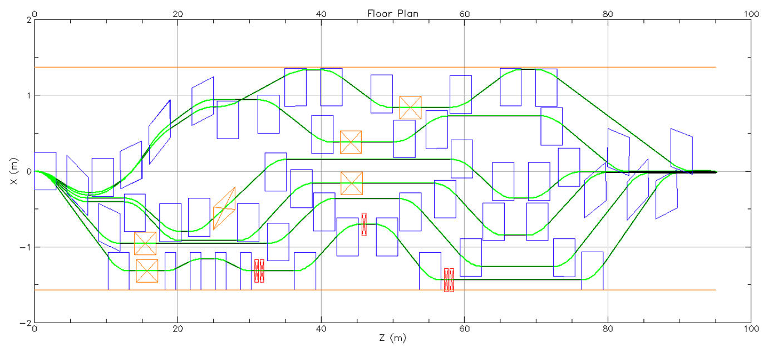
  + Using some of Dejan’s math, which assumes that WITH NO QUADS, path length and R56 are order of magnitude the same
    - Scott: You should not be targeting R56, because once you add quads in, the R56 will mess this up
    - Ryan: this was just my first way to see how I make changes to get close by hand. After I add quads, I won’t be targeting R56, but time
* Ryan Question: reference time or time?
  + Scott – you want time. That’s the time on your watch. Reference time is based on orbit, and is a moderately random number.
  + Ryan – OK good, so I’m using the right one
* Ran Alex C’s FFA lattice, the spreader (and multiplied by two), and left a cell blank for the transition lattice when it comes later:
* 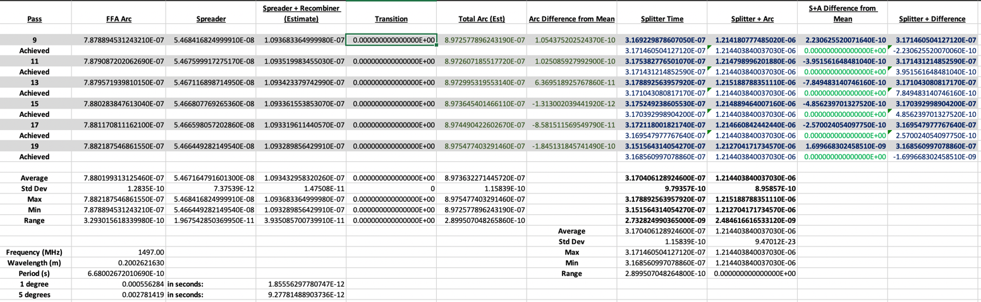
* Got real numbers out (time and R56)
  + Will add in the numbers once Randy and Vasiliy are done
  + Took the mean of the times from the passes so that I can make the all arrive at the same time, or an integer number of wavelengths out (reminded by Scott as well)
* This is where Ryan will do “fine tuning” likely not by hand anymore
* Spoke to Yves and Brian Freeman – throughout the year, we do no more than 1 cm of TOF corrections right now.
  + Assuming keep things within a degree
  + Math is still in the works – making minor corrections.
* Once I finish the math, I’ll refine the lattice based on TOF
* Alex B – Agrees with Scott – R56 will be irrelevant once you add quads
* Ryan – Just to hammer home, once quads are present, I won’t be using the R56 method. This is just the initial way I did it to set things up closely by hand. Once the quads are present, I’ll be using time.
* Alex B – looking at the configuration (Kirsten’s diagram), the transitions are at the other corners of the arcs. You go into FFA from the splitters.
  + Ryan – This exits the spreader, enters the splitter, then enters the arc, then the transition. I need to include a space in my spreadsheets for the transition lattice time. The splitters will need to be included. I’m leaving space so I can drop in the transition values and adjust more quickly.
* Stephen: where are you putting the splitter in this design?
  + LINAC height, splitting horizontally
  + Bottom orange line is the personnel clearance requirement
* Caveat: all dipoles here are half meters square, but don’t have to be. They can be adjusted, and some will need to be. Not saying it’s all perfect, but it’s all based on magnets that were conservatively designed by Jay.
* Stephen: are you colliding with the existing lines in the tunnel?
  + Ryan brings up songsheet – may have to move auxiliaries/cables, etc…
  + Todd points out that row D shows the overhead with walls
  + 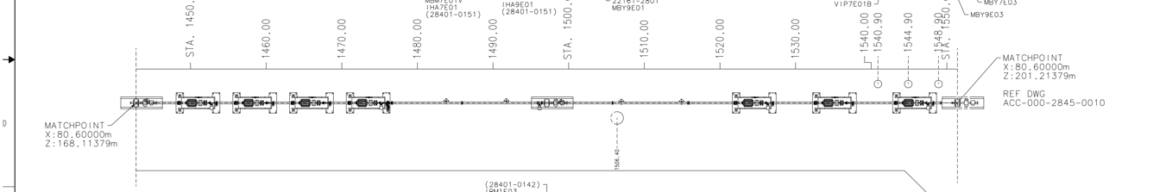
  + May interact with auxiliaries, but not beamlines
  + LINAC height is at y=100 m, but floor is below that.
  + 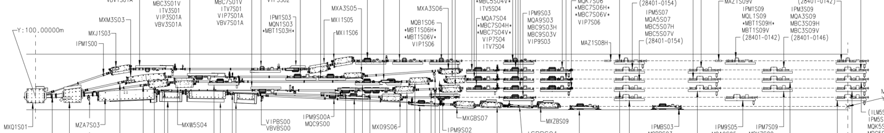
    - We’ll be on the 5th line down (EM line), and this creates the vertical slot for the splitters
    - 1-4 and likely 6 will still be there, and 5 is replaced with the FFA passes
* Hall D is a question – extraction will be an issue. Might be D can’t run when we run A/B/C. Not sure
  + Alex B – D will get one linac less than the other halls
  + Ryan – yes, but D has no RF separator, so we’d need to add an RF separation scheme on the D side to kick it out, but it’s hard at that energy
* Reserved space (orange boxes) are unpowered dipoles to extract the beam vertically down. In the code, I say how much space the need to clear downstream magnets.
  + Will need to bend down, then over toward the wall (up in the floor plan), then up via vertical RF kickers to go up to height and separate into the different halls.
  + This space is reserved, even though this is the NE Splitter, so that I can make the NE and SW splitters have the same geometry and scale magnets.
    - Won’t need the orange ones in the NE corner, but kept them in to make NE and SW same
* Also started “feeling” where quads can go in. Placing for space, not purpose.
  + 53 cm long, go up to 5.1 kG each with 20 A power supply. Wanted to see where they squeeze in
  + Scott – integrated field? Yes
* Alex B – looking at dispersion, we can put the quads where we have large dispersion and real estate.
  + Ryan – Yep! This is the plan.
  + 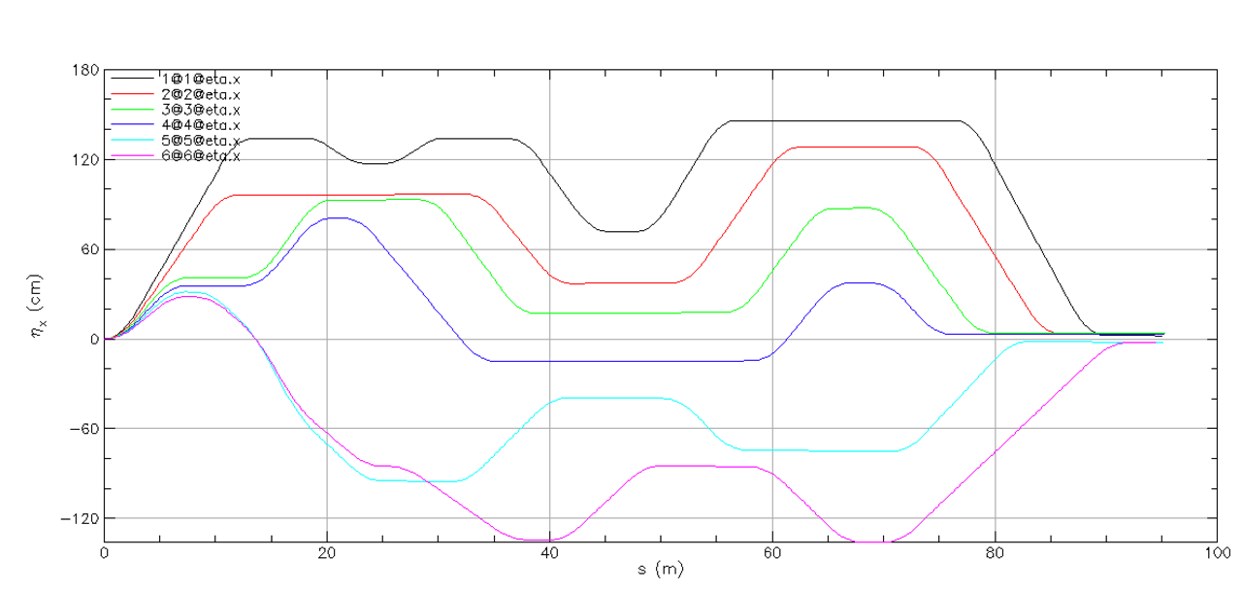
    - Roughly going up to ~150 cm and down to ~-130 cm without quads
    - Scott – this will change with large quads
* Scott – quick math (emphasis on quick part)
  + If you have a half a Tesla magnet, that has a 150 m focal length at 22 GeV. You need magnets that are capable of something in the 20-40 m range (Ryan thought he meant Tesla and dropped his jaw)
  + Need to be capable of 3Pi phase advance down the line. Easy thing to do: lay out evenly spaced 8 quads in a FODO. Get 3Pi/4 phase advance per cell, then add overhead on that. It’s going to be a big magnet
    - Yes, these are already half a meter long – might be higher quality/stronger ones, but yeah, we’re going to need big magnets
  + Go through the calculations, then find someone that can do a 2D design
* Stephen – here you could think about adding SmCo to help
  + Scott – issue with be adjustability
  + Alex B – make a hybrid
  + Stephen – half permanent half electro
  + Scott – doing that commits to a specific solution
* Ryan – I’ll start playing with bigger/stronger magnets. The downside is that they’re not going to be able to be wide, which means they’ll need to be really long. We have more longitudinal space
  + Really don’t want more than 1 m long
  + Scott – you’re probably going to need 1.5 – 2 m magnets
    - Ryan – that’s going to be limiting for placement!
* Scott – if you can have a small gap in the quad (small beam pipe), that can help
  + That also depends on adjustability
* Ryan – One thing I took to heart from discussions with Scott is making sure some dipoles are on movers for path length compensation
  + They’ll have to move together, and some places are very tight
* Again, they don’t have to be half meter square dipoles transversely. We can re-distribute steel and change them around
  + This is why I chose this dimension, to make space.
  + That’s why we did geometry first, to see where and how we can squeeze stuff in
* Scott – the other thing to remember here – bellows are so large that the space become off limits for anything else.
* At first, wanted to recombine everything with common dipoles like in upstream side. But then there are less places to put independent quads!
  + Scott – don’t put them all in one line though!
    - Ryan – jokes – it’s tempting because all my previous IP work!
  + Scott – try to uniformly place them
    - In CBETA, we had a lot of doublets
* Alex B – since we’ll have a vigorous development by many people, this is the baseline layout for now, so this is available in GitHub?
  + The previous version is, where ONLY geometry was done, is available.
  + Once I clean this version up and correct path length, I’ll update it again.
* Alex B – let’s make sure everyone has the same source
  + Yes, this is available, and I’ll clean it up soon and update again.
* Ryan – I recommend superimposing quads, because it makes it much easier to place them and move them.
* As a heads up – be careful if you play with dipoles. There are lots of patches which depend on other things, and changing them might change the positions of magnets.
* Stephen – did you use absolute coordinates?
  + I split patches into pitch and offset. The offsets are used to mainly make sure none of the magnets are colliding.
  + I can spit out coordinates as well
    - Useful for other codes
  + The cords are on GitHub too
* Stephen – if you need a lot of quads in one place, you can use combined function magnets
  + Dipoles can be combined function
* Ryan – not opposed
  + My design philosophy is KISS – Keep It Simple Stupid
    - I try to start with things as easy as possible, and once I cannot find a solution, I then add in more complexity as needed.
* Alex B – thanks. It was great and unscripted.
  + We’ll all have fun looking into that
  + Ryan – give me a bit of time to clean up this one. The one I sent out last week is usable, but I didn’t adjust path length yet.
  + Alex – clean it up, and let it go public. Waiting a bit isn’t a big deal

|  |  |  |
| --- | --- | --- |
| Action Items | Person responsible | Deadline |
|  |  |  |
|  |  |  |

## Special notes

Pathway to Repository: <https://jeffersonlab-my.sharepoint.com/:f:/g/personal/tristan_jlab_org/EqZ5MeS-nipCgPfZB5p0oS4B9Is67d3nQb9sLJI3Zyev9g>