FFA@CEBAF Working Group|Minutes

## Meeting date | time 08/18/2023 | 11 AM EST | Meeting location <https://jlab-org.zoomgov.com/j/1614898082?pwd=TnUzMS81M2sxbDZIbERJU01tYkJCQT09>

|  |  |  |  |  |  |  |  |  |  |  |  |
| --- | --- | --- | --- | --- | --- | --- | --- | --- | --- | --- | --- |
| |  |  | | --- | --- | | Meeting called by | Alex B | | Type of meeting | Weekly Meeting | | Facilitator | Alex B | | Note taker | Ryan | | Timekeeper | Alex B | | Attendees  Alex B, Ryan, Andrei, Edy, Randy, Reza, Todd, Kirsten, Vasiliy, Donish, Dejan |

# Intro Discussion

* FFA23 is 3 weeks away – 35 in-person participants
* 5 remote participants
* Industrial presentations – 1 in person
* Can non-students “sit in” on the lectures
  + Yes – everybody is welcome to do so
  + Open to interested parties
* Bit of a scheduling crunch
* Since everything is complicated, want all the good ideas we can – Andrei spend USPAS with some students working on green field FEL
  + Ideas from this for splitters

# Agenda topics

## Time allotted | 25 mins | Agenda topic Alternative Splitter | Presenter Andrei

* Don’t know if it’s a great idea or a stupid idea
* 1 week course at USPAS mini-project.
  + Like a mini-CEBAF
  + Need 1 GeV energy, only 2 cryomodules – recirculate 5 times
  + Inject on-orbit with laser-plasma
  + Use FFA arcs to recirculate
  + Avoid using spreaders/recombiners
  + Keep bunches at the right RF phase
  + 1 option:
    - Different path lengths for different orbits
    - “Jump” RF buckets
  + Another
    - Delta+length after 5 passes should be small enough, so on-average you’re “on crest”
* Thinking – can we do something differently?
* 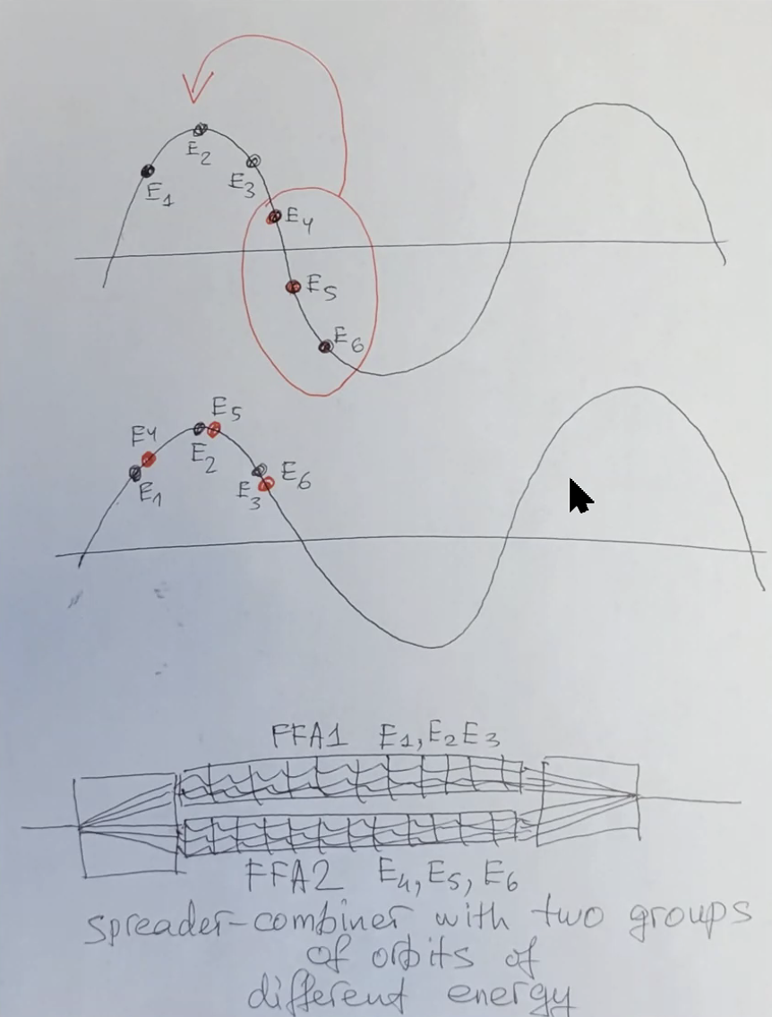
  + Split into two groups of 3 orbits
  + In between, two sets of FFA orbits to separate and bring back
  + Make the E4-6 “jump” to the accelerating phase
  + Spread beams, then catch 3 in each into a mini-FFA, then recombine and put into the main FFA arc
* This would correct timing (Reza)?
  + Yes – you’d use this instead of splitters
  + Correct path length of 3 passes WRT the other 3 passes
* Alex B – this would take into account the timing issue, but doesn’t address all the issues: R56, etc…
  + Interesting element
* Dejan – let me go back to your previous (Stephen’s solution) – remind me on the harmonic number jump so you can switch the arrival by switching harmonics
  + Problem is much larger ToF difference
  + In our case, the ToF difference isn’t very big
  + There are cavities that can do this
  + Other ideas for ToF and R56
    - Alex/Vasiliy – design an FFA such that every energy comes back to the end of the arc at the right time WRT the RF (dogleg?)
      * Vasiliy – that was for 2 pass muons only. We skipped over one wavelength
        + For electrons, c is constant
    - Dejan – would be possible with a lot of effort
      * Maybe instead of FODO-like design, we use a 3 cell FFA arc design to address longitudinal dynamics
        + This would also accommodate ToF and R56
      * Need 3 cells to combine different energies and correct R56
        + Good program can maybe do it
        + Then you don’t need splitters at all!
* Alex B – for our case, for 6 beams, what’s the extent of the phase spread?
  + Dejan – largest wasn’t that bad maybe 6 cm
  + Ryan – shows spreadsheet with Bmad values from Alex C’s FFA arc (current baseline)
* R56 below:
  + 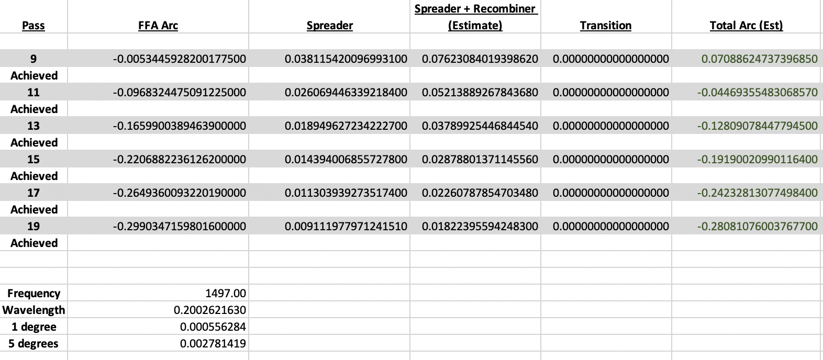
* ToF below:
  + 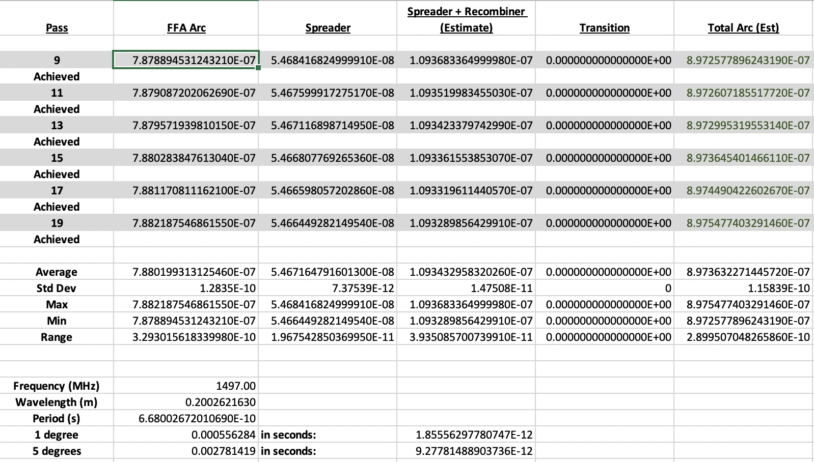
* Transverse deflecting cavities for the diagnostic line – Kirsten has experience
  + Can we use this to push particles longitudinally back and forth
  + Kirsten – that’s not really what it’s for
  + Dejan – can introduce a transverse difference and then use it to translate it into the longitudinal kick
  + The amount of RF kick you need for these energies would be huge
    - 8 normal conducting or 1 SC transverse deflecting cavity
    - May be how we need to implement it. Might not need as strong a kick as needed.
  + Vasiliy – chirping cavity used at zero-crossing
    - Combined with R56 would do a rotation in longitudinal phase space
* Reza – the timing would be different for each energy?
  + Yes
  + How?
  + Kirsten – instead of being a full 2-Pi, the ToF is not 2Pi, so it’s jumping around the RF curve
  + Question about relativistic vs. non-relativistic particles?
* Maybe we need to change FFA arcs to eliminate splitters
  + Splitters are always a mess. It’s a nightmare
  + Andrew Hutton insisted to get it done in the arcs
  + Maybe use 3-cell setup instead
* Vasiliy – parametric resonance approach – excite a certain energy in the arc (find a brute fource solution)
  + Increase orbits until path length differences are integer number apart
* Let’s say we have 100 cells and 5.4 cm total difference, so per cell it’s only 100 times less to allow the difference
* Would be nice to do it systematically – the parametric method may let you do it per energy in the FFA arc
  + We can excite a closed-orbit path
  + No feeling for total range
* Dejan – when designing LHeC rings, Stephen came out with a solution of different orbits/energies (1000 m radius)
  + Small dipole kicks and phase difference could manage it
* Vasiliy – find two places in the ring (90 degrees apart for a specific energy)
  + Kick them to get the right time
  + Complicated by multiple passes, so you have to address each pass and correct for the other passes at the same time
  + Excite orbit so that effect on all other orbits cancels out
  + Similar to Stephen’s idea, except that when you have 2 kickers, if you try to correct one orbit, all the others are hit
  + Dejan – published in a conference with Stephen doing this
* Kirsten – If we’re taking this approach, there’s no standalone control of anything within the arcs, other than the correctors on the arcs
  + Concerned that no control and no diagnostics
* Dejan – how far off closed orbit can you get?
  + Moment you get off closed orbit, you get into trouble
  + You’ll still be in the linear region (field dependence is linear) – large DA, so you can move the beam around
  + How much change will you need?
* Ryan – I share the same concerns as Kirsten
  + We could add more correctors, but if we are off the closed orbit far enough, how can we recover it?
  + We’ll lack diagnostics
* Positive and negative R56 can be controlled in the FFA with more cells
* Ryan – let’s not forget that we still have spreaders/recombiners on either side, plus transitions, that we’ll need to also accommodate in the FFA arc
  + We need to get the 6 passes INTO and OUT OF the arcs
* Kirsten – this option would mean the only place to fix transverse optics is to go back to the previous arc
  + Vasiliy – I think we’d need splitters for optics still, but not to compensate for R56/path length
  + Ryan and Kirsten – that would be great!
* Dejan – if we could do transitions on both ends on the arc, we could be fine
  + Alex B – I think that’s optimistic
* Dejan and Ryan like the KISS philosophy – Keep It Simple Stupid
  + The splitters are probably the solution, but they’re always hard.
  + If we can get rid of them or simplify them, that would be an excellent bit of progress
  + Andrew Hutton was right! Get rid of that!
    - Alex B – 18 beam lines are a bit too much

|  |  |  |
| --- | --- | --- |
| Action Items | Person responsible | Deadline |
|  |  |  |
|  |  |  |

## Time allotted | 25 mins | Agenda topic Transition | Presenter Vasiliy/Randy

* 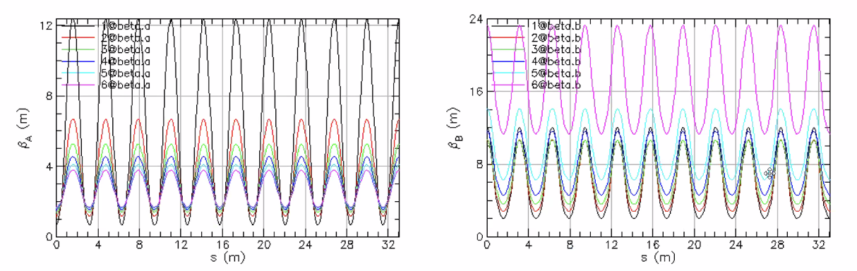
  + Transition section in its original state
  + For simplicity, assuming we’ve suppressed all orbits/dispersion and made colinear
  + This is regular FFA cells with dipoles turned off
  + Matching at end (x and y always at opposite max/min)
    - We WANT a round beam in the linac
* If we assume beta-y is min:
* 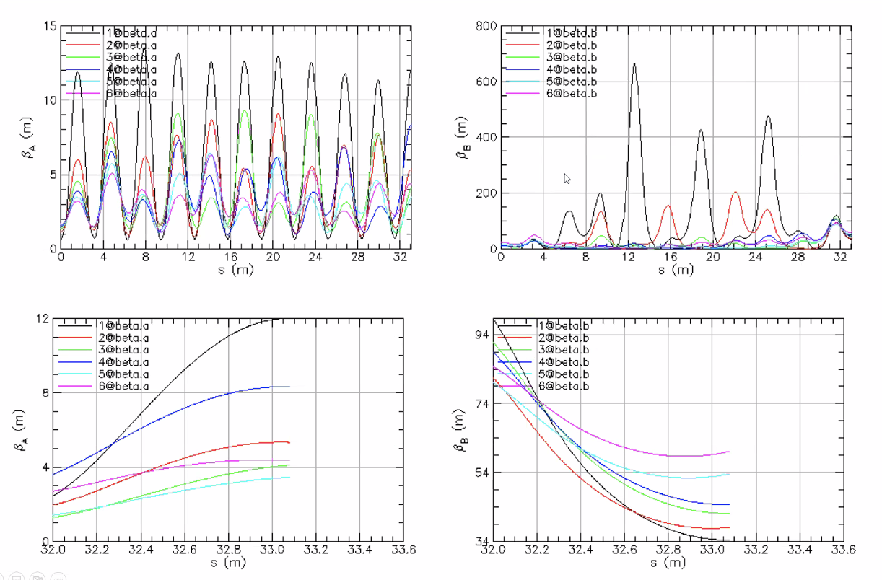
  + Bit excitation of lowest E
  + For high E, phase advance is small, cannot afford several betatron oscillations for highest E – so brute force highest E to expand
* Parametric kicks at maximum of BetaYs
* Couldn’t make all alphas zero, but they can be at least made to be negative
  + Want larger betas at the end of the recombiner
  + Alex B provided the values above, but we couldn’t match with alphas=0
    - Alex B – zero alphas are “soft”
* 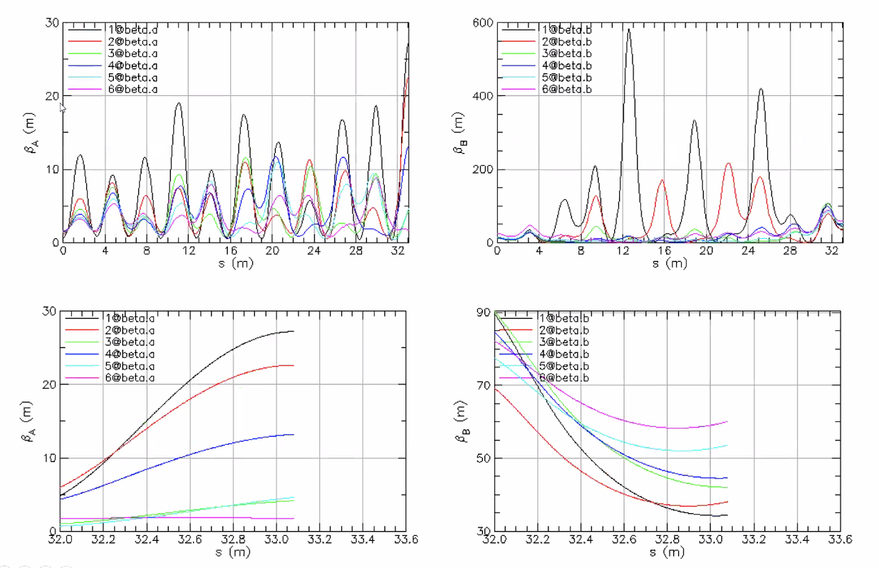
* Now looking at BetaX
  + Matched two lowest E ok. Alphas are 0, betas from Alex B
  + Higher energies aren’t converging
* 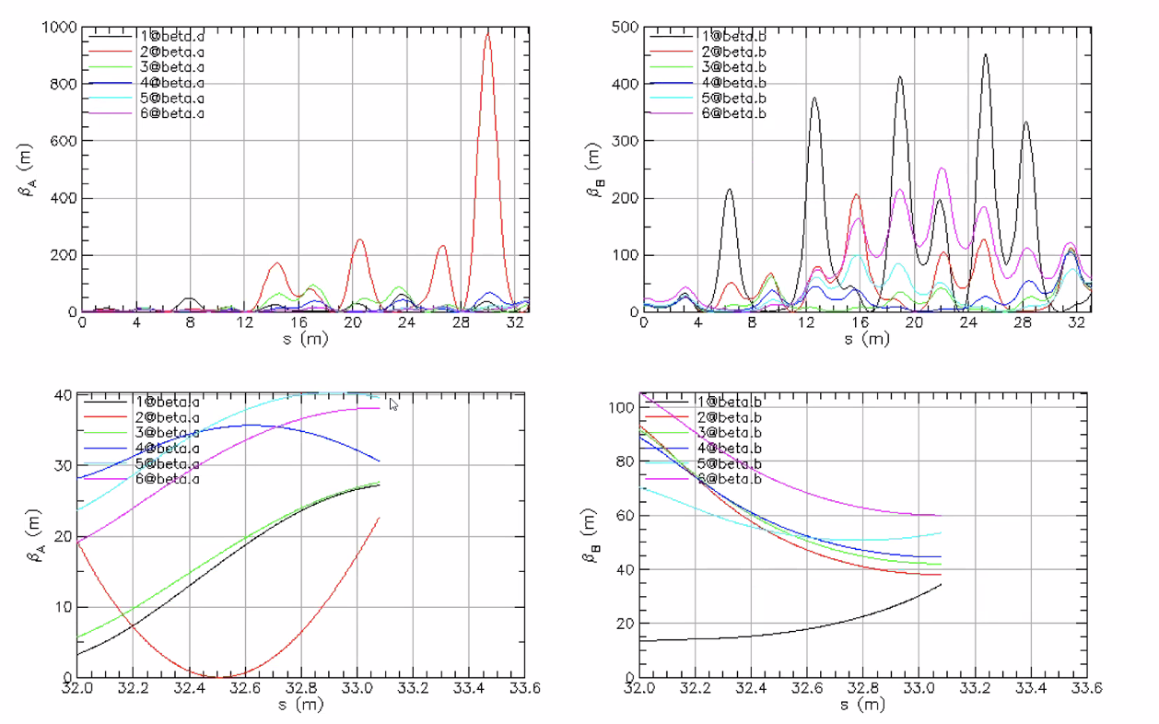
  + Removed alpha constrains, and only matched to betas
    - Trying to get a feel for what beta values needed
* Give Alex B the desired Alpha/Beta values and he can update
* Ryan – have we tried re-matching the weakly-focusing linac?
  + Alex B – we don’t get enough phase advance in the weakly focusing to get the beta beating and get the beta values down for the higher passes
* 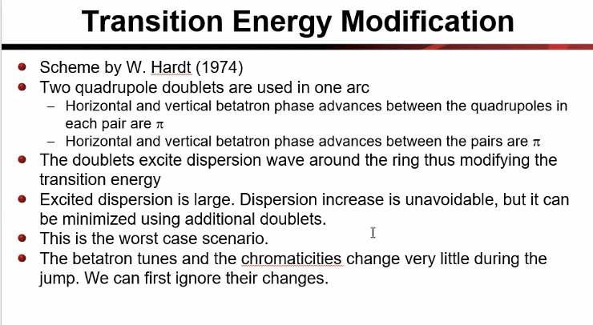

|  |  |  |
| --- | --- | --- |
| Action Items | Person responsible | Deadline |
|  |  |  |
|  |  |  |

## Time allotted | 10 mins | Agenda topic AOB | Presenter All

* Reza – if we could set up the line, so that different energies could be “caught” at different places. Then we can think of easier ways to think of the separation of the beams
  + If we can kick one energy instead of others at a specific place, might help extraction/separation
  + Idea of treating the beams differently gives ideas about extraction
* Dejan – this is quadrupole excitation on the beta functions – there is no bending
  + If you combine for different phases for dipoles to extract, then you could send one energy to a septum

|  |  |  |
| --- | --- | --- |
| Action Items | Person responsible | Deadline |
|  |  |  |
|  |  |  |

## Special notes

Pathway to Repository: <https://jeffersonlab-my.sharepoint.com/:f:/g/personal/tristan_jlab_org/EqZ5MeS-nipCgPfZB5p0oS4B9Is67d3nQb9sLJI3Zyev9g>