FFA@CEBAF Working Group|Minutes

## Meeting date | time 09/01/2023 | 11 AM EST | Meeting location <https://jlab-org.zoomgov.com/j/1614898082?pwd=TnUzMS81M2sxbDZIbERJU01tYkJCQT09>

|  |  |  |  |  |  |  |  |  |  |  |  |
| --- | --- | --- | --- | --- | --- | --- | --- | --- | --- | --- | --- |
| |  |  | | --- | --- | | Meeting called by | Alex B | | Type of meeting | Weekly Meeting | | Facilitator | Alex B | | Note taker | Ryan | | Timekeeper | Alex B | | Attendees  Alex B, Ryan, Dejan, Kirsten, Edy, Alex C, Scott, Todd, Vasiliy, Stephen, Reza |

# Intro Discussion

* As of yesterday – program is finished.
* 3 industrial speakers
* Got student support (lunch on first day)
* Alex C will help with Zoom, etc… on Sunday
* $2500 educational grant helps

# Agenda topics

## Time allotted | 25 mins | Agenda topic Energy Loss/Spread | Presenter Kirsten

* A few weeks ago, looked at splitter layout.
* Andrei provided alternatives
  + Stephen thinks won’t simplify, may not help
  + Will continue discussion
* Based on floor plan, Kirsten agree to see how the SR effects take into account (not transverse emit dilution)
* Just looking at overall budget for loss and energy spread with the splitters involved
  + Still no FFA Transition – so hoping not wildly different than equivalent FFA cells
* 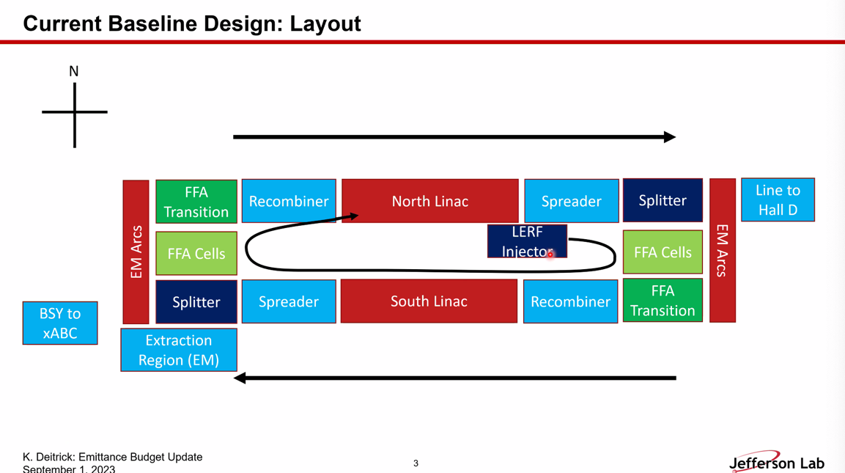
* 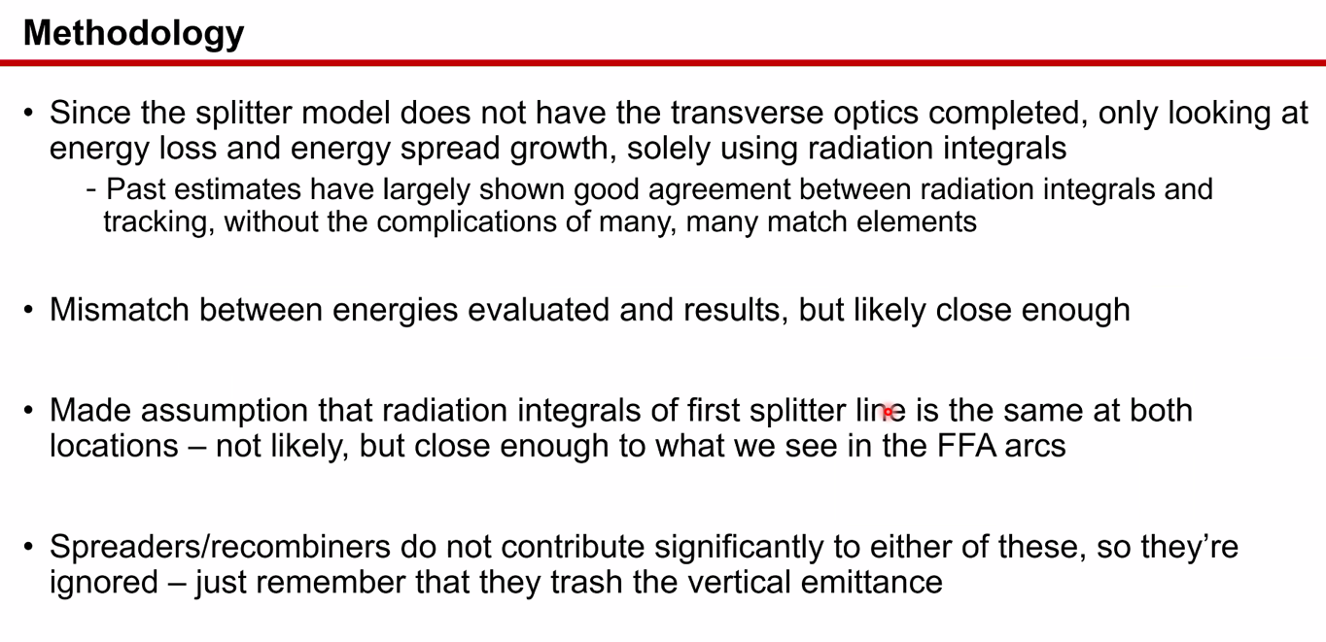
  + Radiation integrals change a little depending on energy, but all within ballpark
  + There is a splitter model (NE corner)
    - While it’s very likely the first line in NE and SW are similar, they won’t be exactly the same.
      * Radiation integral same, energy different
  + Spreaders/recombiners don’t contribute to energy loss or spread, just blow up vertical emittance
* 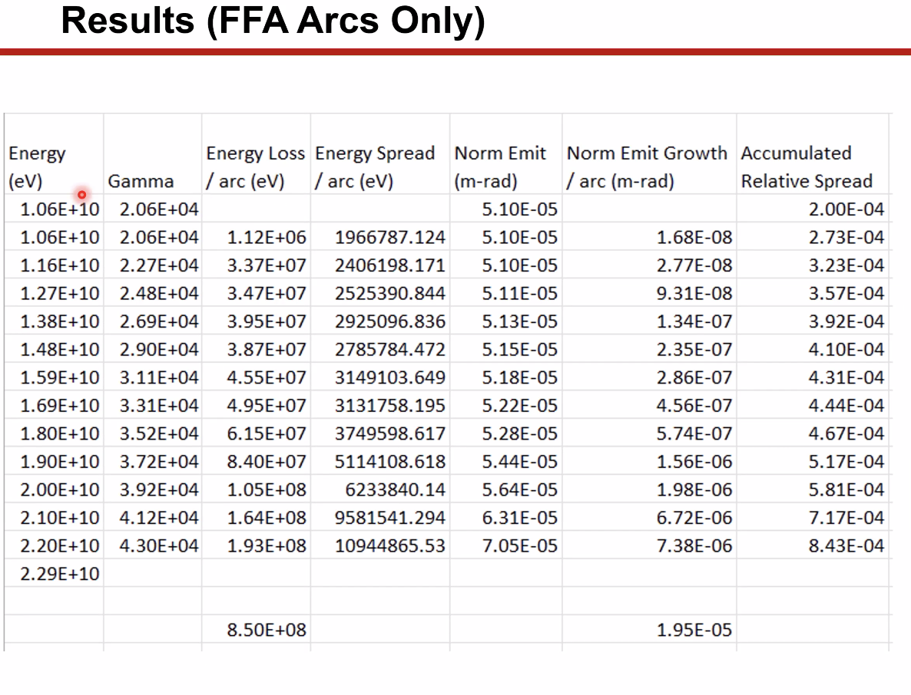
  + Easiest to look at accumulated relative spread (last column)
  + Lose about 850 MeV for all passes and get e-spread below e^-3
* 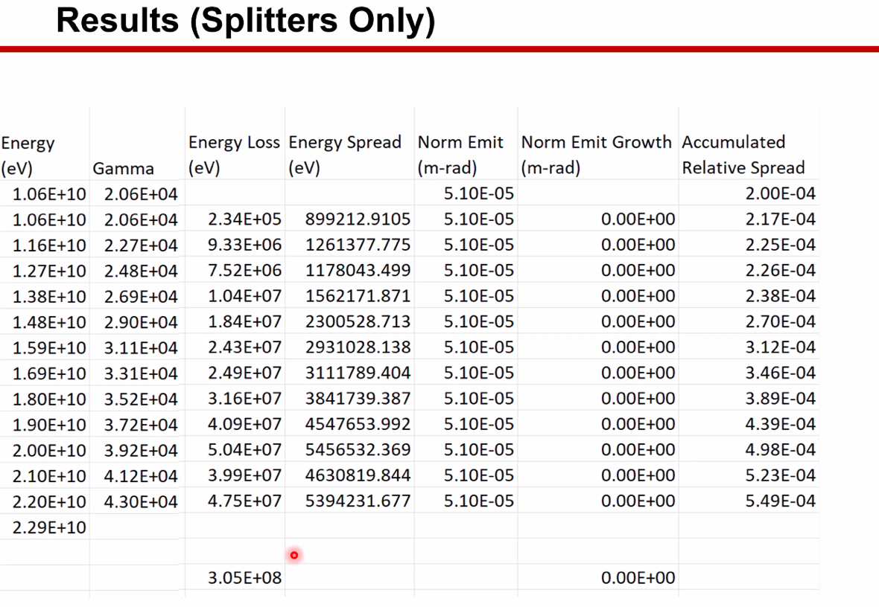
  + 300 MeV loss in splitters
  + 5.5e^-4 accumulated
* Combining it all:
  + 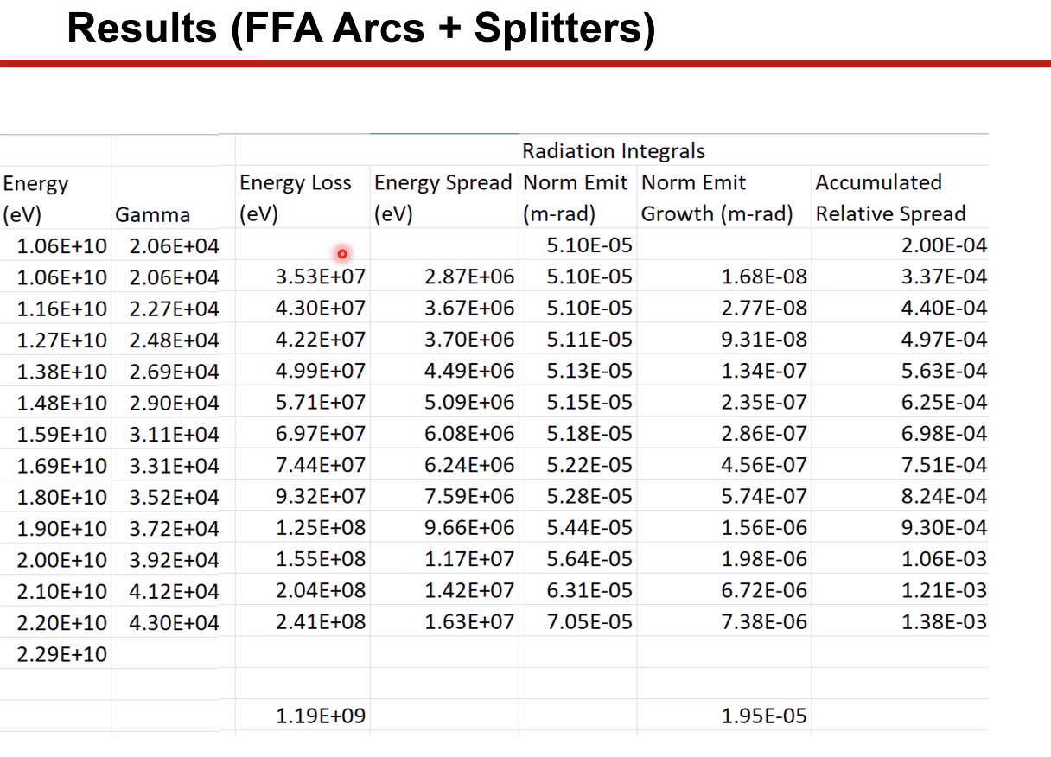
    - Loss of 1.2 GeV for all 6 passes
      * Number will come down b/c total from first column will come down
    - 1.4E-3 energy spread
* Alex B – this is a first estimate number – not too scary. Will have another splitter on the other side
  + Kirsten – no, this is for two splitters (with the assumptions listed above)
    - Integrals are similar for both sides – same ballpark
* Stephen – when I did this, I had to set it up to do each line feeding into the next line. Just using graph of energy loss from tracking (look up table)
  + Kirsten – That’s what I was doing with the FFA arcs alone
    - With the splitter, I didn’t do this b/c mildly concerned about changing in energy b/c patches might not handle that well.
      * Geometry will change due to energy?
        + Scott – that shouldn’t change the geometry
    - This is quick and dirty
* Can do more detailed study later, but this quick and dirty is good enough for this level
* Scott – will we target these energies and overshoot the linac? Or will we simply live with lower energies?
  + We’ll need to decide
* Kirsten – don’t make any assumptions with emittance growth b/c arc and splitter optics are very different
* 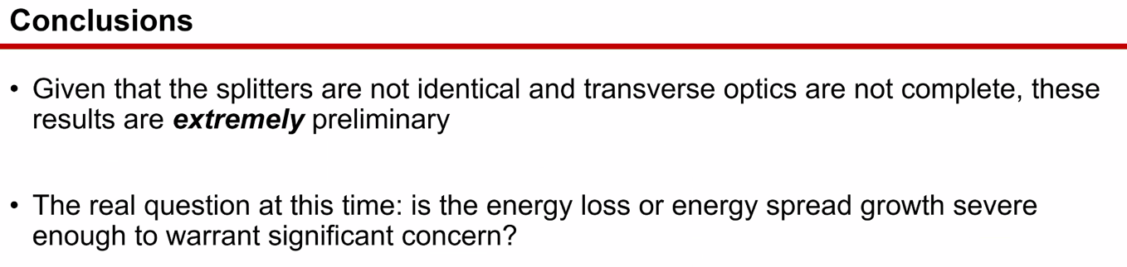
* Alex B – the hope is that we can outfit the splitters with a low-emittance optics option
  + Big challenge
  + Probably won’t be anywhere near close
* Scott – think a bit about:
  + 1. Quadrupole layout -not much choice
  + 2. R56 to target comes into play
  + CBETA was forced into some pretty high curly-H
  + Years away from “cutting metal” – so this is the time to figure it out
* Kirsten – currently, vertical emittance from spreaders is so much higher than horizontal from FFA arc, it might be OK to get something at that level
  + We may need to have a number in hand for an acceptable value – not clear that number exists
  + Dejan – that comes from the unavoidable consequences of the geometry of the spreaders
* Scott – in the spreaders, what drives the large vertical curly-H is b/c you come into the dipole with a large beta function
  + It’s proportional to the beta at the first dipole
  + What’s going to happen in the splitters – same thing will happen
    - Hit first dipole – horizontal beta is high from linac (same as spreaders)
  + Only thing you can do to get that under control is to knock down the curly-H as early as possible
    - Need right combination of quads working with dipoles
    - Easier said than done
      * Hit a lot of dipoles before you can even get to quads
  + Ryan – we could try adding common quads in some places?
    - Scott – maybe.
      * Make the quad a non-tuning object b/c it’s also steering
      * Doesn’t count in 8 quads
  + Dejan – what about multi-function magnets?
    - Could – but then you have a very complicated object.
    - It’s not a crazy idea to make some common dipoles to be multi-function. Start out with simple models to see curly-H
    - Might be helpful on LINAC side – not sure
  + If you do it on the first dipole, the first quad you hit won’t have a significant impact on beta itself
* Alex B – for spreaders/recombiners, the beta coming out of the linac is critical for curly-H
  + This is why we’ve switched from weakly focusing optics to strongly-focusing in linac
  + Now on order of 50-80 m betas
  + This will help with spreaders and splitters
* Still not down to FFA levels, but will improve it
* Things will improve from weakly-focusing linac option
* Need to redo spreader/recombiners with new optics
* Instead of a target, we “do our best” and keep updating it and presenting to experimenters. We have to be conservative. We want them to be up-to-date
* Dejan – also possible (first magnet must spread beams) – if you bend the beams then put them in the quads to help end different ways (b/c spread from dipoles)
* Dejan – conclusion from Kirsten is that emittance is half the arcs (from splitters)
* Reza – what’s the highest dispersion in hall lines?
  + About a meter
  + 1E-3 energy spread delivered now?
    - No, more like 1E-4 – that’s the limit (sometimes 1E-5 level for some experiments)

|  |  |  |
| --- | --- | --- |
| Action Items | Person responsible | Deadline |
|  |  |  |
|  |  |  |

## Time allotted | 25 mins | Agenda topic Multipass Correction | Presenter Alex C

* 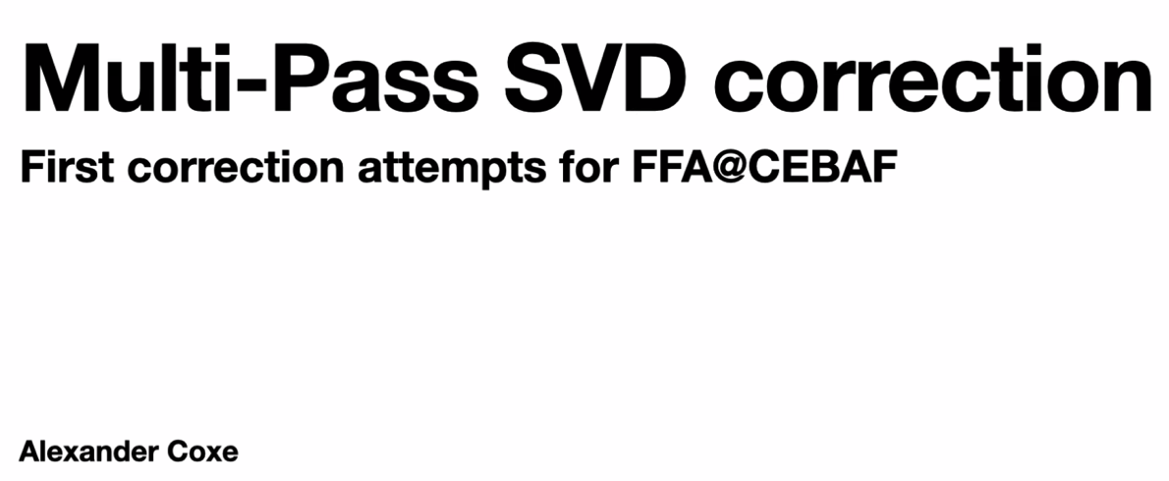
  + Rough so far
  + Got tips from Kirsten for CBETA corrections
    - Hard to implement in Bmad
    - Did something different
* 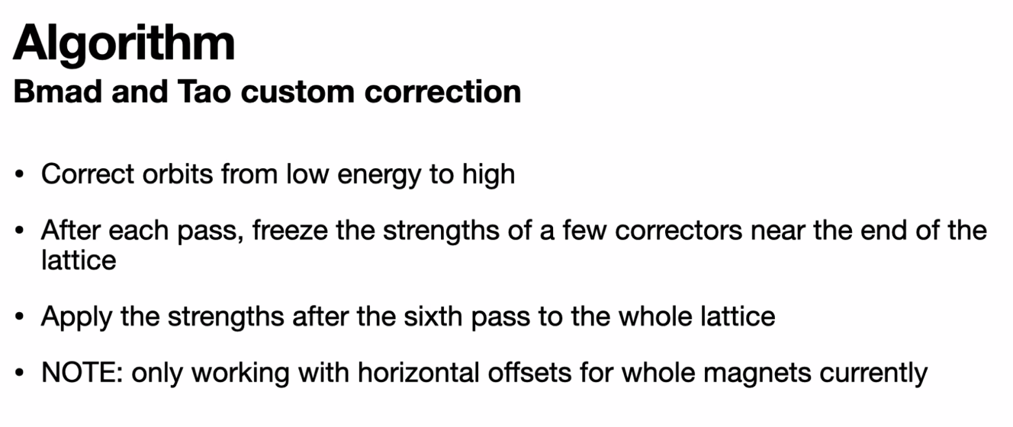
  + Just W-Arc now for test purposes
  + In following example, freeze the last 5 correctors by energy
* Works better for higher energies, looking to somehow get universes to talk to each other, would freeze BPMs instead of correctors
* 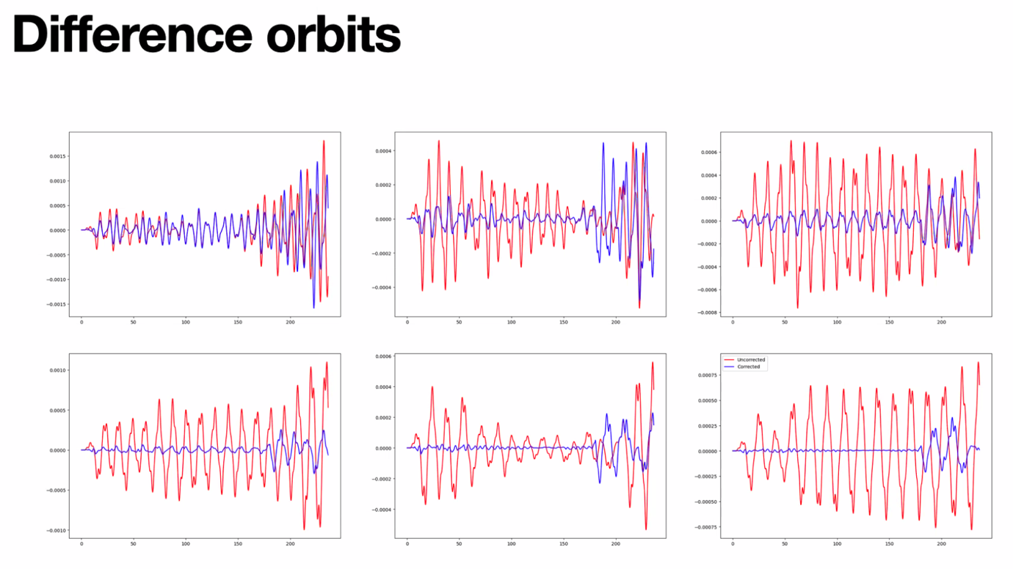
  + Top left is lowest E, bottom right is highest E
* By construction, the corrector fields in U6 don’t impact U1
  + Scott can have a chat about this (or Sagan)
* Scott – when it gets more complicated, start using PyTao
  + Already using PyTao
  + So we can go over what to do with this
  + Not forced to use variables and data anymore if using PyTao, just set element parameters directly
    - If variables are there, but you try to set them, Bmad will complain
    - Evaluate expressions for data
* 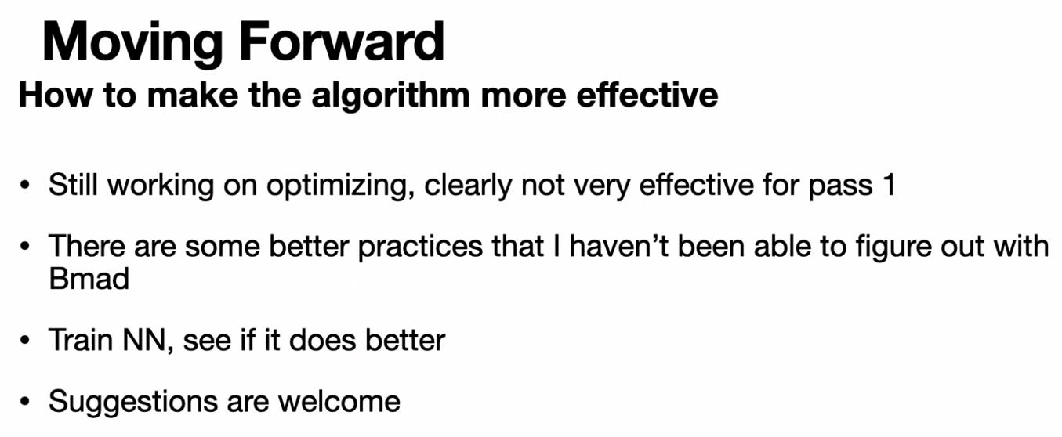
* Stephen – if you want to play with this and feel it, the ffa transport is almost linear in x and x’
  + Make a toy model to get a feel for it
* Dejan – looking at the phases it becomes clear that, at the lowest energy, the correction is much easier b/c you can pick up the correctors at a phase different of half-Pi so they cancel the rest.
  + Should be easier than at higher energies b/c don’t have as much phase difference available
  + Problem is that what Scott was saying – picking up the correctors would effect other passes
    - How would you weight things in an optimal way?
      * Currently all correctors weighted the same, but BPMs weighted differently
* Having trouble with two correctors/cell – it shouldn’t change anything, but it does! Optics breaks for pass 6
  + More correctors will help – maybe in the last 10-15 cells only based on what seeing for single-pass
* Dejan – can run loop for every universe at the same time
  + It’s probably going to take a while
* Keep finding that made programming inefficiencies – when fix things go faster
* Dejan – Stephen uses something good for this
  + For correctors, response matrix and SVD to iterate b/c *mostly* linear with distortions
    - Then iterate further for the nonlinearities
* Alex C – Scott, if there’s a time we can talk, please let me know
  + OK today until about 14:30 (unless forgot something)

|  |  |  |
| --- | --- | --- |
| Action Items | Person responsible | Deadline |
|  |  |  |
|  |  |  |

## Time allotted | 10 mins | Agenda topic AOB | Presenter All

* Alex B – for next two weeks, we’ll have a hiatus b/c we’ll meet in person. So skip next two weeks.
* Money problem for BNL people – now finally have budget code
  + Money has to be deducted from JLab budget and add it to BNL budget
* Vasiliy question – I’ll be giving an overview talk for FFA, most of my slides are things I’ve been working on. I’ll need to reuse slides
  + We can provide slides
  + JLUO talk can be used for a base
* Alex B will give boilerplate (presented by Todd)
* Reza question – can I get access to shared folder?
  + Ryan sent invite
* Kirsten – will add new diagram into folder so we can use it
* New CEBAF images?

|  |  |  |
| --- | --- | --- |
| Action Items | Person responsible | Deadline |
|  |  |  |
|  |  |  |

## Special notes

Pathway to Repository: <https://jeffersonlab-my.sharepoint.com/:f:/g/personal/tristan_jlab_org/EqZ5MeS-nipCgPfZB5p0oS4B9Is67d3nQb9sLJI3Zyev9g>

NO MEETING FOR TWO WEEKS!