FFA@CEBAF Working Group|Minutes

Meeting date | time 10/06/2023 | 11 AM EST | Meeting location https://jlab-org.zoomgov.com/j/1614898082?pwd=TnUzMS81M2sxbDZIbERJU01tYkJCQT09
 | Attendees  Alex B, Ryan, Dejan, Scott, Randika, Edy, Reza, Todd, Vasiliy, Andrei
  Meeting called by | Alex B
  Type of meeting | Weekly Meeting
  Facilitator | Alex B
  Note taker | Ryan
  Timekeeper | Alex B

Intro Discussion
- Lots of people missing – travel/other meetings
- LRP announcement – meetings today at the labs
- LDRD for magnet testing approved – 2 year plan, 1 year + 1 year if approved
  - Ryan, Kirsten, Edy, Randy involved

Agenda topics

Time allotted | 25 mins | Agenda topic Alternative Splitter Optics | Presenter Dejan
- 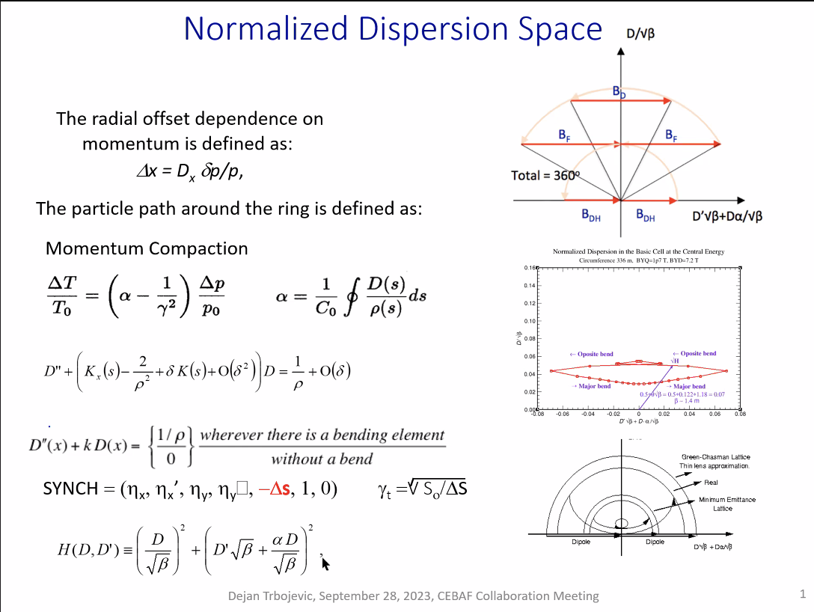
  - Presented this long ago – the most important message here is that it’s nice to use these vectors for the dispersion to understand how you’re going to close the function in the dispersion and dispersion prime
- 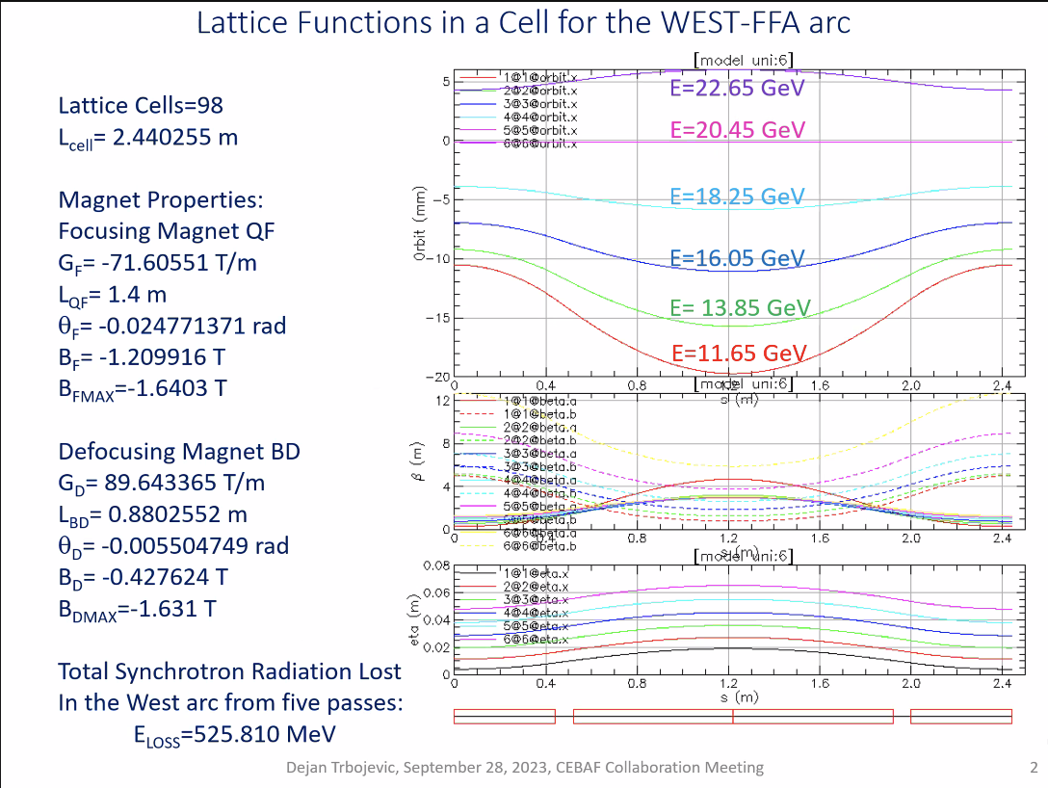
  - Used a different lattice than the baseline – 98 cells
  - Central energy around 20.4 GeV
- 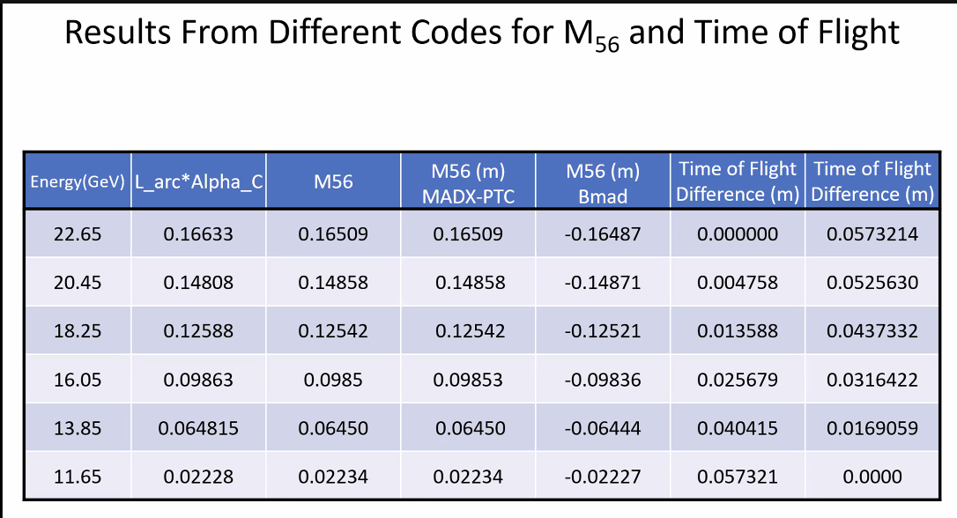
  - Compare ToF/M56 for different codes
  - At 22.65 GeV – 16.5 cm for M56
  - 11.65 is 11.26 cm
- Some of the codes have different definitions for M56 – Bmad has a negative, but value is the same
- 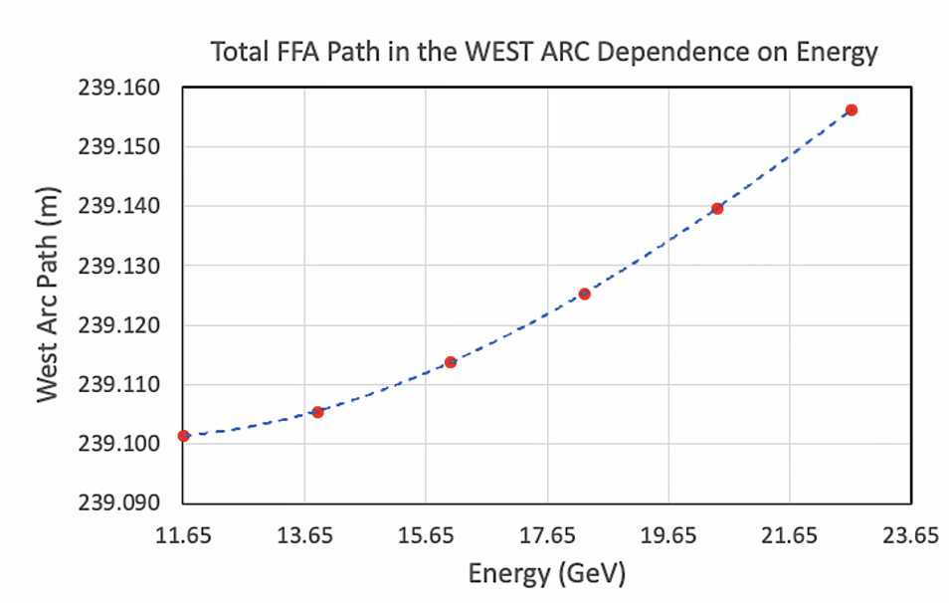
  - ToF Difference
- 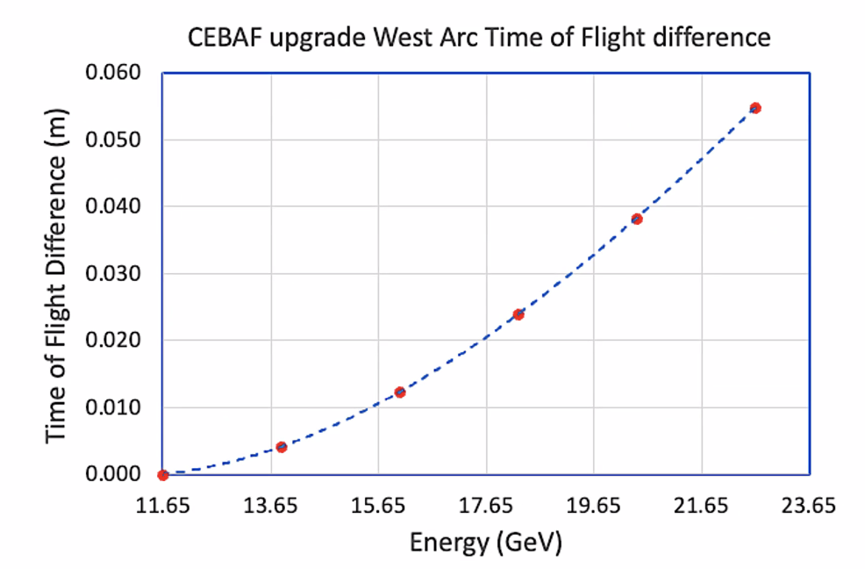
- 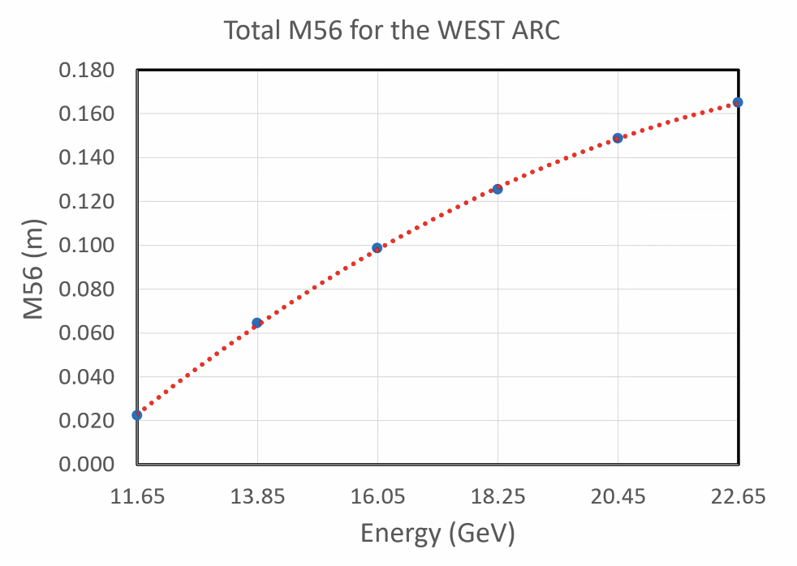
- 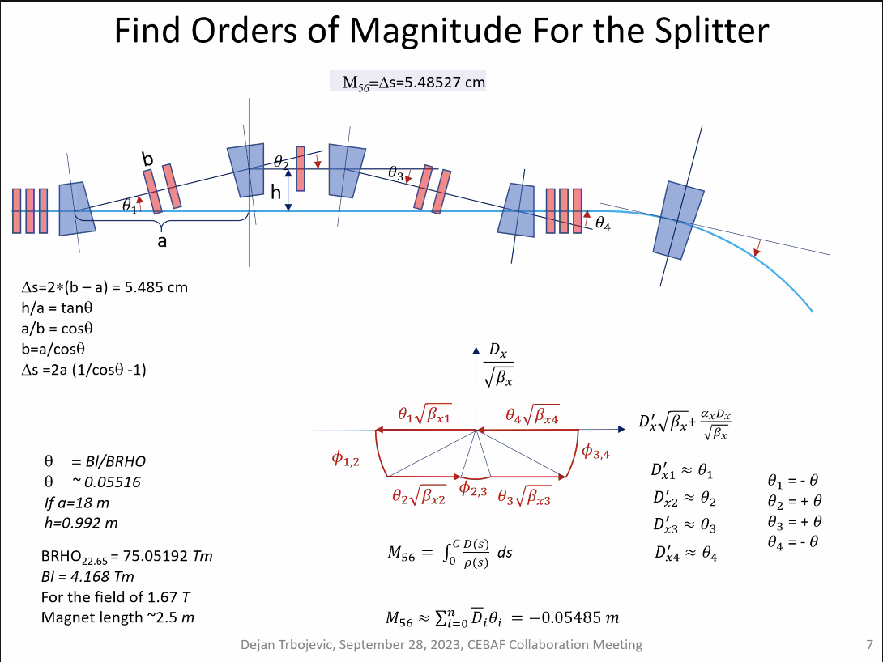
  - Need opposite sign of bending in the arcs
  - Vectors are in lower side of diagram – value of dispersion in bending has to be negative – need it opposite direction from arcs so you can correct
- 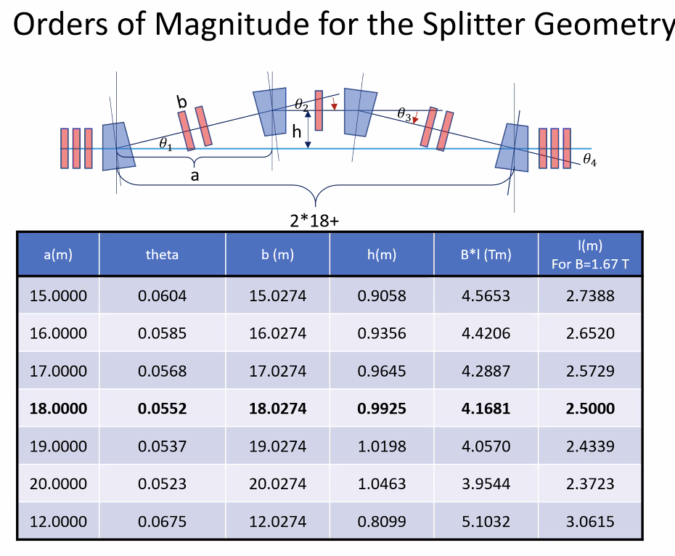
  - a is distance between magnets projected onto straight, b is between magnets on beamline, h is offset from central axis
  - Need ~ 1 m for highest energy
- 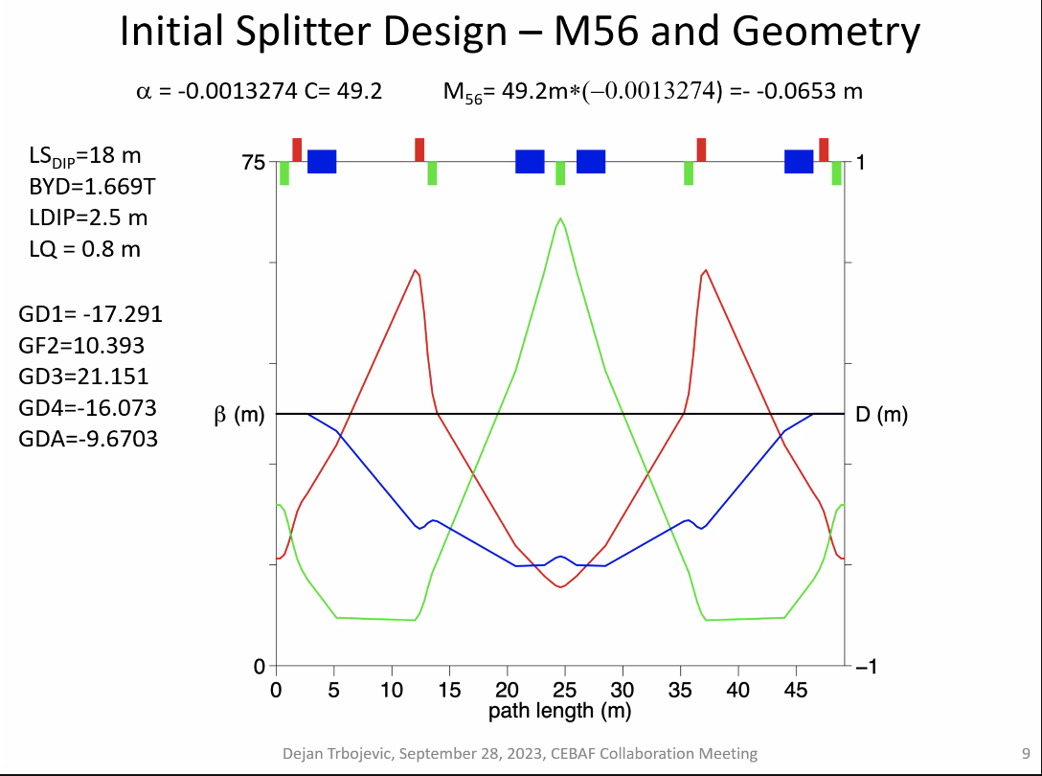
  - Negative dispersion
  - 6 cm M56 – need around 16 cm – not enough to correct
- 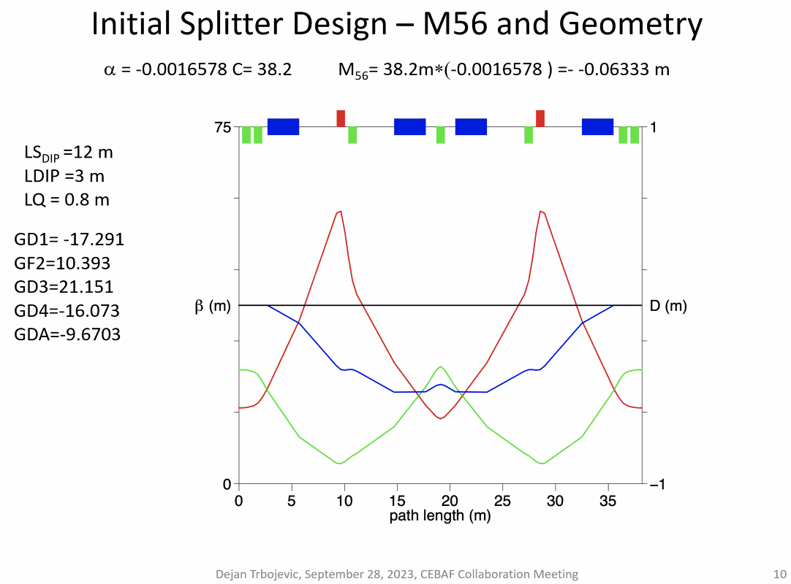
  - No improvement on M56
- Alex B – length of cell is 36 m long?
  - Yes, just an exercise just putting numbers in
  - Started 2 weeks ago more seriously because Ryan and I discussed during the FFA workshop
    - Maybe I can use Ryan’s numbers to see where we really are
- 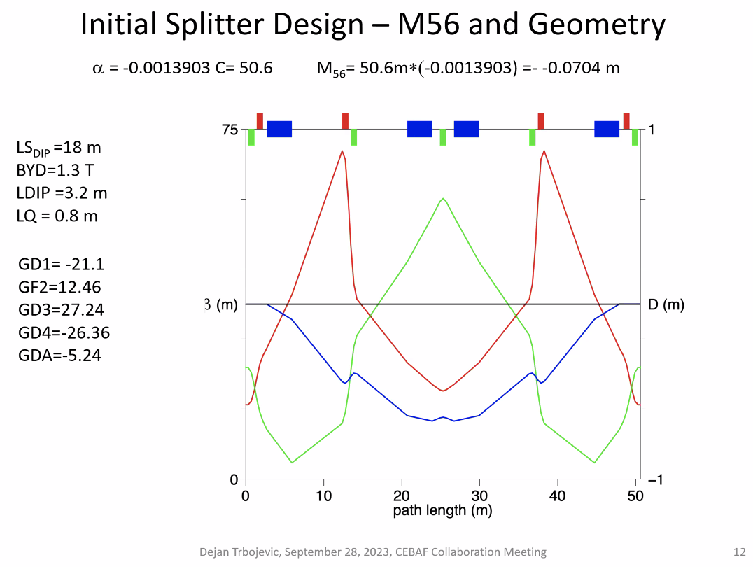
- 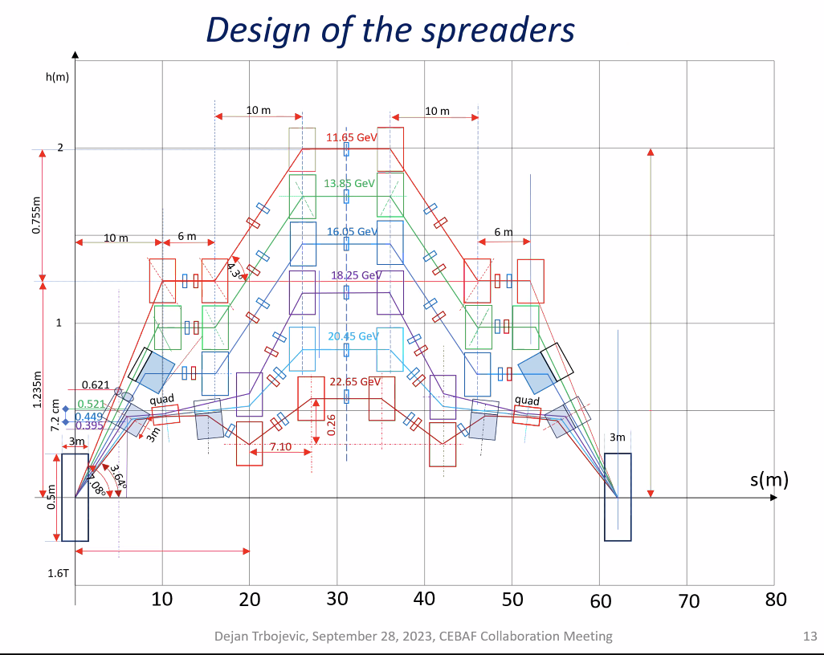
  - Initial thinking
  - Ryan – the wall is at about 1.3 m up, and the walkway is 1.57 m in the downward direction
    - Dimensions: 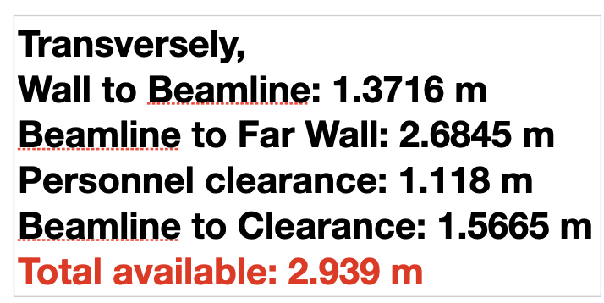
- 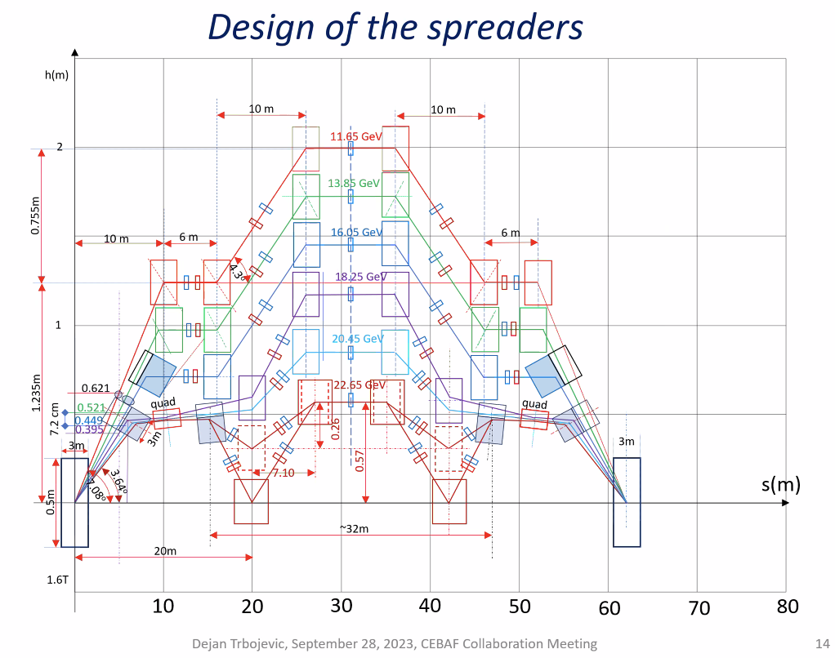
  - Why dotted lines? Needed to move the magnets far down to get the number right (16 cm)
- 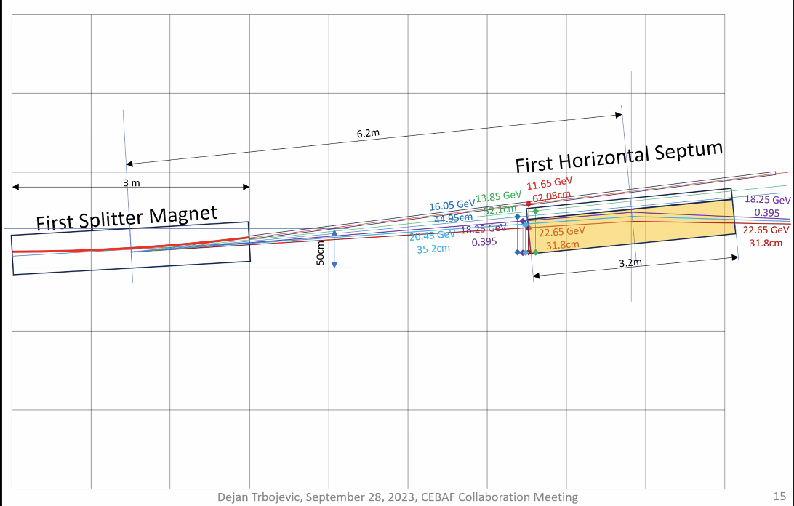
  - Real dimensions
  - Had to use 1.67 T
    - Ryan, 1.8 T is a rough limit – but there are caveats
  - 6.2 m between center of magnets
  - Highest E beams bend less, like they’re being focused
  - Scott – is this an S bend or an R bend
    - Rbend
    - Low E bends toward high E
- 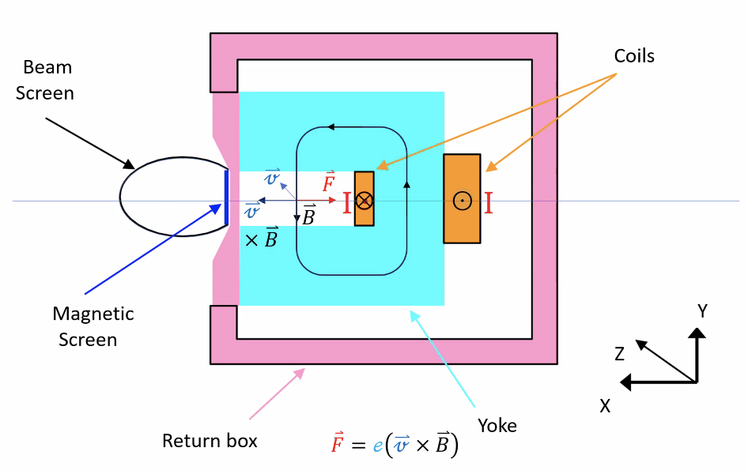
  - What are the “real” possibilities
  - Need to shield, no fields, etc…
- Put quad after second magnet for 3 passes to help bend/focus
- Transverse sizes of dipoles are half a meter
- 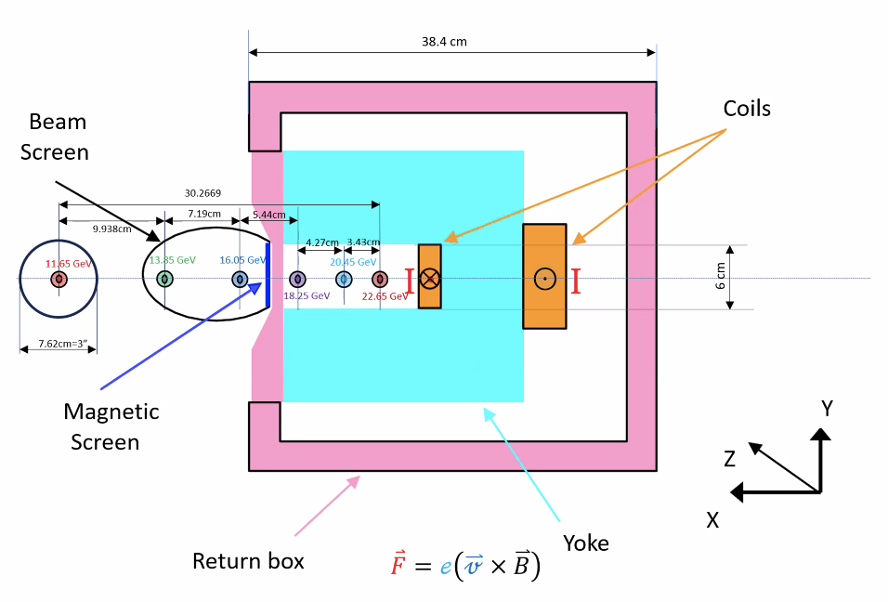
  - Put separate pipe for different passes – 1, 2, and 3 in the different pipes, respectively
  - 3 would go through quad
  - Size is estimated
- Scott – I’m more worried about magnet dimensions.
  - If you look at the portion of the magnet between the coil and the shield, you’re running very close to saturation – that width has to be at least duplicated in the back yoke and top pieces so that the flux can make it around.
  - If only 0.5 T, this would be fine. But if you’re up near 1.8 T, you need a lot more return
- Ryan – this isn’t based on Lambertson, but another design by Jay.
- 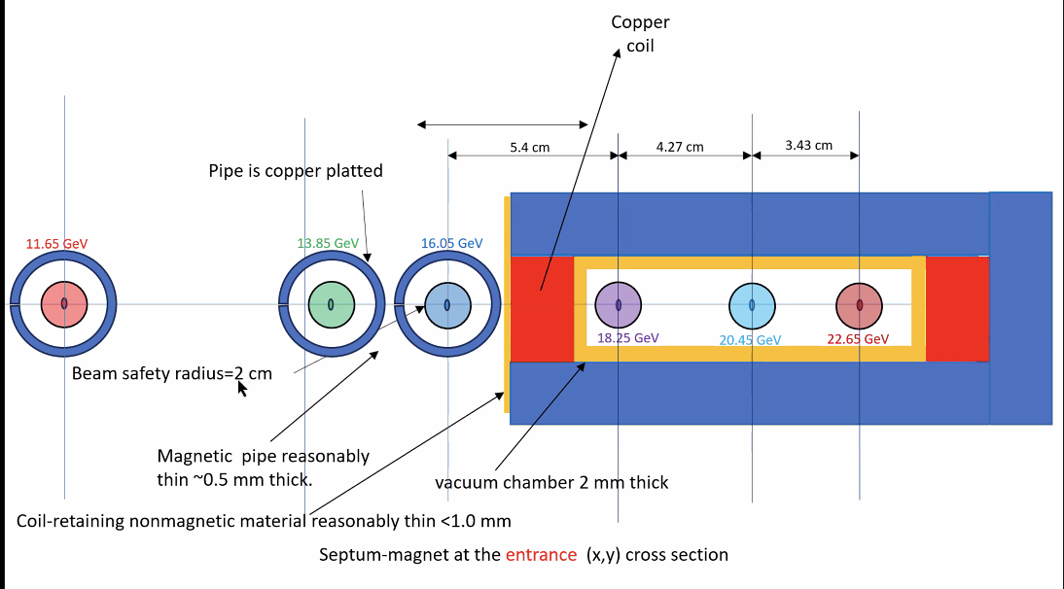
  - Another septum design – never made one before – not sure
  - Just dimensions of rough idea
- Looked at CBETA for septum:
  - 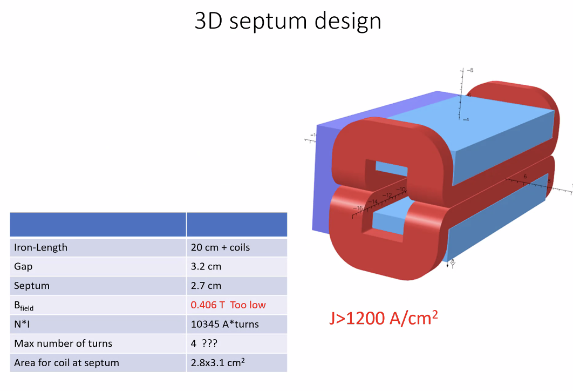
- 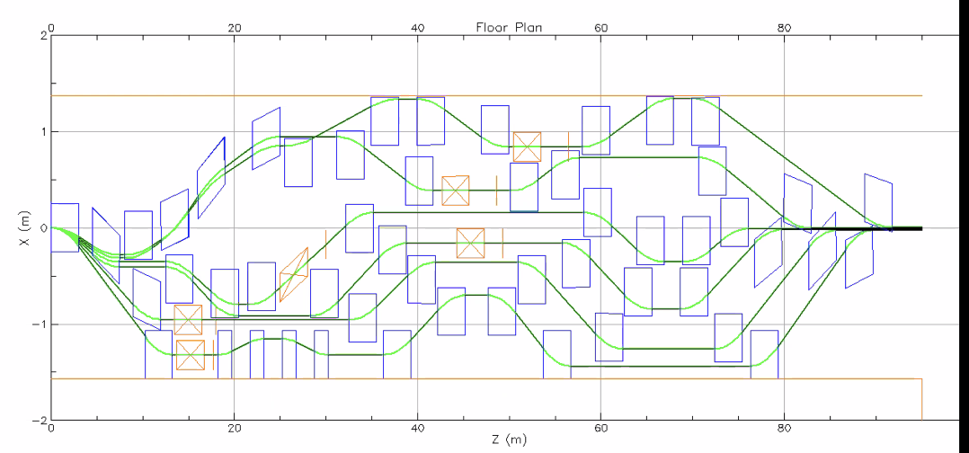
  - Ryan’s design
  - First bending magnet is bending the same way as the arc
  - Stays in the straight section
- Scott – in CBETA – we had a bend between LINAC exit and entrance of splitter. For that case, it mattered.
  - Here, b/c there’s no net bend, up/down is irrelevant.
  - From what seen so far, you’ve found a flaw in the clever idea:
    - What tends to happen is when you use common dipoles at the end, and bend in the same direction at the end, the dispersion wants to be in the wrong place. Wants to be on the wrong side for the M56
    - What Dejan is doing is having the septum trying to split off the high E beam.
      - Helpful for M56, but not geometry
  - If Highest E has 5.7 cm to be ToF, and lowest E has 0, then this might be helping us
- Scott – in CBETA, the ToF wasn’t too hard to manage because we had a DoF – add an RF wavelength
  - Toward the last minute, we added a wavelength to give the engineers more space
  - In principle, I don’t worry about it too much b/c it’s “easy” to add half a wavelength to the outer splitter lines.
- Alex B – for the lowest E, why is there such a big bend?
  - Ryan: ToF correction and flexibility – depends on your target value. Tried flat, but doesn’t get what we need.
    - Can check to see if we can reduce, but it’s needed for flexibility and adjustability
    - Had to bend really far to fit everything. Had 2 mini chicanes and the main one.
    - Kept one mini one, but wanted to keep flexibility to “move the beam” and adjust for up to half a wavelength
    - Also ran into problem b/c the highest E chicanes go in the “wrong direction” in order to uncross the crossed beams
- Dejan – magnets don’t have to be as large transversely
  - Ryan -maybe not, but I started with a conservative design and “fat magnets” because then, if we can use smaller magnets, it’s easy. But if we design with smaller magnets, it’s harder to adjust later and make them bigger.
- Dejan – Need to worry about SR – might need open aperture
- Also need to worry about cooling
- Alex B – you’re only using 60ish meters out of the 90-some meters. So you can alleviate it.
- Dejan – wanted to use far less magnets and succeeded
  - Ryan – yes, but then you don’t have the flexibility. Do you have ~10 cm of flexibility
  - Dejan – yes, that’s right, but this is just a first step.
- Trick with off-center quad might be a good idea to stop orbits from crossing
- Ryan – I’m only seeing 5 independent quads in some of these passes, and we need 8 independent quads per line
  - Yes, we’ll have to add more quads probably. This is just a picture to show that I can do what I did in the code.
- Alex B – the doublets could be useful
- Dejan – 1.6 T is the bending, length of magnets is 3.85 m, values of gradients are very realistic (20 T/m).
  - Got 14 cm M56
  - If I do the most difficult one (9 quads and 4 magnets) – I think we can do it. I’m breathing much easier.
- Alex B – And from the standpoint of the curly-H, there’s potential with the doublets/singlets/doublets, you can keep it under control
- Dejan – dispersion is high – 0.9 m
- Ryan – did you put in quad dimensions? That will start interacting
  - Dejan – good point
  - Ryan – Our QRs will likely work, I can send dimensions
    - Rougly 38 cm steel, so about half a meter long, and not very wide – don’t remember exact dimensions
    - 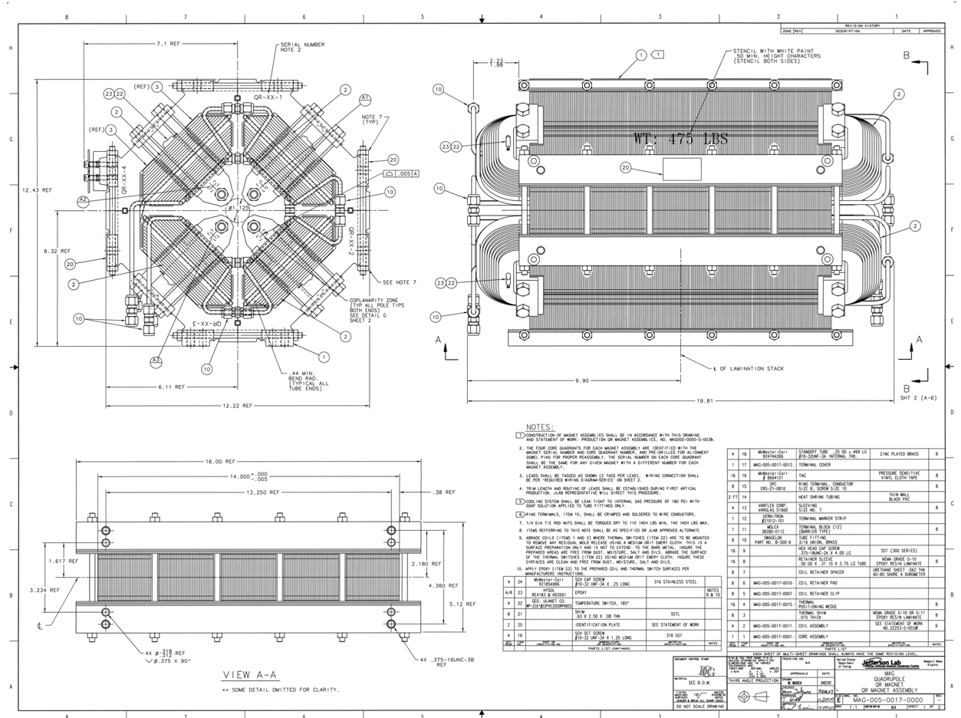
    - Strong enough for all passes, dimensions fit. Not very fat
    - Alex B – this is one of the standard quads at CEBAF – we can think about improving
    - Ryan – yes, but I wanted to start with something real. Everything I’ve done is either based on something real or designed. Occassionally, had to make assumptions, but they’re all based on something real or designed.
    - Alex B – CERN half quad used
      - Maybe we can unleash our imagination
  - Quad lengths for Dejan – 0.8 m long
    - Ours are just shy of 60 cm long and ~40 cm wide with coils
    - Better to use longitudinal space than transverse space
- Dejan – still has permissions problem in sharepoint
- Dejan = want to go back to arc design and make momentum compaction variable with 3 cells
- Ryan shares screen:
  - 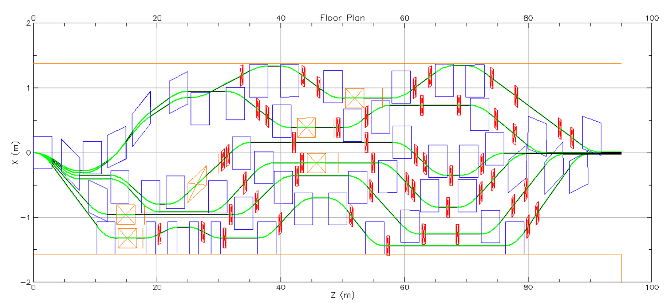
  - 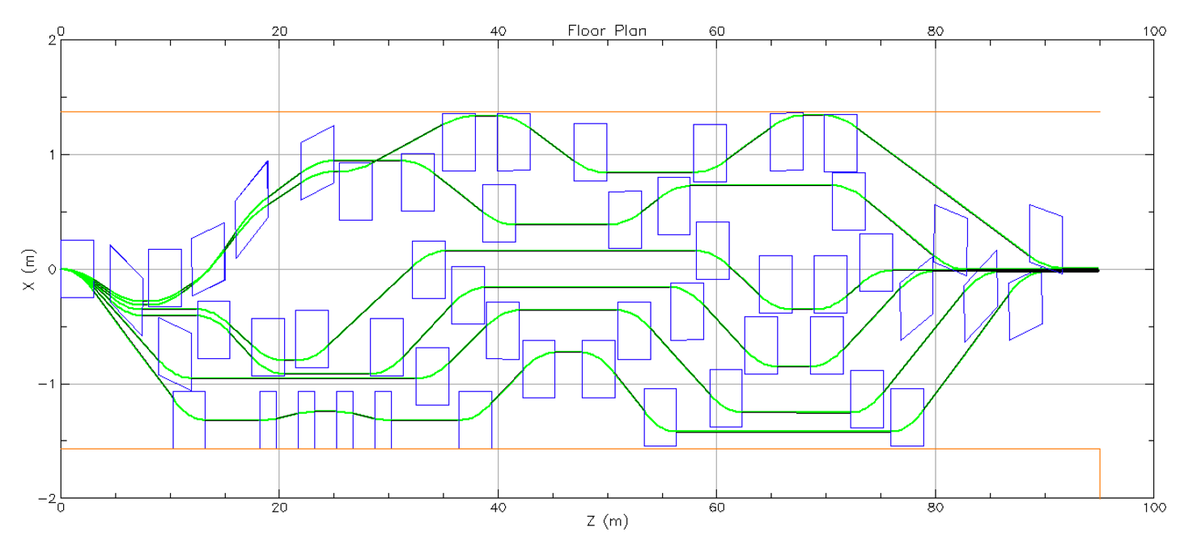
- Alex B – good that Ryan started conservatively, but we can start looking for more state of the art or permanent
- Ryan – yes, but we have to remember tunability. If we drop a cryomodule, then a permanent magnet might not work. Perhaps a hybrid tunable magnet
- Alex B – invited Roger Ruber to our meetings. This will help us to keep in mind operational concerns and SRF/cryomodule concerns.
Action Items | Person responsible | Deadline

Time allotted | 10 mins | Agenda topic AOB | Presenter All

Action Items | Person responsible | Deadline

Special notes

Pathway to Repository: https://jeffersonlab-my.sharepoint.com/:f:/g/personal/tristan_jlab_org/EqZ5MeS-nipCgPfZB5p0oS4B9Is67d3nQb9sLJI3Zyev9g

