FFA@CEBAF Working Group|Minutes

Meeting date | time 10/13/2023 | 11 AM EST | Meeting location https://jlab-org.zoomgov.com/j/1614898082?pwd=TnUzMS81M2sxbDZIbERJU01tYkJCQT09
Meeting called by Alex B  Type of meeting Weekly Meeting  Facilitator Alex B  Note taker Ryan  Timekeeper Alex B | Attendees  Alex B, Ryan, Roger, Reza, Alex C, Scott, Edy, Donish, Andrei, Dejan, Vasiliy

Intro Discussion
- Alex B asked Alex C about update. Encouraged to make tech notes.
  - Alex C is working on 3 drafts, plus a paper already
- We haven’t spoken much about our LINACs – so Roger is here to discuss them today.
  - Assuming 1.1 GeV LINACs

Agenda topics

Time allotted | 25 mins | Agenda topic CEBAF SRF LINACS | Presenter Roger
- 10 years in SRF
- Used to do normal conducting accelerators, SC magnets, particle physics, etc…
- Start with short overview of RF cavities, then our specifics
- We assume 1.1 GeV – right now it’s 1.09 GeV (and have trouble reaching that in a stable way)
- 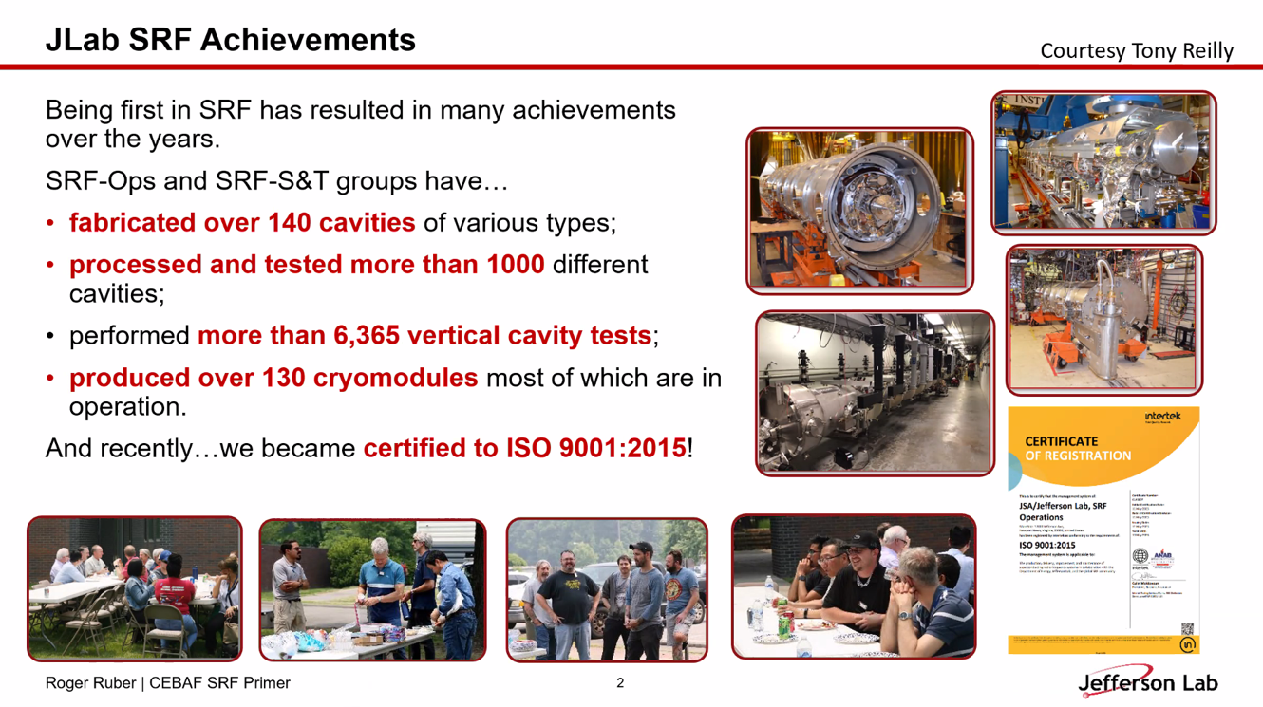
- 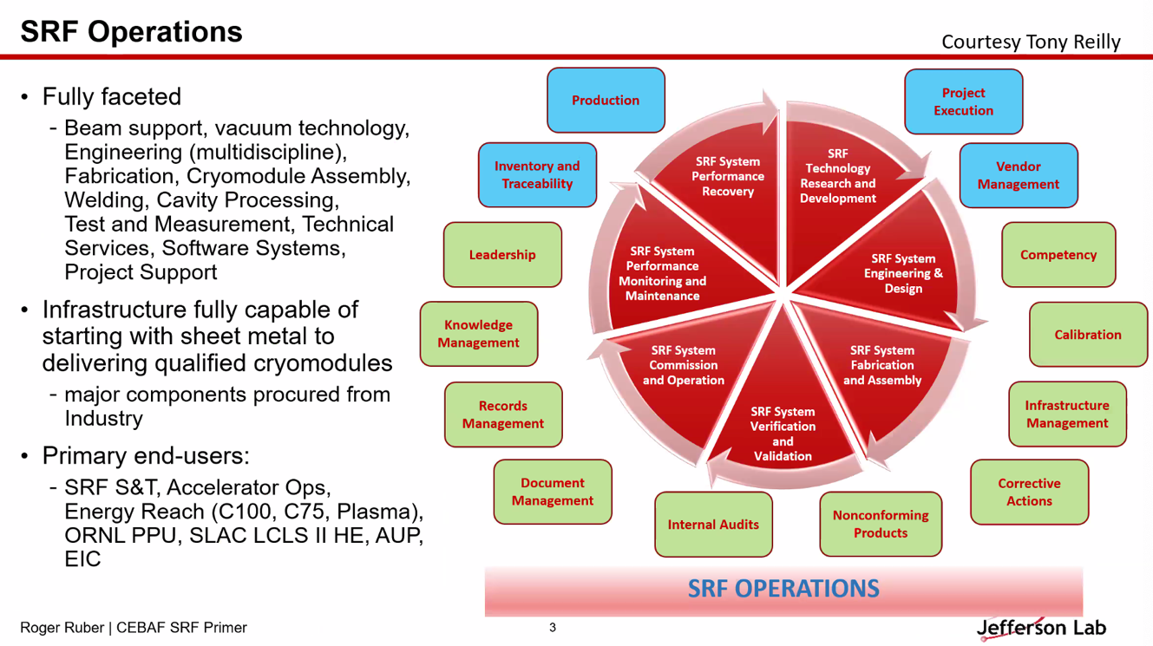
- 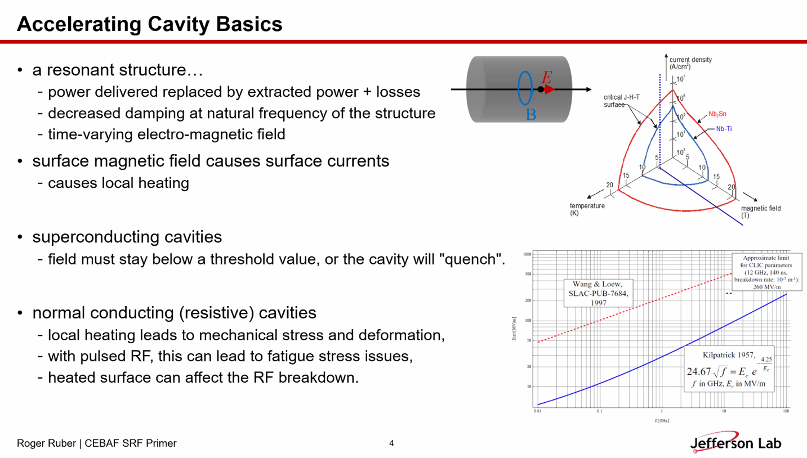
  - Up in frequency, you can reach higher fields
- 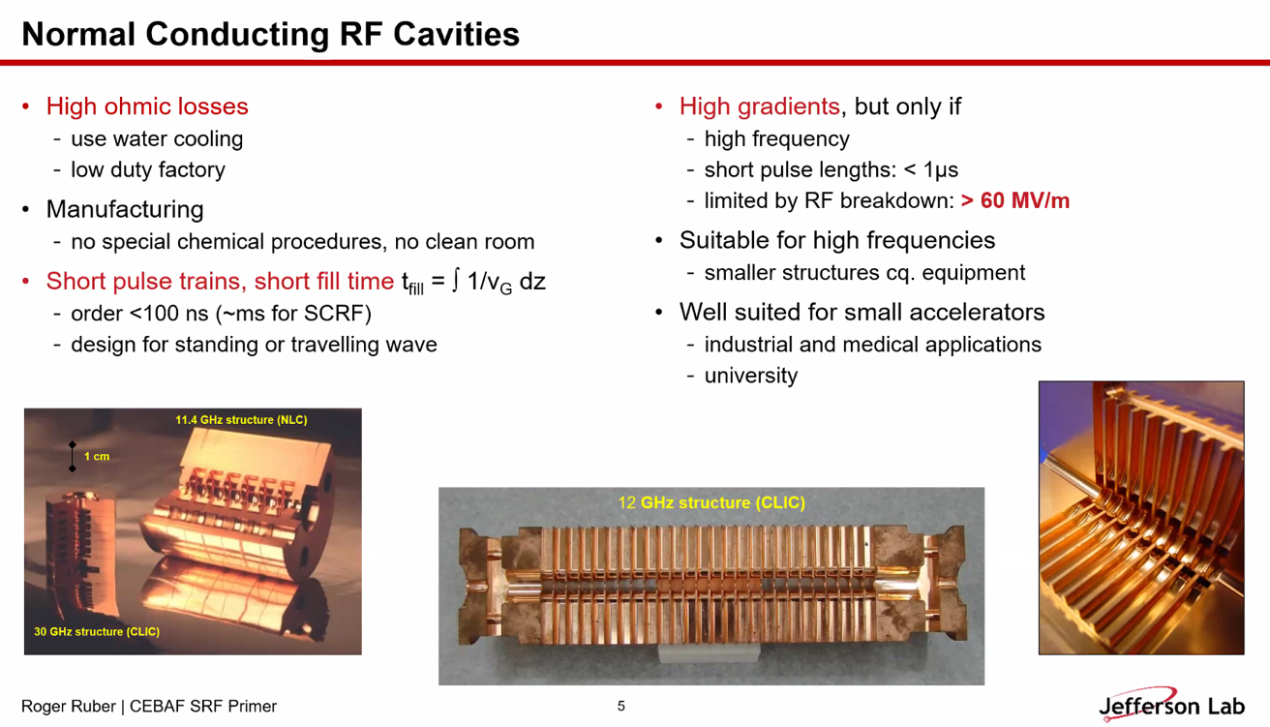
  - 120 MV/m in a few hundred nanoseconds
  - 300 MV/m reached
- 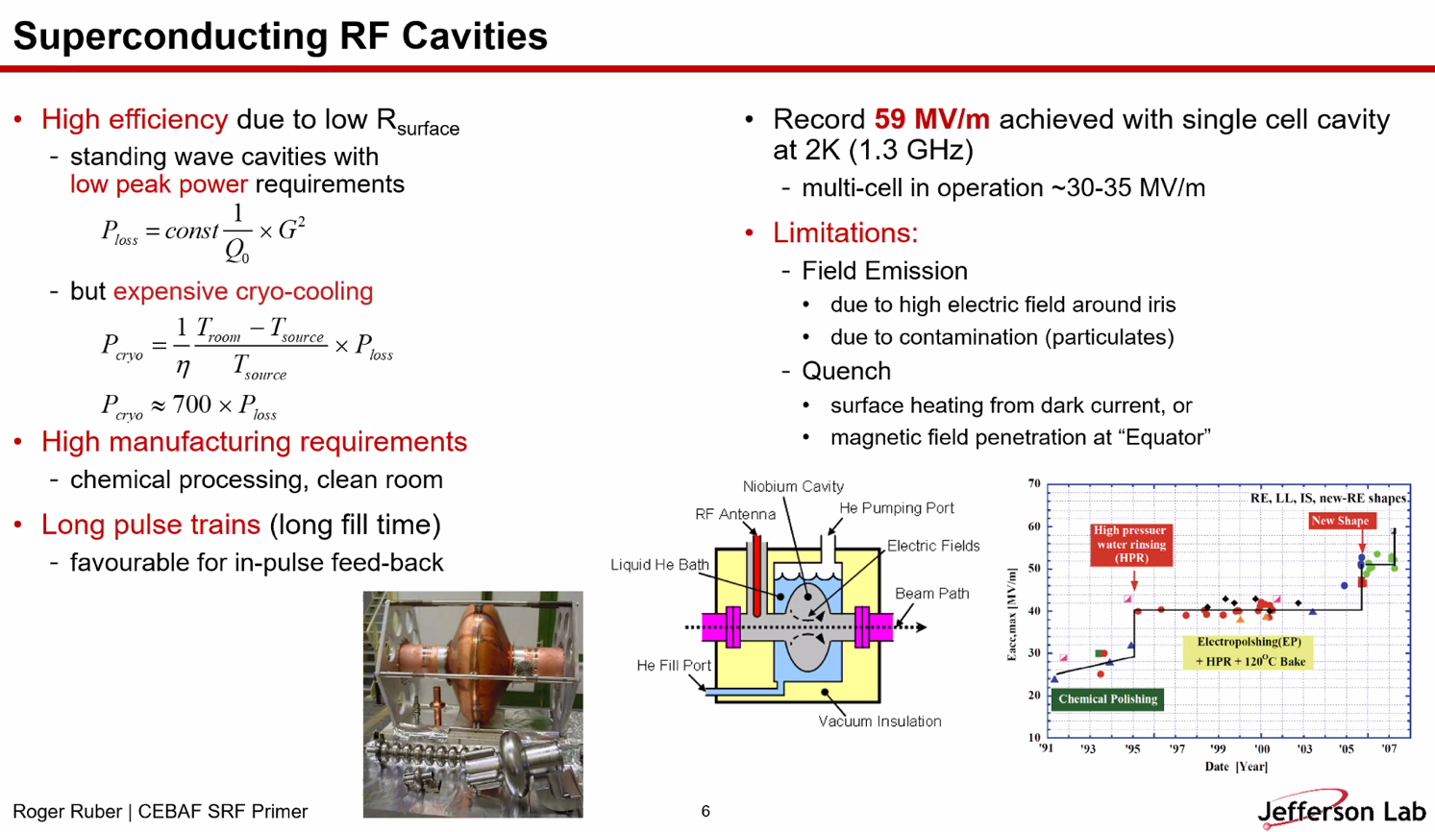
  - Great for long pulse trains
  - 60 MV/m in a single-cell cavity is the current record
  - Normal operational cavities reach ~30 MV/m
    - Lower than normal conducting, but long pulse trains and higher duty factors
- 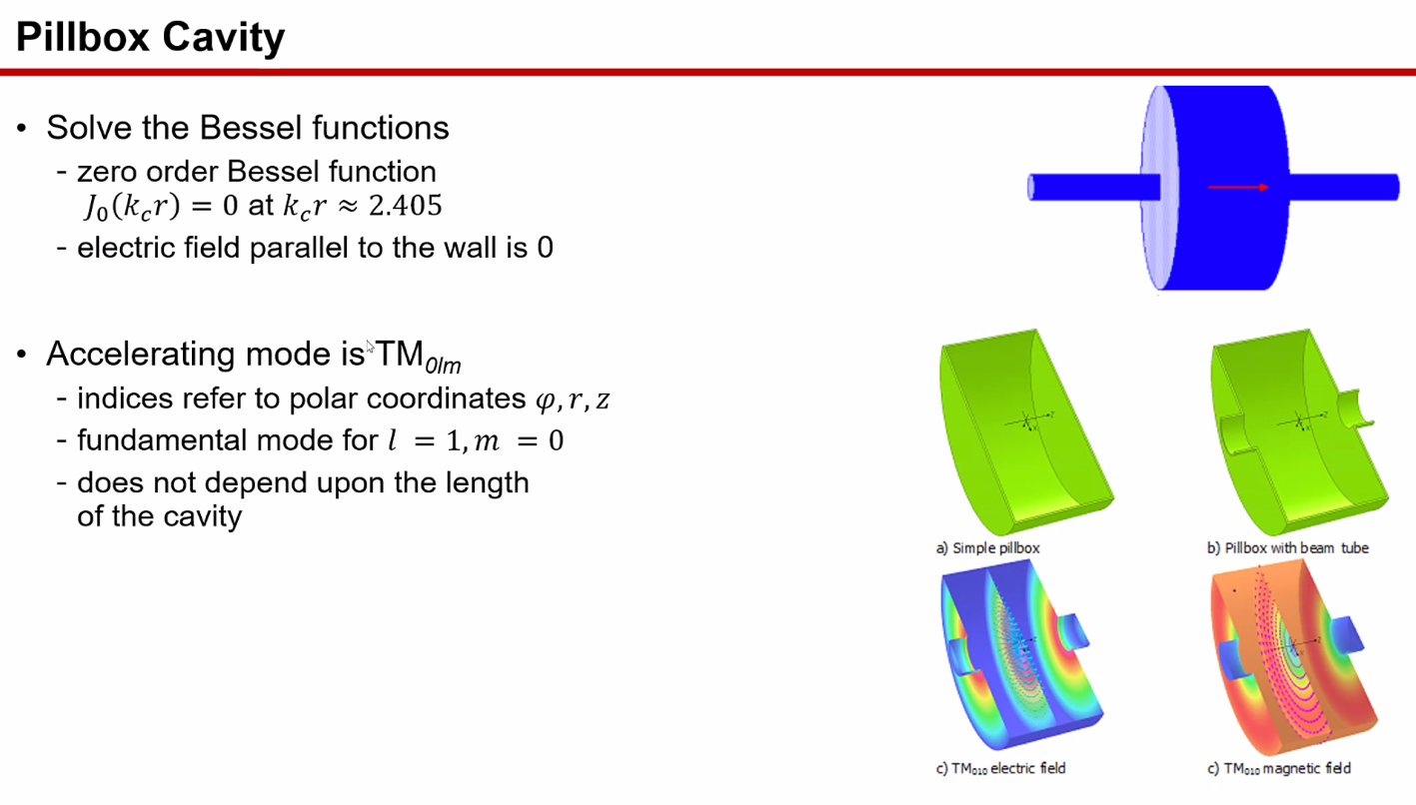
  - Magnetic field highest at surface of cavity (AC field) – surface currents
  - E field is highest at beam
- 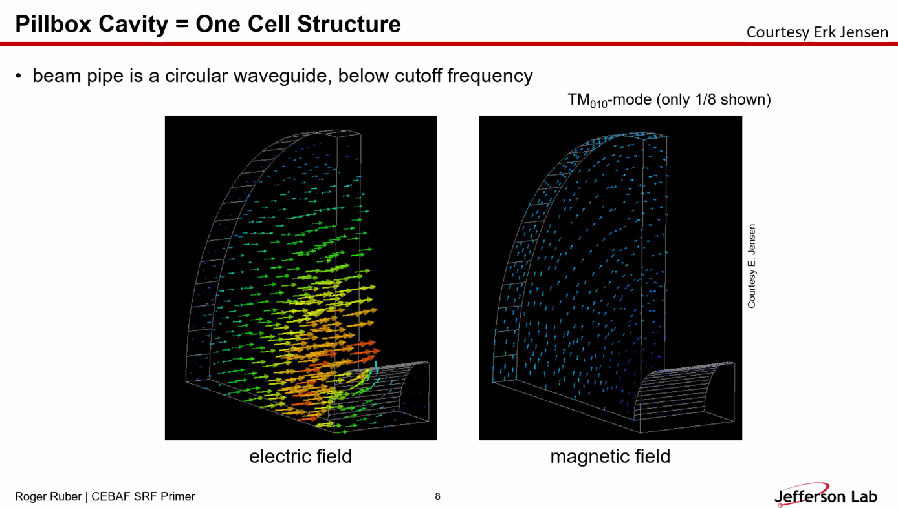
  - This is animated in the actual slides.
- 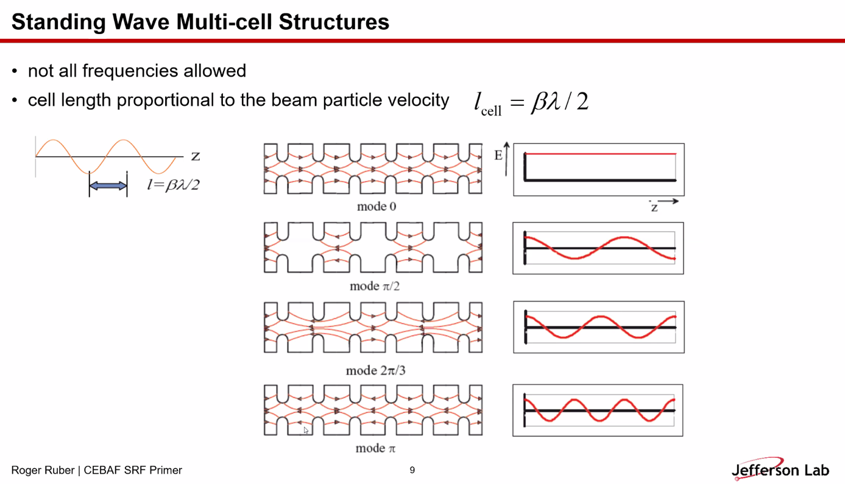
  - CEBAF uses pi-mode. Basically multi-pillbox cavities. Can only have a bunch in every-other-cell
    - Different modes for different filling factors
- 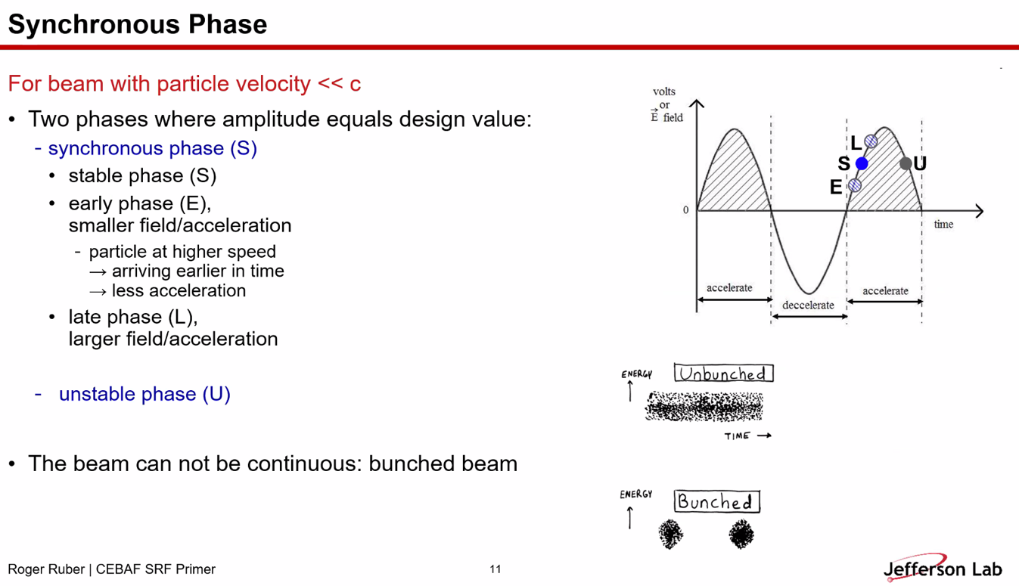
  - CEBAF usually on crest. But can use off-crest for bunching/de-bunching
- 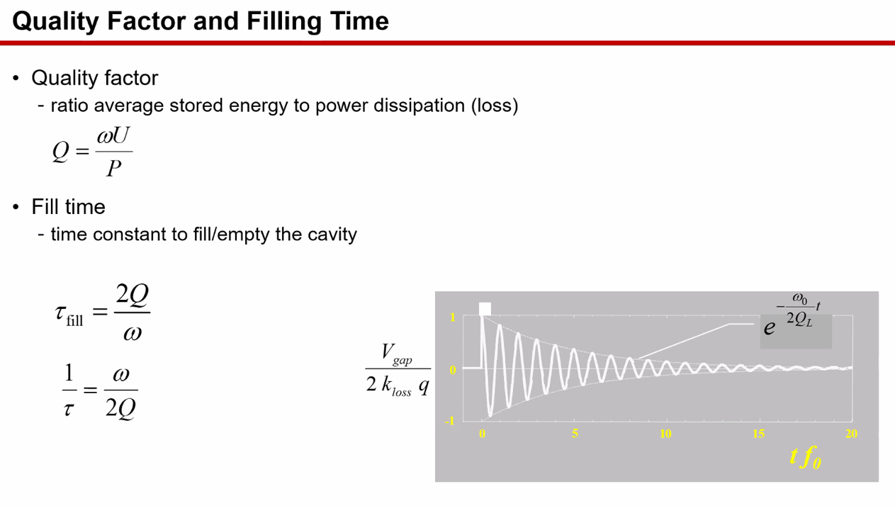
  - Stored energy to power loss
  - For SRF cavities, on order of 10E10
- 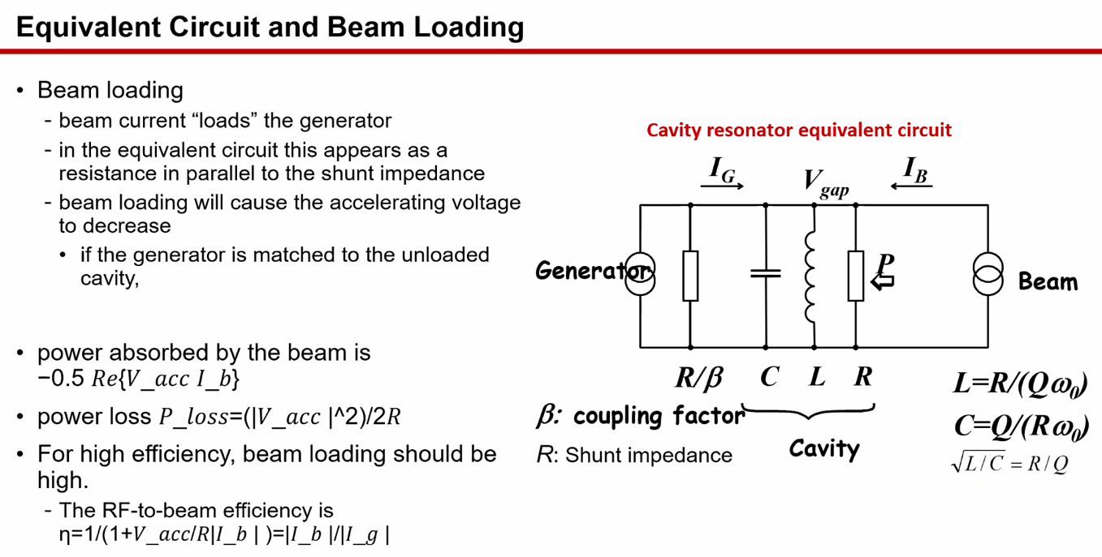
- 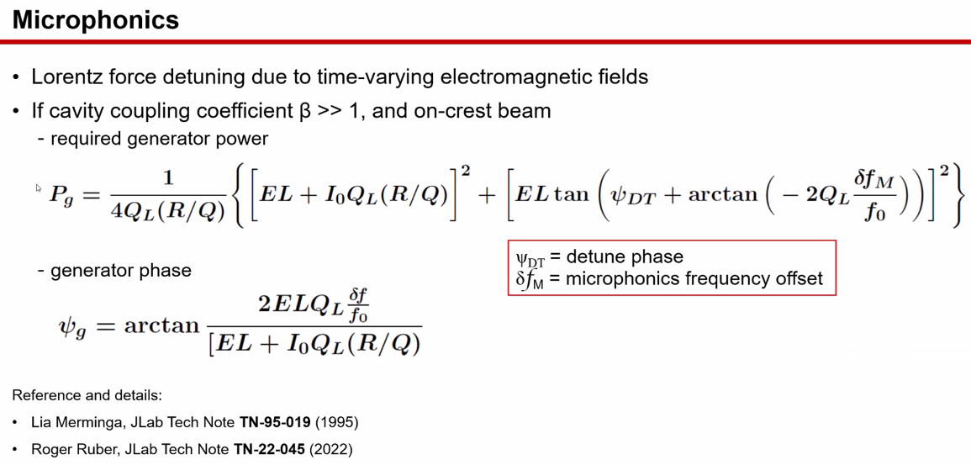
  - Second part from microphonics
  - Need more power to overcome microphonics
  - See TN from Lia for math
- 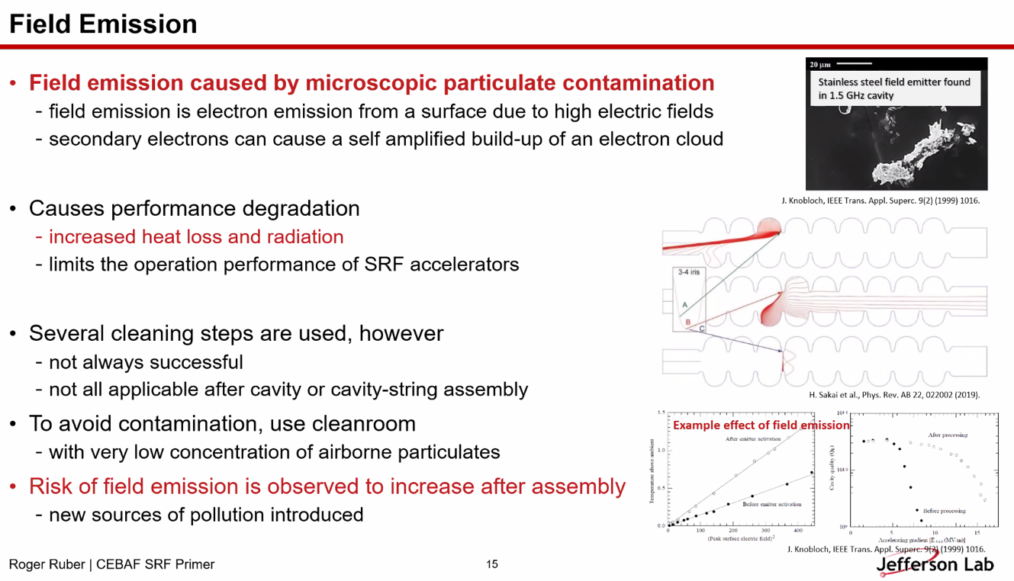
  - Mainly from surface imperfections and contamination
  - Can get electron emission in high-field areas
    - Can create secondaries, electron cloud production (multipacting)
  - This eats up power
  - Heats the cavity – increased heat loss gives less margin b/w operating state and quench
  - Electrons can be captured by RF field and accelerated and impact beam quality and cause radiation (neutrons, etc…)
  - To minimize this, clean the surfaces
    - Electropolishing, ultrasonic cleaning, mechanical methods, high-pressure rinsing
    - Mostly, assemble during cleanroom
- 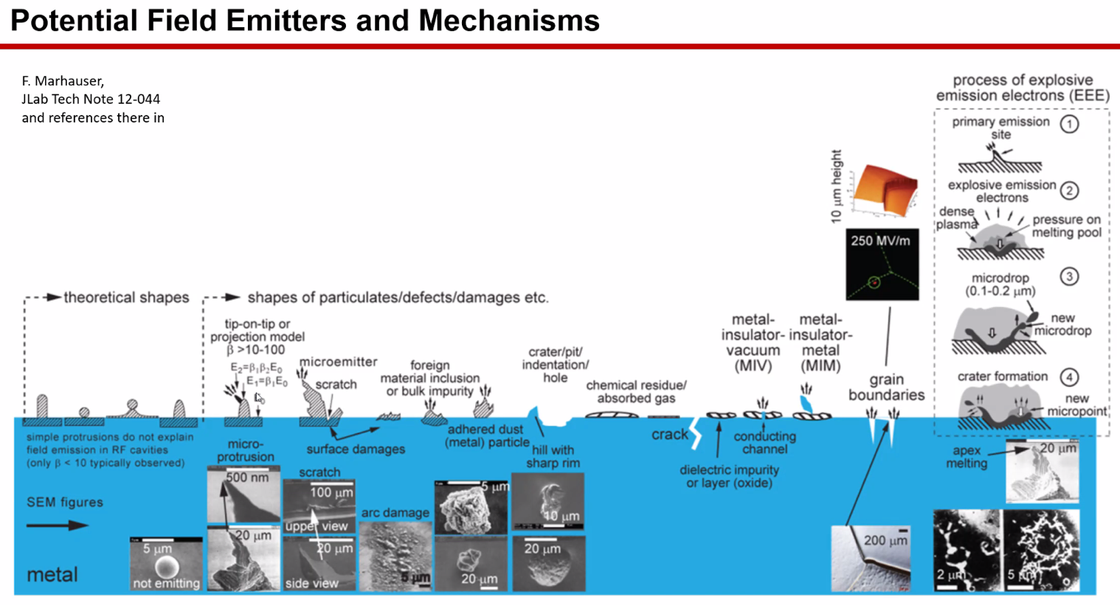
- Reza question on Kilpatrick limit – sometimes we have 2 Kilpatrick, etc… Is this a hard limit?
  - Not intimately familiar to what multiple Kilpatricks mean. The one in the plot on slide 4 is on any metallic surface. Related to the frequency and the electric field. It’s also related to the time that we apply the field.
  - For CLIC or NC accelerators, look at amount of breakdowns per second to see hot affects accelerator.
  - Reza – I just remember on separator design, set voltage on surface higher than 1 Kilpatrick. As long as below 2 Kilpatrick, it was OK. Why is it not a hard limit?
  - Roger – depending on the cavity
    - If you have a new one, you can put the RF field up high and it wouldn’t work well.
    - After, the copper surface looks horrible from breakdowns, but then would work better
    - Detailis not fully understood yet.
- Reza – RFQ cavities – need to condition at the beginning – the shiny surface isn’t a good surface.
- 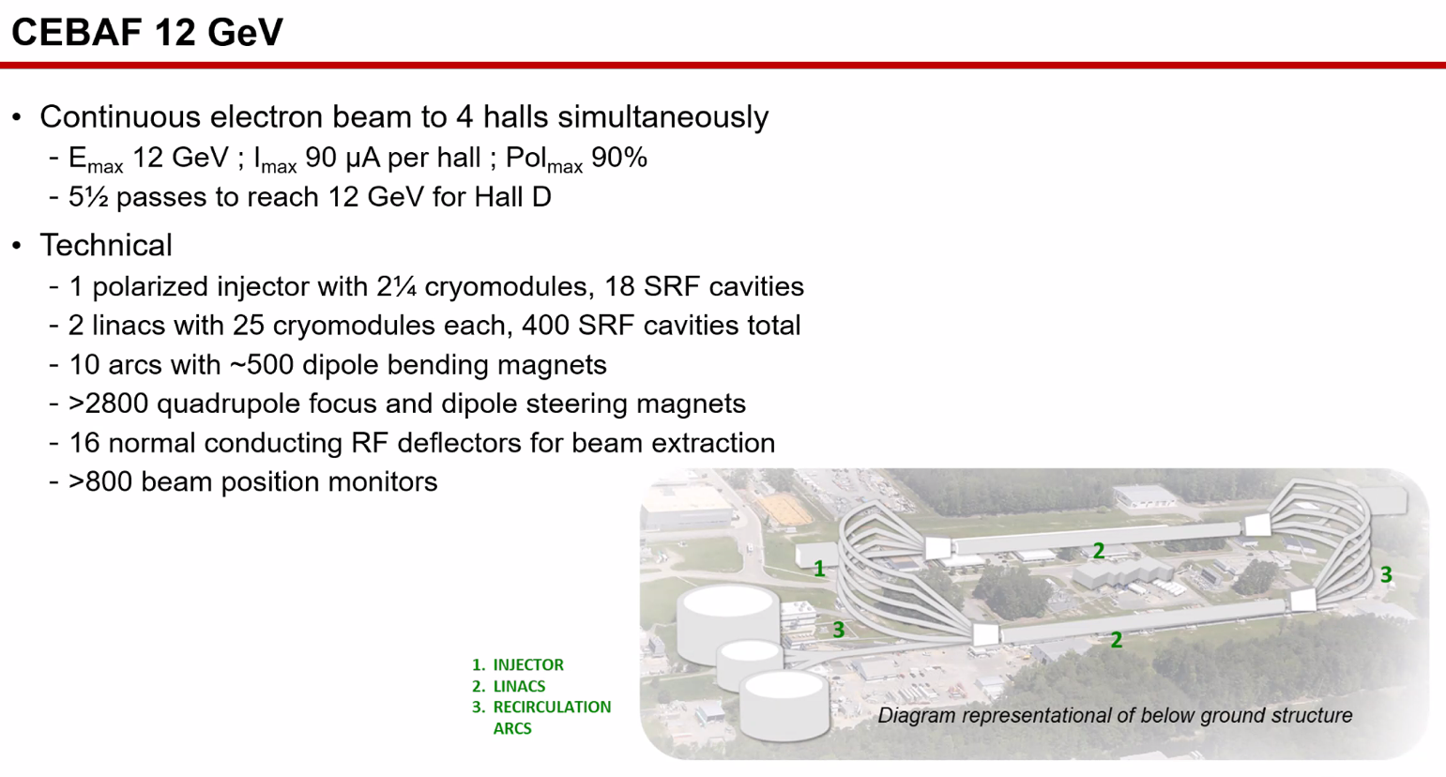
- 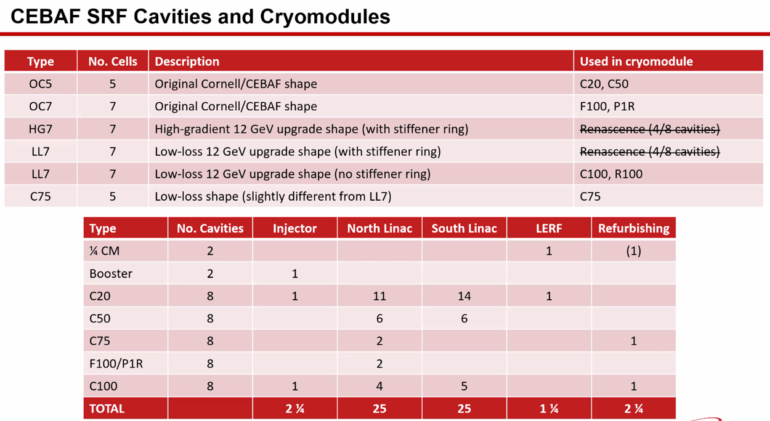
  - 26 OC5s still in use in CEBAF
  - NL has two OC7s
  - Renaissance no longer exists
  - LL = low loss (C100s)
  - C75 is based on Cornell style, but reshaped for LL
  - Ryan – is this up-to-date with the new injector?
    - Yes
- 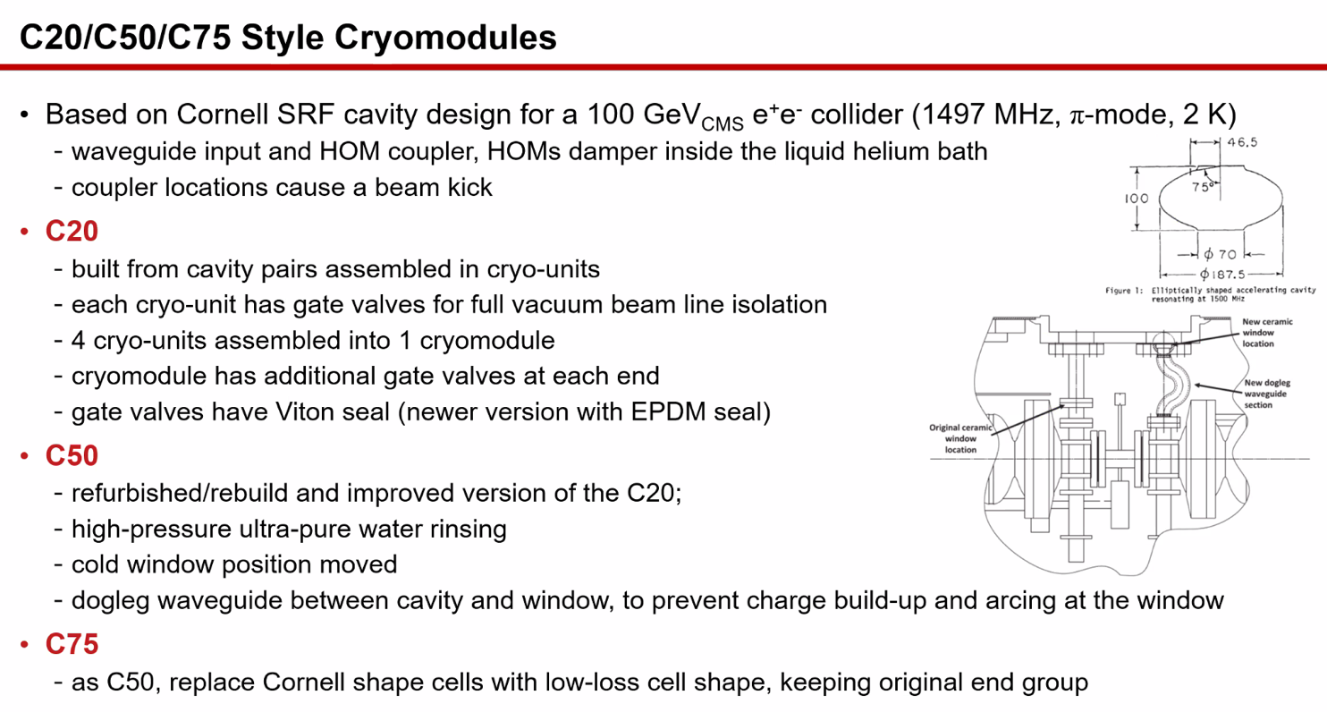
- 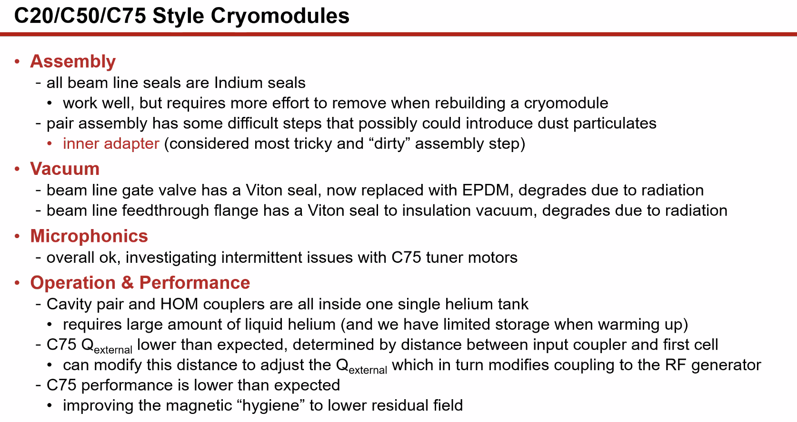
  - Reza – do you test microphonics before install?
    - No – we only measure in the tunnel. We could measure during testing, but not much we can do. It’s a design issue.
    - When testing prior to putting it in the tunnel, we want to make sure it can reach the gradients and at what level we get field emission onset, and if we can tune to the right frequency. Also heat load.
- 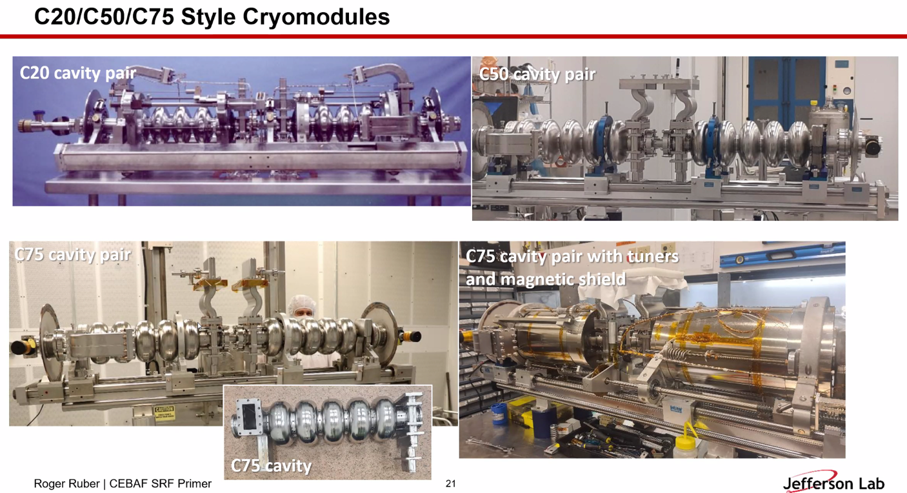
  - Less loss in C75, higher gradient
  - Cavities are like accordians. Press/pull and change resonant frequency
- 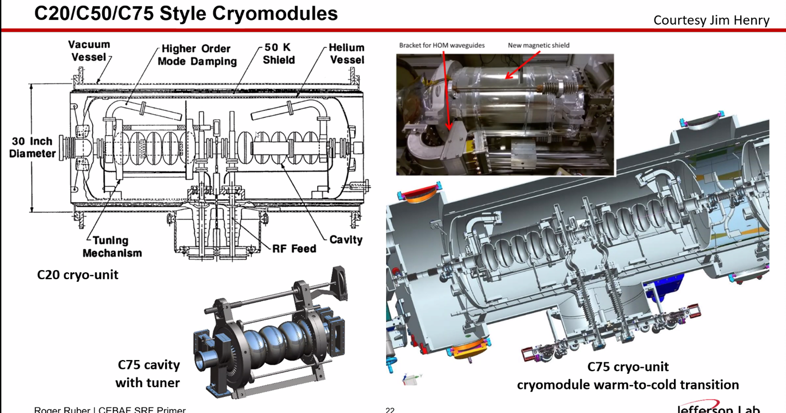
- 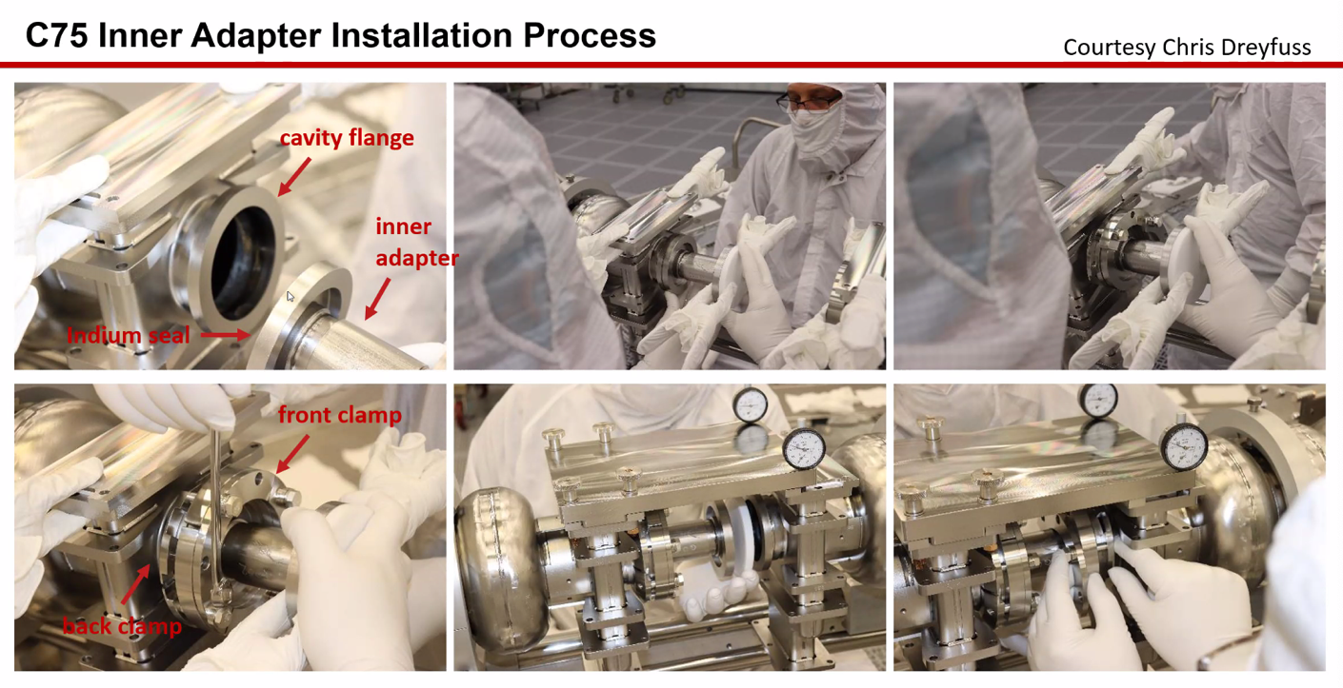
  - Doing this manually creates magnetic dust, and that can cause FE
- 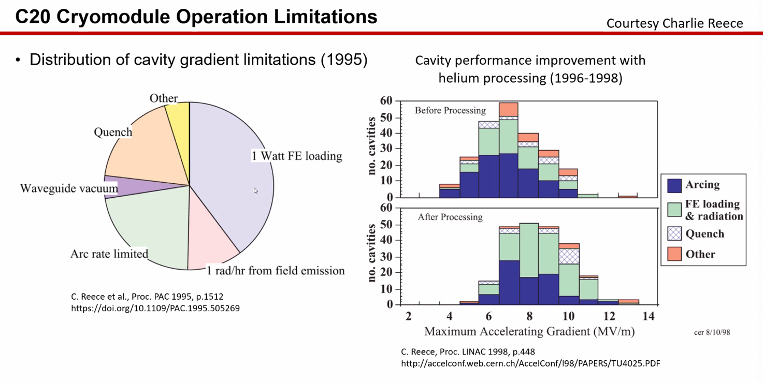
  - Data from mid-90s
  - Half from FE, rest is quench/arcing mainly
  - 96-98 – helium processing helped gradient (about 1 MV/m/cavity)
- 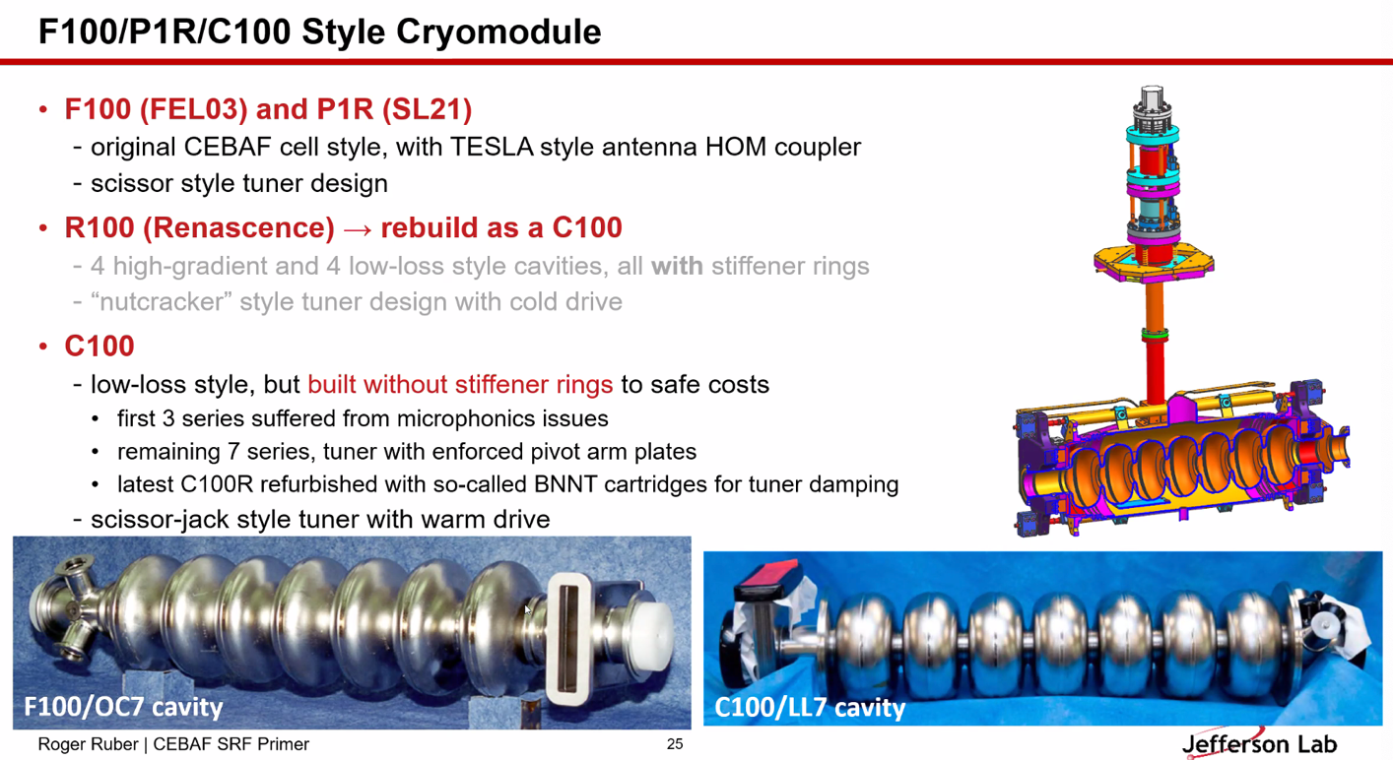
  - F100 has same style as C20
  - C100 has LL shape (flatter) gets higher fields
    - Easier to compress/tune
    - Much more sensitive to microphonics
    - Stiffener ring added in first few cavities – but to save money, these were removed
      - This is why we have the microphonics issues
  - LCLS cavities have the stiffener rings
  - Smaller helium tank
- Thunderstorm detector:
  - Vibrations
  - RF cables
- 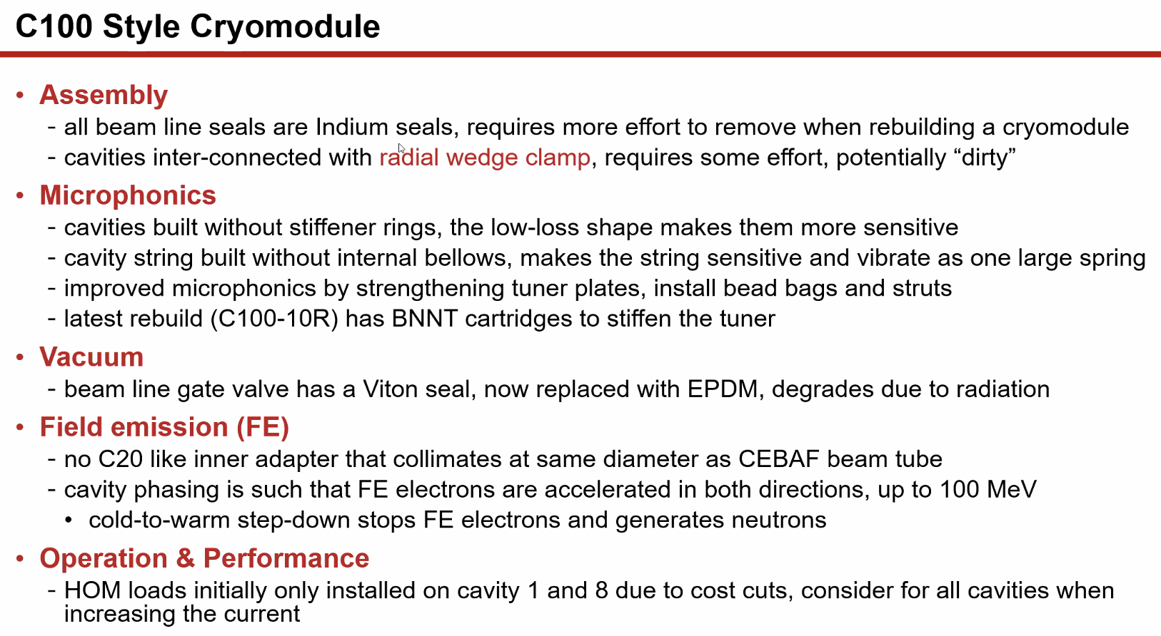
- Reza – field emission can go up to 100 MeV – in one cavity?
  - In one cryomodule
  - Can extend to another cryomodule b/c electrons travel?
    - Yes
  - Only checked single cryomodule so far
- 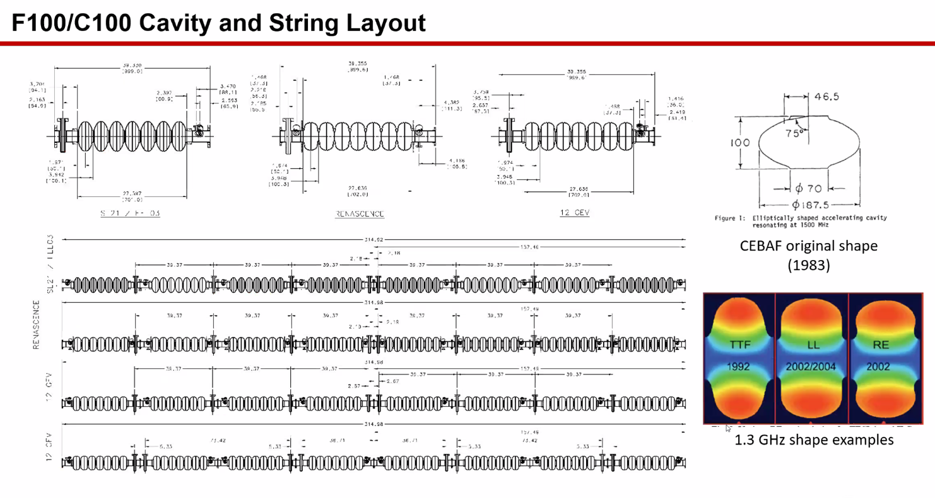
  - Basically one vibrating spring
  - Original tesla shape more elliptical (1992)
  - LL shape and re-entrance shape for higher gradients
    - Re-entrance shape hard to clean, not used
    - LL shape is similar to what use with C100/75
- 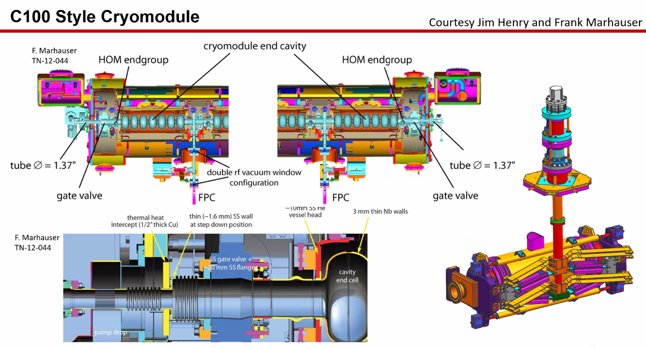
  - Beam tube is smaller than cavity aperture – get electron emission, then neutrons
  - Why different size tubes?
    - Copied from elsewhere.
    - C100 designed for FEL, which has a relatively high current. Want larger tube for higher current
- 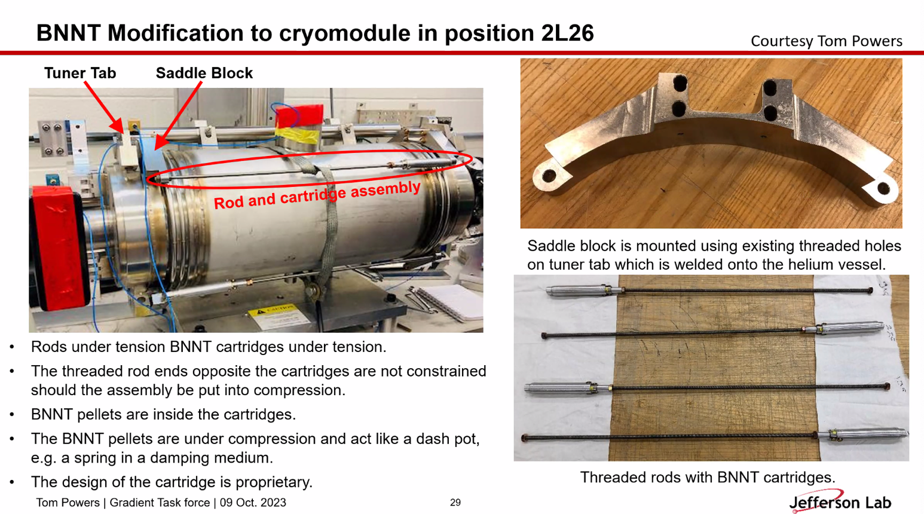
  - Very good at damping microphonics damping
- 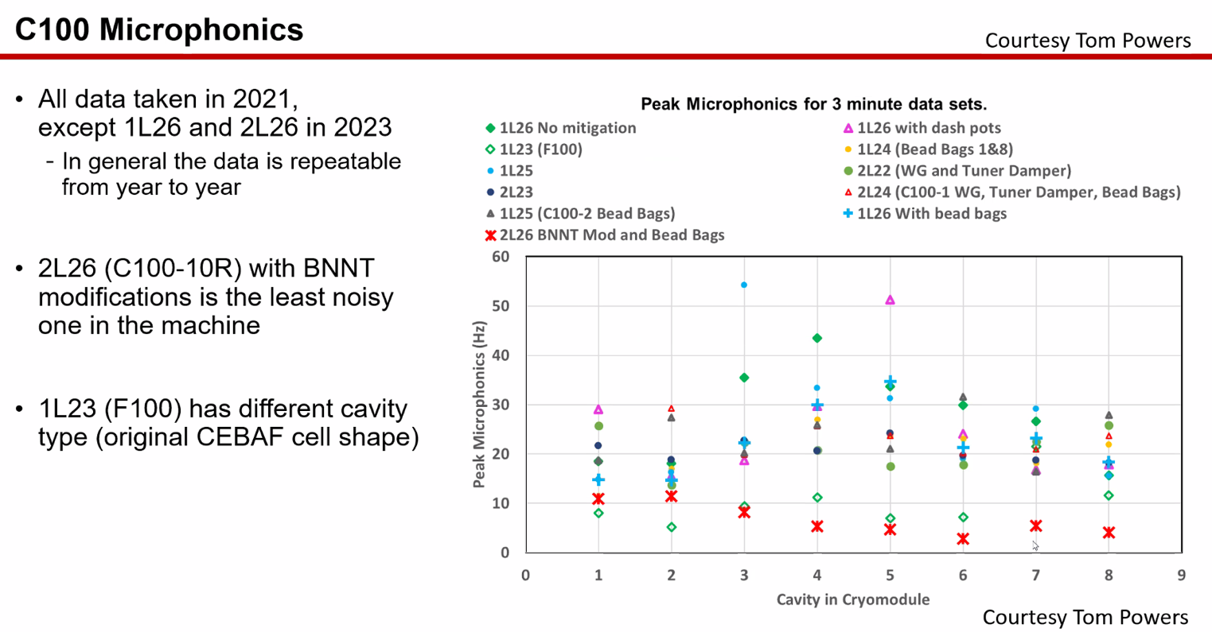
  - Boron-Nitride Nanotubes (Kevin Jordan)
- 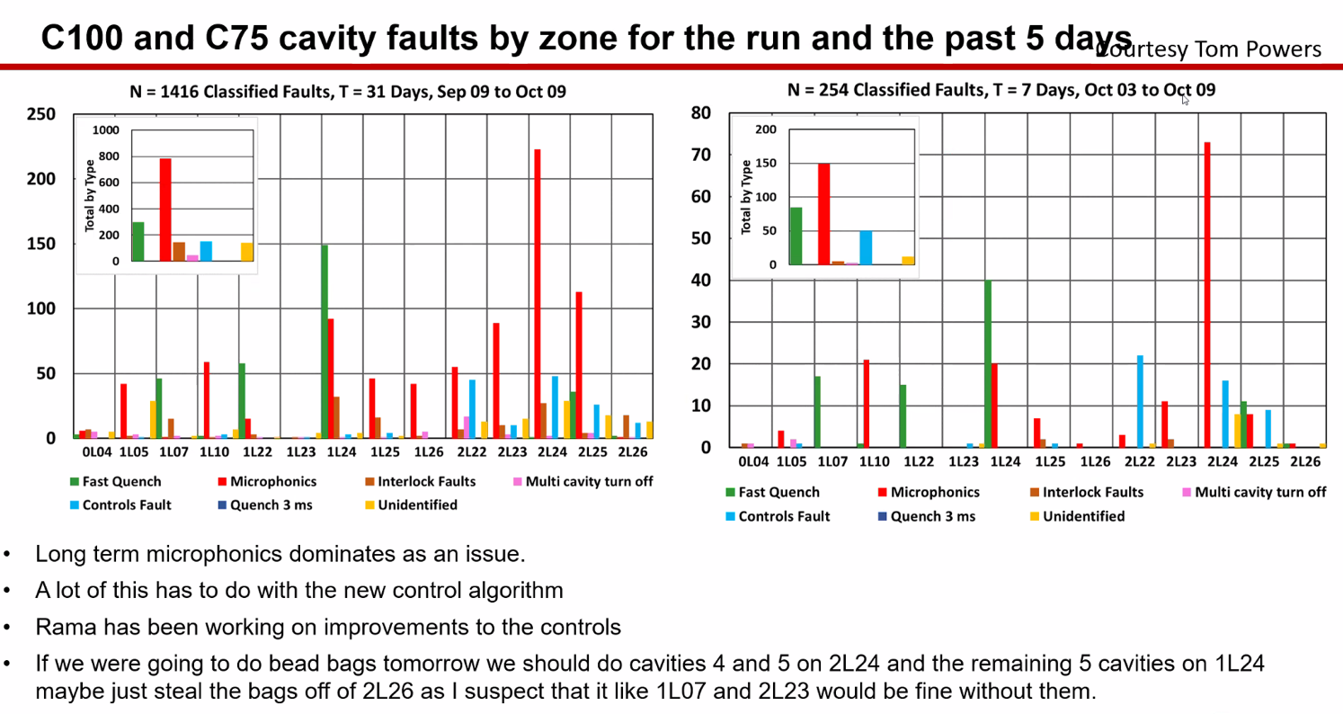
  - Current run faults in C100s and C75s over 31 days
  - Red are microphonics
  - 1L23 (elliptical style) and 2L26 (BNNT)
  - Bean bags on tuner stacks
- 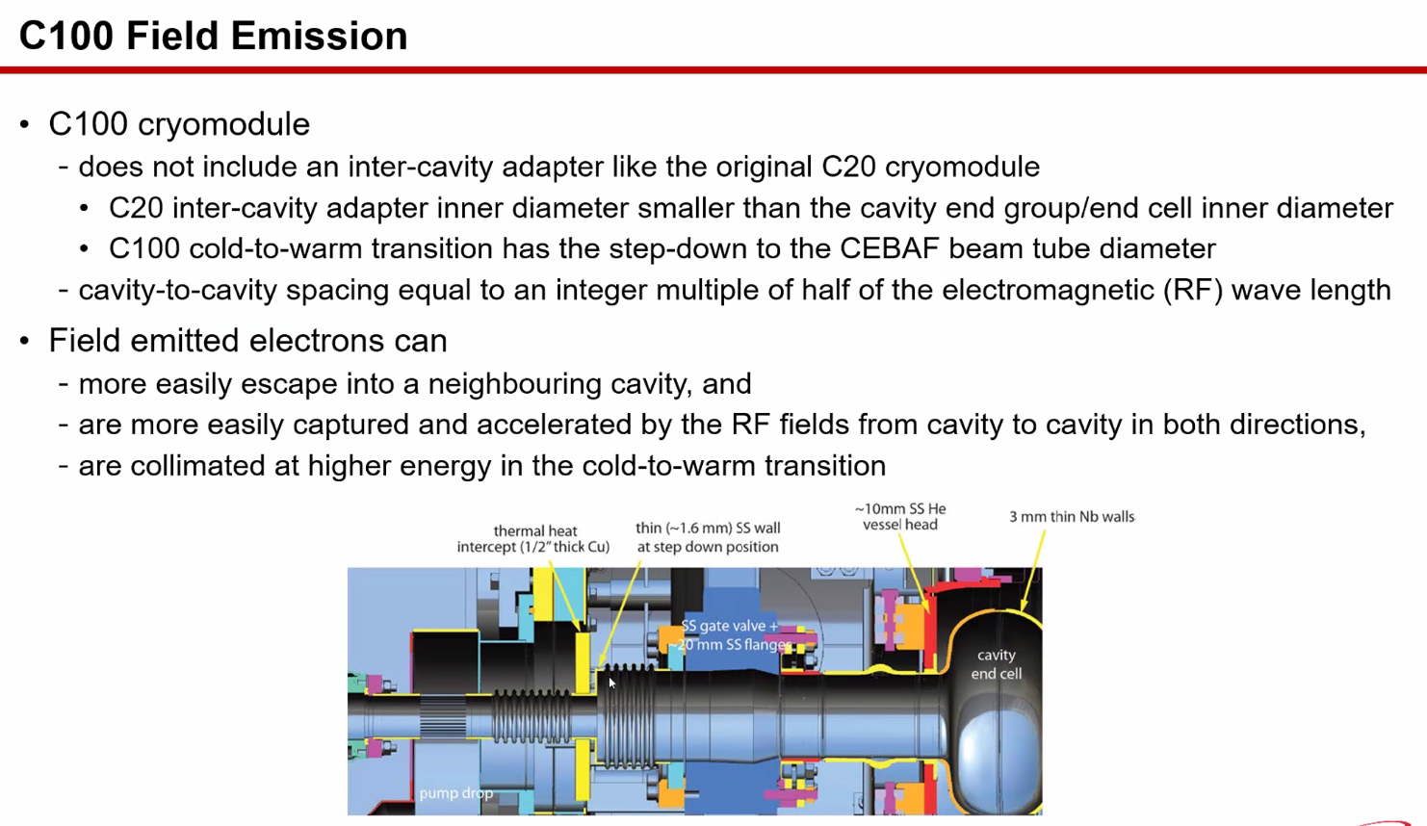
- 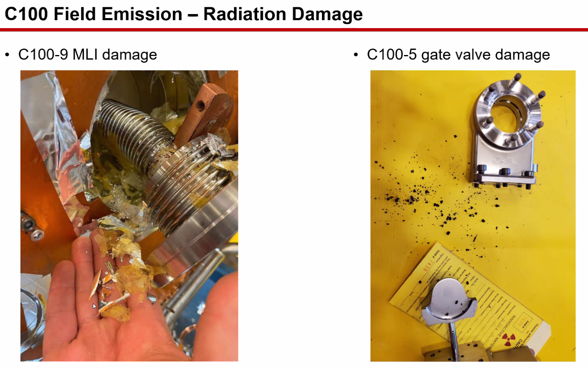
  - Serious problem at vacuum valves. The black powder is the seal
    - Seal is essentially gone
- 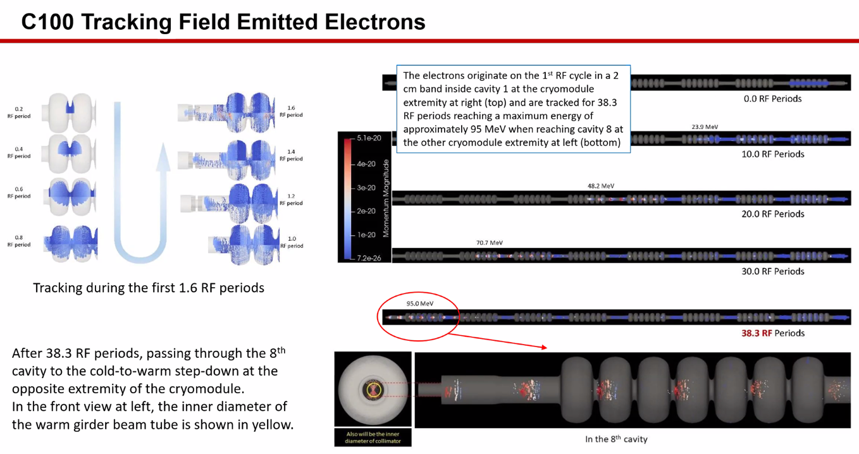
- 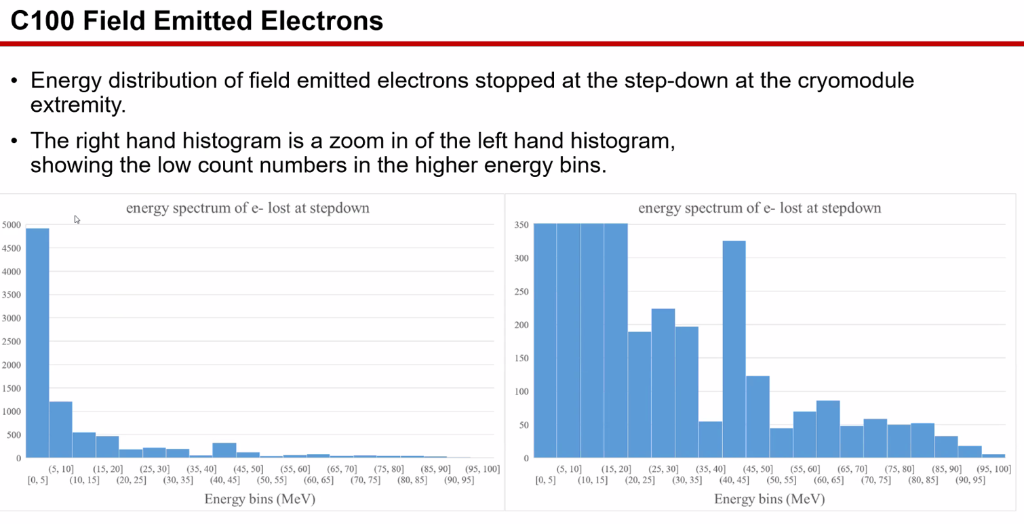
  - Most electrons are low E, but get to above 80 MeV
    - Neutrons start at about 8 MeV
- 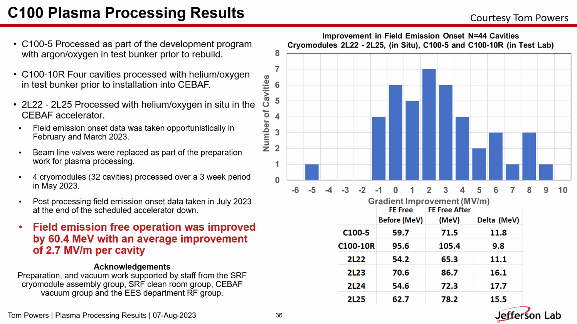
  - Plasma processing improved most cavities.
  - Got an extra 60 MeV+ in SL
- 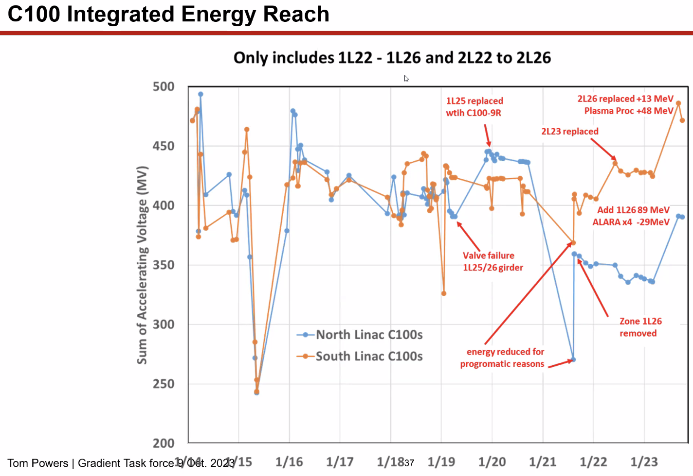
  - Don’t reach the energy we want to reach still, but improved
- 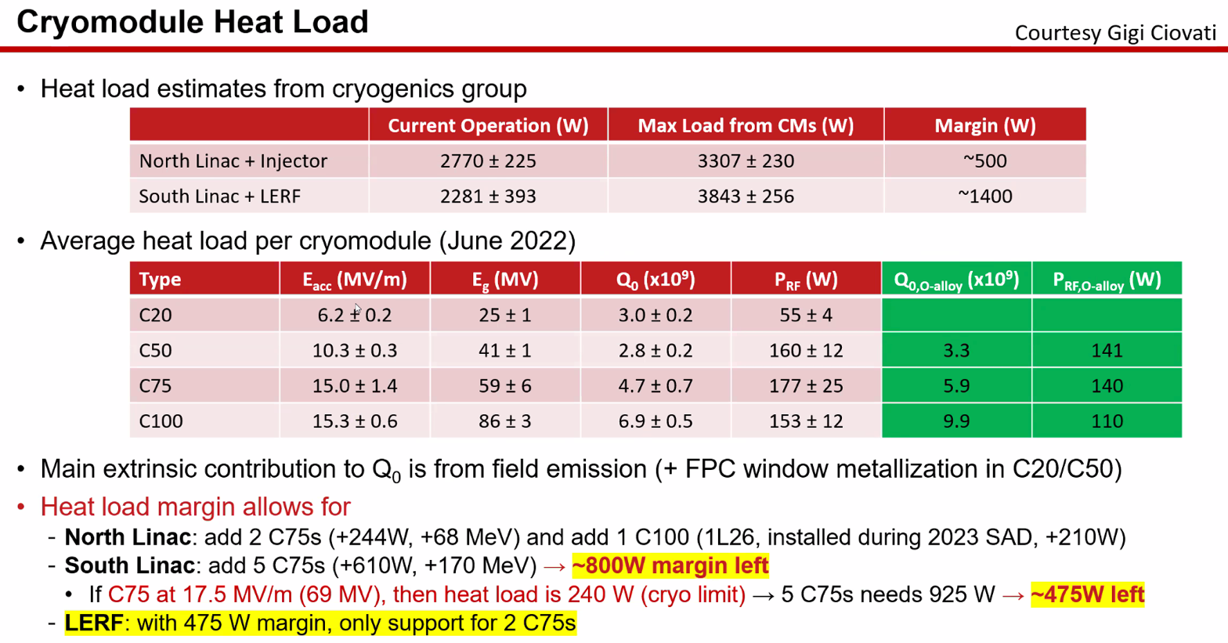
  - Could add 5 more C75s in SL, get higher heat load, so lower the heat load into LERF
  - For CEBAF upgrade with 3 cryomodules in LERF, need to revisit head load limits
    - Previous study in 2022
- 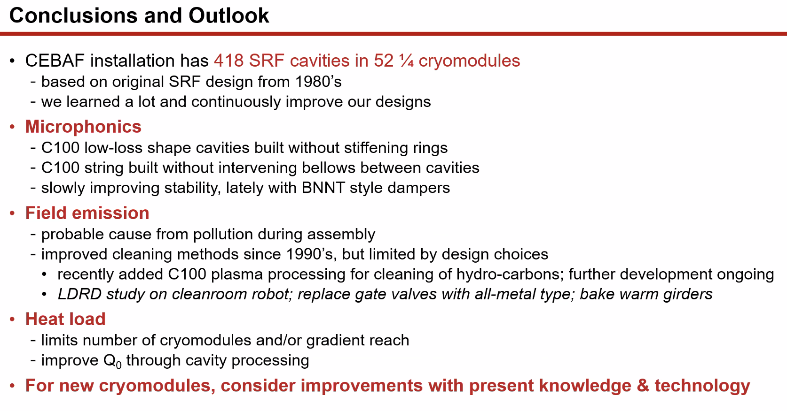
- Scott – let me ask a lot of questions:
  - Talking about LL cavity shape, the statement you made was you get higher gradients. Shape optimized for loss rather than gradient? Why get higher gradient for LL cavity?
    - Lower losses, less heating, more margin to go to higher gradient. Maybe not as high as high-gradient cavity, but higher than with losses
    - So what ultimately limits in terms of gradient? Heat load, FE?
      - Combination of heat load, pipe diameter, FE, quenching, microphonics
        - FE makes radiation, neutrons, etc….
        - FE doesn’t stop you until it’s too high. Makes radiation + heat and therefore loss
  - Table of faults: when you have a fault, what’s the recovery time?
    - Depends on the fault. Seconds usually
    - On the physics side: if the experiment loses the beam, then recover, recover experiment, etc…
    - Usually get 5-10 faults per hour
  - In step-downs, why are they sharp and not tapered?
    - Not sure. Not involved in those designs. I think it was just easier to build it.
  - Removed stiffener rings to save money. Do you really save much?
    - Yes – it simplifies. Need more e-beam welding, so this reduces that. 2 pieces need 4 welds
    - Easy to argue about it in hindsight
Action Items | Person responsible | Deadline

Time allotted | 10 mins | Agenda topic AOB | Presenter All
- Dejan mentions the “enabling language” for FFA in the LRP
Action Items | Person responsible | Deadline

Special notes

Pathway to Repository: https://jeffersonlab-my.sharepoint.com/:f:/g/personal/tristan_jlab_org/EqZ5MeS-nipCgPfZB5p0oS4B9Is67d3nQb9sLJI3Zyev9g

