FFA@CEBAF Working Group|Minutes

## Meeting date | time 10/20/2023 | 11 AM EST | Meeting location <https://jlab-org.zoomgov.com/j/1614898082?pwd=TnUzMS81M2sxbDZIbERJU01tYkJCQT09>

|  |  |  |  |  |  |  |  |  |  |  |  |
| --- | --- | --- | --- | --- | --- | --- | --- | --- | --- | --- | --- |
| |  |  | | --- | --- | | Meeting called by | Alex B | | Type of meeting | Weekly Meeting | | Facilitator | Alex B | | Note taker | Ryan, Donish | | Timekeeper | Alex B | | Attendees  Alex B, Ryan, Alex C, Dejan, Donish, Edy, Scott, Kirsten, Randika, Reza, Stephen, Todd, Vasiliy, Nick, Roger |

# Intro Discussion

* Ryan (notetaker) late (11:04) so Donish took notes as well

# Agenda topics

## Time allotted | 25 mins | Agenda topic Multipass Correction | Presenter Alex Coxe

* 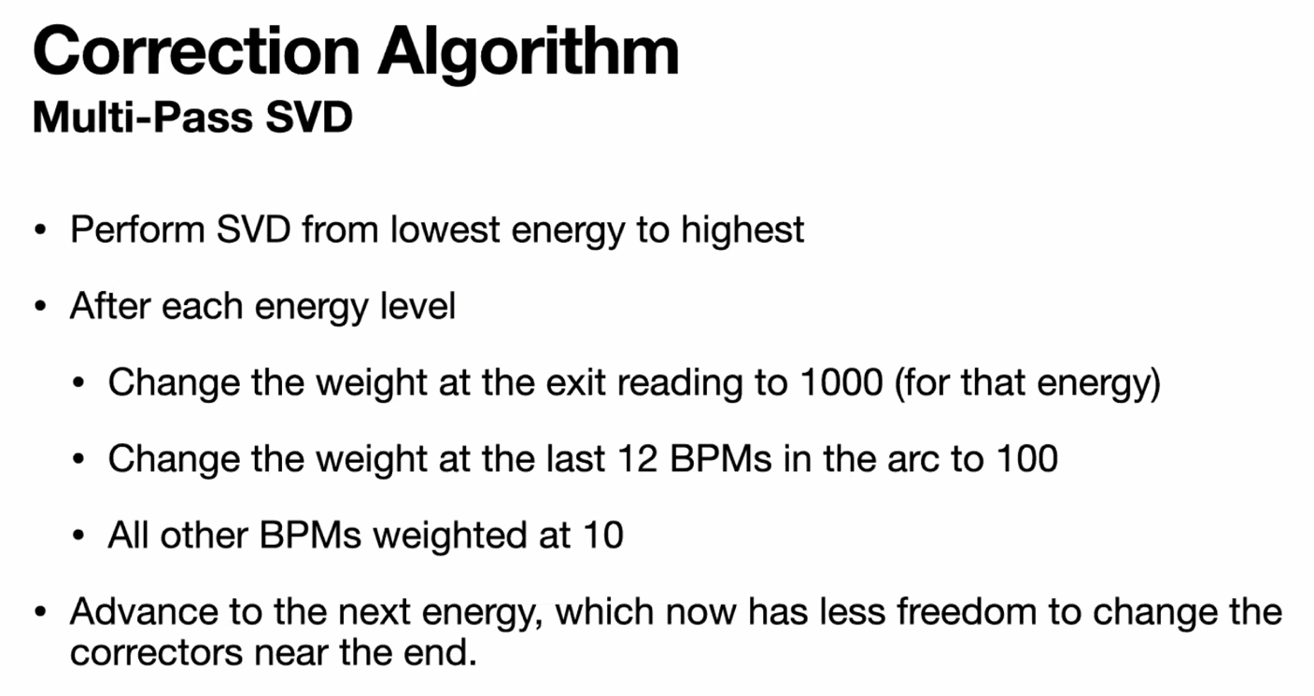
* Work focused on west arc
* Based on how error correction was done in CBETA (via Kirsten's guidance)
  + No quadrupoles
  + SVD correction (from lowest to highest energies)
  + 1 more bpm than correctors
* 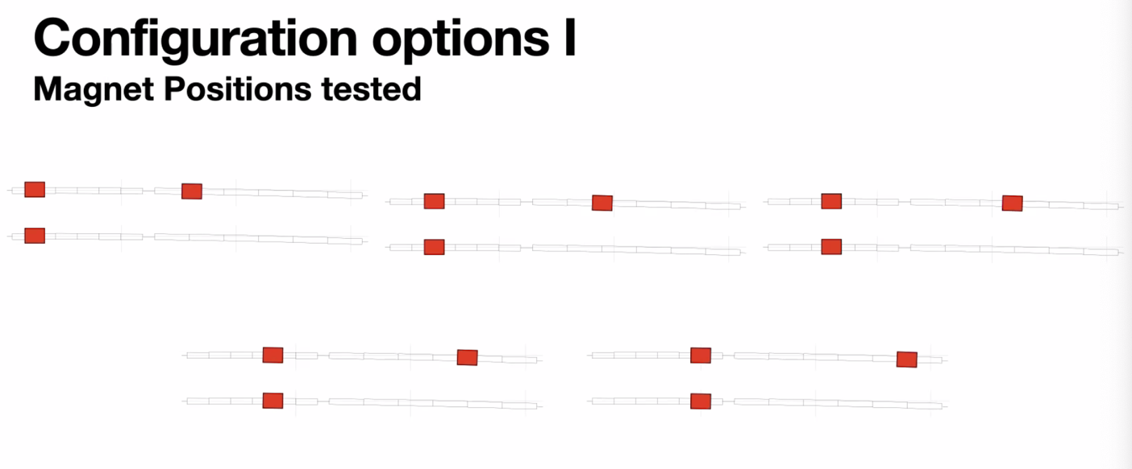
  + 5 configurations shown here.
  + Tests with 150 correctors in arc (1 on each magnet)
    - Very effective
  + 100 correctors in arc
  + This is a view of 1 cell (BD + BF)
  + For each arrangement, there are either 1 or 2 corrector setups. Moving correctors longitudinally on the magnets
* Scott – how long are the magnets? – 1.3 m for BD
* Correctors are implemented as controllable elements in Bmad, but they are 40 cm long, based on Jay’s Panofsky design
  + Integrated kick over 40 cm
* Currently working with 100 correctors in the whole arc
  + First 10 cells have 2, last 15 cells have 2, then the in-between has 1 corrector each
* Scott: why did you focus on leaving it on the first, upstream magnet? Tradition would be to alternate them
* 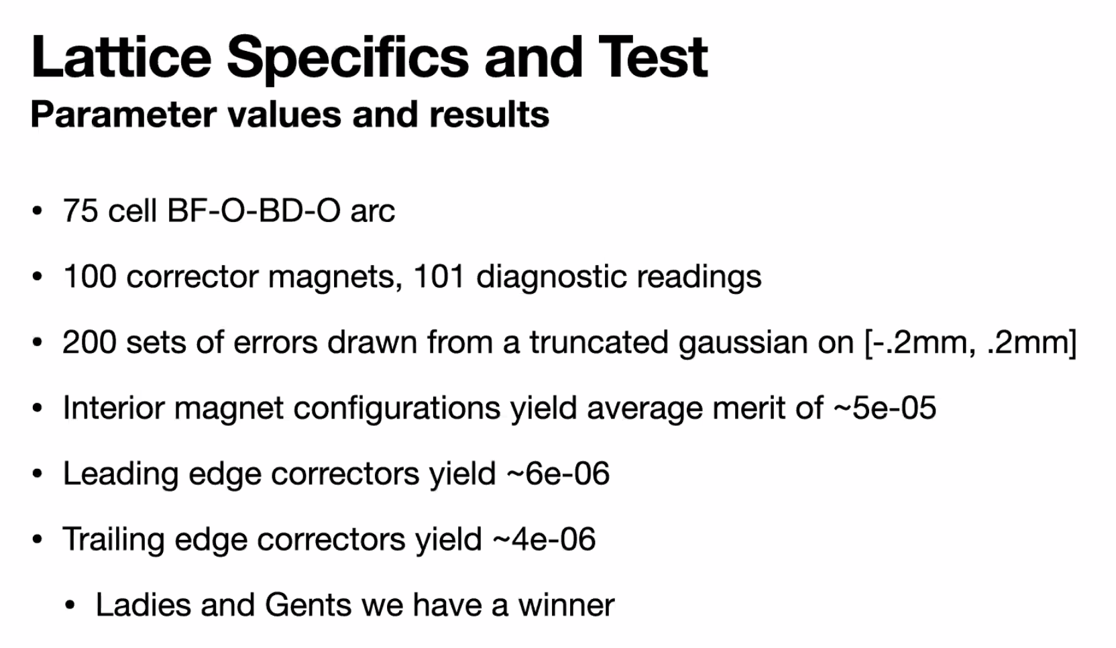
  + Interior magnet configurations (not on the front edge or trailing edge)
  + Upstream does order of magnitude better
  + Downstream does best
* Scott – betas peaking in middle of each magnet
  + Curious that there’s a preference for trailing edge
  + If you have symmetric betas here and every drift is the same, so why is trailing edge better?
    - Artifact of measurement?
    - If you look at an invariant measure, I would expect leading and trailing to be similar
* 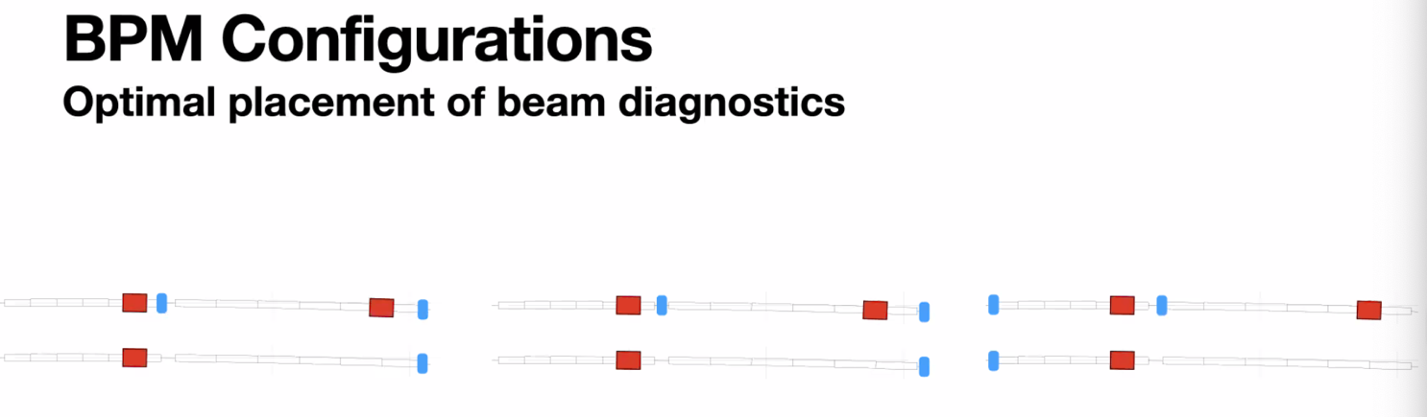
  + Moving BPMs either on upstream, middle, or downstream edges of drifts
  + Small differences
  + Initially, BPMs like that on left (at beginning of drifts) – same number of BPMs as correctors in ARC except at exit (number of correctors +1)
  + Tested all three of these:
* 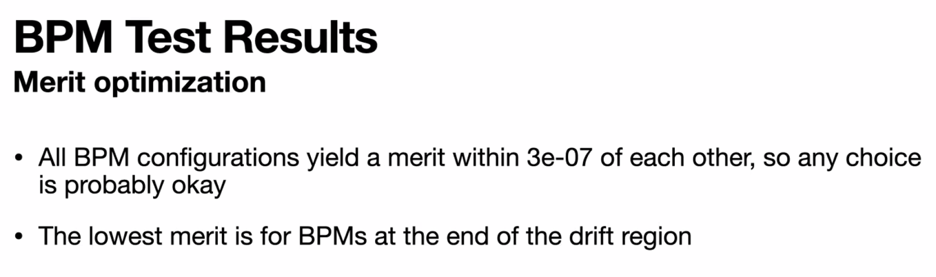
  + Any configuration is OK, but lowest merit is at the end of the drift
* 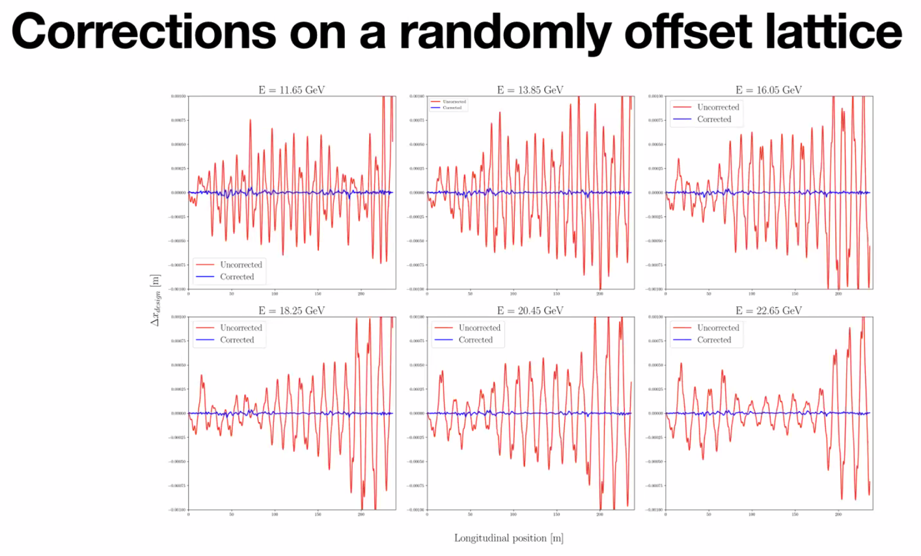
  + -1 mm to +1 mm, so up to ~10 microns
* Scott: when you talk about merit you’re looking at BPM positions over a long section
  + Yes – this is for the full arc
* Todd: doing correction with SVD (tailored)
  + Get list of singular values, are you doing a SV cutoff, and if so, how many SVs are you cutting off?
  + Alex C – it’s built into Bmad, set cutoff at E^-6, so it does it automatically.
    - Haven’t looked at response matrix
  + Todd – if you have a ton of redundancy, you can throw away more BPMs/correctors
    - Kirsten – KEEP THE CORRECTORS!
  + Stephen – might be useful to move the cutoff around a bit and see the response, but suspect it’s not cutting too much
* Dejan – two different response functions
  + Stephen – no, only one. One is correctors, the other is BPMs
* Kirsten – when you say set of errors, is that just directional misalignment, or rotations, etc?
  + Right now, just offsets. Need to run more on the farm
* These include position modeled at other places.
* The final BPM/Corrector situation is 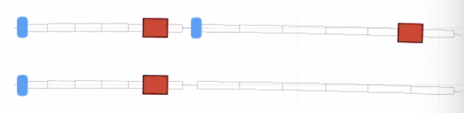
  + Downstream BPMs, trailing edge correctors
* Alex: lattices doing this on, just have orbit and momentum in X direction
  + The ones with correctors are on GitHub and Sharepoint

|  |  |  |
| --- | --- | --- |
| Action Items | Person responsible | Deadline |
|  |  |  |
|  |  |  |

## Time allotted | 25 mins | Agenda topic Transition Lattice | Presenter Vasiliy/Randy

* Last night, thought could show something. But turns out got stuck at pass 5
* Tune separation that thought would work not large enough
* Vasiliy – could meet all constraints except one, but trying to meet that leads to a large beta-function blowup
  + Basically, same harmonic getting in resonance with two passes, so you must carefully chose betatron per cell so it’s only for a single pass
  + Avoid harmonics of other passes
* 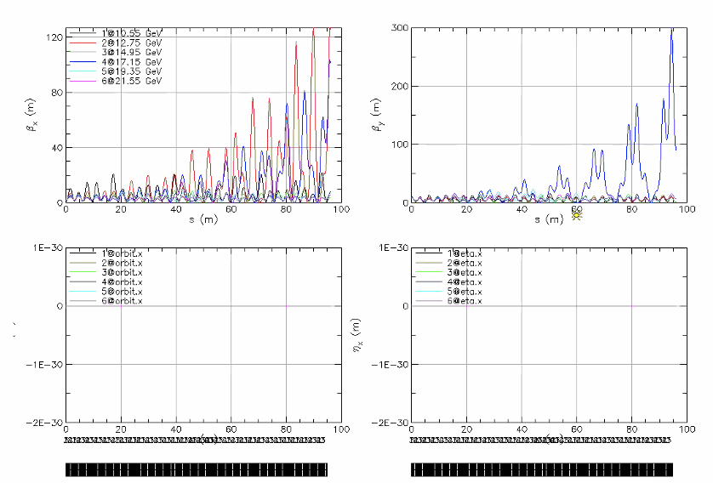
* May have found new set of tunes, but need to run it
* Compare each pass with another, calculate different tunes – anything close to 1 isn’t good
* Need to run and see if it’ll work
* Kirsten – is 100 m the length?
  + No, it’ll be shorter
  + Old trials without everything in it were 16 m, but it’ll need to be much longer
* Todd – some of this is similar to stuff Dave Douglas did, might be worth reaching out or finding papers
* Kirsten – this includes the Recombiner?
  + Ryan – it’s the chicane without quads, about 30 m drift
* Kirsten – do we have spreaders for the new optics?
  + Ryan, everything was based on the weakly-focused linacs, and so we’ll need to go through and rematch everything for the new optics as they are available
* Alex B: Donish is automating this
  + Donish: nearly-automating. Work in progress
* Kirsten – may look at radiation integrals in spreaders/recombiners for strongly focusing linac optics
* Alex B – good numbers for longitudinal emittance
  + Kirsten – maybe I should recheck my latest numbers
* Vasiliy: 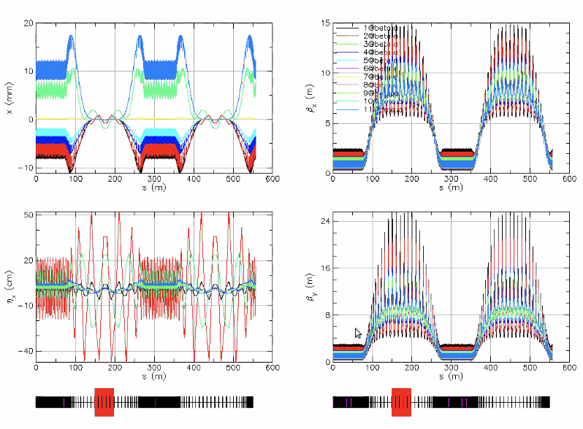
  + Adiabatic match (this isn’t CEBAF, but similar)
  + With finite number of matching cells
  + Dispersion not fully suppressed, starts ringing – we’ll likely need to consider this (dispersion leakage after adiabatic match)
  + Need a knob to control dispersion and orbit, preferably by individual passes 1 by 1
* 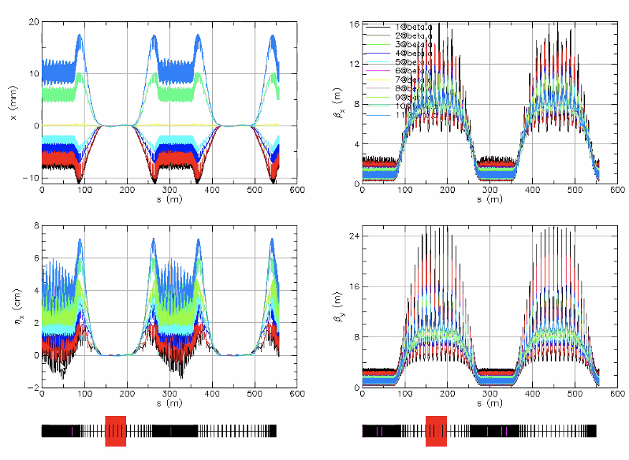
  + Same lattice, but correcting dispersion
* Dejan – In CBETA, 4 passes, had to avoid 0.333 resonance if tune is in cells close to 3rd order, then problem
  + Avoided going through 3rd and a few other resonances, picking up tunes for each energy to avoid it
  + Didn’t do it for 6 passes – all will have to be away from 3rd, and cells are numerous
  + Go back to lattice design to avoid those
  + Depends on max/min tune so you can choose 6 not to hit the third
* Scott: be careful, need energy variability
  + Cryomodule loss and/or user preference
  + CBETA had large energy range
  + High phase advance per cell is the hard spot, jumped over that in CBETA
    - Not hard to jump the hard part at CBETA
  + Here, problem is that the relative energy changes are small, so dodging things is harder
    - Given that we want to dial things, this will be even harder
  + Probably should take lowest and second lowest energies and have them straddle the 1/3rd
    - Or representative energy
    - See what happens when you vary the range you want to cover
  + Also need to worry about ¼
  + Can probably live with all else
* Dejan – if you fix/reduce the tune changes, you get into a problem of how to correct orbits for different energies
  + Maybe add sextupoles? Reduce variations. Unsure. Need to study more carefully
* Kirsten – is there an example of one of these transitions that can test for radiation integrals? Just to look at scale?
  + Ryan – I suspect “not ready for primetime yet”
  + Vasiliy – just the section with dispersion?
    - Yes, if it’s not bending, doesn’t matter
* Vasiliy – to make it useful, need to combine dispersion suppression and beta excitation sections. We can work on that. This was the next step

|  |  |  |
| --- | --- | --- |
| Action Items | Person responsible | Deadline |
|  |  |  |
|  |  |  |

## Time allotted | 10 mins | Agenda topic AOB | Presenter All

|  |  |  |
| --- | --- | --- |
| Action Items | Person responsible | Deadline |
|  |  |  |
|  |  |  |

## Special notes

Pathway to Repository: <https://jeffersonlab-my.sharepoint.com/:f:/g/personal/tristan_jlab_org/EqZ5MeS-nipCgPfZB5p0oS4B9Is67d3nQb9sLJI3Zyev9g>