FFA@CEBAF Working Group|Minutes

## Meeting date | time 10/27/2023 | 11 AM EST | Meeting location <https://jlab-org.zoomgov.com/j/1614898082?pwd=TnUzMS81M2sxbDZIbERJU01tYkJCQT09>

|  |  |  |  |  |  |  |  |  |  |  |  |
| --- | --- | --- | --- | --- | --- | --- | --- | --- | --- | --- | --- |
| |  |  | | --- | --- | | Meeting called by | Alex B | | Type of meeting | Weekly Meeting | | Facilitator | Alex B | | Note taker | Ryan | | Timekeeper | Alex B | | Attendees  Alex B, Ryan, Donish, Dejan, Kirsten, Edy, Scott, Randika, Stephen, Vasiliy, Andrei, Reza, Roger |

# Intro Discussion

* LRP discussion
* Dejan – we need to get ready for the FOA – Alex: we can update the one from two years ago
* Scott – did they start cannibalizing CBETA? Dejan, not sure.
* Lots of planning activities for positrons and FFA, more comment at the end.
* Push for complete design

# Agenda topics

## Time allotted | 25 mins | Agenda topic Alternative Splitters | Presenter Donish

* Talk should be short. Will go through constraints, current baselines, chicane geometries, other ideas, and work in progress
* 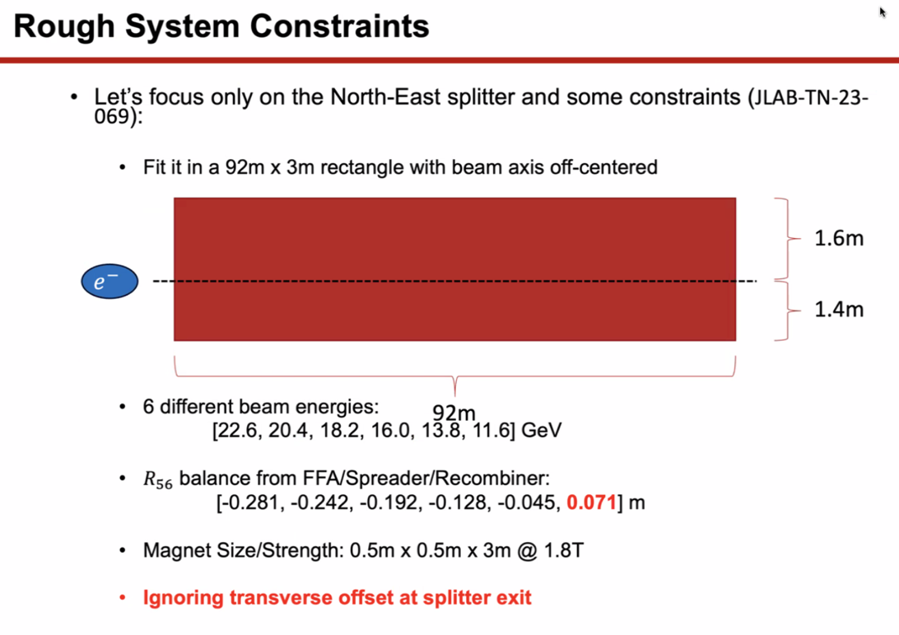
  + Space/numbers from Ryan’s tech note.
  + Ryan: the beamline is centered the other way
* 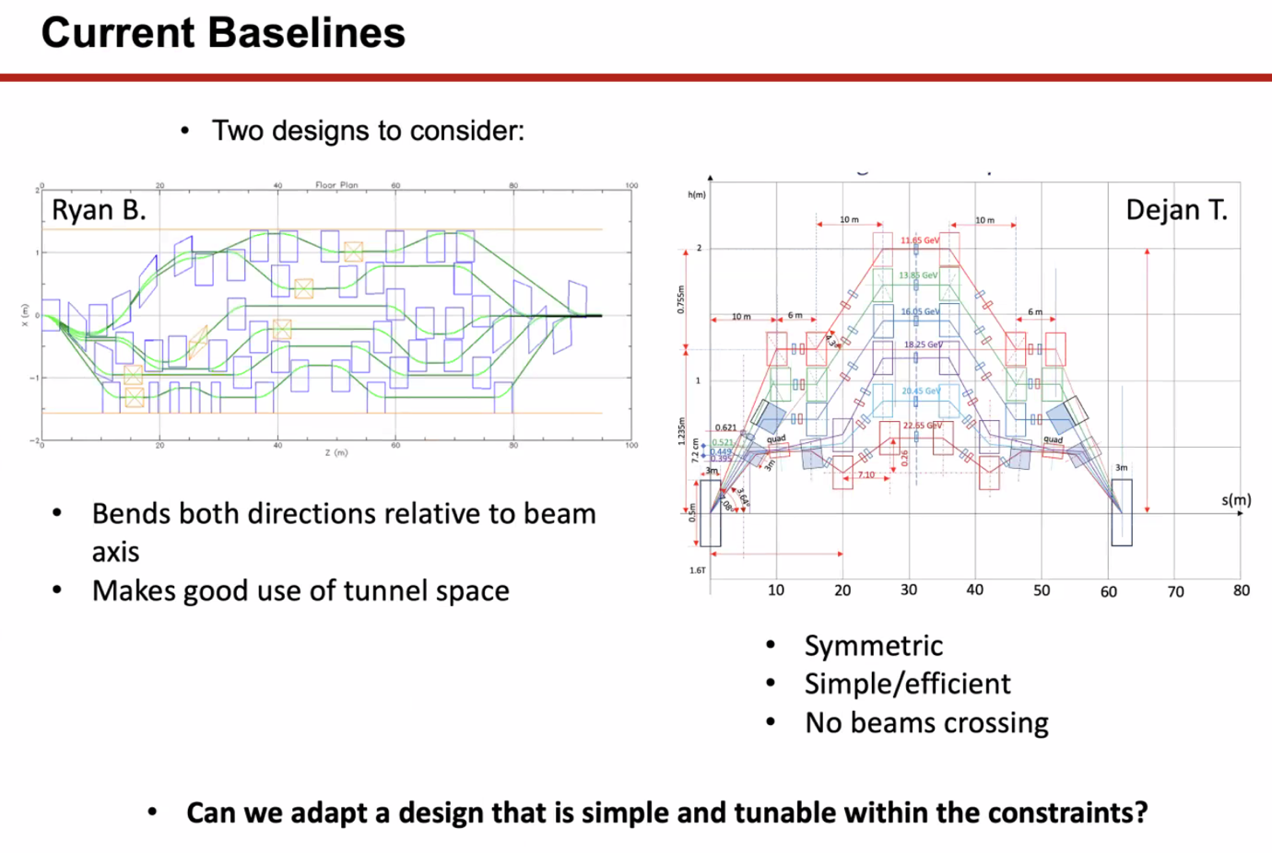
  + Ryan’s good parts: uses all the space
  + Dejan’s good parts: symmetric, no beam crossing
  + Can we make it simple and tunable withing constraints
* 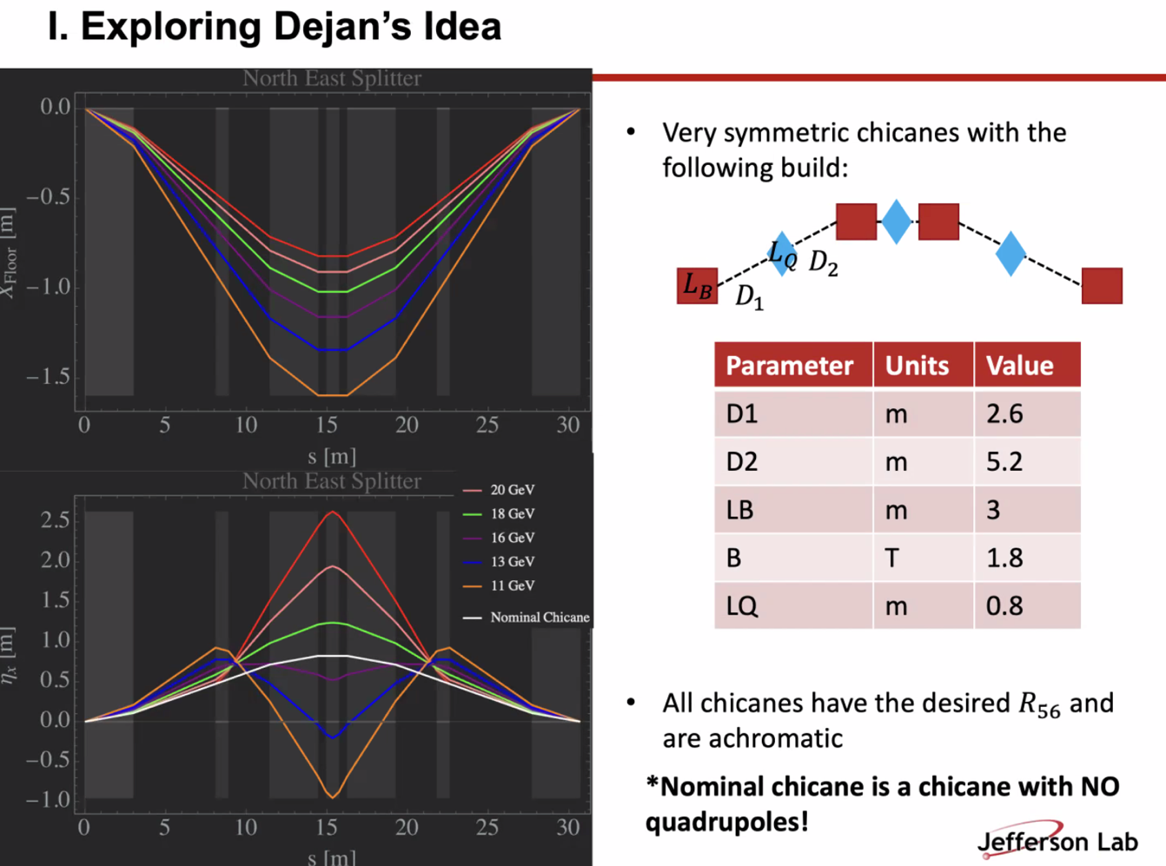
  + Simplified, and started with chicanes
  + Tunes so get R56 needed
  + Top left is floor coordinates, shows positions of beamlines (red is 22 GeV)
  + Bottom is dispersion (white line is nominal chicane without quads)
  + Skinny grey is quad, fat grey is dipoles
* 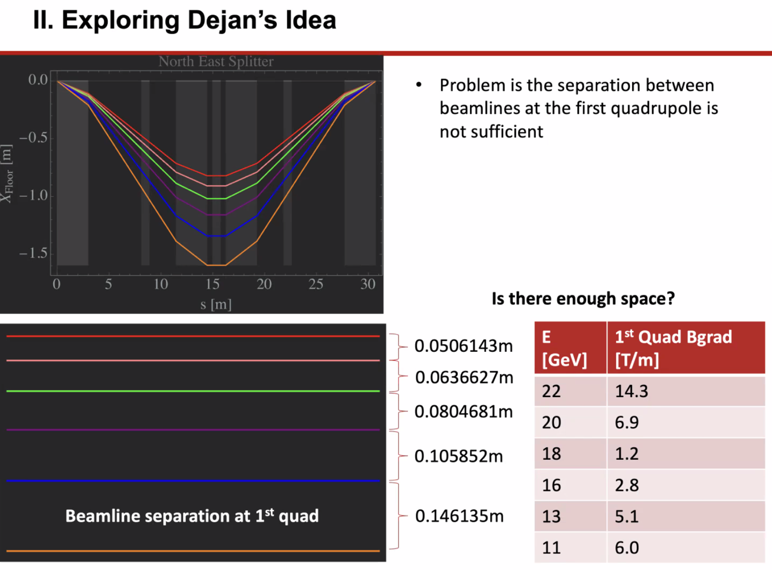
  + First problem: **not enough separation between passes** (only 5 cm between highest two passes). Can’t fit side-by-side quads there
  + **Is there enough space?**
  + Gradients aren’t huge, but how big do those quads need to be?
  + Stephen: what aperture will this need?
    - Dejan – just used standard aperture (1 m)
    - Stephen – in reality, this depends on how big the pipe is?
      * Can likely do this with permanent magnets
      * Ryan: but if we drop a cryomodule, can they be permanent?
  + Kirsten: splitters are the ONLY place where all the beams are separate. It’s the only place we can control the passes
* 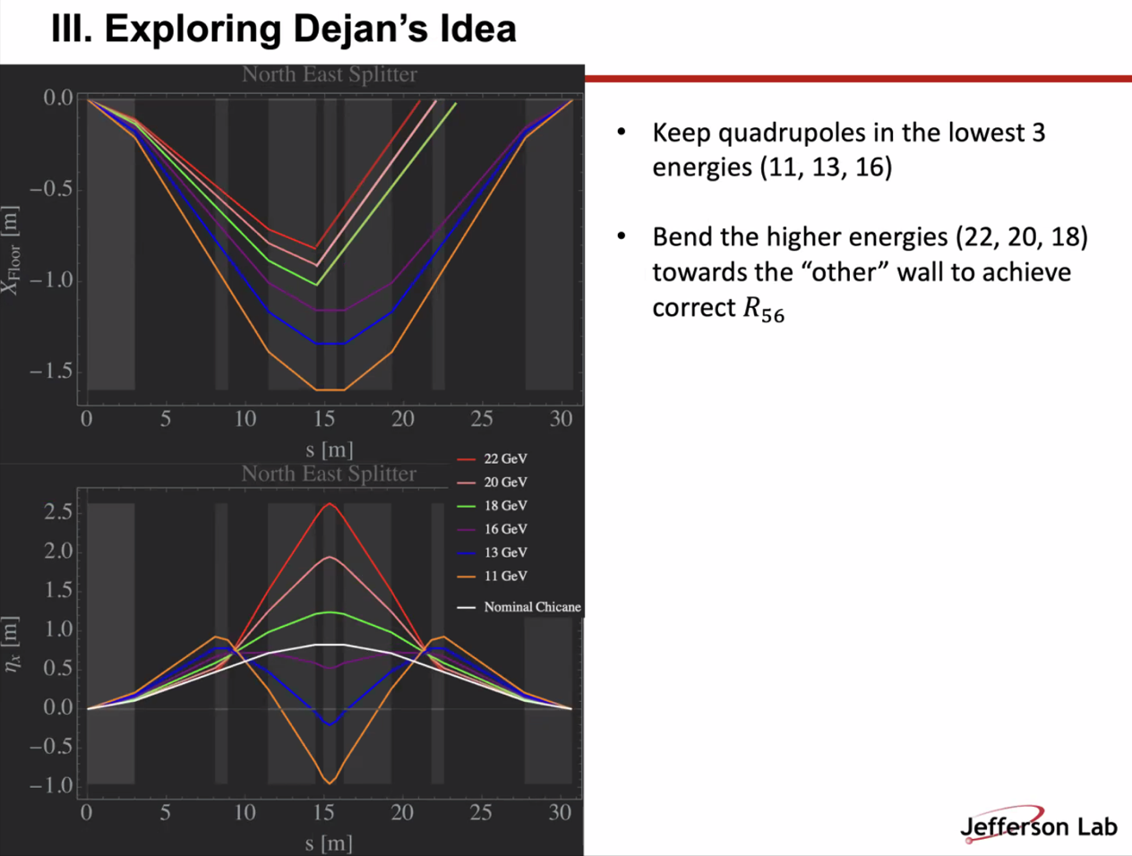
  + If fit quads in the lowest 3 energies, bend the higher energies toward the other direction, might help correct
  + Last slide shows that there’s not enough room for quads in each line
* 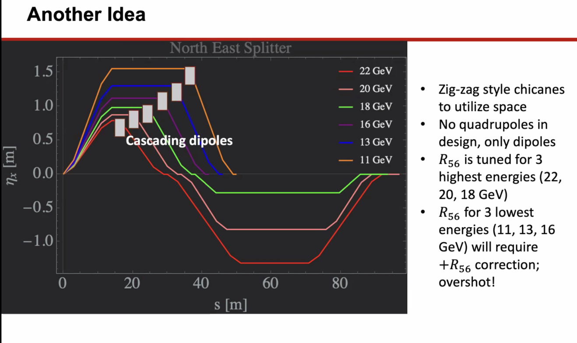
  + Zig-zag chicane to utilize space, using both sides of the beam axis
  + No quads yet, just dipoles
  + Red/pink/green have the right R56 – lower energies will need correction
    - 3 lowest energies will have the “wrong” R56 – still space at end, but need more bending
* 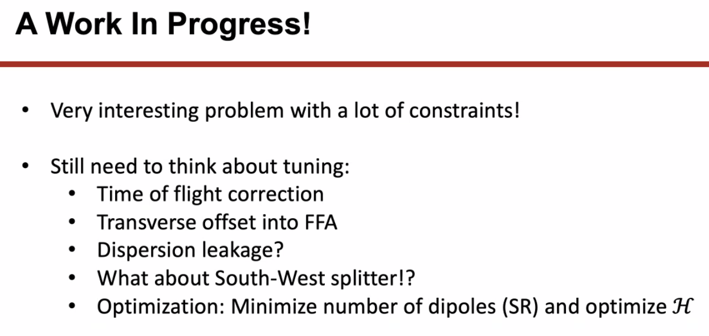
* Dejan – to make them more separated, used a trick with one quadrupole where one energy is bent one way, and the other is bent the other way b/c the quadrupole is off-center
* Stephen – what if first splitting dipole is a gradient magnet or multifunction?
  + As soon as things split, can use quad so they bend away from each other.
* Dejan – shows that the R56 values can be fixed with the chicanes
  + ToF can be done two ways: take into acct the largest or smallest energy to compare
  + Highest R56 is highest energy, so can correct this way
* Dejan – perfect startup to make this simple
  + Next, make use of quadrupoles to separate more
  + Lowest energy and two more of them are separated enough that you can take them away without big problems – the rest are harder
    - Need Lambertson or another way to move them away
* Alex B – already put in quads
* Ryan – are these recombining co-linearly?
  + Yes, and that’s important
  + Was thinking that can put quads in at the end, and maybe separate
  + Didn’t want to put in too many constraints
* Scott – the orbit separation at the end doesn’t have a big impact
  + Stephen put half quad at end of FFA
  + Low energy wasn’t coming out parallel
* Scott – One you get to matching, the big thing you’ll have to face is that the betas are assymetric from one side to the other
  + This severely constrains what you’re able to do with the quads
  + You’ll have to break your symmetry
  + Need at least 7, likely 8 or more
* Scott – quads won’t be tiny anymore once they are doing all the things they need to do
* Ryan – you’ll need to pull the max orbit back a bit to make room for magnet steel
  + Also, if the first dipole is set at 1.8 T, you won’t be able to scale on the SW corner, since the beam is 1.1 GeV higher, and 1.8 T is nearing the limit of the magnet strength, you won’t be able to scale it.
* Working on design using a quad to separate the beams after the first bend.
  + Separate the beams but also flip the orbits
* Roger – I’m new, so two questions
  + How would existing arcs fit here?
    - This is at LINAC height, spread horizontally
  + What would the aperture of the beam tube be?
    - Not sure
* Edy – Does this need to compensate for the Spreader elevation?
  + No, Spreaders do this already
* Alex B – put Donish on the spot, so he didn’t have time to weigh all of it.
* Ryan – Must pay attention to operational concerns
  + Errors make separation/recombination difficult, be cautious of sharing magnets with passes
  + Example from current extraction, where machine errors often cause complications extracting vs. recirculating beam: we paint the nose of the septa.

|  |  |  |
| --- | --- | --- |
| Action Items | Person responsible | Deadline |
|  |  |  |
|  |  |  |

## Time allotted | 25 mins | Agenda topic Strategy/Resources | Presenter Alex B

* 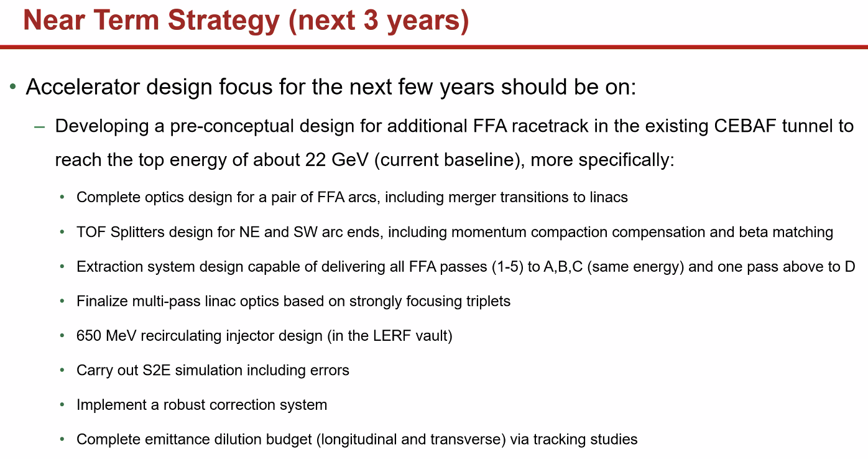
  + Task juggler project management tool being used eventually
  + Assuming ambitious strategy made by Reza
  + Reza – for new injector work, the beginning part is similar
    - Since this isn’t just making positrons, we need to also make usable beams, need parity quality, etc…
    - Have to look at this much deeper, and perhaps think about using another cryo or booster
    - Also think about more complicated Wien angles, etc…
    - Basically, need all of our qualities now
    - Have a positron injector, but not all the way there for the electron beam delivery
* Dejan – need to really improve the injector optics, no more powerpoint
* Reza – need a requirements document for the injector
* 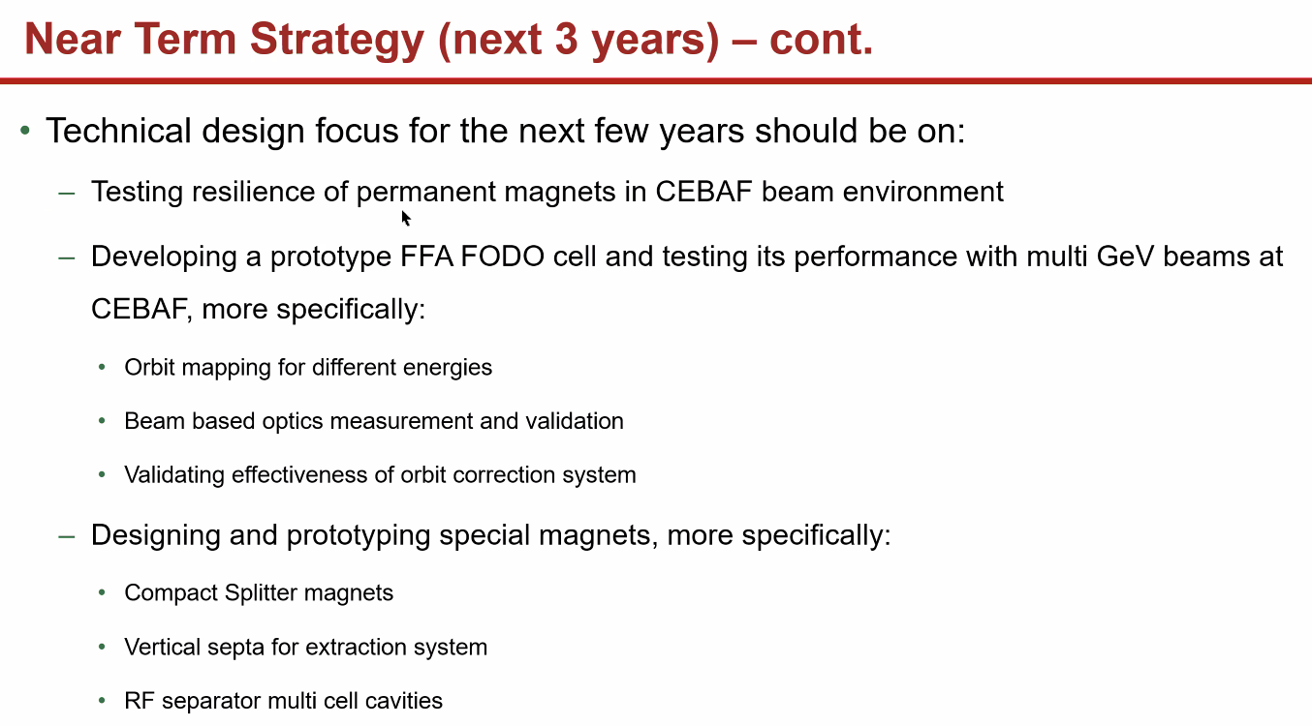
* 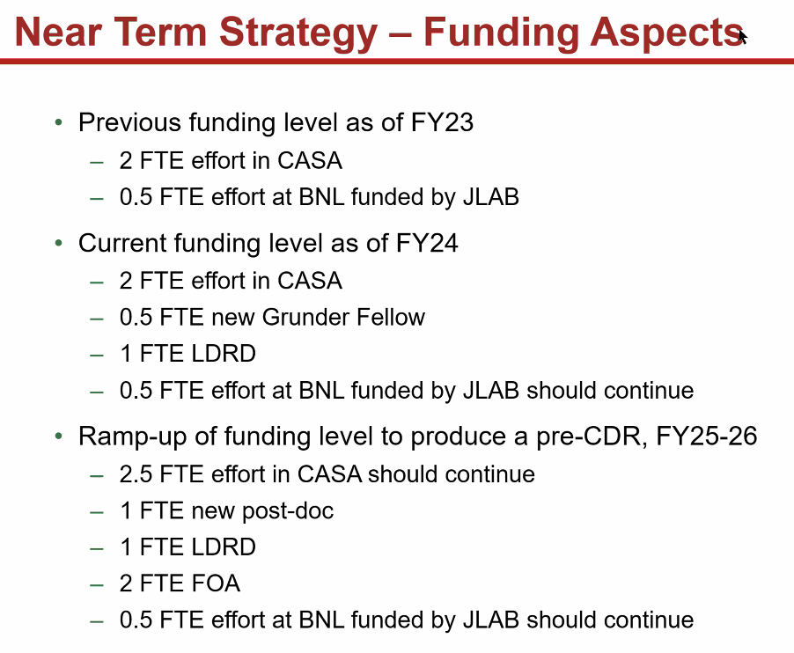
* 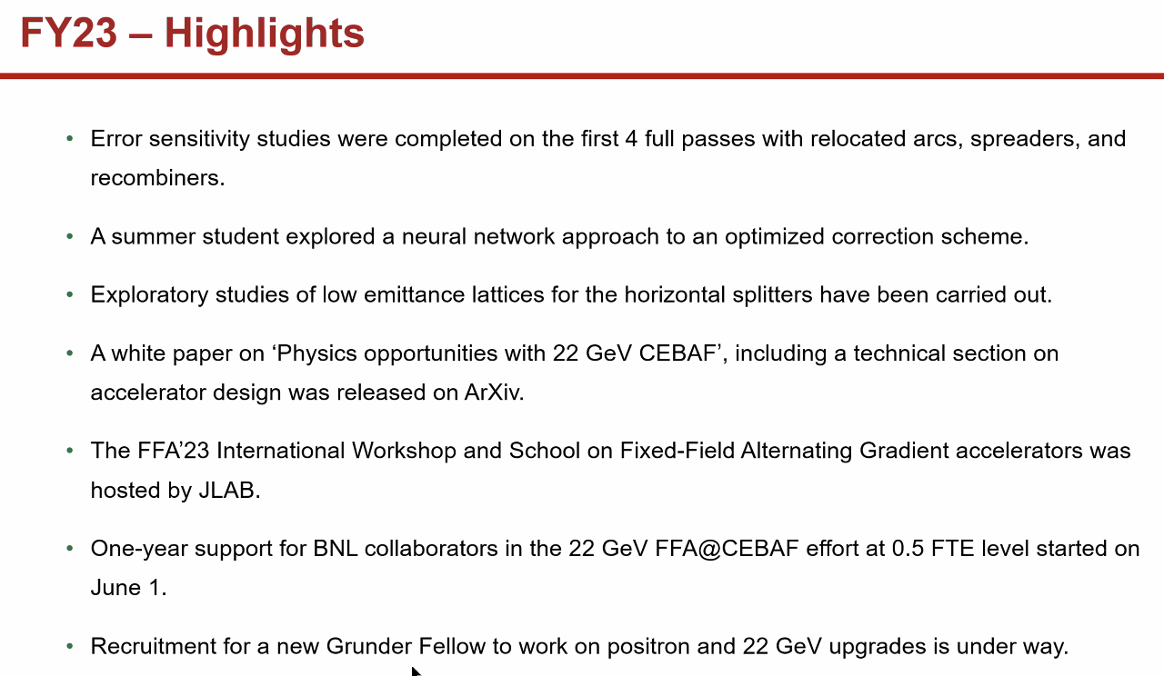
  + Ryan – don’t forget Alex C’s work!
* Dejan – warning: CEBAF is an extremely good opportunity to get the beamlines for 4th Gen light sources
  + DOE doesn’t like to see other types of physics – shame b/c it would be an unbelievable light source.
  + Alex B – we looked into putting an insertion device into the 10 GeV CEBAF. Put out paper on brilliance
    - Maybe the climate will change!

|  |  |  |
| --- | --- | --- |
| Action Items | Person responsible | Deadline |
|  |  |  |
|  |  |  |

## Time allotted | 10 mins | Agenda topic AOB | Presenter All

|  |  |  |
| --- | --- | --- |
| Action Items | Person responsible | Deadline |
|  |  |  |
|  |  |  |

## Special notes

Pathway to Repository: <https://jeffersonlab-my.sharepoint.com/:f:/g/personal/tristan_jlab_org/EqZ5MeS-nipCgPfZB5p0oS4B9Is67d3nQb9sLJI3Zyev9g>