FFA@CEBAF Working Group|Minutes

Meeting date | time 11/03/2023 | 11 AM EST | Meeting location https://jlab-org.zoomgov.com/j/1614898082?pwd=TnUzMS81M2sxbDZIbERJU01tYkJCQT09
Meeting called by Alex B  Type of meeting Weekly Meeting  Facilitator Alex B  Note taker Ryan, Alex C, Donish  Timekeeper Alex B | Attendees  Alex B, Ryan, Edy, Alex C, Scott, Donish, Kirsten, Andrei, Reza, Vasiliy, Randika

Intro Discussion
- Stephen on travel.
- Posted Grunder Fellowship on LinkedIn – Alex is advertising.
  - Trying to converge on good candidates – still open
  - Half positrons, half energy upgrade – 3 year position
- Dejan – spoke to Georg, CBETA does not need to be dismantled. Sergei is taking over Ferdinand’s position
  - Scott – it’s official
  - Might be chance to run CBETA again – SBIR
  - Taking over on 15th
- Try for FOA
- Scott – what is the state of CBETA?
  - Might find a way to connect the new linac without disturbing CBETA arcs
  - Looking for NY State funding and maybe DOE (~$1M) – talking about $8M for project they’re doing.
  - It’s still under vacuum? Yes.
  - Only run 1 turn
- Kirsten – under impression they removed part of FFA arc
  - Dejan – doesn’t think so

Agenda topics

Time allotted | 25 mins | Agenda topic Alternative Splitters | Presenter Edy
- 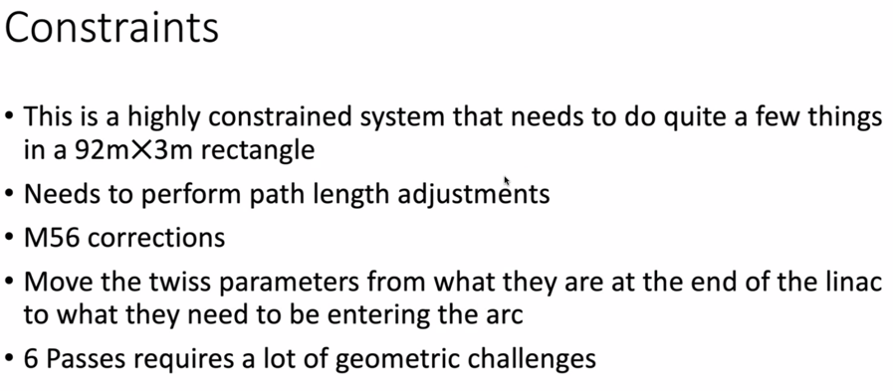
  - Pay attention to extraction as well!
- 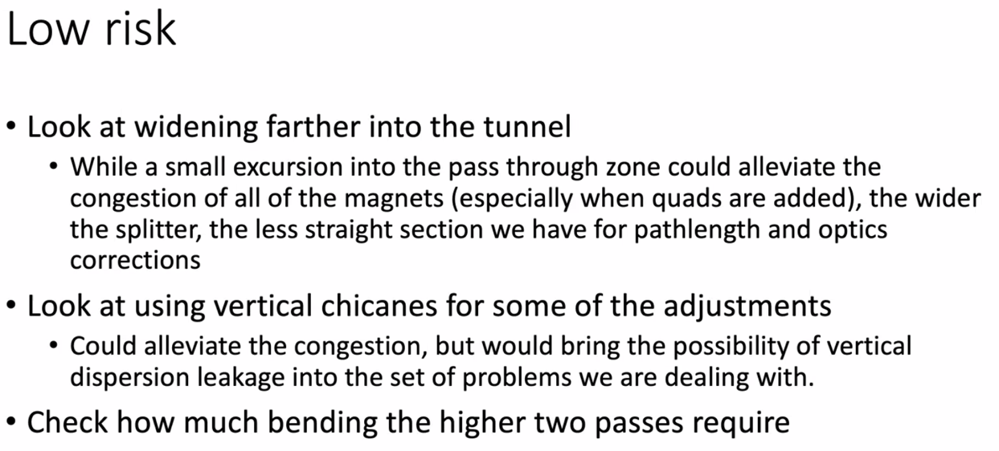
  - Either avoid or allow highest-energy passes cross over or bend back
- Fitting quads into available space, there’s basically a huge section without quads
- 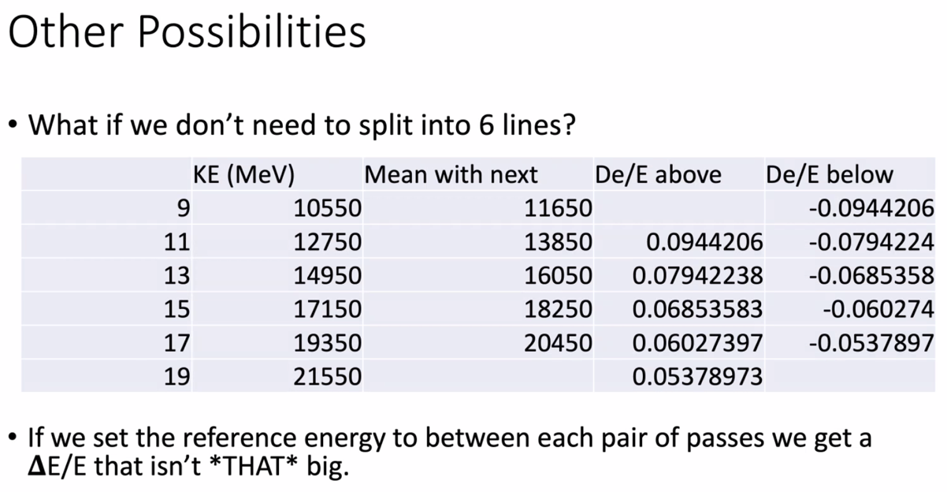
  - Split into 3 lines, make average energy of two passes in each line
  - Not a massive different between any two passes in a line
- 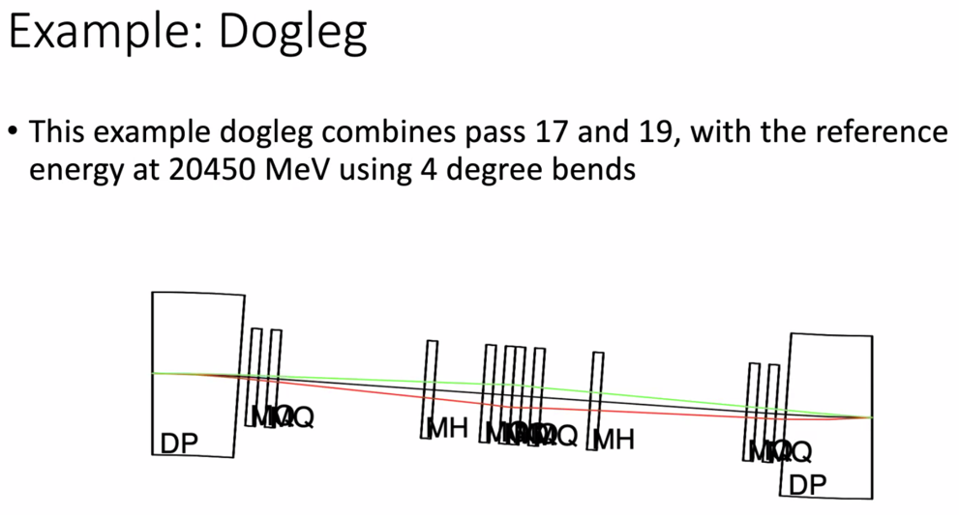
  - If you use quad and sextupoles, can maintain this.
  - M56 harder here
- 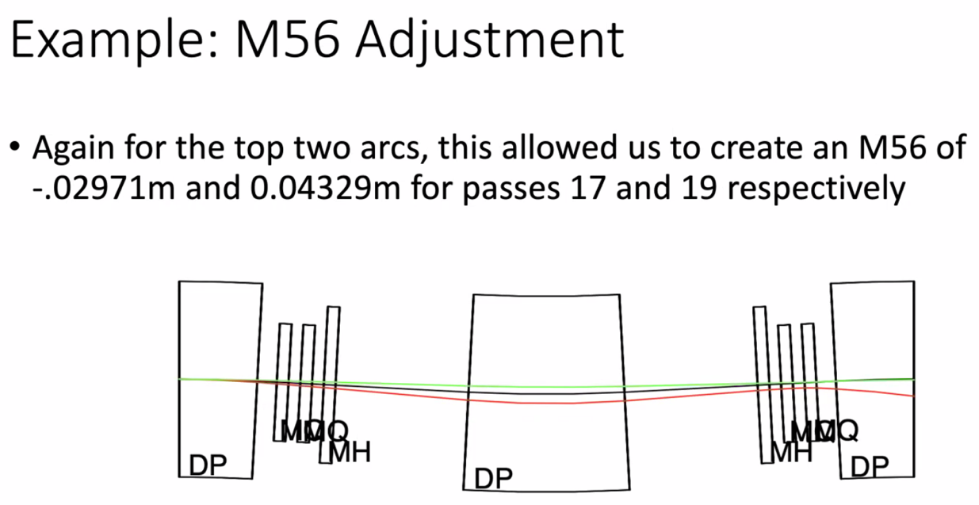
  - Not closed yet, but it’s likely a matter of making it work
  - Do need to add higher order elements (sextupoles) to add another knob
  - Adjusting optics and extraction, use local chromaticity as another knob for how many different betatron tunes they’re off
    - Can adjust
    - Vary the energy between the two a bit
    - For extraction – arrange the tunes in the straight section with RF kickers where one beam is in phase to extract, and the other beam has cancelled kicks
- All very preliminary!
- Is there a show stopper?
- 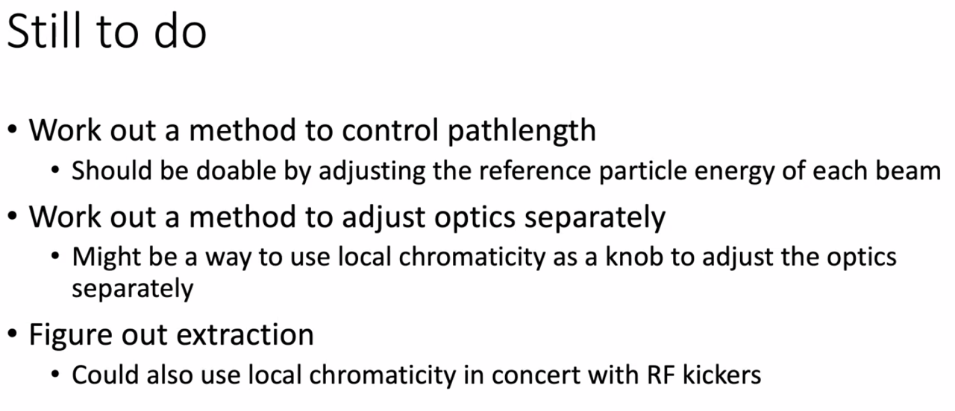
- Big issue – using nonlinear elements, and then having to cancel that out before going into FFA arcs. Not worked out yet. Might be show stopper, unsure
- 5 beamlines instead of 6 would ease the congestion
  - Ryan concurs
- Kirsten – left out on constraints: orbit into FFA – it’s not co-linear. Not same exit trajectory into FFA arc
  - On one hand, lack of individual control gives Kirsten “horrors” but if you can expand each of three lines into a different area maybe?
    - Separate out at some point for individual control
  - Coupling hard
- Scott –
  - From a purely mathematical perspective – this is a load of fun! You’re effectively creating knobs by slipping in sextupoles
  - Problem is that all the knobs are heavily coupled.
  - CBETA – ideal world was just quads doing quad things. But the quads ended up accidentally steering a lot. This made things challenging
  - By design, this system has 3 classes of magnets that participate in steering in this idea. Two classes that participate in focusing. Might be OK, but it is complicated
  - Nice idea from that point of view if you can make the numbers high enough, R56, etc… and still getting significant independence on focusing
    - Might need more magnitude on sextupoles
  - Mathematically, interesting to see what happens
  - Going to need much more sophistication in control system to make this work in practice
    - CS will need to create fake independence for us – did this a bit at CBETA
  - Kirsten – 2nd pass of given pair, to measure response, you’d have to search around with knob-thing?
    - Scott – have to create steering knobs that could steer one orbit without another
    - Alex B – question of orthogonality
    - Yes – easier said than done
  - Would probably want to try out these controls on CBETA
  - Scott – encourage this study – potential for improving some space issues with number of passes
  - Don’t think of this as something that is only done for a couple of passes
  - Due to small energy range, relative passes of adjacent passes are “kind of the same”
  - Turn it into three lines – will make some things easier at expense of big magnets
  - Will take a hit on radiation – doing this in multiple lines with multiple beams per line cannot be optimal for radiation. Might not be a big deal, but there will be a cost.
  - Worth pursuing in sense that it can solve a lot of space problem, potentially
- Dejan – I’m confused with this discussion.
  - Adding multipoles to FFA magnets for using additional higher-order magnets to create fixed tunes
  - In this case, I don’t get the purpose of this exercise yet
    - You have a difference in energies
    - Now add additional multipoles
  - The rule in physics is always “the simpler the better”
    - Maybe AI can tell you a solution
  - What is sextupole doing?
    - Each sextupole sees a different tune, and you can get an identity matrix
- Ryan – where are we splitting these to 3 lines?
  - Go through dipole, separate, then recombine into 3 lines and go into lines
- Kirsten – orbit AND dispersion into FFA is nonzero
- Scott – we’re too focused on details at this point. The idea is that you create independence of lines by adding in sextupoles to make knobs
  - How that’s split up is another problem that has to be addressed
- Kirsten – it’s really clever, but it’s scary for lack of individual control
  - Edy – agree, and if we do this, please make sure on travel when we tell operators (HA!)
- Scott – YOU’LL be the operator!
  - Will be very dependent on control room software to be workable.
- Virtual machine?
- Scott – in the end we’ll need all the space
  - If you can make this work, you’ll be happier with space
  - Go to Ryan’s pictures – and same was true in CBETA
    - Line next to you is preventing you from using some of your longitudinal space. Magnet from another line is blocking the line you want to use.
  - Decreasing the number of lines will benefit
  - Design is pretty tunable
- Ryan – Also need to see what Physics wants, 20 GeV and tunable, or 22 GeV and specific energy bands
- Dejan – what do you want to do with these?
  - M56 correction
  - ToF correction
  - Now beamline where put a lot of magnets, and they all come with different energies with different energies and ranges, and come back with same tunes
  - To add same tunes and add ToF condition and M56 condition, this would require many more variables
- Scott – here’s the big downside of this:
  - Each of these lines will have twice as many magnets (more or less) as an individual line when you go through it. You still need the same number of knobs. So now, instead of 8 quads, you’ll need 8 quads and 8 sextupoles per line
  - You’re replacing individual quads in a single line with a quad and a sextupole
  - Alex B – could make them on top of each other/multiuse
    - Dejan – no, it’s not the layers. We have the magnets up to 13th, but how can you tune it?
  - Issue here – these are not combined function, they’re EM.
  - Can add coils, if you’re going to do some kind of windowframe design. But with that design, you won’t get the fields
  - Want iron-dominated magnets, and with those, you can add a pipe-winding for a perturbation but nothing more than that. You’ll need separate magnets for real control. Will need real, separate magnets here.
  - May get longitudinal space problem
- Some gain in longitudinal space b/c no overlap with adjacent lines, but not sure end up “winning”
- Dejan – look at FFA workshop presentation about extraction/entrance
Action Items | Person responsible | Deadline

Time allotted | 25 mins | Agenda topic Magnet LDRD | Presenter Ryan
- Notes by Donish/Alex Coxe

- Put together a sharepoint for LDRD
  - SLACK channel for fast communication
  - BDSIM for simulation work
  - Task/Progress trackers
  - FY24 Milestones fleshed out
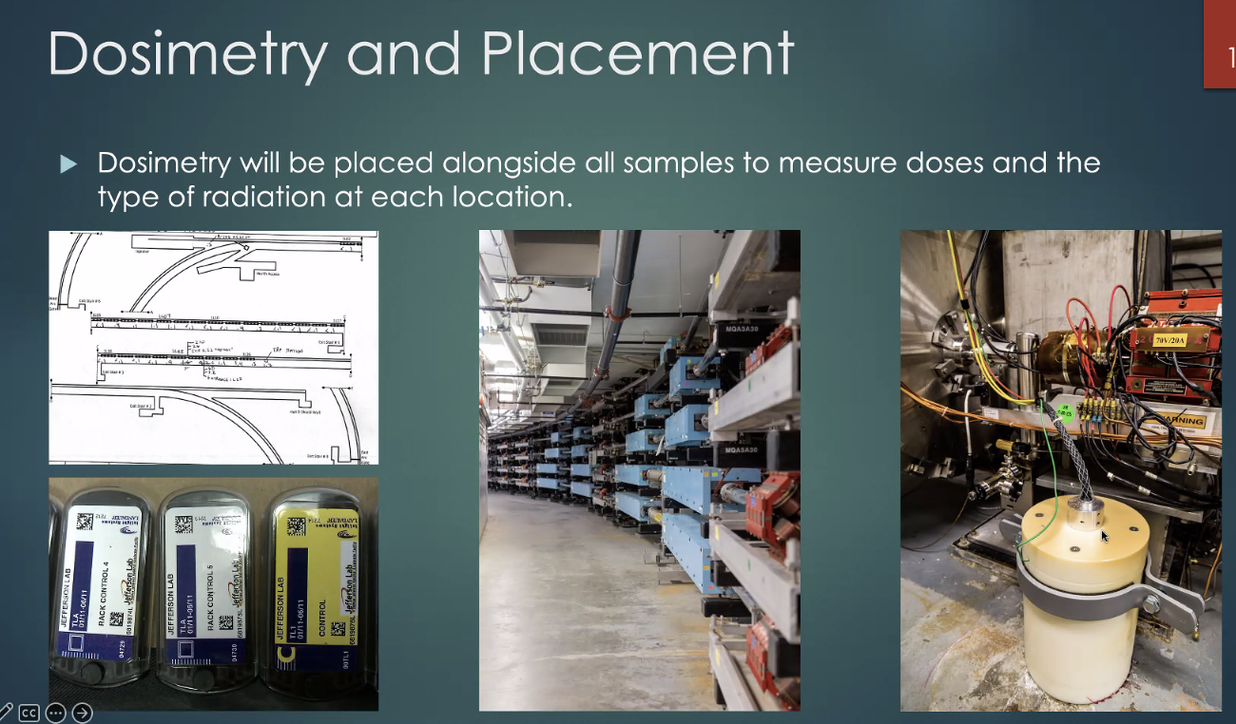
- Neutron and gamma are a concern – need to read both separately
- NDX detector gives live readback and archives data.
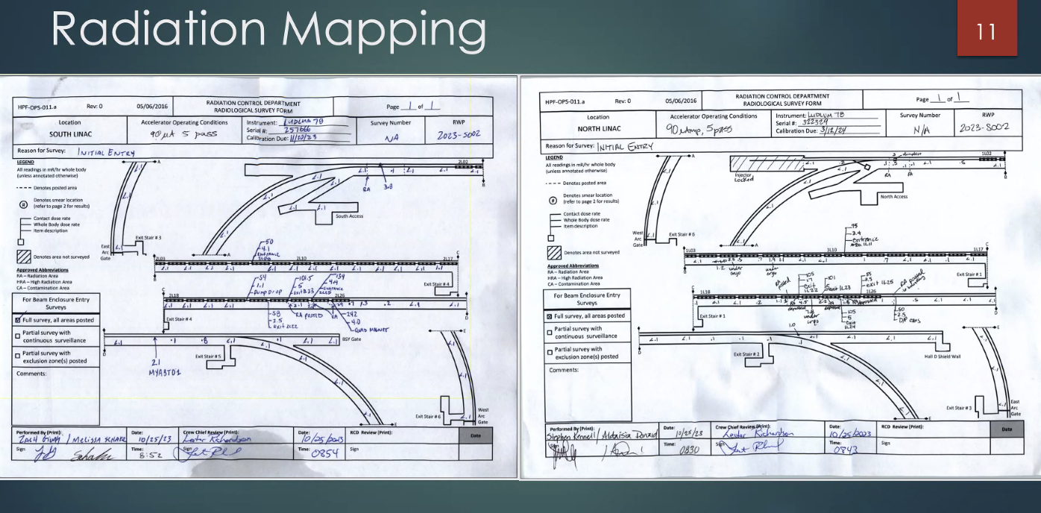
- No digital true mapping
- Find hotspots
- Hall C mapping is complicated
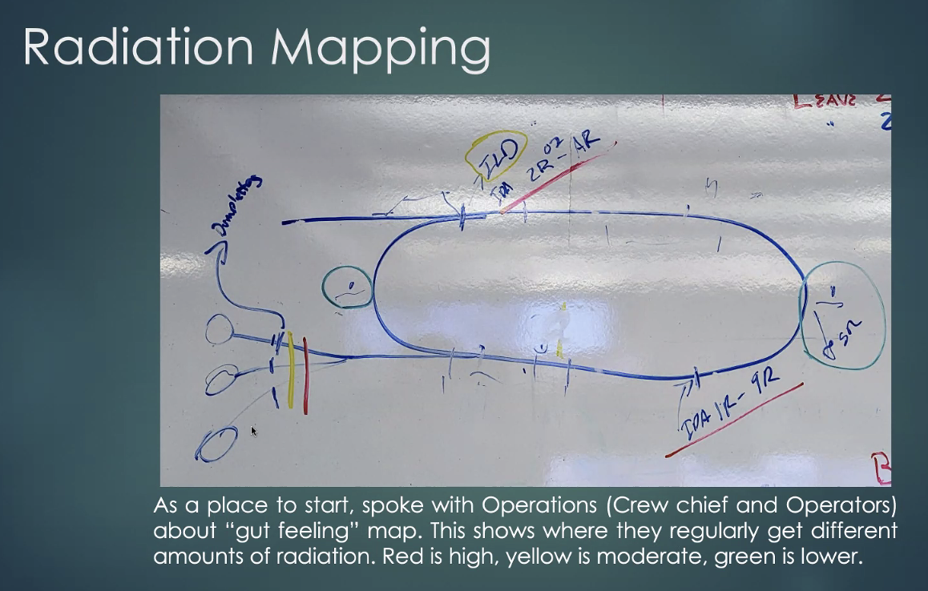
- Gut feeling from Operations Crew
- Red: Most, Yellow: Moderate, Green: Lowest
- Not a lot in ARCS
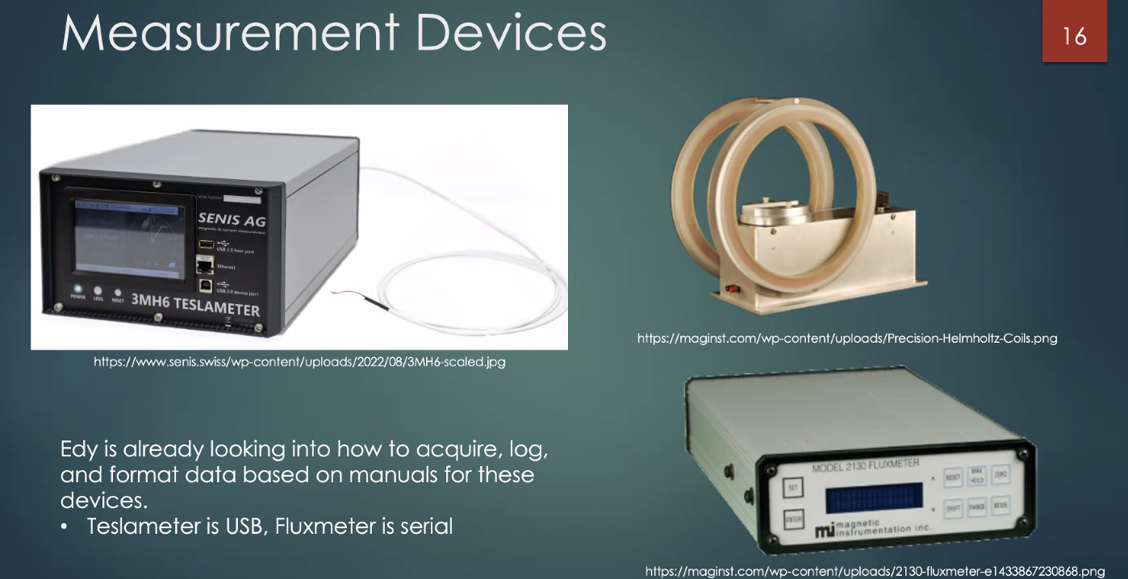
- Edy is working on how to use devices; acquired manuals already
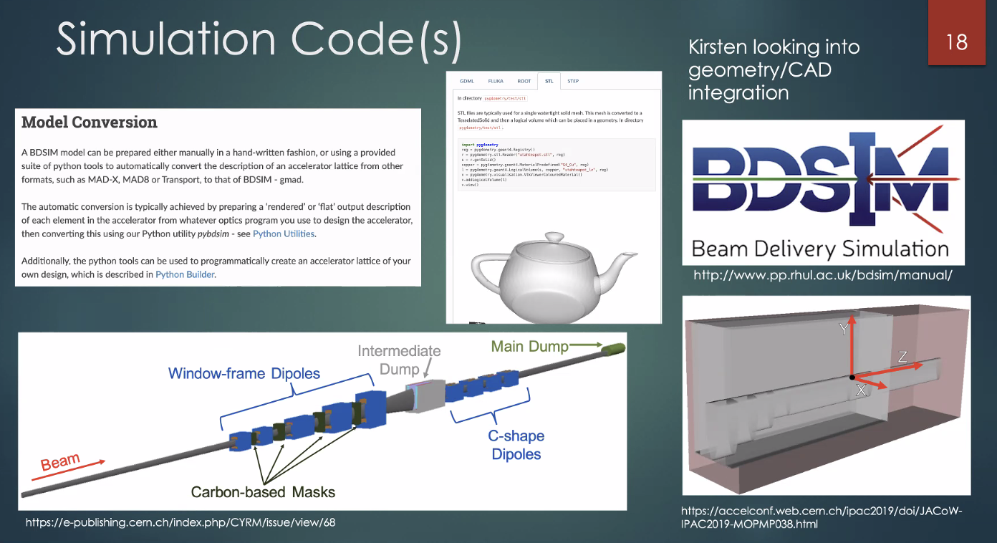
- Installing BDSIM
- Wrapper for GEANT4
- Dosage
- Can import MADX line or CAD drawing; useful for Stephen magnet designs
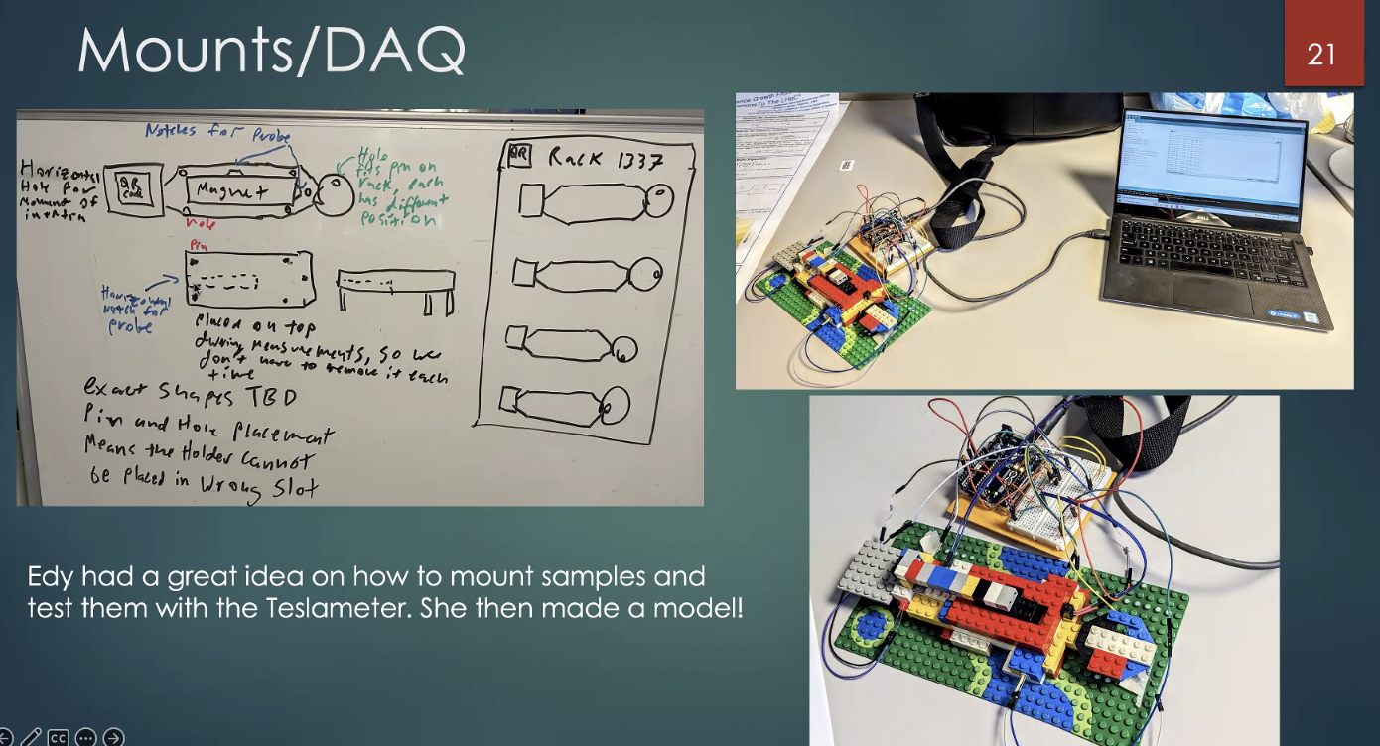
- Edy had a great idea on mounting set up and built it with LEGO!
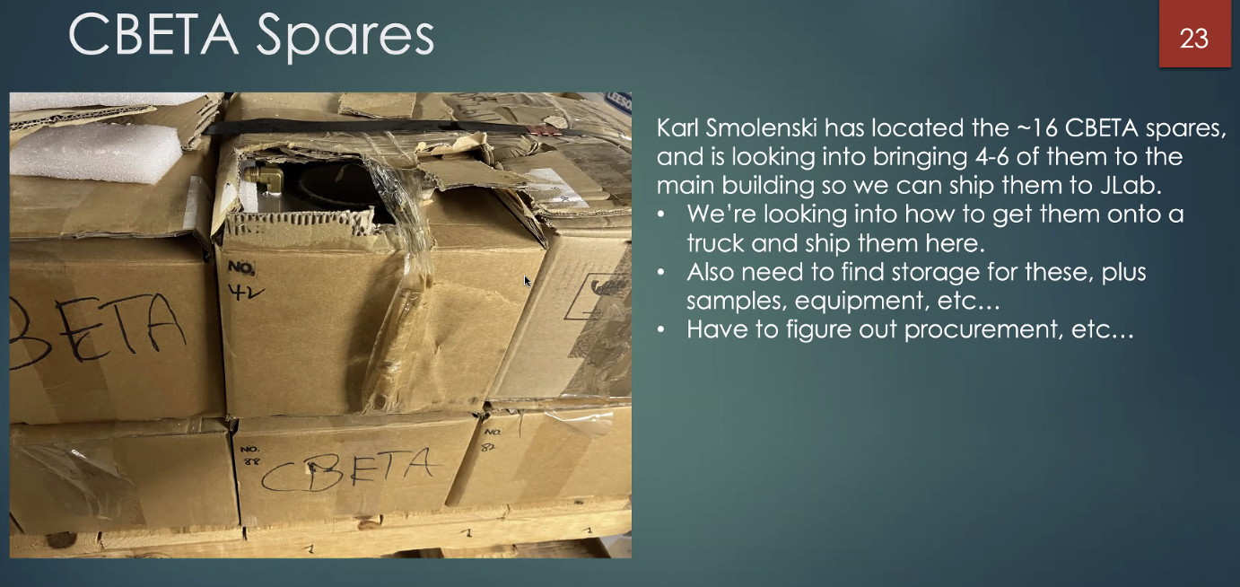
- Karl S has located 16 CBETA spares and maybe bringing 4 to 6 to JLAB
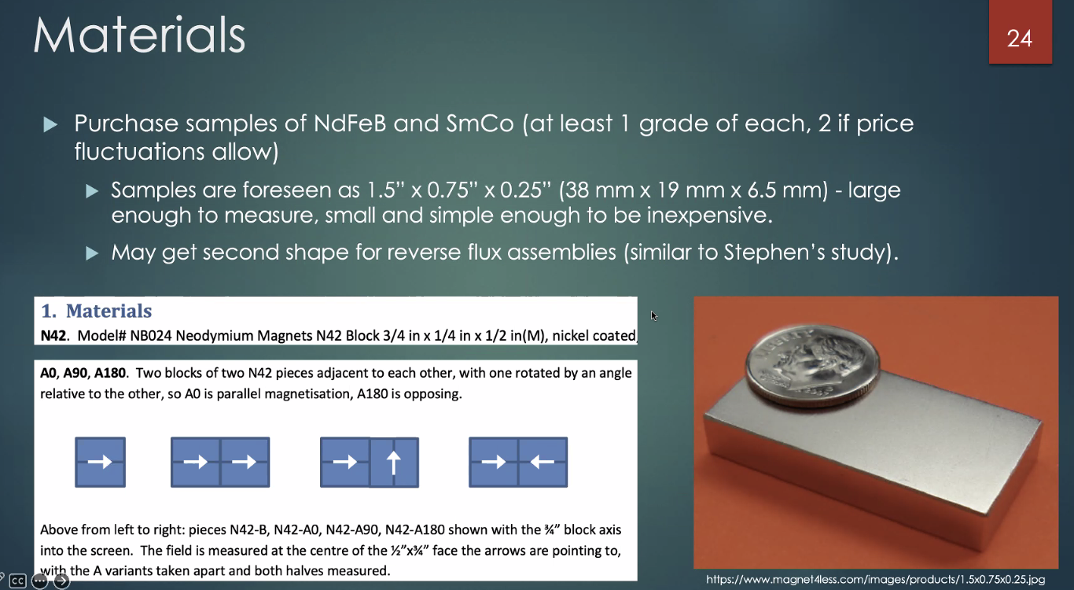
- Samples of NdFeB and SmCo
- Looking into cost/prices
- May get a second shape for a study similar to Stephen's study
- Alex: Can you explain the different grades?
  - Ryan: Different processes and treatments for different environments. "H" is a heat treatment for example.
  - Alex: Looks like a lot of flexibility
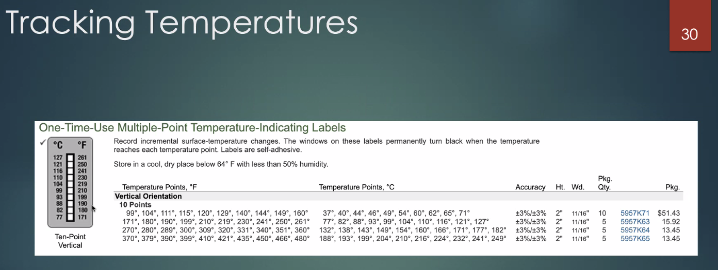
- Once it gets really hot, discerning the demagnetization because is important
- Edy had idea of using stickers
- Reza: Are the stickers radiation proof?
  - Ryan: They're used in the wave guides, so yes
- Scott: What you want for a permanent magnet you want a high value for magnet
- Dejan: This is important point because Stephen's magnet can get demagnetized
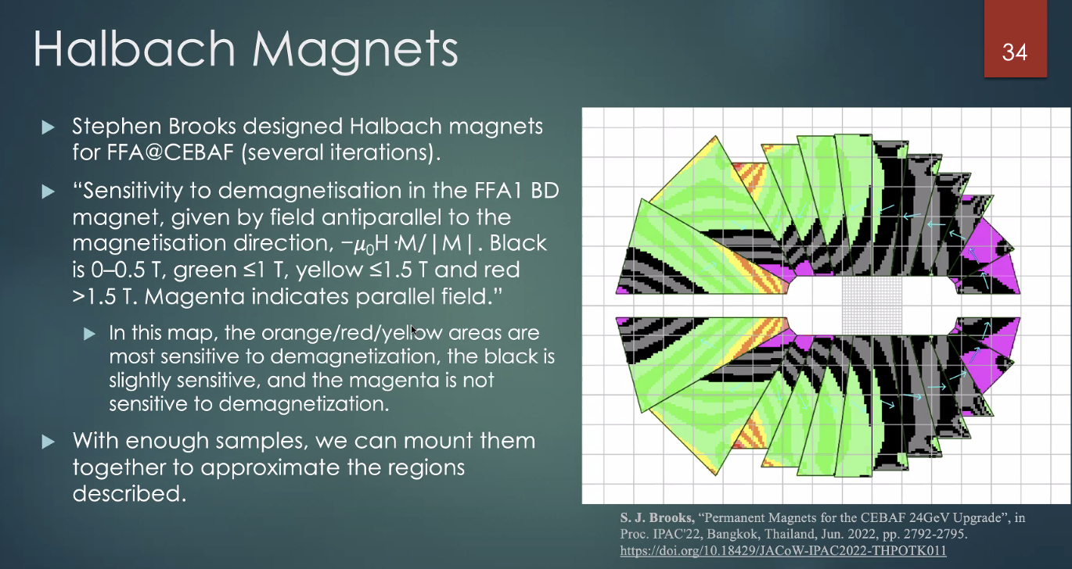
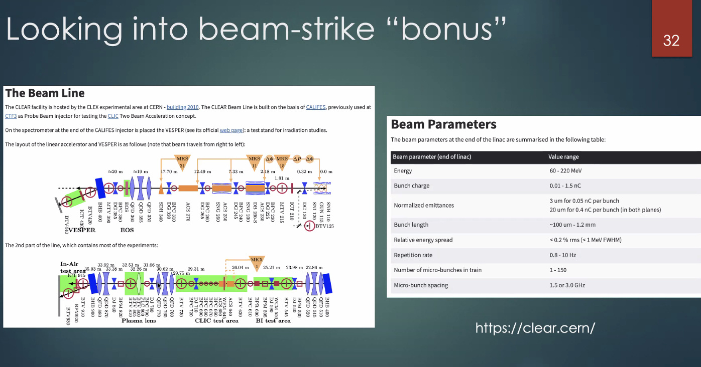
- If we have time we can run an experiment at CLEAR (old CLIC facility)
- Not in current proposal, but if we can do it, why not!
- Alex: Agreed, if its free!
Action Items | Person responsible | Deadline

Time allotted | 10 mins | Agenda topic AOB | Presenter All

Action Items | Person responsible | Deadline

Special notes

Pathway to Repository: https://jeffersonlab-my.sharepoint.com/:f:/g/personal/tristan_jlab_org/EqZ5MeS-nipCgPfZB5p0oS4B9Is67d3nQb9sLJI3Zyev9g

