FFA@CEBAF Working Group|Minutes

Meeting date | time 11/10/2023 | 11 AM EST | Meeting location https://jlab-org.zoomgov.com/j/1614898082?pwd=TnUzMS81M2sxbDZIbERJU01tYkJCQT09
Meeting called by Alex B  Type of meeting Weekly Meeting  Facilitator Alex B  Note taker Ryan  Timekeeper Alex B | Attendees  Alex B, Ryan, Max Bruker, Shaoheng Wang, Reza, Andriy Ushakov, Andrei, Edy, Jay, Alex C, Joe Grames, Larry Cardman, Amy Sy, Donish, Eric Voutier, Kirsten, Bob Rimmer, Todd, Roger

Intro Discussion
- Positron group joining in today as well.
  - May have more joint meetings
- Need alternatives for pre-CDR
- Today is Veteran’s Day – Holiday for BNL
- Talk is also recorded – find recording in presentations folder

Agenda topics

Time allotted | 25 mins | Agenda topic Alternative e+ | Presenter Andrei
- Want to show evolution, maybe inspire more ideas
- Present, questions at end.
- 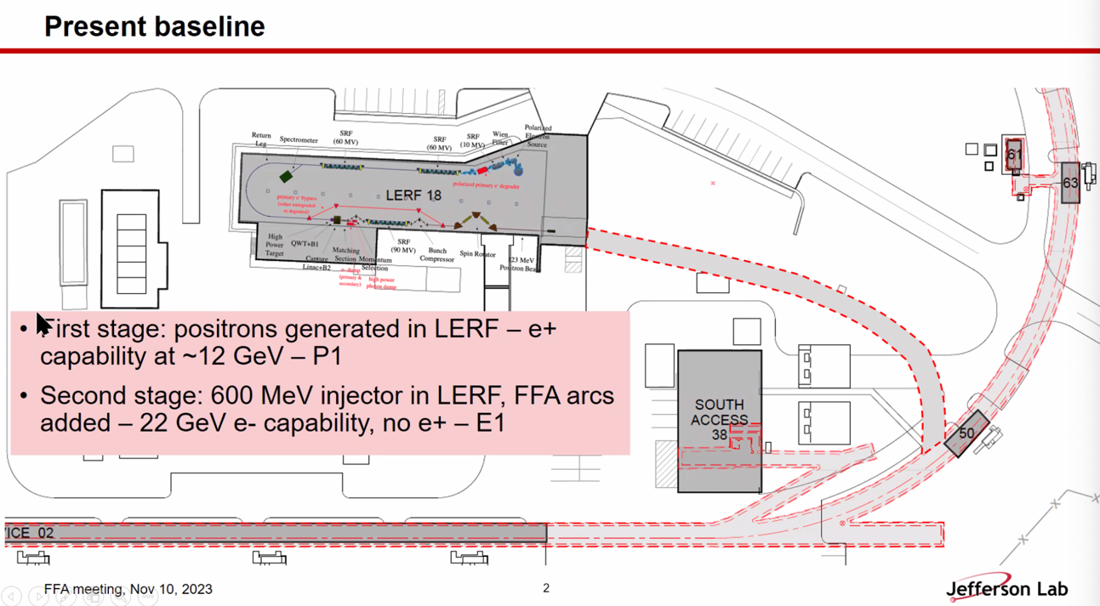
  - P1 alternative
  - Second stage is 650 MeV e- with no e+
- 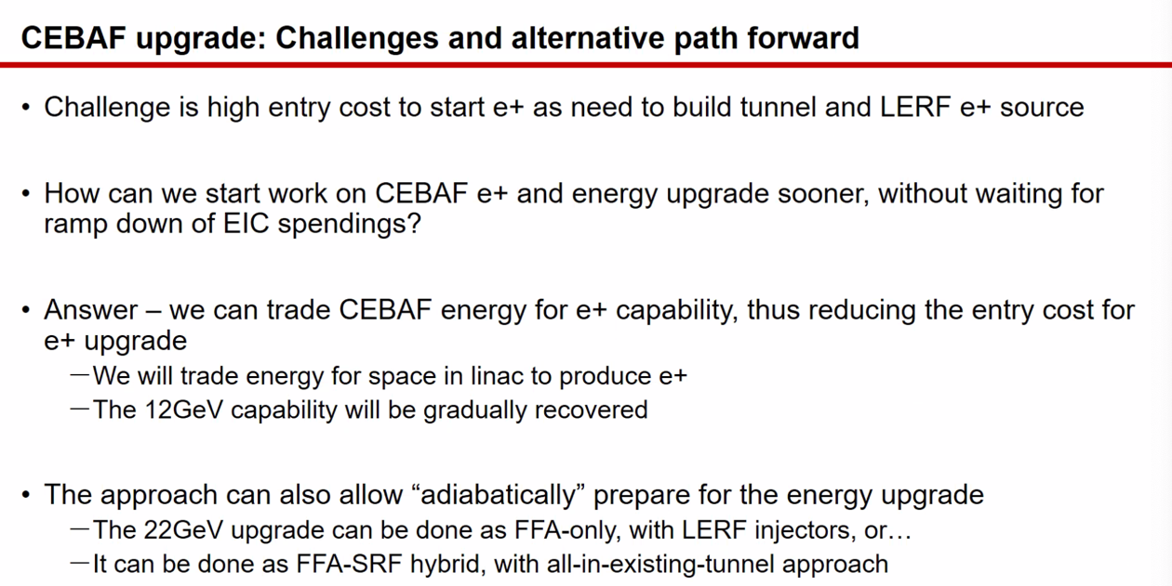
  - Including the tunnel with e+ may be tied to EIC spending profile – coupling can be troublesome
  - Trade energy for space to make e+, then bring back energy as needed
- 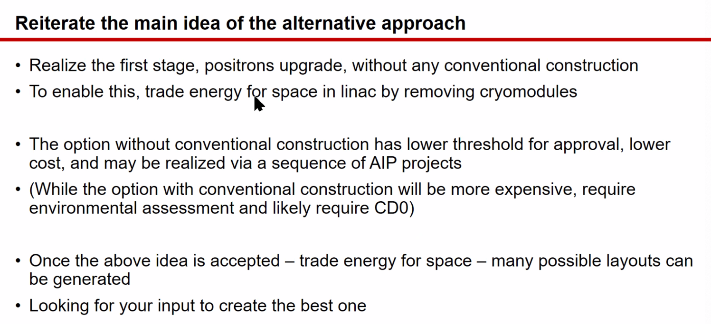
- 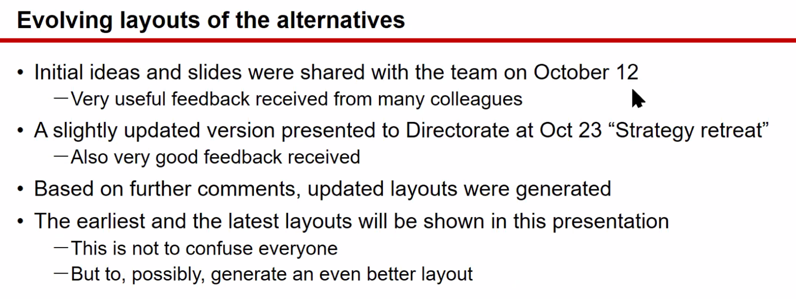
- 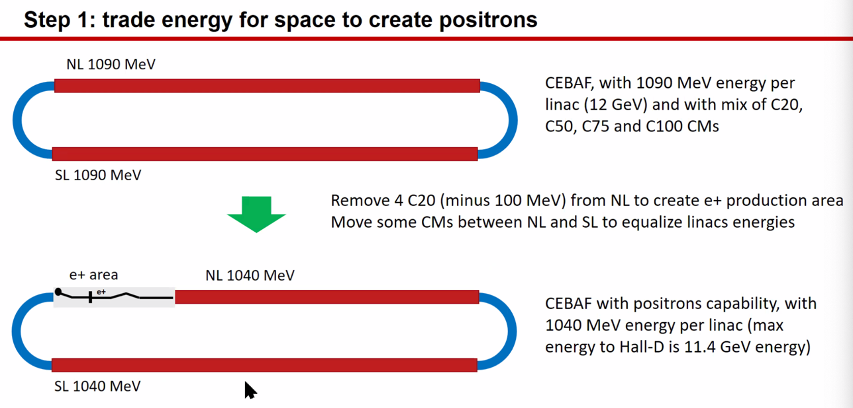
- 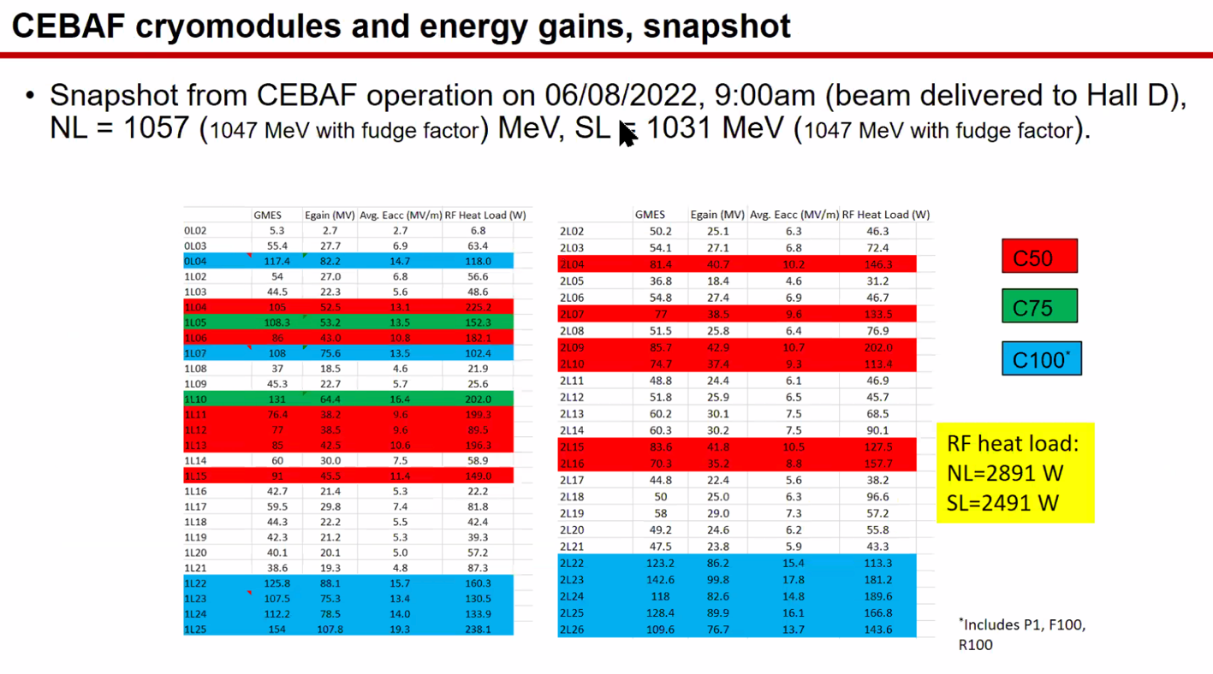
- 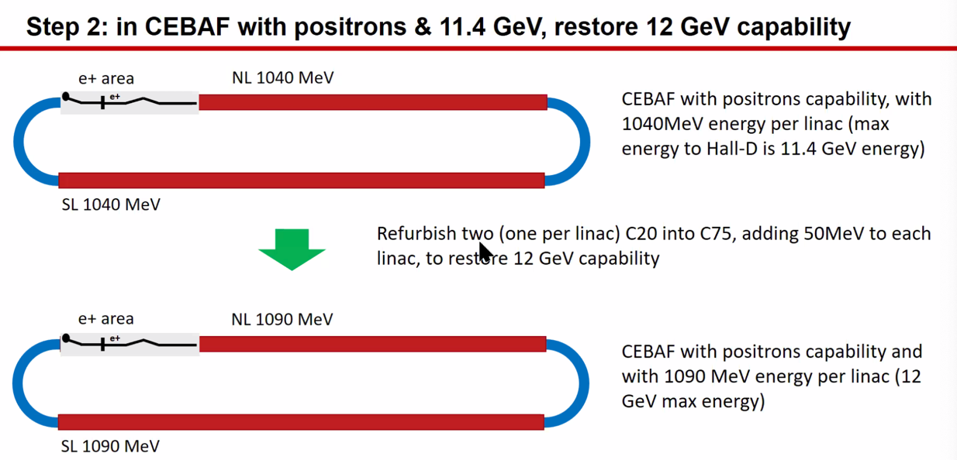
- 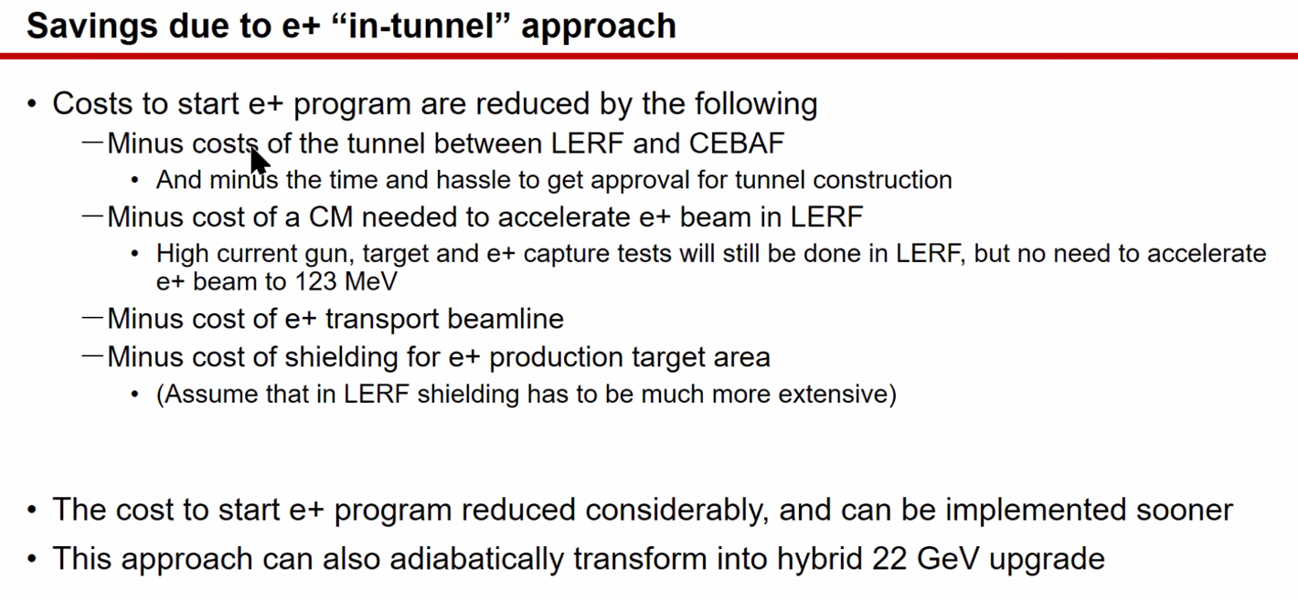
- 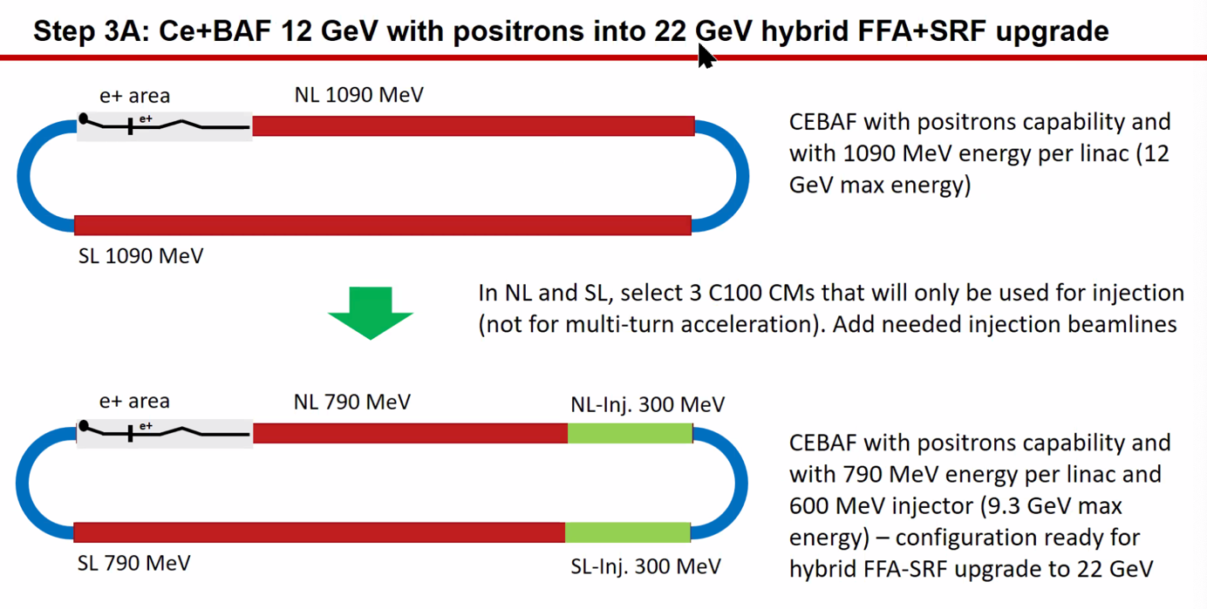
- 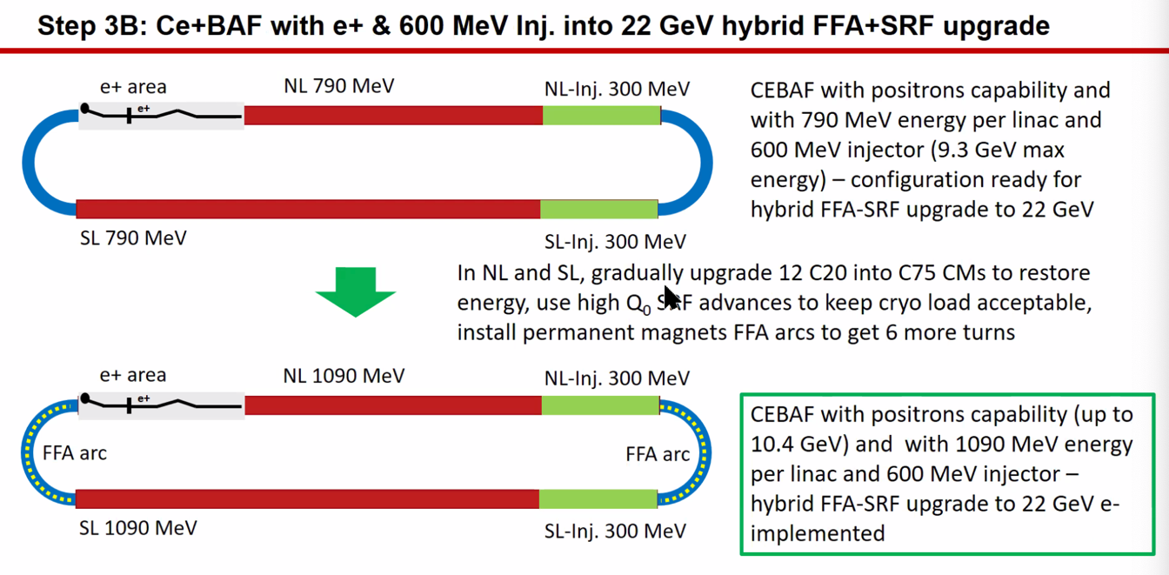
- 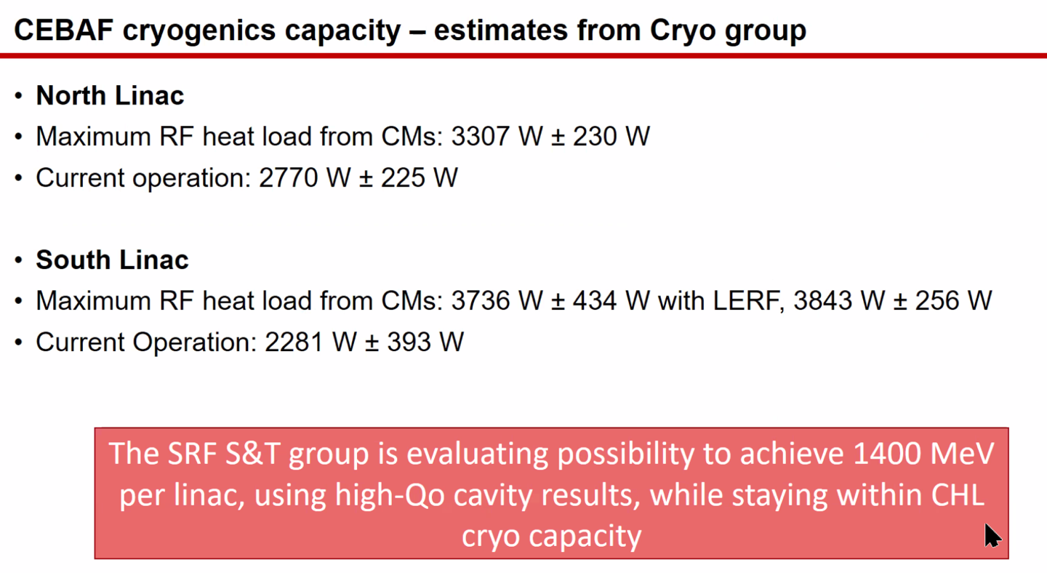
- 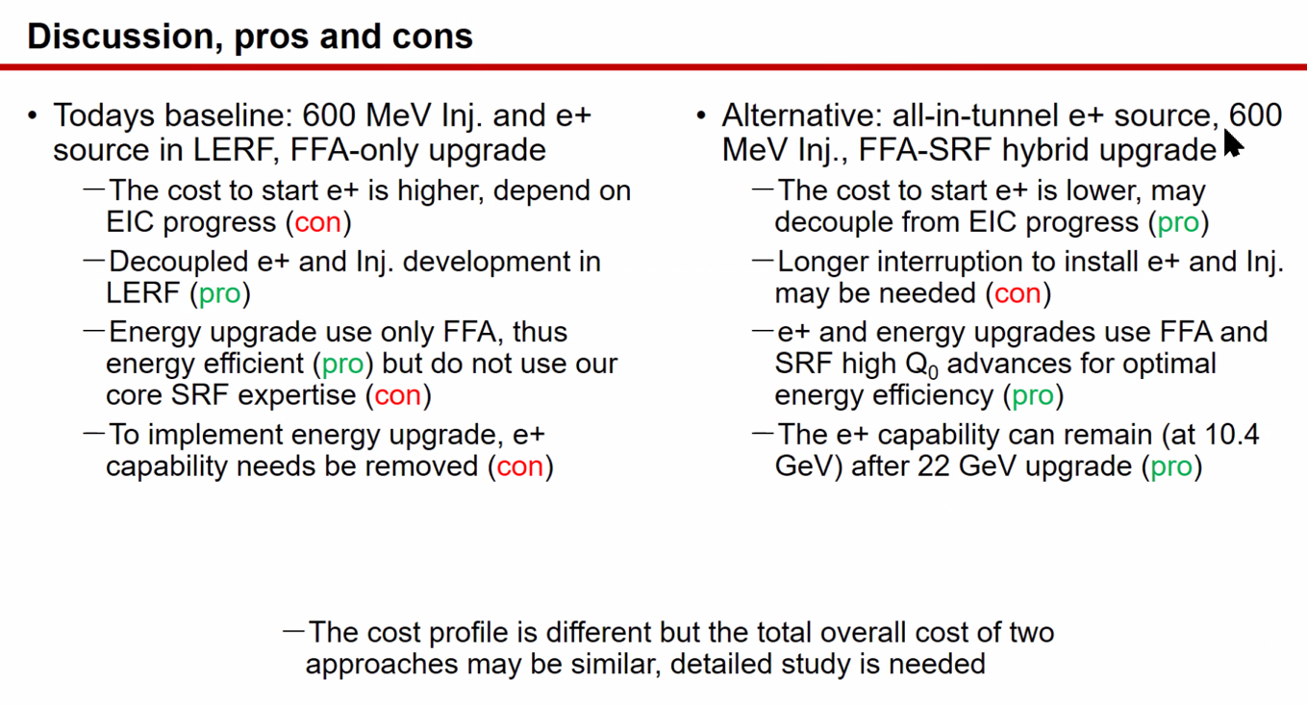
- 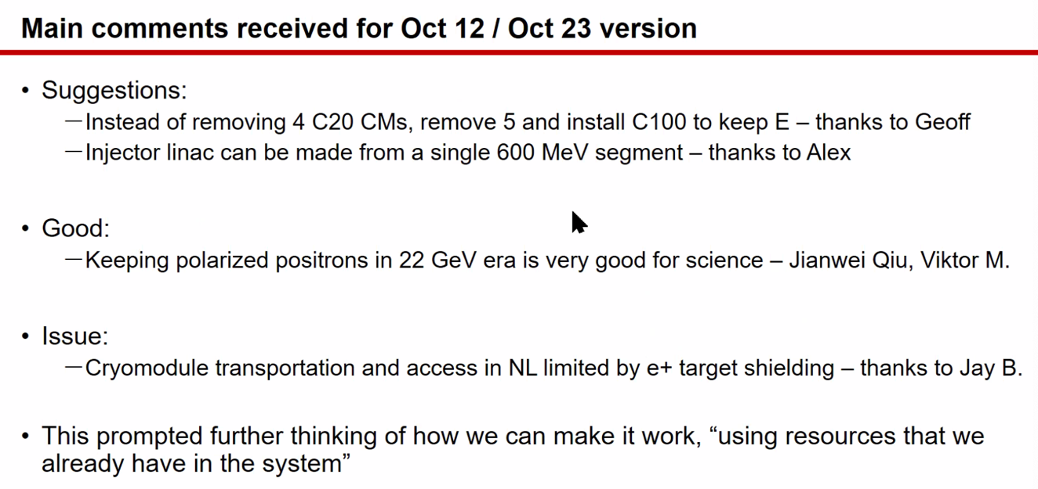
- 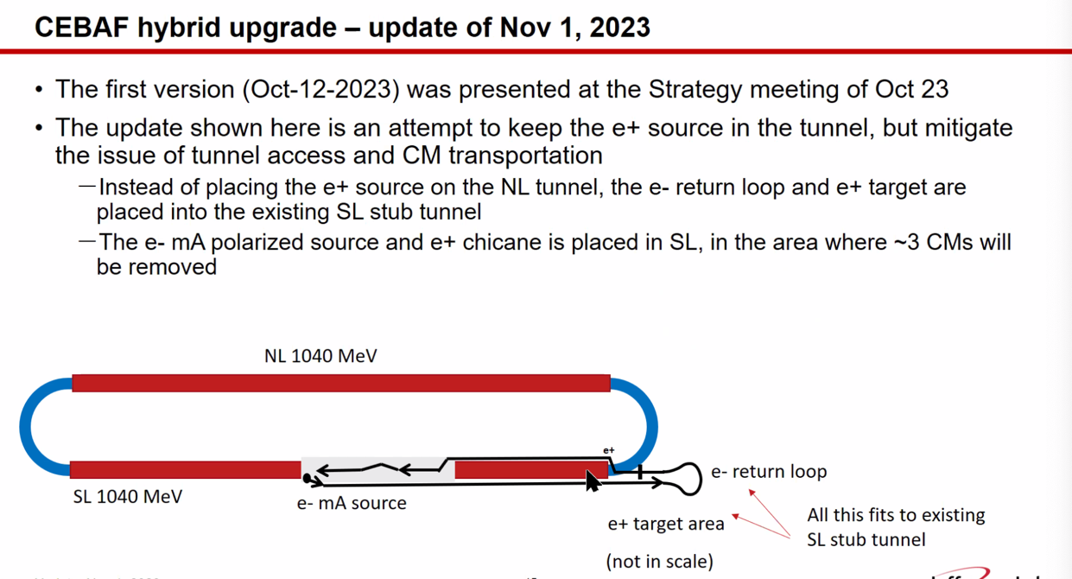
- 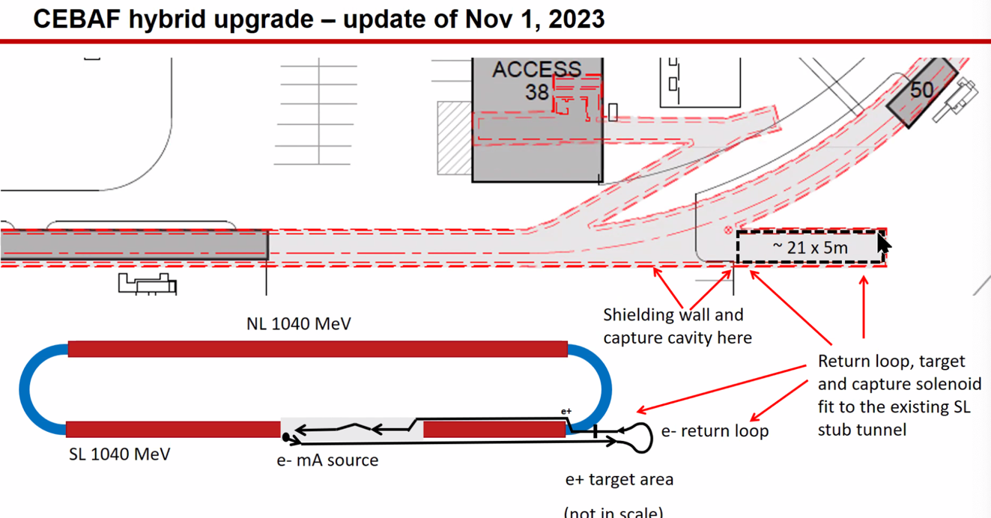
- 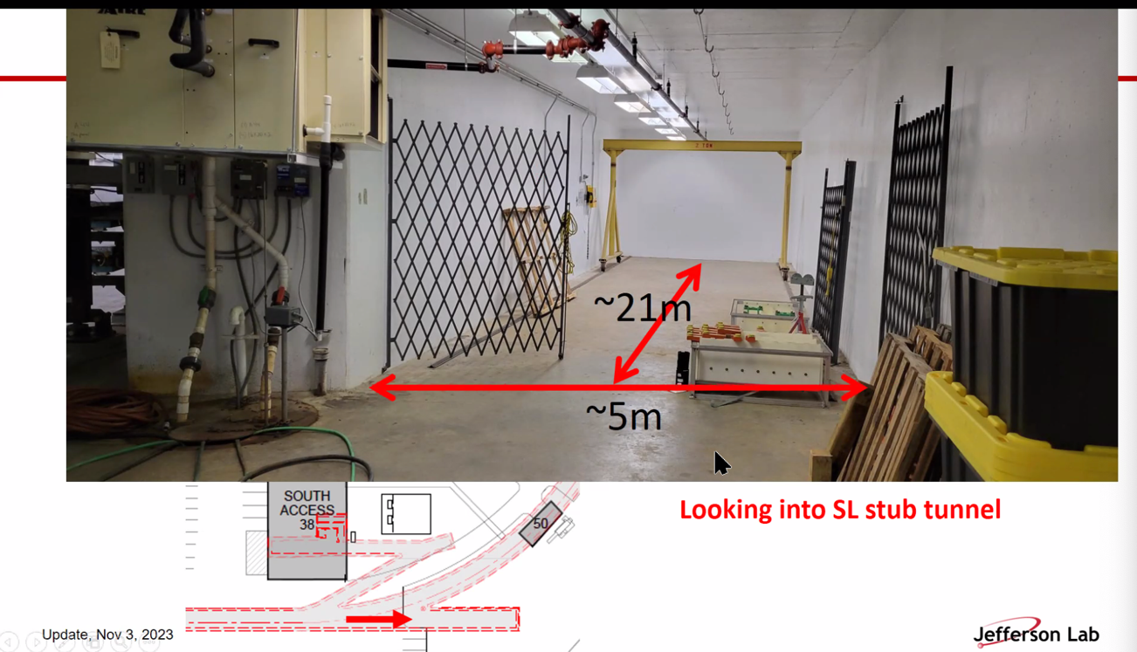
- 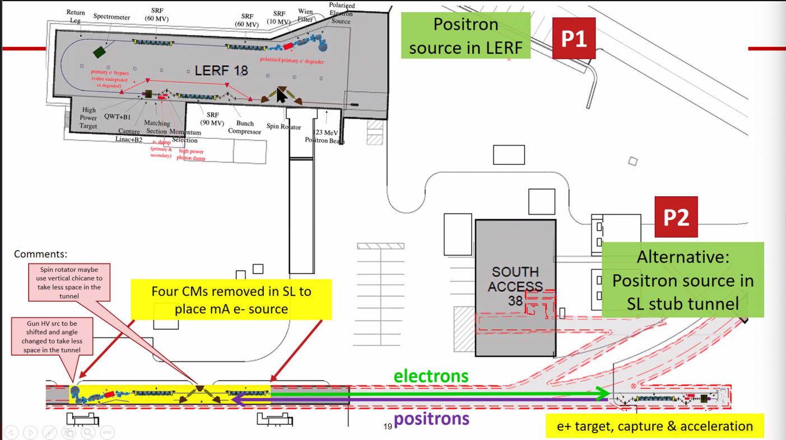
  - Why electrons that way? Polarization preservations
- 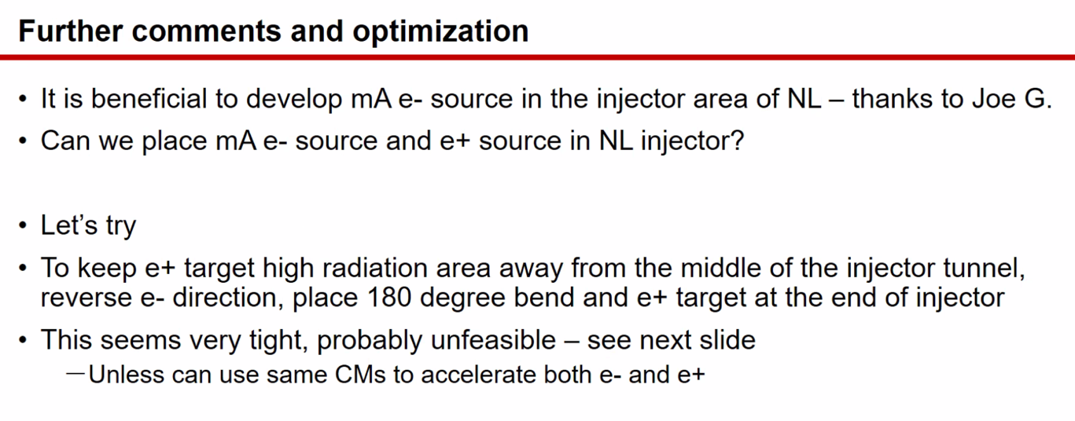
- 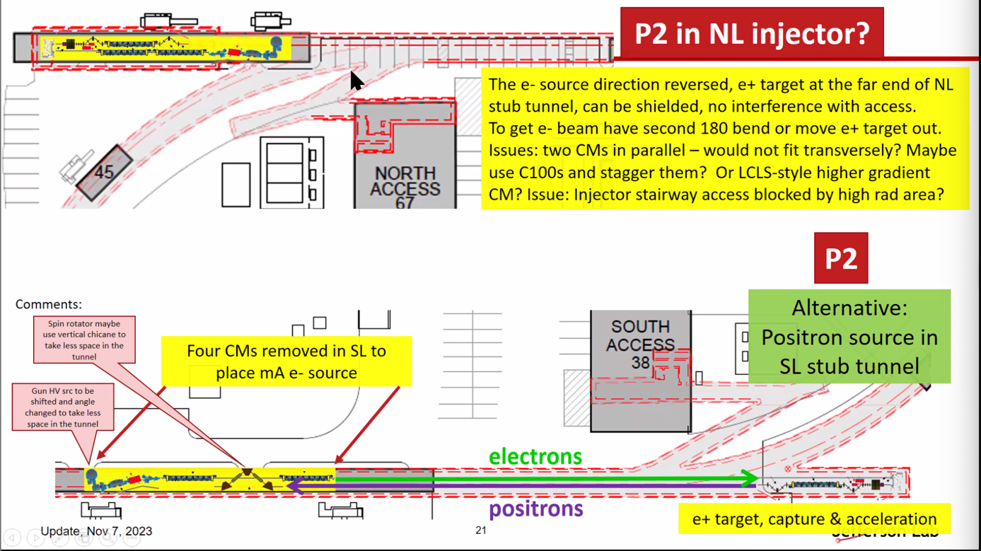
  - Electrons start off going left, positrons go right
  - Very tight in existing tunnel
- 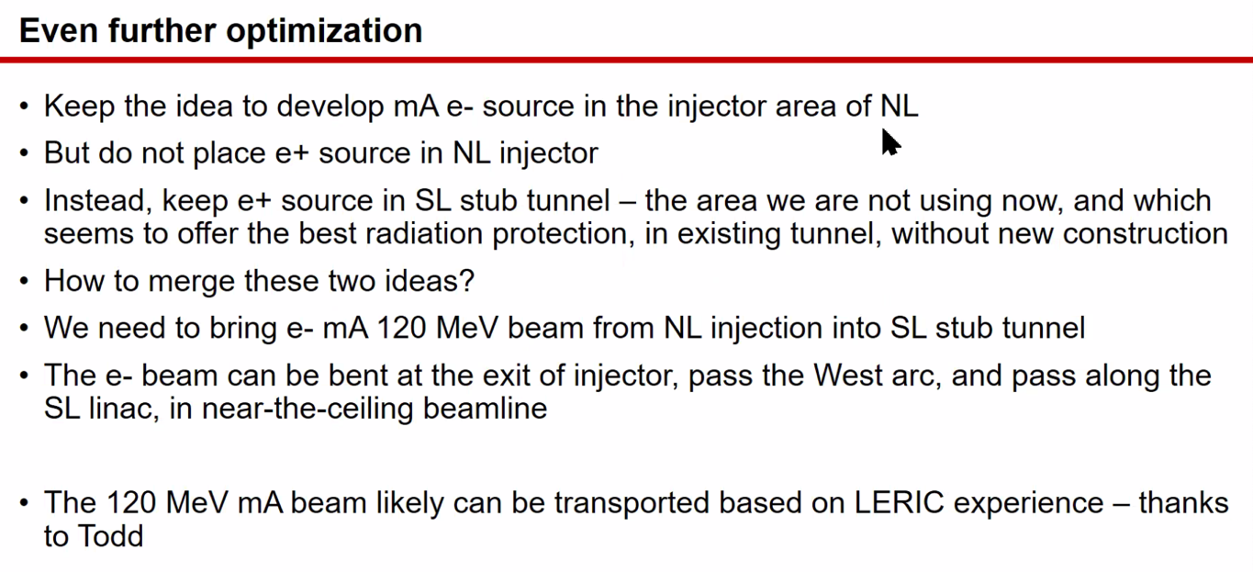
- 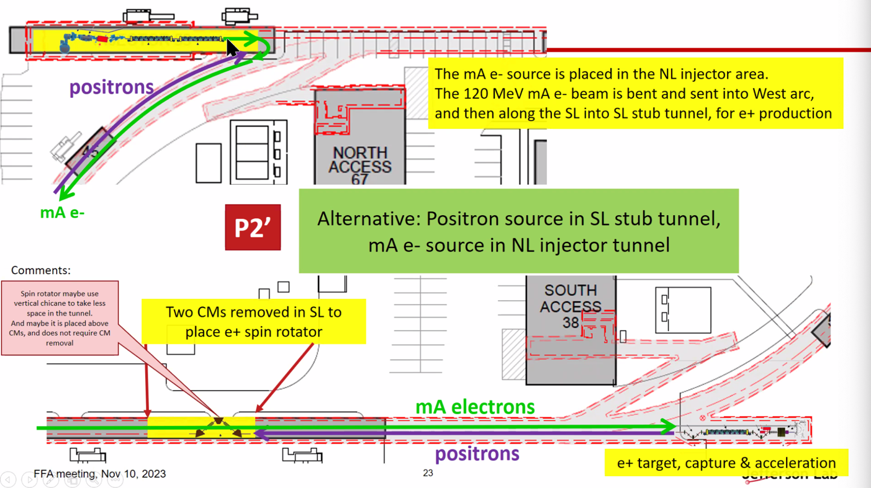
  - This brings back the ceiling line and makes a SHARP bend at the injector
- 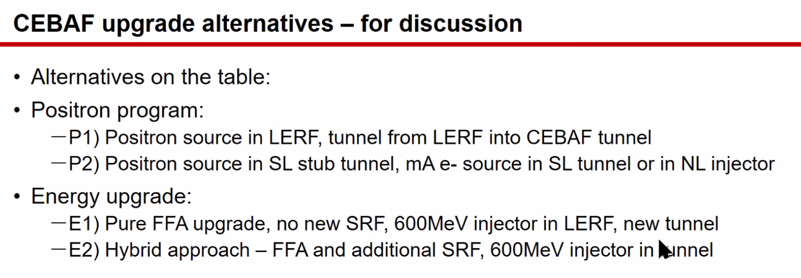
- 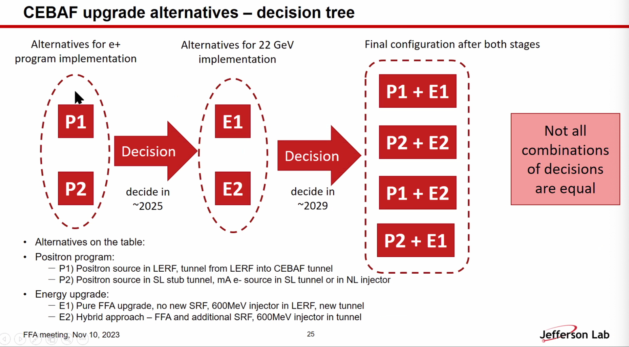
- 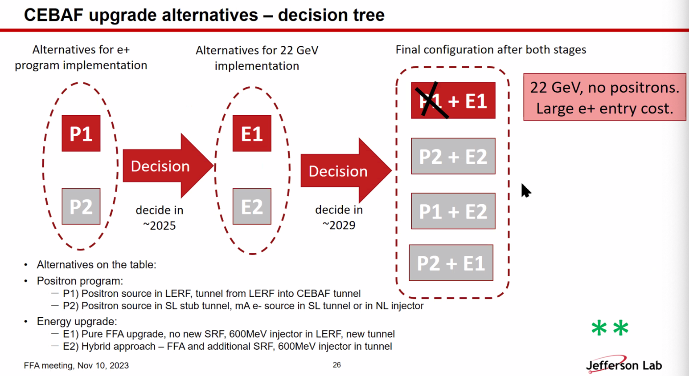
  - 2/4 stars
- 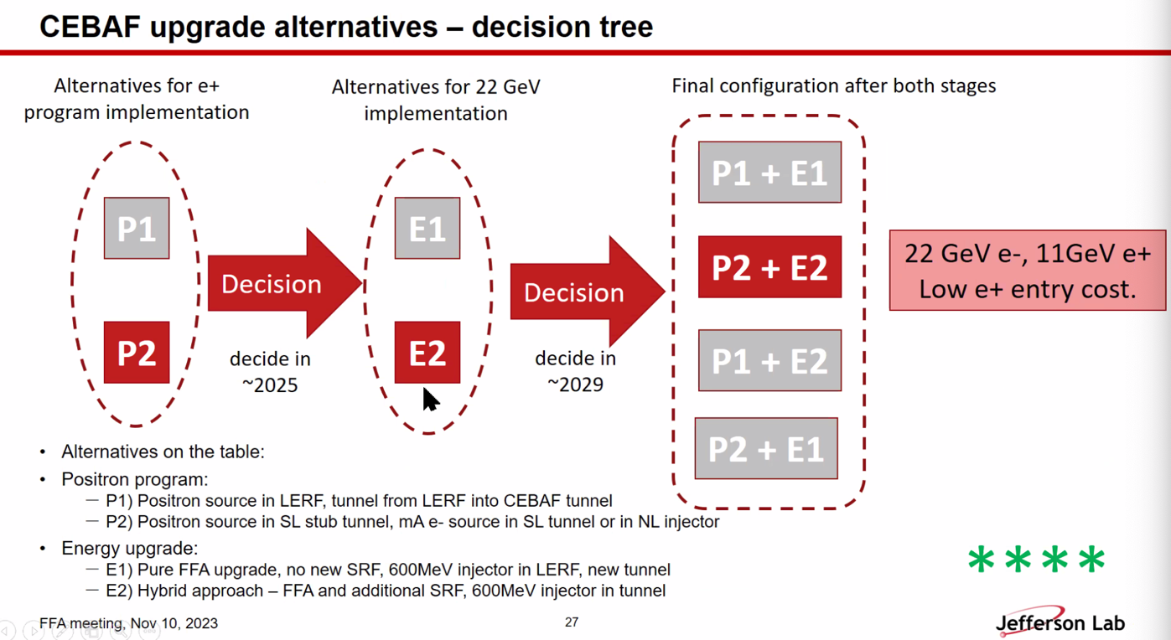
  - 4/4 stars
  - Maybe not feasible for SRF?
- 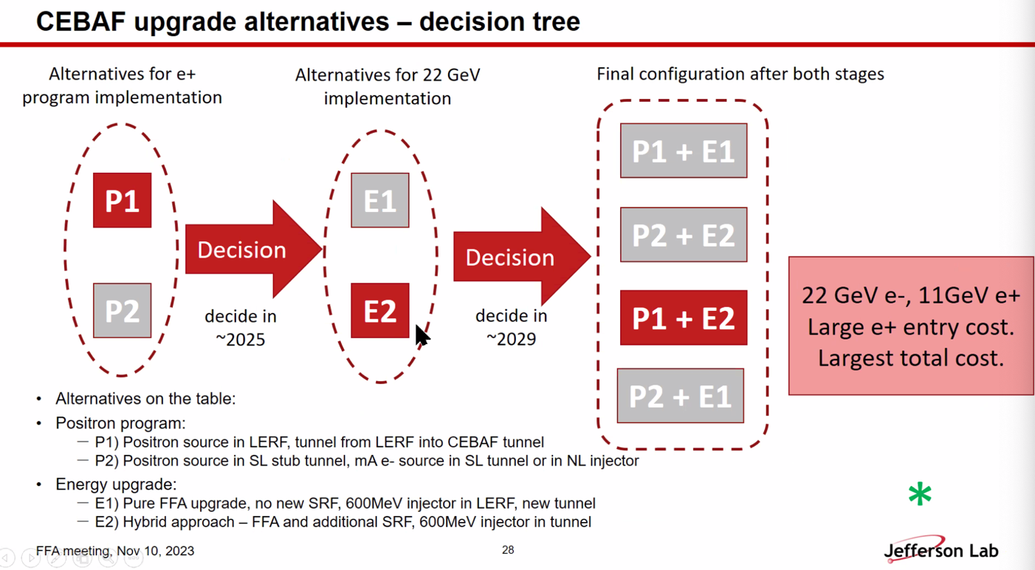
  - 1/4 stars
- 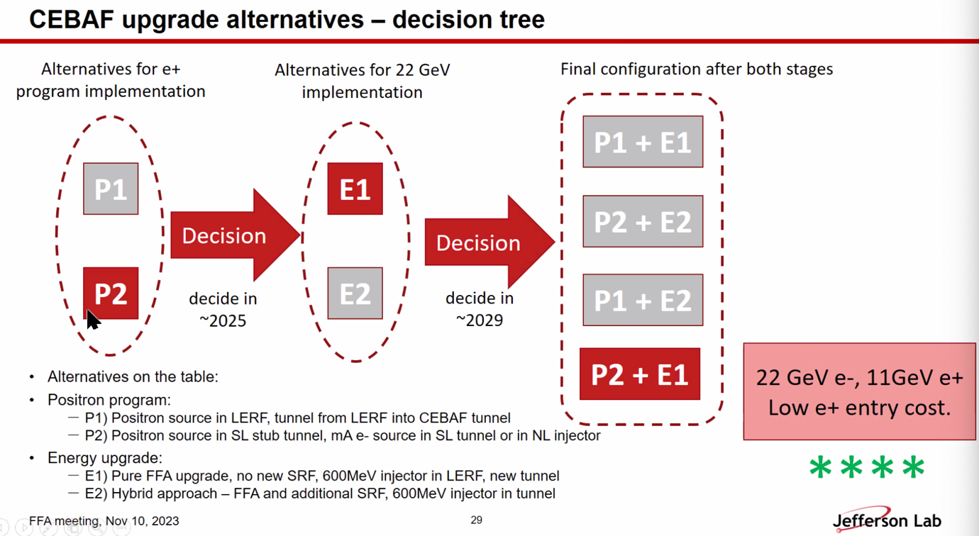
  - 4/4 stars
  - P2 seems to be preferrable
- 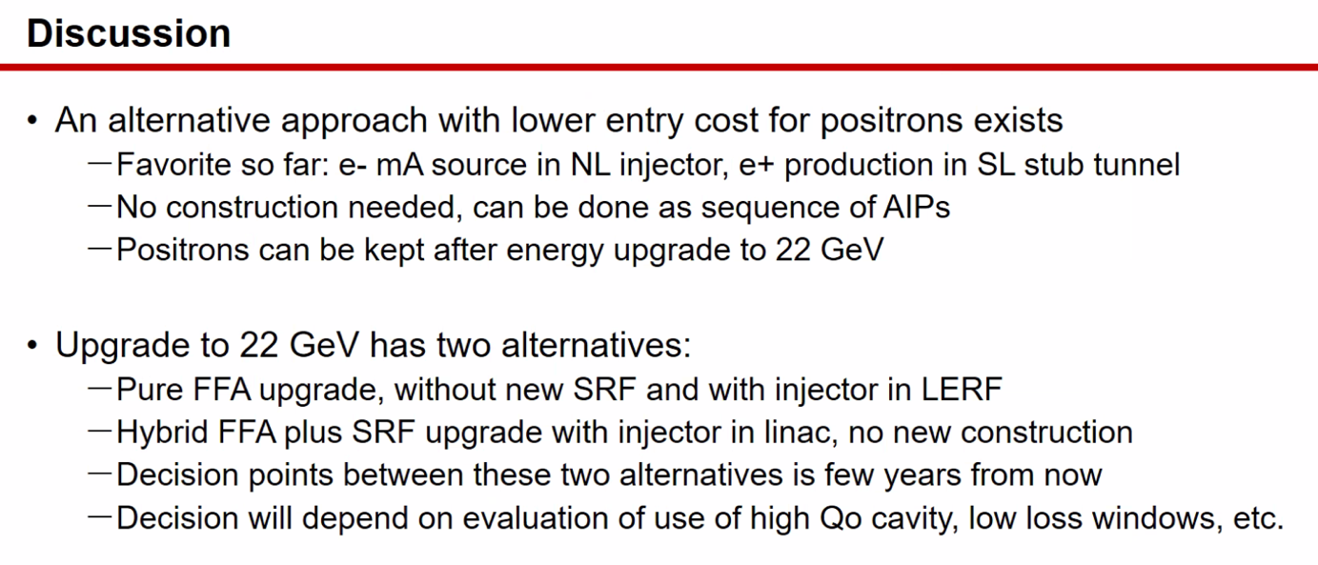
- Alex C – changing layout in linacs will take up more space in tunnel, and splitters is complicated and space intensive – how do you synergize those ideas?
  - Ryan – splitters on other side, but access needed
  - Andrei – this won’t interfere with splitters
- Ryan – bending from injector into W Arc might be hard
  - Andrei – could be done – see in stub, the 180 works
  - Trying to think of ways to only fund through AIP without CD0
    - No new tunnel, etc…
- Ryan – would R&D in SRF increase price?
  - Andrei – higher for some
- Joe – few comments:
  - Take what you’re saying seriously b/c de-coupling from EIC funding is important
  - One important thing: probably list the max energies of e+ delivery for different plans to each hall
    - Some of physics will need to know this
    - Might get different max energies for different configurations
  - Bottom left – spin rotator. Still exploring this idea. It’s not a full rotator, but adds flexibility. Could be eliminated and then choose electron linac energies
  - We’ve been thinking about polarized e- gun as two separate beasts. For 22 GeV, we envision something much larger than positron injector
    - Need to look at layout and see how we can either split them, or make the same injector for both.
- Alex B – one advantage is having e+ available after energy upgrade
  - Need to take a closer look at energy ratios. We will need to change the “switchyard” (spreaders)
- Eric – this is very important to have the capability of positrons during 22 GeV
  - Only thing we lose is possible ability of having low energy high intensity at LERF
    - Andrei – after development in LERF, do we move it, or keep it?
- Building off Larry’s idea might need construction
- Eric – timing is a big deal – good not to compete with EIC
  - But then, if you look at the tentative schedule proposed by David Dean, can we “win time”?
    - Andrei – probably win time, or avoid losing time. Good chance to avoid delays
- Jay – WRT polarization, go back to what the FFA group discussed before:
  - Can’t adjust linac energy if you have 6 beams. Have to drop back to 5 beams to have enough adjustability
  - If you need energy flexibility, have to have only 5 beams in FFA. 20 GeV max.
  - Andrei – why?
    - Stephen said to get more space, you need to ~quadruple magnetic material.
    - When discussed a year ago and before JLUO, working group wanted to ask what is more interesting. 6 fixed energies, 5 variable energies?
      - Now, with polarization issue, we need to adjust LINAC energy
  - Alex B – can have 6 passes with headroom in LINAC with polarization.
- Joe – question: has there been any analysis of the spin for the energy upgrade yet?
  - Will get real effects at these energies
  - Alex B – no, we haven’t looked at this. We’ve looked at SR effects.
- Ryan – are we sending the positrons in the same direction? Then what about permanent magnets?
  - Andrei/Alex B – no, they’d only get up to the EM passes
  - Ryan misunderstood, thought Eric wanted full 22 GeV energies.
- Reza – said you’d start at lower energy in arcs?
  - Already have lower energy linacs and FFA arcs, but they don’t have energy acceptance for such low energy beam.
  - So lower acceptance takes lower E?
    - Needs to be looked into
- Andrei – 5 FFA beams and hybrid, can you get to higher E after FFA arcs? Maybe 17 GeV?
- Ryan – did we actually confirm that 6 passes can work in the arcs?
  - Alex B – yes
  - Ryan, that’s not the impression I got from Stephen, we should probably have him confirm.
- Kirsten – also the splitters need to accommodate that energy range change. So this problem hasn’t been solved yet.
- Bob Rimmer – please clarify civil construction issue. Like, if we just want an annex or an alcove – when do we have to worry about approval vs just doing it.
  - Andrei – will check.
- Ryan – did you ask engineering?
  - Michalski also said he wants to help, but no weighing in yet.
- Roger – when talking about hybrid, the gun itself could be on service building and bring beam downstairs – would save space.
  - Jay - New service building for 500 keV and bring it down vertically
  - Save ~5ish meters
  - Joe – could think about it a bit
Action Items | Person responsible | Deadline

Special notes

Pathway to Repository: https://jeffersonlab-my.sharepoint.com/:f:/g/personal/tristan_jlab_org/EqZ5MeS-nipCgPfZB5p0oS4B9Is67d3nQb9sLJI3Zyev9g

