FFA@CEBAF Working Group|Minutes

## Meeting date | time 12/01/2023 | 11 AM EST | Meeting location <https://jlab-org.zoomgov.com/j/1614898082?pwd=TnUzMS81M2sxbDZIbERJU01tYkJCQT09>

|  |  |  |  |  |  |  |  |  |  |  |  |
| --- | --- | --- | --- | --- | --- | --- | --- | --- | --- | --- | --- |
| |  |  | | --- | --- | | Meeting called by | Alex B | | Type of meeting | Weekly Meeting | | Facilitator | Alex B | | Note taker | Ryan | | Timekeeper | Alex B | | Attendees  Alex B, Ryan, Donish, Alex C, Dejan, Edith, Scott, Kirsten, Vasiliy, Stephen, Reza, Todd, |

# Intro Discussion

# Agenda topics

## Time allotted | 10 mins | Agenda topic IPAC24 Abstracts | Presenter All

* Alex B made an IPAC24 folder on the shared area.
* We’ve alternated the main paper authorship – this time maybe Donish?
  + Yep.
* Ryan doing 3: Last LDRD, New LDRD, and Splitters
* Alex C: Writing at least 1, also on the Bmad.jl, error studies
* Edy doing alternative splitters, doing one for magnet LDRD mounts and software
* Vasiliy: one from LDRD, may also mention some overlap (maybe one with Randy)
* Stephen – machine sustainability possible talk, maybe update FFA arc? Tunability of energy and removing turn?
* Reza – extraction? Can do something.
* Donish – at least one for last LDRD

|  |  |  |
| --- | --- | --- |
| Action Items | Person responsible | Deadline |
|  |  |  |
|  |  |  |

## Time allotted | 25 mins | Agenda topic Alternative Splitter | Presenter Donish

* 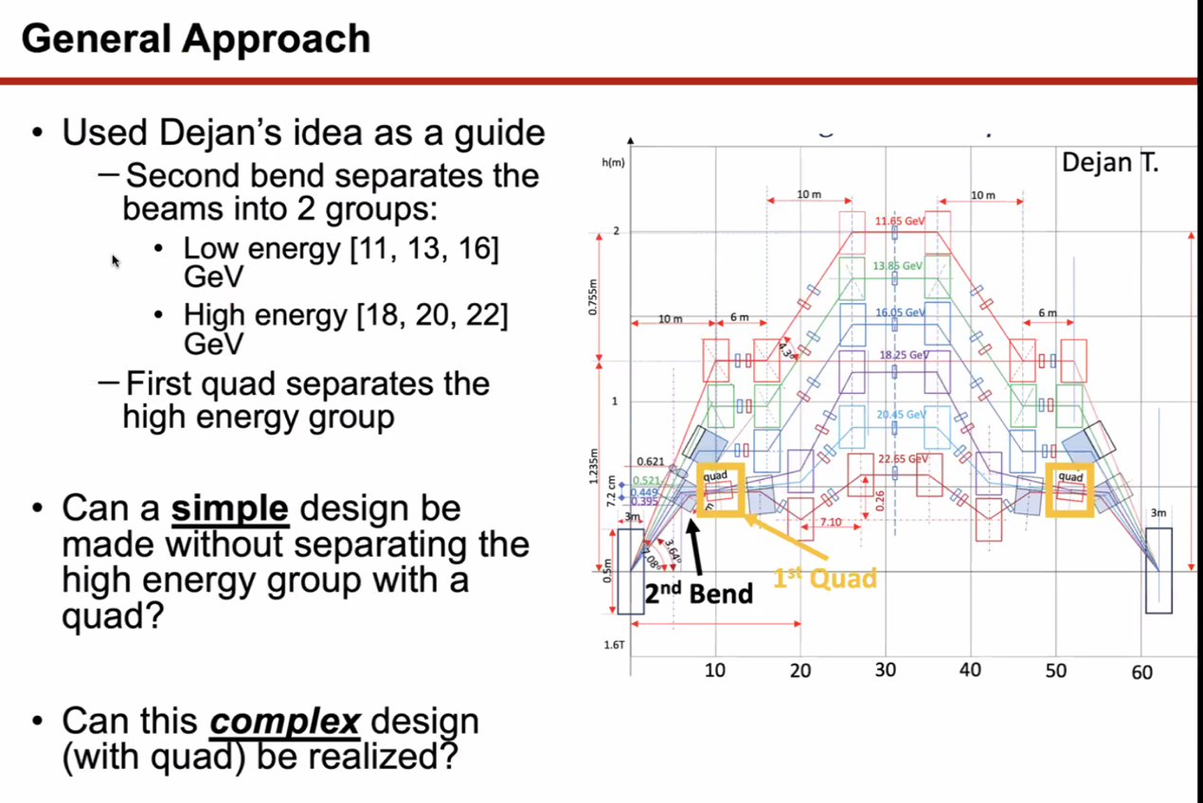
  + Two groups, then second group further separated by quad
  + Is there a simpler way to do this? Without quad?
  + Is the quad method feasible?
* 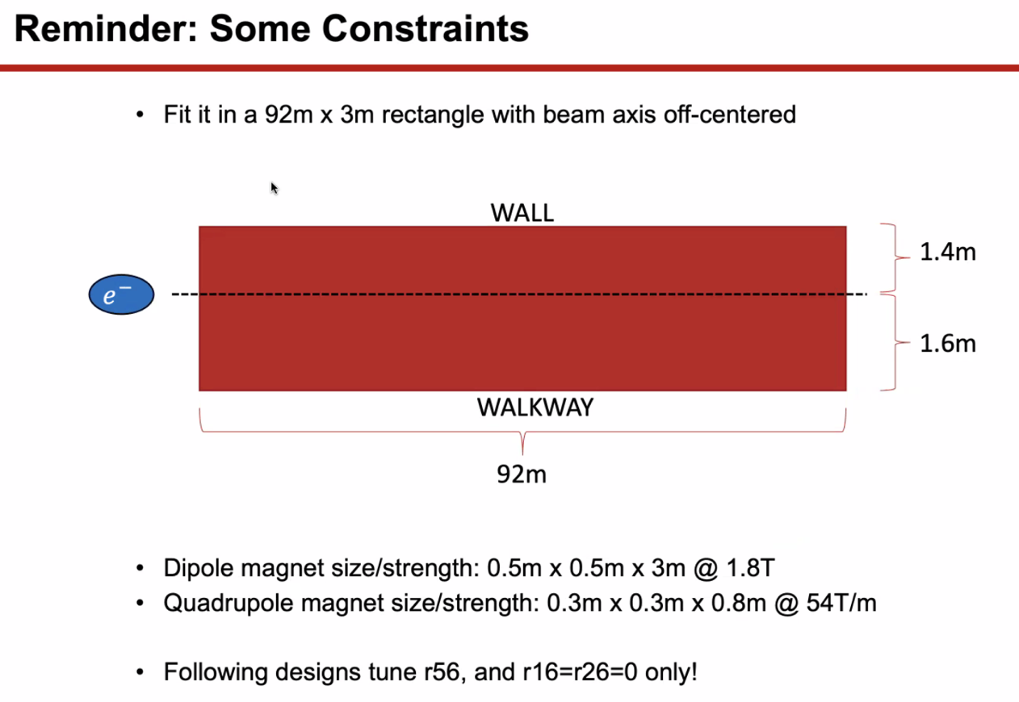
  + Magnets are very conservative with space. Can likely get smaller ones, but starting with large ones first
  + Tuned R56 correctly, and dispersion and dp go to zero, but that’s not “right”
* 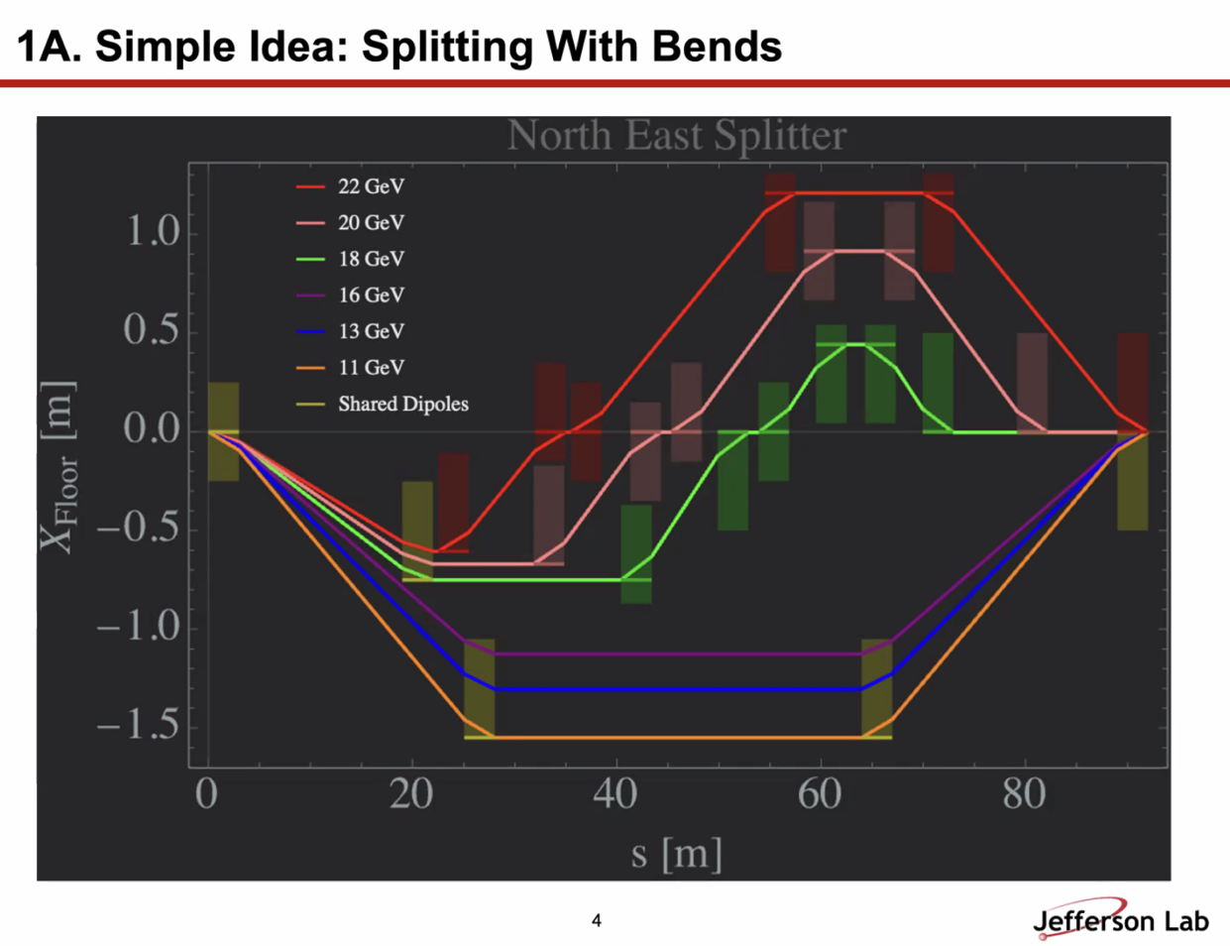
  + Yellow dipoles are shared dipoles, all others independent
* 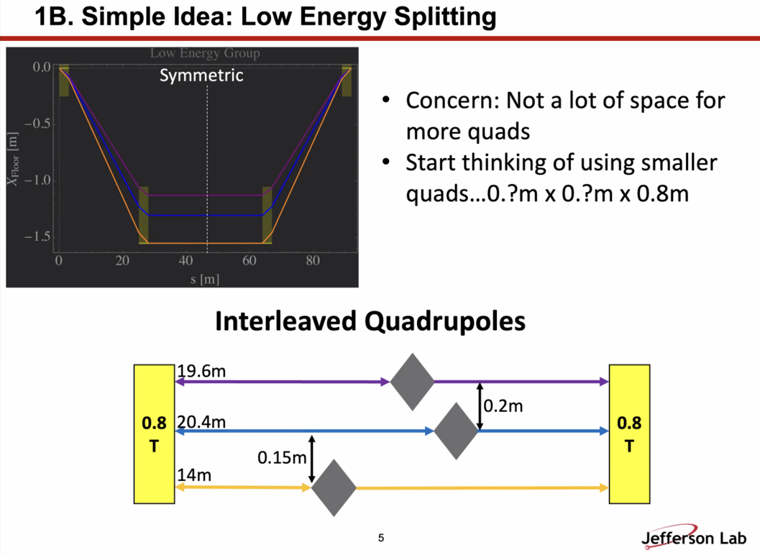
  + First and second bend
  + Within 14 m of first drift, get 0.15 m of space between passes of highest E
  + All beams fit in same dipoles with independent quads
  + One concern – not a lot of space for other quads. Plenty in center drift, but not much else
    - Beams aren’t separated enough
    - Smaller quads (transversely?)
  + Dejan – when you add more quads, they must adjust the vectors of the dispersion so that R56 is satisfied. Must combine them WITH dipoles. In the normalized dispersion diagram, this only changes the parts where there are no dipole vectors.
    - Donish: meant for twiss tuning
* 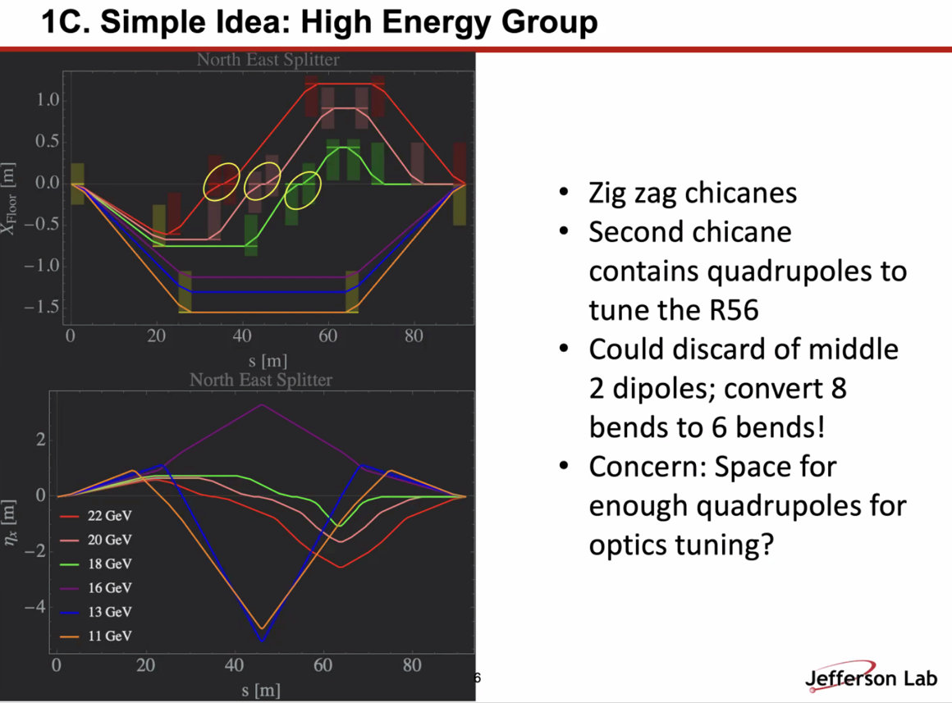
  + Zig-zag chicanes
  + No quads in first chicanes, second tunes R56
  + Middle two dipoles in high E groups could be taken out, decreasing the number of dipoles
  + After R56 tuning, maybe not enough space for other tuning quads.
    - Red, pink, green – things get very crowded. Not confident that Twiss won’t blow up by that point
  + Dispersion closes at end
* 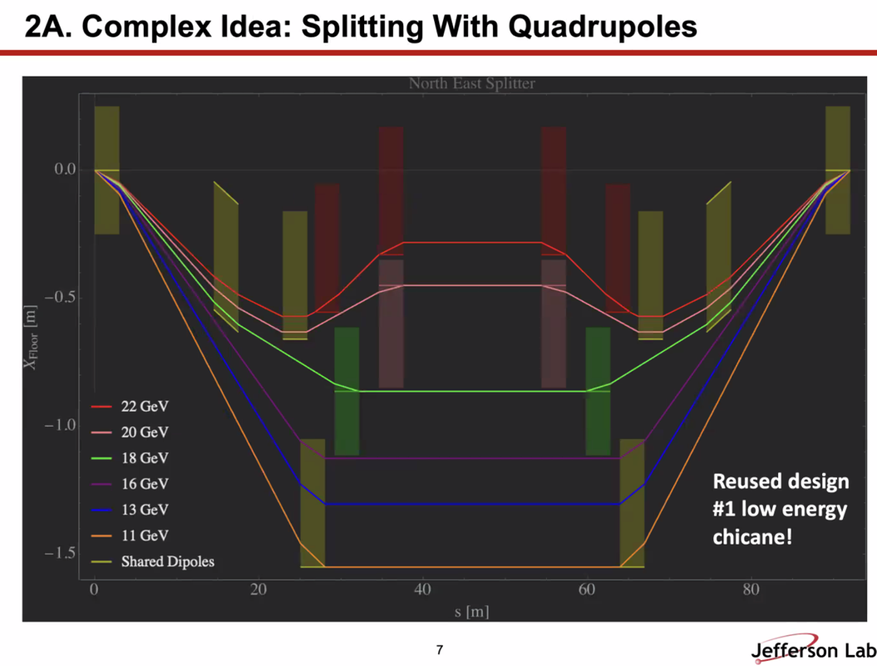
  + Simplified version of Dejan’s
    - Main difference is how high E groups are treated.
* 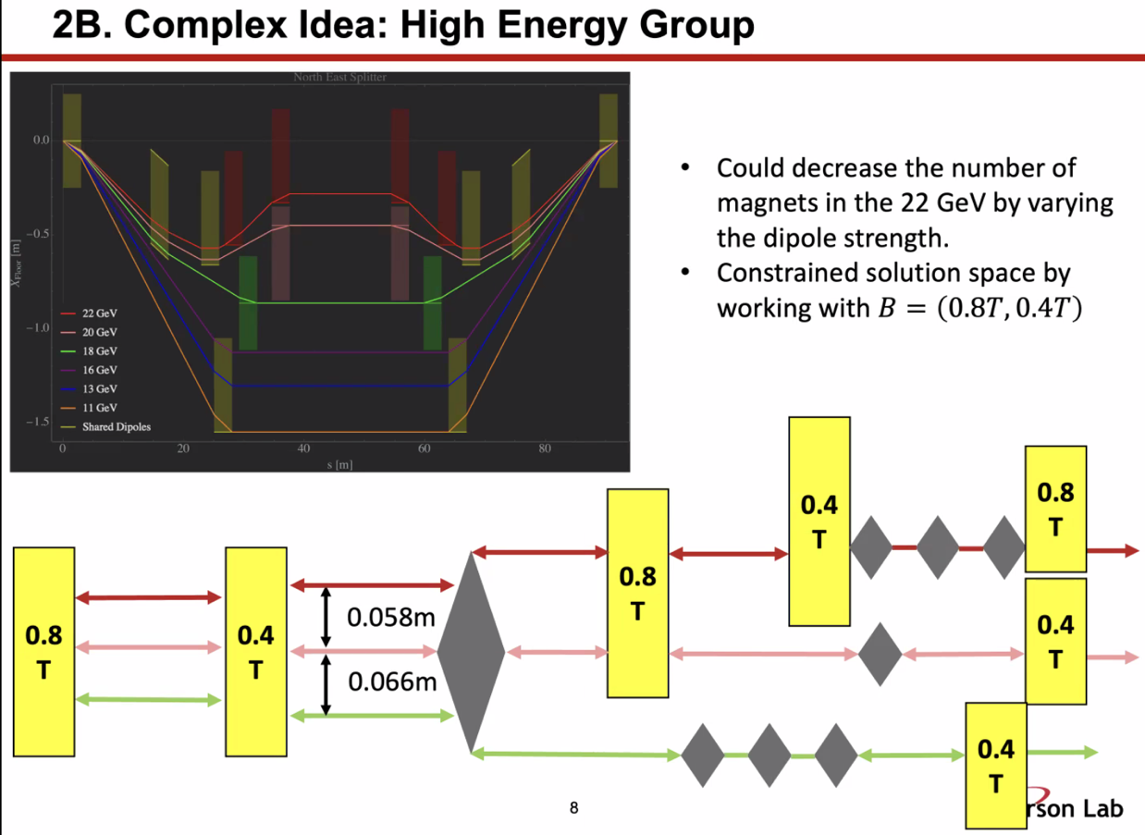
  + Sharing dipoles for low E, not higher E
  + Hardest is higher-E beamlines
  + Could vary dipole strength for 22 GeV line and use less magnets
* Ryan: for the low E lines, you’d need to put all 8 quads in between the two dipoles. You’d have a final drift that is very long with no quads, and you’d need to correct for orbit offsets and angle offsets required for matching into the FFA arc.
  + You don’t really want to put all your quads in the same place.
  + Also concerned about having the shared dipoles for those three lines – they’re not independent if you need to make adjustments.
* 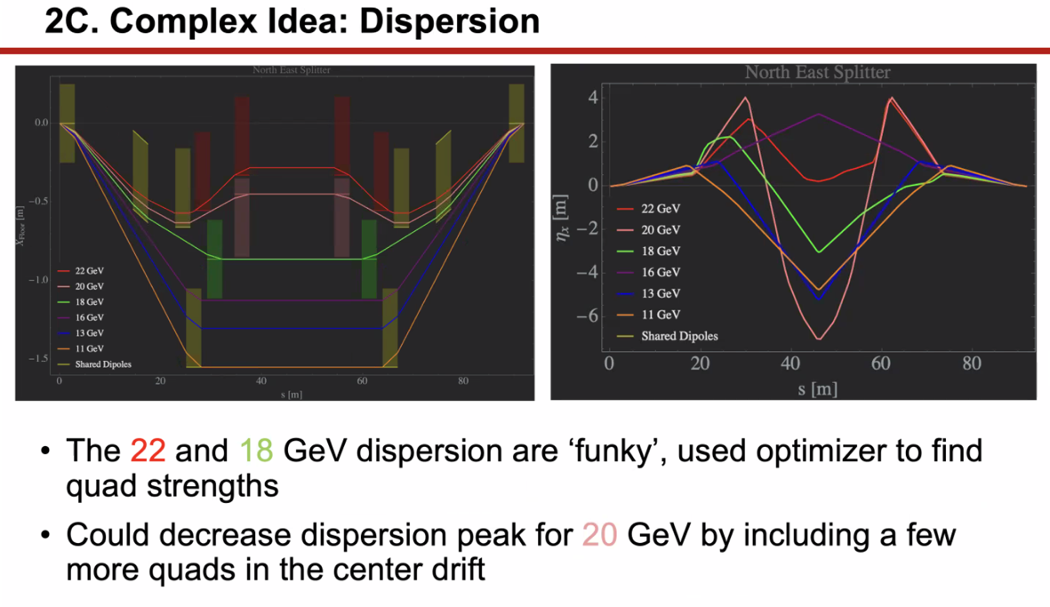
  + Didn’t try to bring down dispersion yet, just close it. So the dispersion is very large b/c missing quads in the middle
  + Dejan – 16 GeV dispersion looks like the integral is the opposite sign. Something doesn’t look right.
  + Ryan – I think this might be an optimizer issue.
  + Donish – may have accidentally switched the colors for the plots
  + Ryan – you could increase the distance between the (for example) red dipoles at the beginning to use more transverse space, and add in quads to help control things.
    - Good point – didn’t optimize for drift lengths for quad strengths, etc…
* Dejan – sent a picture of the dual-bore magnet for separating beams
  + Worried very much about these beta functions coming in from linac. They are enormous, and have to be very small at the FFA arc. Doing this in the splitter is very challenging.
  + Major problem in splitters was betas going from hundreds of meters to cm and being very unstable. Avoid this.
    - Donish – great point. Don’t have results yet, but haven’t looked at Twiss yet
    - Looked at backtracking from FFA arc
* Donish – Ryan, does yours address Twiss yet?
  + Not yet, quads are placed for spacing.
  + Need Strong Focusing to be propagated through machine to get updated
* Scott – you’re basically making an achromat. Need certain amount of phase advance in the achromat to make it work. Even ignoring R56 and getting the job done in this space with constrained quadrupoles, you need to get your phase advance the easy way by “diving” the phase through zero.
  + Want it to kind of sort of look like a FODO lattice.
  + Dejan – need to gradually bring them down, not in a short space
    - Scott – unfortunately, you have to do it quickly. You have to create phase advance
    - Dejan – in a couple of steps
  + If I look at this picture – initial reaction is don’t place quads all in one place. You want to distribute them fairly uniformly (like a FODO sort of)
* Dejan – have to remember – spreaders have an impact on what is coming into the splitters.
* Might be eliminating line – that would simplify
* Dejan – we could go back to 2 FFA arc idea
  + Alex B – we abandoned that twice
* Scott – let’s solve the problem now without adding passes
  + If anything, might consider starting one pass at a time and do two splitter lines
  + Get a two-pass design, make them fit and pretend that you only need those two to fit. Make it work. Then add another pass. Iterate
  + Prettier than Ryan’s design (not necessarily better, but prettier)
    - Kirsten – prettier, but maybe not something I’d want to be in the control room commissioning.

|  |  |  |
| --- | --- | --- |
| Action Items | Person responsible | Deadline |
|  |  |  |
|  |  |  |

## Time allotted | 25 mins | Agenda topic Transition | Presenter Vasiliy/Randika



|  |  |  |
| --- | --- | --- |
| Action Items | Person responsible | Deadline |
|  |  |  |
|  |  |  |

## Time allotted | 25 mins | Agenda topic AOB| Presenter All

* Haven’t worked directly on CEBAF stuff lately. The LDRD is over, but still writing up findings.
* Done some theoretical and more lattice work – results should be applicable (even though for proton RLA)
* 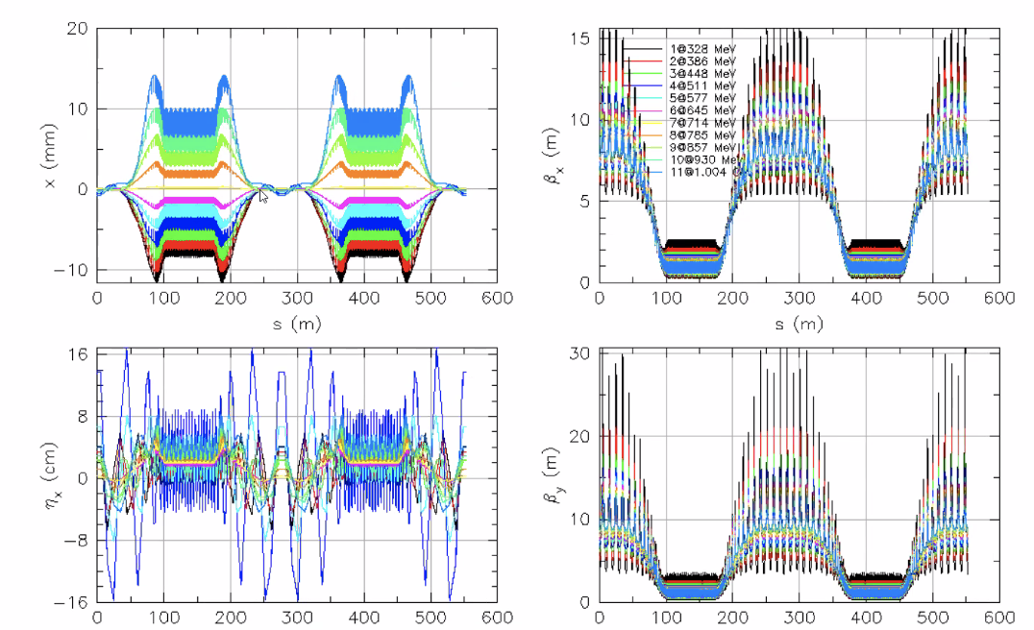
  + Adiabatic transitions only work to a certain extent.
  + Orbits look ok, but significant deviation
  + Betas look OK
  + Dispersion got out of hand.
  + Applied harmonic corrections:
    - 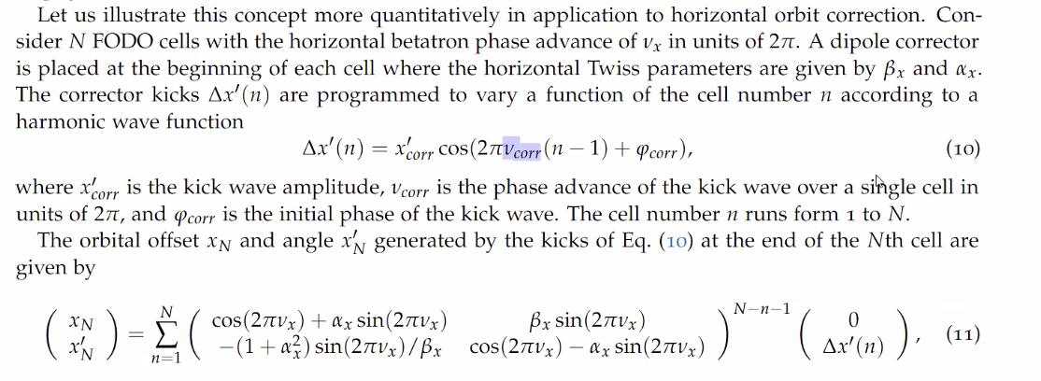
  + 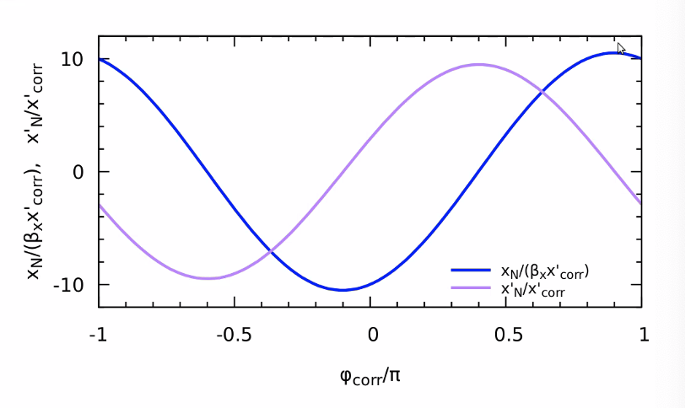
    - Create angle or offset – introduce kick and only applies to a particular energy.
  + 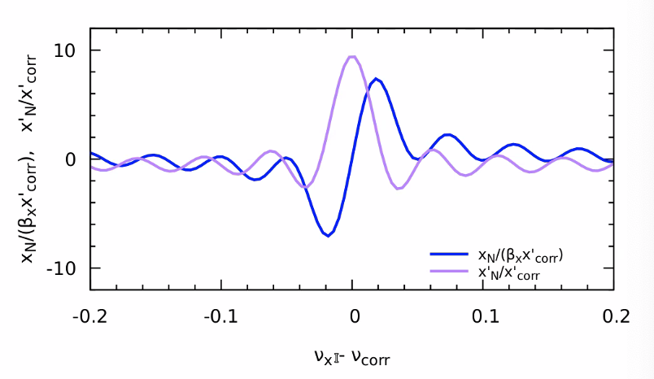
    - Offset and angle as function of phase advance
    - Pick the phase that lets you adjust the angle with zero orbital offset
    - Effect averages out
    - As you go off in betatron tune, the angular kick cancels, but the offset increases.
  + 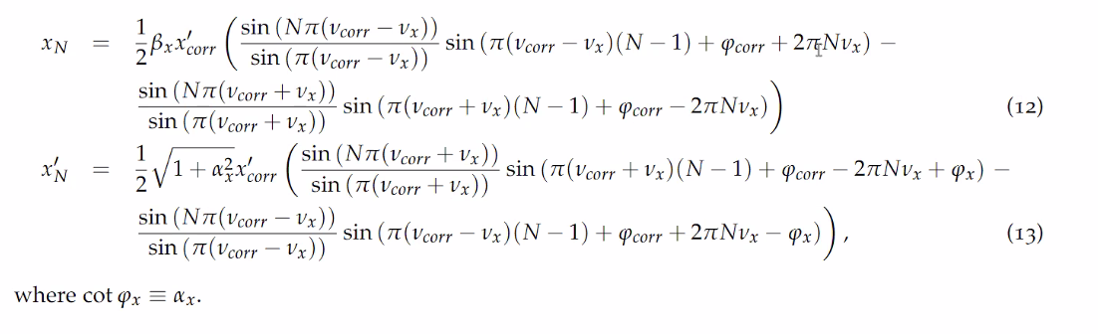
  + 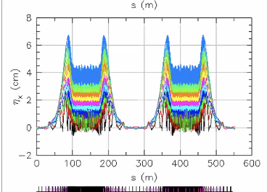
    - Dispersion got nicer
* Ryan – how would this work with a real beam?
  + This would allow you to correct locally
  + Can do it with response matrix – treat independent lines independently
  + Here, semi-local correction. Apply wave over several FODO cells
  + 3 Knobs per each pass
* Alex C – how control them for each pass separately?
  + They add up. It’s the sum for all passes. So 3 knobs times number of passes.
  + So how select out which knob works on each pass?
    - Choose the tune
  + What if the tune is not correct? Misaligned, etc…
    - Measure it or tune the knob until it works

|  |  |  |
| --- | --- | --- |
| Action Items | Person responsible | Deadline |
|  |  |  |
|  |  |  |

## Special notes

Pathway to Repository: <https://jeffersonlab-my.sharepoint.com/:f:/g/personal/tristan_jlab_org/EqZ5MeS-nipCgPfZB5p0oS4B9Is67d3nQb9sLJI3Zyev9g>