FFA@CEBAF Working Group|Minutes

## Meeting date | time 12/08/2023 | 11 AM EST | Meeting location <https://jlab-org.zoomgov.com/j/1614898082?pwd=TnUzMS81M2sxbDZIbERJU01tYkJCQT09>

|  |  |  |  |  |  |  |  |  |  |  |  |
| --- | --- | --- | --- | --- | --- | --- | --- | --- | --- | --- | --- |
| |  |  | | --- | --- | | Meeting called by | Alex B | | Type of meeting | Weekly Meeting | | Facilitator | Alex B | | Note taker | Ryan | | Timekeeper | Alex B | | Attendees  Alex B, Ryan, Todd, Kirsten, Stephen, Edy, Vasiliy, Randika, Reza, Donish, Dejan |

# Intro Discussion

* Holiday plans
* Interesting article from Ben Shepherd: <https://www.nature.com/articles/s42254-023-00678-w.epdf?sharing_token=0w9pdi3ozh-7swiUL6ffp9RgN0jAjWel9jnR3ZoTv0NtvawVutnpiQBGZoMhIQ89y54AJ1oYJ5WufxIs0JYm-erqSqgCrhVxUrUXhhyuF_SH1wWGz_9V2a4UsDYZ-j9GXZcuxTRecj62kvBptwq5YZ8sAZ7l-k1Sbe1FMynnJgg%3D>

# Agenda topics

## Time allotted | 10 mins | Agenda topic IPAC24 Abstracts | Presenter All

* Please upload them to the sharepoint
* Lots of them uploaded, more coming

|  |  |  |
| --- | --- | --- |
| Action Items | Person responsible | Deadline |
|  |  |  |
|  |  |  |

## Time allotted | 25 mins | Agenda topic Energy Flexibility | Presenter Dejan/Stephen

* Can we get 6 passes, or do we need 5?
  + What about scaling the LINACs up as well to get back to 22 GeV?
* No slides
* FFA accommodates a range of energies
* Let’s say 22 GeV at the top, bottom around 10-12 GeV
* Energies sit inside the range in discrete places
  + If we change the LINAC energies at all, either the top or bottom will fall out of the range
  + This is why this doesn’t allow a lot of LINAC adjustability
  + 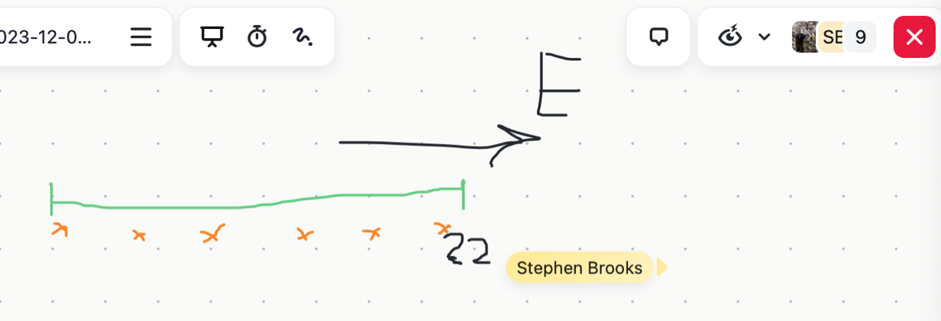
* Now, if you have 5 passes, and they go to 20 GeV
* Want to change LINAC energy so that 20 GeV can move down to lower spot
  + Now lower energy is the limiting factor, so can’t scale to 22 GeV
* 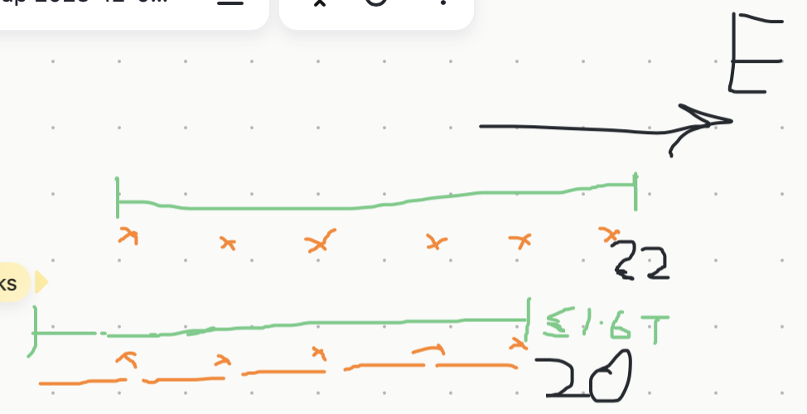
* Dejan – ran previous design with sextupoles, orbit offsets were a little off
  + Tunes mostly unchanged
  + What Stephen is saying might not be a problem, b/c if we can expand the sextupole, the tunes might expand enormously
  + Stephen is right though, with the existing lattice, the range is the limit
  + First exercise added too much sextupole. Tune got flat – not wanted.
* Stephen – might not need too much sextupole
  + Adding sextupole could helpl
  + Andrei said go up in energy for the LINACs – this would keep the original energy range.
    - 5 turns at first, then upgrade LINACs and get 6 passes
  + 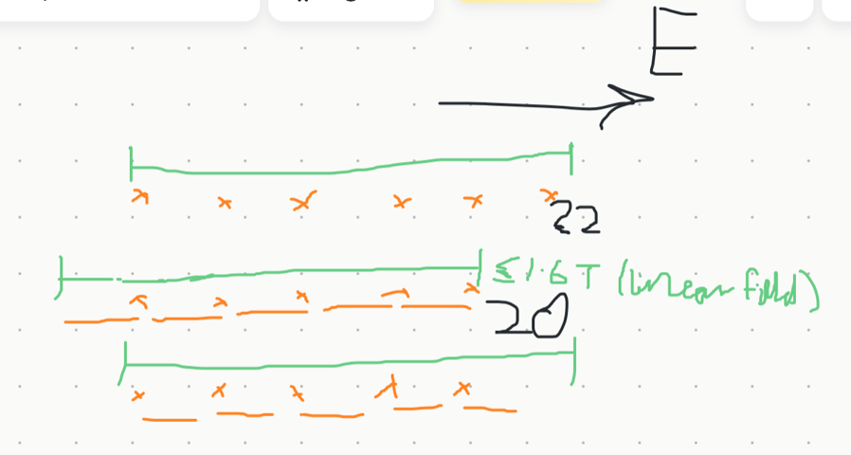
* Kirsten – we have to worry about EM arcs as well
  + Promoting arcs
  + Ryan – Donish, how much headroom do the magnets have?
    - Donish – not sure, maybe 25%
* 5 line splitter much easier, and can still get to 22 GeV
* Users are fine with 20 GeV – it’s a soft energy profile
  + Hall D needs 22 GeV for polarization
  + Other halls don’t care as much
* Dejan – maybe we aim for 24 GeV?
  + Ryan – the hall lines can’t handle that. 22 GeV is already close
  + Alex B – also, look at Kirsten’s work – we’d lose too much SR and the beam would be bad quality. Basically losing a linac per pass of SR at 22, so maybe that’s a limit.
* So, is there a decision?
* Ryan, so are we dropping to 5 passes?
* 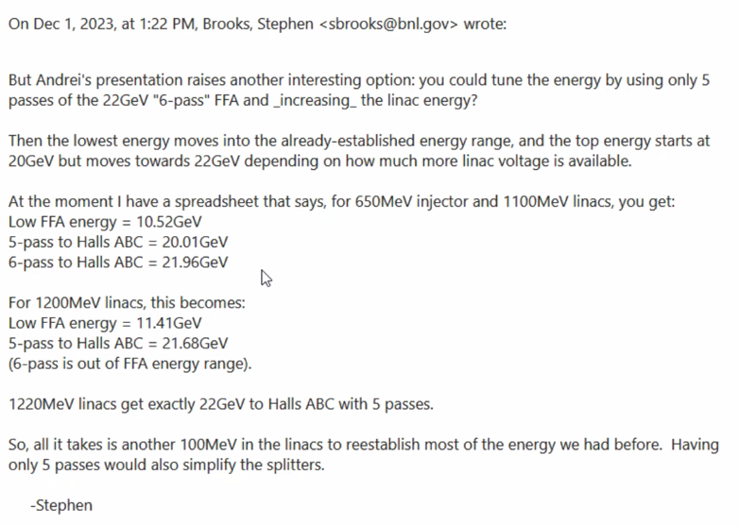
* 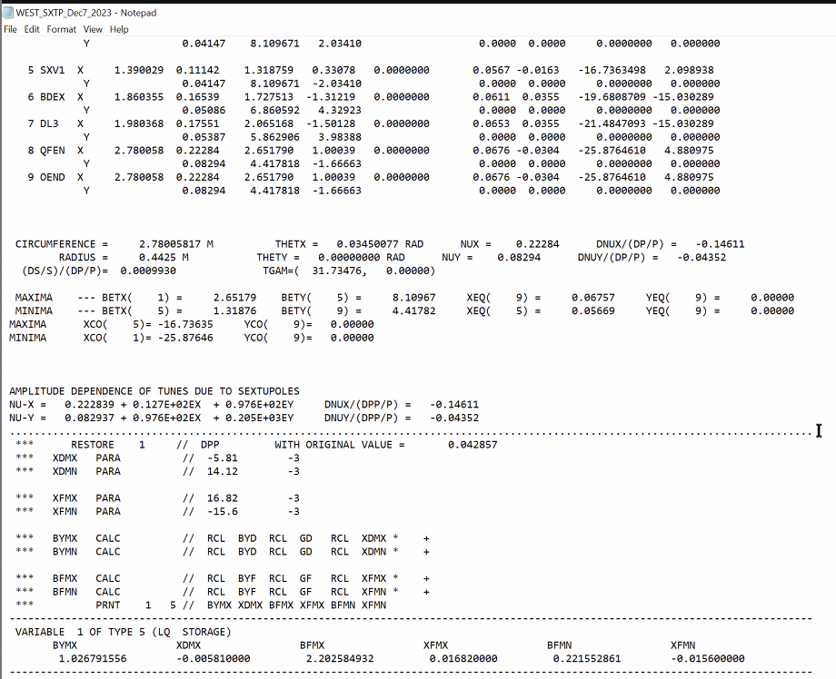
  + This is too much
  + Not a problem with lattice stability
  + This is just a first step – adding sextupoles is easy with Stephen’s program
    - This is too much change
    - .38 to .28
* Stephen – if your tune is too low, don’t you have more energy range at the bottom end?
  + Yes, you can scan this up to the top
* Orbit offset at top is only 2.1 mm
* 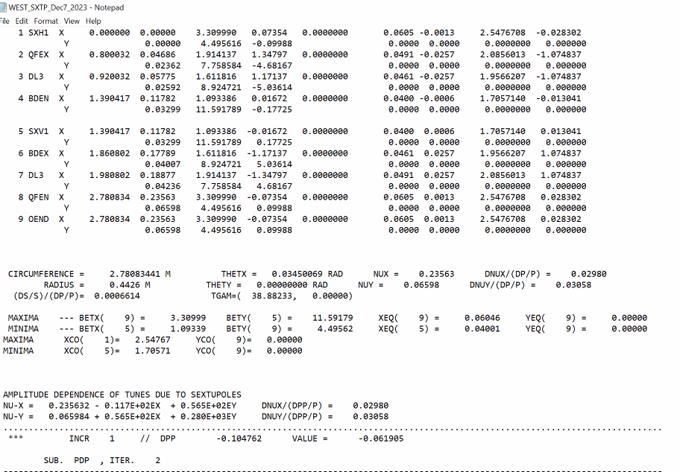
* Ryan – will introducing sextupoles into these arcs persist in the rest of the machine?
  + We can add sextupoles to cancel them out.
* SYNCH is being used by Dejan for these quick studies – they need to go into Bmad and Stephen’s codes for real optimization.
  + Stephen – does it give max field?
    - At the bottom of the file
* Ryan – so are we stamping 5 passes or 6?
  + Alex B: Configuration board
    - We’re still looking at Stephen’s ideas and Dejan’s optimizations
    - We need to make a decision, not today, but soon
    - Alex’s feeling – we’re not there yet.
  + We need to talk to the users to make sure they’re OK with it
    - 5 passes was an easy sell. 20 to 22 seems reasonable to users
  + Ryan – there’s also a mix of 5 passes AND Dejan’s idea
* Reza – some of us have to change the abstracts for number of passes
  + Ryan – focus on generalities
  + Alex B – focus on current studies
* Stephen – don’t drop 6 passes until we fully decide

|  |  |  |
| --- | --- | --- |
| Action Items | Person responsible | Deadline |
|  |  |  |
|  |  |  |

## Time allotted | 25 mins | Agenda topic Extraction| Presenter Reza

* Assuming we remember the last time presented at FFA Workshop
* 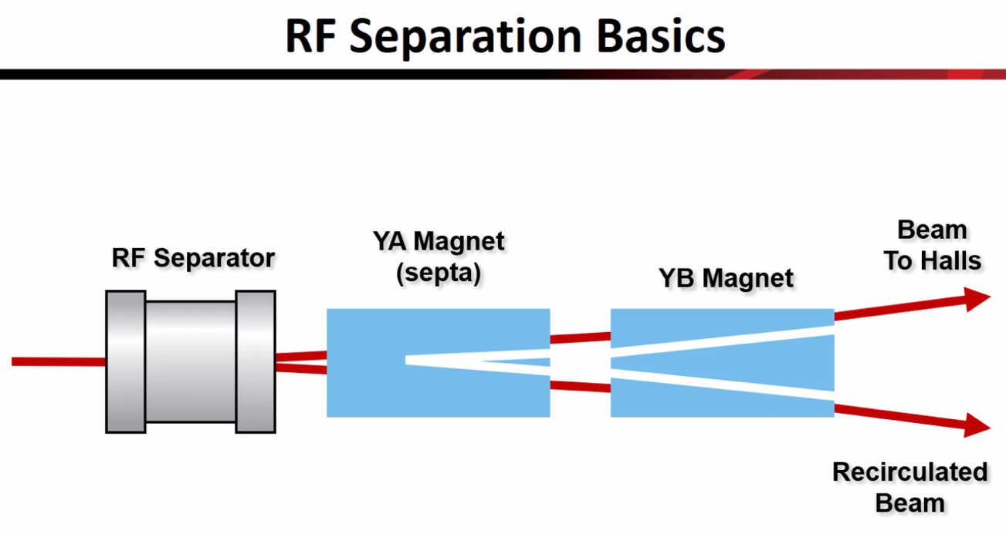
* 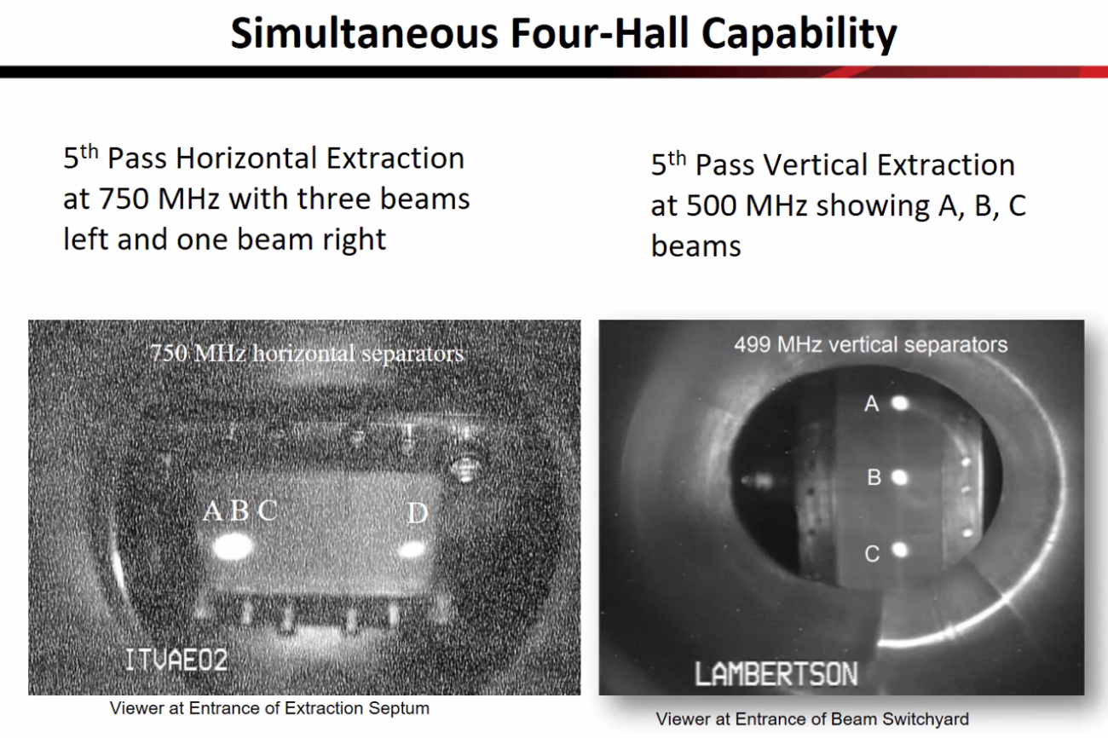
  + Change the left picture vertically for our system – we’re separating vertically
* 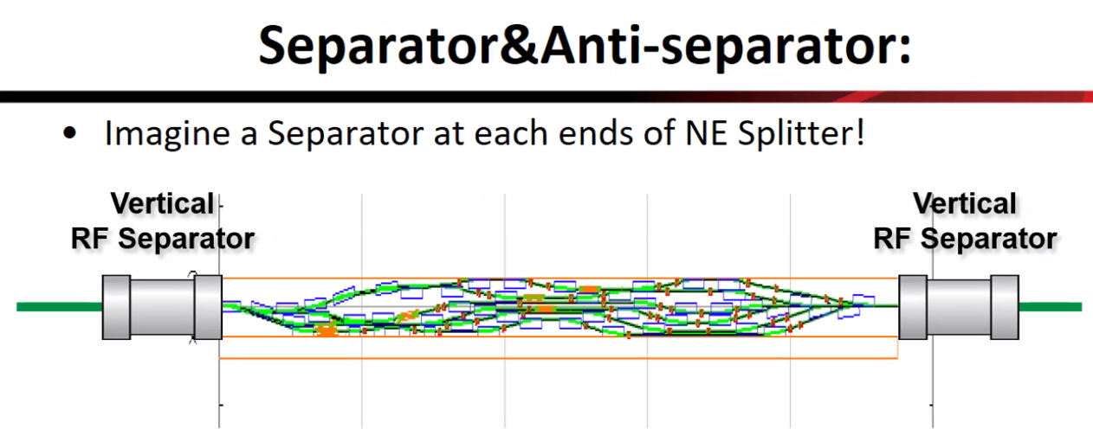
  + Maybe no room
  + What if we do vertical RF separator at beginning of splitter then cancel the kick at the end
  + 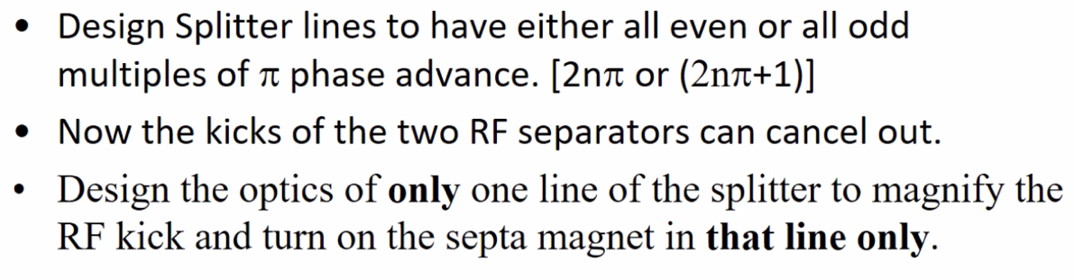
  + 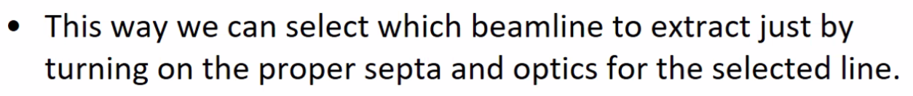
* The problems we’re having with the design of the splitters – adding more requirements makes it much harder
  + How simplify it?
* 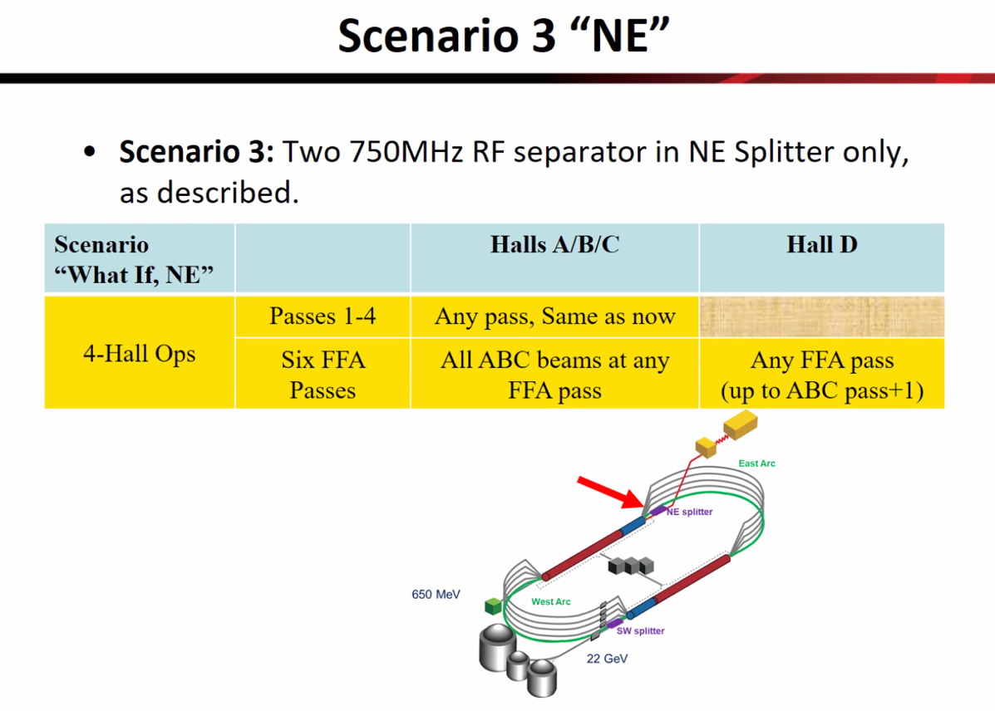
* 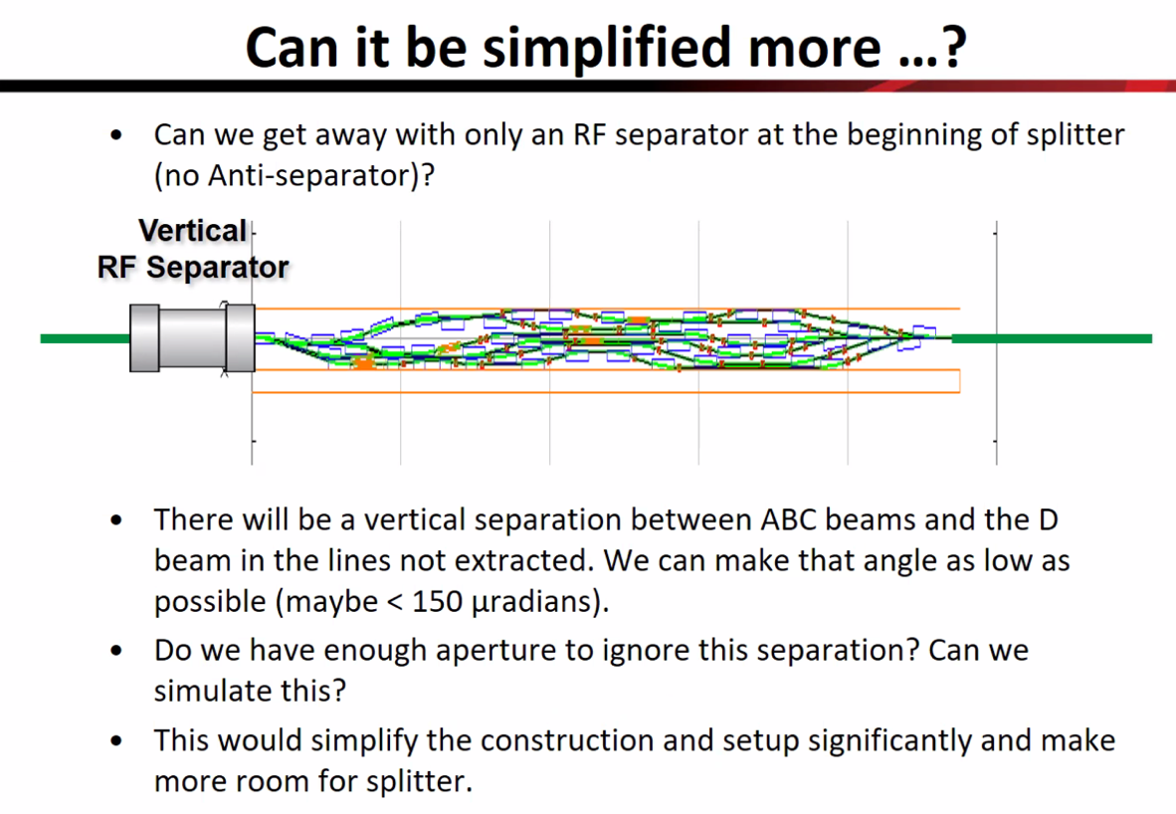
  + Put quads and septa “turned on” on line where you extract. Other lines would have a small separation
  + Separate Hall D from the system – send it separated through the whole machine?
  + Dejan – called a single-dipole error, it propagates all the way and must be canceled by 180-degree phase difference. Don’t propagate
  + Ryan – can it propagate for only half a pass?
* Dejan – the transverse plane will induce oscillations, so you always want to correct it
* Ryan – but if we kick down, then kick flat, the angular component is cancelled
* If RF separator gives a kick, but we turn off the other elements, then just have a small angular separation from A/B/C
  + Make the small angle kick, get slightly separated beams (maybe one beam size). They’d go through the whole machine that way.
  + Ryan – if we cancel out the angular component, can we send the beams through with a vertical spread?
  + Alex B – do we have enough vertical aperture in the FFA arcs?
    - Ryan – we have ~2 cm in the vertical and under 6 cm in the horizontal
* Ryan – I can ask Alex Coxe to see if he has a better idea on the vertical aperture – he may already have an idea

|  |  |  |
| --- | --- | --- |
| Action Items | Person responsible | Deadline |
|  |  |  |
|  |  |  |

## Time allotted | 5 mins | Agenda topic AOB| Presenter All

|  |  |  |
| --- | --- | --- |
| Action Items | Person responsible | Deadline |
|  |  |  |
|  |  |  |

## Special notes

Pathway to Repository: <https://jeffersonlab-my.sharepoint.com/:f:/g/personal/tristan_jlab_org/EqZ5MeS-nipCgPfZB5p0oS4B9Is67d3nQb9sLJI3Zyev9g>