FFA@CEBAF Working Group|Minutes

## Meeting date | time 12/15/2023 | 11 AM EST | Meeting location <https://jlab-org.zoomgov.com/j/1614898082?pwd=TnUzMS81M2sxbDZIbERJU01tYkJCQT09>

|  |  |  |  |  |  |  |  |  |  |  |  |
| --- | --- | --- | --- | --- | --- | --- | --- | --- | --- | --- | --- |
| |  |  | | --- | --- | | Meeting called by | Alex B | | Type of meeting | Weekly Meeting | | Facilitator | Alex B | | Note taker | Ryan | | Timekeeper | Alex B | | Attendees  Alex B, Ryan, Alex C, Kirsten, Thomas Planche, Donish, Stephen, Dejan, Andrei, Roger, Vasiliy |

# Intro Discussion

* Thomas Planche joining as a visitor

# Agenda topics

## Time allotted | 10 mins | Agenda topic FFA Arc Vertical Acceptance| Presenter Alex C

* After Reza’s discussion, can we transport a vertically offset beam in the FFA arcs?
* Aperture scan in ideal FFA lattice – no correction
* 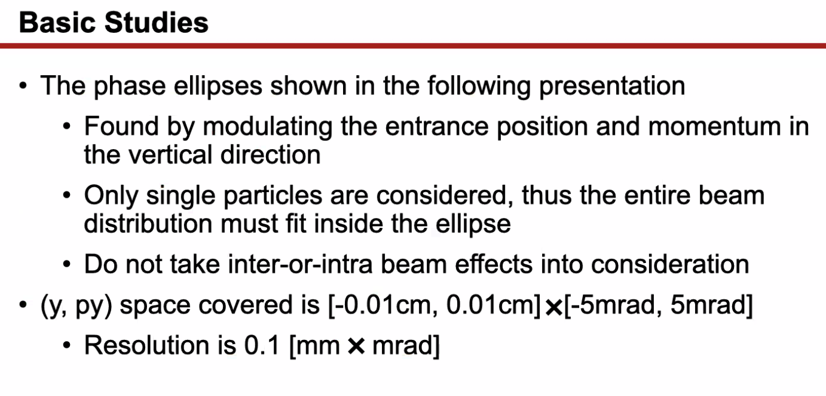
  + If centroid toward edge of phase ellipse, you’ll lose a lot of particles.
  + These are ONLY for single reference particles
  + 100 microns by 0.1 mrad for whole vertical physical aperture (of 2 cm)
* 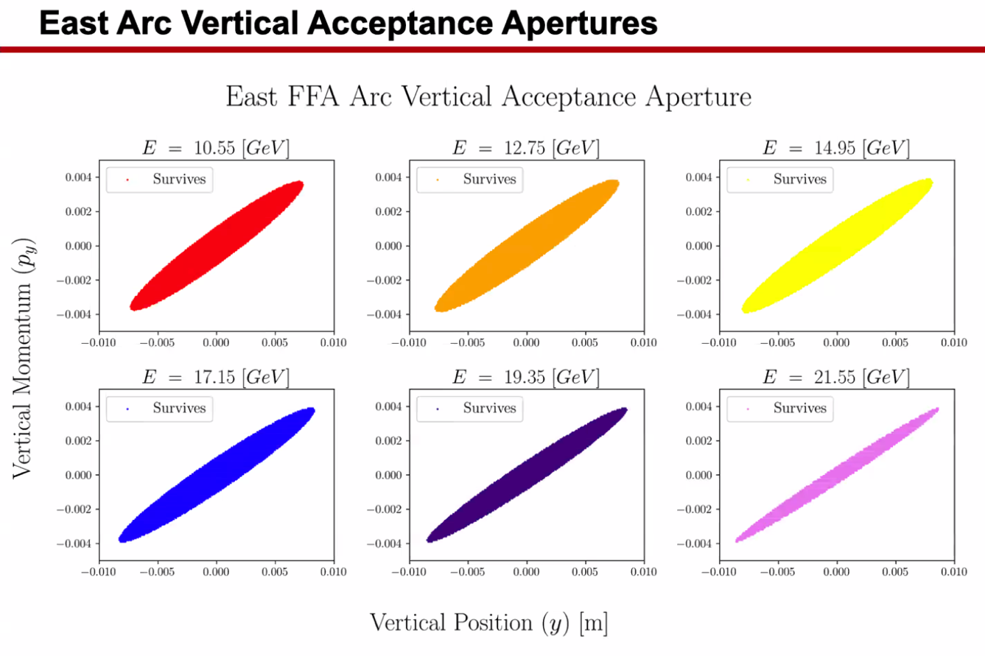
  + Most of vertical space covered for all energies
  + Radians on the vertical axis
* 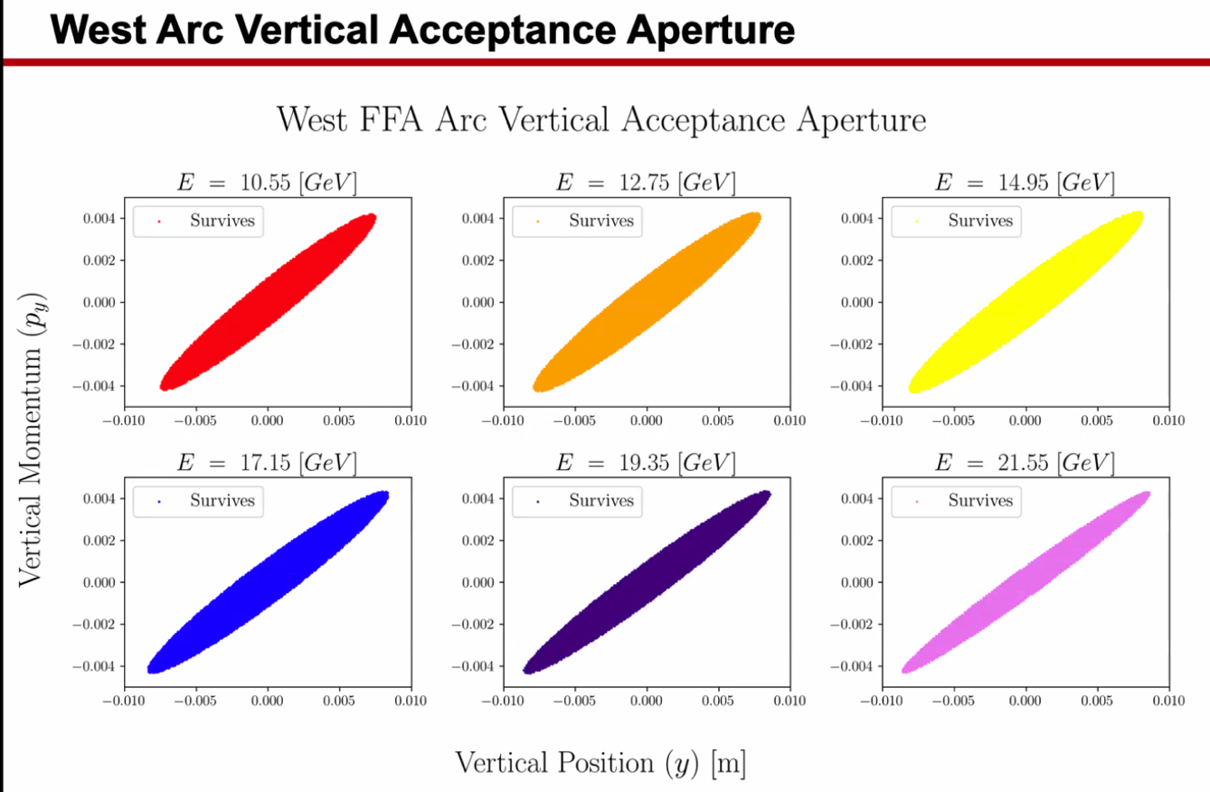
* Ryan recommended looking at the exit aperture:
* 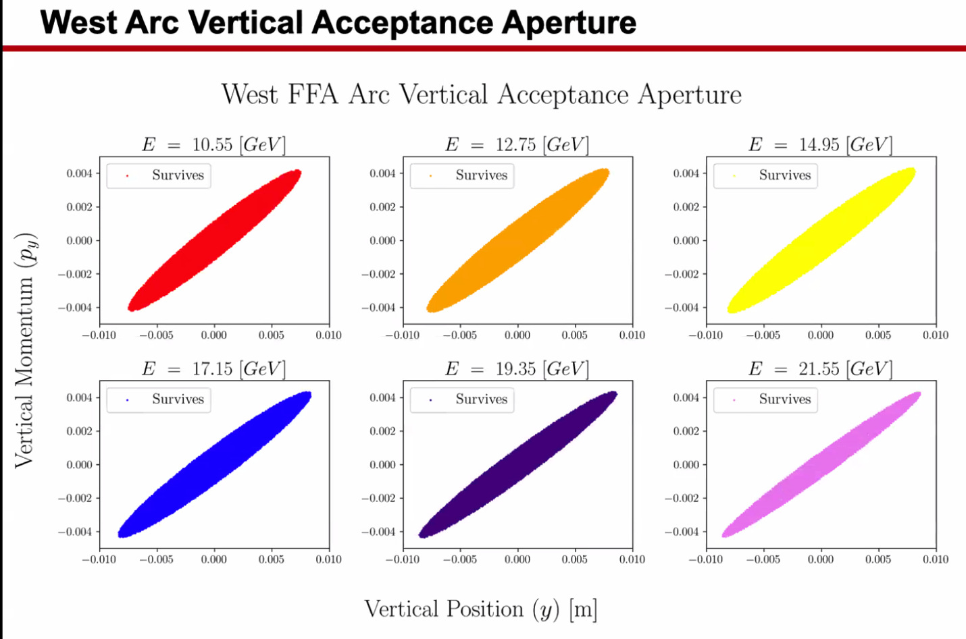
* 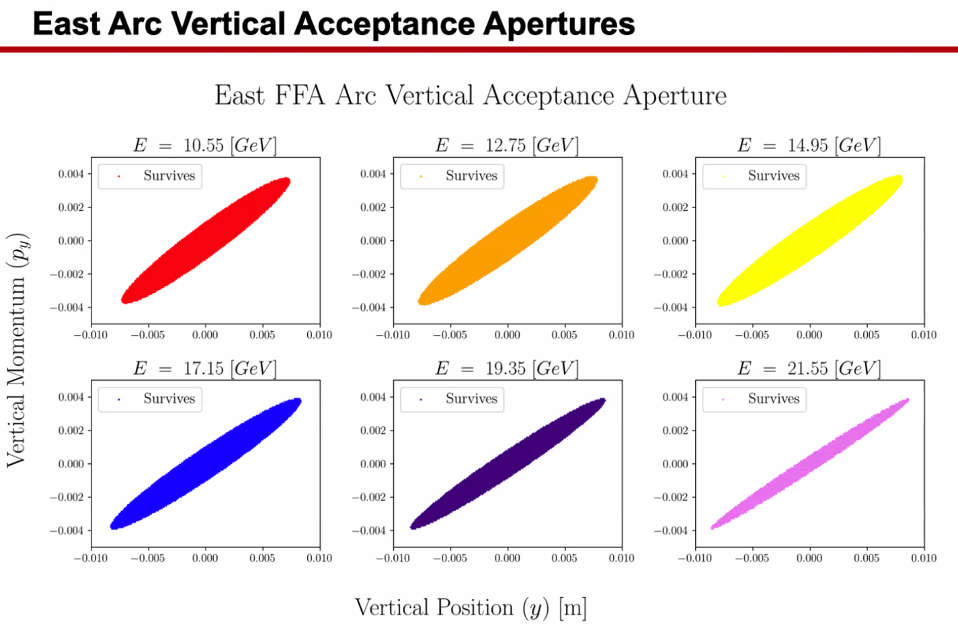
  + End up in a bounded region, not periodic
  + Exit apertures look almost the same as entrance
* 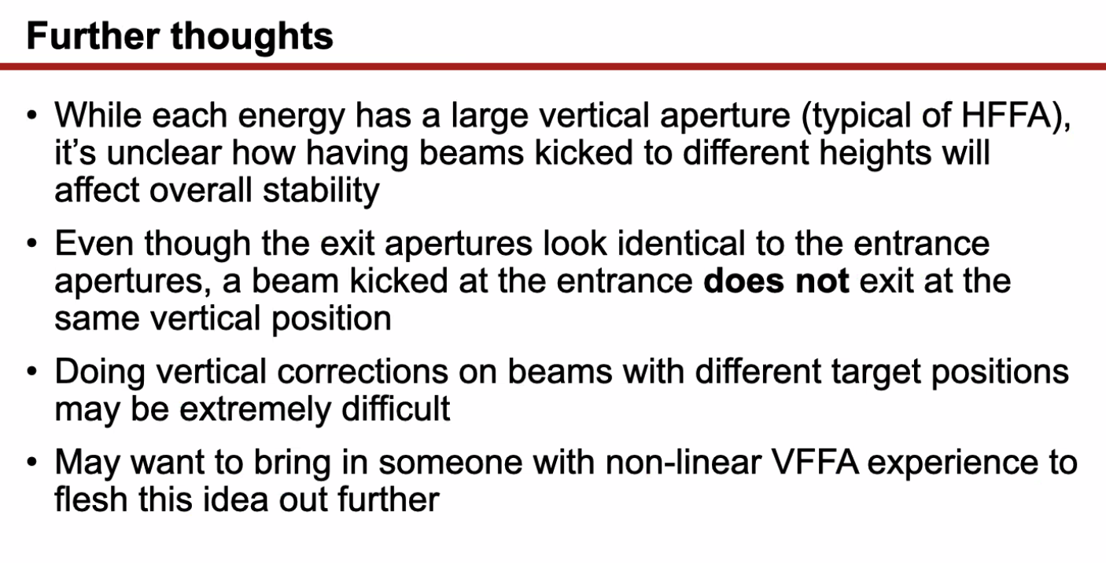
  + Corrections may be hard
* Stephen: as soon as you have energy spread, transmitting a beam that’s not on the closed orbit isn’t a good idea
  + Dejan – especially low energies
  + Try to send one with an energy spread through – would be educational
* Alex C – offset reference particle by a few mm and mrad and lost whole beam.
  + Stephen: Tune of whole FFA varies a lot with energy. If you’re off, the beam is going round and round in phase space. So with energy spread, you’re smearing out over the phase space – get a funky-looking plot.
* Thomas – your requirement isn’t that the splitter section is doubly-achromatic?
  + If you have a section that is doubly-achromatic for all energies, it would be transparent to energy spread
  + Stephen – yes, but this is the arc, not the splitter
* 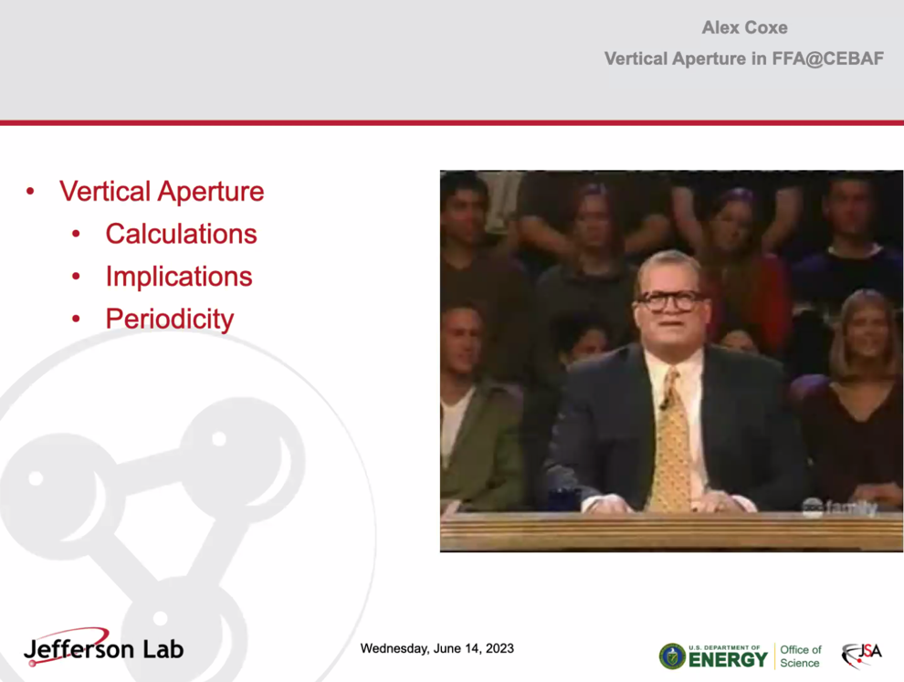
* Alex C – not sure how changing the tune in the splitters will change this, or how much we can correct for tune
* Basically – we need to keep things on or near closed orbit as closely as possible (using correctors, etc…)
  + We want to see if it can be used for the extraction presented by Reza
  + Need to look at momentum spread to be sure
  + Start with 10^-4 momentum spread at the beginning, then get close to 10^-3 roughly
    - Chromaticity per cell can be order of 5-10, then you end up multiplying by ~1000
      * Can get a few radians smeared out
      * Can correct, but worrying
* Dejan – playing with sextupoles helps with chromaticity
  + Decreased tune to avoid 3rd order, chromaticity dropped a lot
  + Can use if needed
* So if we start with roughly 10^-3 momentum spread to see the effects
  + Alex C – can have a look
* Dejan – I think we need to close it before the FFAs.
  + Alex B – if Reza’s idea doesn’t fly, so be it
* Alex Coxe comment – you won’t have results until at least the middle of Feb. It’s out of scope for dissertation and a lot of stuff in between now and then.
* Thomas – Could you catch me up a bit?
  + 10-23 GeV, roughly. 6 passes
  + What’s the constraints? How far apart are the beams when they come in, how much length, etc?
    - Entrance end, beams are roughly evenly spaced by about 3-4 cm. Same-ish spacing at the end of the arc
  + Ryan – maybe we send you some documents?

|  |  |  |
| --- | --- | --- |
| Action Items | Person responsible | Deadline |
|  |  |  |
|  |  |  |

## Time allotted | 25 mins | Agenda topic Splitter-Free Option? | Presenter All

* Lots of new ideas thrown around for splitters
* Andrei was speaking at DESY about trying to optimize the splitters
  + Got suggestion for trying to avoid using the splitters all together by adiabatically transitioning to and from arcs
  + This would take a lot of space
  + Doesn’t NEED to be adiabatic – can you make it sharp?
* For time interactions – can we do this by adding kicks to the orbits in the transitions?
* Vasiliy/Randika trying to do adiabatic – too long. Now the kicks are more localized, but not converging for all 6 passes.
* Stephen – trying to do a splitter constrained into a beam pipe – won’t work.
* Dejan – made a design for LHeC with smooth adiabatic transition. Very large ring (1 km radius). So there’s space for it.
  + The problem is that the ToF must be adjusted for different energies. Did that by making a corrector setup that would introduce oscillations in the arcs such that the total path was equal for each energy.
  + Problem with M56 – that remains. Can be corrected in arcs. Make the cells (maybe 3) such that the total M56 is isochronous in a sense. Correct it through the arcs so that dispersion is 0 for every energy.
* Stephen – ToF is usually the hardest to correct. Usually bad to do in the arcs b/c makes growth in chromaticity
* Dejan – reduce chromaticity with sextupoles
* Alex C – very small vertical perturbations of any beam makes a wild variation of dispersion.
* Huge number of cells to correct dispersion – likely too many cells for us
* Vasiliy – conceptually, this is all possible. Haven’t applied to ToF correction yet. We have a large number of identical FODO cells in arcs. A systematic way to excite the orbit of a particular energy is to program a harmonic into the correctors.
  + Each FODO cell has a kicker. Excite the orbit, increase the length, then damp it down
  + Stephen was using a matrix of correctors to create the path length difference
  + Vasiliy superimposes a separate set of harmonic for 11 passes and it works
* Vasiliy – there’s clearly an aperture limit. No intuition on how much you can change the ToF
  + Would be an interesting study
* Stephen – need a lot of wiggle to flatten ToF. When checked before, increases the maximum magnetic field by a lot
  + Also need to look at momentum spread. Need D and D’ to be zero
    - Dejan – can solve that with 3 cells
* Ryan – right now the phase difference is roughly 150+ degrees between the highest and lowest passes in the arc.
  + If we can reduce that, it might be easier to correct outside of the arc
* Dejan – for 6 cm path length difference
* Ryan – for Thomas – our fundamental frequency is 1497, so about 20 cm wavelength for RF
  + Alex B – and we need to correct cm of M56
* From Donish:
  + 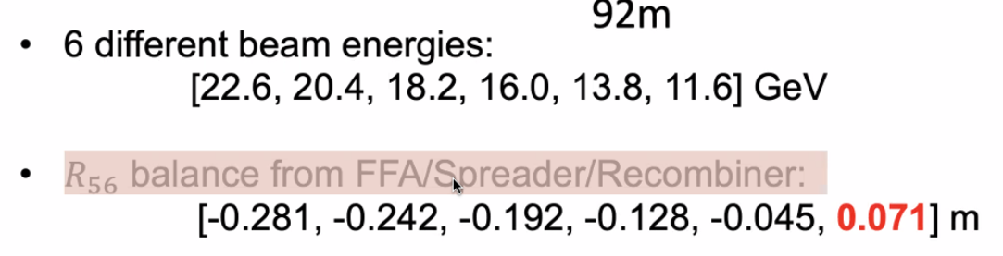
  + Numbers from Ryan’s Tech Note
* Discussion on how to catch Thomas up, and his availability.

|  |  |  |
| --- | --- | --- |
| Action Items | Person responsible | Deadline |
|  |  |  |
|  |  |  |

## Time allotted | 5 mins | Agenda topic AOB| Presenter All

* Dejan looked changing tunes with sextupoles. Readjusted the gradients of the magnets. Looks good
* Looking at SR now
* Alex C spoke with a group of people – including Tief, Kirsten, about averaging BPM measurements
  + Might be good for an orbit lock setup

|  |  |  |
| --- | --- | --- |
| Action Items | Person responsible | Deadline |
|  |  |  |
|  |  |  |

## Special notes

Pathway to Repository: <https://jeffersonlab-my.sharepoint.com/:f:/g/personal/tristan_jlab_org/EqZ5MeS-nipCgPfZB5p0oS4B9Is67d3nQb9sLJI3Zyev9g>