FFA@CEBAF Working Group|Minutes

## Meeting date | time 01/05/2024 | 11 AM EST | Meeting location <https://jlab-org.zoomgov.com/j/1614898082?pwd=TnUzMS81M2sxbDZIbERJU01tYkJCQT09>

|  |  |  |  |  |  |  |  |  |  |  |  |
| --- | --- | --- | --- | --- | --- | --- | --- | --- | --- | --- | --- |
| |  |  | | --- | --- | | Meeting called by | Alex B | | Type of meeting | Weekly Meeting | | Facilitator | Alex B | | Note taker | Ryan | | Timekeeper | Alex B | | Attendees  Alex B, Ryan, Scott, Dejan, Edy, Kirsten, Alex C, Todd, Vasiliy, Donish, Stephen, Randika, Reza, Tristan, Andrei |

# Intro Discussion

* Everyone has been sick (COVID and not)

# Agenda topics

## Time allotted | 10 mins | Agenda topic 5-Pass Emittance Dil.| Presenter Kirsten

* Looking at 5 pass option and 20 GeV
  + Andrei wants to look at 5-pass 22 GeV too – by improving our LINAC gradients
    - Staged approach. So 20 GeV first, then 22 GeV
    - Physics has been working hard to put together the 22 GeV program
      * Not a big difference between 20 or 22 GeV for physics
* Scott – need flexibility in FFA line to handle that. Doable, but we have a small range
  + Be cautious about future upgrades (cryomodules, etc…)
    - Concerns about high-Q, we don’t have a lot of experience
      * Get degradation over time – not clear what extent you can renew them
  + Dejan – we were thinking about this. Stephen added sextupole into lattice, so we can play with this a bit. Allows larger energy range
    - What about peak fields in magnets? Not studied yet
  + Ryan – but we’re also talking about degradation – so the low end will matter, and *HEADROOM*
* Dejan – can improve on machine flexibility and keep max magnet fields low
  + Also looking at 3-cell FFA design to make the FFA arcs isochronus
* Alex B – for now, stay at 1.1 per linac, but later maybe get to 1.2 per linac
* Kirsten – no tracking, only radiation intervals
  + What is the baseline?
  + 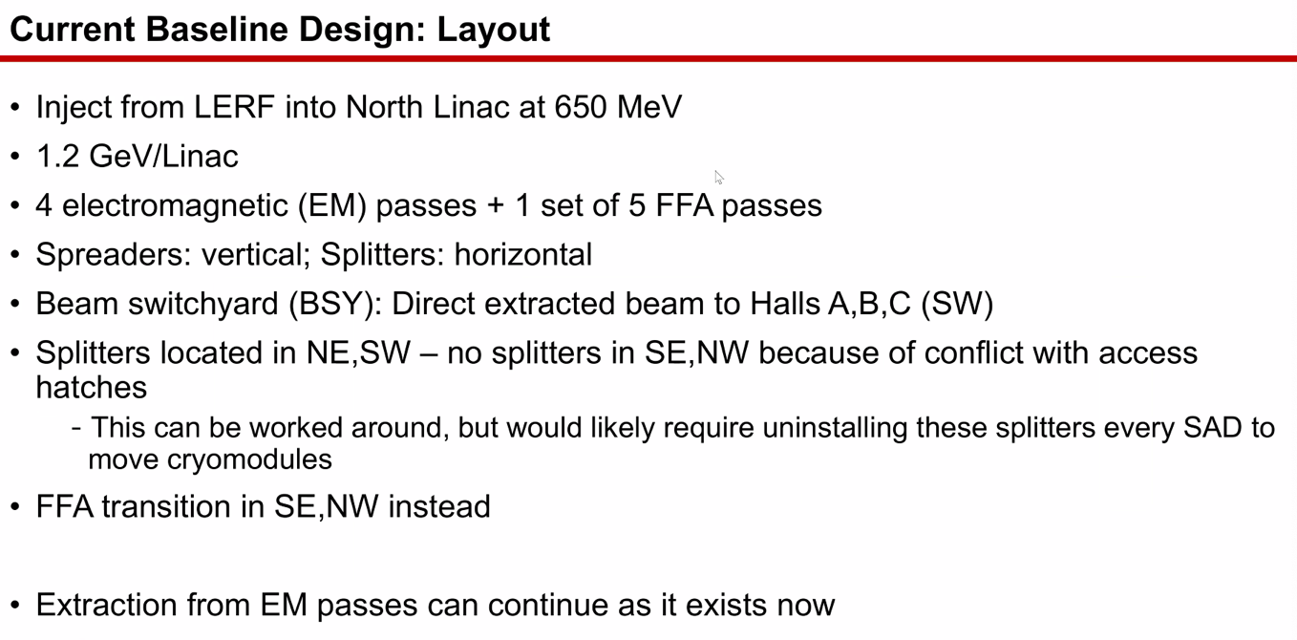
* 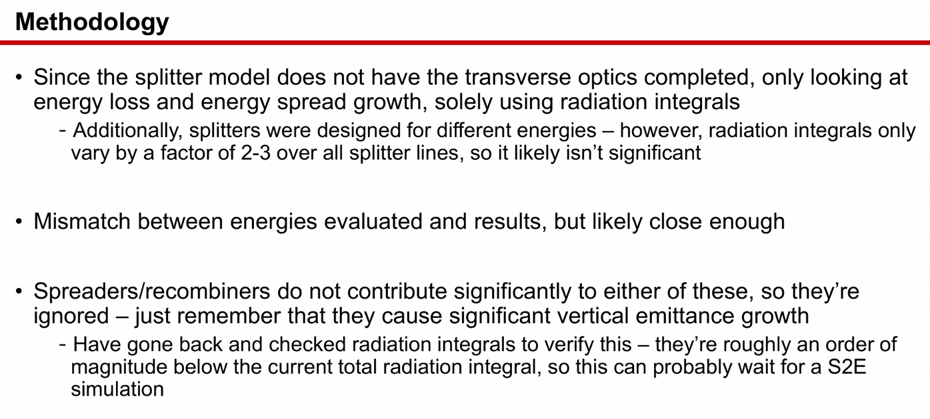
  + Only small changes in splitters anyway – but only doing right order of mag.
  + Ryan – and changing to 5 passes (and energy) would change the geometry
    - Stephen – but probably pessimistic anyway
* Kirsten – FFA arcs are the biggest driver
* Spreaders/Recombiners – skipped for now. Very low contribution
  + Will need to be recombined anyway
* 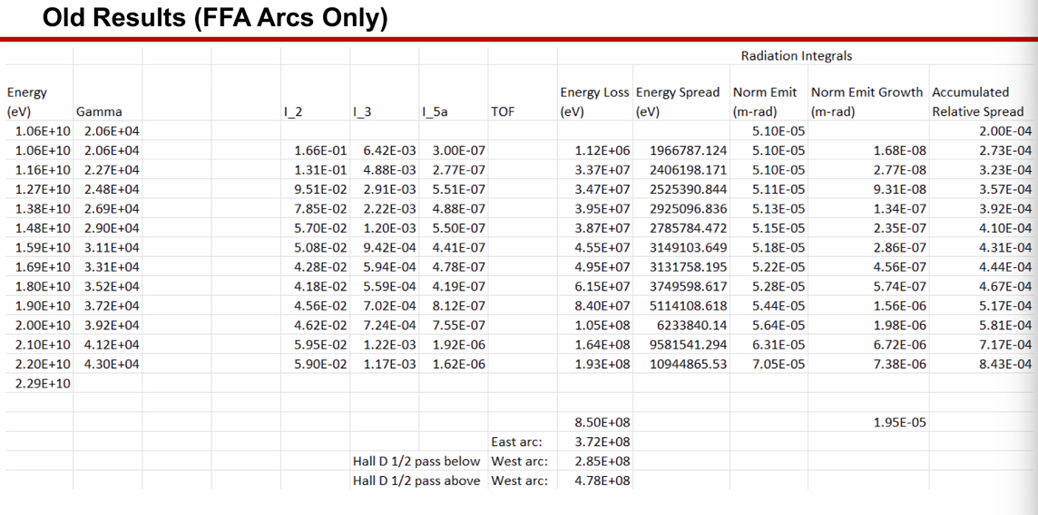
  + 1.1 GeV/linac 6 pass above
  + Lose about 850 MeV over entire course
* 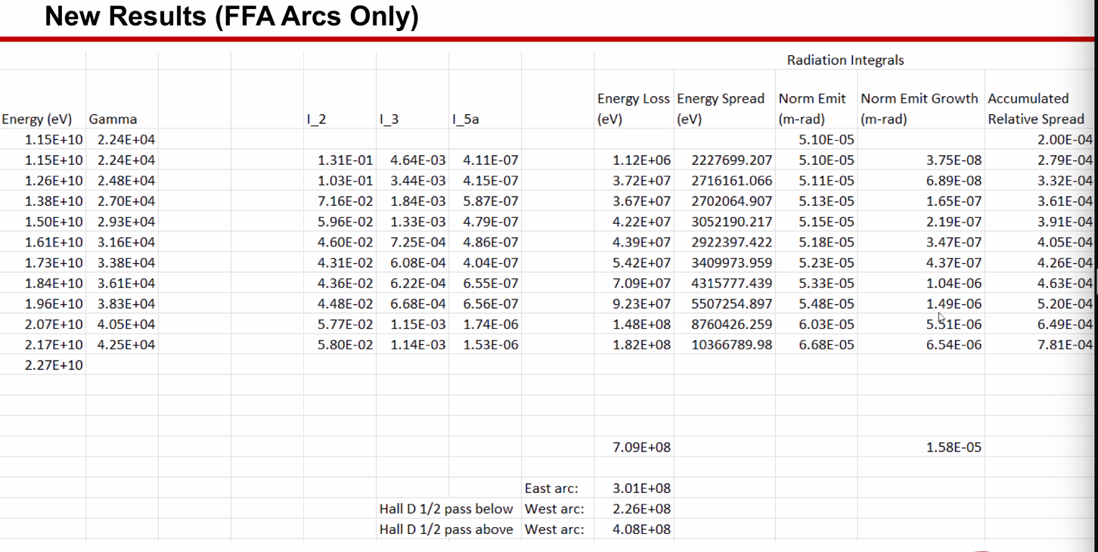
  + Slight improvement, but “in the noise”
  + Most things are about the same. You’ve cut off the bottom energy, so the worst parts aren’t’ changed
* To the halls (A/B/C) – old was 22, new is 21.7 GeV.
  + Slight decrease
* 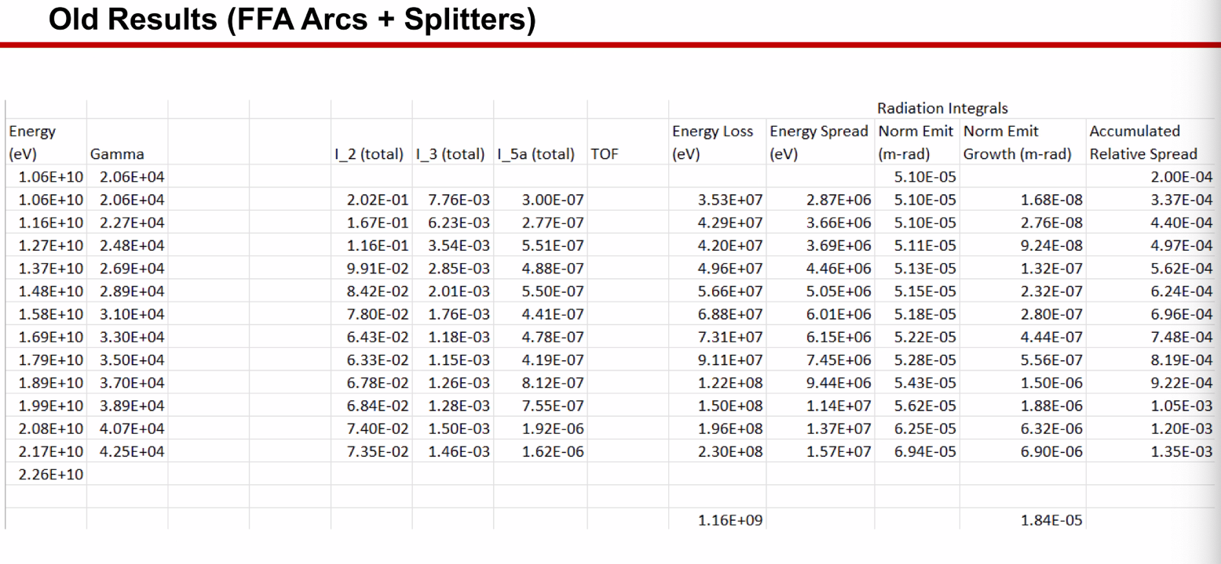
  + Adding in the splitters, you lose more
  + This is the 1.1 GeV, 6 pass still
  + Top to A/B/C is 21.7 GeV, still have 1.3e-3 relative energy spread
  + Emittance improved b/c lost energy
* 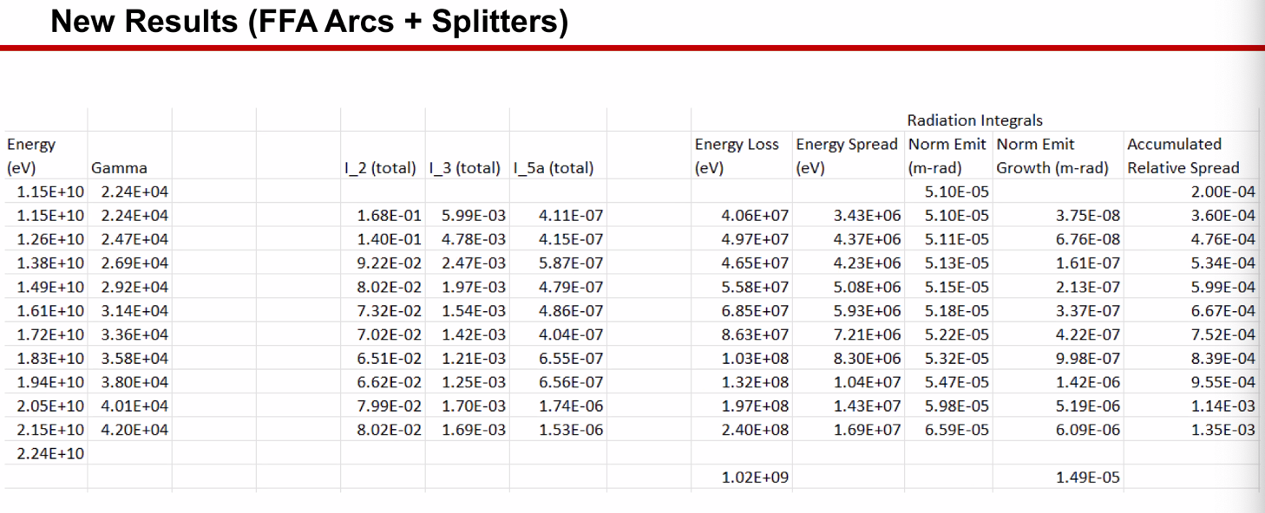
  + Drop to 21.5 GeV in A/B/C
  + Still similar
  + Again, you’re taking out the lowest E, so there’s not a lot of change
* 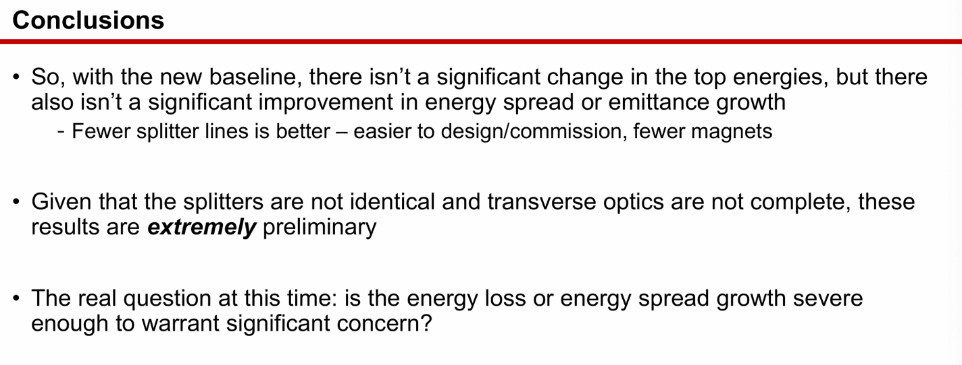
  + Remember – it’s very preliminary
* Alex B on slide 8: looking at cutting at pass 5 with 1.1 GeV: get 19.9 GeV with 1e-3 relative energy spread
* Discussion on spreadsheet – usage.
* So 1.1 GeV, 5 pass into the halls A/B/C, emittance would be 56 mm-mrad
* At 1.2 GeV, 5 pass, we’d get 69 mm-mrad into A/B/C
* Different story if you “chop off” the top passes. Those are the troublesome passes
* Reza – is this all sourced from SR? Doesn’t show up on first few passes?
  + Yes
  + Scales with gamma^4
* Alex B – we’re in a transition of baseline definition. Still comparing 6 pass and 5 pass FFA options.
  + Likely doing a 5-pass FFA and staging from 1.1 to 1.2 GeV/linac
* Reza – when designing current injector for lower energy, we had to worry about bunch length and contribution of that to the final energy spread. Since this is mostly dominated by the Synch Light, for higher passes, I wouldn’t have to worry as much about the bunch length as long as it gets through.
  + Will the experiments still want lower E passes? And if so, do they have requirements on dp/p?
    - Alex B – we usually do it in the injector with non-isochronous optics in chicane
      * But this is limited.
      * Good question – will address with users.
      * For this upgrade, the higher passes would be favored by users.
* Dejan – no matter what lattice we pick, we’re always confronted with SR. It’s unavoidable.
  + Alex B – but at least the curly-H is ~50X smaller than conventional arcs
  + Dejan – but gamma^4 will always be there
* Packing fraction needs to have attention paid to it

|  |  |  |
| --- | --- | --- |
| Action Items | Person responsible | Deadline |
|  |  |  |
|  |  |  |

## Time allotted | 25 mins | Agenda topic Transition Lattice | Presenter Vasiliy

* Not much to share – only documented what he’s done
* Mostly writing up Vasiliy’s LDRD results
* Good way to proceed would be for Randy/Vasiliy to come up with small steps to implement at CEBAF – no chance to really discuss yet
* Randika – tried, but can’t do 6 passes. Keep resonating 2 energies at once. Changed frequencies, no better
  + Can do 5 passes, but not 6
* Alex B – old one was ~10 m long. What’s the scale for this now?
  + Vasiliy’s would go into the arc
  + Randika got close to 90 m for 5 passes
* Vasiliy – in principle, have half of the arc available.
  + If the section is shorter, then you need stronger kicks, and you might get several overlapping kicks
  + But if it’s too narrow, you want to cover beta frequency spread
* Alex C – logistical question: what kind of accuracy do you need the beams to have entering the transition from the FFA arc?
  + Vasiliy – ideally we should be able to tune to anything
    - Care about the tune of the energy, not the energy itself, then we tweak the orbit itself
    - Got orbits exact, but dispersion not right
    - 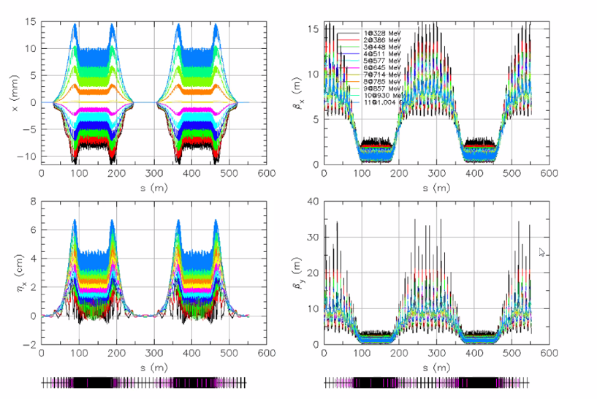
* Dejan – with a small number of magnets, you can match the orbits, then take care of betas downstream. Example for +/- 30 percent dp/p.
  + Think it can be done analytically
  + 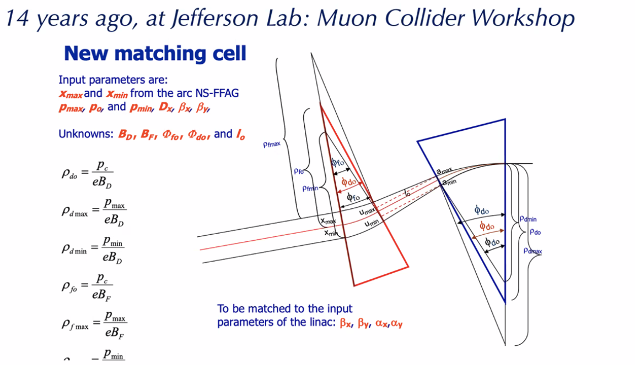
  + 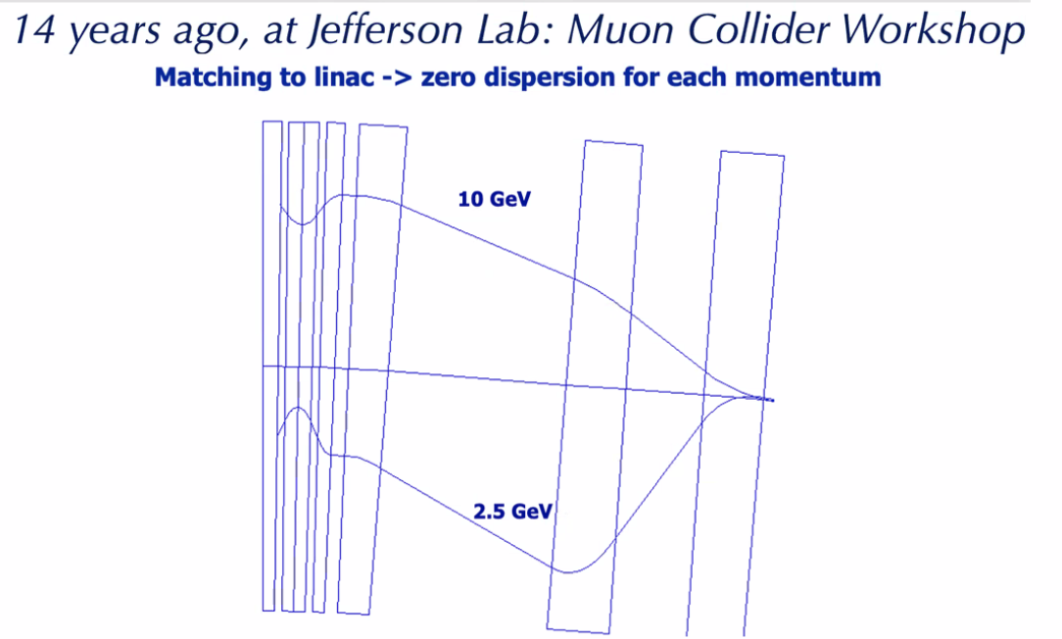
  + So merge shortly, then deal with betas
* Vasiliy – this is what we started with. Solved analytically. We were able to bring the orbits together quickly, but never the betas. There was no space for beta matching
* Ryan – this may have been attempted with the weakly focusing linac optics – can’t recall. But with the strong focusing, the betas are smaller.
* 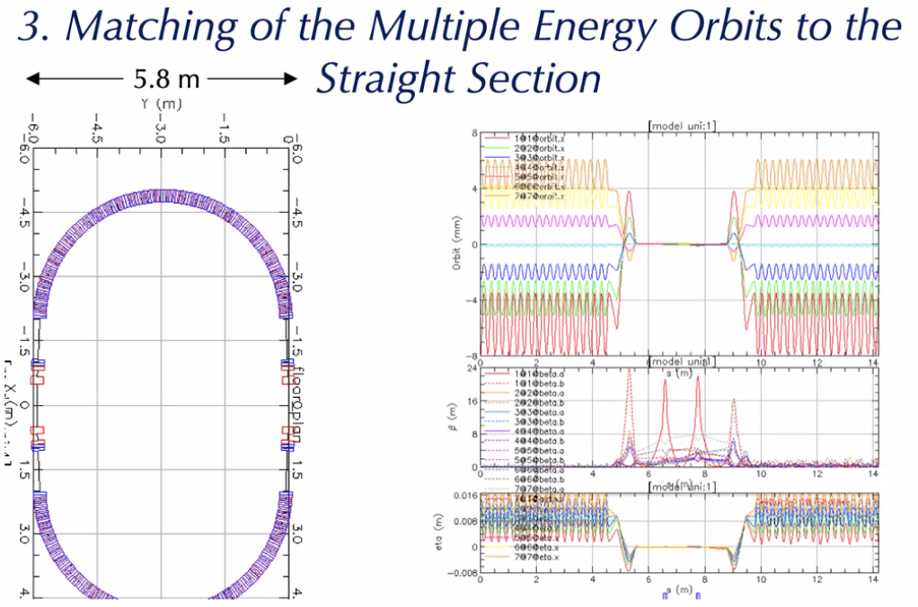
  + Dejan shares this now.
  + Betas went to 24 meters in the middle – if the distance is small, the betas won’t be magnified too much
* Vasiliy:
  + We tried this: 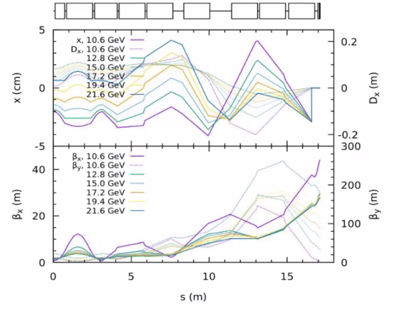
    - Vasiliy – we were trying for the weakly focusing optics solution. It was too hard.
* Dejan asks Scott – is there a way to do the adiabatic approach with 12 instead of 24 cells?
  + You’re facing a very tough issue here – there’s a vast range being covered (especially for betas). Much harder than CBETA – almost ignored betas there b/c it was so easy
  + Issue with adiabatic approaches: trying to make changes that are small in a betatron period Large beta means large period. Trying to fight that fact here
  + Adiabatic transition itself ends up being a very large object.
  + Randy and Vasiliy have done an extraordinary job trying, but they’re fighting this.
  + Might need to be in between – not quite adiabatic
* Dejan – let’s suppose that the phases in the FFA cells are not changing much by adding sextupoles? What would that do WRT matching? Keeping gradients, just reduce bending to merge the orbits into a single one
  + Scott: Fine as long as the betas are down.
    - The trouble is on the LINAC end, not the FFA end.
* Multipass linac discussion
* 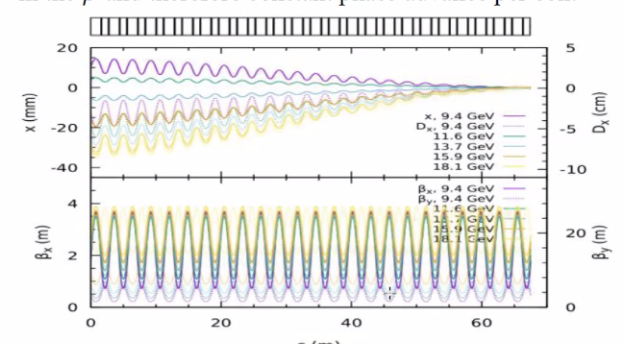’
  + Do adiabatic matching for orbits, then apply the parametric resonant excitation?

|  |  |  |
| --- | --- | --- |
| Action Items | Person responsible | Deadline |
|  |  |  |
|  |  |  |

## Special notes

Pathway to Repository: <https://jeffersonlab-my.sharepoint.com/:f:/g/personal/tristan_jlab_org/EqZ5MeS-nipCgPfZB5p0oS4B9Is67d3nQb9sLJI3Zyev9g>