FFA@CEBAF Working Group|Minutes

## Meeting date | time 01/05/2024 | 11 AM EST | Meeting location <https://jlab-org.zoomgov.com/j/1614898082?pwd=TnUzMS81M2sxbDZIbERJU01tYkJCQT09>

|  |  |  |  |  |  |  |  |  |  |  |  |
| --- | --- | --- | --- | --- | --- | --- | --- | --- | --- | --- | --- |
| |  |  | | --- | --- | | Meeting called by | Alex B | | Type of meeting | Weekly Meeting | | Facilitator | Alex B | | Note taker | Ryan | | Timekeeper | Alex B | | Attendees  Alex B, Ryan, Alex C, Kirsten, Edy, Roger, Dejan, Donish, Stephen, Andrei, Randika, Vasiliy, Scott |

# Intro Discussion

* Discussion over Kirsten’s lectures
* Alex B will teach USPAS in the summer
* Steve Benson retirement lunch – so let’s keep the meeting quick

# Agenda topics

## Time allotted | 25 mins | Agenda topic FFA Arc Correction/Energy| Presenter Alex C

* This is an update – uncorrected tolerances in horizontal and vertical plus energy acceptance
* 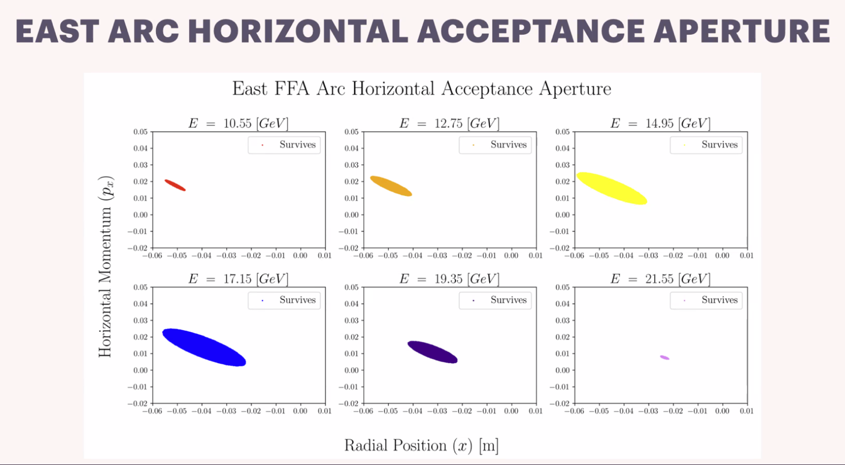
  + Smaller apertures when beam closer to walls
  + East Arc pictured here. WA is odd.
* 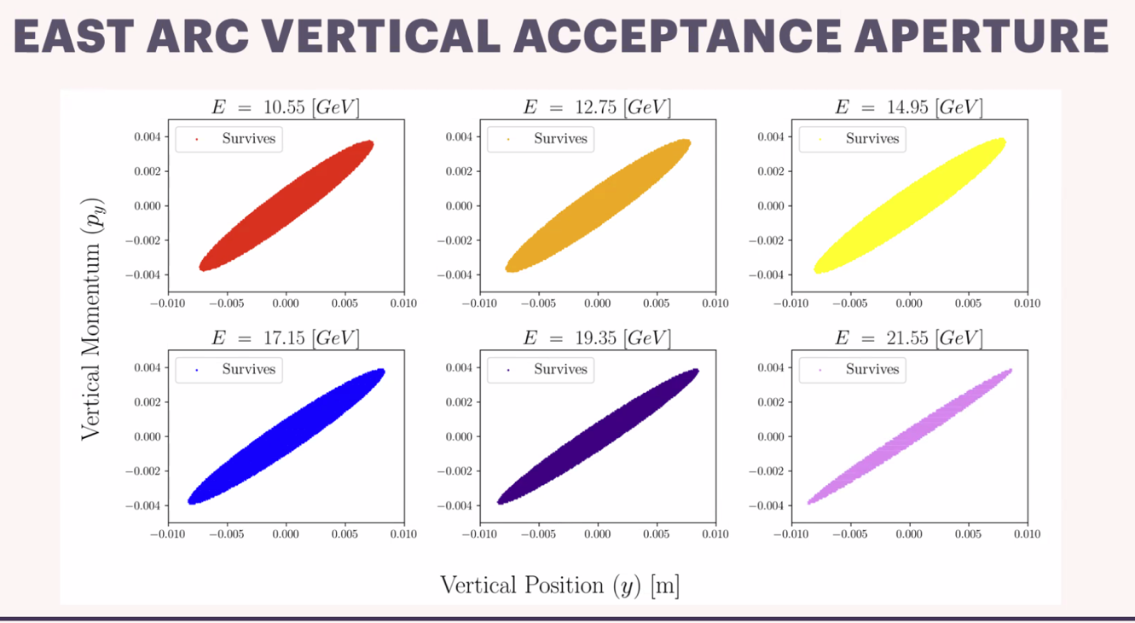
* 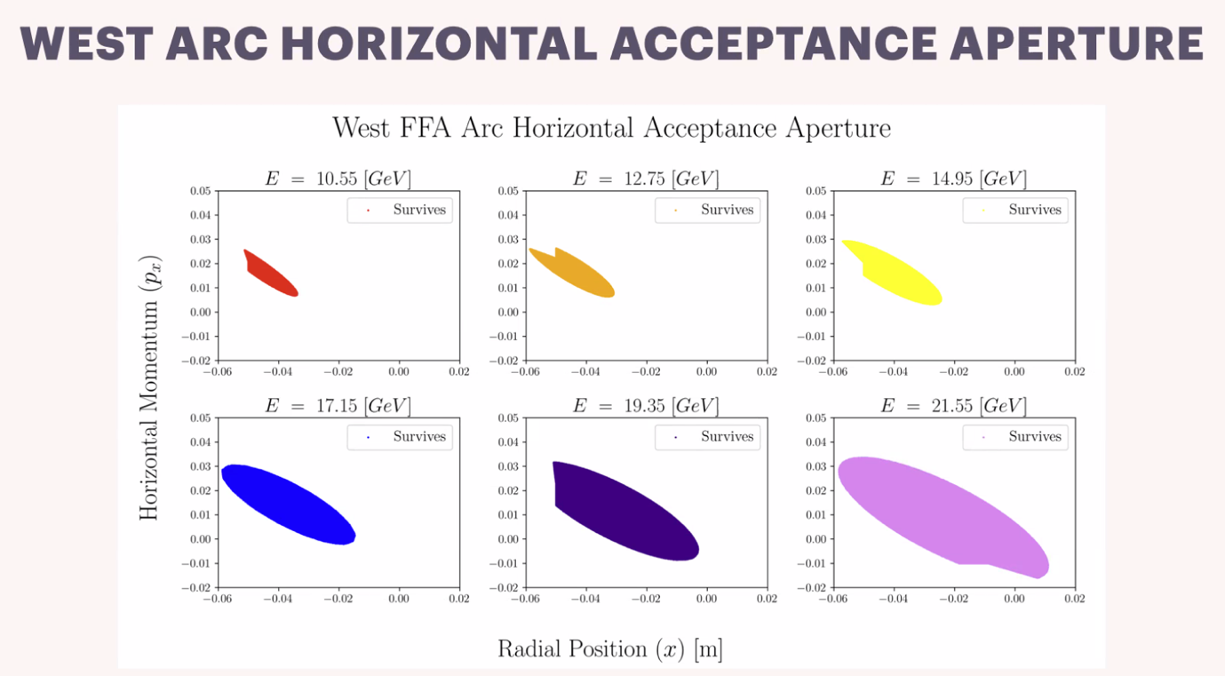
  + Weird chunks taken out. Not sure why, can’t find bug
  + Alex B – remove/enlarge apertures and run
    - Alex C – systematically start a particle at a position and see if it gets to the end. These are high-res scatterplots
  + Kirsten – you’ve been holding betas/alphas constant when doing sampling?
    - I think so, but need to check
    - Kirsten – find it very weird that it’s only in one arc
    - Want to see if there’s a closed-form solution
  + Stephen – made of points? (yes) Vertical axis is momentum
    - Canonical units (Bmad) – please write them next time or use x’
    - Px/Pz?
    - But only single reference energy for all passes
    - Maybe x vs x’ in the future
  + Stephen – how do you know what particles are lost?
    - If it hits physical aperture (rectangular)
    - Odd to get slice that shape out
  + Radiation on
  + Kirsten would track the particles you lose
  + Alex C also not sure why it’s happening!
* Dejan – compare the two files
  + Alex C – I’ve been doing that
* 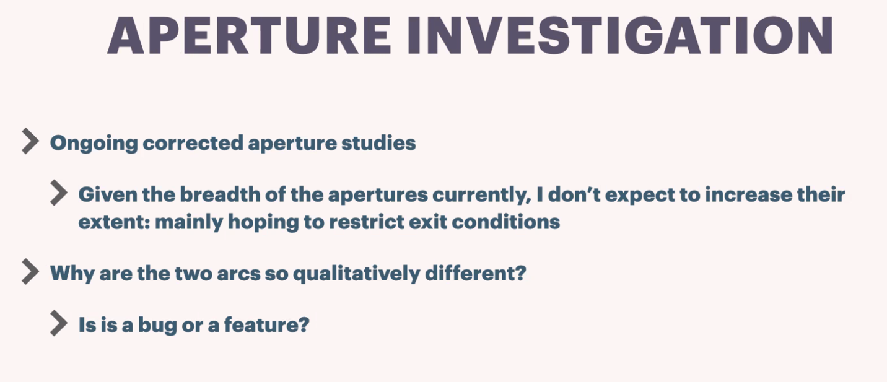
  + Odd python problem, can’t remove certain points
* Roger – looks like there’s a difference between E and W arc. Does this imply that more particles are filtered out b/c they won’t pass both arcs?
  + Alex C – not sure the code in the W Arc is correct b/c of the notches. But it seems yes
* Stephen – why is 21.55 so tiny?
  + Not sure, but it implies it’s right near an aperture
  + Does surprise me that the aperture for 6th pass is smaller than 1st pass.
* Likely a bug, not a feature
* 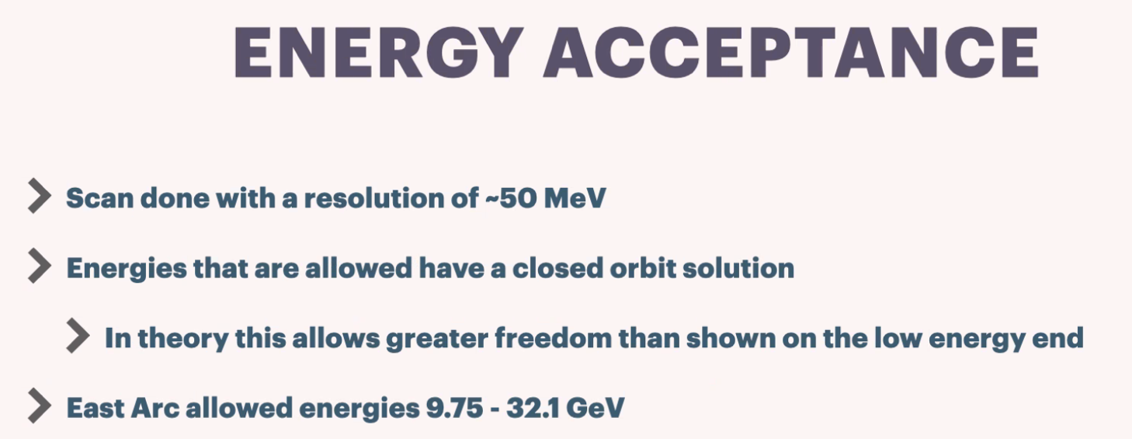
  + Just looked for closed orbit solutions for a variety of energies. Adjusted optics as needed to get closed orbit solution.
  + Everything in this range has a closed orbit solution
    - Some of the very high-energy orbits are very close to the edge, lower E has wild optics
* 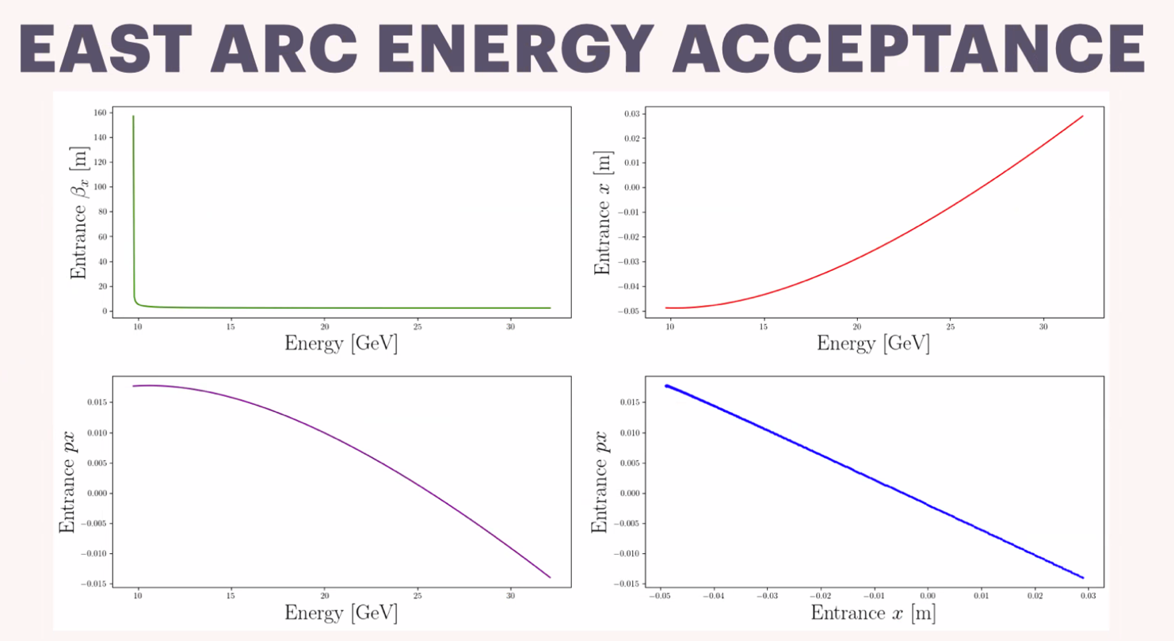
  + If cut off higher E, aperture would look more elliptical and less linear
  + Stephen – useful to plot is maximum magnetic field experienced by these at each energy.
    - Practicality check – maybe some of these magnets are 6 T for example
    - Using the magnets outside the “good field” region gives you very different magnet strengths
* 
* 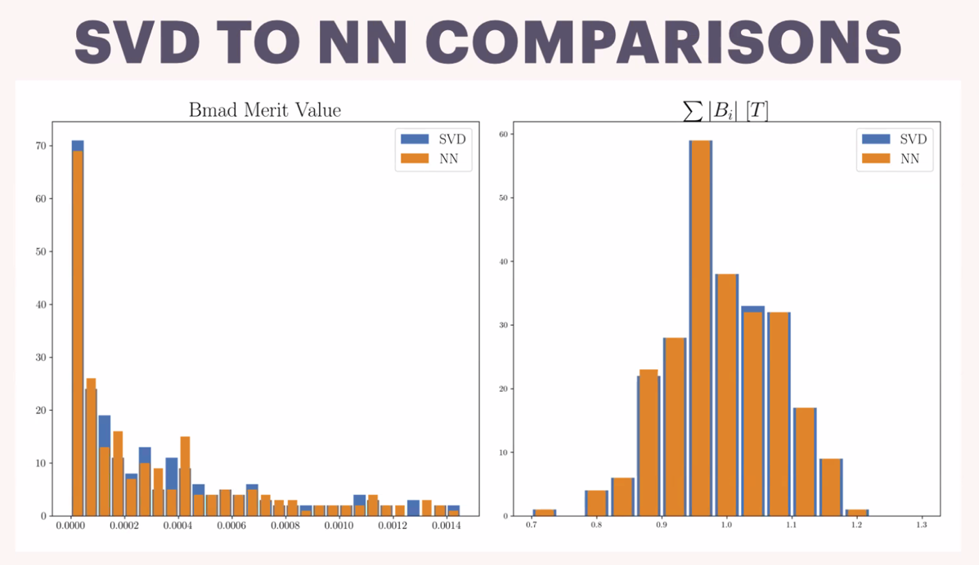
  + Merit function histograms
* 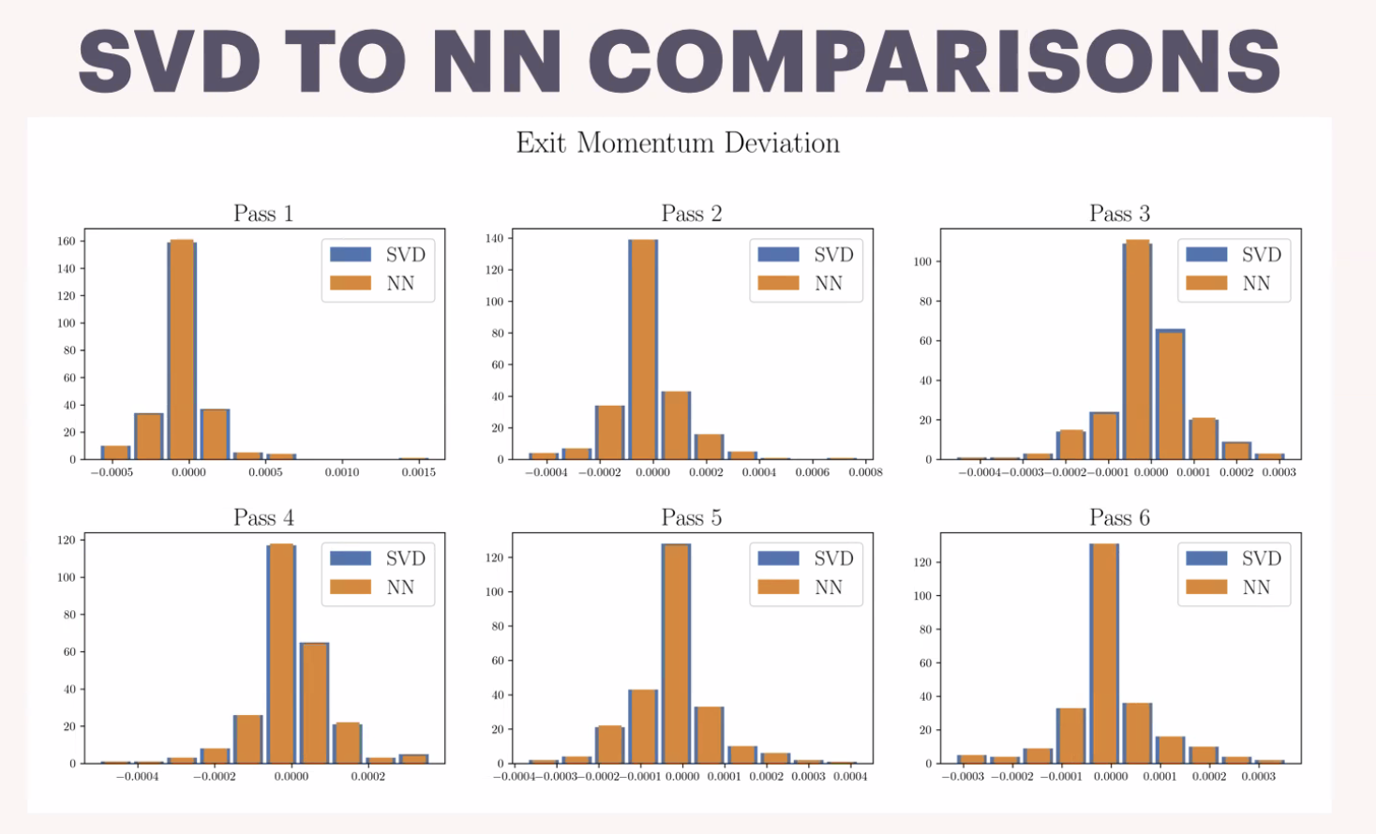
* 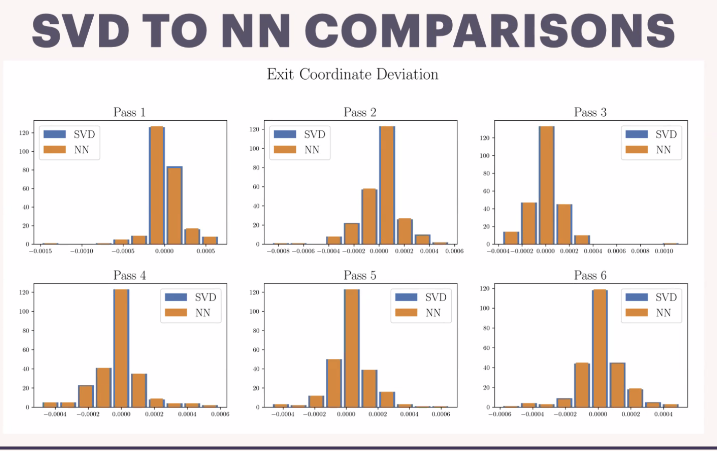
* NN do as well as SVD, but faster
* 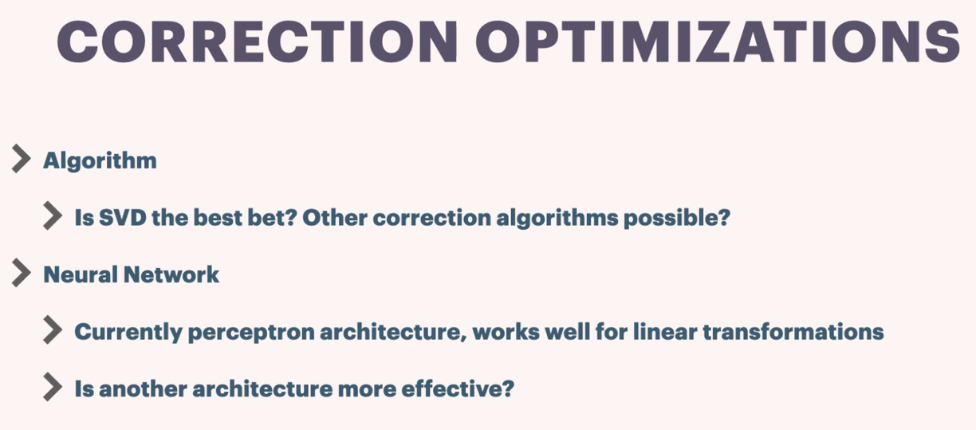
* Roger question: when going through arcs and magnetic fields, how does this affect the spin polarization?
  + Alex C hasn’t looked into it. Has a start of a code
  + Expect it doesn’t impact it too much, but not sure
* Roger – energy tunability from LINACs – need to have enough margin in both linacs so we can lose some cavities/gradients
  + This needs to be clear and have a reachable goals
  + Alex B – want to make sure they’re governed by the arcs and operations
* Roger – what about the physics to be done? Recall at CLIC, we targeted the energy to produce Higgs. Realized physicist also wanted to make top quarks, etc… but we hadn’t talked about tuning the energy. Do we want one energy, or tunable?
  + Alex B – we’ll have the capability to extracting at different energies to the arcs
    - Know that the physics agenda is not related to any resonances.
    - Starting at 20 GeV and ramping up was well-received.
  + Dejan – the non-scaling FFAs are accepting every energy between 9 and 20 GeV. If you lose some energy in the LINAC, it’ll still get through
  + Scott – but we need to have margin on the bottom!
  + Alex B – if we keep 6 passes in the current design, our energies are at the edges.
* Dejan – Stephen has been working on new magnets and designs for expanding the energy range.

|  |  |  |
| --- | --- | --- |
| Action Items | Person responsible | Deadline |
|  |  |  |
|  |  |  |

## Time allotted | 25 mins | Agenda topic Conferences, etc… | Presenter All



|  |  |  |
| --- | --- | --- |
| Action Items | Person responsible | Deadline |
|  |  |  |
|  |  |  |

## Time allotted | 10 mins | Agenda topic AOB | Presenter All

* Stephen’s new magnets and designs.
* 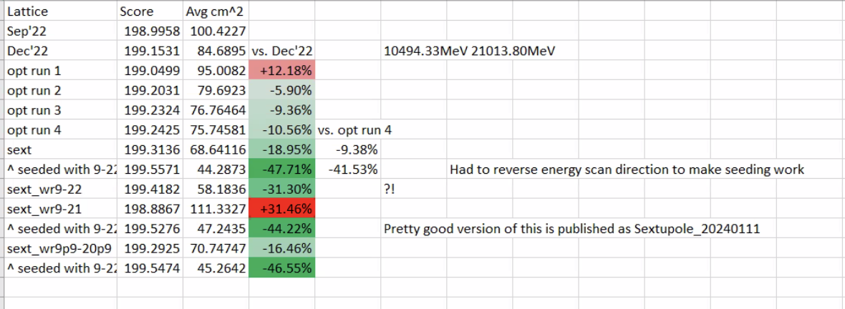
  + Magnet volume is the figure of merit
* Got about 10% improvement with linear optimizations.
* Added sextupole, improved instantly.
* 930 MeV linac can get you into the full range 9-21 GeV
* In shared area – Sextupole folder (green)
  + Readme: warnings – might not be right, but interesting
* Cell tunes:
  + 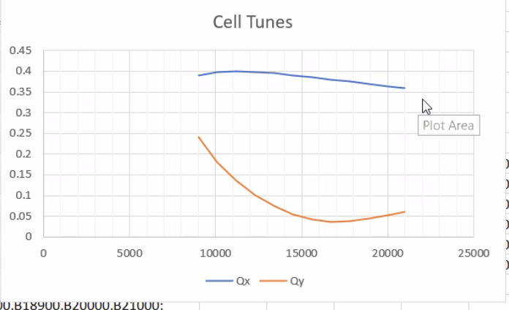
  + 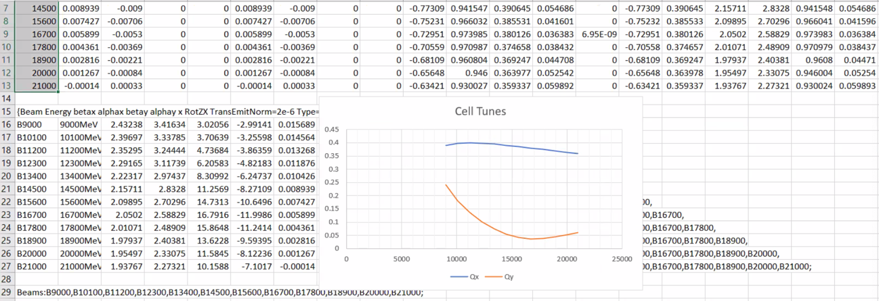
  + Might not want this – tunes for Qx are above 0.3. Correction can be hard. Tunes too close together, makes correction harder
  + Dejan sent another with a larger magnet but better tunes
* 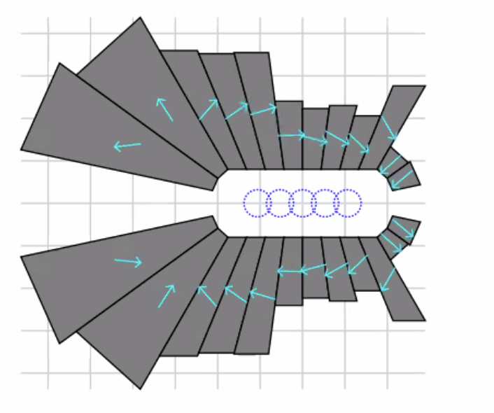
  + About 9 cm (Focusing)
* 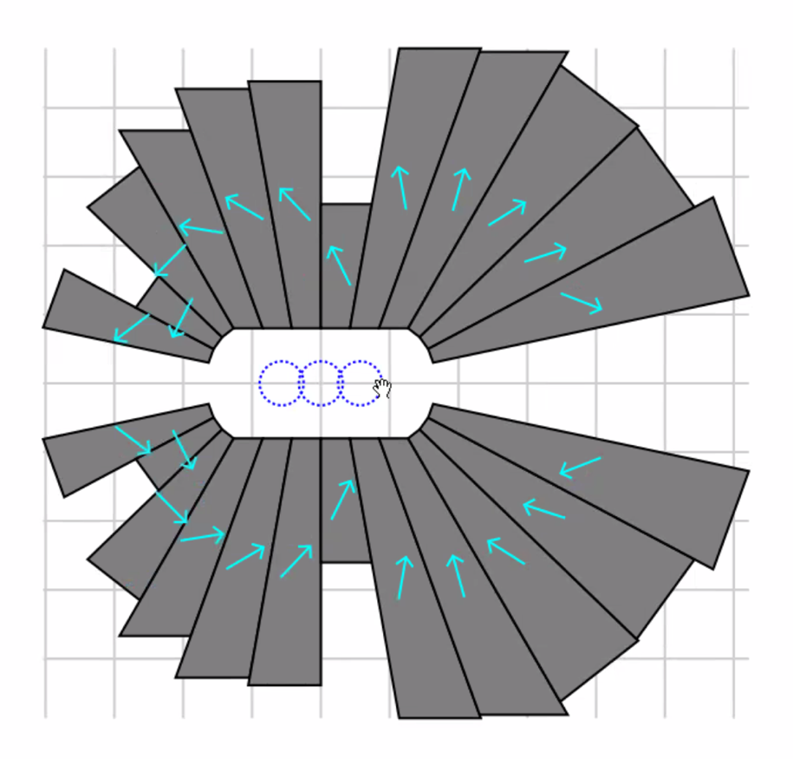
  + BD – smaller aperture
* 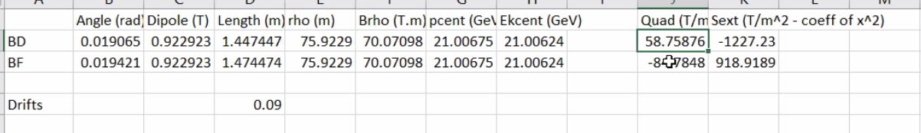
  + Values at central energy
  + 21 GeV usually about a circle
  + Sextupoles are large (maybe too large?)
  + Fun case for Dynamic Aperture like Alex C is doing
* Sextupoles do seem to solve energy range problem
* Alex B – we could compare with what we have now. Alex C is doing this now.
  + Alex C – b/c USPAS is starting soon, won’t be available for a few weeks. Afterwards, need to write up dissertation. Will do what I can.
    - Ryan – can’t expand Alex C’s work scope too much.
* 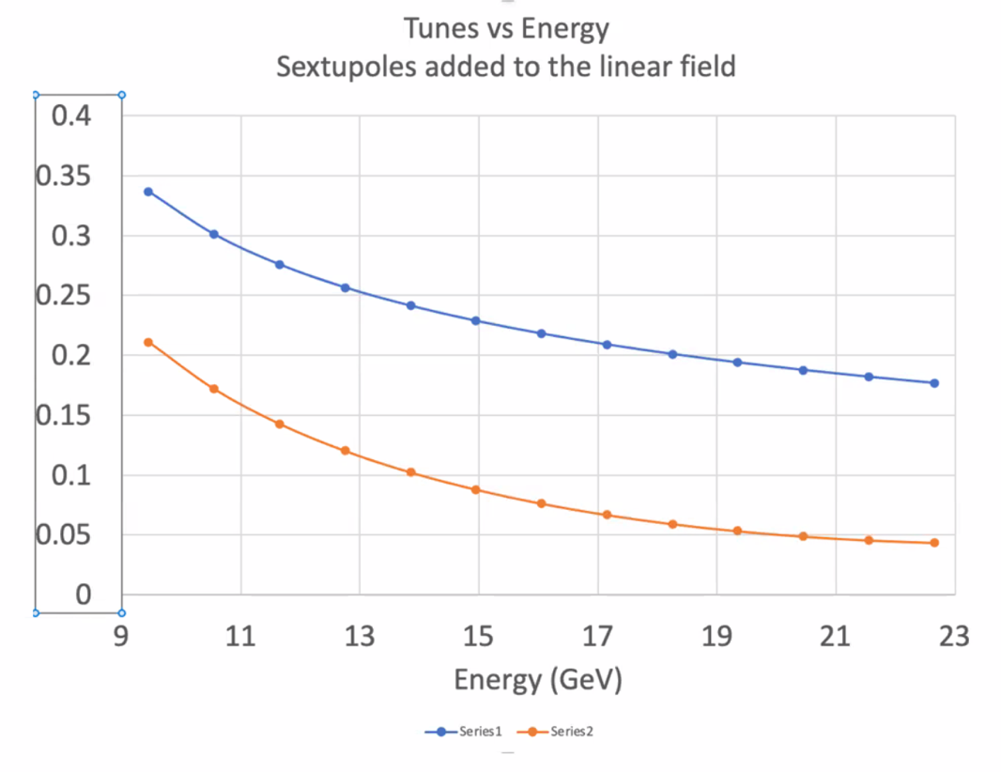
  + Dejan’s plot. These sextupoles are much weaker
  + Replicated in Muon 1
    - Magnets are big, but can be optimized
  + Different plots: pick the one you like
* 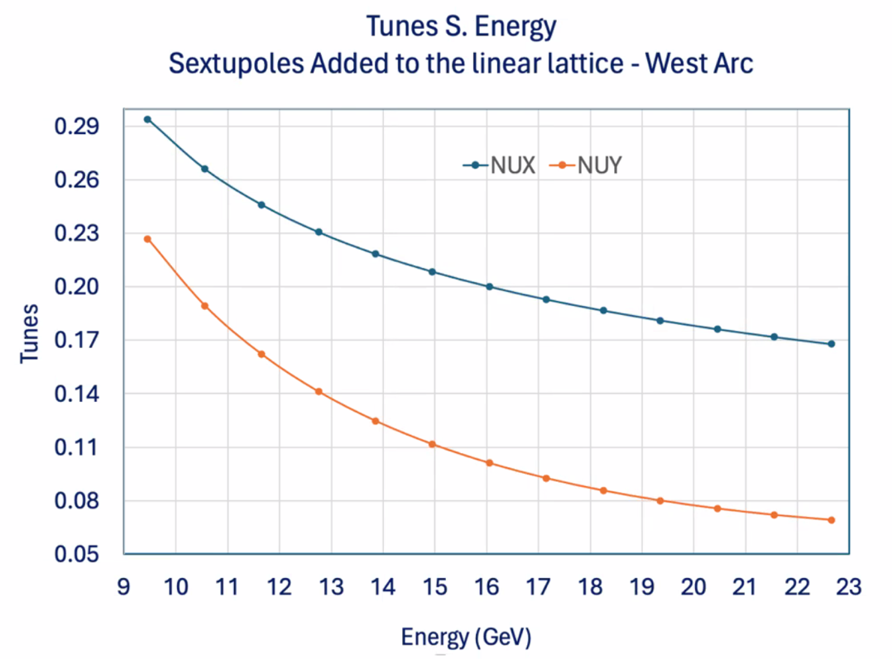
* Shows advantage of some sextupoles with energy range
* This covers a pretty large range, but Stephen needs to optimize
* Stephen, can set rules, had previously had a large range of tunes. Can narrow the range and smaller sextupole upper limit and go from there
* Scott – when we reduce the difference between tunes, how does that impact the correction schemes? Need to study this
  + Dejan – this is important for correction. If they’re smooth like above, it’ll help correct different energies with the same correction system
  + Scott – you’re flattening horizontal tune, so reducing the difference in phase advance between different energies.
    - May find that it’s better to make larger magnets where tune variation goes 0.3 to 0.1 in horizontal. Not sure, needs to be studied
    - Look at quarter as well
* Scott – in EMMA, also had noticeable behavior change in DA across quarter.
  + Stephen – we will hit it for some parts of the energy range.
* Ryan – simple minded question, but this isn’t a ring. We’re only going through half a circle once (or up to 6 times)
  + This isn’t resonant crossing, but DA near a resonance
  + Still systematic resonances, but our period is effectively one cell
  + May have small enough emittance so none of this matters. Might have problems where if you’re unlucky on a resonance, and need to energy tune.
    - If you’re on the wrong side of the 1/3 resonance, you will have no DA.
    - Maybe something on the ¼
    - Pretty sure easily dodged with energy tuning
  + Once you slap sextupoles on, the 1/3 resonance gets really strong! This is why it was previously avoided.
    - Maybe not a real problem, but we might need some flexibility in our head where the pass that’s close to 1/3 and the beam blows up or has losses – maybe tweak energy to dodge it
* Stephen – set 2000 mm-mrad normalized (bigger than CEBAF) – did some tracking.
  + Get phase space distortion on nominal beam
  + Get 25% beam loss with alignment errors
  + 10E-3 energy spread
* Scott – if you see the blowup, try tweaking energy gain and final energy/initial energy and see if you can dodge it.
* 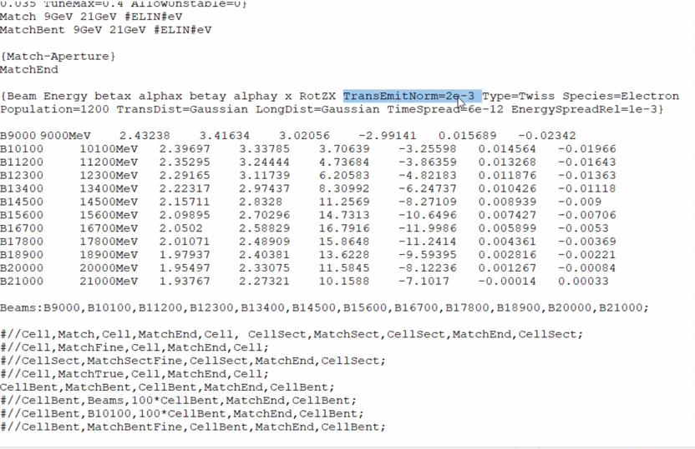
  + Huge beam – just about made it through
  + Very little chromatic stuff
* Alex B – our emittance is usually 10s of mm-mrad
* Scott – what’s our energy spread like when we enter?
  + Alex B – I think ~10E-4
  + Kirsten – assume enters FFA at 10-11 GeV normalized emittance is 50 mm-mrad, energy spread is 2E-4.
    - 15 or 50? Alex says 15, Kirsten says 50.
* At 12 GeV, we deliver nominally 12 mm-mrad normalized emittance to the halls?
  + Only like 20 mm-mrad growth throughout
  + Alex B – we’ll eventually get to 69 mm-mrad after all the FFA passes. But you start with something smaller
* Last spreadsheet started with 10-11 GeV at 50 mm-mrad – trying to figure out why it started there, and why it hasn’t been caught.
* 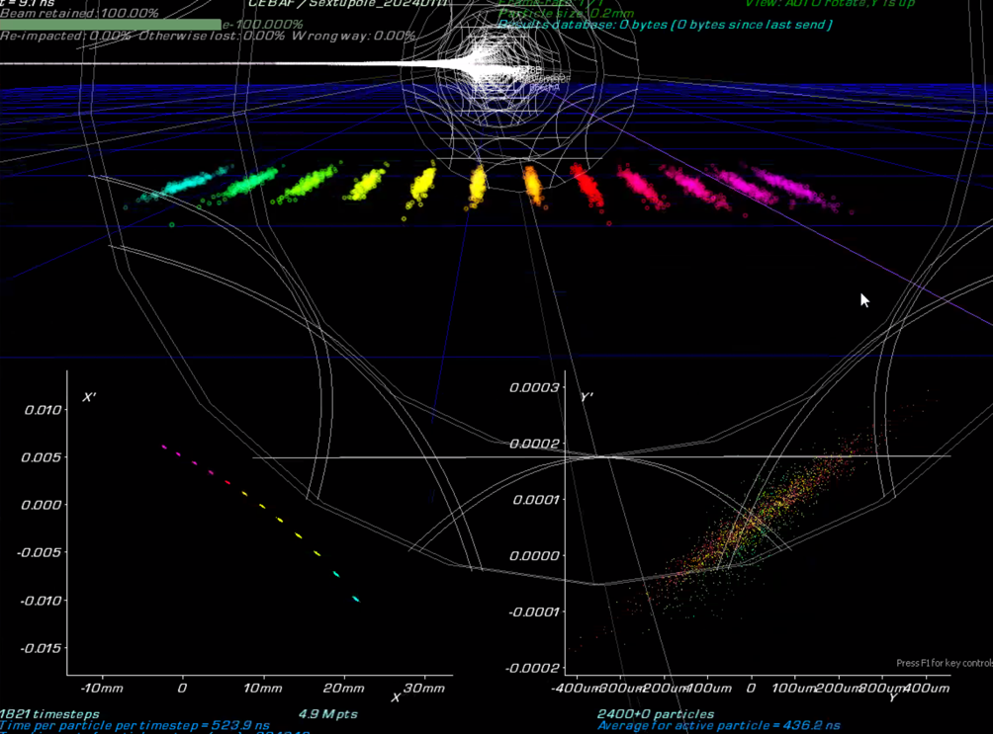
  + Stephen shows simulations running
* 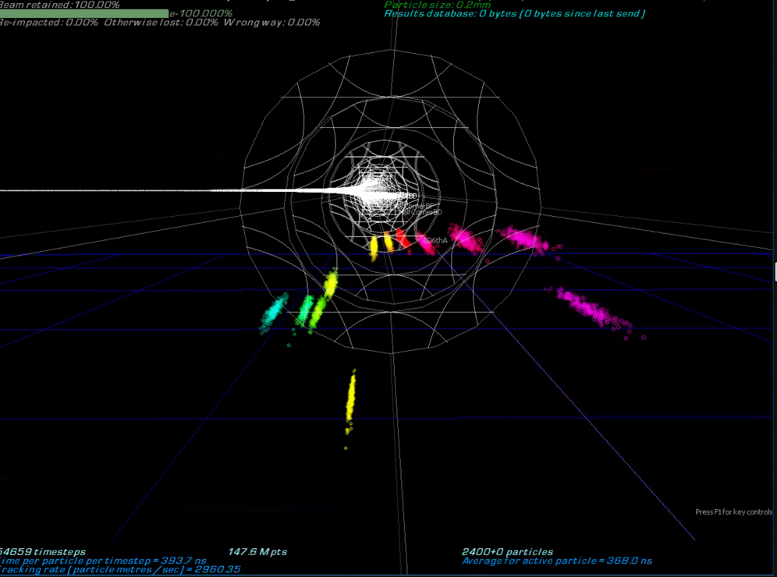

|  |  |  |
| --- | --- | --- |
| Action Items | Person responsible | Deadline |
|  |  |  |
|  |  |  |

## Special notes

Pathway to Repository: <https://jeffersonlab-my.sharepoint.com/:f:/g/personal/tristan_jlab_org/EqZ5MeS-nipCgPfZB5p0oS4B9Is67d3nQb9sLJI3Zyev9g>