FFA@CEBAF Working Group|Minutes

## Meeting date | time 01/26/2024 | 11 AM EST | Meeting location <https://jlab-org.zoomgov.com/j/1614898082?pwd=TnUzMS81M2sxbDZIbERJU01tYkJCQT09>

|  |  |  |  |  |  |  |  |  |  |  |  |
| --- | --- | --- | --- | --- | --- | --- | --- | --- | --- | --- | --- |
| |  |  | | --- | --- | | Meeting called by | Alex B | | Type of meeting | Weekly Meeting | | Facilitator | Alex B | | Note taker | Ryan | | Timekeeper | Alex B | | Attendees  Alex B, Ryan, Kirsten, Scott, Stephen, Edy, Reza, Vasiliy, Donish, Dejan, Tim Michalski, Roger |

# Intro Discussion

* Ryan’s computer woes
* Stonybrook discussions from BNL folks.

# Agenda topics

## Time allotted | 25 mins | Agenda topic JLAAC & FOAs | Presenter Alex B

* 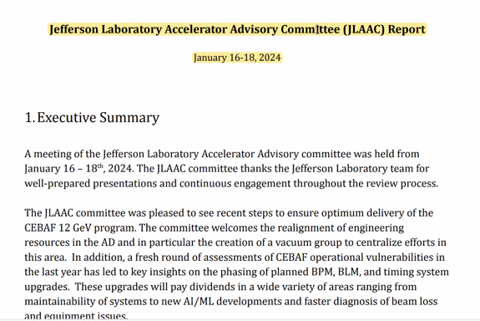
* 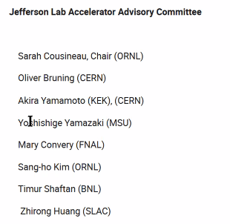
* First day was OPS and technical review
* Second day had FFA, Positrons, etc…
* Last day was closeout
* Preliminary recommendations:
  + 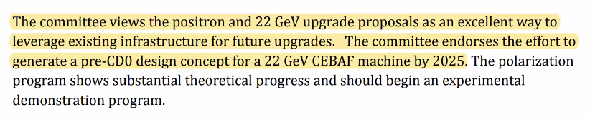
    - Scott: they used nice fuzzy language: “design concept”
    - Positrons are a bit ahead of us
    - Pre-conceptual design report –
    - Scott - CD0 is “mission need” – my reading is “show us something and we’ll decide”
    - Alex B – this is from management. Need to in next 2 years show pre-CDR. Internal
  + 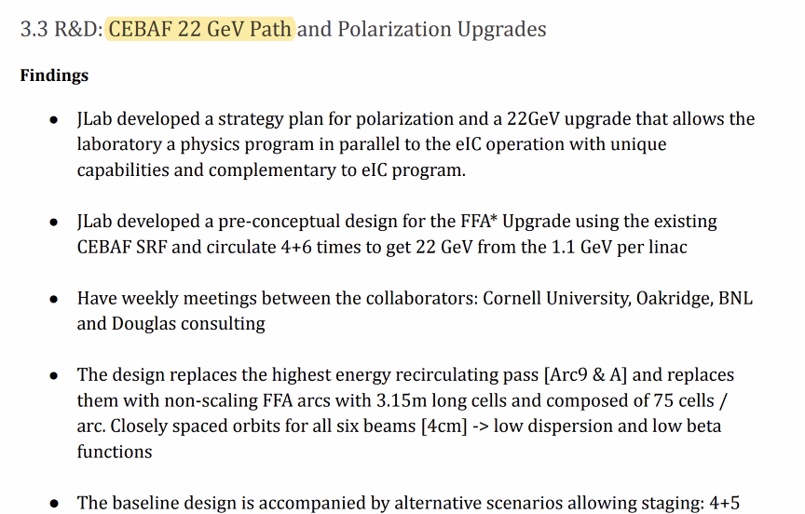
  + 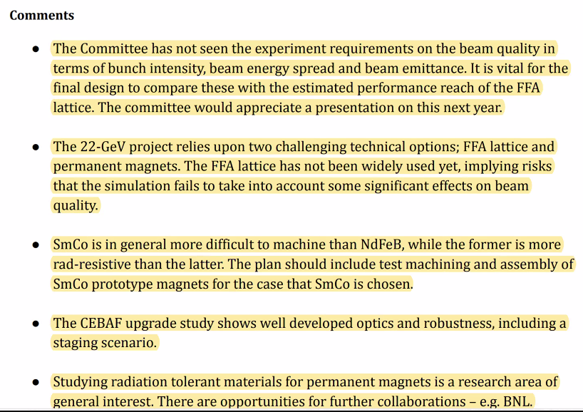
    - Pointed them to the white paper for physics motivation, but they’d like to see requirements
    - Not many accelerators use FFA – do we trust it?
    - Fabrication difficulties with SmCo (after molding, need to machine sometimes to address errors)
    - Timur mentioned using hybrid instead of Hallbach magnets
* Roger – if we have evidence that backs up what we’re saying, it’s very simple for us to write down the lines and point them to publications.
  + Working 20+ years on detectors. Every time something goes in it must work for 30+ years. We have to prove that it’ll work. That’s the question.
  + Can see this as an advantage – we can make a prototype and test. Ask for funding to show it. If we think it’s not necessary, simply mention it’s not necessary b/c it’s been done.
* Dejan – annoyed that we have to keep rehashing old complaints.
  + Guy wants to build the lightsource upgrade. He doesn’t understand the structure that he’s built IS AN FFA!
  + Alex B – he basically showed a multibend achromat
* Stephen – Timur is making a Halbach for an LDRD out of SmCo
* Scott – modern MBA isn’t that different from an FFA
  + Basic idea, tight focusing structure. We take advantage to get large energy spread
* Stephen – no one has noticed that point 1 (above) is a bit of a trap. This could be oversimplified. Do not set higher requirements and fail. Get the minimum requirements to get meaningful physics. But you want the requirements to be delivered, not “wish list”
* Important in FOA to show future for nuclear physics
* 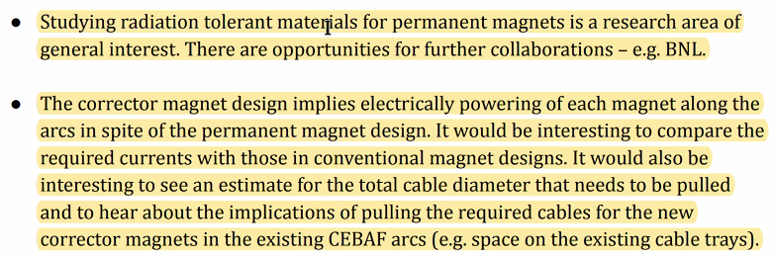
* May invite Timur here to discuss
* Ryan invited up to see their work
* Bit of a history lesson at BNL
* Stephen may introduce Ryan to the magnet people here doing similar studies to the LDRD
* Interesting question about powering the Panofsky magnets.
  + Scott – always have very impressive cable trays at these places
  + When Jay designed the magnets – uses the same trim cards as the current correctors. Have to cable and replicate them
  + Scott – there will be a significant cable tray needed
* Stephen – put motors on magnets to correct as well
  + Ryan – those can get big
  + Scott and Stephen – they can be smaller (like at EMMA)
* 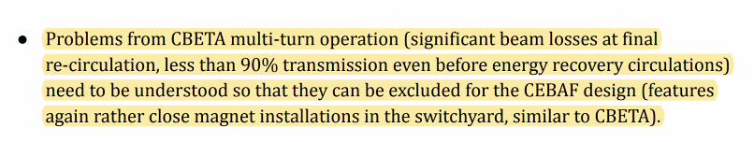
  + Scott – they’re right here! Dejan disagrees.
  + Scott – of course you don’t have losses in the FFA. The issue is, in the system as a whole, to what extent did we blow up the beam? We don’t know, and don’t know that’s why we had problems.
    - Dejan disagrees
    - Roger – Oliver was making the point about transmission. Not aware if the explanation has been written down and presented. He’d like to know if it’s written down.
    - Oliver thinks they’re related to crosstalk in splitters, etc…
    - Scott says crosstalk is manageable
  + Kirsten – didn’t have time to clean up, didn’t know the optics (diagnostics) – we can say here are the likely causes, here’s the diagnostics and instrumentation.
    - Scott – integration here is the issue. Not even just splitters, let’s worry about the entrance to the splitters. Common magnets. Have closed orbits in FFAs have to end up on axes of beamlines for splitter lines after shared magnets. If you don’t do that on one end or the other, you’ll have de-facto emittance growth. That little portion is the hardest part. We see that when trying to get the beams into the splitters. We couldn’t get them on the axes on the splitter lines. Integrating things together is the problem – we missed the mark.
    - Dejan says first turn is fine.
    - Kirsten says yes, first turn, but then after that no.
    - Scott – first turn is easy. Second and more – you don’t get to choose.
    - Dejan – second turn you do with a separate beamline
    - Scott – yes, but the first magnet sends the beam somewhere. Shared magnets is where you have to be spot on.
      * Beam pipe axes for single pass pipes end up in the right places. B/c you can’t get that perfect, you have to have a management scheme to get the beams on the axes well enough.
      * When the beam comes out, you’re blind.
        + Dejan – we had perfect second turn too
      * Scott – you only see the centroid, but you’re blind to what the beam looks like. No idea if emittance was right or not.
        + Kirsten – sure emittance was screwed.
  + Oliver got all his knowledge from a paper – so he doesn’t know all these discussions.
    - Scott – he was on the CBETA committee too.
* Scott – milestones were critical. But never got to answer the questions before shut down
* 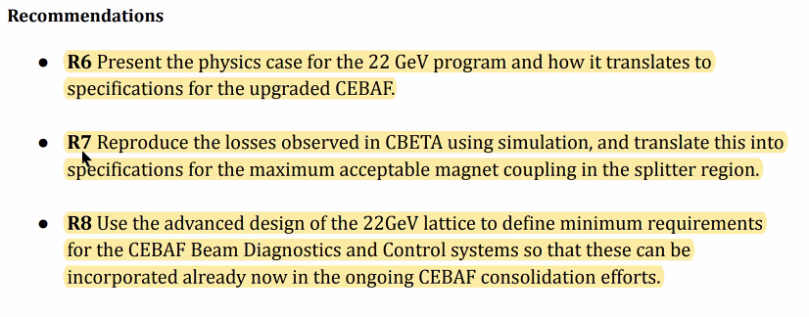
  + Alex B will handle R6 with Physics.
  + R7 addresses the losses. Set a simple goal. Look at splitter and use simulation to figure out coupling – make sure do better than CBETA
    - Scott has no idea how to do that believably.
    - Stephen – invent something and say it’s “magnet coupling” to make committee happy”
    - Oliver will be happy if we do this
    - Stephen – philosophically, this is garbage (Scott agrees)
      * Scott says run CBETA again
  + R8 CEBAF undergoing upgrade for instrumentation. BPMs, FFB, etc…
    - This says we should make sure current upgrade efforts consider the upgraded machine
    - Currently planned button BPMs don’t have the range for our FFA passes
    - Nate Rider will start coming to meetings when he can
* What BPMs in CBETA?
* 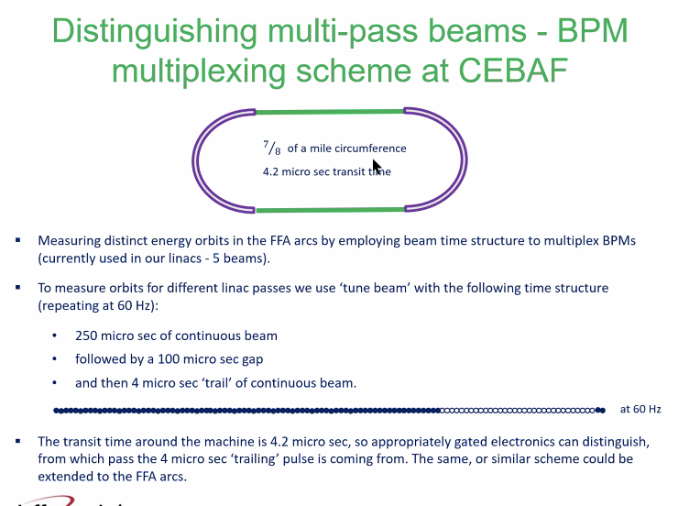
  + This is how CEBAF does it
* Had timing problems at CBETA
* Kirsten: Set bunch length short enough so individual passes didn’t overlap in FFA, then use helper scripts to auto-window the passes you wanted to see.
  + Would only see parts of passes in certain sections. MLC bpms – only two of them.
  + Had a not-great workaround
* Wanted engineering input. Invited Tim Michalski – WELCOME!
  + Tim – glad to sit in. Does similar with EIC at JLab.
* 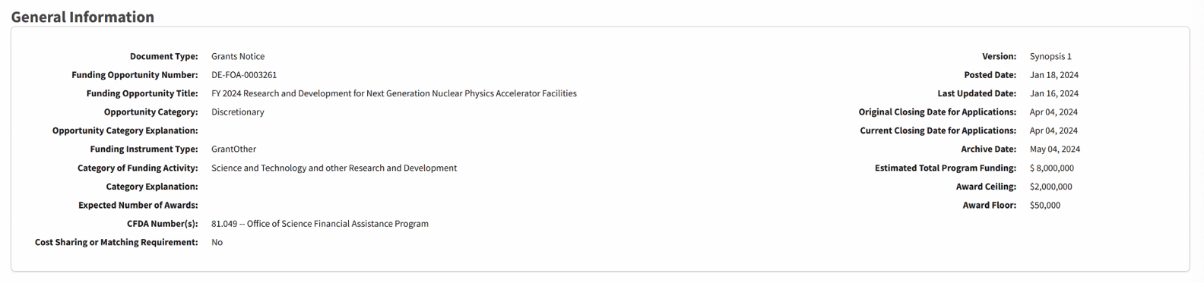
  + FOA open. This one seems OK for us
  + There will be one on the upgrade.
* How will we upgrade/change the previous study?
* Ryan – BSY idea is $2M at full size. But can pare it back to focus and reduce cost.
* Scott – we still need significant accelerator design work
* Alex B – look in folder, and everyone start thinking about what to propose.
  + Dejan will provide a BNL report
* Let’s assign different JLAAC recommendations to people to address.

|  |  |  |
| --- | --- | --- |
| Action Items | Person responsible | Deadline |
|  |  |  |
|  |  |  |

## Time allotted | 25 mins | Agenda topic Adding Sextupoles | Presenter Dejan/Stephen

* No time. To be addressed later.

|  |  |  |
| --- | --- | --- |
| Action Items | Person responsible | Deadline |
|  |  |  |
|  |  |  |

## Time allotted | 10 mins | Agenda topic AOB | Presenter All

* N/A

|  |  |  |
| --- | --- | --- |
| Action Items | Person responsible | Deadline |
|  |  |  |
|  |  |  |

## Special notes

Pathway to Repository: <https://jeffersonlab-my.sharepoint.com/:f:/g/personal/tristan_jlab_org/EqZ5MeS-nipCgPfZB5p0oS4B9Is67d3nQb9sLJI3Zyev9g>