FFA@CEBAF Working Group|Minutes

Meeting date | time 02/09/2024 | 11 AM EST | Meeting location https://jlab-org.zoomgov.com/j/1614898082?pwd=TnUzMS81M2sxbDZIbERJU01tYkJCQT09
Meeting called by Alex B  Type of meeting Weekly Meeting  Facilitator Alex B  Note taker Ryan, Kirsten  Timekeeper Alex B | Attendees  Alex B, Ryan, Scott, Dejan, Kirsten, Edy, Salim Ogur, Stephen, Tim, Todd, Vasiliy, Donish, Georg

Intro Discussion
- Problems with shared document editing
- How work it out?

Agenda topics

Time allotted | 25 mins | Agenda topic FOA| Presenter All
- Dejan – wants to continue the editing even though on vacation. Scott/Ryan should provide tools to do that the right way!
- Stephen found out that the deadline changed. It *was* April 4th, and now it’s March 4th.
  - Internal deadline was last Friday for letter
  - Ryan – what’s the internal deadline for the full review?
    - Looks like possibly Feb. 19th internally.
    - Will follow up with Spata/Marla/Etc…
- Ryan/Scott have slides from a discussion:
  - 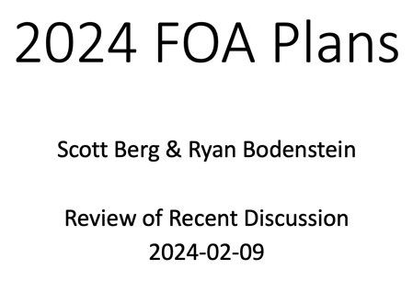
  - 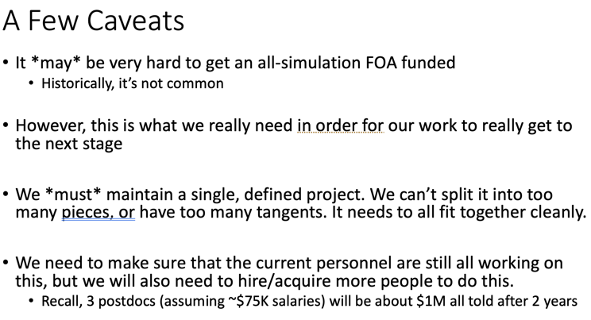
  - 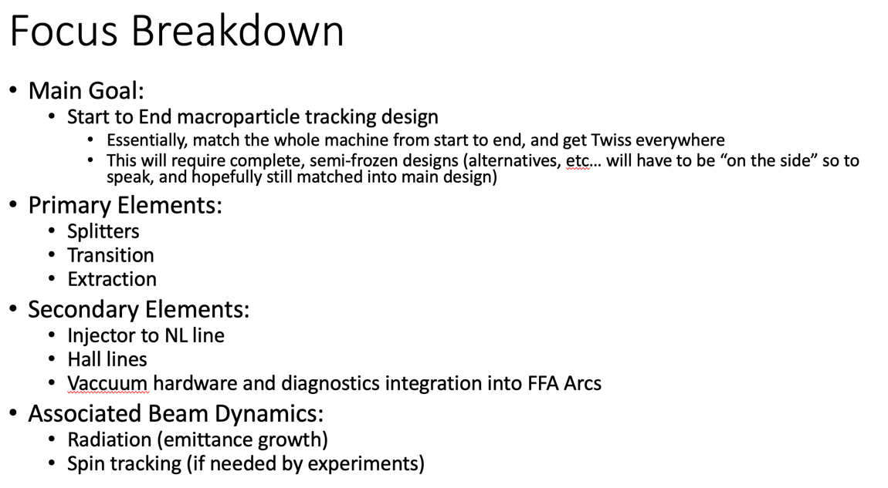
    - Scott – primary concern is polarization degradation due to radiation
    - Alex B – 12 GeV has become skilled at handling high energy polarization
    - Scott – okay, maybe it's a secondary effect or it's too much even for the new personnel to handle on top of everything else
      - focus is self-consistent s2e; individual parts may have later design changes that have not been incorporated
    - Alex B – need to sort out diagnostic requirements, to be taken into account during CEBAF's instrumentation upgrade in the next few years
- Alex B – what about the title?
  - Scott – "22 GeV" in title commits us too strongly to this energy
    - Alex agrees, Dejan doesn’t
      - Discussion about title, referring to NSAC language as well
      - Ryan recommends waiting until the proposal is more written before deciding
  - 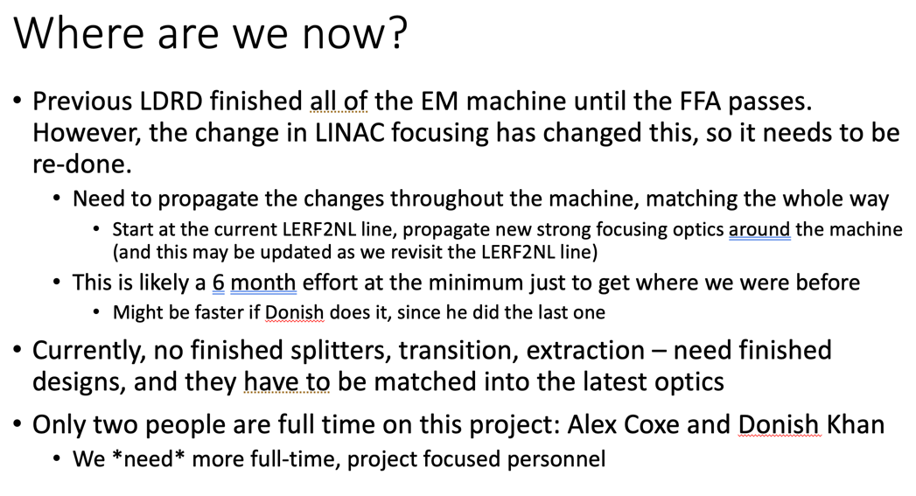
- Hello Salim! Coming April 1st
  - Worked at CERN as a PhD student – FCC-ee injector (positron)
    - LINAC and transferline optics
    - Beam transfer physics for antiproton machine
  - Then IJCLab
  - Then hadron therapy company
  - Looking forward to joining!
- 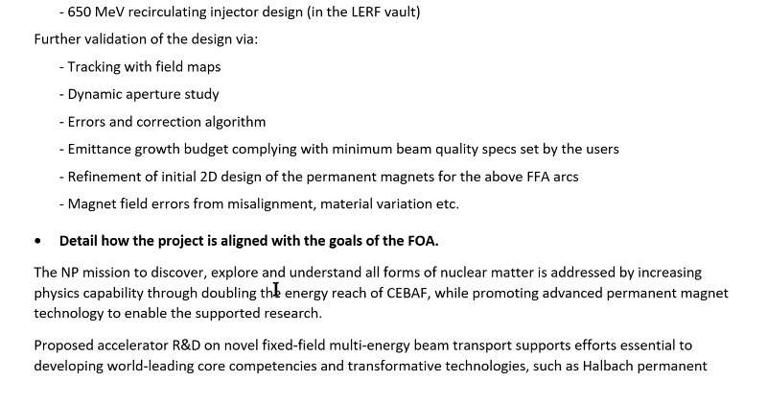
- Dejan – Scott and Ryan’s ideas were good
  - Put Ryan’s LDRD radiation damage work in the text to show it’s being worked on
- Alex – take Ryan/Scotts viewgraphs, and try to include some of the things on Alex’s text
  - 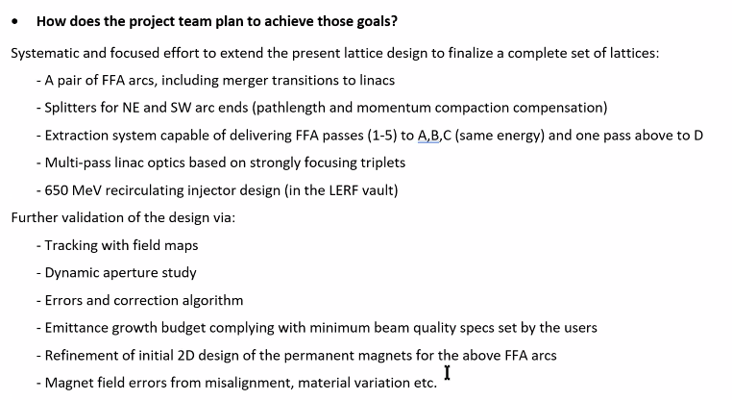
- Scott – if there’s things we need to add to meet our primary goals
  - If we make the FFA arc more believable but can’t integrate, probably fine
  - To avoid throwing everything in that might be possible – don’t overpromise
- Stephen – magnet designs already take into account 2D design, may as well put it in b/c it happens when the optimization
- Scott – designate an “owner” to make sure everything is integrated properly
  - Ryan nominated – agreed to oversee, but also very busy in the tunnel and Moller review
- Ryan uploaded an annotated copy of the FOA – please read
- Georg – would like to take part in this FOA at all
  - Magnet testing (Ryan doing in LDRD)
  - Bmad
  - Any way to be involved?
    - Alex B – what would you want to take from the list?
      - Georg – since much of it is done with Bmad, might be good to include David Sagan
      - Kirsten – not sure there’s any Bmad capabilities not included
    - Scott – maybe depolarization due to SR effects? Can Bmad do that?
  - Alex – if you want, write a brief description on how Cornell could contribute to the depolarization studies
- Stephen – put him on the last two sections (magnets and correction backup)
- Splitters – Ryan can copy/paste a lot from tech note, maybe Donish as well?
- Vasiliy – transition/matching section (Randy takes lead?)
  - Already wrote a technique paper, so easy to convert – it’s in the tech note folder already
- Kirsten – contribute text for emittance/radiation studies?
  - Why on here?
    - Hall lines
    - Splitter radiation issues
  - Scott – we should mostly be ignoring the radiation and just match. But a parallel effort to tracking this so we have the results – imaging post-FOA design improvements
    - Post-FOA, we have S2E simulation – now we can focus on improvements
- Alex will ask Reza for input on extraction

Action Items | Person responsible | Deadline

Time allotted | 25 mins | Agenda topic Sextupole FFA Arcs | Presenter Stephen/Dejan
- TBD
Action Items | Person responsible | Deadline

Time allotted | 10 mins | Agenda topic AOB | Presenter All

Action Items | Person responsible | Deadline

Special notes

Pathway to Repository: https://jeffersonlab-my.sharepoint.com/:f:/g/personal/tristan_jlab_org/EqZ5MeS-nipCgPfZB5p0oS4B9Is67d3nQb9sLJI3Zyev9g

