FFA@CEBAF Working Group|Minutes

Meeting date | time 03/08/2024 | 11 AM EST | Meeting location https://jlab-org.zoomgov.com/j/1614898082?pwd=TnUzMS81M2sxbDZIbERJU01tYkJCQT09
Meeting called by Alex B  Type of meeting Weekly Meeting  Facilitator Alex B  Note taker Ryan  Timekeeper Alex B | Attendees  Alex B, Ryan, Donish, François, Scott, Alex C, Reza, Edith, Randika, Dejan, Kirsten, Salim, Stephen, Todd, Vasiliy, Roger

Intro Discussion
- Chat about other projects
- FOA Submitted

Agenda topics

Time allotted | 45 mins | Agenda topic Alternative Splitters| Presenter Donish
- 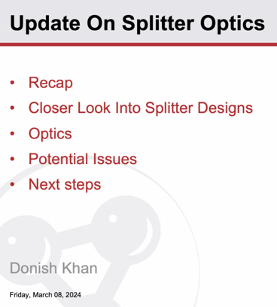
- Two splitter designs working on
- 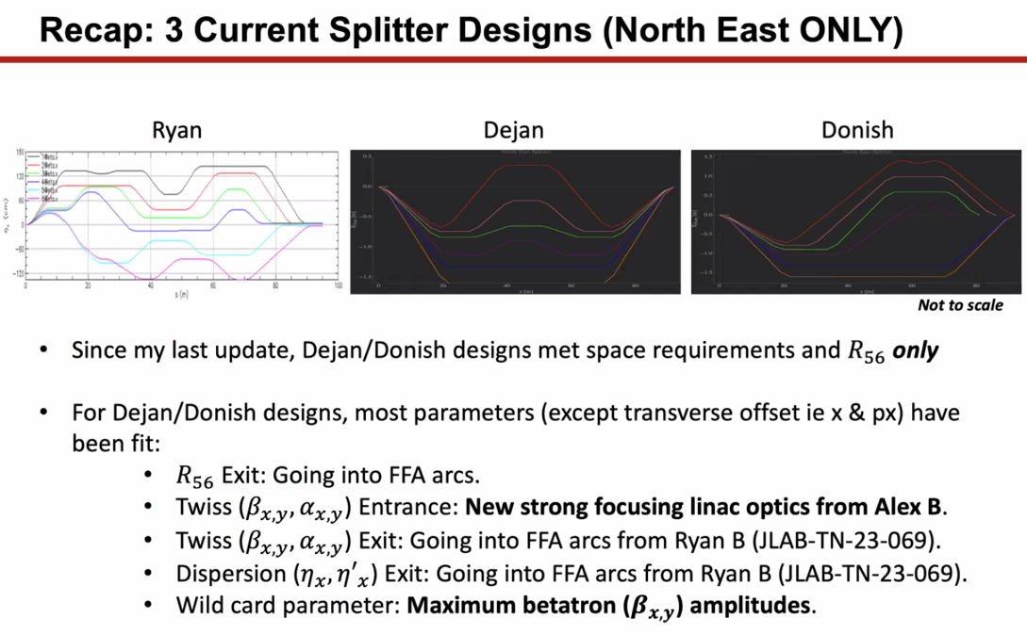
  - Designs have been put together – met space requirements. Only matched for R56 before
    - Started matching other parameters (except for x and px, y and py offsets into FFA)
  - Now working from strongly focusing
    - Ryan – could you have please sent that around? I’ve been working on weakly focusing
  - Ryan – please actually propagate this around the machine
    - Is South Linac done?
    - Alex B – yes.
- 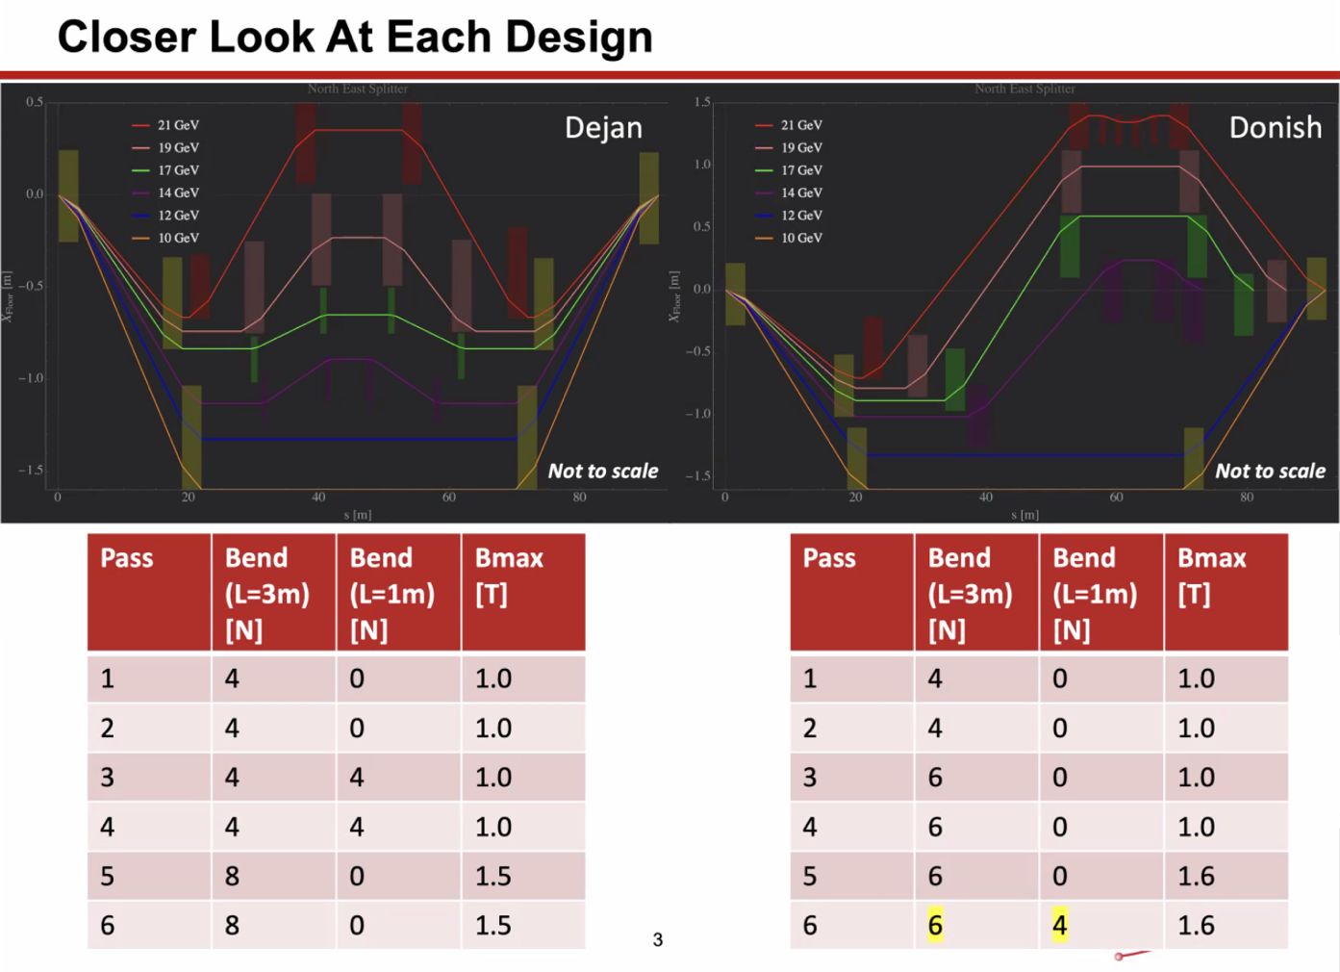
  - Ryan – both of these cannot control path length for all passes independently. In both cases, two beamlines cannot independently control path length. Blue and Yellow in both
  - Donish added more chicanes to add degrees of freedom
  - Using two types of magnets – 3 m and 1 m
- On Donish’s new design – the purple line is completely separated. Now only two shared beamlines.
  - Highest E (red) needed to add a mini chicane at the top to increase DOF to match all parameters
  - Only two types of magnets again, 1 m and 3 m
- Scott – looking at the Dejan picture (and yours) – looking at the lowest E beamlines
  - These are 70 cm wide poles? Why not make it three magnets?
  - Donish – only been working with 3 m magnets. If we can fit it with the big magnets, then we can adjust with smaller ones if need be.
    - Agree – need to do a bit more research in the available magnets that we have and dimensions. Would ease constraints on designs.
- Dejan – if look at notes, drew a picture of the magnets (first separator) to make sure beam can get in/out the right way.
  - Ryan – Jay actually designed one that works.
- Donish – using less magnets overall – decrease SR
- 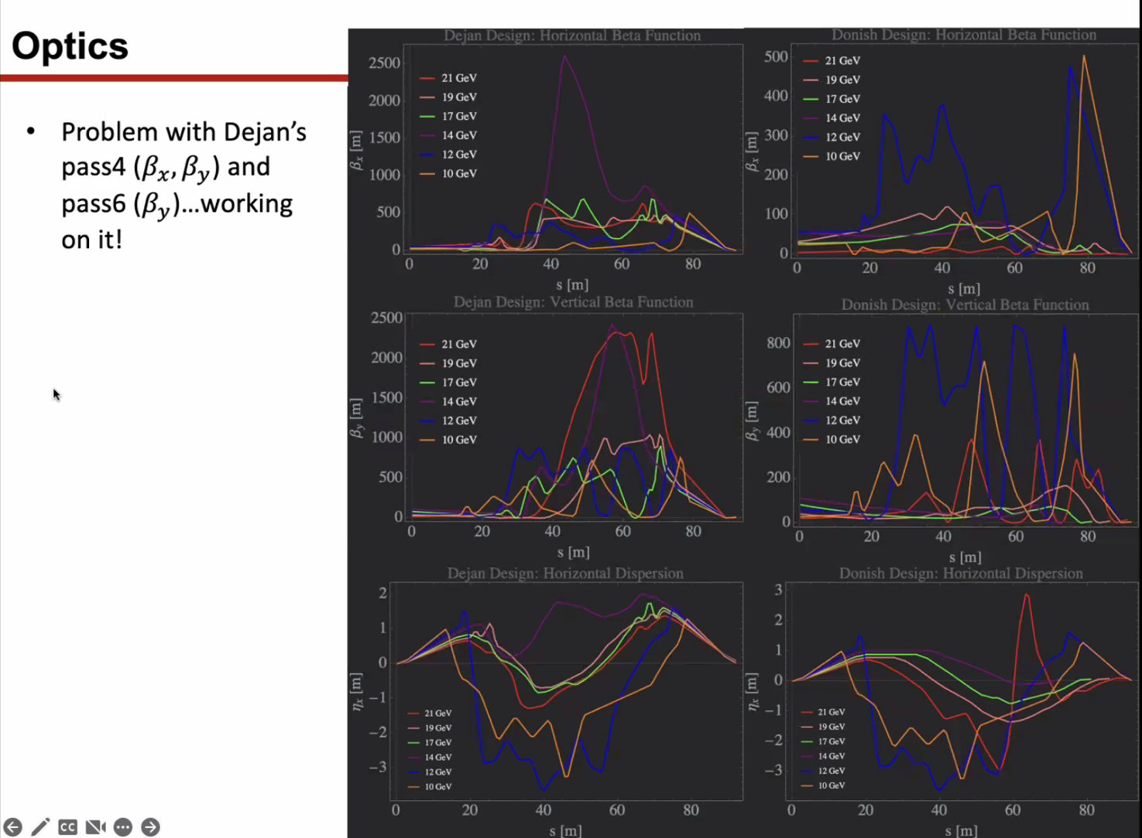
  - This is what the optimizer gave – not pretty
  - When just using optimizer to get match at the end. Dejan’s works quickly, but the beta functions explode.
- Scott – how many quads in each line?
  - Not sure, but plenty of space to place them.
  - Scott – when did this for CBETA, I had 8 quads for 7 constraints. Took that extra degree of freedom and basically figured out the direction in the 8D quad space and then step in that direction. Would basically scan and record and make plots to compare
    - Basially let the scan rip, and at each step you redefine
    - Scan and find solutions, and then look for solution that would minimize bad beta functions
- Donish – has at least 9 quads per line
- Stephen – are these unique solutions, or if you start from a different place will it give the solution?
  - Pretty much unique.
- Ryan – how do you set your initial quad settings?
  - Donish - Sometimes just set + or -, or just set to 0 and let the optimizer run
  - Alex B – yes, sometimes you have to be careful with the optimizers
  - Ryan – yeah, sometimes an optimizer will find you a wonderful mathematic solution that doesn’t actually translate to a usable beam
- Dejan – let’s zoom to talk
- Scott – turn off R56, get a solution, then turn it on and start walking the R56 toward the right value, but at a different one
  - Ryan – that’s a good idea. The R56 is very hard
- Dejan – you have to understand R56 – it’s an integral of the dispersion
  - Have something symmetric, make Dispersion Prime and alpha 0 in the middle
- Ryan – Randika had mentioned another good idea: find a different part of the FFA arc cell that has easier match parameter
  - Stephen, yes, you can have a partial magnet at the end to do that
  - Scott – that’s sort of what happened at CBETA
    - Want alphas to be zero at the end – maybe do at the beginning
    - Common dipole is hard
    - Maybe have a half quad at the end, it kind of sort of helps.
      - Worked well for high E, not as well for low E
      - They used a half magnet at CBETA
  - Dejan – always using triplet config for FFAs, at end, the alphas and dx’ are zero, and orbits are parallel to each other
    - Beam comes out of FFAs straight and parallel for each energy
- 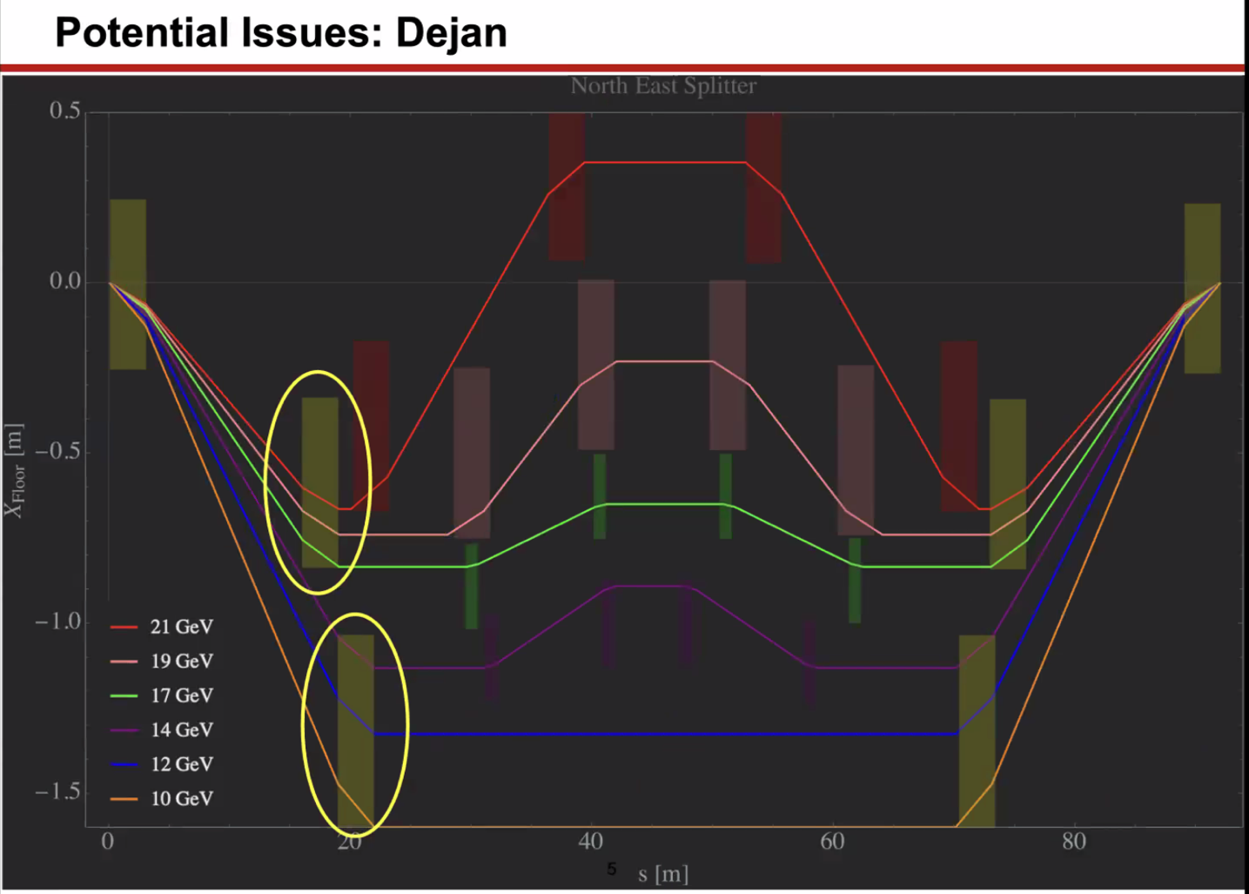
  - Large dipoles sharing common beamlines.
  - Dejan’s didn’t fit, but Donish made it fit
    - Fact that it fits depends on the three lowest beamlines being shared with common dipoles. It might not fit
  - Scott – to cover beams, you need a 90 cm wide magnet to make this work. So instead, you stagger the dipoles.
    - Common dipole in top left, just after that, you have a septum that separates off purple, then another to separate blue, then dipole for orange
    - Staggered so they don’t take up as much space
- 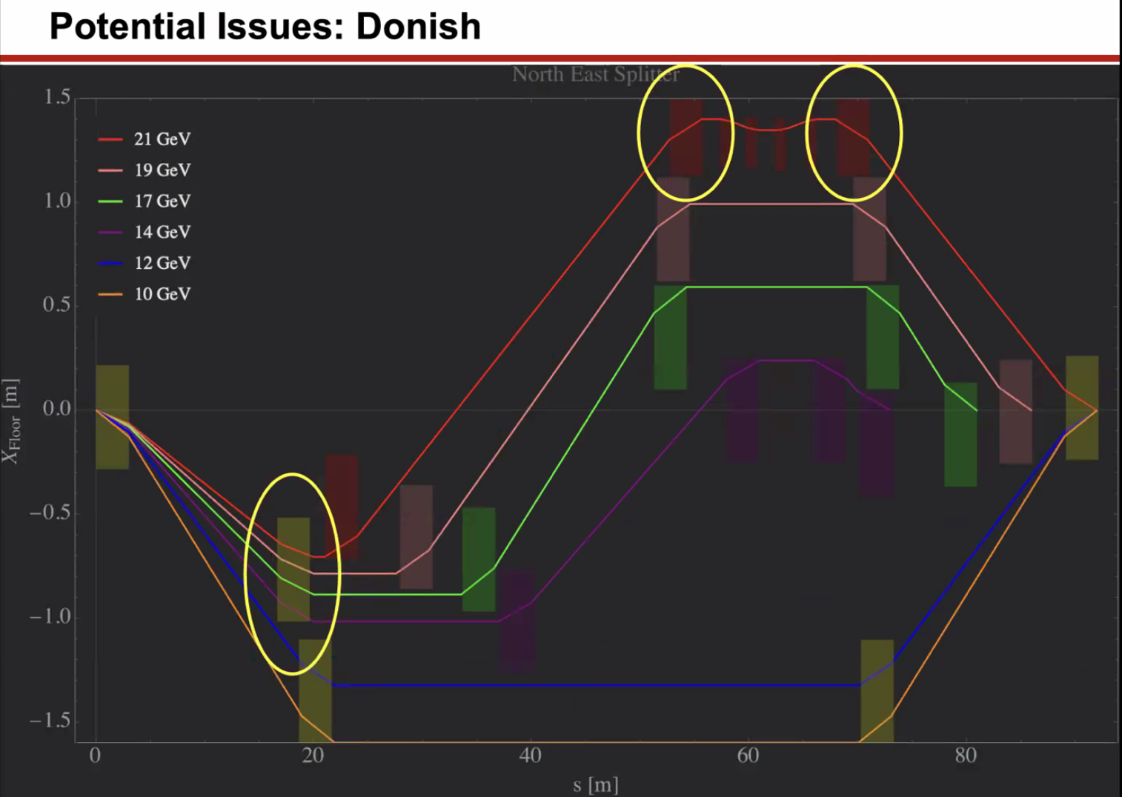
  - Top dipoles don’t fit in the required space. Red ones stick into the wall
- 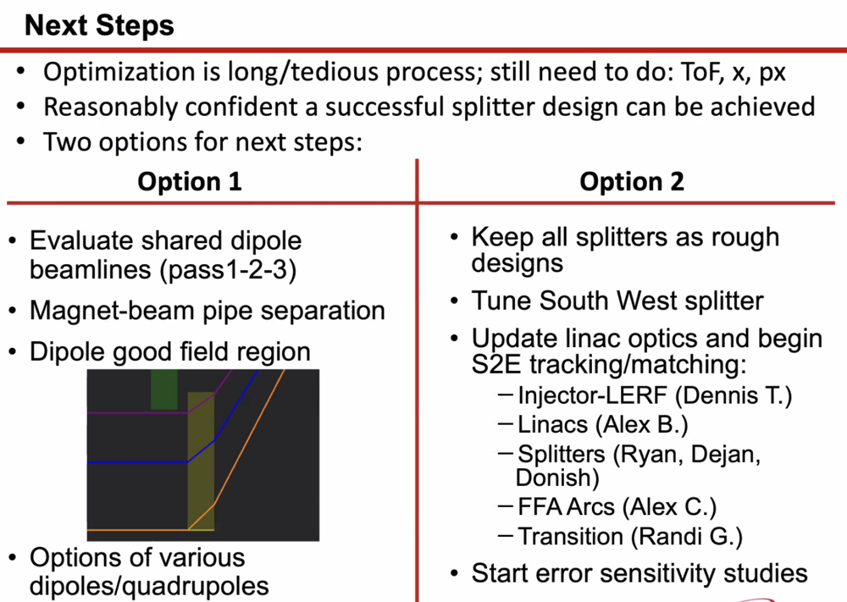
  - Evaluate shared dipole concerns
  - Quantify magnet/beam pipe separation – not much space between purple line and green dipole – shifted magnets to make them fit
    - Ryan – don’t forget, we can trim return steel (or put a hole in it like in the Spreaders)
    - Scott – you really want to do this with smaller magnets.
  - Put a limit on the good field region of the magnets: looks like only the blue one would go through the good field in this version
- Dejan – in Germany, common dipole has an angle for each pass – complicated magnet, but maybe not a bad idea?
- Roger – when I look at this design, has the beam already had optimization for any energy/momentum variations
  - Not yet – that’s a “next step” that Alex brought up
- Kirsten – there’s all this talk about good field magnets, etc…
  - Even then, you still have no individual pass control for two or three lower energy passes.
  - Cannot think of how that feasibly works in this machine
  - Dejan – there are very nice small magnets that can be put in a small space
    - Kirsten – permanent or EM?
      - Dejan – permanent or EM, but can trim energies
- Scott – seems like a reasonable option, where you have permanent magnets and then trim dipoles
  - Ideally, the trim dipoles would steer into the center of the PMs
  - Ryan – but how much flexibility could the trim/PMs take?
    - They’d be real dipoles, not correctors
  - But, let’s say you need 5 cm pole, so return yoke ~ 1 cm – you get a roughly 10 cm wide magnet
- Stephen – could also use movers to move the PM (SmCo probably)
- Kirsten – we can detect thunderstorms from 100 miles away
  - Roger – from a coax cable from NL to SL. Old cable – being replaced by fiber. That should fix it
  - Ryan – but then how can we check the weather? (Bad joke)
- Donish – option 2, keep all splitter designs rough
  - Tune SW splitter
- Dejan – thinking about changing the arc to be isochronous
  - Can also make the dispersion oscillate differently
- Reza – is there any advantage for having a symmetric geometry? If it’s symmetric and draw a line in the center, and have the beam characteristics at the center?
  - Yes, but there’s a break in symmetry
  - Scott – biggest issue is that you have very large beta at LINAC and tiny in FFA
- Scott – I like the symmetric geometry, but gut says you want quad layout on FFA end and looser on LINAC end, b/c super tight quad spacing with 100 m Betas is useless
- Ryan – can you put any extraction dipoles in to use Reza’s methods?
  - Donish – haven’t thought about it yet. There’s lots of space
  - Ryan – would it fit with a 3 m dipole with your optics?
    - No, absolutely not.
- Alex B - 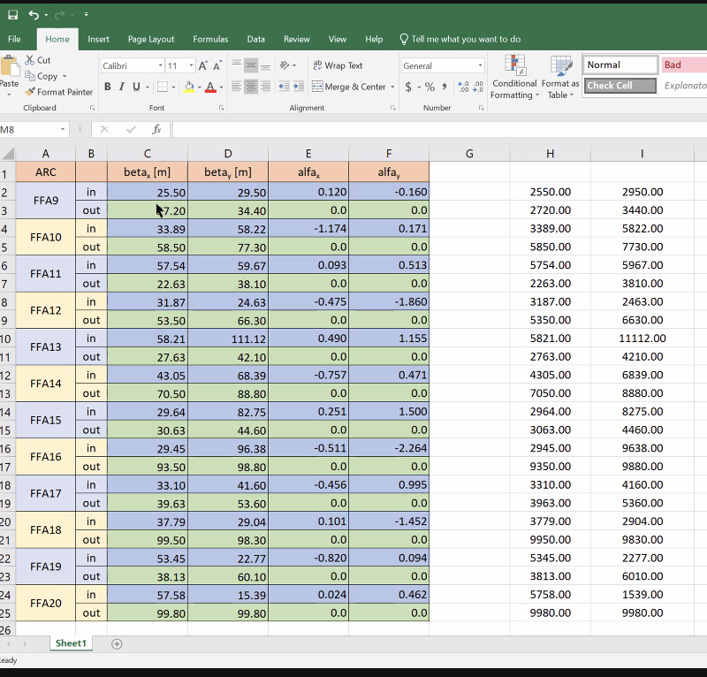
  - Includes recombiner and spreader at end of NL
  - Did similar for SL
  - Uploaded in August of 2023 (when Ryan was on vacation)
  - Ryan – did you also match these including the lower, EM passes?
    - Alex B – that can be done easily, but just focused on FFA passes
  - What energy? – 1.1 GeV per linac
- Scott – these betas look almost too good to me.
  - There are large values in the middle, but they’re smaller at the ends
- Transition prefers low alphas
- Reza – can you reverse the lattice?
  - Ryan – yeah, that happens
  - Alex B – that’s what I did here
- Dejan - 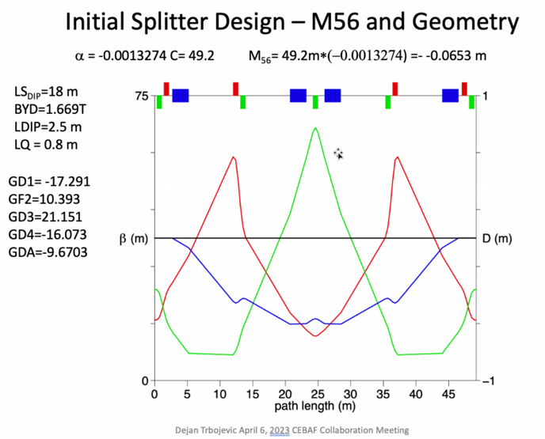
  - This is the symmetric method using doublets
  - Need to start with something reasonable before you use the optimizers
Action Items | Person responsible | Deadline

Time allotted | 15 mins | Agenda topic AOB | Presenter All

Action Items | Person responsible | Deadline

Special notes

Pathway to Repository: https://jeffersonlab-my.sharepoint.com/:f:/g/personal/tristan_jlab_org/EqZ5MeS-nipCgPfZB5p0oS4B9Is67d3nQb9sLJI3Zyev9g

