FFA@CEBAF Working Group|Minutes

Meeting date | time 03/15/2024 | 11 AM EST | Meeting location https://jlab-org.zoomgov.com/j/1614898082?pwd=TnUzMS81M2sxbDZIbERJU01tYkJCQT09
Meeting called by Alex B  Type of meeting Weekly Meeting  Facilitator Alex B  Note taker Ryan  Timekeeper Alex B | Attendees  Alex B, Ryan, Kirsten, Randika, Reza, Dejan, Todd, Stephen, Edy, Donish, Scott, Andrei, Tim, Nick Sereno, François,

Intro Discussion
- AccApp discussion
- Alex noticed Splitters on Social Media – will revisit

Agenda topics

Time allotted | 45 mins | Agenda topic Sextupoles in FFAs| Presenter Stephen/Dejan
- 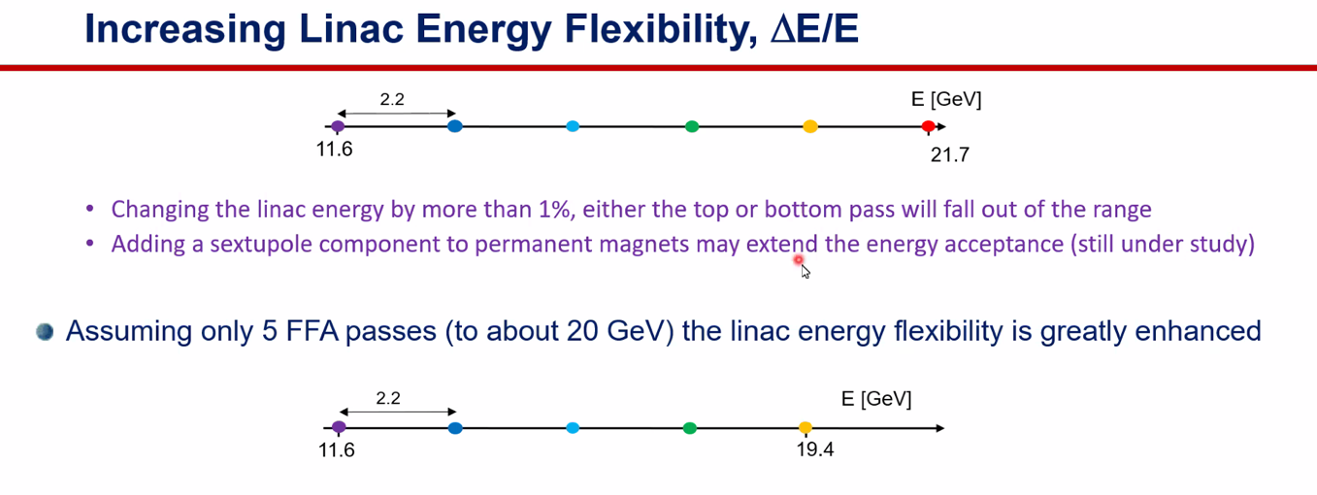
  - Alex shows this – review from previous discussions
  - Previous design done in hasty way
  - Energy acceptance – 1.1 GeV/linac energy gain (West Arc Shown) – 2.2 GeV per pass
    - “Edge to edge” on energy acceptance
  - Jay pointed out that this is a “dangerous situation” leaving little flexibility
    - Due to polarized beams, need to do gymnastics to get polarized beams to halls with energy variation
  - If we add sextupoles, perhaps increase the length of the plot
  - But safety net – 5 passes gets us to about 20 GeV – but there’s some extra room
    - Can stretch both sides to give flexibility:
    - 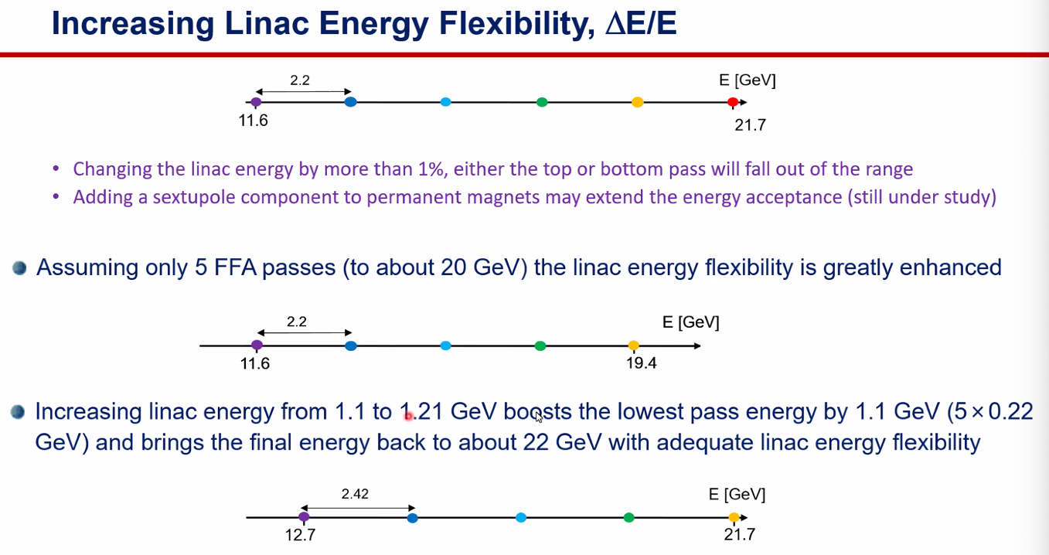
      - Future increase in LINAC energies to get to ~22 GeV (after revamping linacs)
      - 2.42 GeV per pass, so start at 12.7 GeV and up
      - Really want a good cushion on lower side
- Dejan – looked at West Arc – higher energy
- Stephen has magnet updates:
- 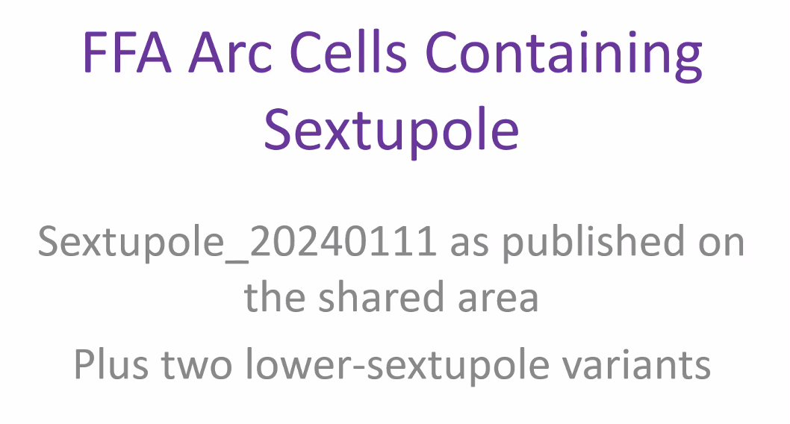
- 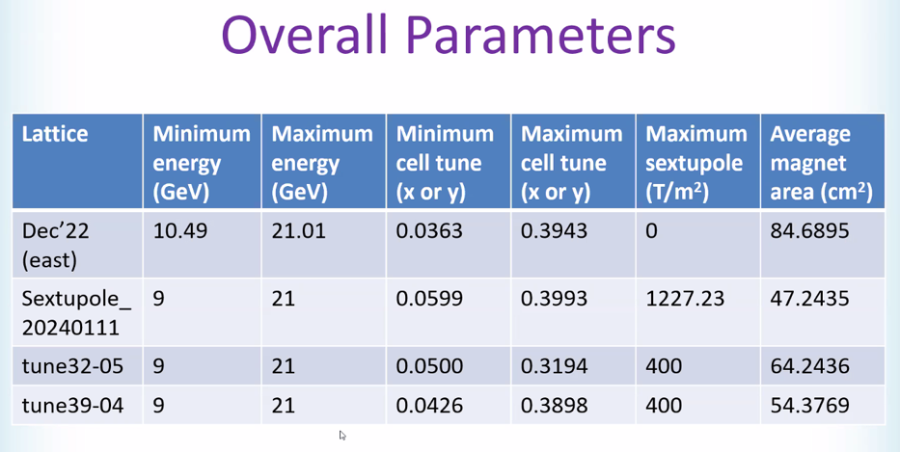
  - Never went above 21 GeV (but would get nearly 23 GeV at Hall D)
  - Average magnet area went down a lot
  - 4 designs: baseline, January version (massive drop in area), two more capping at 400 T/m^2 with different tune rangges
- 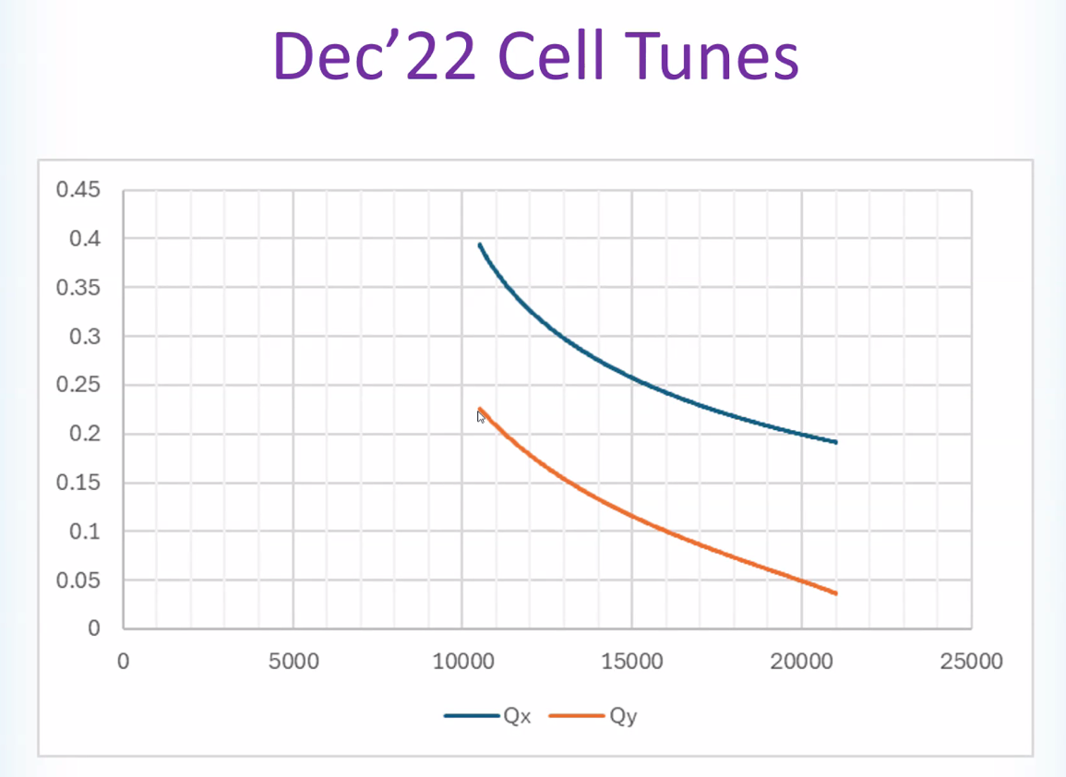
- 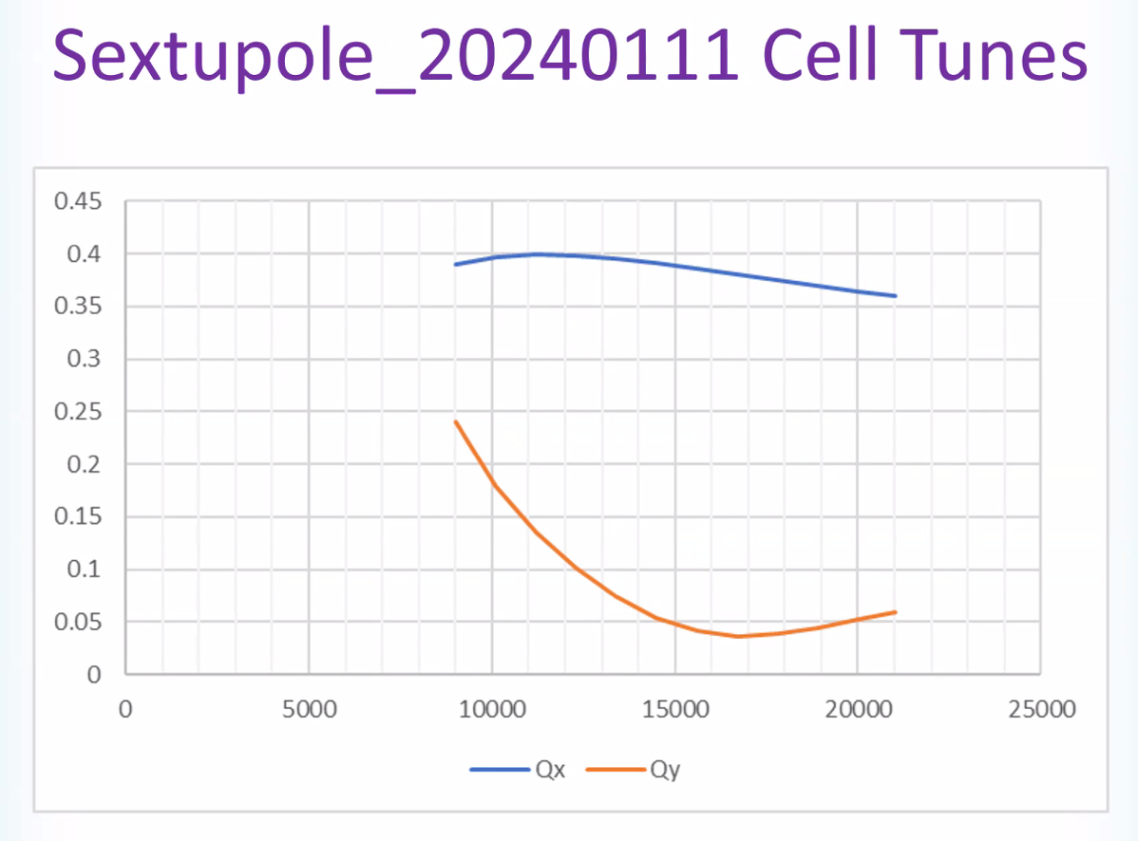
- 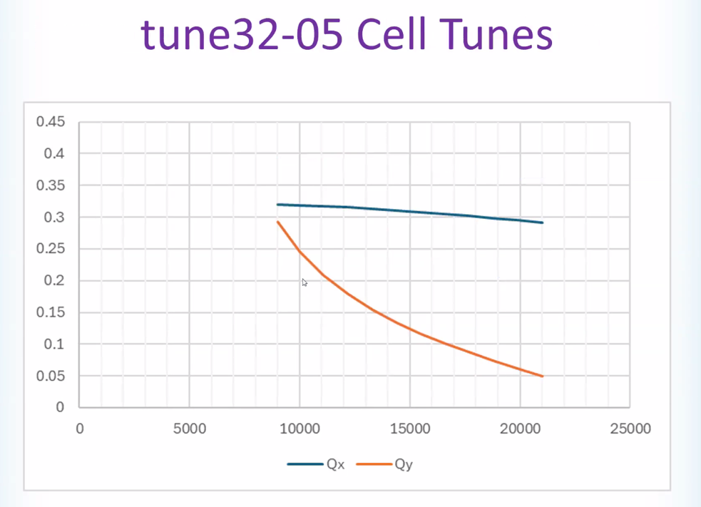
- 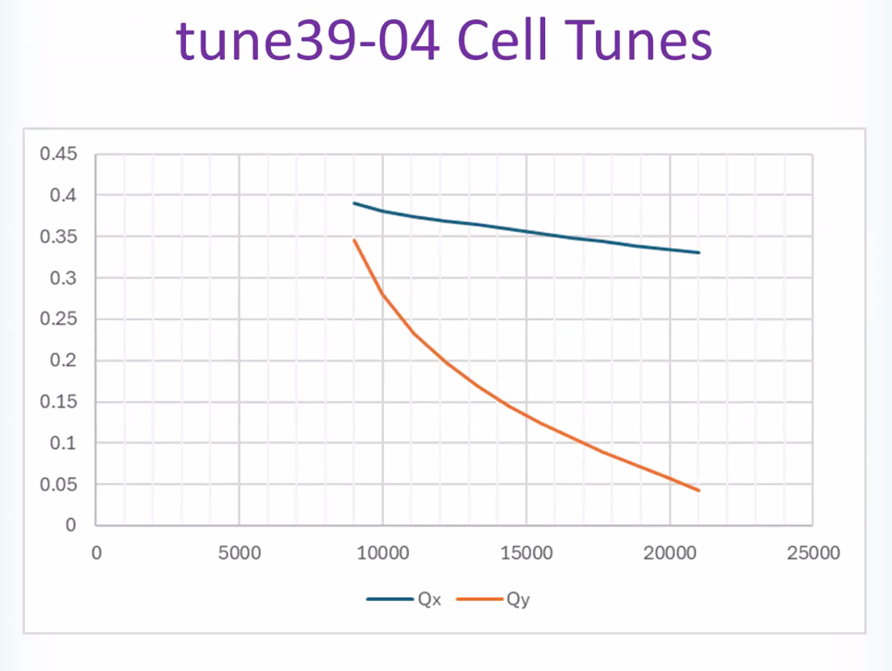
- 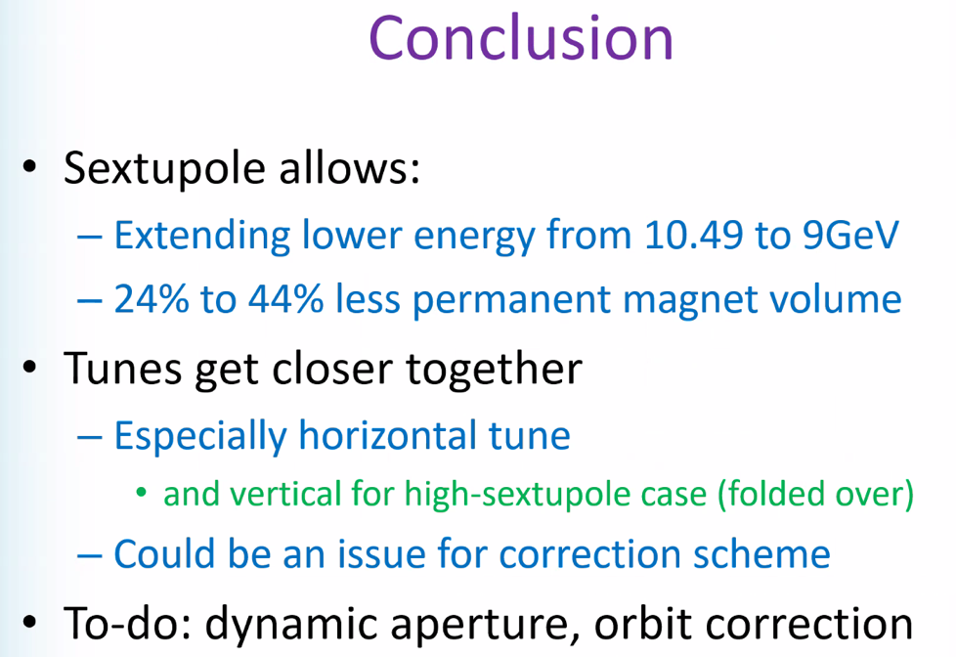
  - Could this hurt correction? – maybe want lower sextupole?
  - Tried to run beam through – wasn’t a disaster but depends on size of the beam
    - Need to check dynamic aperture
- Magnet size actually going down
- 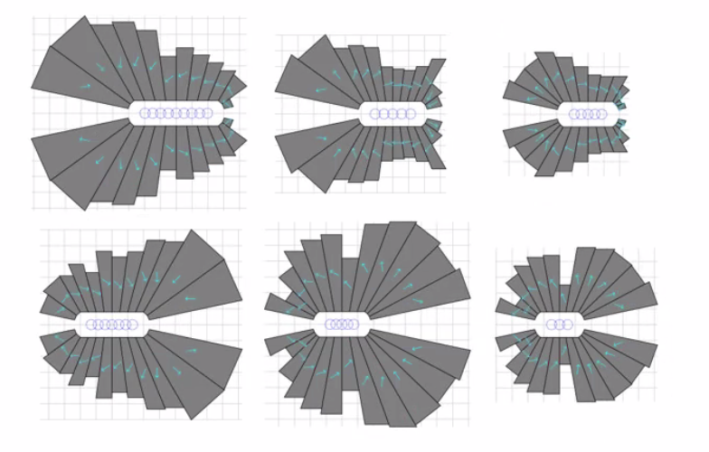
  - This was in FOA
- An aside: welcome Nick Sereno
  - What is meant by DA and tunes here? I think of those in terms of storage rings, etc…
  - Stephen – it’s periodic for a bit – so transfer line can’t blow up emittance
  - So it’s phase advance? – yes, per repeating cell
  - Dejan – resonance is totally different than in a storage ring.
    - If tune is 0.33 then errors in magnets magnify if errors go through cells
- Dejan – my work was not optimizing the magnets – was just looking at the tune dependence. Let’s see if can find the file
  - 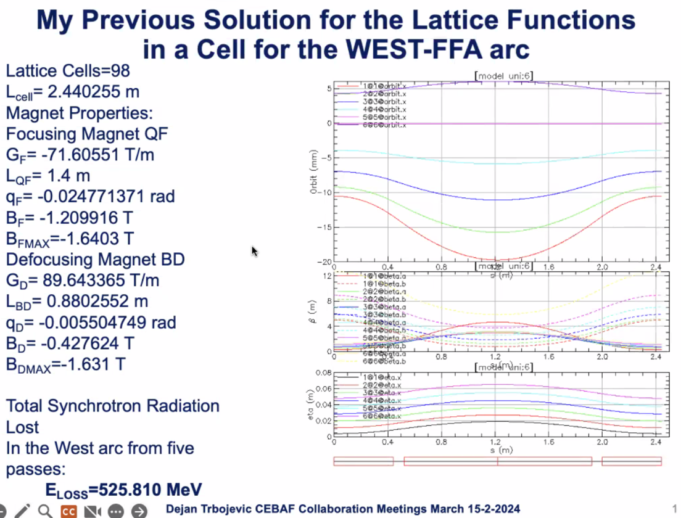
  - Long ago when designing lattice. This is to reduce SR loss – used 98 cells
    - Max of 1.6 T mag field
  - What about adding sextupoles?
    - Orbit offsets end up over 40 mm – not good for Stephen’s magnets
    - 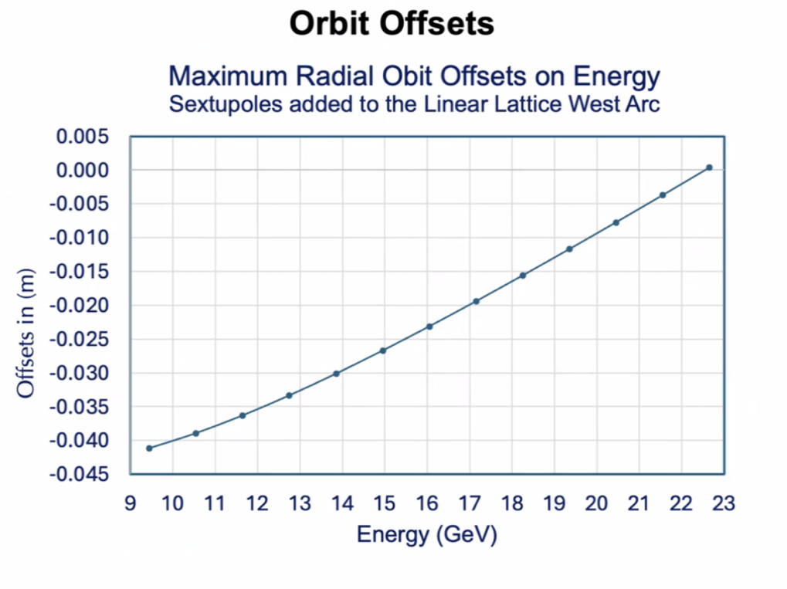
  - Changed tunes:
    - Got better – orbit offsets smaller
- Horizontal vs Vertical tune plots – what’s different with Stephens?
  - Easy to do, - different than Stephen’s
- 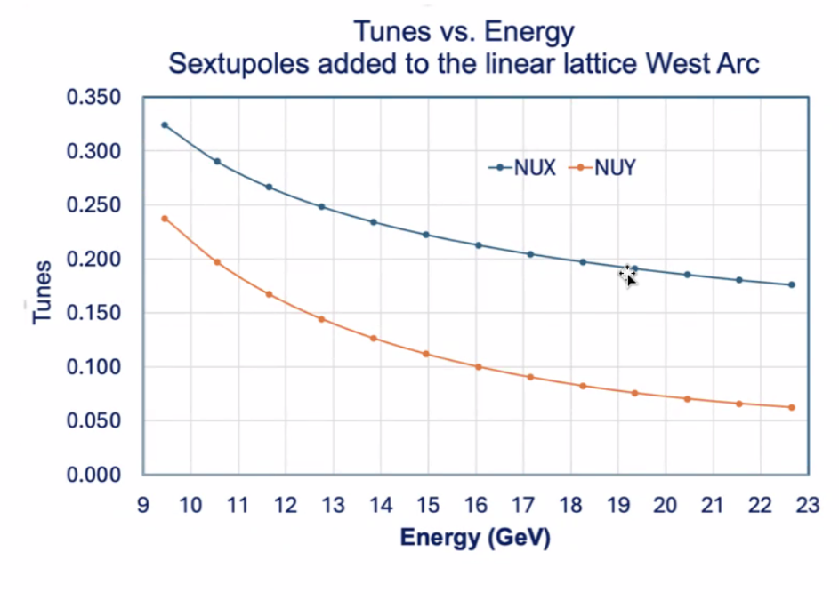
  - More separated is easier to correct along the arc
- Stephen – take this one, then play with cell length to optimize
  - As long as it’s reasonable
  - How much sextupole did you use in this one? Stephen reduced to 400
  - Dejan – surprised how small of sextupoles are needed
  - Stephen – we only want a small perturbation
- 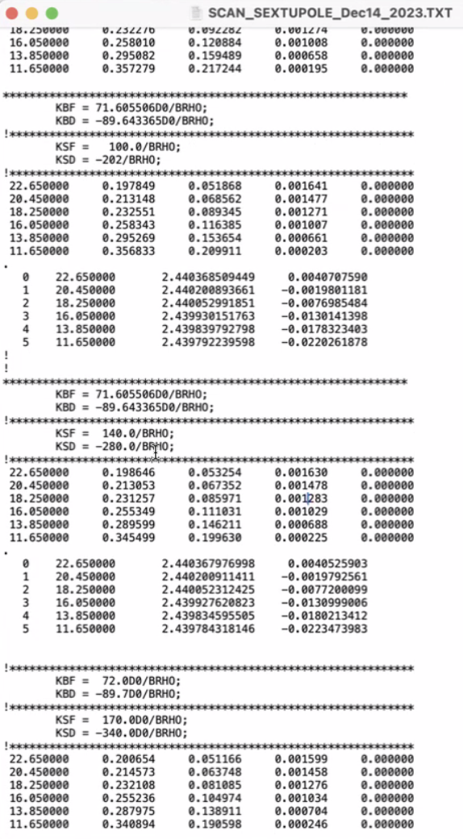
  - Sextupole strengths – all less than 400
  - Stephen may run limiting to 200 to see how it does
  - Alex B – just a perturbation on linear
- Kirsten – If we’re introducing sextupoles into the FFA arcs, does this imply we’ll need to correct those effects in the slitters as well?
  - Stephen – we hope that the beam won’t be distorted at all
  - Scott – you’ll have to think of this as a sequence of beamlines, like multiple arcs. All periodic lattice – linear lattice about closed orbit
    - Errors mean you’ll displace the orbit, and you won’t just get kicks from quads
    - Now we’ll get additional focusing b/c displacing sextupoles
    - Don’t think focusing will be a big deal – sort of derivative of focusing
  - Dejan – in storage rings, they usually have a pair so things cancel out
  - Scott – DA study will be the key. Tells you where/how much tolerance characterization
    - Will be interesting to see how they differ for different magnet designs
- Scott – worry a bit about of sensitivity to model. Play with model parameters like fringe field length, etc…
  - Especially the ones where the tunes were strongly swinging – that will sometimes when you tweak the model a bit – one tune may do something odd
    - Minimum tune might fall apart too
    - When you perturb it, it makes a funnel
  - When you have compact cells with small betas, you get large angles
  - 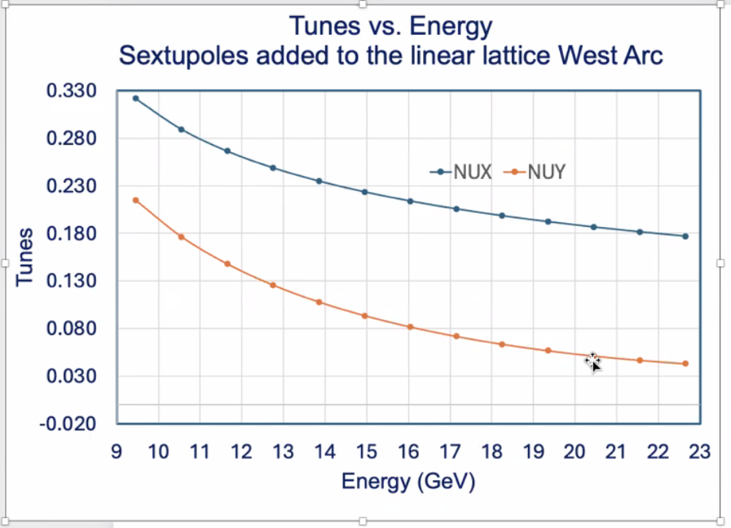
    - This doesn’t look bad – getting close to 1/3 resonance though
- Dejan – fringe field becomes very important with small radii
  - François – ran case with hard edge and can’t find constant tunes – “drama” in low energy
    - Dejan and François will discuss offline – different than CEBAF
  - Scott – both Stephen and François can do this to get an idea of the level of sensitivity
- François shares related (but not CEBAF) stuff:
  - 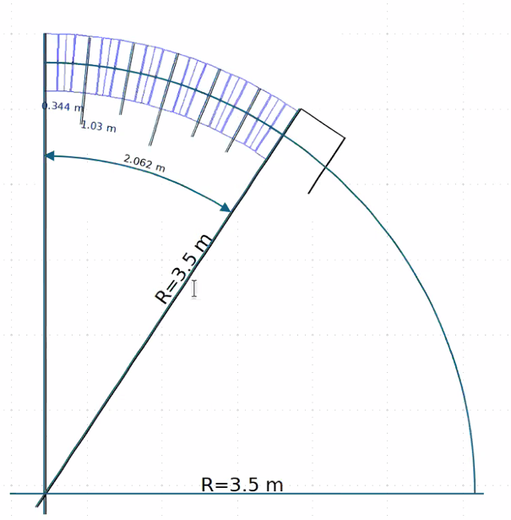
  - 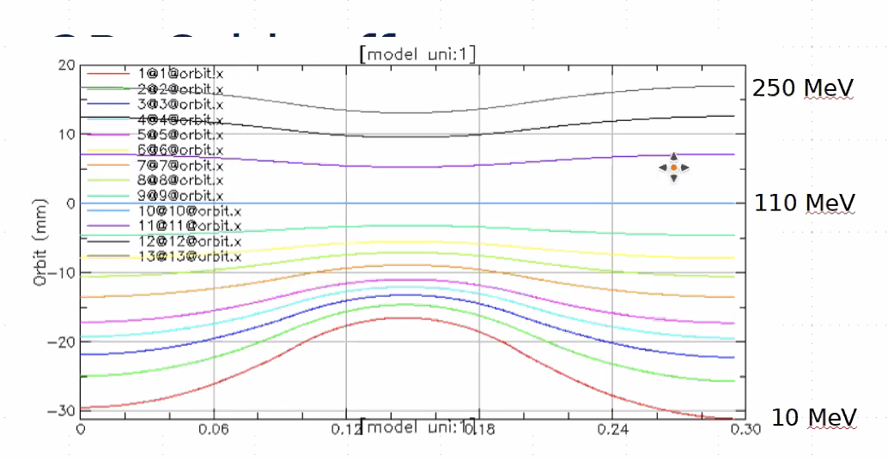
  - 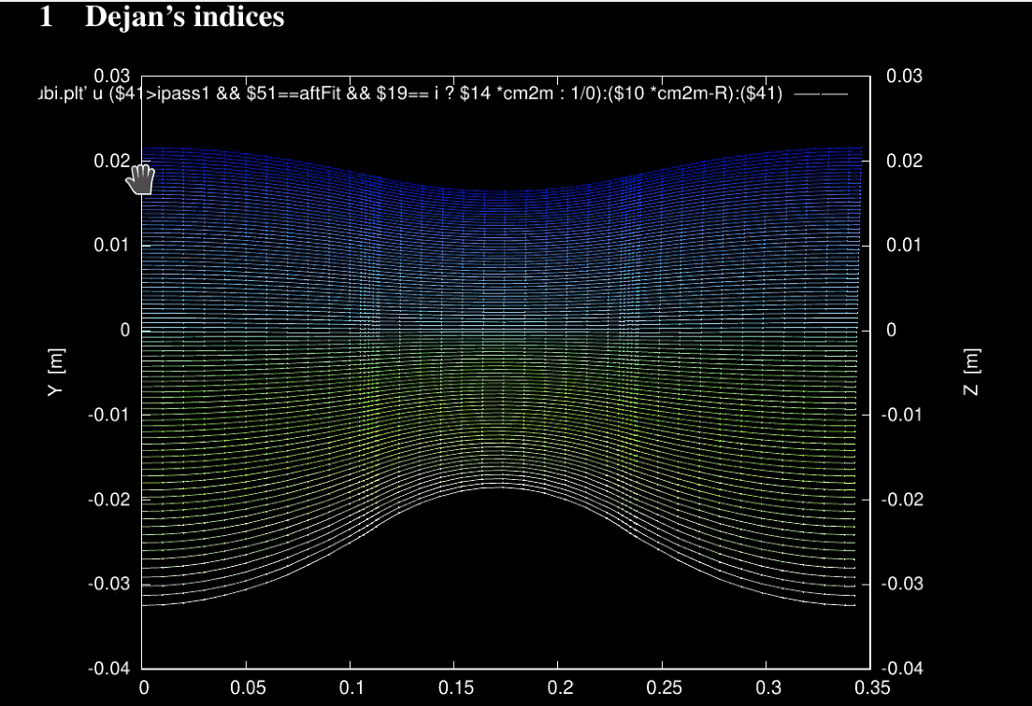
    - Very close to Dejan’s
    - Alex B – what is z?
      - It’s zero, but it’s the orbits
  - 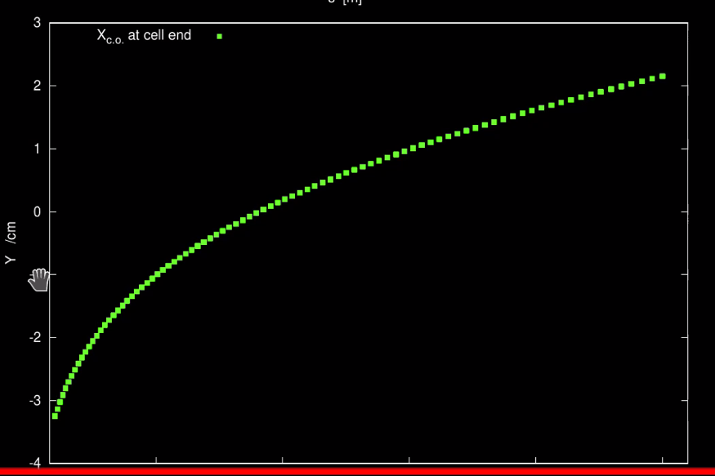
  - Not far from Dejan’s design – almost constant tunes all the way
  - 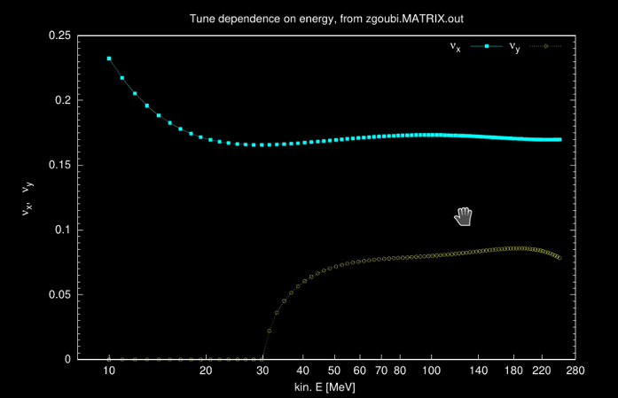
    - Maybe error in coefficients using
    - In high E region, similar tunes to Dejan
    - 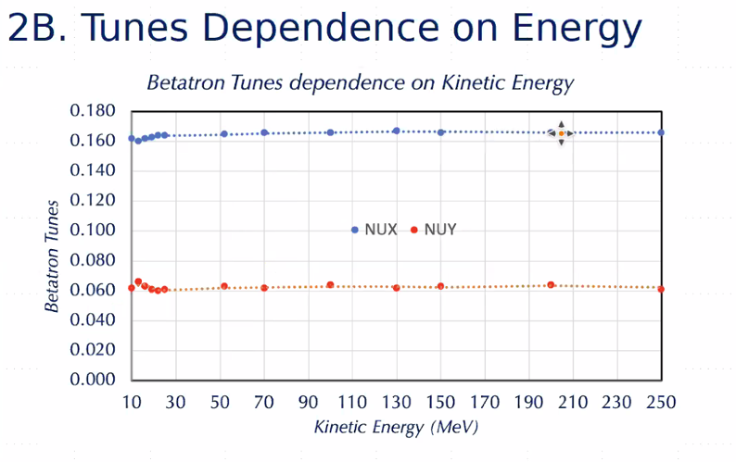
- Stephen – problems with low E end. Basically the same thing
  - Got tunes to 10-3 – flat with fringe fields
- Maybe problem with translations of multipoles
- This might be a problem in CEBAF – maybe lattices modelled differently
- Good to compare Zgoubi, Bmad, and Muon1
- Please put viewgraphs in presentation folder
- Dejan – not interested to do this with CEBAF
  - Want the tune variations to correct orbits for different energies
- François shares again:
  - 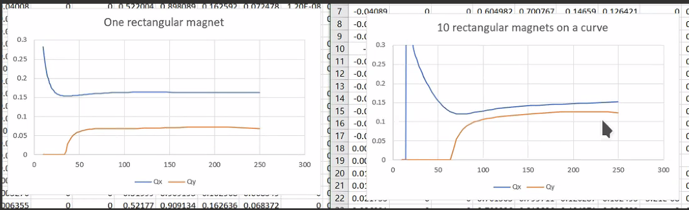
    - Stephen’s results – very similar to Zgoubi
    - No fringes – so something wrong
- Need fringe field – but that’ll always be a model without a field map. If you’re doing it in PTC, it has options to include. FFAs will never be right if you don’t put them on the magnets.
- In François’ model, it’s just hard edge. But Dejan’s is with FF.
  - There is a first order correction added, though. So it’s sort of the “minimum” needed
- Stephen – going to hard edge is wrong – less realistic
- Model:
  - 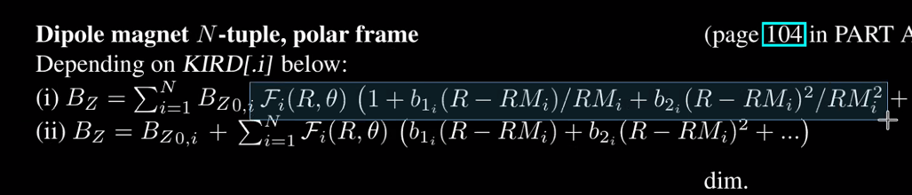
- 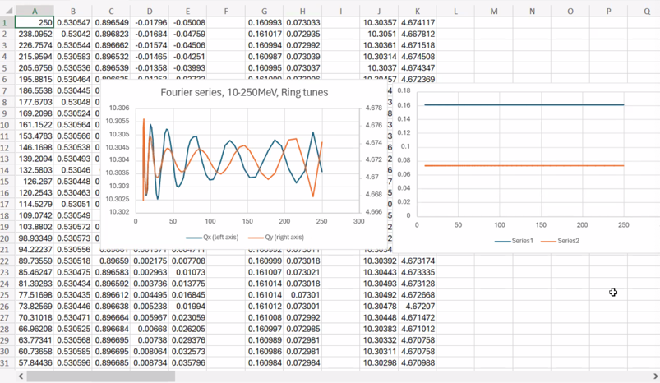
  - Fourier coefs are nicer
  - Cell tunes on right
  - Ring tunes magnified on left
- Sextupole expansion: still needs more work and optimization
- Donish will be looking at DA studies
- Will revisit correction schemes – also likely Donish
- Next week – see if Alex C can give a summary of work
- Ryan has matching for the splitters – will revisit
Action Items | Person responsible | Deadline

Time allotted | 15 mins | Agenda topic AOB | Presenter All

Action Items | Person responsible | Deadline

Special notes

Pathway to Repository: https://jeffersonlab-my.sharepoint.com/:f:/g/personal/tristan_jlab_org/EqZ5MeS-nipCgPfZB5p0oS4B9Is67d3nQb9sLJI3Zyev9g

