FFA@CEBAF Working Group|Minutes

Meeting date | time 03/22/2024 | 11 AM EST | Meeting location https://jlab-org.zoomgov.com/j/1614898082?pwd=TnUzMS81M2sxbDZIbERJU01tYkJCQT09
Meeting called by Alex B  Type of meeting Weekly Meeting  Facilitator Alex B  Note taker Ryan  Timekeeper Alex B | Attendees  Alex B, Ryan, Alex C, Todd, Scott, Edith, Kirsten, Nick, Donish, Stephen, Reza, Dejan, Andrei, Vasiliy, Randika, François, Georg

Intro Discussion
- Spring break time
- FOA – no news yet
- Next LDRD season?
- Andrei encouraging to apply for sextupole option for arcs
  - Donish “getting up to speed with DA”

Agenda topics

Time allotted | 45 mins | Agenda topic FFA Arc Corrections| Presenter Alex C
- A bit sick
- Some slides will change by review time
- While including optics in appendices, scope is all about corrections
- Using the non-sextupole lattice. Use the current baseline instead of the new stuff that’s not solidified.
  - Can update for new lattice
- 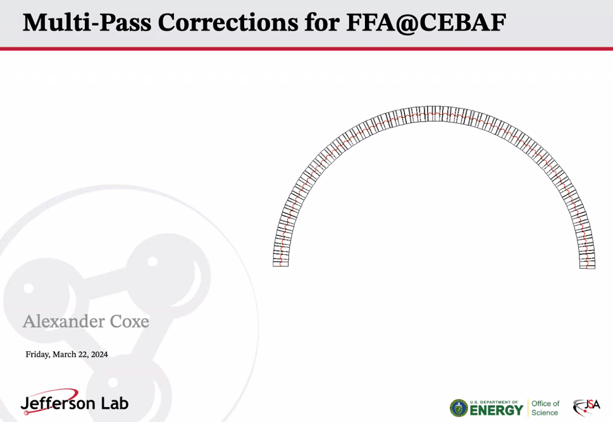
- 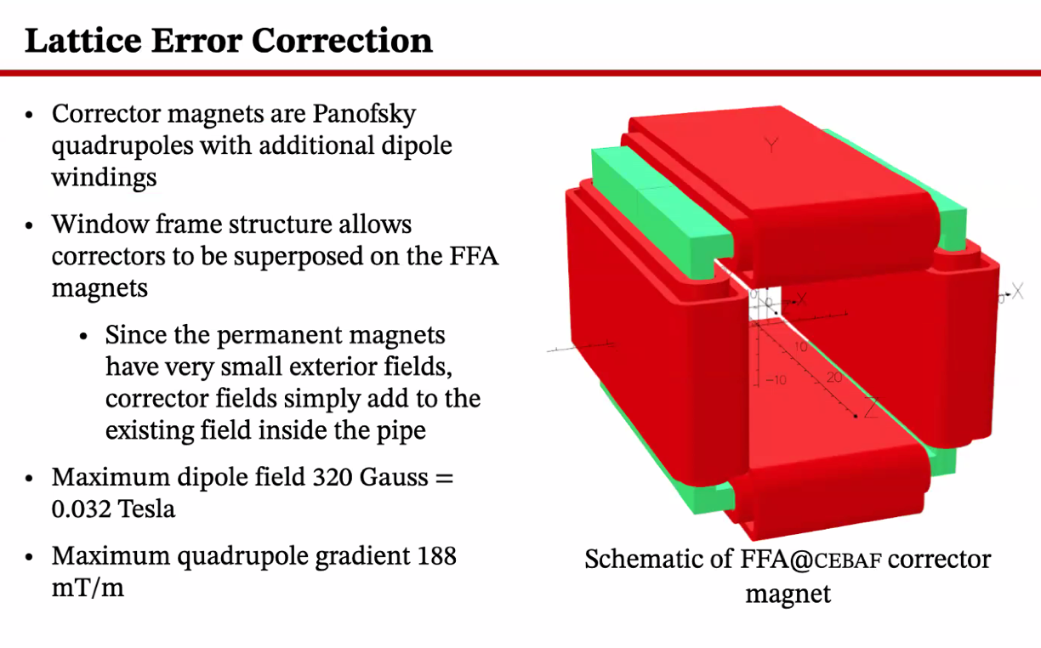
- 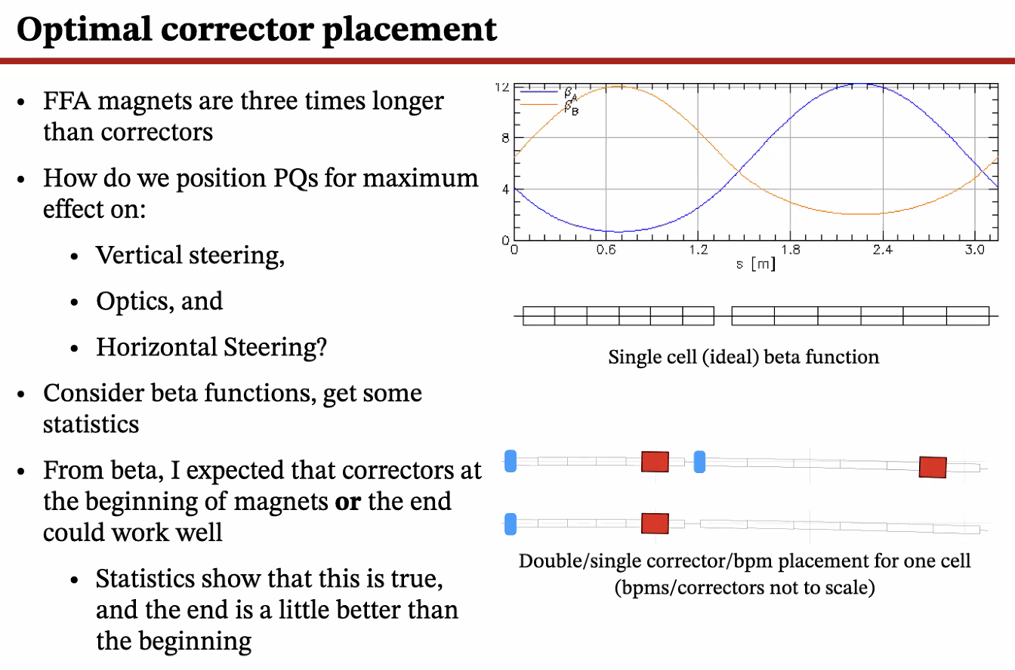
  - Started with a “guess” based on beta functions – so place where non-minimal betas (not at an extremum)
  - Turns out, the optimum placement is at the trailing end (last two segments) of FFA magnets
  - Bottom right corner shows optimal placement
  - 100 BPMs and 100 Correctors
  - 25 cells, 2 correctors and 2 bpm
  - 50 cells with 1 of each
    - Place correctors on focusing magnets for this option
- 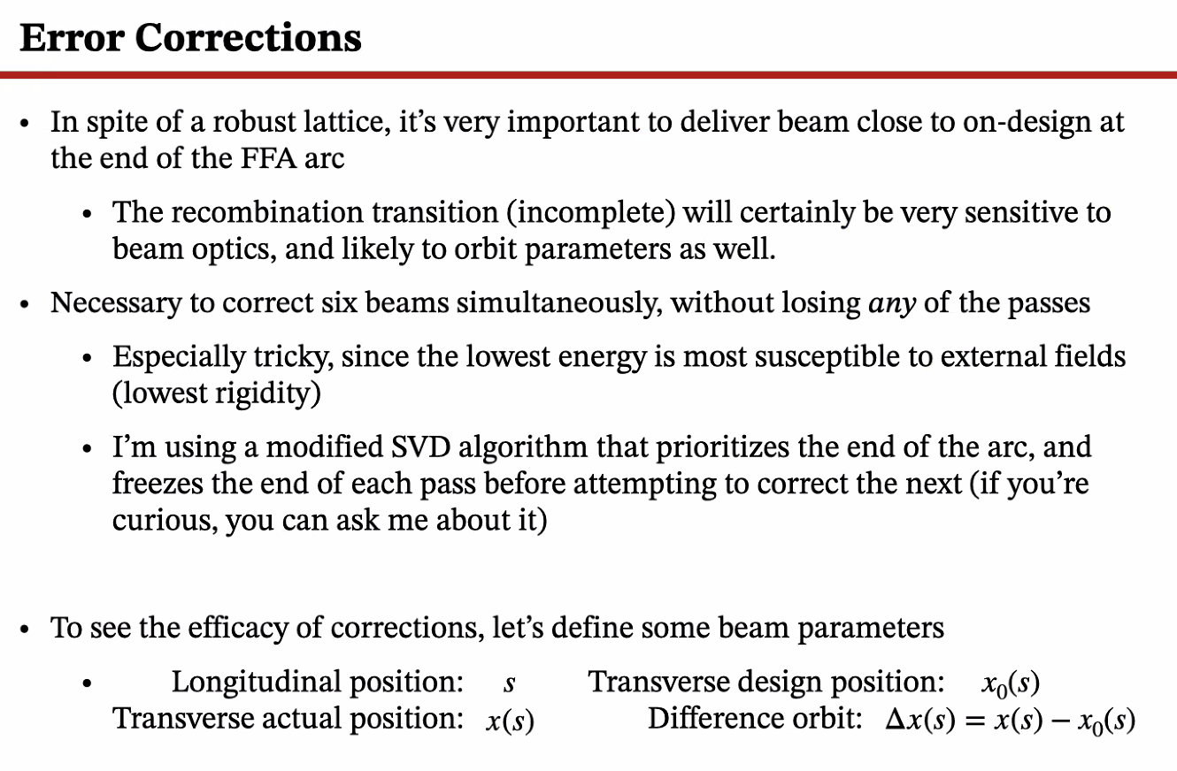
  - If beam comes in with significant position or momentum offset, it’s hard to correct
    - Errors in lattice seem to be easy to “disappear”
  - Recently, realized that high E beam gets lost easier
    - Low E lost easily too, but less rigid
- 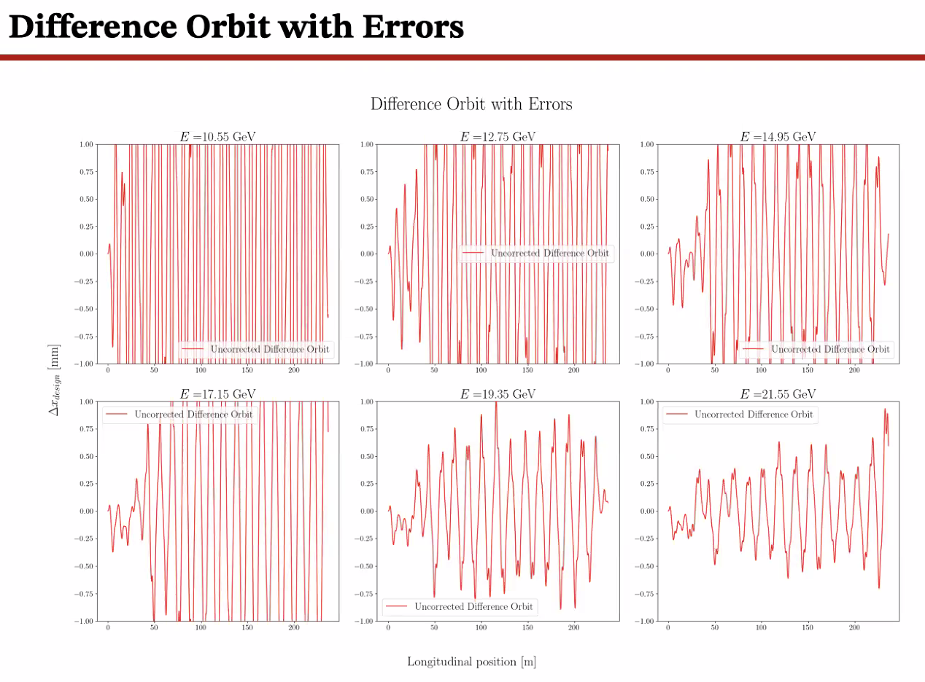
  - Errors of 1/5th of 1 mm
  - Uncorrected orbits – wildly nonzero
  - Highest E most robust
- 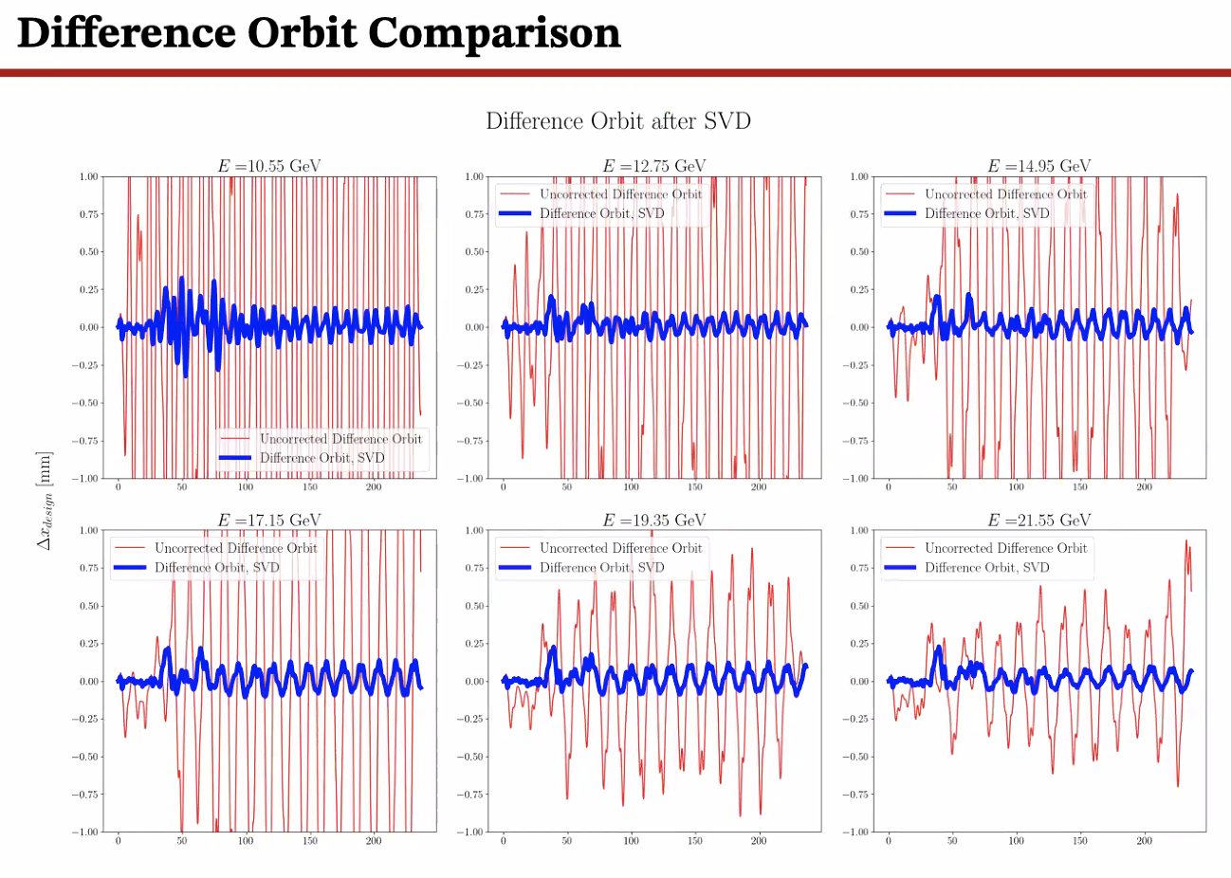
  - Applied SVD algorithm
  - Scale is 1 mm +/-
    - Can deliver beam to within 10s of microns (without input offsets)
- 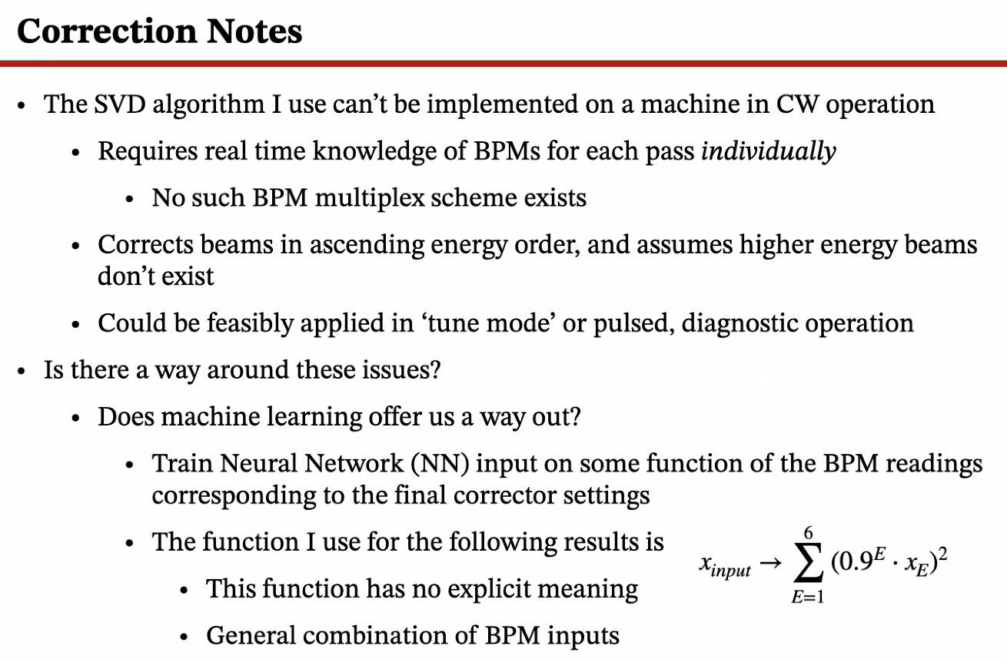
  - Can’t use in CW b/c don’t know individualized orbits with multipass
  - Can apply in tune mode
  - We have 1 Hz orbit lock system – based on data pulled from machine
    - Can we have this in FFA?
- Trained a NN on a function of BPM inputs and final corrector outputs
  - Reduced inputs from 6 to 1 using the function above
    - Took charge center for each energy (x_e) multiplied by 90%^e – about losing 10% of the pass
    - Some not-exactly linear way to get information from BPMs – used this as input for NN
- 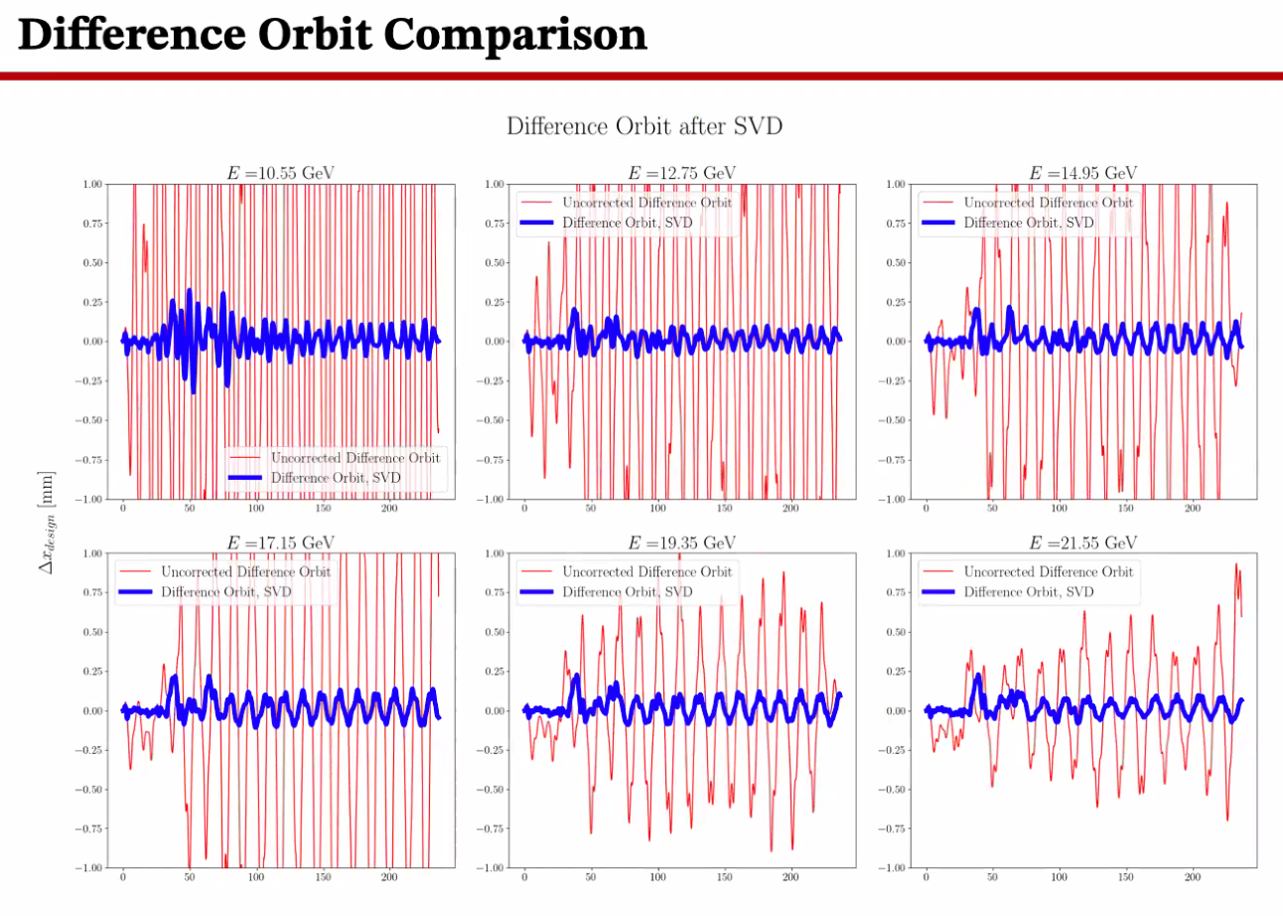
- 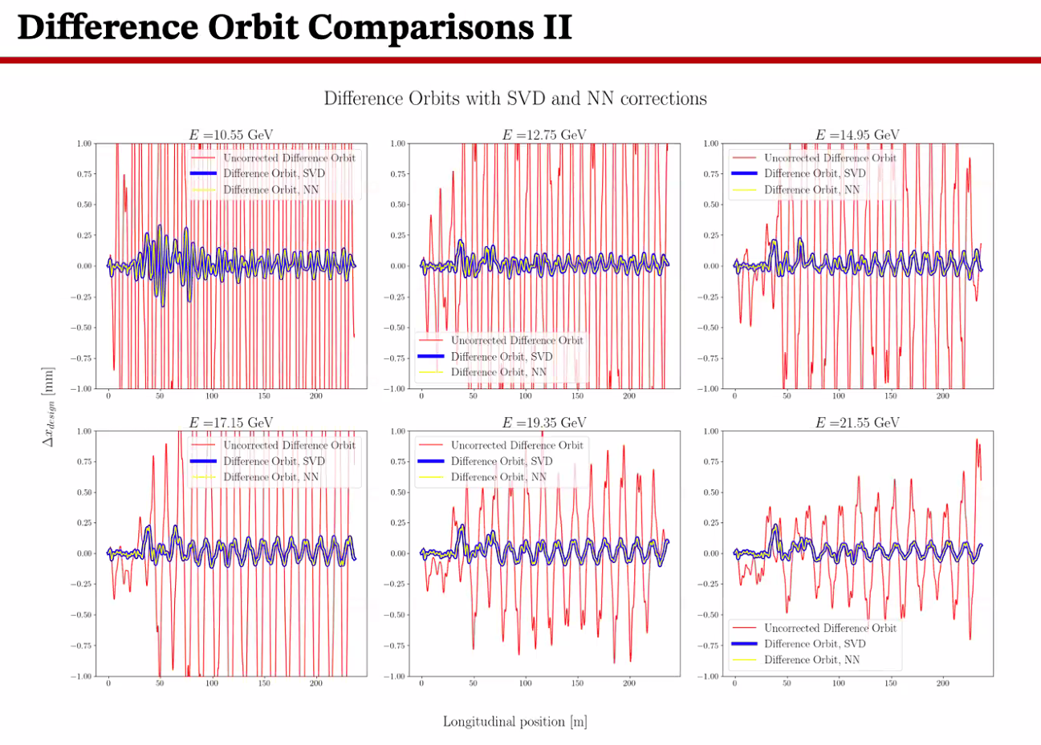
- 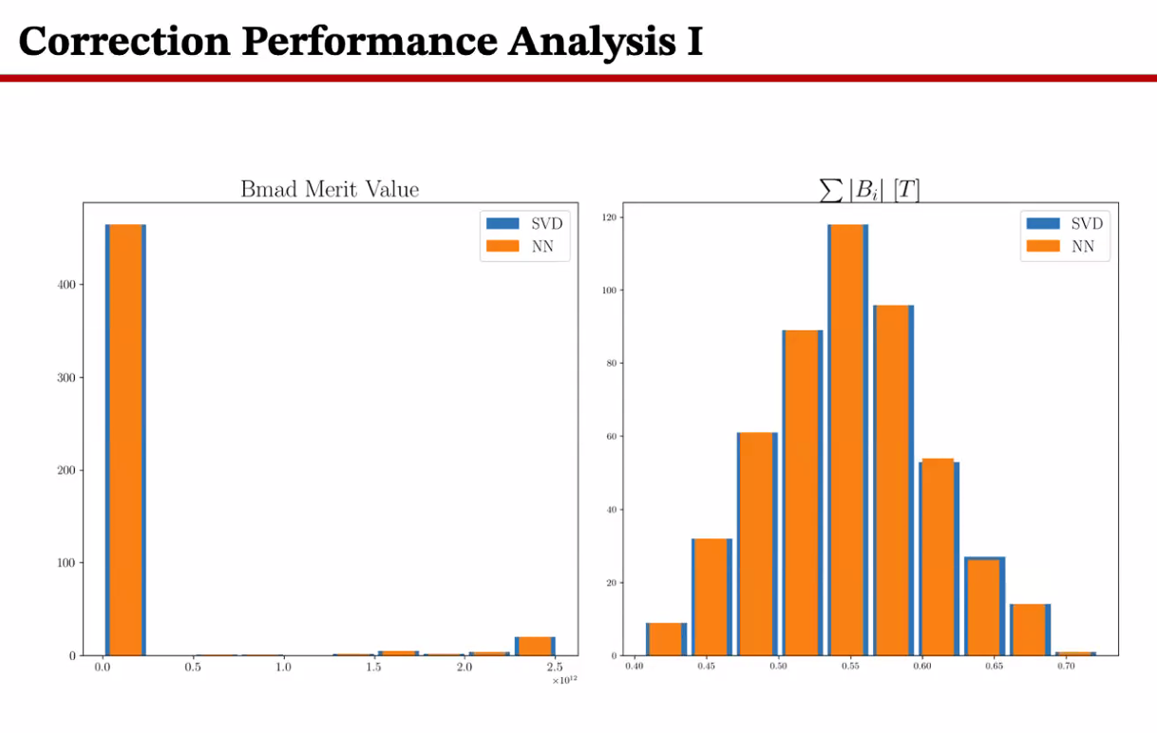
  - Initial beam offsets likely cause of beam loss
- Zooming in:
  - 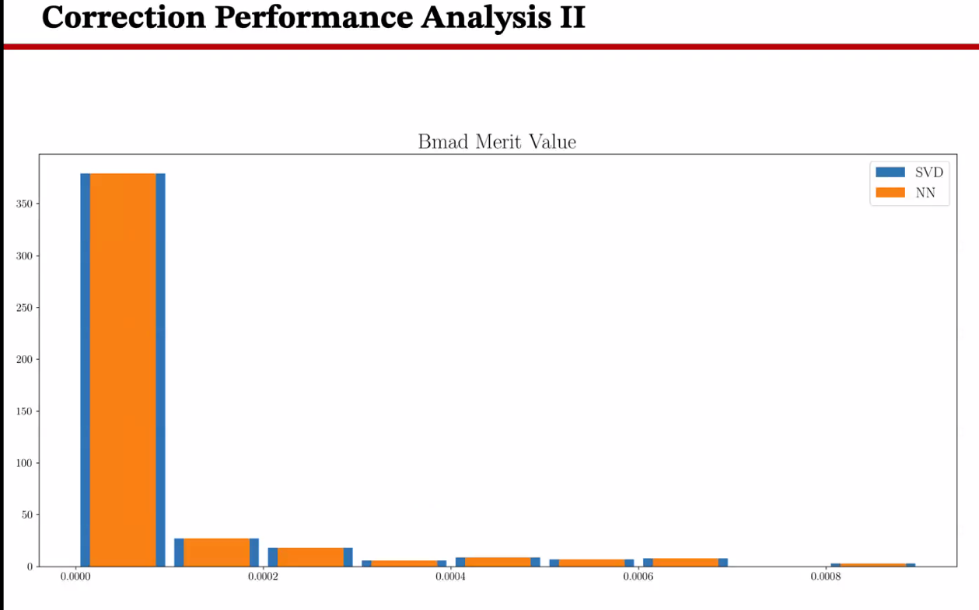
    - For most conditions, work out perfectly well
- 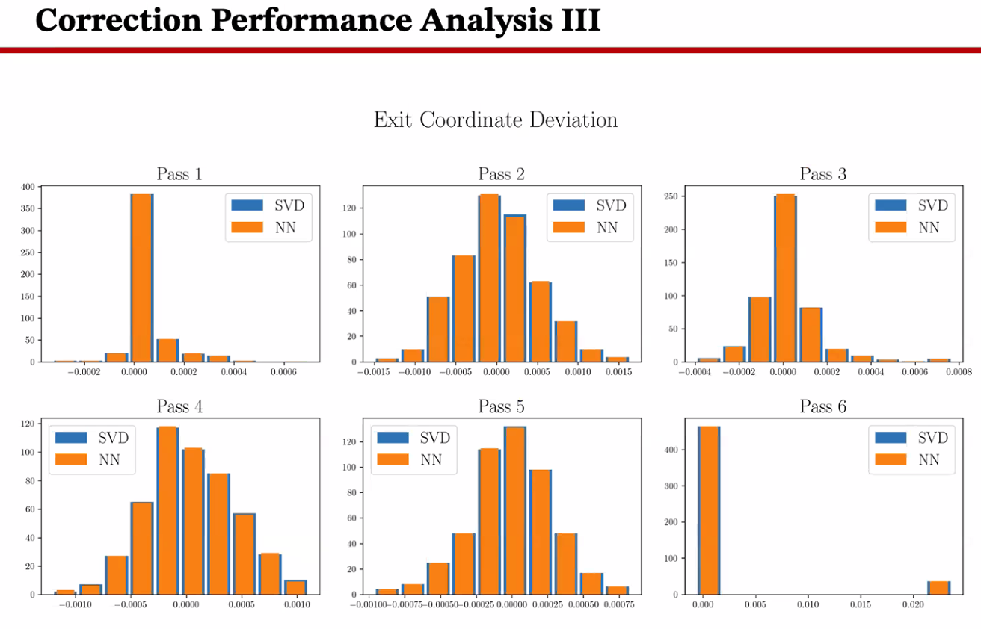
  - Looking at position
  - SVD and NN perform almost exactly the same, except the last pass where a few trials were way off target
    - Still trying to figure out why
- 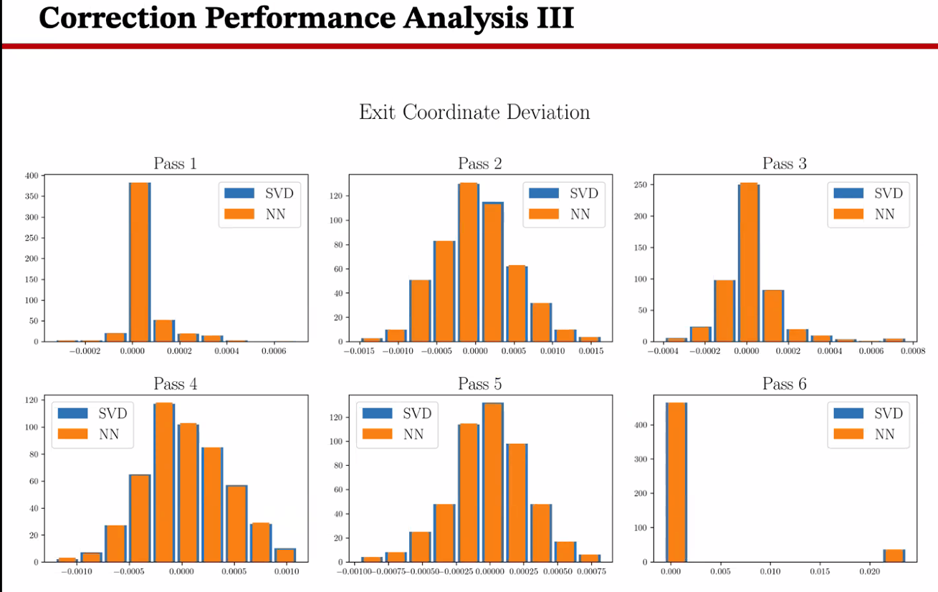
  - Momentum offset
- Dejan – do you have aperture limits installed?
  - Yes, horizontal apertures are ~ 5 cm total
- Nick – very interesting, couple things:
  - Way to do this in operations? Essentially SVD to correct each individual pass first?
    - Alex – not quite, but close. The SVD corrects lowest E pass, waits to the point of not being able to change the last 8 or so BPMs on the lowest E pass, then does the next higher energy, but can’t change what happens at the end
    - As you go up the passes, you can’t change what you’re doing to the end of the previous passes
  - Dejan – there is a phase difference changing for each energy. By picking up the most suitable correction element b/c of the phases. When they’re picked up, then the next pass has a different set of optimum correctors to be used. Etc…
  - Alex – worth noting that the SVD algorithm carries most of the weight of this b/c it uses the least squares ….
    - Nick – ah, so you only use some correctors for each pass
    - Alex – yes, more or less
  - Dejan – 2nd pass would ruin the first pass
  - Alex – that’s the point of “freezing” the final BPMs – make sure the last 6-10 BPMs don’t have any changes – SVD won’t skew fields in previous passes
- Ryan – basically the SVD gives you an orthogonal set of knobs for each pass
- Nick – in CW they can’t see each pass?
  - Alex – right.
  - Alex B – in pulse mode, can get individual passes
  - Alex C – but in CW, you can’t.
- Ryan – the point of looking at the CW diagnostics is to not “fly blind”
  - Alex C – hard to see how we do the orbit feedback in FFAs – have ideas from 1 Hz system in CEBAF now
  - Nick – do we need faster?
    - Not sure, but Alex C’s scheme can be used at any frequency
- Nick – Panofsky quads superimposed? Slide 3
  - They fit over the permanent magnets?
  - Dejan – the nu of the permanent magnet material is ~1.03ish – so superposition works beautifully b/c fields from correctors goes through the PMs and goes to the beam
  - Nick – does quad field also correct?
    - Yes – correct in this order: vertical steering alone, then turns off and does quads, then turns off quads and does horizontal steering
      - If there’s a better order tell him
        - Depends – magnets are much longer now. Quad correction may not be necessary
  - Nick – so you correct optics with quads?
    - Not sure what diagnostics yet. For now, been assuming “something” will work
- Dejan – distance b/w lowest and highest orbit not to be neglected
  - Used 4 button BPMs at CBETA
  - Were considering 6 button as well
- Nick – energy locks?
  - Ryan – that’s part of the FFB system – vernier in the LINACs
- Dejan – right now, only single quads in the cells. If we do triplets, how would this change? Which way would we go for the triplets?
  - Alex C – scope of dissertation doesn’t include LINACs – only thought about LINACs a bit
- Alex B – we don’t correct optics in LINACs – do it in recombiners, etc… before we get into LINACs
  - Multiplexing very useful in pulse mode when we thread beam through
  - Algorithm corrects for zeroeth order optics
- Alex B – looking into upgrading BPM system – in your scheme, what are the initial requirements?
  - How many, how many buttons, etc? Just strictly theoretically?
  - Alex C – requirement – not sure minimum req
    - Assumes that over the whole FFA arc, there is 100 button BPMs in different locations
      - In the first 10 cells after the splitter, you’d have 2 BPMs
      - Next 50 only 1
      - Last 15 have two again
    - More important for general passthrough. FFA arcs pretty robust. Important in beginning to correct input errors, and very important at end of arc to deliver very precisely
      - So doubled up at beginning and end
      - In the middle, as long as you’re coming in ok, it is really robust – correction not as needed in the middle
  - Have you done an optimization on this?
    - No, not yet. Don’t want too many, but not too few
  - Not a full optimization. Want at least 1 per pass to have an idea of what the phase is doing per pass
    - Started with 2, then reduced until the delivery at the end was flagging
- For the Panofsky quad – does this need optimization?
  - If this magnet could be a little stronger, that would be nice
  - Algorithm currently not pushing power supplies.
  - Scott – current density?
    - Can find that out
- Alex C – know smallest amount you can change by
- Scott – you could also make them longer
- Alex C – assuming beam injected close to x, xp – these are great and delivers almost perfectly
- Alex B – so headroom wouldn’t hurt?
  - Wouldn’t hurt
- There was some cooling requirements – air vs water cooled?
  - Water cooling a corrector magnet would be moderately unusual (“EXTRA”)
- Dejan – keep temperature steady. Used 80-85 F at CBETA
- Scott – what in the main part of the arc with 1/cell – are you putting them in the same place in every cell?
  - Yes. Vertical beta is a bit bigger, but they’re similar magnitudes off of zero when you take the central point of the wave
- Dejan – sqrt(beta)*theta
  - Right – but trying to balance for both planes. So compromising and not doing at a peak of either
- Topic got changed to CBETA? Hard to follow without inside knowledge
Action Items | Person responsible | Deadline

Time allotted | 15 mins | Agenda topic AOB | Presenter All
- A lot of discussion about CBETA and other stuff. Ryan stopped taking notes at this point.
- Discussion of next LDRD cycle – sextupole arcs, DA studies, etc…
  - 5 pass vs 6 pass
  - Ryan – 5 pass is better not just for arcs, but also for Splitters/Transition
  - Alex C – if we can get the transition that works, then look at changes. Instead of changing the arcs, maybe get a finished system first
    - Not saying kill it – might not be highest priority yet
- Alex B – this is a subject we just started, and if we can get funding, it could be a useful study to do
- Dejan – main reason why this is important, if we can add sextupole and extend energy reach good
- Alex B – thorough studies need to be done to conclude
  - Good subject for LDRD
- Dejan – serious question from Hutton – why not remove splitters totally?
Action Items | Person responsible | Deadline

Special notes

Pathway to Repository: https://jeffersonlab-my.sharepoint.com/:f:/g/personal/tristan_jlab_org/EqZ5MeS-nipCgPfZB5p0oS4B9Is67d3nQb9sLJI3Zyev9g

No Meeting for Next Two Weeks

