FFA@CEBAF Working Group|Minutes

Meeting date | time 04/12/2024 | 11 AM EST | Meeting location https://jlab-org.zoomgov.com/j/1614898082?pwd=TnUzMS81M2sxbDZIbERJU01tYkJCQT09
Meeting called by Alex B  Type of meeting Weekly Meeting  Facilitator Alex B  Note taker Ryan  Timekeeper Alex B | Attendees  Alex B, Ryan, Alex C, Donish, Edith, Nick, Scott, Kirsten, Roger, Dejan, Vasiliy, Tim, François, Thomas

Intro Discussion
- Let’s add our work to the IPAC24 folder for the collab
  - Due date May 15 – but must go through internal review. So put them in the internal reviews early enough for review before final date.
  - Make sure co-authors are all fully aware of what they’re on

Agenda topics

Time allotted | 25 mins | Agenda topic Transition| Presenter Randika/Vasiliy
- Randika can’t be here today – will have to update at a later time.
  - All in Randi’s hands – he’s the one doing the work and should be present. Let’s wait a few weeks.
Action Items | Person responsible | Deadline

Time allotted | 25 mins | Agenda topic LDRD | Presenter Donish
- Exciting option to explore – do we expand energy with sextupoles or not?
  - Alex B and Andrei in “upgrade study group” and decided this should be studied
- Donish is “PI” for proposal – working on concept paper
- 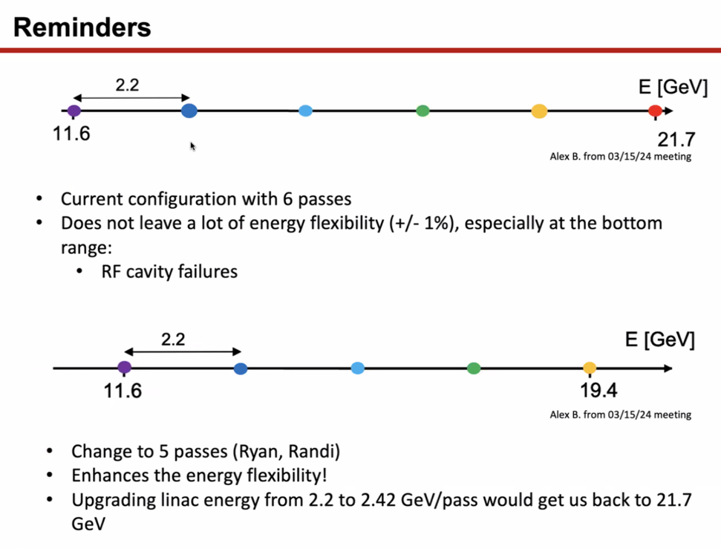
  - Not a lot of energy flexibility – 1% change in energy falls out of range of FFA arcs
  - Can decrease energy to 5 passes, making it 19.4 GeV and increases energy flexibility
  - Roger – if energy of LINAC is upgraded, can you use the same FFA arc?
    - Potentially, yes
  - Alex C – the studies we currently have show that if we increase the LINAC now with current baseline, not good -aperture not good
    - Drop last pass, ton of headroom, lots of space at the bottom
- 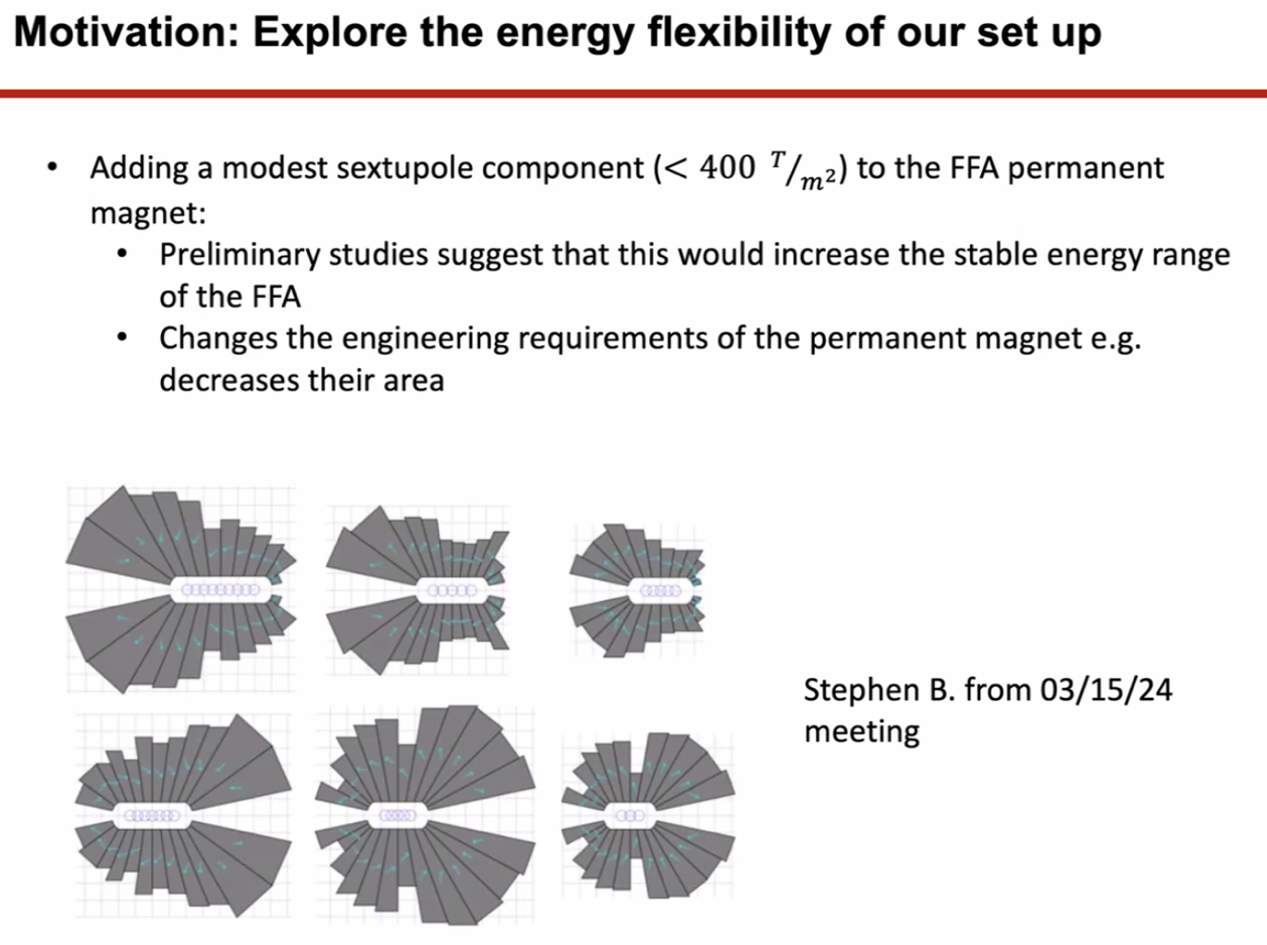
  - What happens if add higher-order components?
  - Prelim studies say it’ll increase energy range, decreases area of magnets
- 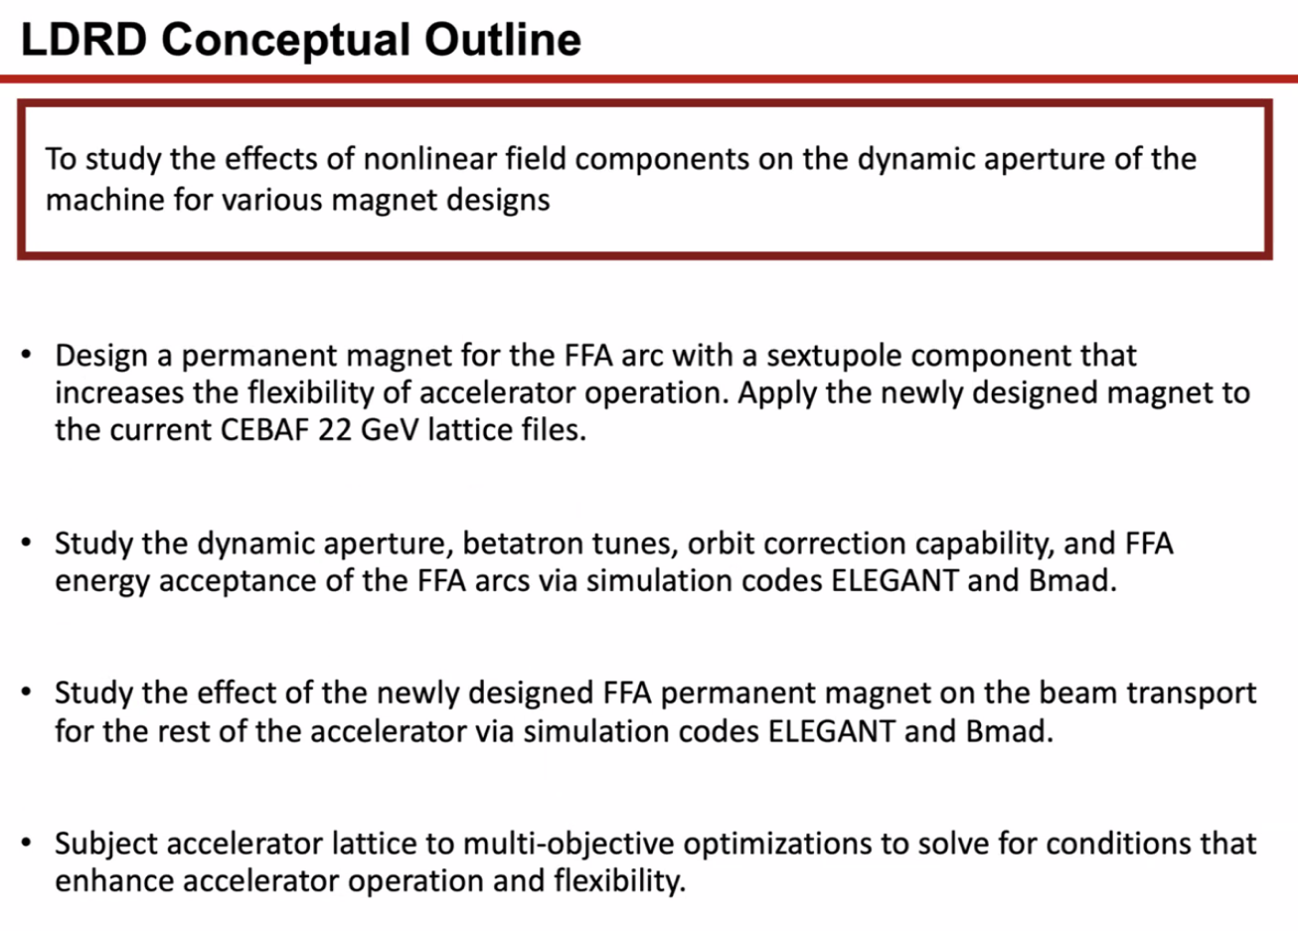
- Alex B – could you show the concept paper a bit as well?
- 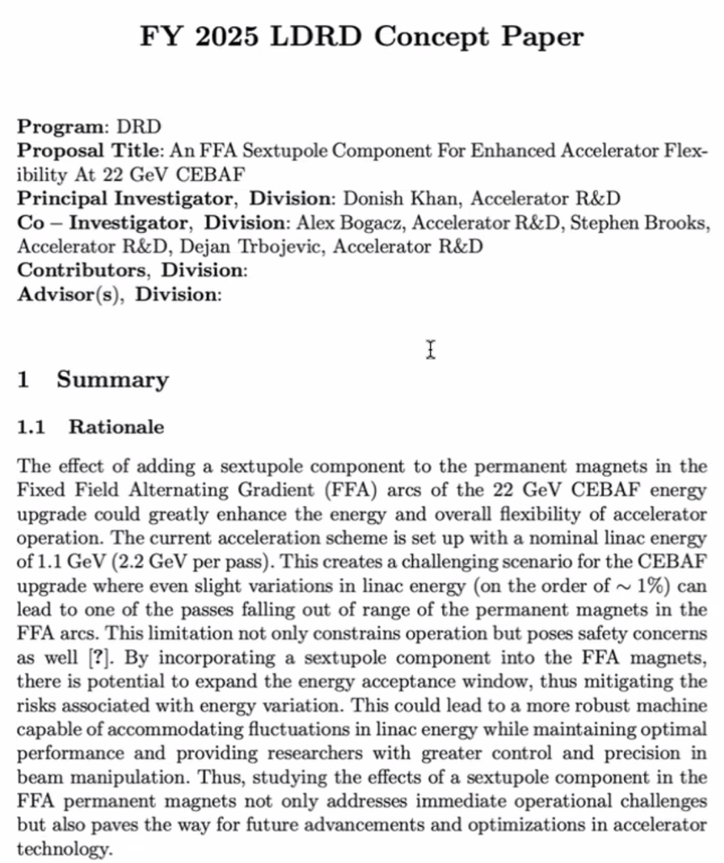
  - Frame as energy flexibility study instead of just adding sextupoles
- Ryan – two things:
  - 1 you have to be staff to be a PI
    - Alex B – Donish is in transition to Staff 1 now.
  - 2 you have to keep as much of this in house as possible – external people have to do the work here
    - Roger says this is definitely important – may not get funded if money goes out of the lab
- Dejan – spoke to Andrew Hutton about deleting splitters overall
- We can focus the title on energy flexibility instead of sextupoles
- 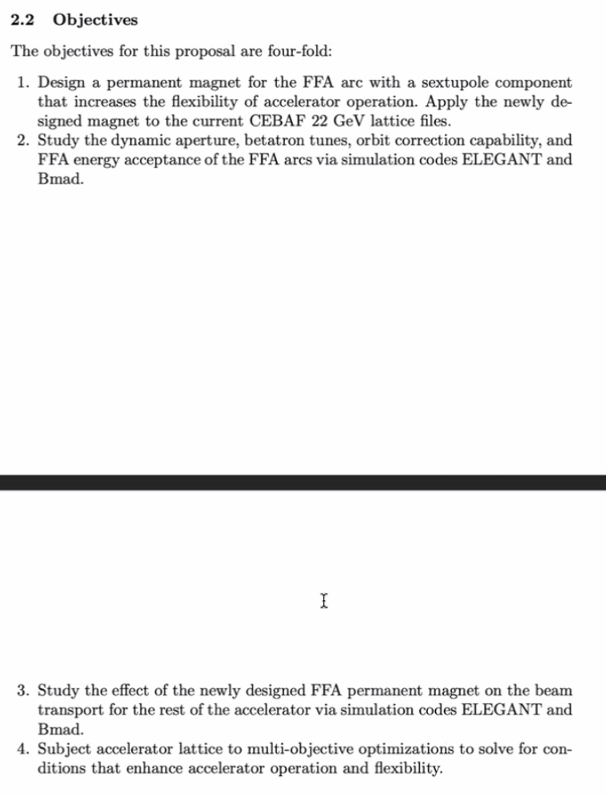
  - JLab will still send 0.5 FTE to BNL nonetheless (Alex B)
- Ryan – if we get both the FOA and the LDRD, have to make sure the funding doesn’t overlap FTEs
- Scott – raining on Donish’s parade
  - Energy flexibility point is a good one.
  - Issue is that we start with sextupole in arc, but then when you start looking at subsequent steps, they involve things that we essentially don’t have down yet
    - Need a set of beamlines from LINAC to FFA and back again
      - Energy flexibility important at this design as well (Splitters and Transition)
      - Even looking at transitions – these rely on nailing specific energies
    - Need a “full solution” first at entire energy range
  - Would think in terms of refocusing this: goal is to really work out in detail that transport between LINAC > FFA > Back to LINAC is achievable
  - The really hard work that needs to be done are the connection points
    - Could venture into splitters and transitions
- Dejan – if we have splitters, it’s always allowed to adjust the currents in the elements/splitters
  - Scott – yes, but have multiple beams going through elements. Need to make sure you can have enough steering control to control common beams.
  - RYAN HAD TO DO A FEW MOMENTS OF OPTICS ON CALL AND MISSED A MINUTE
  - Scott – need one trackable solution
- Ryan – make sure you have two years of work, with milestones, etc…
- Dejan – work in progress:
  - 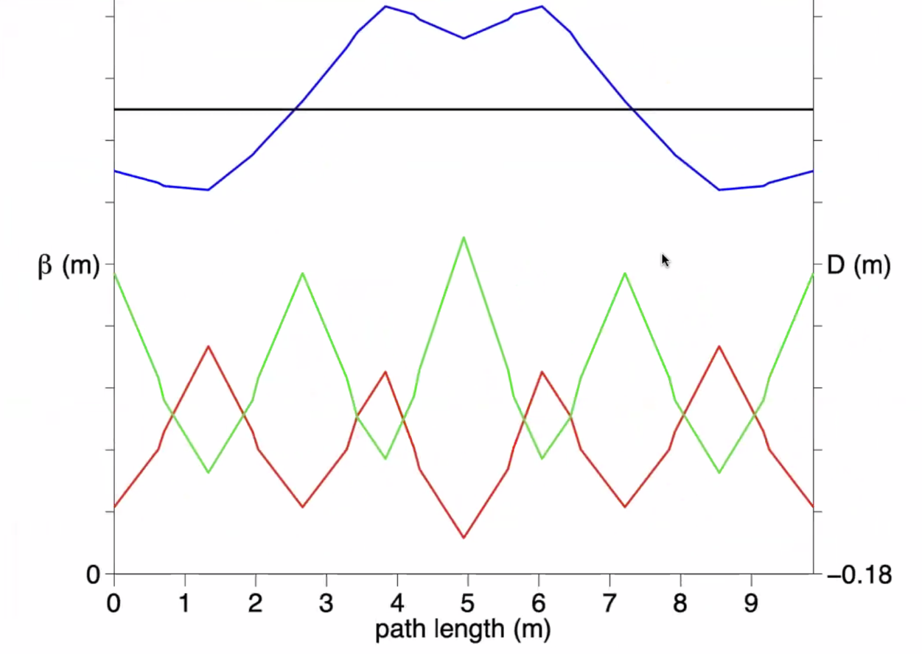
  - 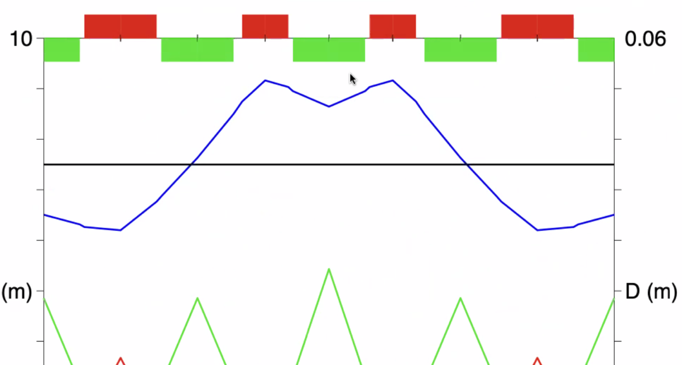
    - Dispersion varies between -2 cm to +4 cm
    - Isochronous – mom. comp. = 0
  - Betas similar to now
  - Flip signs in middle
  - Values of gradients: 160 T/m, 88 T/m
    - Possible to do with Stephen’s magnets
    - Will add multipoles (sextupoles)
    - Curly H very small
- This is alternative to FODO style we have in FFA now
- This is about 10 m long
- Central energy same as before to reduce SR – 21.97 GeV – close to end of range
- Length of mag = 1.25 m
- Alex B – nice variation on FODO – still has alternating feature
  - Dispersion/momentum compaction smaller – great deal
  - Smaller emittance dispersion / curly H
- Donish can take these and start playing
- Scott – gradients?
  - -87.9 and 78.4 in FODO
  - 161 and 88 where you switch phase
- Scott – 4 defocusing and 4 focusing – so two kinds of focusing, 3 kinds of defocusing
- Variables – central two focusing are 160 T/m – middle defocusing are 88
- Scott – you have 5 DoF in here
  - If this is the central energy, if you plot ToF as function of E, you’d be at a minimum here
  - To flatten that out, put in sextupoles – they’ll need to be strong b/c of low dispersion function
  - Sextupoles will need to do three things:
  - 1 flatten out ToF, 2 keep control of chromaticity,
  - Dejan – also need to control amplitude tune shift (will need more families)
- 19 cm between F and D, 15 cm between FODO and Strong Mags in middle
  - Not enough for ports/vacuum – will need to accommodate
    - Maybe split the defocusing in middle to give pump station, etc…
- This might eliminate splitters?
  - Pimplets (?)
  - ISIS upgrade
- Tomas – what’s your impression of Dejan’s idea
  - Came late
  - Don’t understand enough yet to have an opinion – will try to join more often
- Ryan – sent Donish the old concept paper as a template
- Dejan – if this idea works, it opens up enormous space and changes ERLs
  - Can go down to energy of ERL
  - Opens up new field in Accelerator Physics
- Alex C – gives top/bottom ends on energy ranges
  - 22.8 - 22.6 max end
  - 11.6 - 10.6 low end
Action Items | Person responsible | Deadline

Special notes

Pathway to Repository: https://jeffersonlab-my.sharepoint.com/:f:/g/personal/tristan_jlab_org/EqZ5MeS-nipCgPfZB5p0oS4B9Is67d3nQb9sLJI3Zyev9g

