FFA@CEBAF Working Group|Minutes

## Meeting date | time 04/19/2024 | 11 AM EST | Meeting location <https://jlab-org.zoomgov.com/j/1614898082?pwd=TnUzMS81M2sxbDZIbERJU01tYkJCQT09>

|  |  |  |  |  |  |  |  |  |  |  |  |
| --- | --- | --- | --- | --- | --- | --- | --- | --- | --- | --- | --- |
| |  |  | | --- | --- | | Meeting called by | Alex B | | Type of meeting | Weekly Meeting | | Facilitator | Alex B | | Note taker | Ryan | | Timekeeper | Alex B | | Attendees  Alex B, Ryan, Alex C, Donish, Edith, Kirsten, Randika, Timur, Dejan, Todd, Andrei, Reza, Stephen, Vasiliy, Scott, Tim, Sushil Sharma |

# Intro Discussion

* Dejan happy with his work – apparently will be part of LDRD
  + Salim may help
* FODO arc is a “boring lattice” – if we can massage dispersion and make 25 supercells, might be more interesting
  + Dejan – DOE likes FODO
  + AlexB – we can call it “FODO-like”
* Good to have alternatives in pre-conceptual design
  + Will put extension of perturbed FODO into concept paper
* Dejan – trying to see if other codes show same thing. Translating to 3 other codes.
* Alex Coxe update – responding to review comment: 6th pass not so limited. Aperture limit imposed that was incorrect
* Ryan mentions uploading things to IPAC folder

# Agenda topics

## Time allotted | 25 mins | Agenda topic NSLS-II Magnets| Presenter Timur Shaftan

* Timur Shaftan joins with mechanical group leader
* Exciting designes for permanent magnets for light sources – started at Grenoble, continued by BNL
* **Graphical user interface, diagram

  Description automatically generated**
  + Replace magnet assemblies with complex bend lattice
  + 6 combined function focusing PMQs
  + Replace 1 dipole and collection of quads
  + Worked with Stephen Brooks on this
* **Graphical user interface, application

  Description automatically generated**
  + Compact
  + ~130 T/m, 16 mm aperture
  + Reduce energy consumption by over 80%
  + Iron-core dominated hybrid option under fabrication
    - Good control over field quality
    - Space for BPMs – vacuum chamber not so tightly integrated with PMs
* Pursuing 2 designs – Hallbach and Hybrid
* Concerns on PM radiation hardness – looking into this
  + 10 kW xray in broad spectrum
  + Measuring the PMQs
  + Rotating coil good for measuring small aperture magnets
  + Plan to measure – before and after install
* Running 29 beamlines with IDs – 1-3 m long undulators (4.7 mm gap)
  + Extract 8-10 kW
  + Sensitive detectors
  + No degradation of spectrum in beamlines
* Recently hired PhD engineer from DESY – good with radia program. Day-scale turnover
* Alex B – can you define the radiation environment?
* Graphical user interface, application

  Description automatically generated
  + Two ways to adjust: magic fingers w/ small PMs
    - Different combinations can adjust harmonics
  + Numerical simulations can adjust ~50 units of harmonics
  + Another method tried and works – EDM the internal aperture of Halbach quads
    - Adjust up to 200 units by profiling internal apertures of Halbachs
  + For hybrids, allowed enough room to adjust harmonics
* Scott – burning question: EDMing permanent magnets. Thought blocks come coated. Does that mean you’re EDMing the coating?
  + The coating is required for NeFeB, but we are working with SmCo
  + Problems cutting through parts – had to try a few times
  + Does EDM do heating?
    - Yes, it demagnetizes about 10-15 microns – taken into acct during optimization
    - If we stick with this design, EDM is not production-friendly. Will eventually move the gradient
    - Modifying internal aperture adjusts harmonics. But in production, we’ll do this differently by moving them in and out
* Dejan – isn’t that hard?
  + Just do a few, then automate
  + What is reason for large error in harmonics when assemble magnets?
    - 1 – magnetization angles if you want to go with the usual range could be off by 2%
    - Got better as well, but 1% level is still large at times
  + Maybe assembly is the problem?
    - Can be – internal aperture could be off by 100-200 microns
* **Diagram, engineering drawing

  Description automatically generated**
  + Made from spare parts
* Ryan – do you directly measure dose?
  + Yes – RadCon can
  + Also use PMQs – effect from electron beam
* **Graphical user interface, text, application

  Description automatically generated**
  + Multi-bend-achromat, but adjusted
  + More space for elements in arc
  + Emittance is near diffraction limit
* **Timeline

  Description automatically generated**
  + Complex bends are 1.5 m each
* **Timeline

  Description automatically generated**
  + Flips gradients in PMQs
* Chart, line chart

  Description automatically generated
* **Diagram

  Description automatically generated**
* Doing error simulations now
* **A picture containing chart

  Description automatically generated**
* Presented to basic sciences committee – they say approach is excellent, they are hoping for significant funds to finish both Halbach and Hybrid configurations
  + Will place in tunnel
* Dejan – did you get picometer emittance?
  + At moment, 23 pm-mrad
  + If go round beam, and insertion devices helping
* Dejan – would you replace all magnets with PMs?
  + Not all, sextupoles have too high requirements
  + Stephen – you can impose sextupoles on combined function mangets, but then you can’t change the sextupoles
  + Combine sextupole corrections around Halbachs – allows superposition – likely in the future
  + Timur – not for us
* Scott – wondering for Halbachs, why not choose wires in aperture method of correction used by Stephen. For correcting errors in Halbachs, wires in aperture can be used for this.
  + If you want to achieve very high gradient, there’s no room. The vacuum chamber is right against (0.5mm gap) magnets. There’s not structure to accommodate the wires – the wires themselves are 1-2 mm themselves.
  + Stephen – like the wire EDM system, but you have to get it right the first time. But it’s great for small aperture magnets.
* Will make new branches for further testing of magnets
* Ryan – SmCo is very brittle – how are you dealing with it?
  + They had that issue too
  + 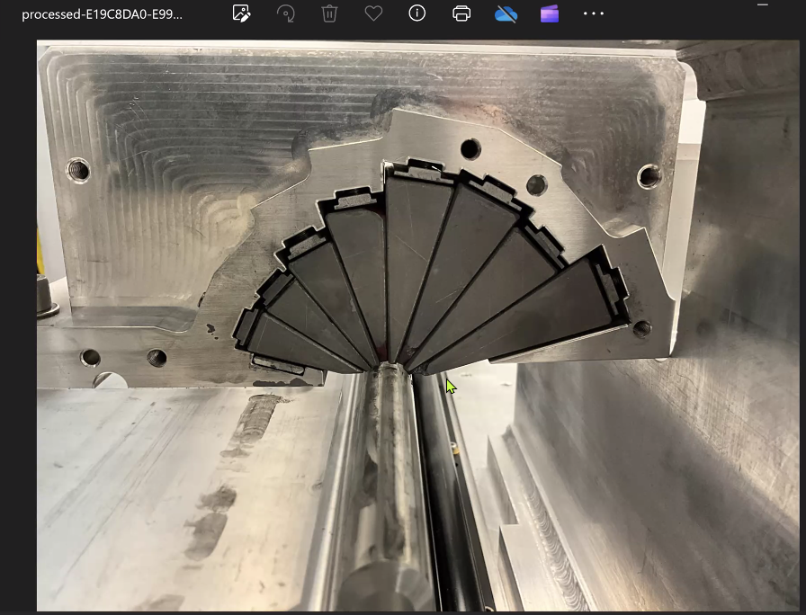
  + Chippng didn’t cause much change in harmonics as assembly errors
  + Now have in-house assembly method with no chipping
* Dejan – KYMA work, and brass spacers to use epoxy
* Scott – our magnets were coated, right?
* Sushil – suggested coating to reduce chipping, but it didn’t help.
* **A picture containing text, person, indoor

  Description automatically generated**
  + Halbach on left, hybrid on right
* Dejan – Scott found that 12 magnets in a row had crosstalk between iron pieces, so went with Halbach
  + Scott – found that this was manageable. Able to do the calculations for crosstalk. When close together, flux from iron in close magnets is real
  + Sensitivity to worry about, but no worse than error analysis done for placement of Halbachs, except more involved – with Halbachs, just superimpose. With iron, do the full simulation with multiple magnets to see errors in each.
* Stephen – crosstalk made us lose strength with Iron magnets. F magnet lost strength to D magnet.
  + Scott – my recollection is that Dejan thought they were too big
* Dejan – took 1 year to convince 3 comittees to go with Halbach
* Stephen – reason magnets were big b/c they had to be made bigger to deal with crosstalk
* Timur – we already discussed. Don’t compare FFA to light source
* Reza – quick question: those “magic fingers” are half a circle? The number of wedges you have, were they the same number of wedges you have for PMs, or you want to keep multipoles corrected?
  + Wedges is determined by mechanical issues. More fingers you have, the better. 8 wedges in Halbach, have 16 or more in magic fingers.

|  |  |  |
| --- | --- | --- |
| Action Items | Person responsible | Deadline |
|  |  |  |
|  |  |  |

## Time allotted | 25 mins | Agenda topic LDRD | Presenter Donish

* How expand scope? Package differently?
* Graphical user interface, text, application, email

  Description automatically generated
  + Ryan – be careful pitching 22 GeV instead of energy upgrade. 12 GeV was a mistake.
  + Alex B – but we already pushed it, so we’ll stay there.
* To address Scott’s concerns – including splitters and transition. Dejan’s work will change requirements on splitters, or remove the need of them
* Ryan – be careful how you pitch the S2E – rules state it can’t be a continuation of a previous LDRD/study
* Scott – didn’t want an expansion of scope. Wanted to redirect scope instead. Need S2E, but understand that have to be careful how you pitch it.
  + Want to steer so that more in direction of accomplishing S2E.
  + First bullet – delete –
    - When I go to PAC, and see “generative AI” I just stop.
  + Leverage the funding to get to the point where we have a tracked design to present
* Alex B – can change last bullet. It’s about different changes to overall design.
* Ryan – Scott – are you saying we’re splitting focus?
  + Scott – no, we’re trying to go from 0 to 1. Not 1 to 2 or 0 to 2.
* Dejan – Scott is right. We don’t have a complete solution. That’s the starting point. Need to finish connection of pieces. Then we explore other pieces.
  + Alex C agrees.
* Alex B – so maybe truncate study. Not at level where we’ll be improving things, but at the level on how other systems can take some functionality to make it easier to achieve splitters

|  |  |  |
| --- | --- | --- |
| Action Items | Person responsible | Deadline |
|  |  |  |
|  |  |  |

## Special notes

Pathway to Repository: <https://jeffersonlab-my.sharepoint.com/:f:/g/personal/tristan_jlab_org/EqZ5MeS-nipCgPfZB5p0oS4B9Is67d3nQb9sLJI3Zyev9g>