FFA@CEBAF Working Group|Minutes

Meeting date | time 04/26/2024 | 11 AM EST | Meeting location https://jlab-org.zoomgov.com/j/1614898082?pwd=TnUzMS81M2sxbDZIbERJU01tYkJCQT09
Meeting called by Alex B  Type of meeting Weekly Meeting  Facilitator Alex B  Note taker Ryan, Alex C  Timekeeper Alex B | Attendees  Alex B, Ryan, Scott, Edith, DAQ, Alex C, Randika, Stephen, Dejan, Kirsten, Todd, Vasiliy, Roger, Salim, Andrei, François

Intro Discussion
- Discussion of another meeting with Alex B and Scott in Japan

Agenda topics

Time allotted | 25 mins | Agenda topic Transition| Presenter Randika
- 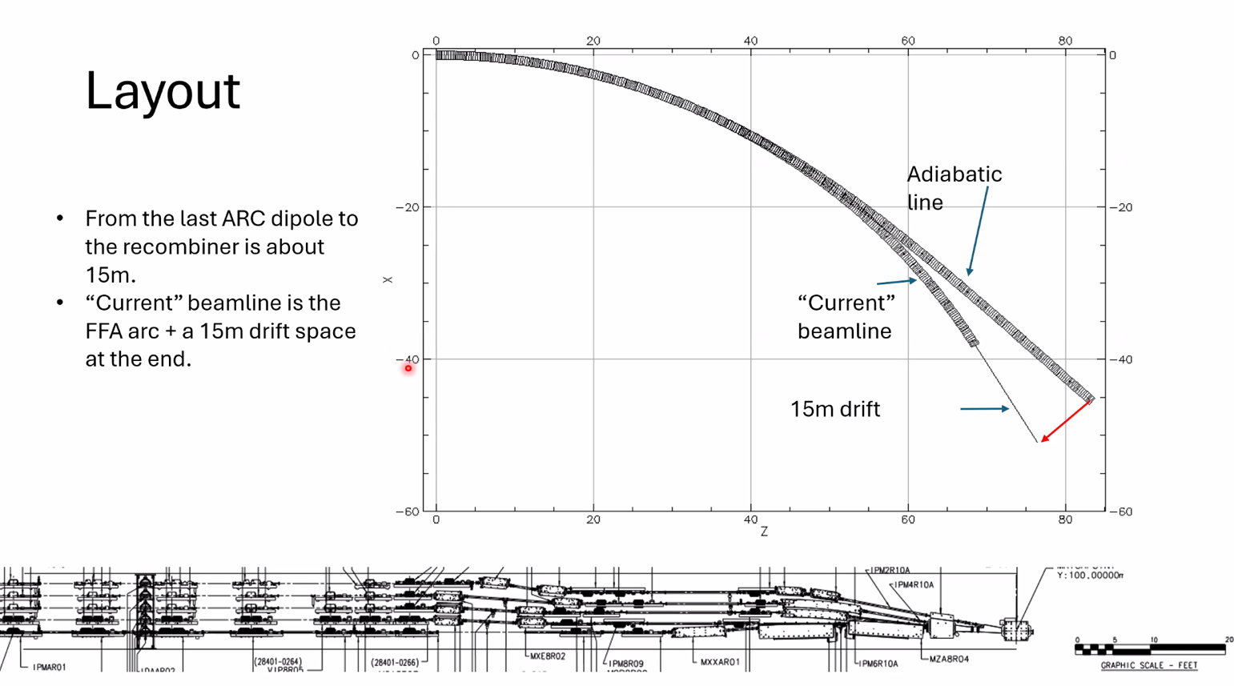
  - Adiabatic at the end of the ARC – can’t make a normal adiabatic section
  - This is two lines on top of each other
  - 15 m is from the last bending dipole to the recombiner
  - Big difference between current and adiabatic
- 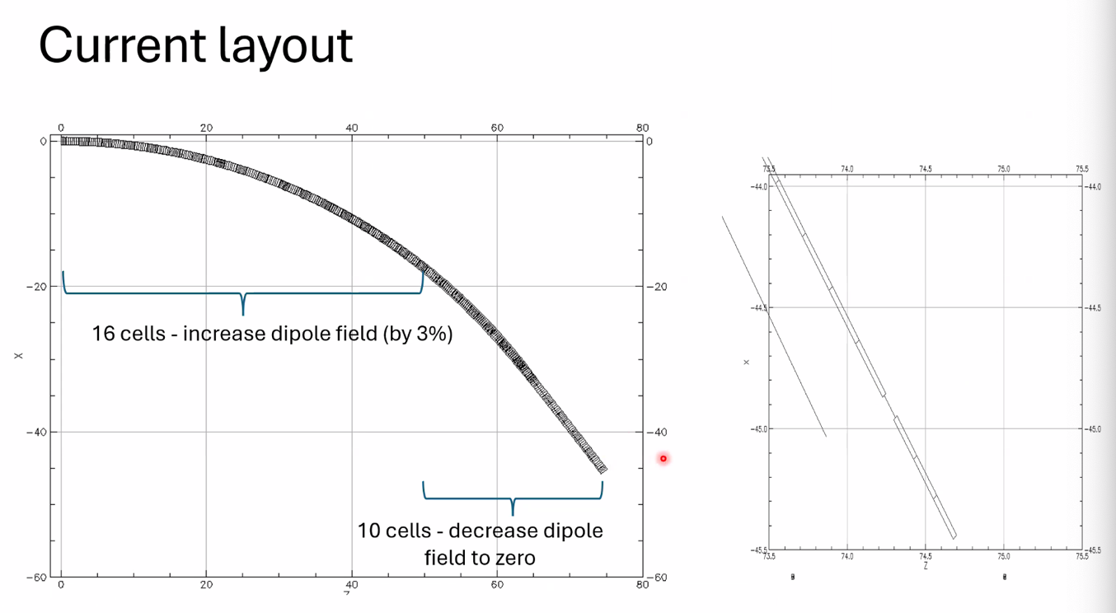
  - Increased bending fields by ~3% over FFA arcs, then decrease it again
  - 15 m is a rough estimate, maybe 1-2 m left
- 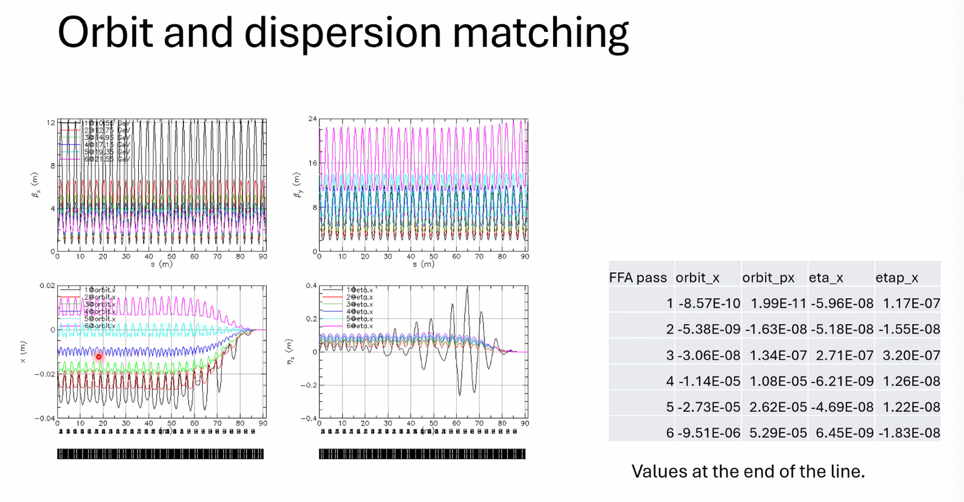
  - Using dipole fields of correctors
  - Left bottom is orbit, right bottom is dispersion
  - Numbers from most recent match in table
- 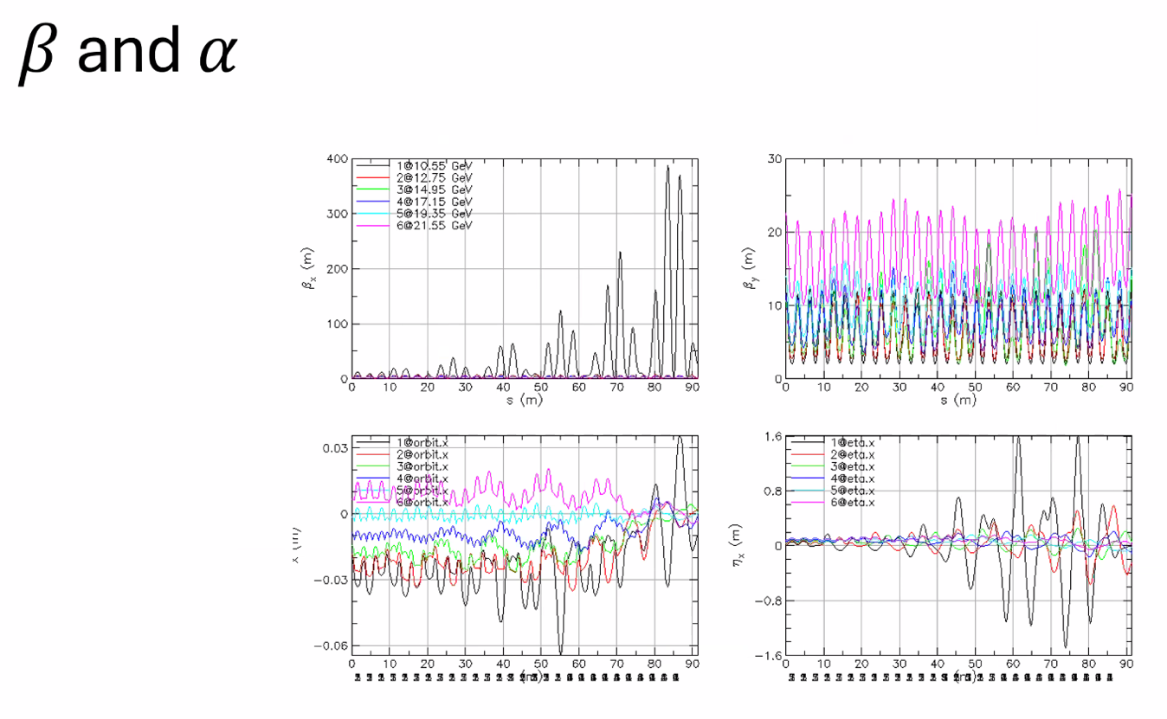
  - Kicking impacts a bit b/c it’s dispersion region
- Stephen – why beta/alpha smooth in last slide
  - Only matching orbit and dispersion
- Have to keep the orbit spreads contained
- Stephen – have you solved getting rid of orbit dispersion then beta/alpha?
  - No space
  - Adiabatic section ends right before recombiner. Only have one straight section
  - Stephen – if you can’t match in a straight line, then can’t with curvature
  - Right – but have to do it in a curve. Do it fine in a straight section
- Dejan – what are your variables? Surprised you couldn’t match it
  - Betas are from: 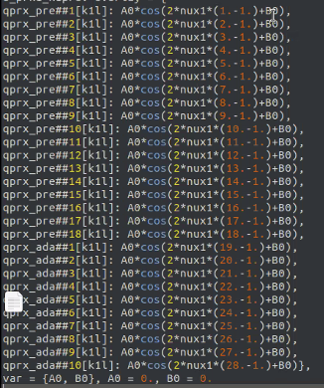
    - Gradients and bending fields, quads for betas/alphas
- Dejan – found out that there is an interesting thing that happens at the end. There’s a triplet that somehow has the orbits on the opposite sides of the previous input. Does the matching using SVDs and matching programs. Can discuss offline
  - Think you can do it – only problem is limited space
- Randika – when doing betas and alphas before, used a lot of cells (26)
- Dejan – so maybe merge orbits, then match betas downstream.
  - No – there’s no space after. There’s no straight section. Goes right into recombiner
  - The method works, but there’s no space here
- Stephen – allow self more space to see if you can do it without overlap in sections, then try to merge them together
  - Know you can do it separately. Try to gradually overlap them more and more. Get slowly harder.
- Dejan – Stephen could reproduce the power law to make the distance between the triplets (cells) larger and larger, and merge all the orbits (betas go up). Not sure you have enough room for that.
  - Vasiliy – That only worked when the phase advance per cell didn’t change too much.
  - Dejan concluded that if the LINAC covers the energy range of the FFAs. In CEBAF, it’s not true. Has a much larger energy range. But if the energy range of the LINACs is the same, then it’s fine.
    - If we use triplets from one to another and there’s a cavity in between, the betas will be different in the next one, everything is perfectly matched
    - Triplets impact the betas less as the energy goes up
    - If you match it for the single energy, as you go through the triplet, the beta will slowly go up, and everything will match under the condition that the linac range is the same as the FFA range (in energy)
- Vasiliy – you’re using quad kicks? At twice the frequency?
  - Yes. And normal frequency for dispersion and orbit
- Randika – trying to do the buildup first, limit quad excitations
  - Didn’t have time to test all
- Vasiliy – can we reduce the cells in the adiabatic section?
  - Have to see
  - Dejan used 26 in the beginning b/c that’s what was used in CBETA – did it in 6 cells in the end (orbits, betas not matched)
- Randika – have not tried changing magnet lengths yet
  - Stephen – will be useful in beta matching
    - Run all magnets you’re doing in the HallbachArea tool – make sure they’re doable.
    - Can’t make custom magnets for 40 different magnets
      - Maybe reduce fields and space differently, but don’t introduce too many different types of magnets
    - Right now, just changing bending fields
      - That’s the easy part- just shift the magnets. Just check the apertures and make sure you’re going through sensible fields.
      - Staying in incoming orbit range – had to remove limit to see if works
    - Stephen – and lowest E is always the problem
- Stephen – what about spreaders?
  - No quads in FFA passes
- Lowest pass is separated from the rest in spreader – so maybe some half-quad coils around it only
- Alex B – thanks for keeping us in the tunnel
  - Looking at Betatron match – there’s an underlying parametric resonance feature (top left plot on beta/alpha) – lots of variation, but at the end you end up with something you get at the LINAC
    - Looks quite touchy in a sense of getting the values. If there’s a set of values for the linacs you’d prefer, we can change the linac optics.
    - Randika – I’d like the values from the FFA arcs
  - Dejan – can use splitters to match
  - How much spreader/recombiner impact beta?
    - It’s basically a drift – 20ish meters, so if you have the right launch conditions, you can basically have small changes
- Dejan – if we can match by using the quads in the splitters to make the betas close to the place where they need to be according the picture, we might have the problem solved.
- Dejan - We need a complete solution before we continue into alternatives.
  - Alex B – but if we start getting into other ARC options, then we can put it into use
  - Dejan – We keep jumping into different possibilities without finishing one. We need to get all of our current solutions done first then move on

Action Items | Person responsible | Deadline

Time allotted | 25 mins | Agenda topic LDRD - Magnets | Presenter Ryan/Edy
- Alex Coxe took minutes (Thanks!)
- 
  - That thin image is actually ARC1 in BDSIM
    - BDSIM is wrapper for GEANT4
- 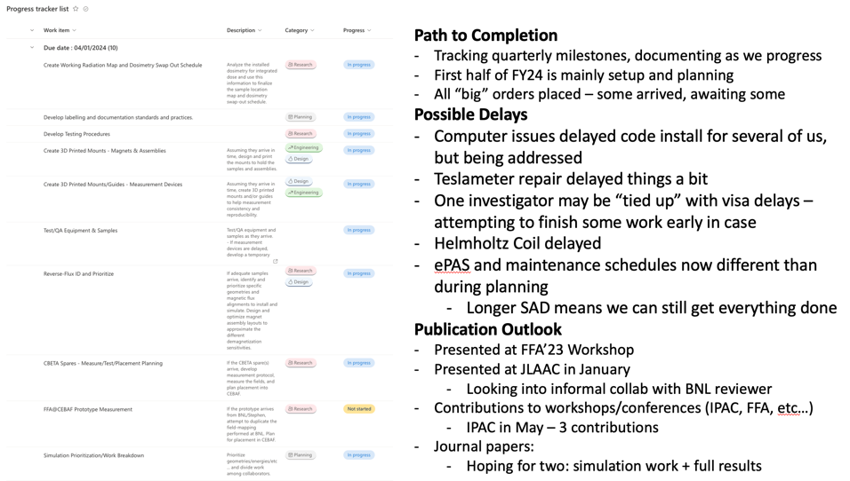
  - Shipping delays and ePAS, etc…
- 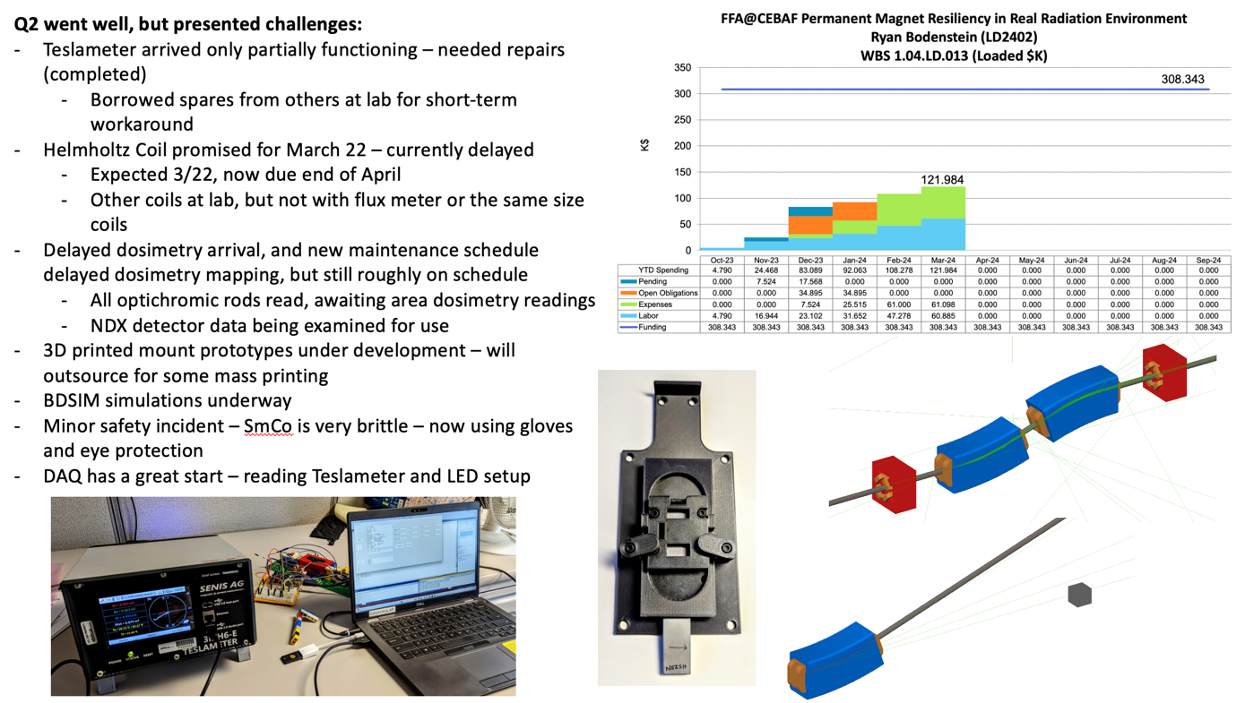
  - Mostly on budget, progress made in all fronts
- 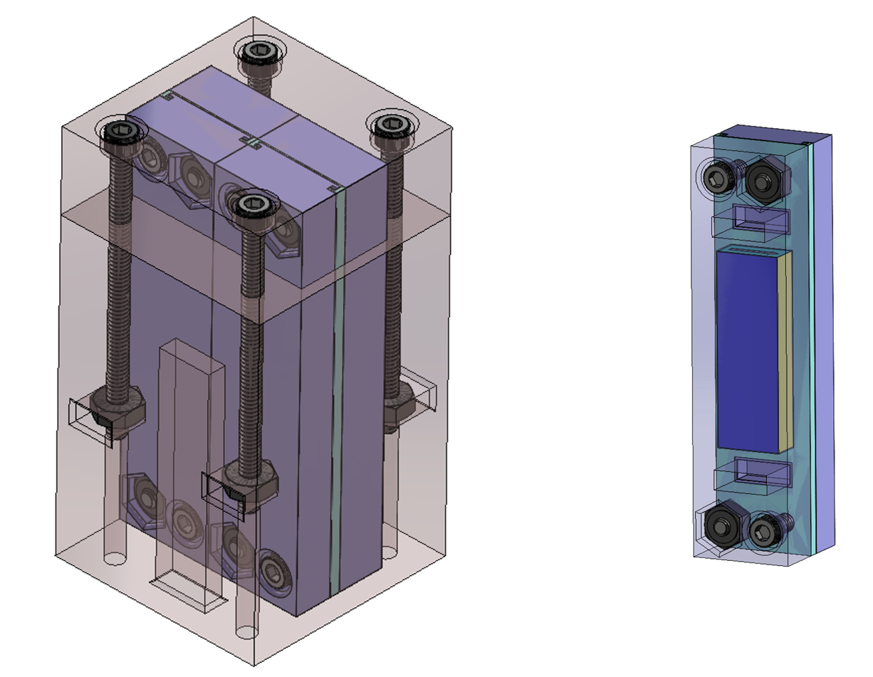
  - Using some sort of plastic/vinyl screws
    - Stephen says aluminum should work too
- 
  - Delayed, but arriving today
- 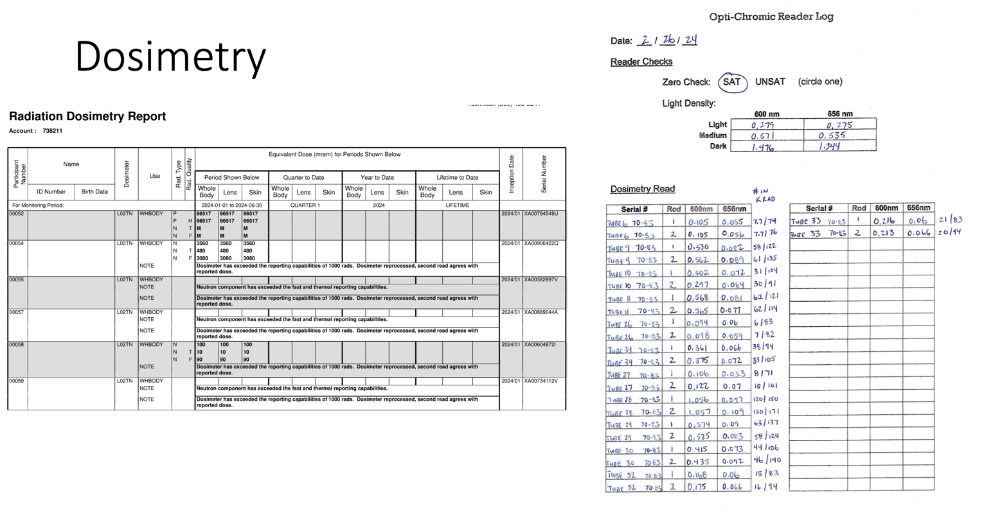
  - Hard to read – but Kirsten is parsing
  - Lots are saturated
  - Roger wants to share the data if we can
    - Ryan will share with all interested parties
  - Trying to show neutron vs. SR vs. mixed radiation
- Dejan asks about instrumentation getting damaged by radiation
  - Ryan explains that nothing is live feedback, all meters and whatnot are coming in and out of the tunnel with us when we take measurements
    - May cause problems when finally taking out magnets. AllStar Magnetics informed us that SmCo can become activated
      - Samples will stay in for long time, not coming out at end of LDRD
    - ALARA concerns for personnel
      - One of reasons for making measurements fast
- 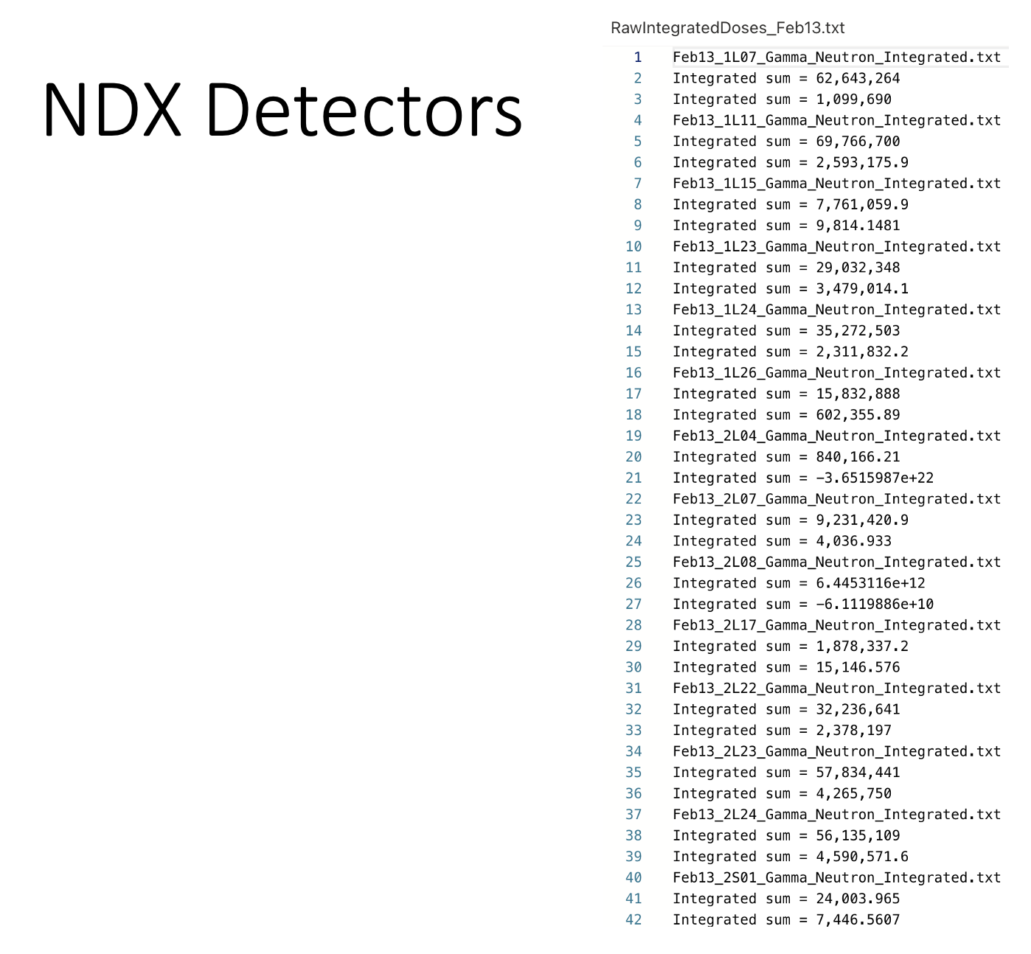
- Live demo of Edy’s work:
- 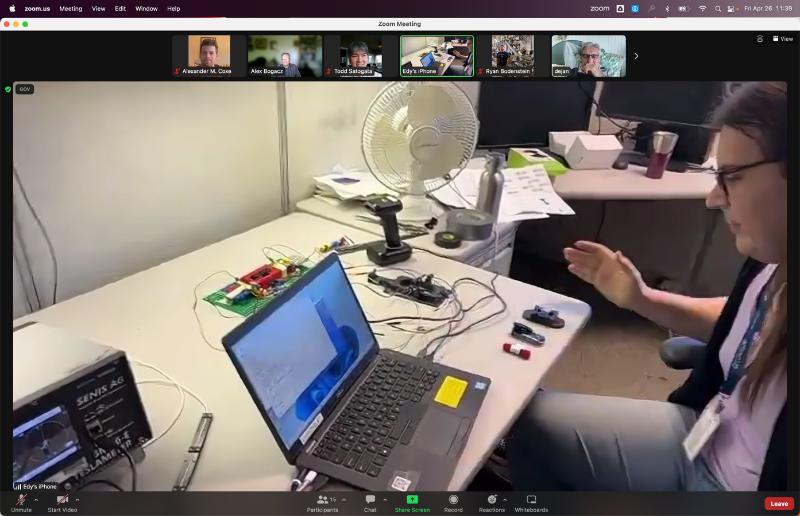
  - The rig
- 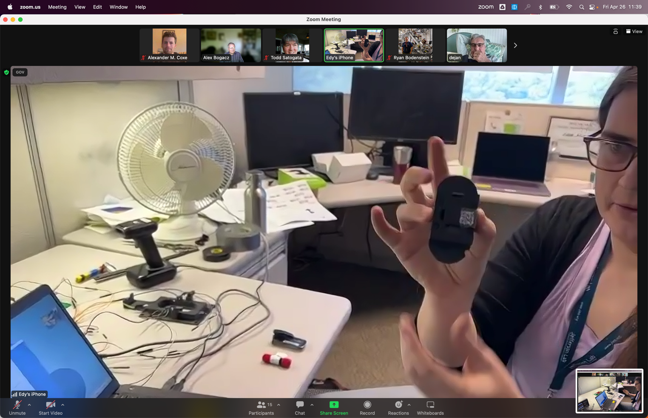
  - QR codes on dosimetry and samples
  - Barcode scanner used to read each part
- 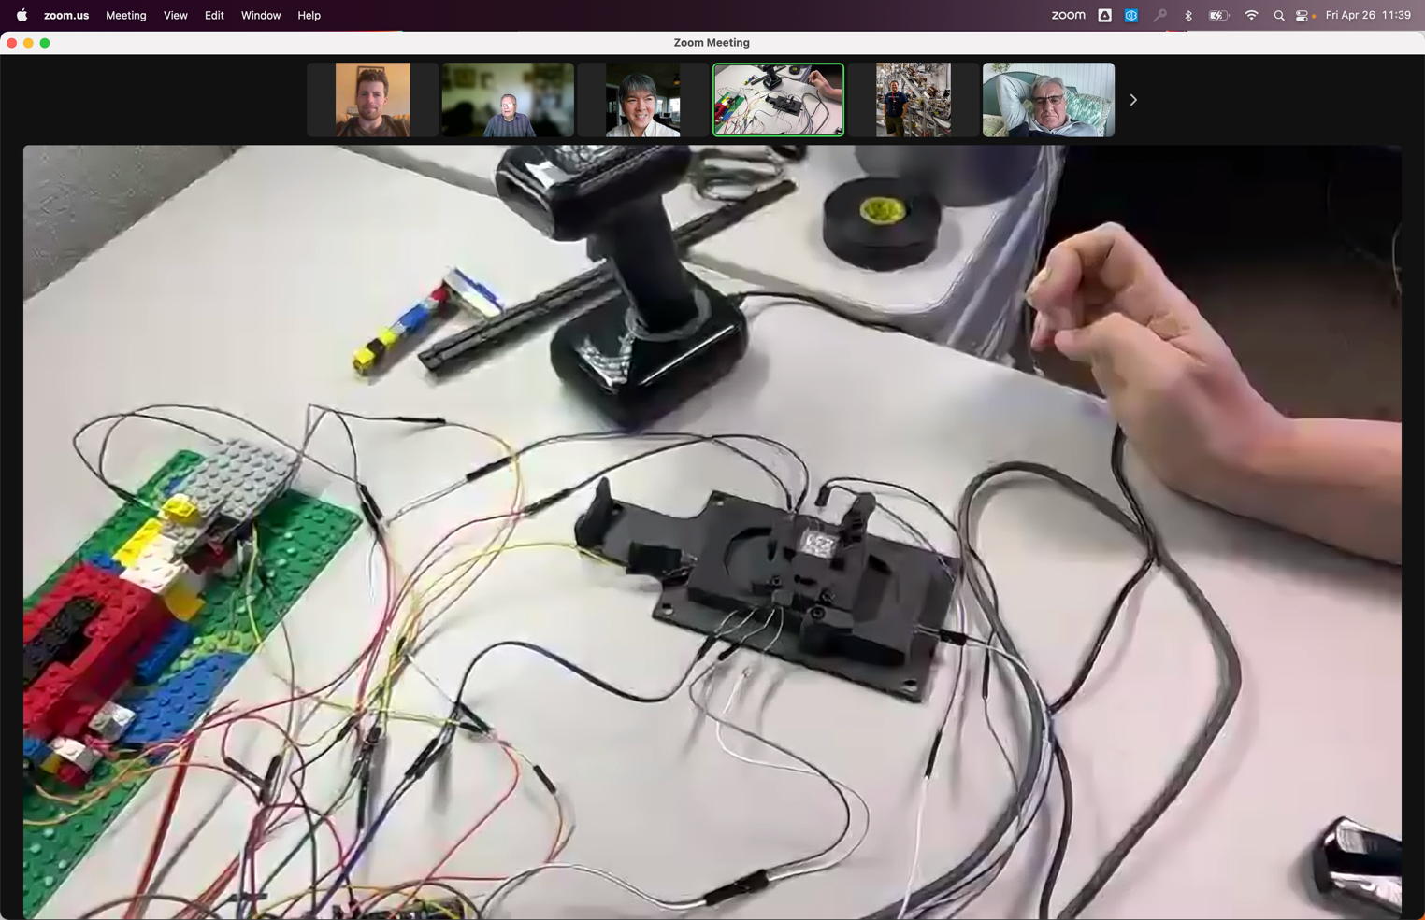
  - Measuring rig – LEDs used to make sure the probe is inserted fully
- 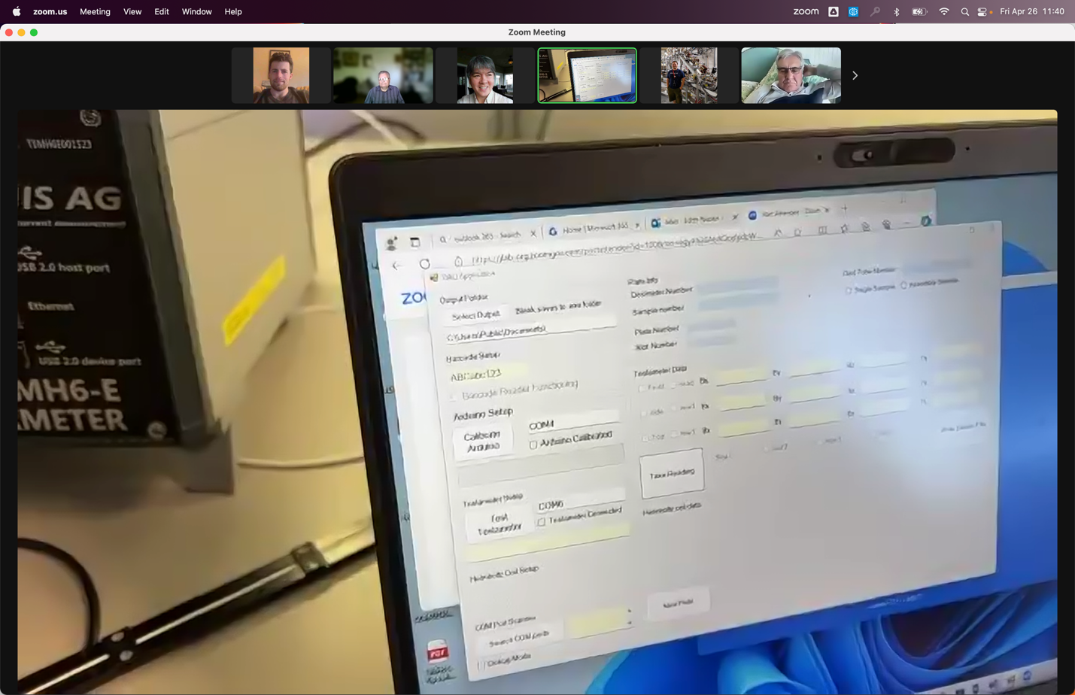
  - DAQ program
- 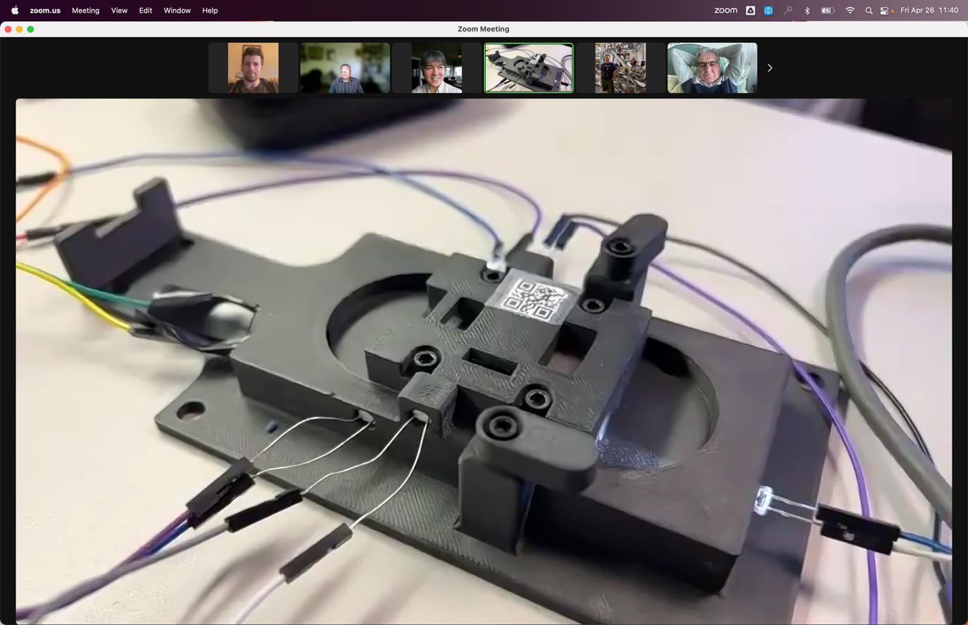
  - Closeup of measurement rig
- 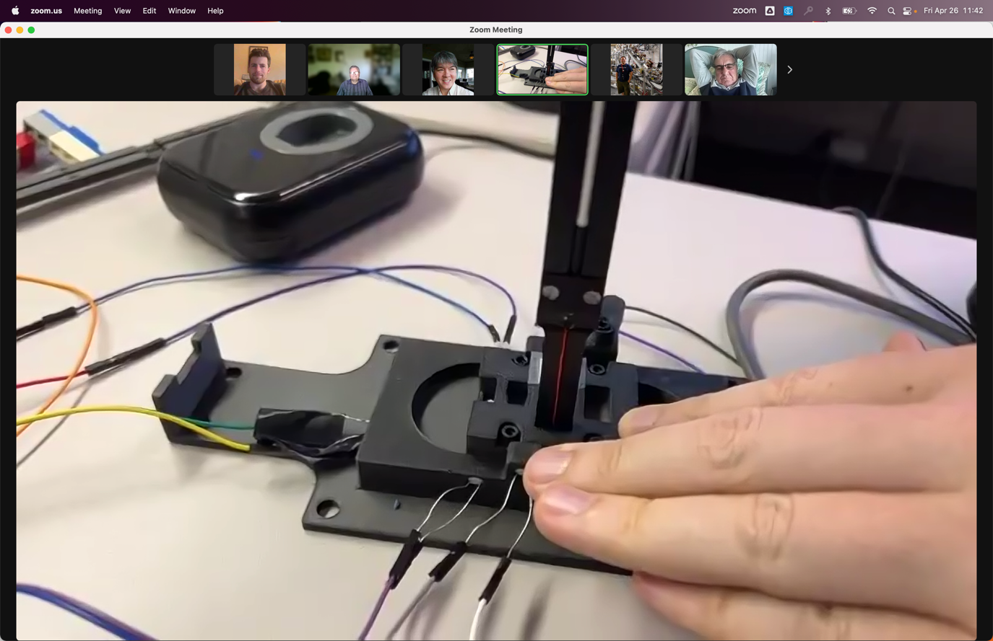
  - Insert probe into 3 different slots. LEDs make sure you’re only recording for the correct slot
- 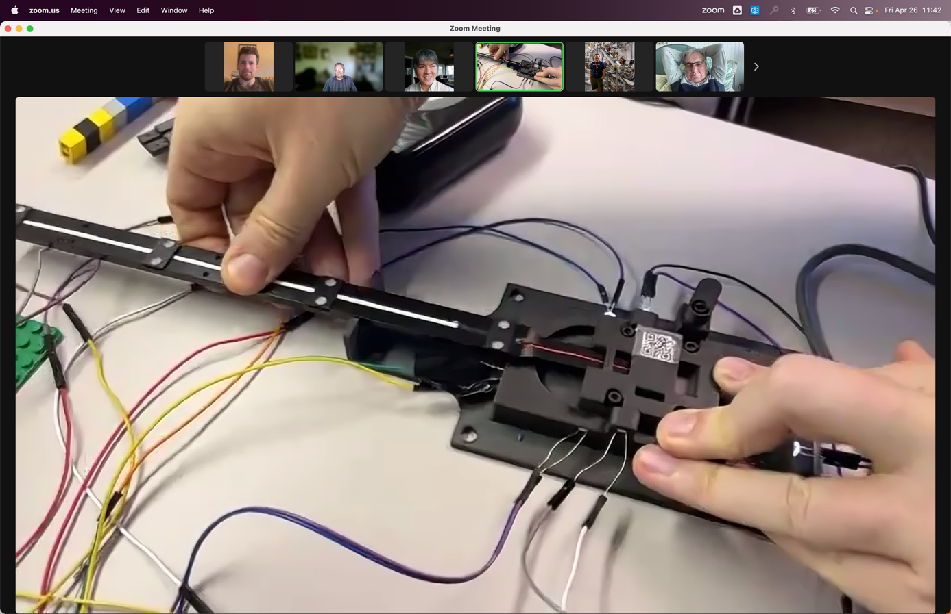
  - Different slot position
- 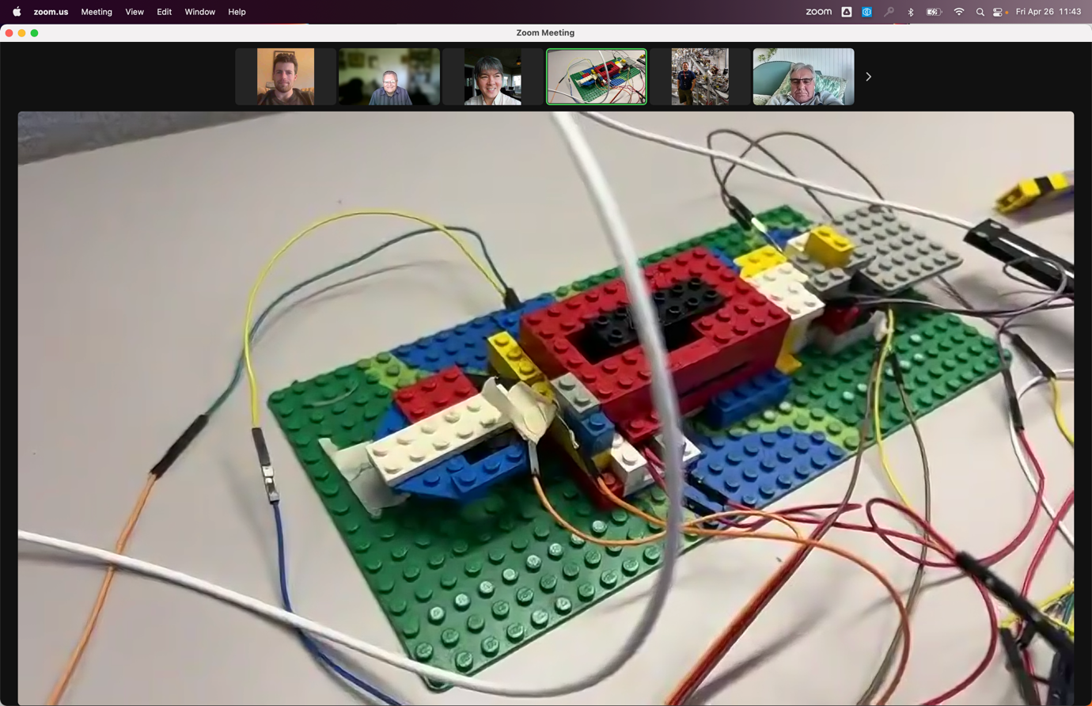
  - The LEGO setup that started it all!
- 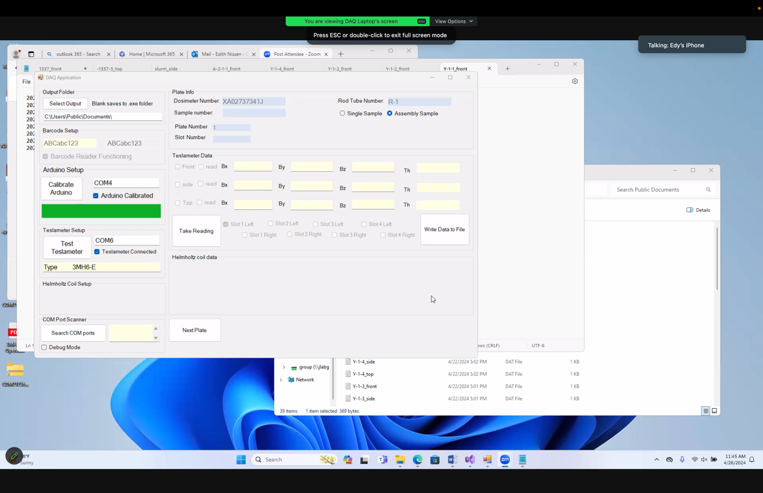
  - The program as it is currently.
  - Doing this to reduce human error, and reduce time spent in radiation environment.
- Roger mentions Charlie Reece had tech notes about radiation in the LINACs
- Roger asks about temperature dependence with magnets
  - Ryan mentions using temperature stickers to make sure temperatures remain below critical temps (~140 C for some samples, most higher)
Action Items | Person responsible | Deadline

Special notes

Pathway to Repository: https://jeffersonlab-my.sharepoint.com/:f:/g/personal/tristan_jlab_org/EqZ5MeS-nipCgPfZB5p0oS4B9Is67d3nQb9sLJI3Zyev9g

