FFA@CEBAF Working Group|Minutes

Meeting date | time 05/03/2024 | 11 AM EST | Meeting location https://jlab-org.zoomgov.com/j/1614898082?pwd=TnUzMS81M2sxbDZIbERJU01tYkJCQT09
Meeting called by Alex B  Type of meeting Weekly Meeting  Facilitator Alex B  Note taker Ryan, Alex C  Timekeeper Alex B | Attendees  Alex B, Ryan, François, Scott, Edith, Alex C, Randy, Stephen, Kirsten, Donish, Roger, Todd, Georg, Salim, Dejan, Tim

Intro Discussion
- Discussion of FOA – no news yet. Likely due early summer.
- In the full proposal, wanted to put side-by-side FODO and new flexible momentum compaction. Please send them to Alex B for full proposal (LDRD).
  - Will update when we know if this will progress to full proposal

Agenda topics

Time allotted | 25 mins | Agenda topic Polarization| Presenter François
- Parity experiments need polarization. François here to address how to do this.
- 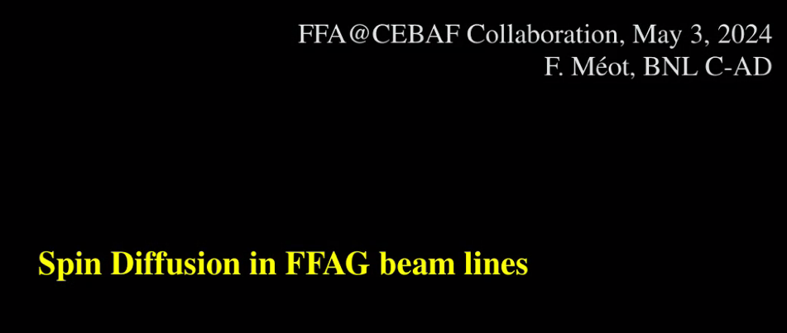
  - Will be François opinion based on his experience
- 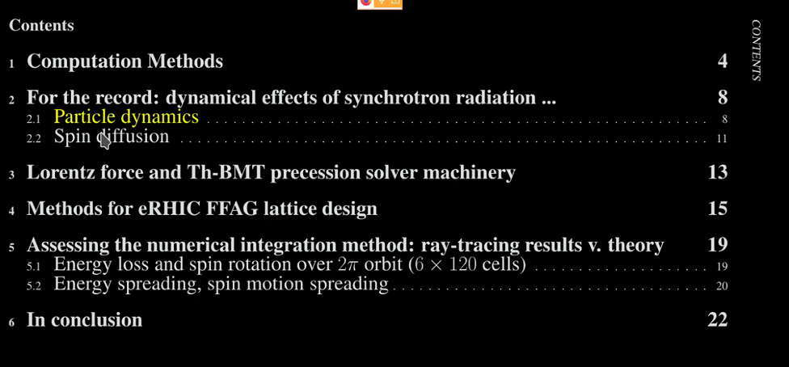
- 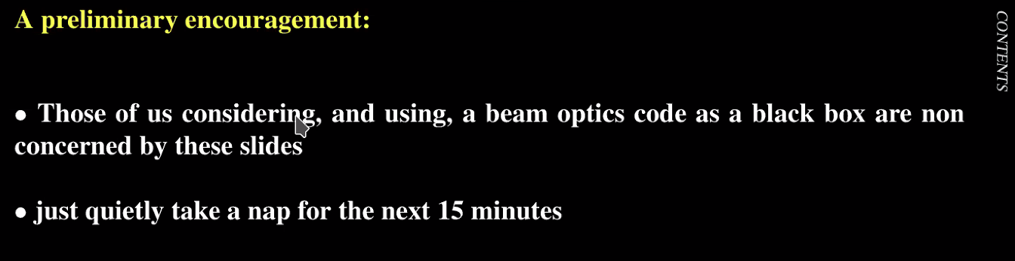
- 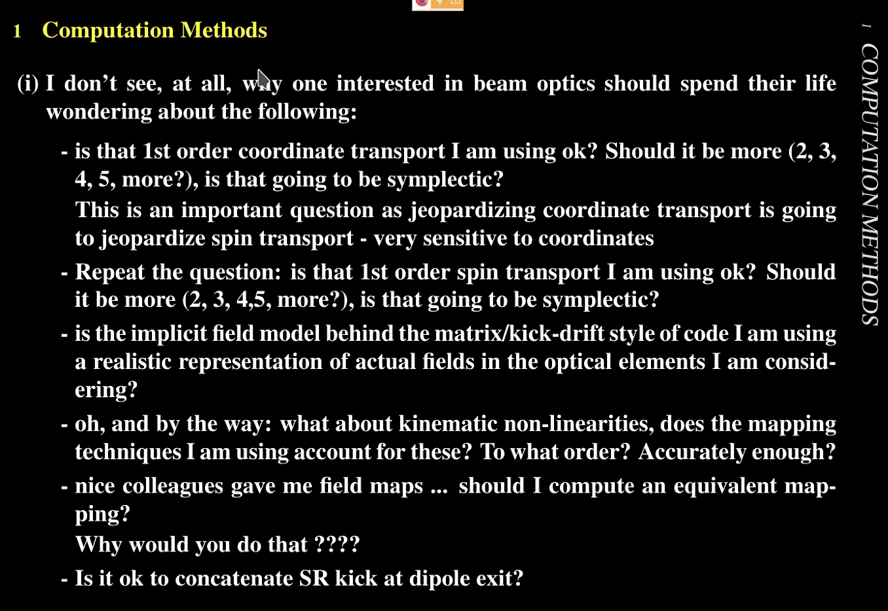
- 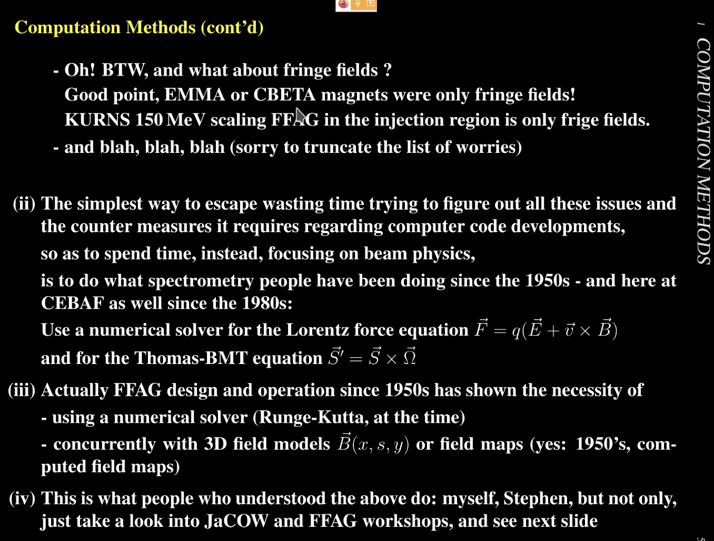
- 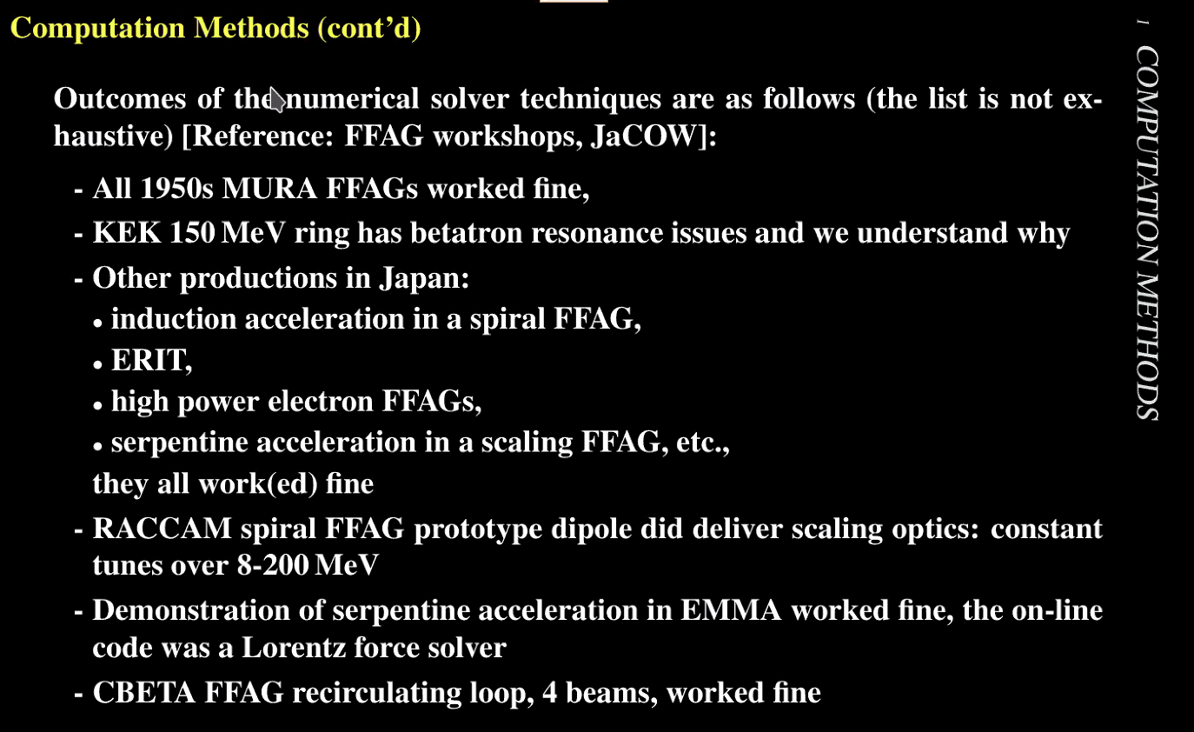
- 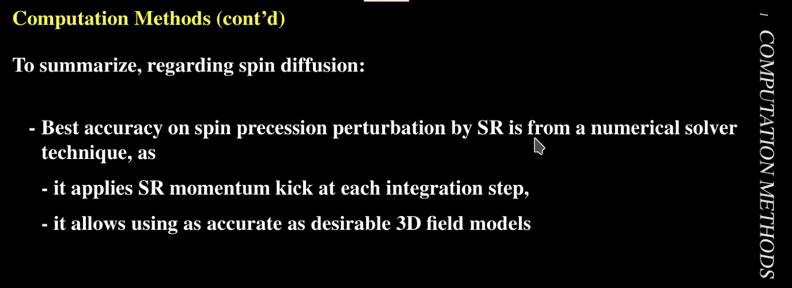
- 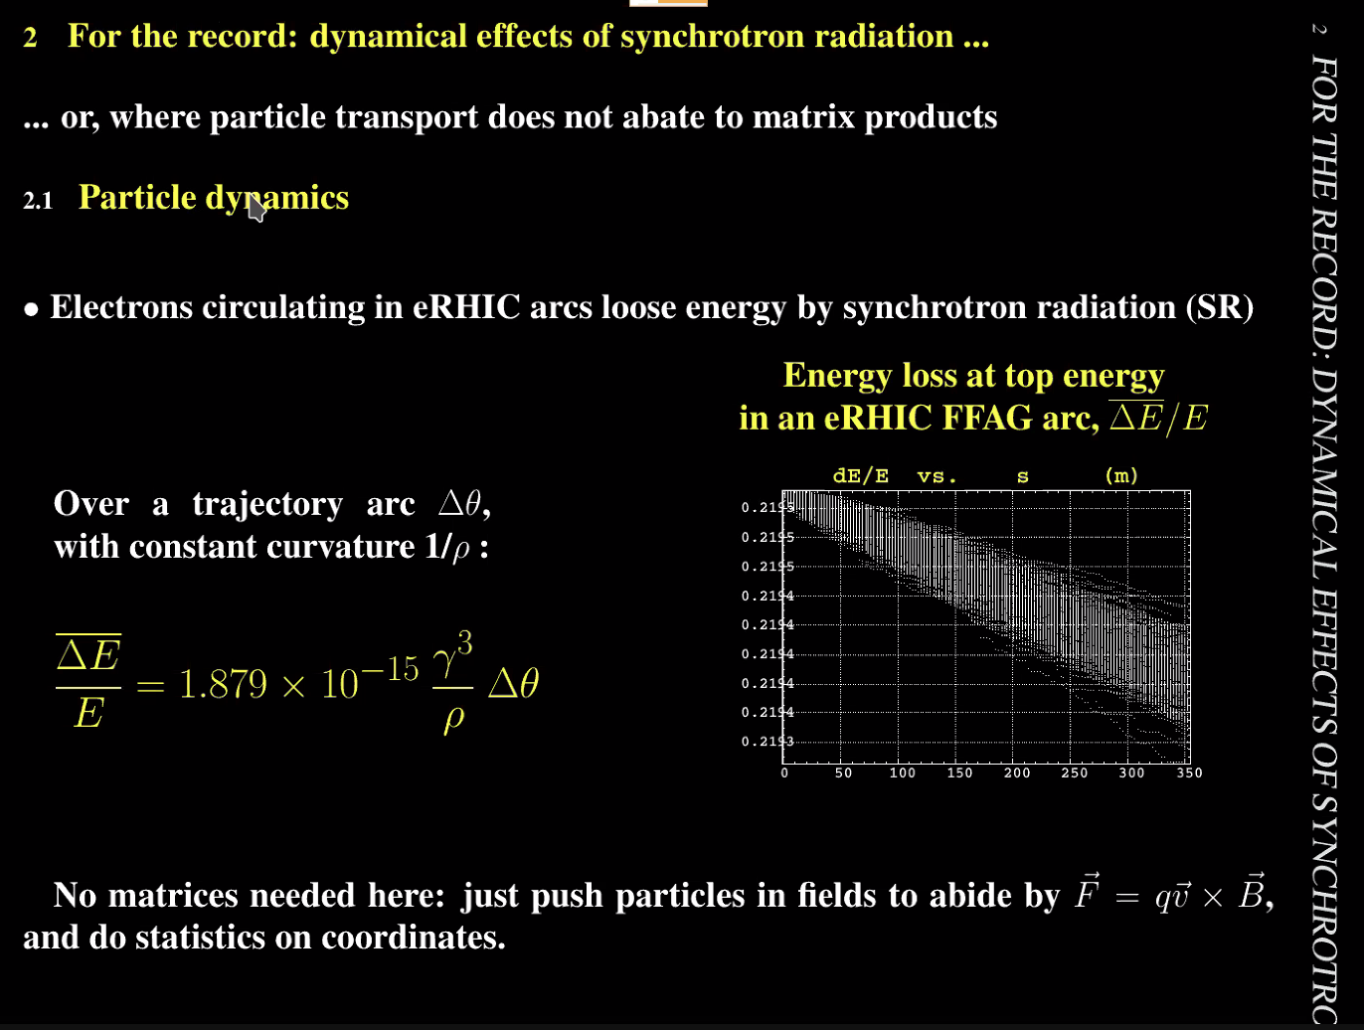
- 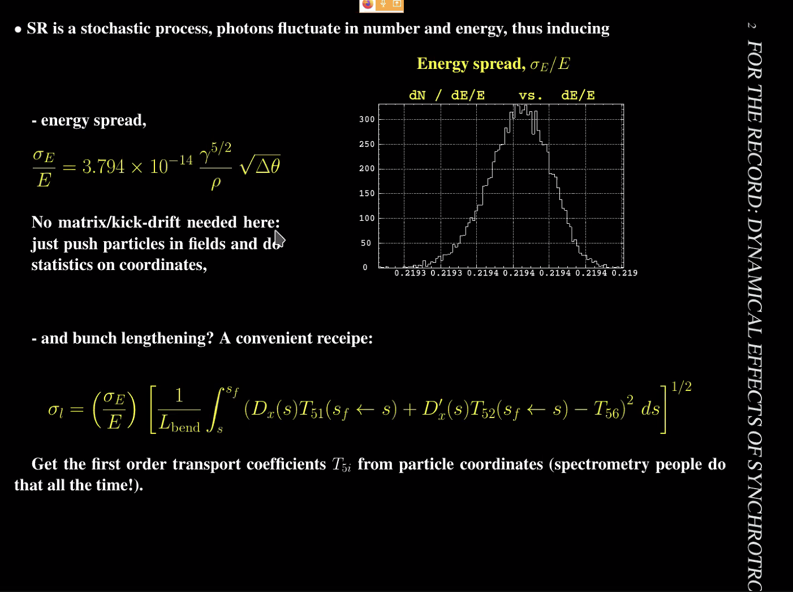
  - Just push particles in the proper way here.
- 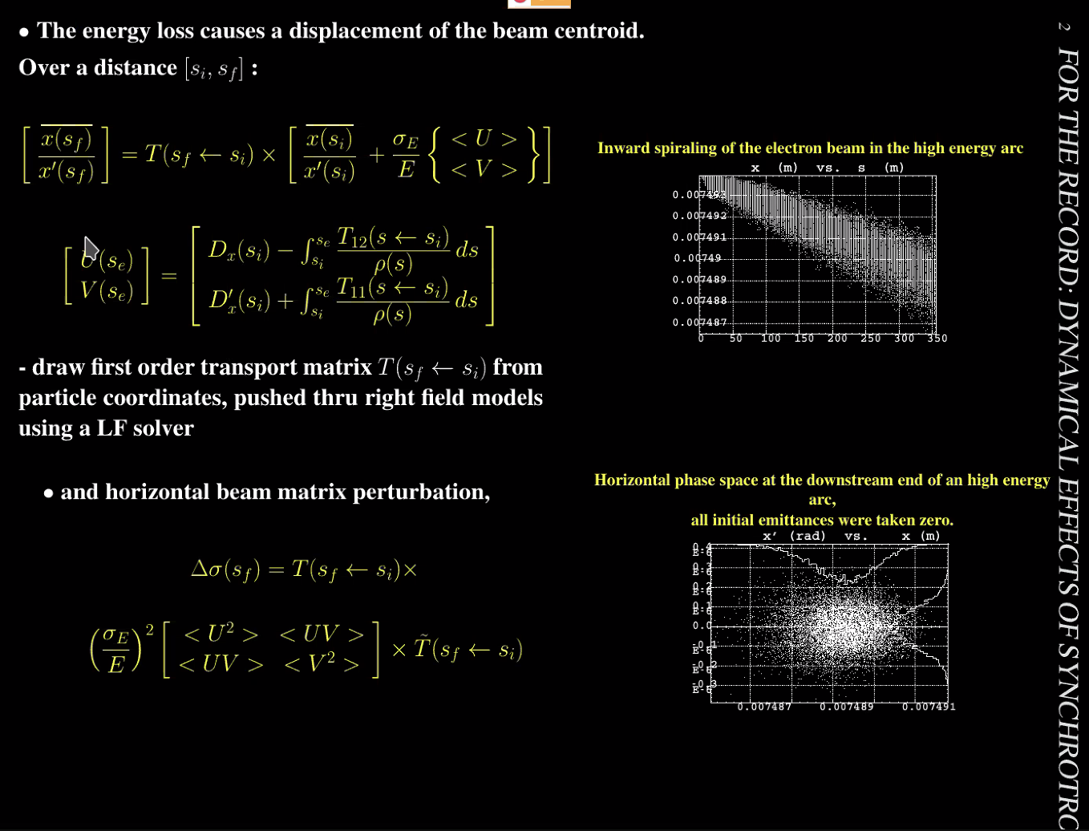
- 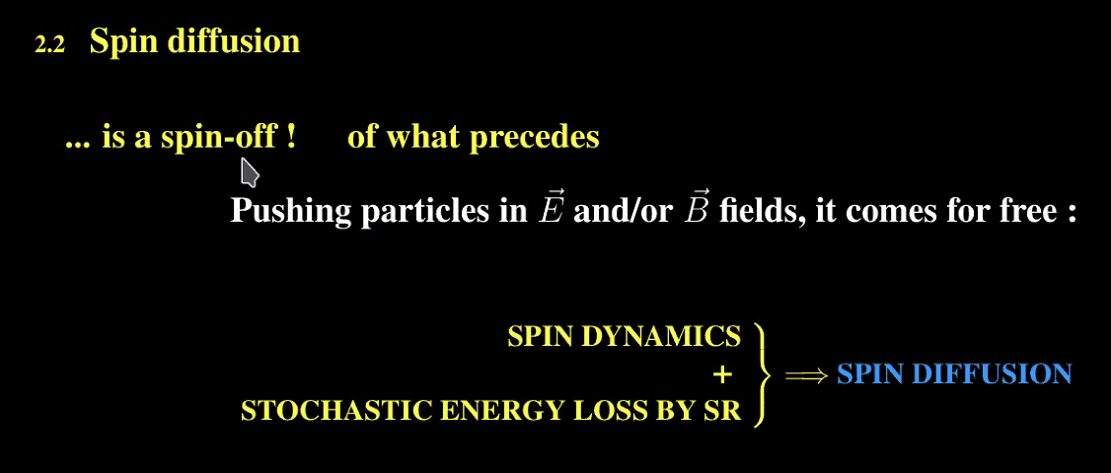
- 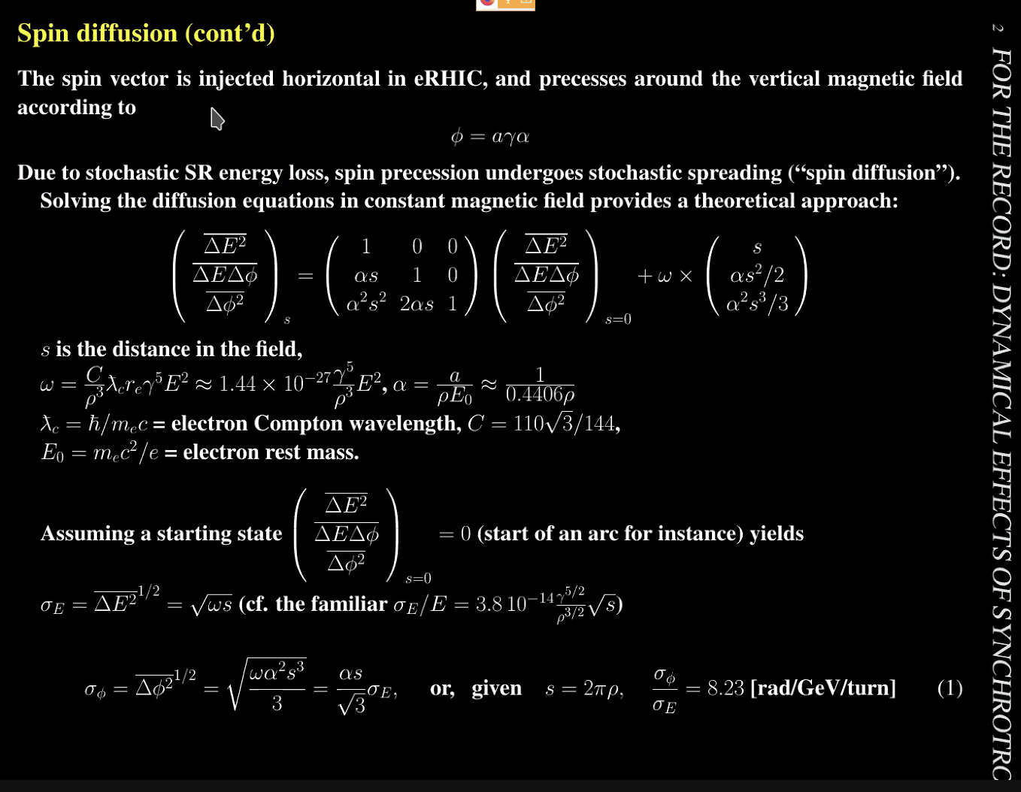
  - Statistical average on some variables
    - Energy loss, spin motion, etc…
  - Diffusion equation – get sigma equation, proportional to gamma as shown
  - Spin procession spreading over energy spreading (bottom right of slide)
- 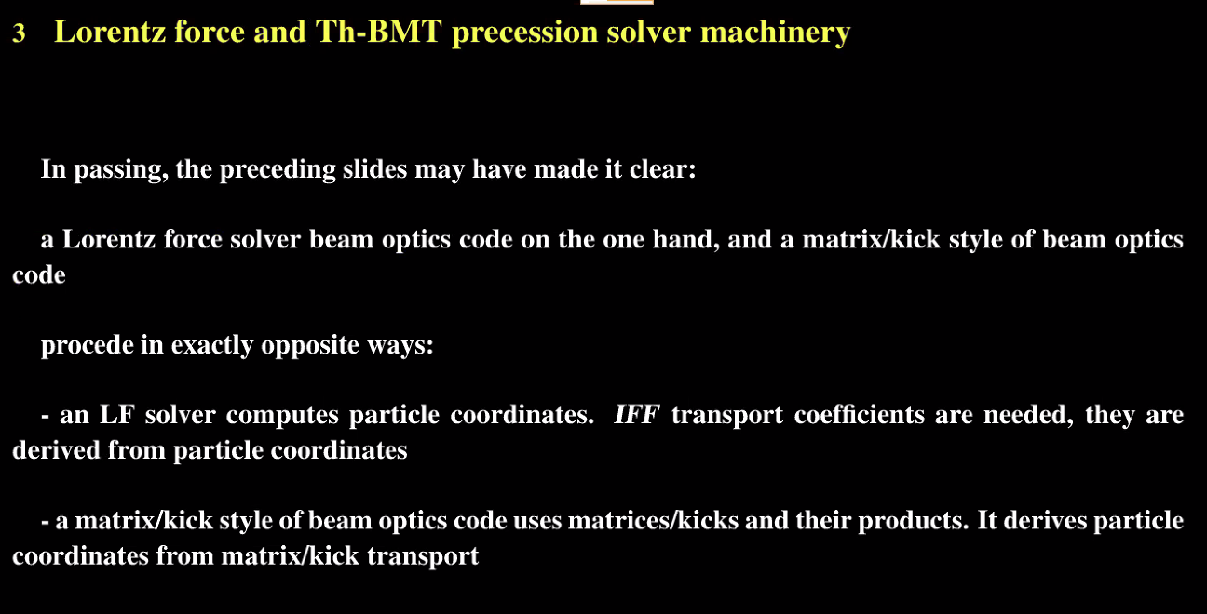
- 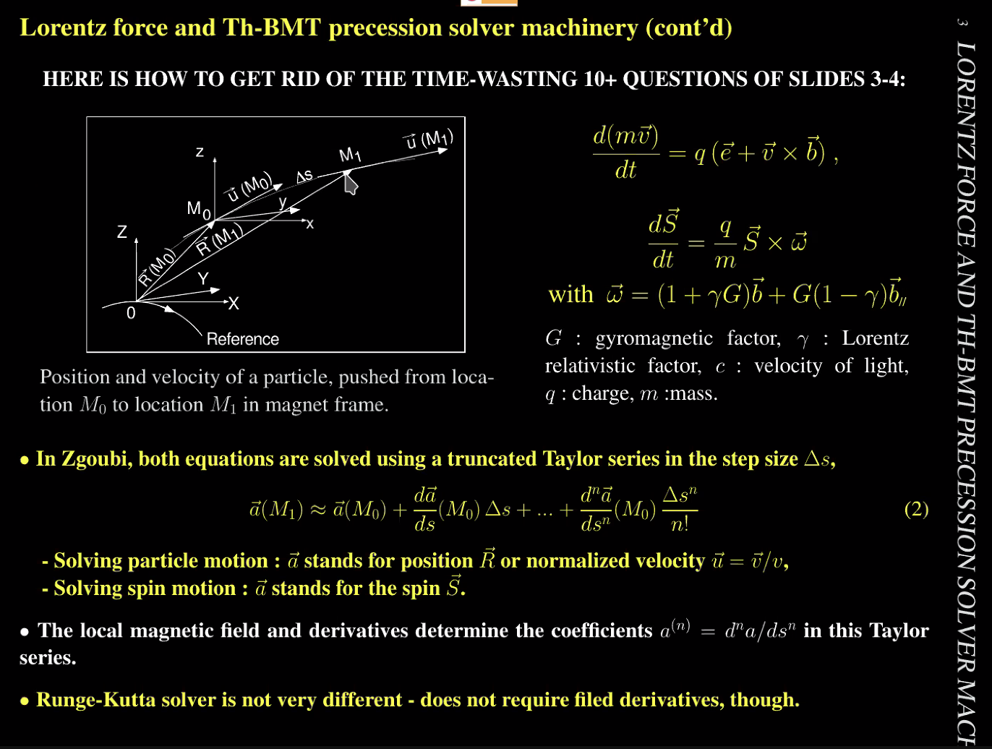
  - Need to push particles. Start with initial conditions, move to M_1
  - Proper E and B fields, etc…
  - Code in which solver is based on Taylor series technique
    - Not symplectic, but close
    - Most people use Runge-Kutta
      - This is easier for coding
- 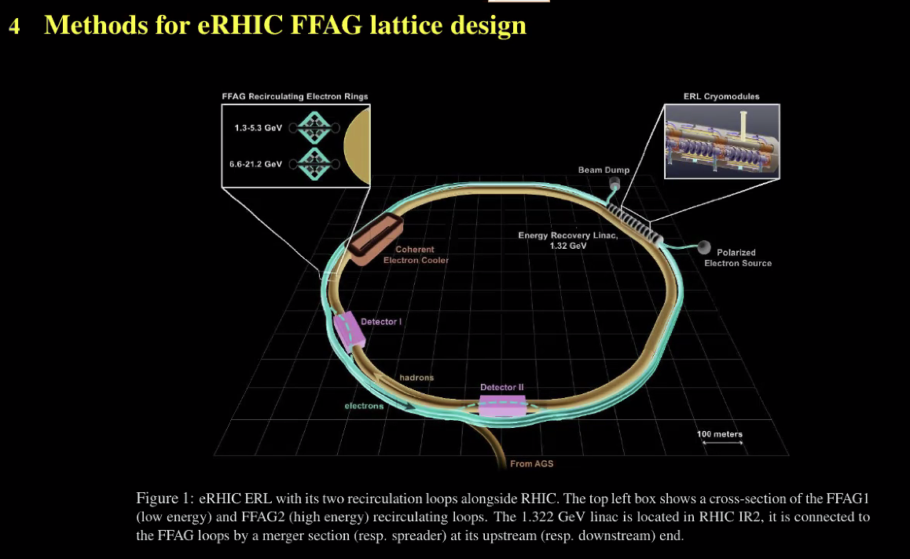
  - Used in eRHIC – electron inside, 1.5 GeV linac injector
- 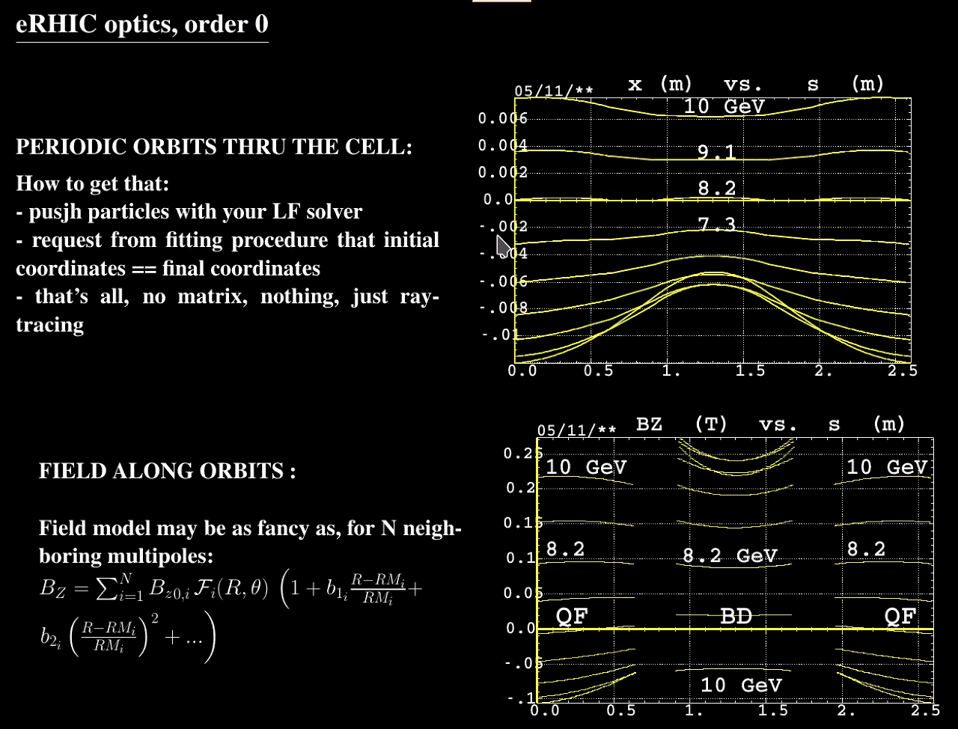
  - 2.5 m cell – need 6 x 120 cells
  - Periodic orbits
  - Push particles and preferred fitting procedures
  - Check magnetic fields after
- 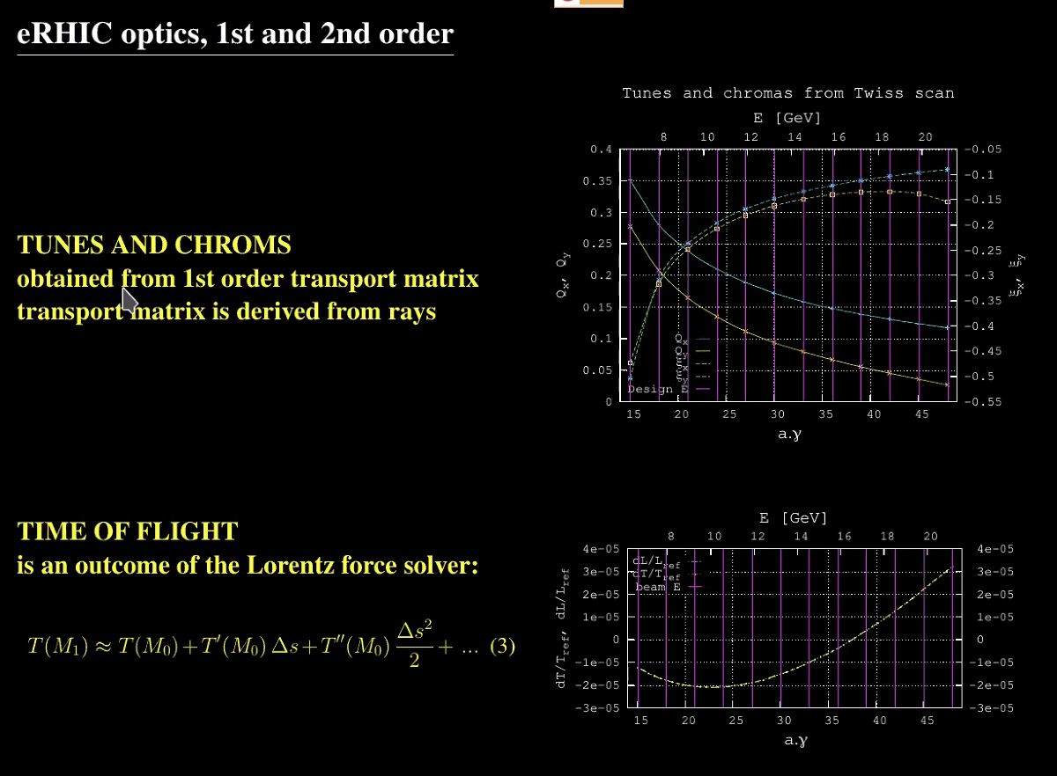
  - Make 1st order TM from raytracing
- 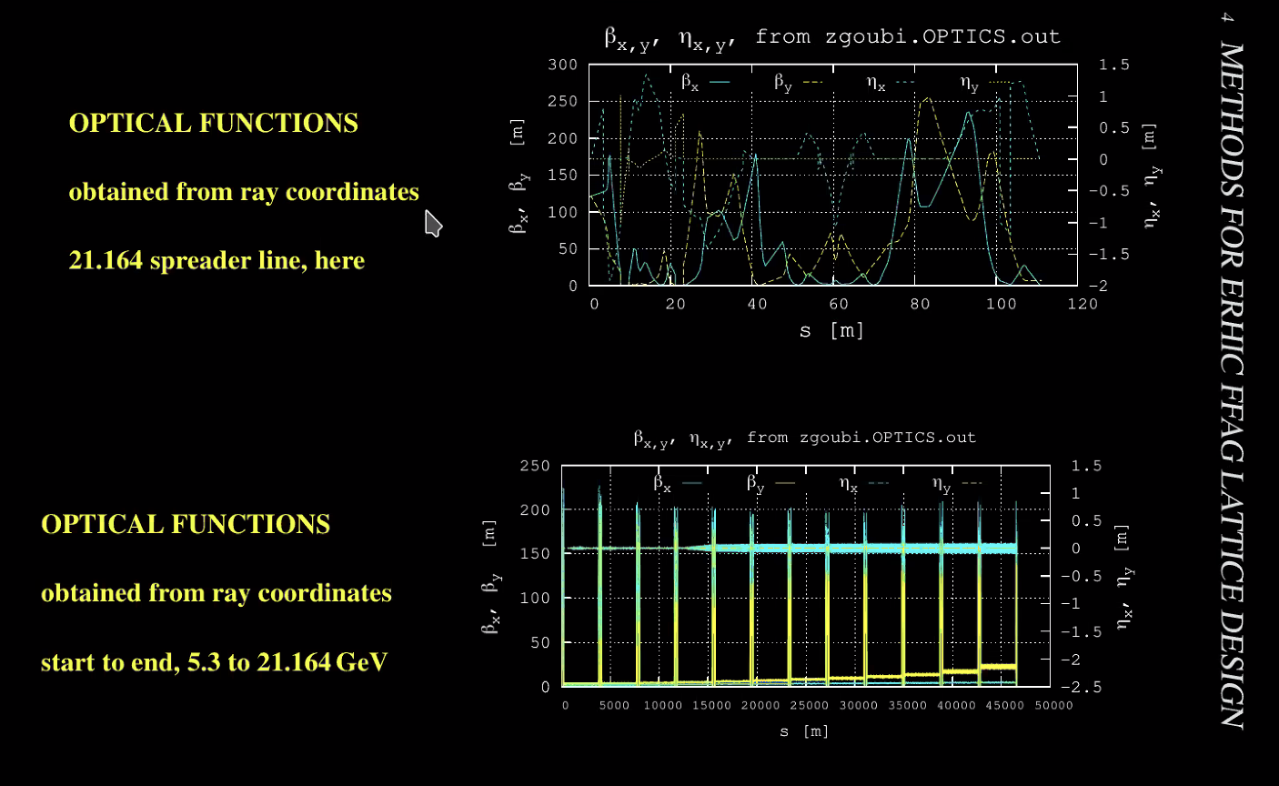
- 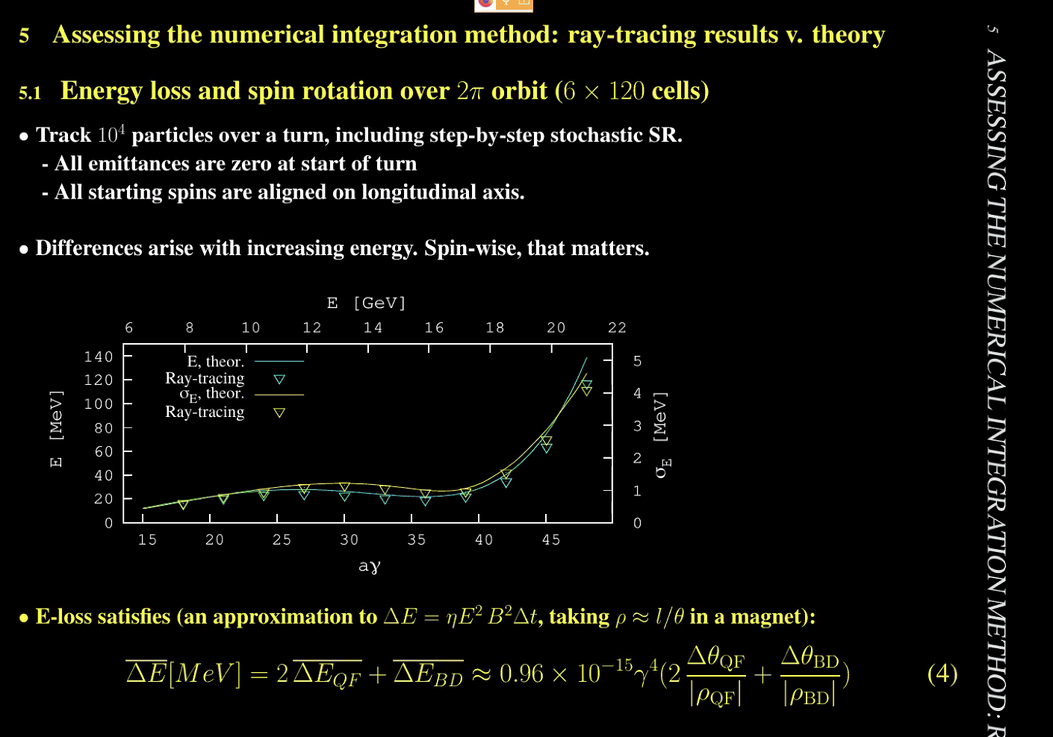
  - Energy loss as function of energy – calculated by raytracing
  - If increase energy to 20 GeV range, get discrepancies – this may make things interesting for CEBAF upgrade
- 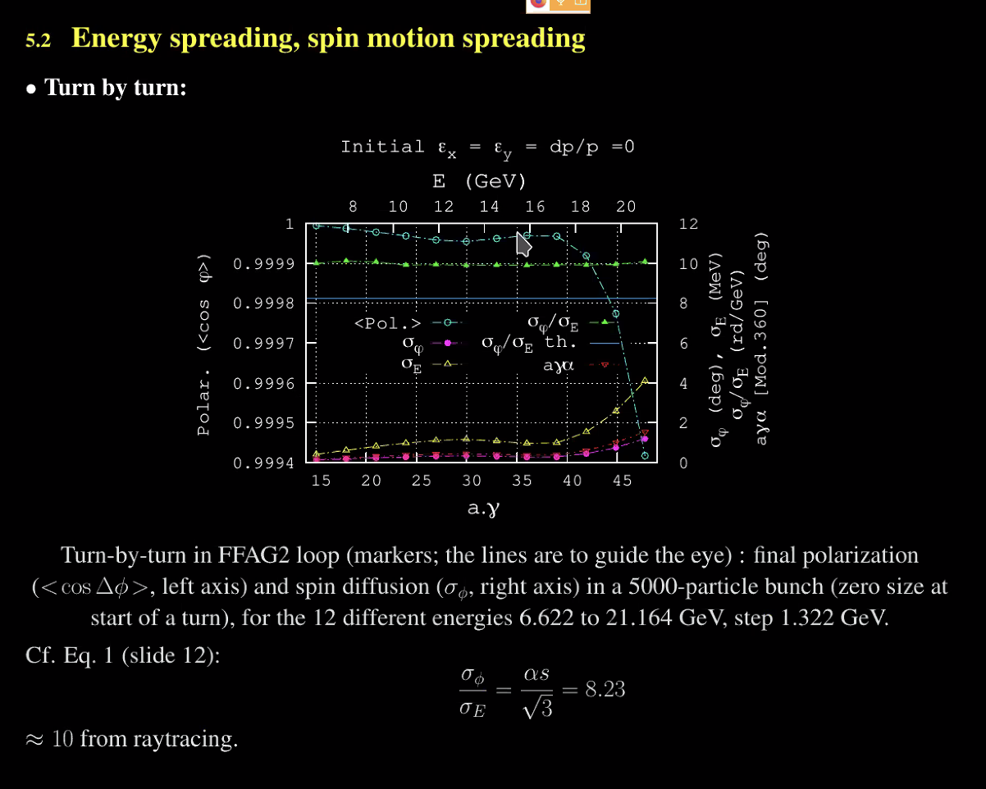
  - Polarization – want a constant ratio (8.3) – numerical gives it right
- 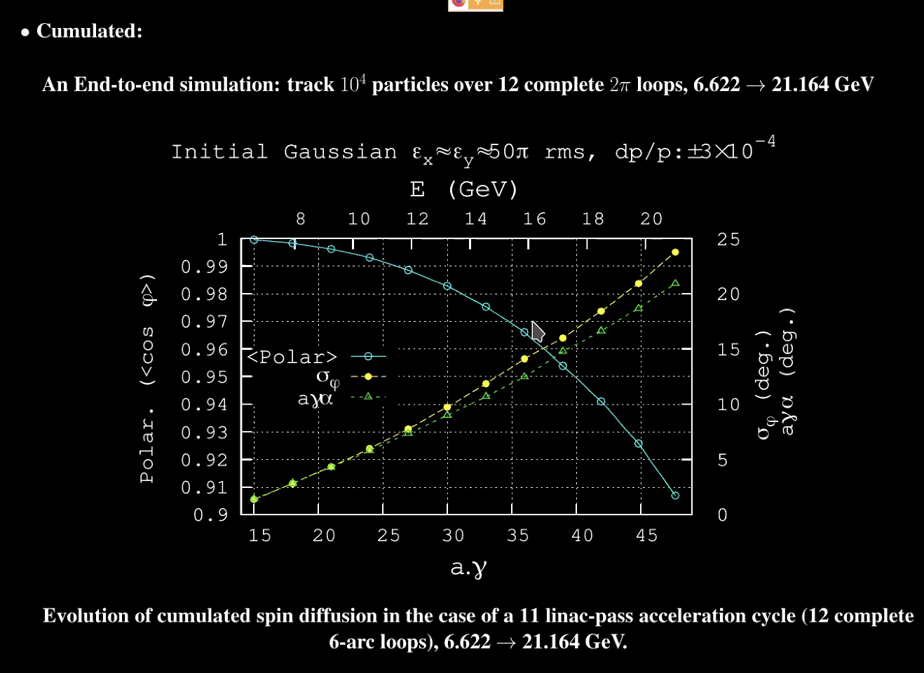
  - Integrated over ramp-up loops
  - Polarization down by 10%
  - Sigma-phi is yellow
- 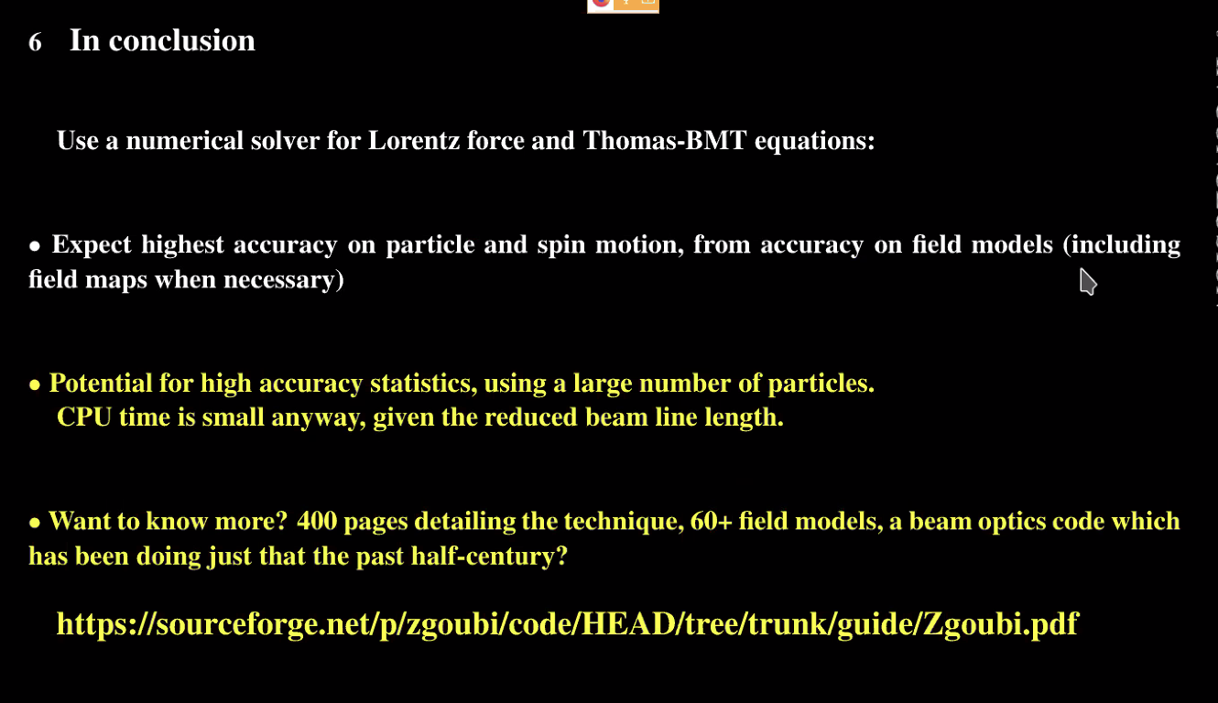
  - CPU time will be minimal
  - Opposite from kick-drift technique
  - Use the link to see the manual from Zgoubi – roughly 400 pages
- Alex B - Question of symplecity – certain approximations and truncations, so sometimes not preserved. You say “almost symplectic” – how do you measure the departure from symplecticity in the code?
  - Long term tracking in RHIC with many terms, first check that. Look at accuracy first. Check that it’s behavior is invariant over many turns
  - Step size is the knob to get accuracy
  - For a recirculator, just check against analytical expectations from theory
  - AB – check transfer matrix to see if it’s symplectic by inspection
    - Yes – that’s another way. Determinant won’t be =1, but differ by maybe 10^-6
    - Get matrix from interpolation – may not be due to tracking
  - AB – so symplecticity violation is not that important
    - Right
    - Spectrometry people care more – they are happy with Lorentz force interpolators
  - Dejan – better to do things right than BS about a hundred thousand turns
- Dejan – we should check where are we with each pass WRT the resonances. Especially 0.33 resonance
  - CBETA had problems with that.
- François – my experience at CBETA – problem is mostly in combiner lines (not the FFA lines)
  - Dejan – b/c we missed the 0.33 resonance
  - For FCC ERL, 100 km ring – checked spin resonances over 100 km loop, and can have spin resonance and betatron tunes related
- Alex B – so for us, it’s 75 cells or less. They’re periodic
  - François – when we gave the spin class 4-5 years ago, there’s a numerical exercise which is exactly this. The problem was pointed out at SLAC for the collider. They got polarization deterioration due to spin resonance conditions in arcs between linacs and collision point
    - USPAS spin class book (Yves Roblin)
  - Able to recover the results from SLAC
- Alex B – even along LINAC, each linac has periodic cells. So going 20 periods, will there be some sort of resonance problems?
  - Scott – you won’t see 1/3rd in LINAC. Mostly we’re worried about the linear resonances at lower energies. Doubt that the LINAC is a concern
  - Scott – depends what you do. If you do your technique where you grade the linac so lowest pass is flat, then worry about ¼ resonance. Otherwise you’ll fly through.
    - To manage betas, make sure phase advance of first pass is higher than ¼
      - 150 degree phase advance in triplets
  - For arc – the question is a valid point
- Dejan – François just published big book on accelerator physics
  - Open access at Springer – 650 pages (700 limit)
  - Cover history of accelerators from electrostatic to present
  - Alex B wants to use it for USPAS
  - It’s still in production. Need to read the proof
- Dejan – without looking at magnetic fields you can do a lot of studies, but they’re not valuable. The codes not based on real fields are not reliable.
- Stephen – had short non-linear magnet (large entrance angles) – lots of dynamical terms are not small (assumed in MAD) – so have to use Muon1 or Zgoubi for that.
  - For CEBAF, mapping might work better b/c the magnets are far larger. Disagreements are much smaller
- Dejan – measured end fields of permanent magnets in office. Knows shape and can compare to predictions.
- François – wouldn’t say it doesn’t matter for CEBAF. Yves showed that vertical dipole (BCOM) – Lorentz force solver, could not find first order transport coefficients. Tried to match matrices by varying the Lorentz solver, edge angles, etc… - never could do it
- Stephen – differences were 0.003 in tune difference for CEBAF – way smaller difference, but present
  - Dejan used sector magnets – can’t do that
- Alex B – we know it handles spin/orbit, how does it compare to others?
  - Does Bmad have spin-orbit
  - Alex C – yes, Bmad has spin tracking.
  - Alex B – so we could compare
- Alex B – looking at Etienne Forrest – did he add into Bmad?
  - Georg – Bmad has many spin routines. Integration, nonlinear mapping, spin-orbit coupling, etc…
- Alex C – Bmad/Julia code – developers are working with Etienne to include a lot of this built in
- Alex B – Etienne helped with JLab’s EIC too.
- Etienne and François compared Runge-Kutta and Lorentz
- Dejan – heard there’s a possibility of running CBETA (related to small SBIR company). Might get one turn
  - Georg – we are preparing a list of items to make a proposal for high-current 1 turn with X-Light
- Side CBETA discussion…
- Bmad school – no remote option.
  - Bmad user lunch and a breakout session
Action Items | Person responsible | Deadline

Time allotted | 25 mins | Agenda topic IPAC | Presenter All
- 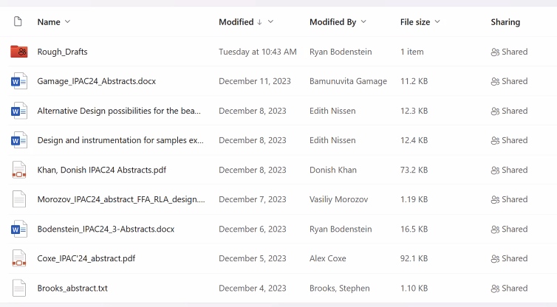
- Lots of abstracts – please upload to the drafts as they’re ready
Action Items | Person responsible | Deadline

Special notes

Pathway to Repository: https://jeffersonlab-my.sharepoint.com/:f:/g/personal/tristan_jlab_org/EqZ5MeS-nipCgPfZB5p0oS4B9Is67d3nQb9sLJI3Zyev9g

