FFA@CEBAF Working Group|Minutes

Meeting date | time 05/17/2024 | 11 AM EST | Meeting location https://jlab-org.zoomgov.com/j/1614898082?pwd=TnUzMS81M2sxbDZIbERJU01tYkJCQT09
Meeting called by Alex B  Type of meeting Weekly Meeting  Facilitator Alex B  Note taker Ryan  Timekeeper Alex B | Attendees  Alex B, Ryan, Reza, Edith, Roger, Kirsten, Stephen, Vasiliy, Donish, Dejan, Andrei, Tim,

Intro Discussion
- Beam studies on Sunday
- Ryan driving to IPAC, as is Randika – rental cars are a pain at times.
- No meeting next Friday due to IPAC
  - Ryan, Randika, Donish, Alex C, Stephen, Dejan, Vasiliy

Agenda topics

Time allotted | 25 mins | Agenda topic LINACs| Presenter Alex B
- 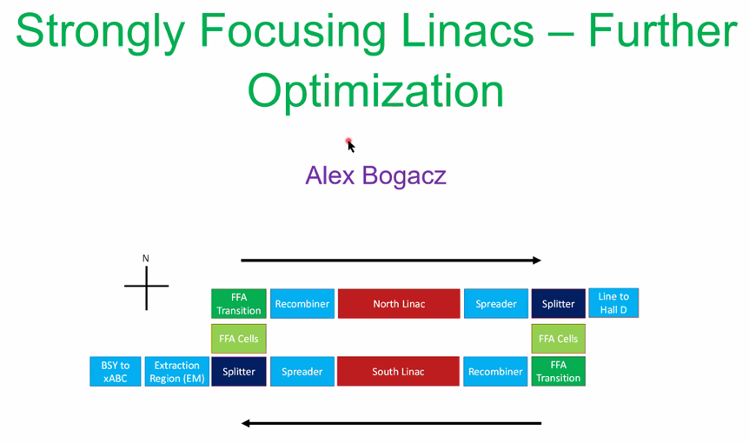
  - Over 6 months ago, re-did NL and SL
  - Will revisit and made changes
  - Optimize Twiss to get ready for matching in reasonable way
  - LINACs 250 m long
  - Quads are set once in LINACs
  - No quads in FFA passes for spreaders/recombiners – essentially 30 m drift
- 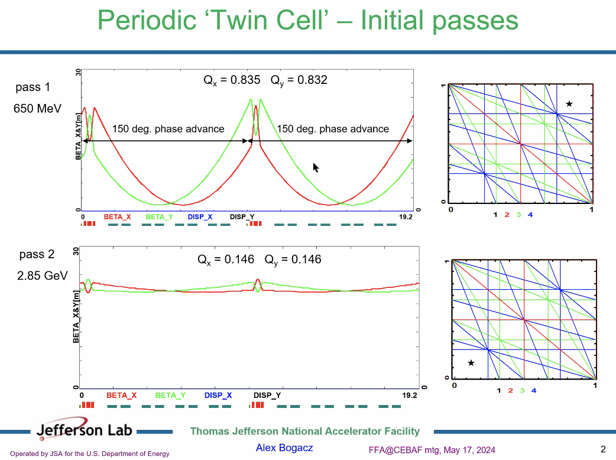
  - Periodic structure. Triplets between sets of triplets
  - Triplets are reverse polarity at each iteration.
  - 150 degree phase advance per cell – gives stability at lower passes
  - 14 twin cells – betas reproduce
  - Quads will scale with momentum as progress through LINAC
  - Pass 2 in NL (3 in CEBAF naming), betas compressed b/c focusing is weaker for higher E (magnets set for low E pass)
- 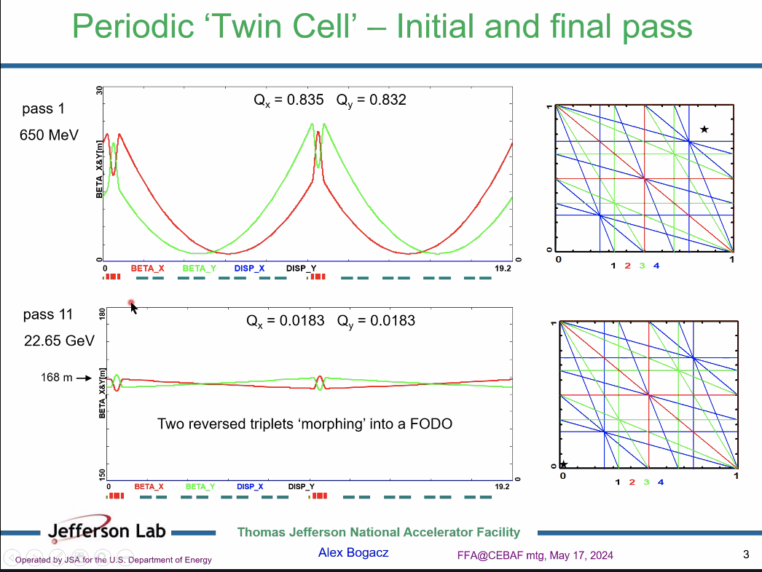
  - Comparing pass 11 – tune nearly disappears. Still enough phase advance to contain beam
  - Beta ~168 m for this. Need to do better
  - Triplets morph into FODO-style
- 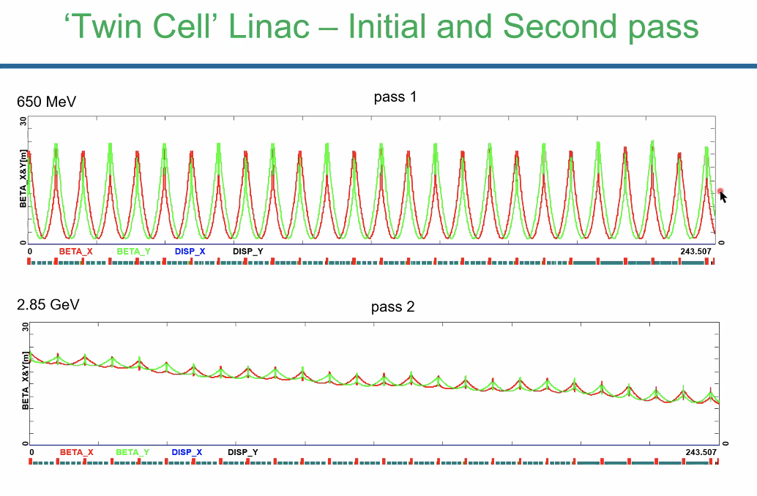
- 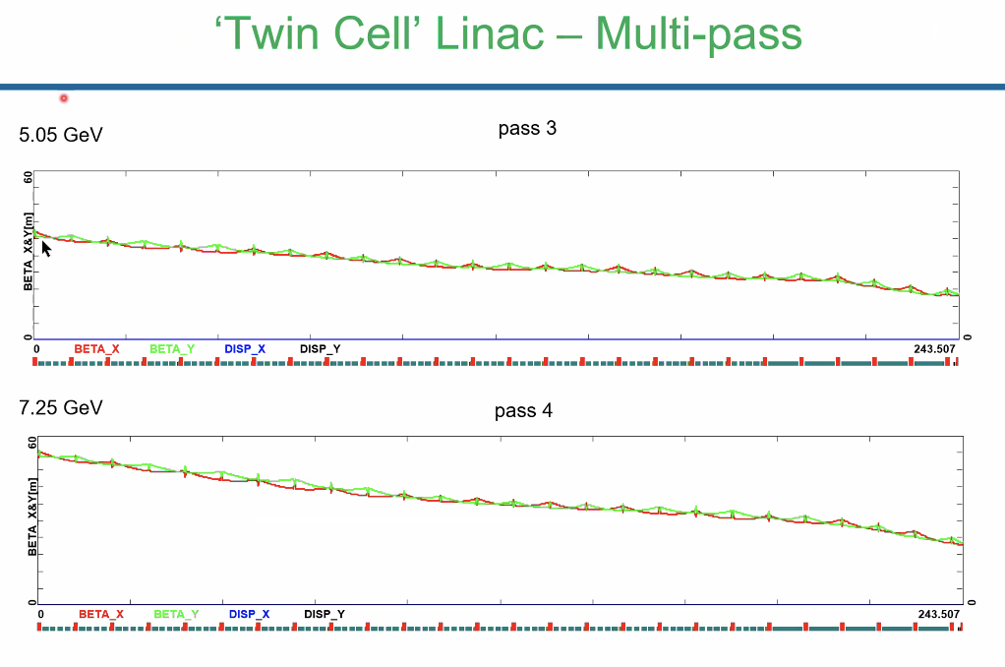
  - Dejan – not concerned both tunes are the same?
    - There is some small cavity focusing at lower E
    - Phases go in step
  - Dejan – so as you go from one cell to next cell, due to the energy change, the betas and tunes are changing?
    - No, tunes are the same
  - Dejan – if full E scale is in LINACs – fine
    - Triplets are scaled with E, so tune constant
- Dejan – why is beta going down along LINAC as energy goes up? Energy is gaining, beta should increase
  - Quads stronger at end.
  - Dejan – are they strong enough to reduce beta of next E? First pass is fine. Next energy, expect beta to go upward
    - Alex – I don’t have a crisp answer to that
    - Vasiliy – the relative change in energy is higher in the first pass, so a change in quad strength is linked to the change in momentum. At higher E, the relative changes are lower, but the quads are tuned for 1st pass energy
- Basically – if choose to scale at beginning of pass 1 and scale through with 1st pass to end of LINAC. The higher passes will have a lower ratio of start:end energy
- Dejan – maybe better to do the grading of the quads between cryomodules like Alex is doing. If you do all same, the betas will blow up.
- Vasiliy – another confusing effect: imaging beam through a single cavity, beta lower at start than end.
  - End field focusing
  - R-S formula for cavity gradients and focusing
  - Lowest cell focusing comes from end-field focusing. Almost comparable to quad focusing
  - K is changing in quads – yes
- Dejan – you kept k same in linac
- Amount of focusing WRT to end field focusing diminishes at end of LINACs
- Flat envelope for lowest pass for “elegant” solution – could aim to flatten out other passes. Can’t do it for all passes though.
- Don’t worry about EM passes b/c Spreader/Recombiners: passes 1-4 go through this for EM passes
- However, the FFA passes (5-10), they go through Spreader b/c they must, but are then steered back down to LINAC height co-linearly.
  - No quads here.
  - In terms of betas, it’s basically a drift
- Need to optimize Twiss not at end of NL, but through recombiners and spreaders
  - Optimize for higher FFA passes – optics should minimize betas and alphas at start/end of Recombiners/Spreaders
- 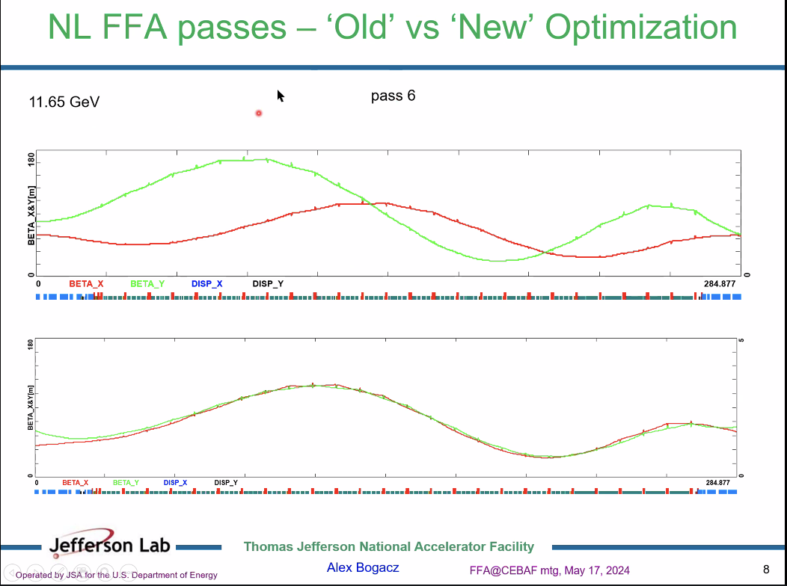
  - Have added in recombiner on left side, and spreader on the right side.
  - No longer aim for periodic function (168 m) – instead you have weird alphas/betas, and it will break the periodicity. Instead, adjust betas and alphas at the beginning of the recombiner.
    - All you can do is define betas at start of recombiner.
    - Start with alphas = 0, use Monte Carlo to increase betas and see what the beta max would be in the linac
  - Old on top, new on bottom
    - Alpha = 0 is not a hard constraint. Change alpha to get the betas to match through machine
  - To do Monte Carlo, cooked up error function to optimize
    - Produced bottom plot
- 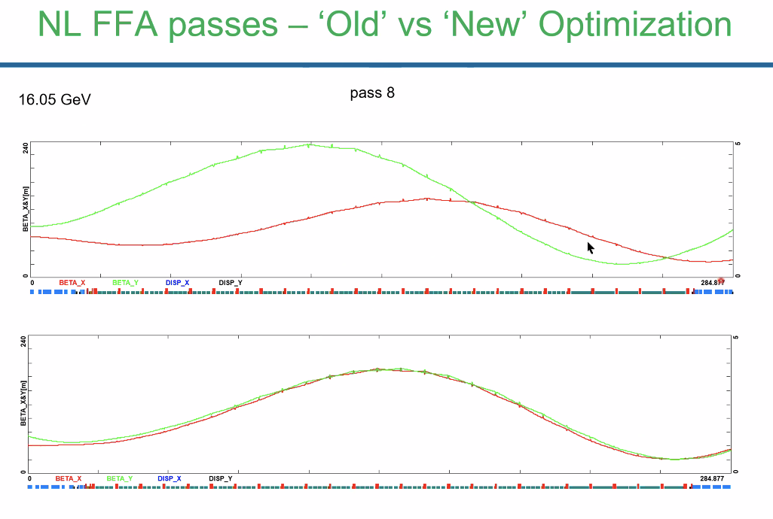
- 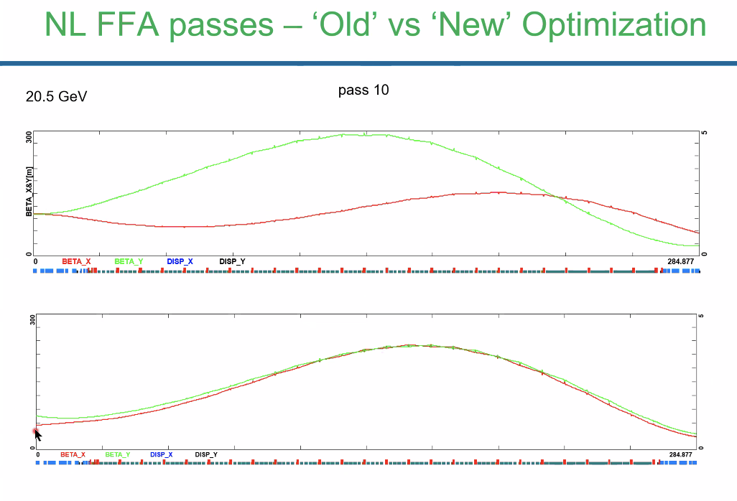
- Ryan – what Monte Carlo tool did you use? OptiM?
  - No, something external – “cooked up function” not something specific
- SL different:
- 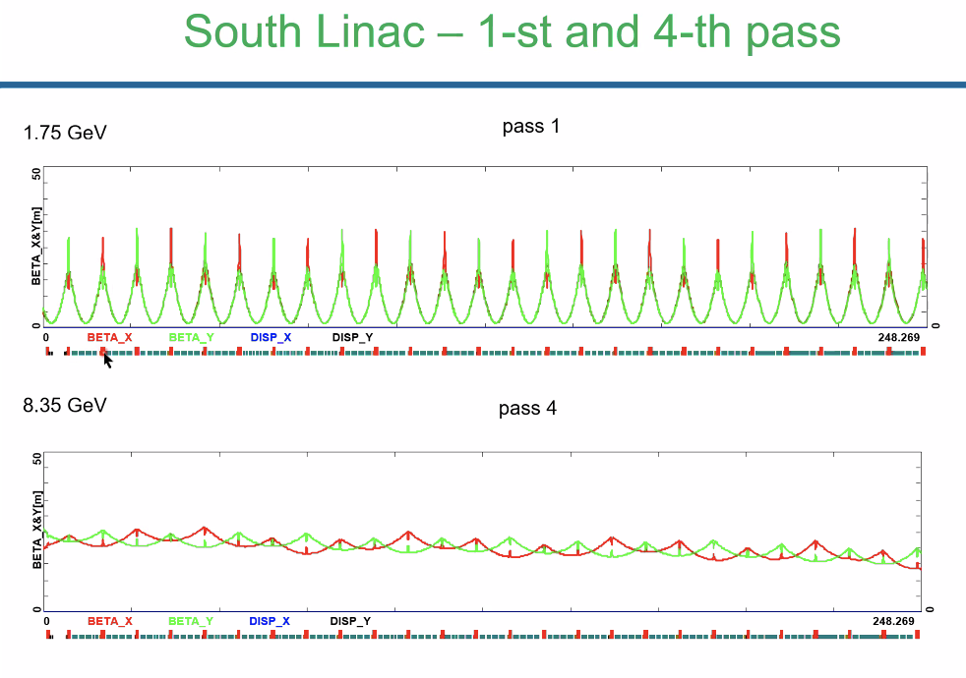
  - Rematching cell-by-cell not needed
  - SL a little longer – extra triplet at the beginning
  - Initially when put together, didn’t pay attention to that initial triplet (set to 0)
  - Up to pass 4 things are nice
- 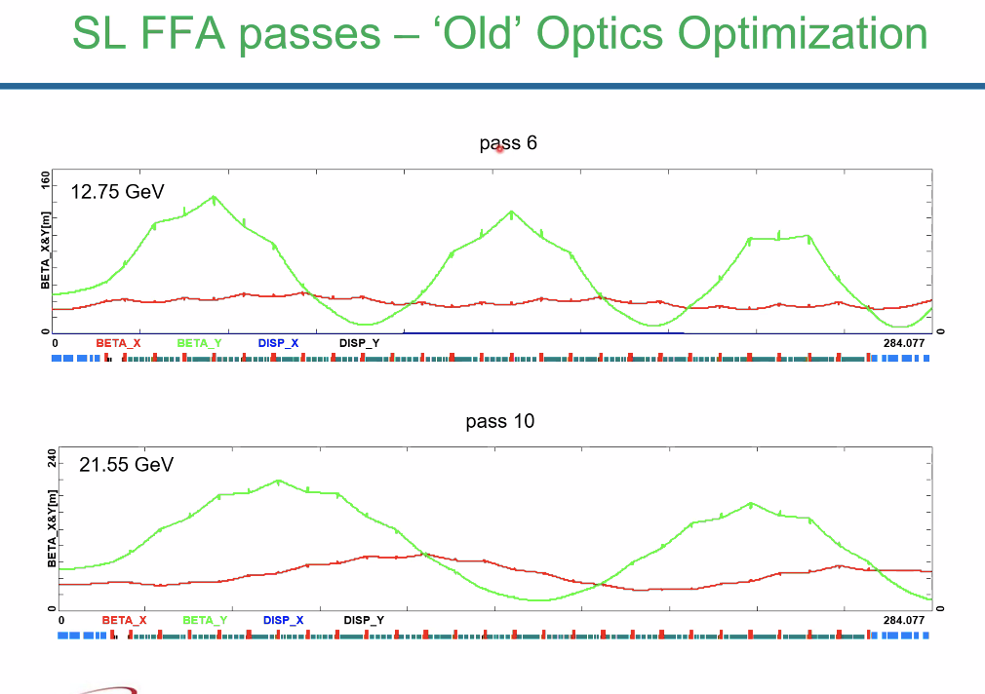
  - Higher passes falling apart
  - Couldn’t optimize in a nice way – qualitative difference between horizontal and vertical planes
    - Phase advances cause imbalance of horizontal. Deficiency in vertical focusing
  - Strong, positive alphas – got “wacko” results
- 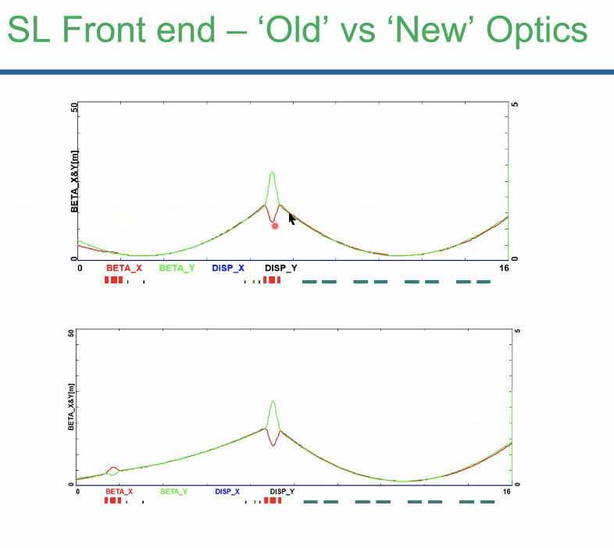
  - Added focusing to balance horizontal/vertical phase advance
  - Started with negative alphas
  - First triplet set right
- 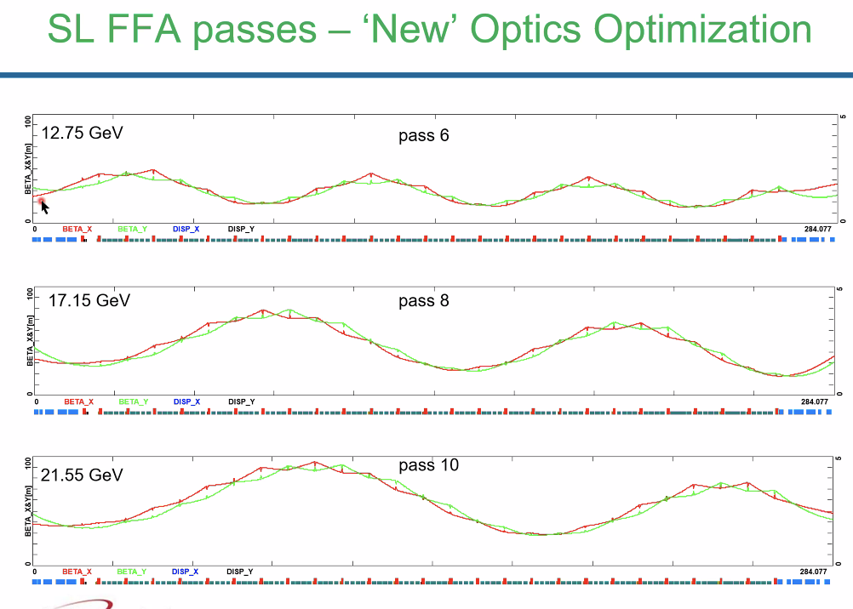
  - Now can play “beta beating” game for higher (FFA) passes
  - Betas kept less than 50 m at end
- Reza – what causes longer wavelength wave through LINAC?
  - If you start with a smaller beta than the one for the periodic solution, it will start beta beating (overshooting) and having an onscillation.
  - So you induce the oscillation by looking for the right initial Alphas/Betas
- 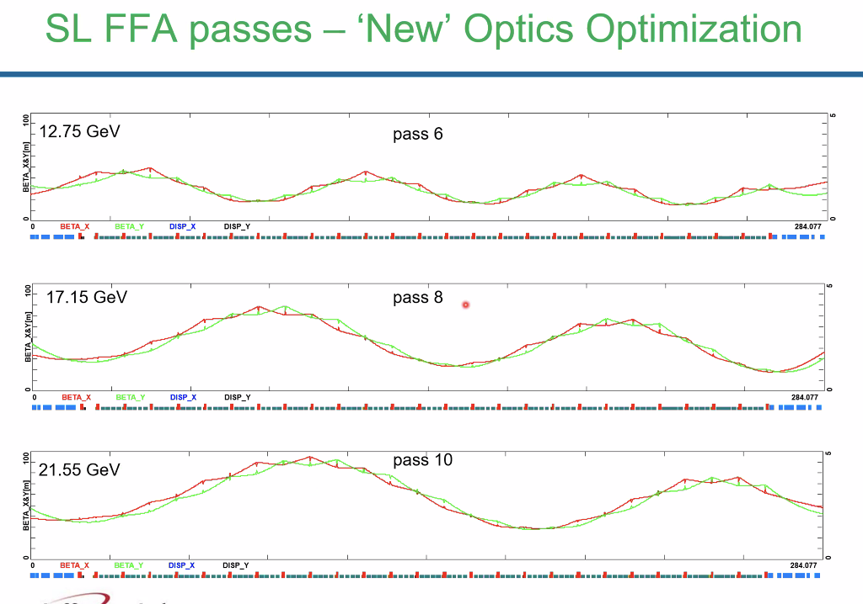
- Optics files passed to Donish – he will clean them up and use them
- 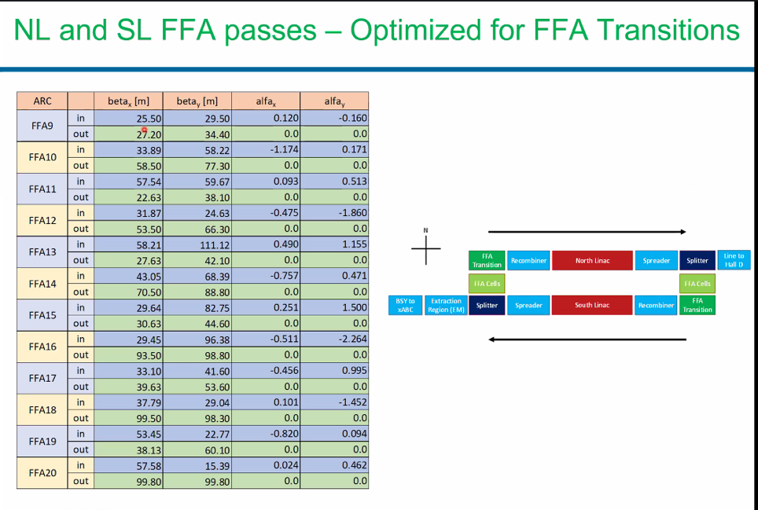
  - These are the old values – will update
- Every time look into LINACs – room for improvement.
- Summary – re-optimized and changed triplet at beginning of SL
  - Isurumali did excellent stuff with simulations to go further
    - Could use GA
  - Go further than playing with input conditions

Action Items | Person responsible | Deadline

Time allotted | 25 mins | Agenda topic IPAC | Presenter All

Action Items | Person responsible | Deadline

Special notes

Pathway to Repository: https://jeffersonlab-my.sharepoint.com/:f:/g/personal/tristan_jlab_org/EqZ5MeS-nipCgPfZB5p0oS4B9Is67d3nQb9sLJI3Zyev9g

NO MEETING NEXT WEEK DUE TO IPAC

