FFA@CEBAF Working Group|Minutes

Meeting date | time 05/31/2024 | 11 AM EST | Meeting location https://jlab-org.zoomgov.com/j/1614898082?pwd=TnUzMS81M2sxbDZIbERJU01tYkJCQT09
Meeting called by Alex B  Type of meeting Weekly Meeting  Facilitator Alex B  Note taker Ryan  Timekeeper Alex B | Attendees  Alex B, Ryan, Todd, Salim, Randika, Kirsten, Alex C, Stephen, Donish, Edy, Dejan, Nick, François, Andrei, Tim

Intro Discussion
- Short meeting
- HUGs tour

Agenda topics

Time allotted | 25 mins | Agenda topic LINACs| Presenter Alex B
- Last time, presented strongly focusing linacs
- Will show the summary
- 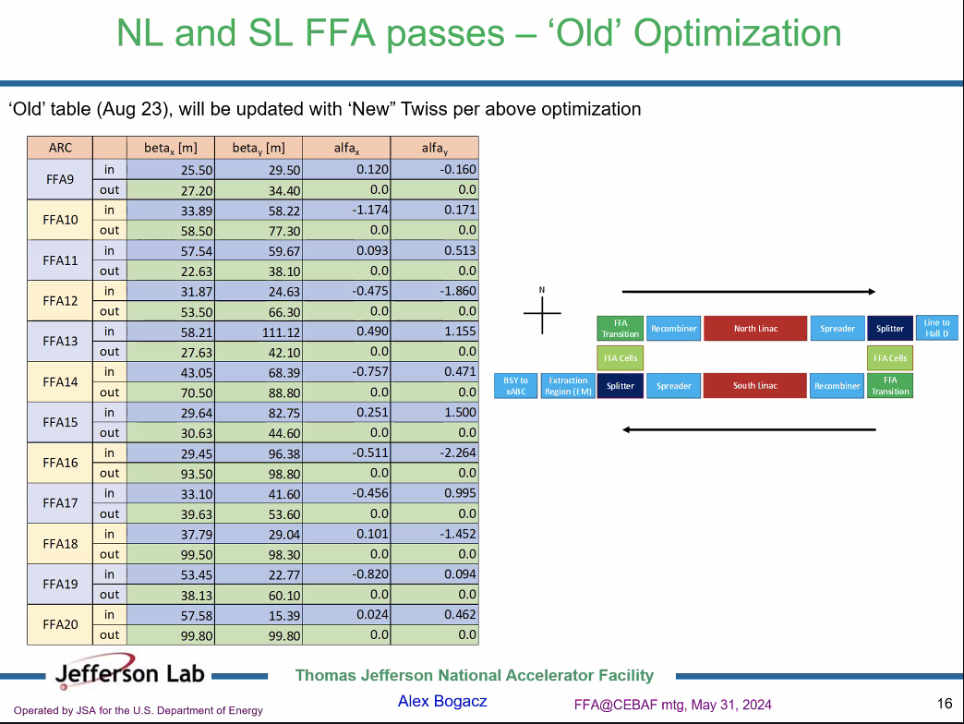
  - This is from last summer
  - To read this, started with pass 5 (FFA Passes). Not at linac, but recombiner/spreader is start
  - Values from beginning of Recombiner and end of Spreader
  - Stephen – what you’ve done is the right thing but called it the wrong thing.
    - Maybe call extended LINAC or Spreader points.
- Odds are East, Evens are West
- 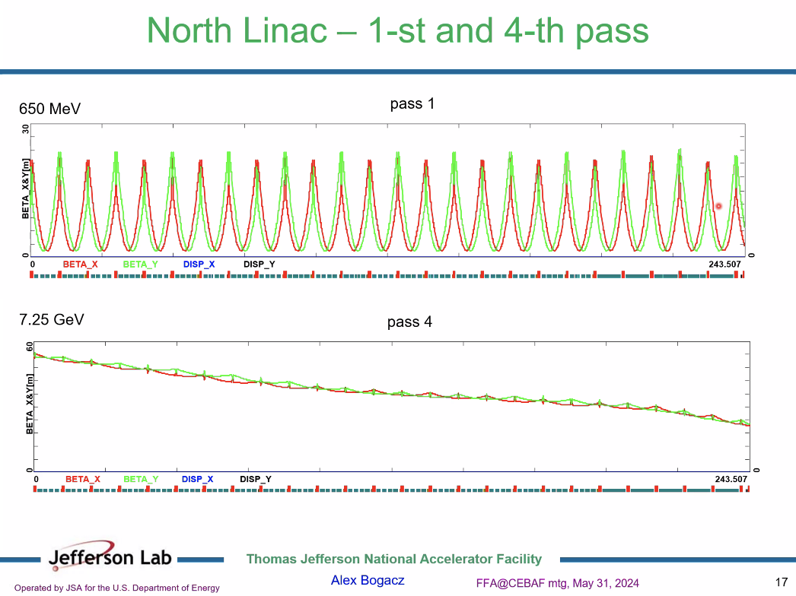
  - NL – enters at 650 MeV – make first pass flat with triplets
  - All other conventional passes follow semi-periodic plot
    - Higher passes drop b/c of scaling chosen
  - This is JUST LINAC PROPER – not extended
- 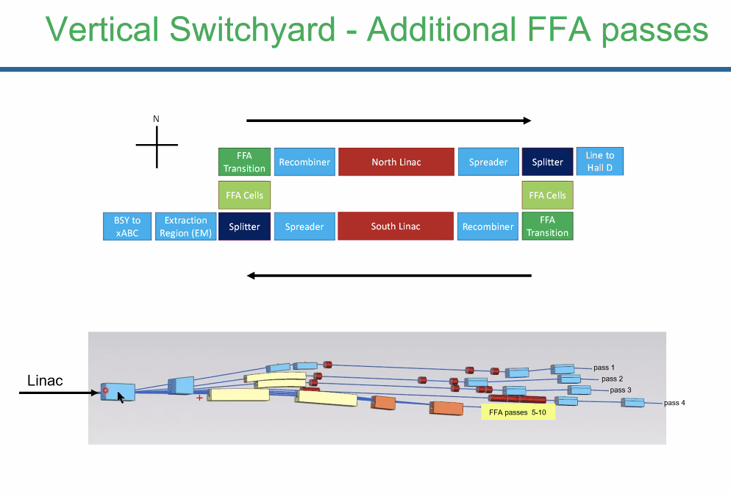
  - 4 EM passes separated out, 6 passes through FFA
  - 6-point chicane – for higher FFA passes, extended NL with SW recombiner and NE spreader
- 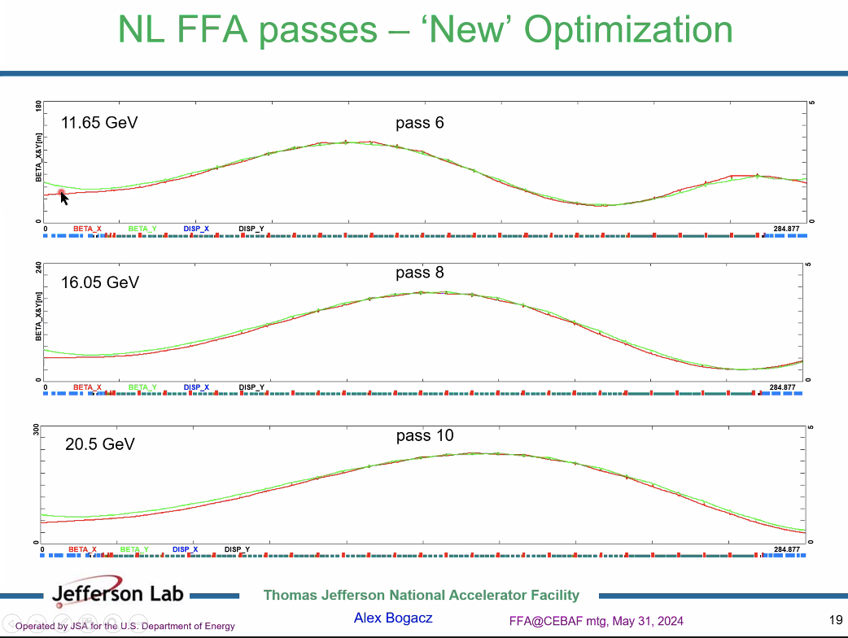
  - Different error function and monte carlo to find Twiss.
  - Now, including recombiner and spreaders
  - “explore beta beating”
  - Morph into FODO lattice
  - Previously, put alphas = 0, but now, open that up
- In Monte Carlo, was feeding Twiss functions with some distribution to get small values at ends
- 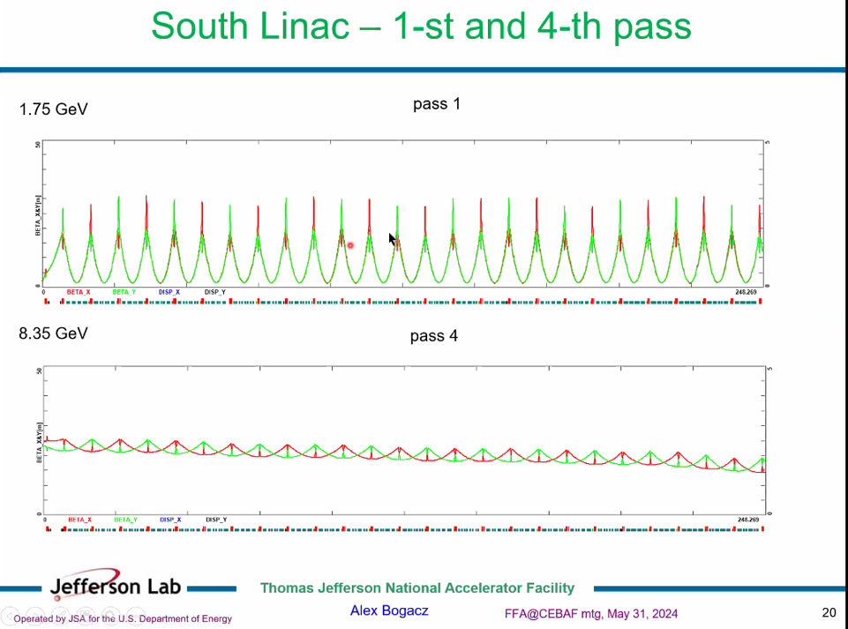
  - Assymetry b/w Horizontal and Vertical phase advance, and wrong slope for function
- 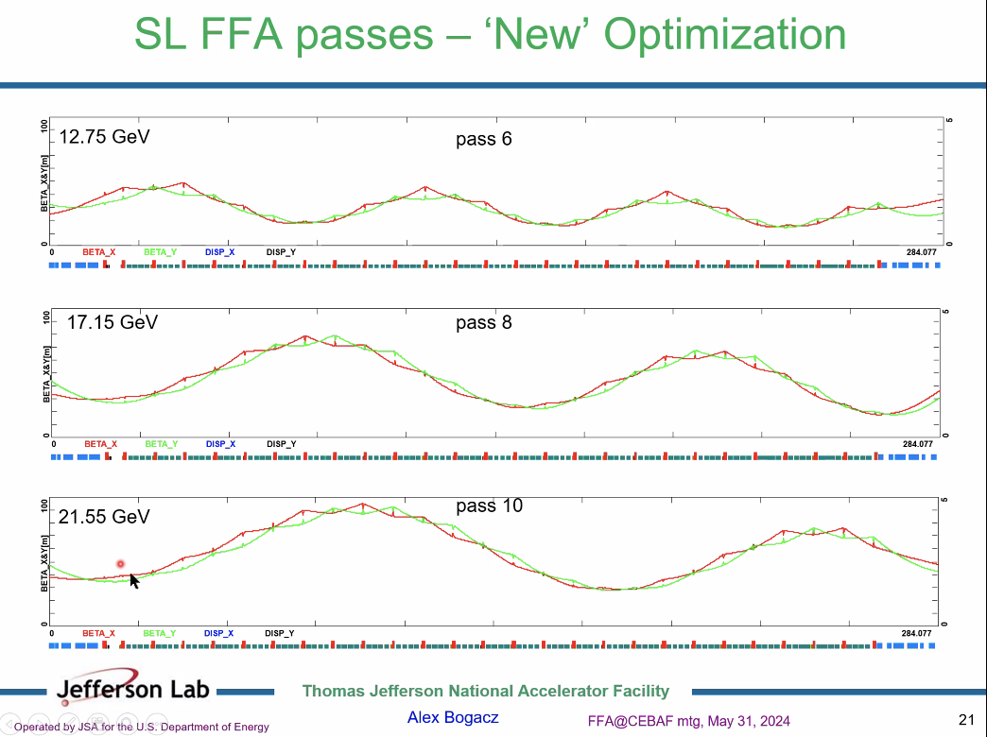
  - The Betas are confined pretty well with this optimization
  - Trying to put nodes at ends and confine max betas
- 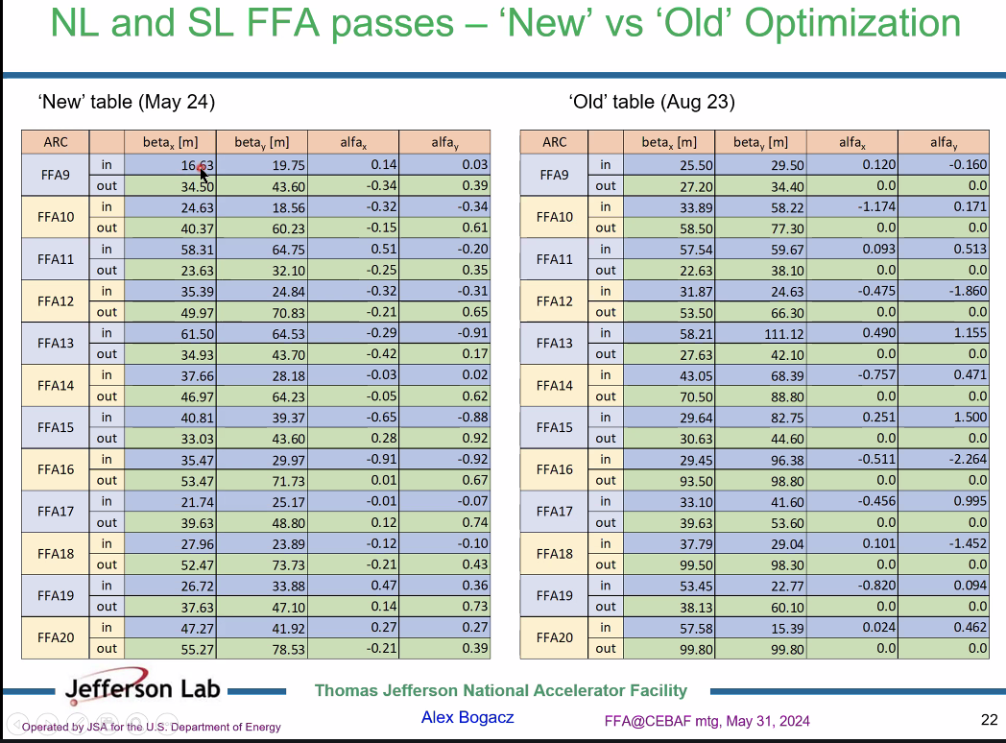
  - May change labels
  - More balanced now
  - Betas well below 100 m
- Ryan – did you use the newest OptiM files provided by Donish? They were aligned with CED already.
  - Alex B – yes, used those files. Donish will process them.
- Donish – yes, I’m processing them now.
  - Will be elegant, OptiM, Bmad
- Ryan – could you share the Monte Carlo code in case we need to re-optimize?
  - Did this in Matlab – still experimental, but will clean up and share eventually.
- Dejan – very impressed. 75 m was the largest Beta?
  - You’re right.
- Big different with input energy of 175 – so quads much stronger b/c high energy input. But cannot do that in the other LINAC b/c the energy range is smaller
  - Yes – start with NL at 650 MeV and go to higher energy
  - For SL start at 1.7 and go to 21 GeV – scaling gives nicer optics.
  - Larger injection energy, smaller beta
  - 11 pass – got feature where get half of the wave – two nodes and one mode at middle
    - Mode is still within aperture of LINAC
- Dejan – now concerned with plans to get R56 to zero with LDRD
  - Let’s suppose we fix that – still have to match Betas
  - Need splitters
    - Ryan – yes, still need them
- Ryan – spoke with Stephen and R56 may actually be adjusted in FFA arc
  - Stephen – noticed ToF changed by order of 2 in some of the other FFA arc designs. Maybe not R56, but could be looked at.
- Dejan – 5 elements to change R56
  - Still need to match into FFA from LINAC
  - Need splitters
- Stephen – relative ToF change is 2 parts in 10^4, was 3.9 parts in 10^4 – almost halved ToF different among FFA arc
  - Likely b/c cell got shorter, so smaller orbit excursions.
- Alex B – will update or make reading instructions for table
- Stephen, got improvement with linear lattice without sextupoles
  - Sextupoles could make it go even smaller.
Action Items | Person responsible | Deadline

Time allotted | 25 mins | Agenda topic AOB | Presenter All
- Dejan – didn’t like IPAC talks – nothing connected to our field.
  - Didn’t have many talks, no talks for CEBAF upgrade
  - Spoke with Manoucher a couple times. There were two meetings already toward making decisions. Didn’t say anything specific.
  - Mentioned to SBIR people that Stephen made deal to make permanent magnets
    - Sabr (sp?) enterprises in MA – was at FFA workshop industry session
- Who is delegation to DOE?
- Dejan – suggestion to Michelle Shin – invite company to meeting. If present, could realize other options.
- Timur is looking for PM upgrade – similar trajectory as us. Started with LDRDs, has to ramp up. Will use departmental funds
  - He’s getting his from BESAC instead of NSAC
- Dejan – Timur et al want to participate
  - Placing magnets in Xray beamline
  - Experts on getting SR out of small slots
- KYMA giving PM workshop
  - Everyone is afraid of radiation
  - Always mixing iron and PM before iron – CBETA looked at this but gave up
  - People are hesitant about Halbachs
- Stephen will be part of someone’s LDRD related to this
- Stephen – told Timur about Ryan’s LDRD, but we should coordinate
  - Ryan needs a two-axis platform to do field maps
  - Joe Meyers may have what we need already
- Ryan – interesting new device from GMW – essentially an array of hall probes to quickly field map (low accuracy, but fast).
- Ryan – looked into CERN facility tests (CLEAR etc), may be able to get “free” time to get beam-strike tests
  - Just cost shipping and/or travel
  - Salim – could be used in electron part of SPS as well
- Alex B – could we use injector?
  - Maybe. CLEAR gives us a range of 50-200 MeV, so we can get a scalable dosage and real beam strikes, instead of just environmental radiation
  - AB – there’s a 5 MeV dump that could be used parasitically
    - Ryan – yes, that’s worth checking out.
Action Items | Person responsible | Deadline

Special notes

Pathway to Repository: https://jeffersonlab-my.sharepoint.com/:f:/g/personal/tristan_jlab_org/EqZ5MeS-nipCgPfZB5p0oS4B9Is67d3nQb9sLJI3Zyev9g

