FFA@CEBAF Working Group|Minutes

Meeting date | time 06/07/2024 | 11 AM EST | Meeting location https://jlab-org.zoomgov.com/j/1614898082?pwd=TnUzMS81M2sxbDZIbERJU01tYkJCQT09
Meeting called by Alex B  Type of meeting Weekly Meeting  Facilitator Alex B  Note taker Ryan  Timekeeper Alex B | Attendees  Alex B, Ryan, Donish, Dejan, Edy, Reza, Salim, Scott, Kirsten, Stephen, Randika, Vasiliy, Roger, Todd

Intro Discussion
- New email list for physics case(s) for energy upgrade
  - Alex B is liaison
  - Meetings every-other-Monday to discuss
- ERL in Japan this year – tell Scott about good speakers.
  - Maybe Kirsten – Scott has the POWER!
- How far apart are ERL and FFA?
  - Not back to back. Roughly 2 weeks in between
- Hutton asked about getting rid of splitters
  - Probably can’t – need to match all the other optics still
  - If space and money are not concerns, anything is possible!

Agenda topics

Time allotted | 25 mins | Agenda topic Splitter Crosstalk| Presenter Donish
- 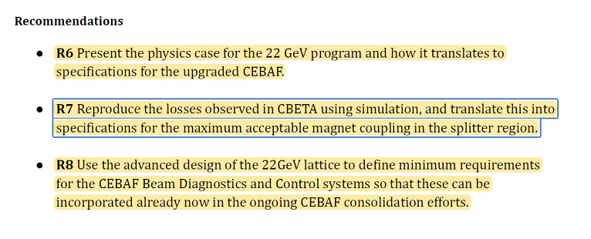
- Scott – not convinced crosstalk was cause of problems.
  - Need sufficient crosstalk management. With standard magnets, you have an expected pattern. Just manage it.
- Kirsten – crosstalk IOC tried to compensate. Wasn’t constant, but could have been worked out. Contributing problem, but bigger thing was that we “were flying blind”
  - Stephen – put hall probes in splitters to see what we have
  - Need more diagnostics
- Dejan – Adam was only using two magnets. Not following the optics. No one knows how he did it.
- Scott – at the last ERL workshop – Adam showed that by-and-large, he was really close to design optics by the end
  - Kirsten – we all got stuck on R2. All quads close except in R2 – that’s complicated.
- Dejan – interesting new development. New company called XLight. Bruce Dunam mentioned that there might be money for running CBETA again.
  - Also Chris Mayes, Georg, etc…
- Alex B – let’s disentangle from CBETA – murky
  - Scott – yes, murky
- Asked Donish to see what we can tolerate
- 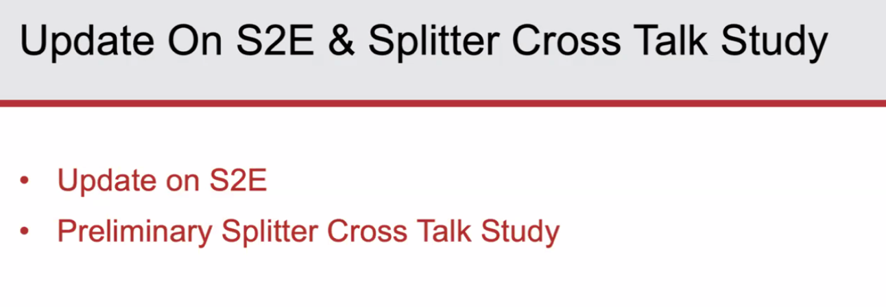
- 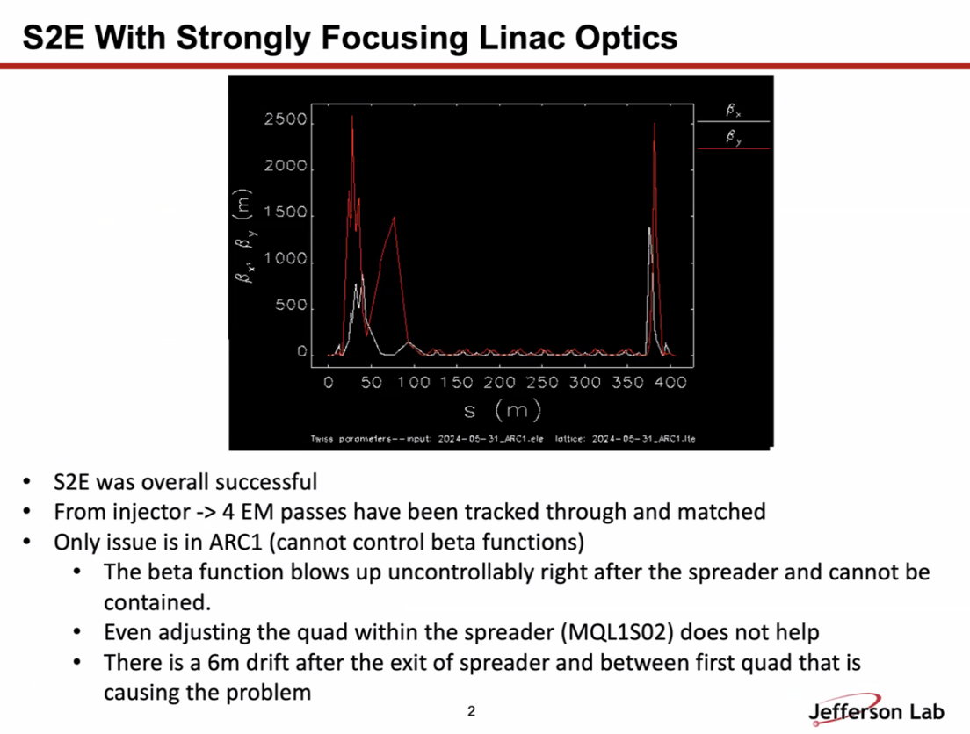
  - Rematched the whole machine based on new LINACs
  - Right after spreader, there’s a 6 m drift before the next quad. Betas blow up huge
  - Using spreader quad – but didn’t help.
  - Will have to look into Arc1 lattice file to control betas
  - Might add a quad to help control it – there’s a 6 m drift
- 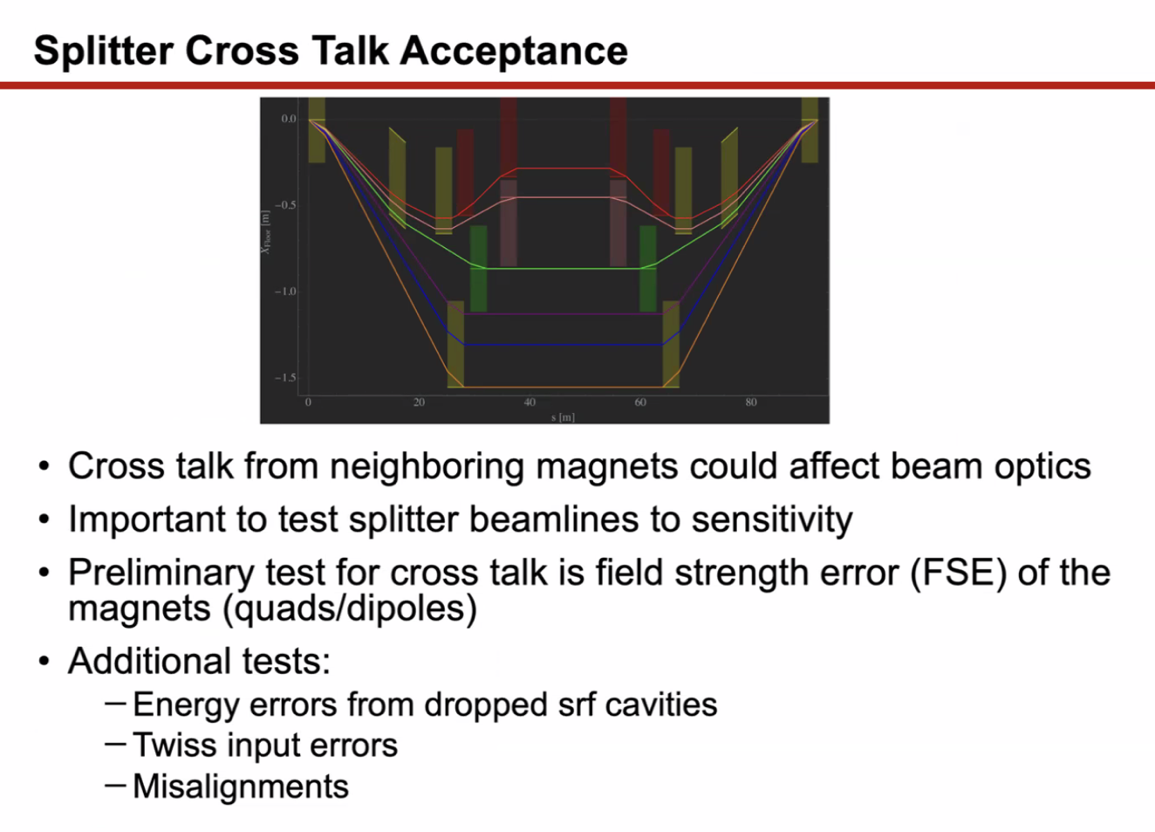
  - Preliminary study – field strength error on all quads and dipoles
  - Added energy and twiss errors as well
  - Using Dejan’s lattice
- Didn’t do all 6 lines. Focuesed on lowest E
- 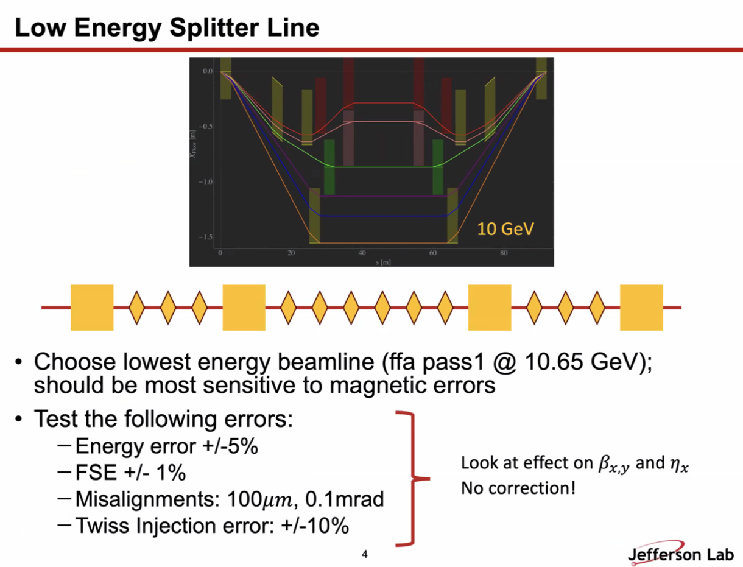
  - Since beamlines aren’t finished, no correction applied
- 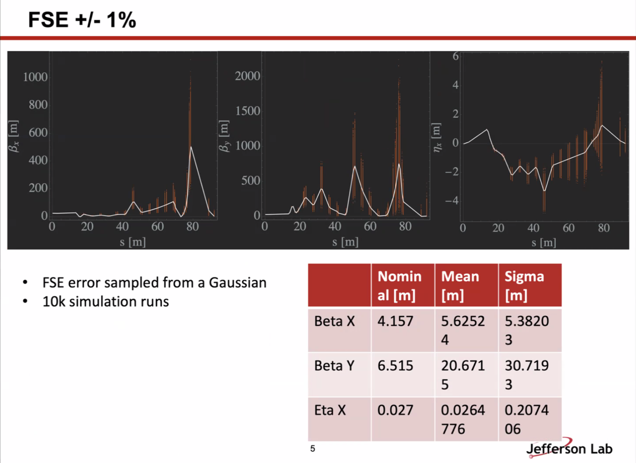
  - White is nominal, orange are “watch point”
  - Field strength error +/- 1%
  - 1% plays a slight role at exit of splitter line
- 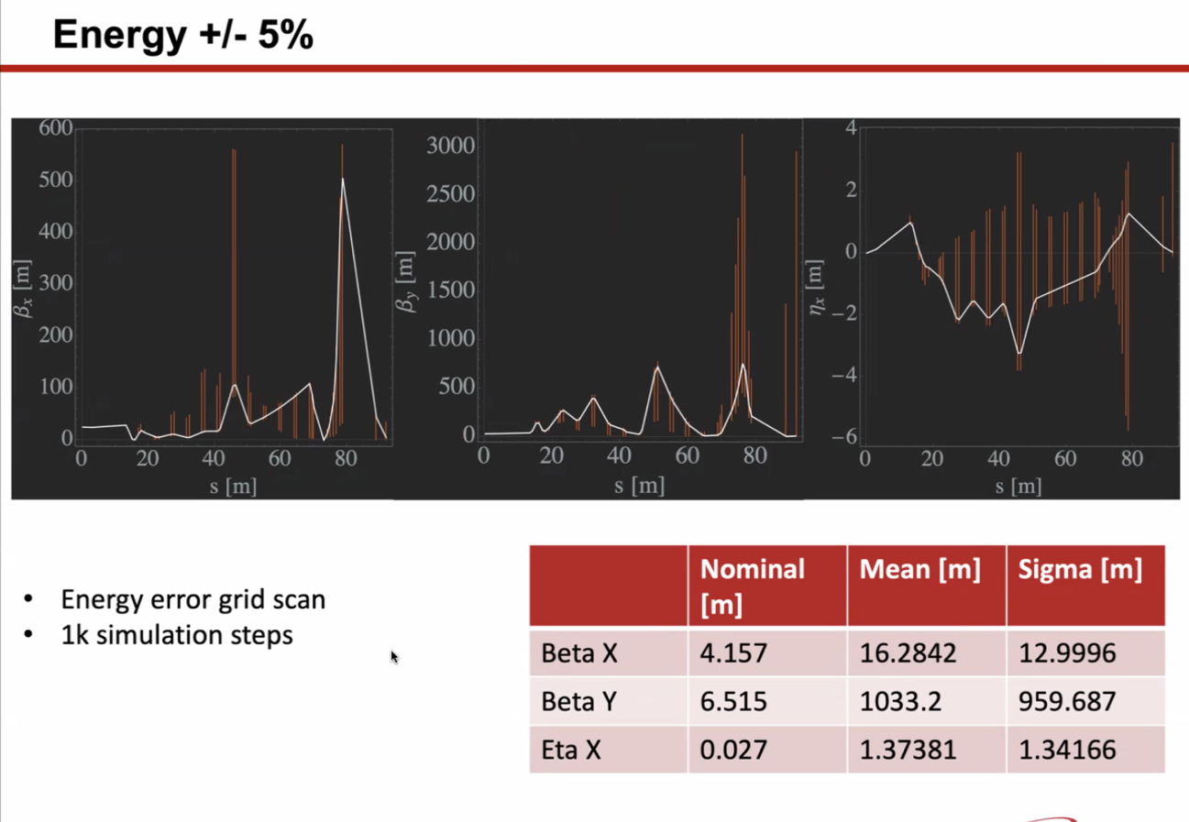
  - Scanned energy error in steps
  - Much larger effect on output optics
  - Vertical beta explodes, huge dispersion leakage
- Reza – does 5% energy error allow the beam to get through the arcs?
  - Not sure
  - Dejan/Stephen – ought to go through the arcs
  - Reza – I mean through the whole machine
    - EM part of machine should be fine
    - Just looking at Splitters – good question. Didn’t add any correction, didn’t look at orbit. It’s too early at this stage without correctors
  - Reza – what is a reasonable energy error?
    - Got 5% by dropping a cryomodule, multiplied by 4 just to give energy change of 4 passes as enter this beamline.
    - Reza – at this level now, we could not transport this without changing settings.
      - Halls talk about 10^-4 level energy. 5% is too much
- Salim – for the magnets – is 1e-3 the limit for magnet errors? Trying to understand.
  - Seems like a lot
  - Donish – trying to overestimate with worst case
- Ryan – when we have a cavity drop, we can operate by scaling magnets (LEM) and arc magnets.
  - Alex B – we can compensate
- Reza – would choose 2-3e^-3 to estimate how beam would go off. More than that, the rest of the machine would have too many problems.
- Alex B – we’ll have to evaluate adding correction to the splitters
  - Ryan – we have to build that in from the beginning.
- Remember, splitter lines aren’t done – this is just preliminary.
- 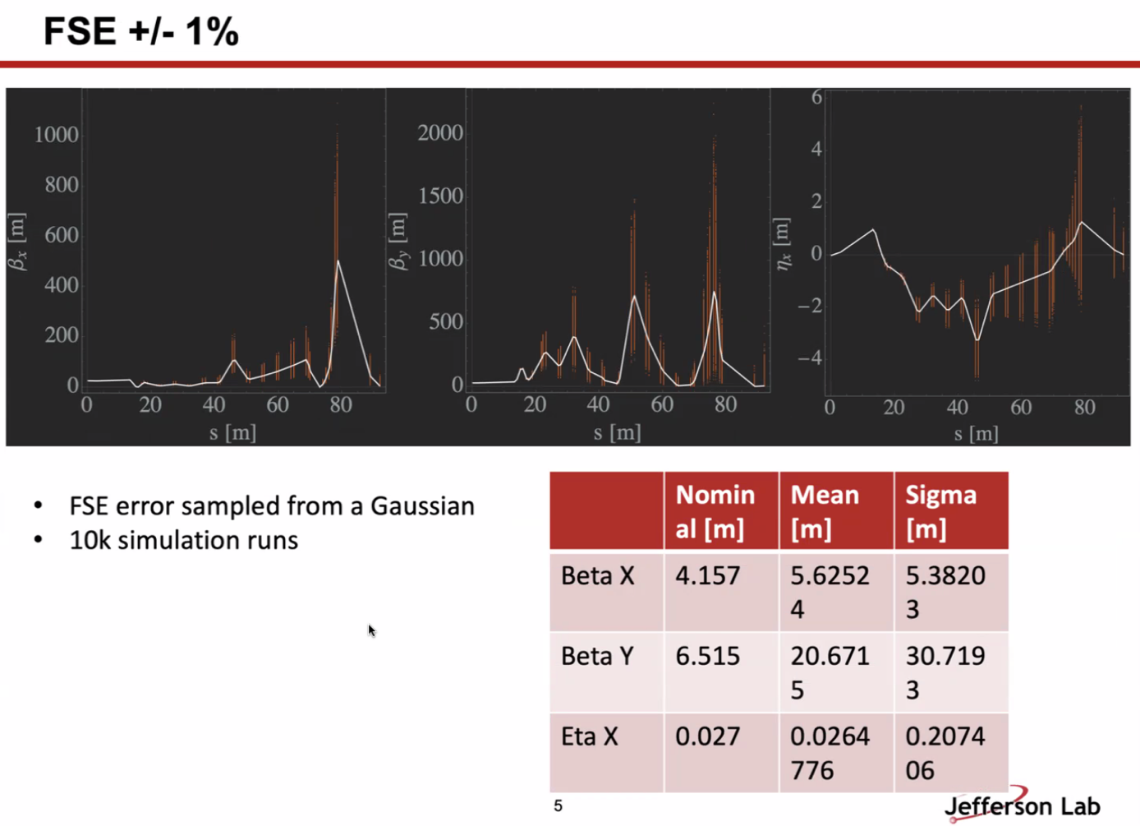
  - Reza – this is just a one-time error?
  - Are these studies concurrent, or separate?
- For each simulation, each magnet samples from a gaussian that is +/-1% at 10K runs. Unique set of errors on magnets.
- For energy, just a grid scan
- 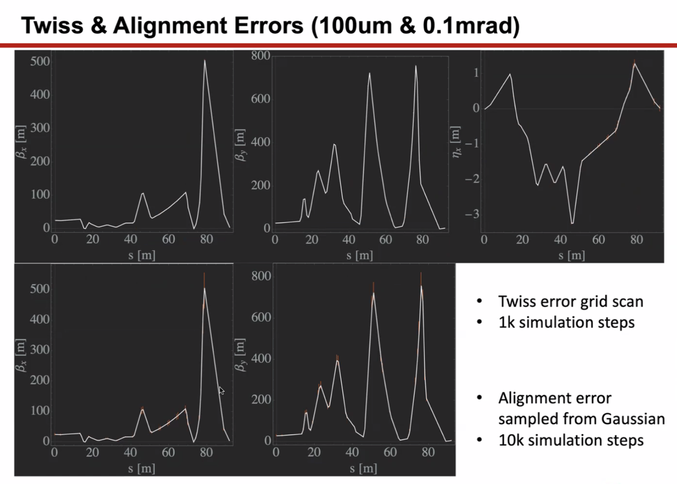
  - Tested 10% errors on Twiss. It was an overestimate.
  - Grid scan on Twiss as well
    - Would be better to sample errors from random distribution, but for this preliminary study, focused on simple grid scan
    - Only 1000 this time
  - Alignment from gaussian – 10K runs
  - Doesn’t impact things too much. Alignment is hardly changing anything. Plays a bit of a role in Twiss input, but didn’t completely destroy the beam
    - Might be promising to give some flexibility in Transition
- Dejan – if we run CBETA, Stephen wants to put hall probes in each magnet and watch what happens in each magnet
  - Stephen – help with hysteresis also. And get an idea of crosstalk
    - Problems with repeatability
  - Dejan – had to ramp the magnets 5-6 times to get the right values
  - Stephen – reduced errors by 5-fold, but still not repeatable
  - Maybe hall probes would help.
- Ryan – did you have problems with power supplies?
  - Yes – looks like wrong ones bought, had to add capacitors to reduce oscillations, etc…
  - Circuit very unstable.
- Reza – in our machine, there are places with crosstalk. Two things we do:
  - Doing the order correctly (cycle them the right order and repeat)
  - For spectrometers, we go and put power supplies with that magnet and only do them with that PS and magnet.
- Dejan – in RHIC, when running low E, remnant field and hysteresis very important
- Ryan shares pictures:
  - 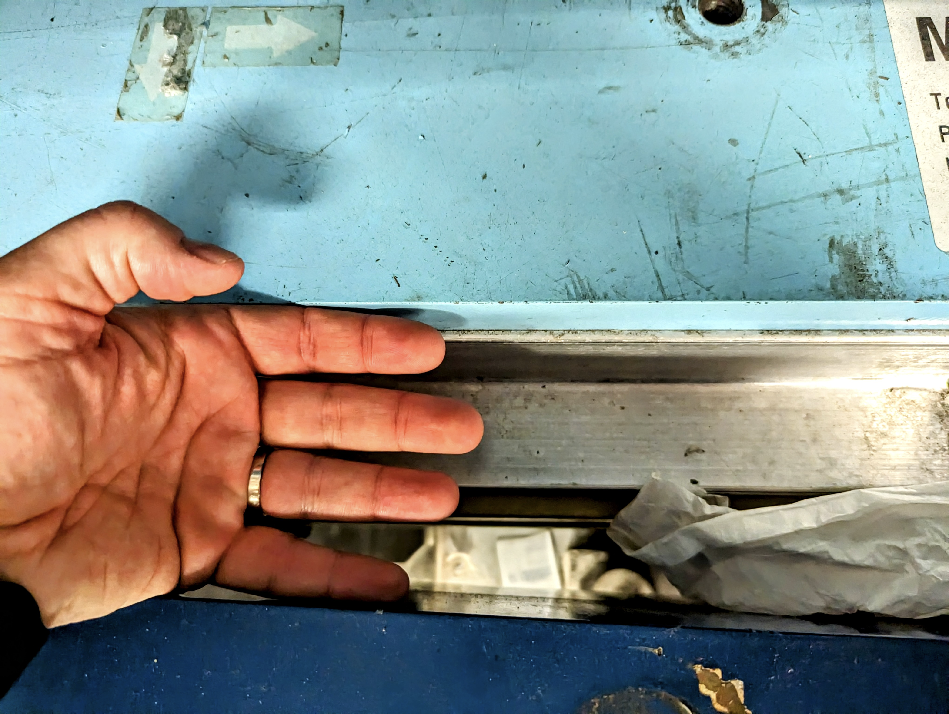
    - Ryan’s hand is about 3.5” from outside to outside.
    - Septum on top, recirculated beam on bottom in dark blue
  - 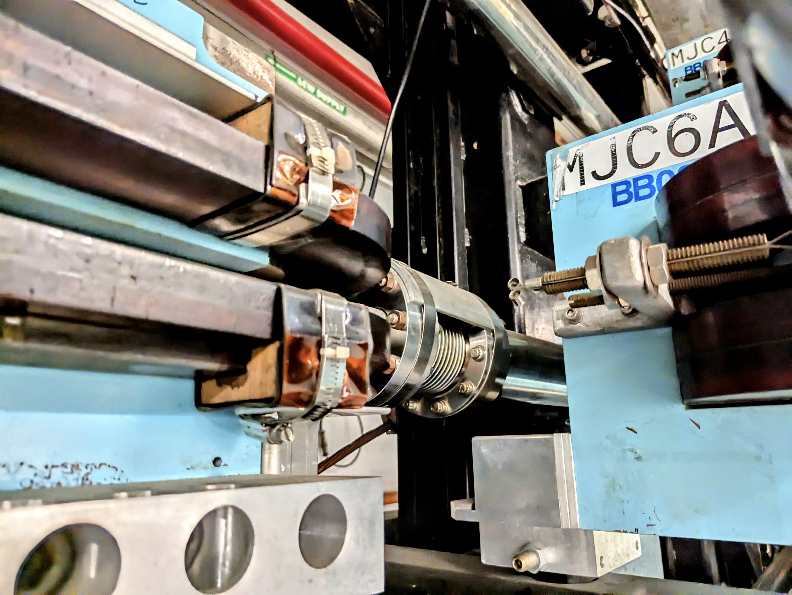
  - 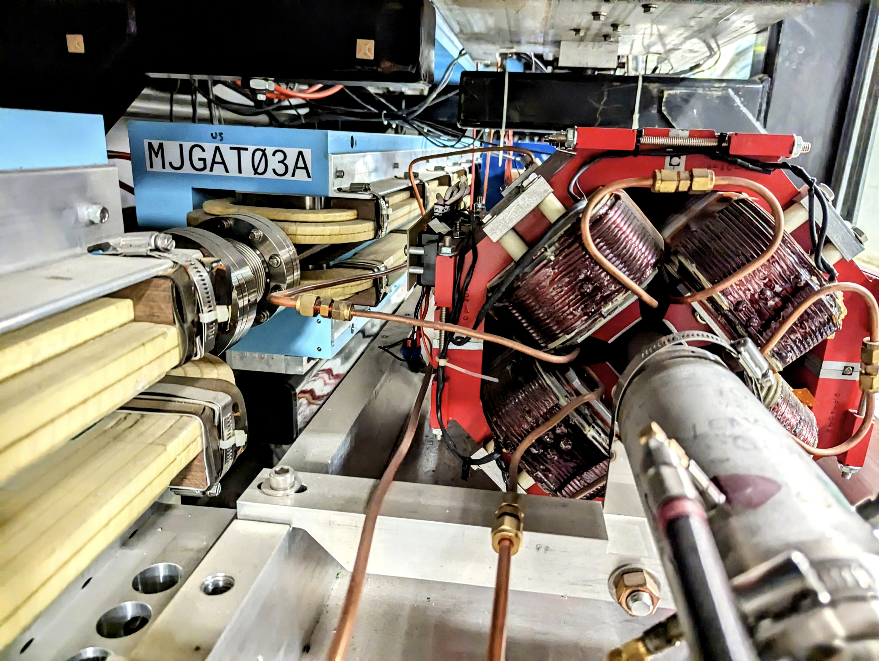
- Reza – one of biggest problems for crosstalk is not magnet to magnet, but the cable to the beam crosstalk.
  - The cables themselves impact the beam
  - Dejan – this happens a lot – important to remember that first ring was made of permanent magnets – couldn’t get beam through magnets b/c of impact of ring above.
    - Shielded with mu metal
    - Ryan: conversation with Jay, and apparently beam pipes made with layers of carbon steel with air gaps in between work great. Mu metal if more is needed.
- Alex B – thanks for starting this work, Donish
  - Thanks to all for bringing in more input
- Alex B – will have to look at which splitter – like the symmetric option
  - Ryan – yes, but that option doesn’t have two lines completed. Two lines are still shared, and do not have independent control. So that’ll change the layout once that is added.
Action Items | Person responsible | Deadline

Time allotted | 25 mins | Agenda topic AOB | Presenter All
- JLUO meeting next week.
- Alex B – maybe we only meet every two weeks instead of weekly for the summer.
  - Will resume in two weeks.
  - Dejan and Ryan agree
Action Items | Person responsible | Deadline

Special notes

Pathway to Repository: https://jeffersonlab-my.sharepoint.com/:f:/g/personal/tristan_jlab_org/EqZ5MeS-nipCgPfZB5p0oS4B9Is67d3nQb9sLJI3Zyev9g

Next meeting in two weeks. This will persist for summer (every other week).

