FFA@CEBAF Working Group|Minutes

Meeting date | time 06/28/2024 | 11 AM EST | Meeting location https://jlab-org.zoomgov.com/j/1614898082?pwd=TnUzMS81M2sxbDZIbERJU01tYkJCQT09
Meeting called by Alex B  Type of meeting Weekly Meeting  Facilitator Alex B  Note taker Ryan  Timekeeper Alex B | Attendees  Alex B, Ryan, Alex C, Scott, Salim, Reza, Dejan, Kirsten, Donish, Stephen, Alex C, Edy, Nick, Tim

Intro Discussion
- Muon collider mini-chat
  - Still early in the process, hard to see where things will go
  - August meeting at Fermilab (early August (7-9)– Inaugural Muon Collider Collaboration meeting)
    - https://indico.fnal.gov/event/64493/
  - MuFact at Argonne around the same time
    - Sept 16-21

Agenda topics

Time allotted | 25 mins | Agenda topic FFA Arc Corrections| Presenter Alex C
- Have been figuring out how to optimally correct FFA arcs. Been working with segmented linear permanent magnet designs from Dec 2022 (Stephen’s design).
  - However, the algorithms should be extensible to any situation of the FFA baseline design
  - Documentation is not finished on *how* to extend yet, but it’ll be there before Alex leaves.
- 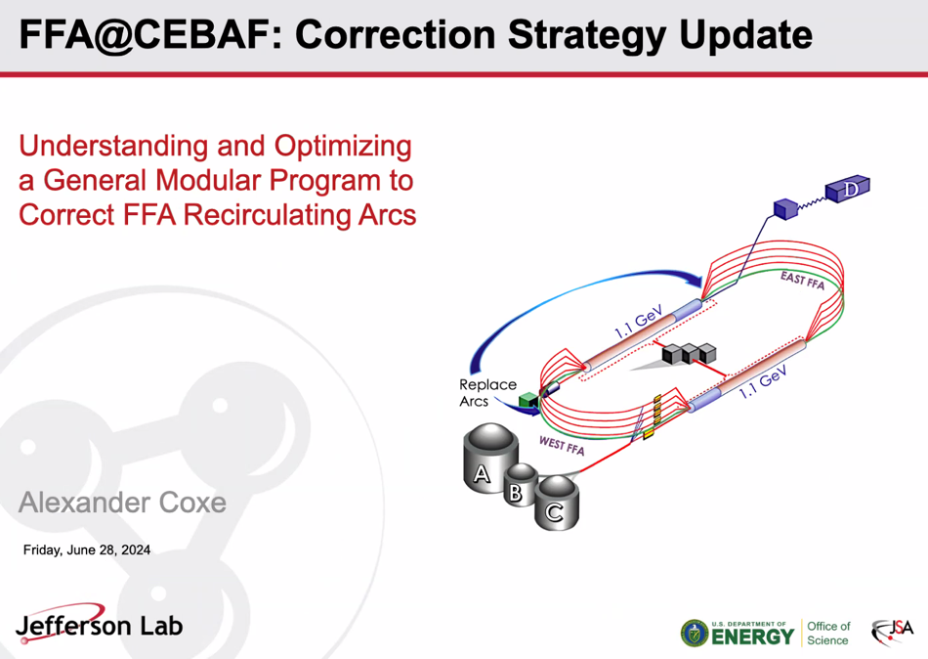
  - Don’t know all precise specifics yet: how much will get taken by transition, how splitter optics will look, final FFA magnets, etc…
  - Took general approach using BPM readings and corrector settings.
- 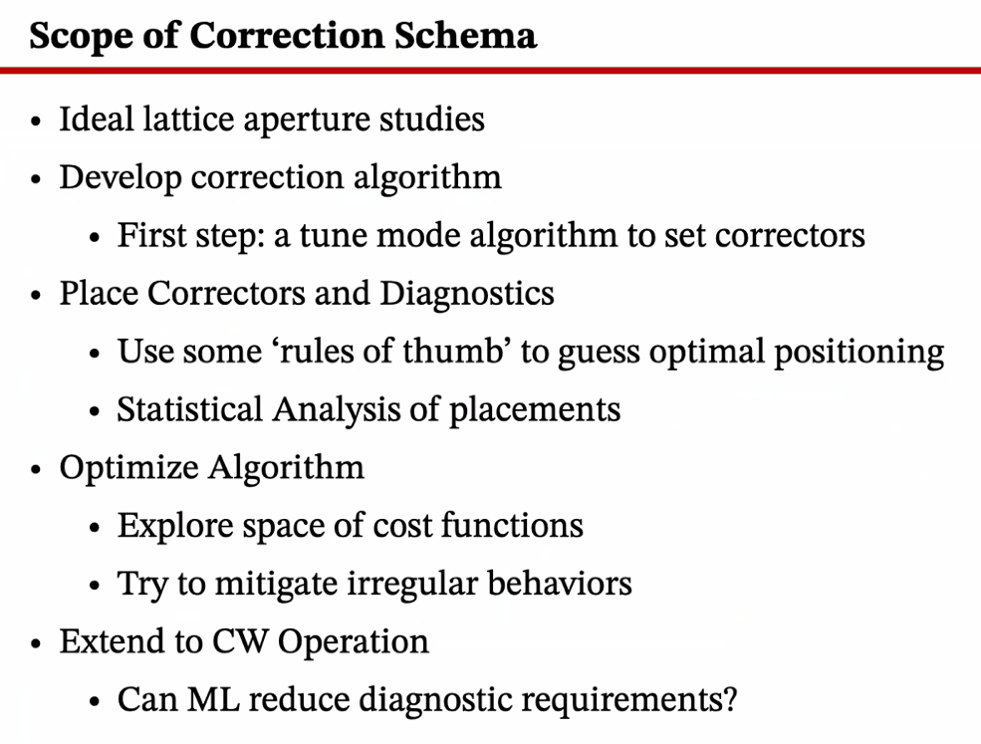
  - Started with CBETA algorithm, and modified to place correctors and diagnostics in arc.
    - Using Bmad figure of merit (FoM), judged best placements.
- 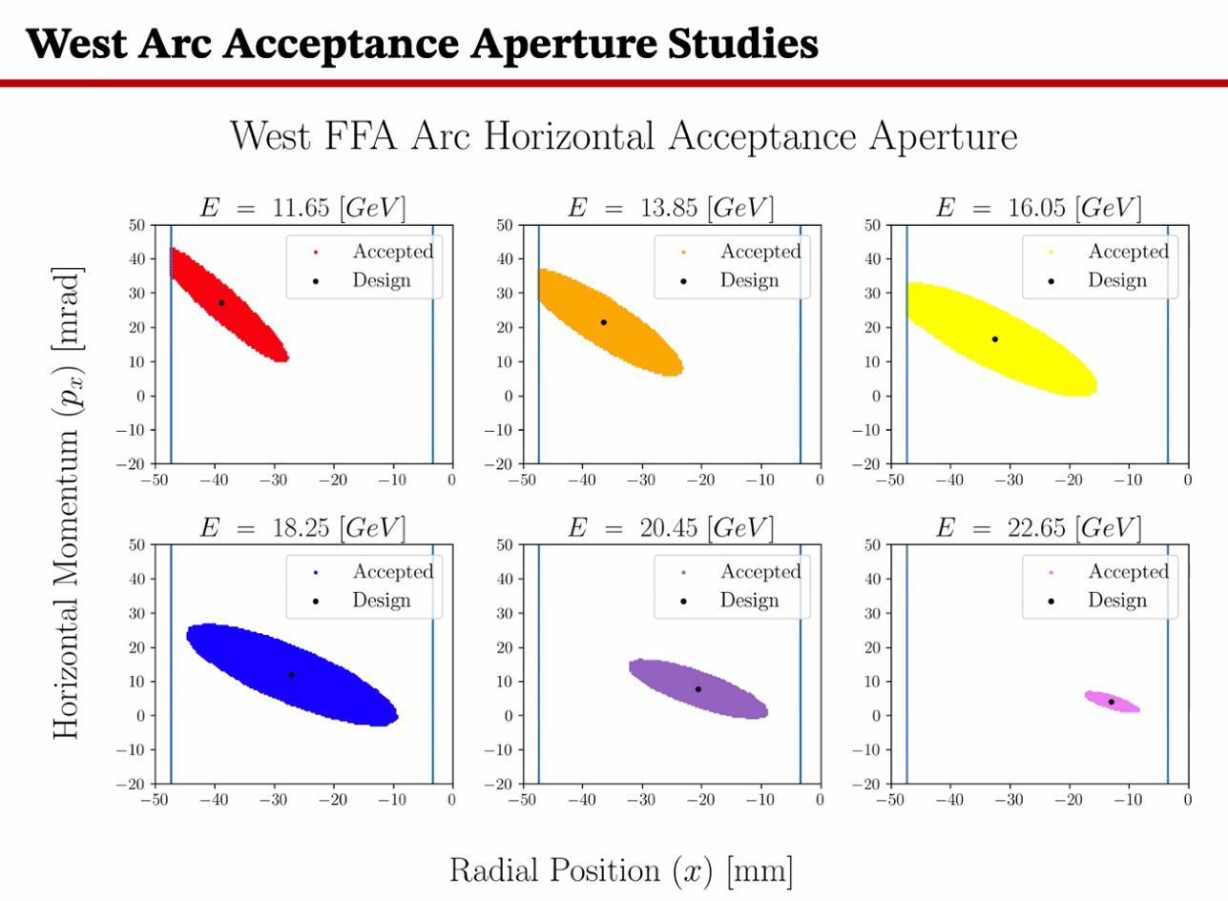
  - Magnet apertures at vertical lines.
  - Roughly 20 mrad by 40 mm space
  - Lots of room to put these into the FFA
  - Tighter at lower energies – first 3 energies in W arc bump into wall
- 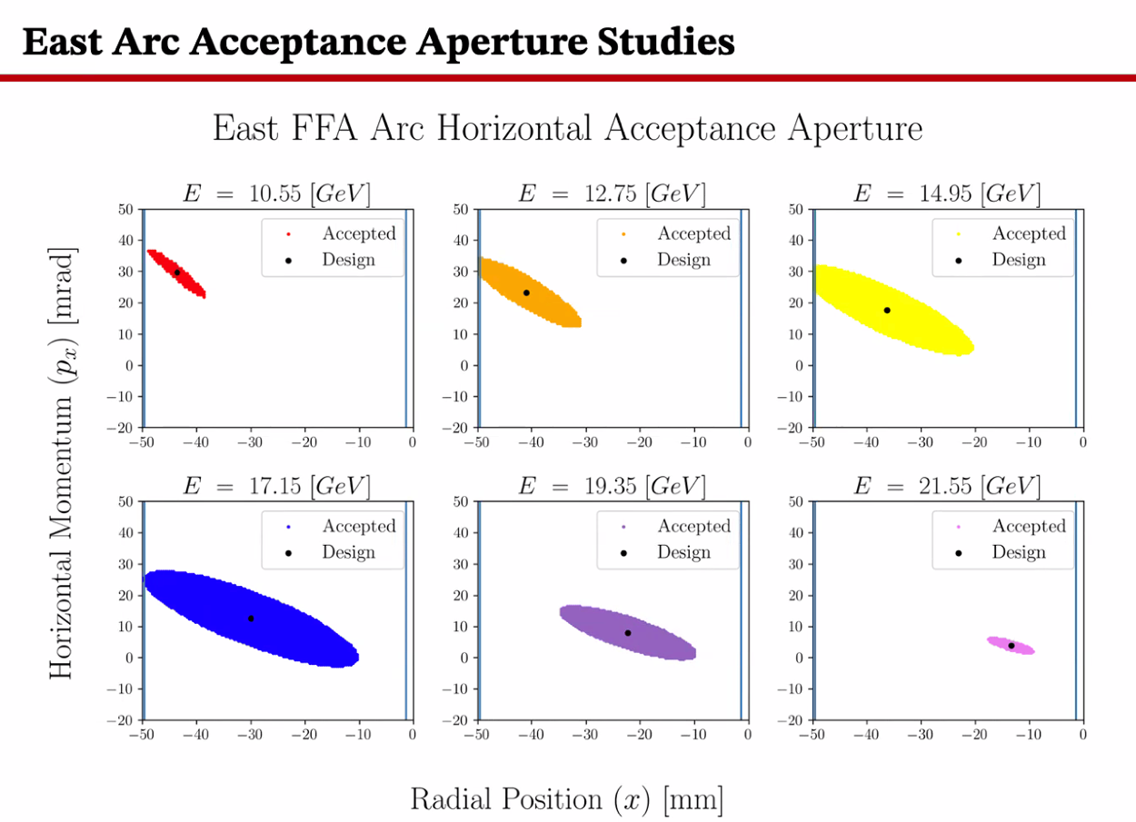
- If distribution is larger than these ellipses, you’ll lose particles.
  - Stephen – ellipses should be trangential to lines.
  - AC – particles start halfway into drift between magnets. Lines drawn at entrance to magnets.
    - So the aperture changes through magnets
  - Dejan – do you have errors for misalignments?
    - Not on these, but I’ll get to those in a bit
    - Dejan – should be huge acceptance for ideal
      - Yes, and it is.
- 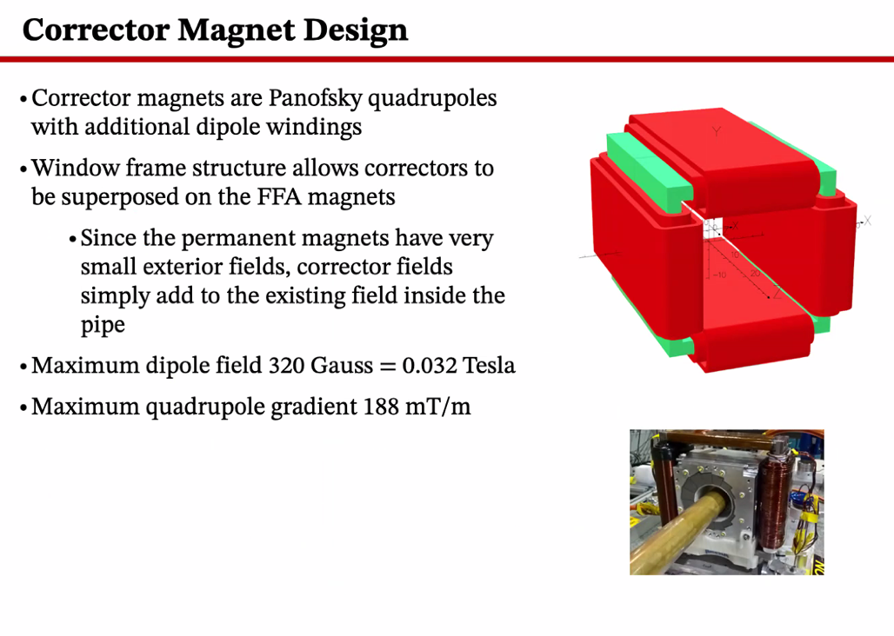
  - These have horizontal and vertical dipole windings, as well as quad windings. All bi-modal. Can by positive or negative.
  - Designed by Jay
- 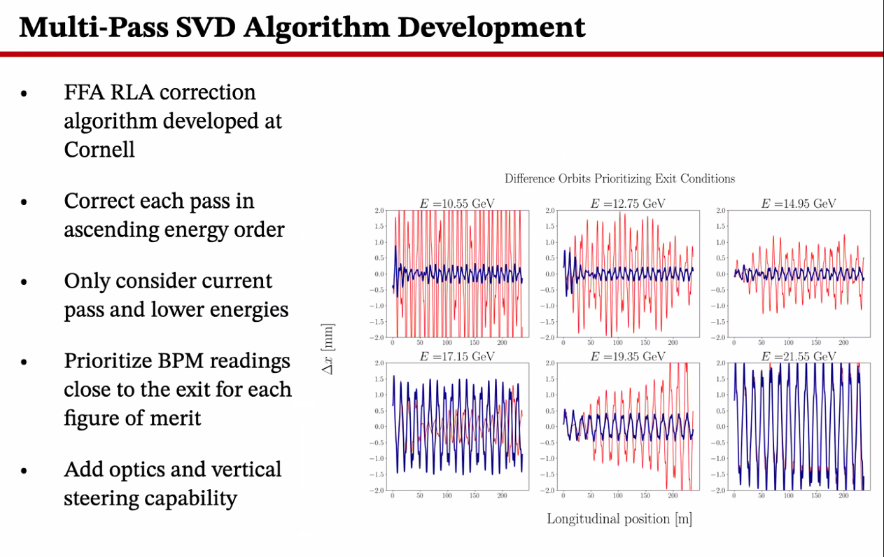
  - This is based on CBETA algorithm. Works pretty well.
  - Correcting in ascending order of energy
  - Correct, change weight, move on to higher pass
  - By locking in the positions at the exit BPMs with high weights after correction, on the next pass things won’t change too much for lower energy passes.
  - This doesn’t work well for higher-E passes.
    - Better the first pass tends to mean the last pass are the worst.
- 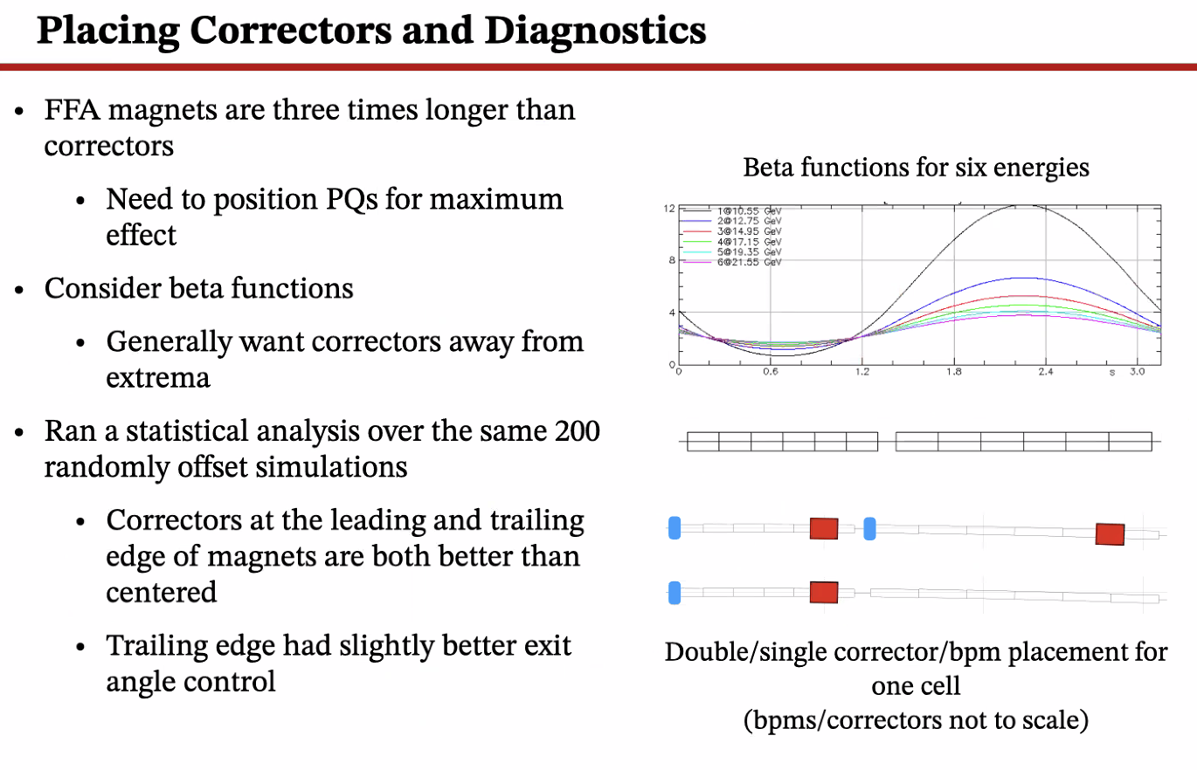
  - After first run, start looking at placement of correctors and BPMs
  - Want to be effective at quads AND dipole modes. Get away from extrema
    - End up placing near the nodes of the beta functions (not exactly)
    - Using some USPAS info, put BPMs approximately Pi/2 away from corrector.
      - Sometimes, Pi/2 away from a different cell
  - Started with guess-and-check at first before statistical analysis
  - AB – did you do this with a different number of correctors/BPMs?
    - Yes, at first. But then in the middle of the FFA arc, took BPMs/Correctors on each BF magnet
    - For 75 cells, there are 100 BPMs and 100 correctors
    - 50 in middle only have one each. Outside ones have two on each
  - Correctors at leading and trailing edges work better than in the middle of the magnet.
    - Trailing edge had slightly better px control, so chose that options.
- 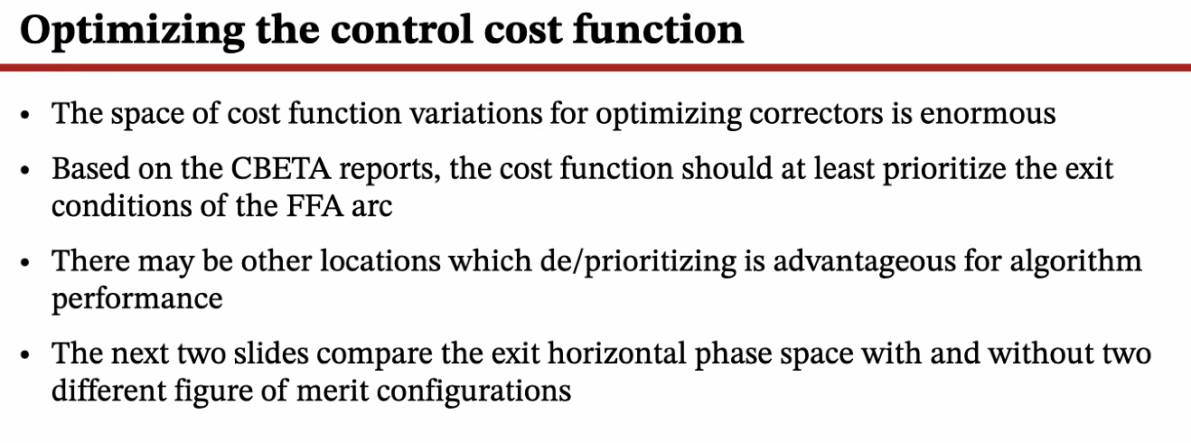
  - Change the manner of weighting for SVD (bpms)
  - A weighted LS-SVD, instead of taking the matrix of SVs as is and cutting, a weighted one multiplies the diagonal matrix by a vector of weights.
    - Emphasize or de-emphasize different BPMs
    - CBETA – heavily weight exit end.
  - Wondering if different weighting priorities would help. Still need most on end, but wanted to check.
- 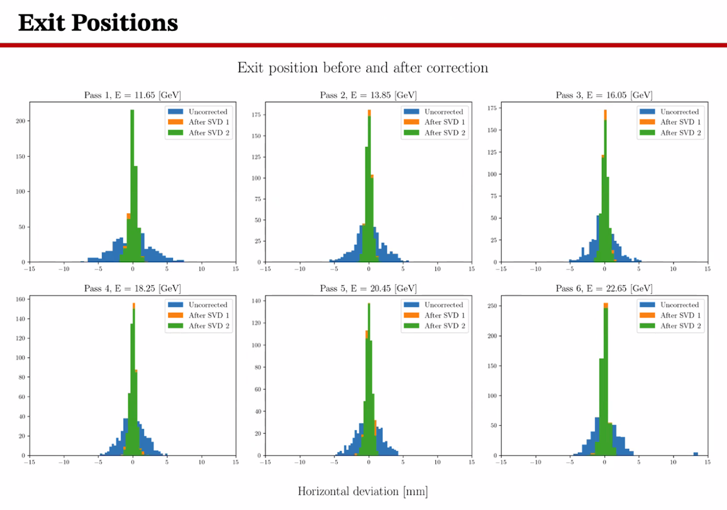
  - Not seeing anything drastically different with different weights. Still mostly weighting exit end.
  - Uncorrected in blue, exit priority in orange, green is periodic higher weights in lattice.
  - Almost no difference in position
- 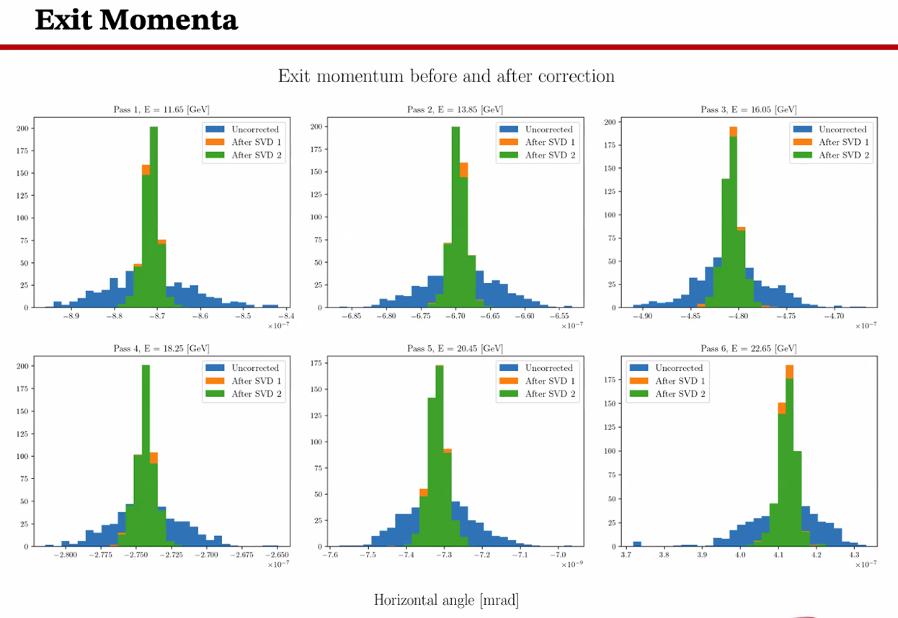
  - Similarly through momentum.
  - Can’t go through every option. Curious if you can improve it by changing weights.
- 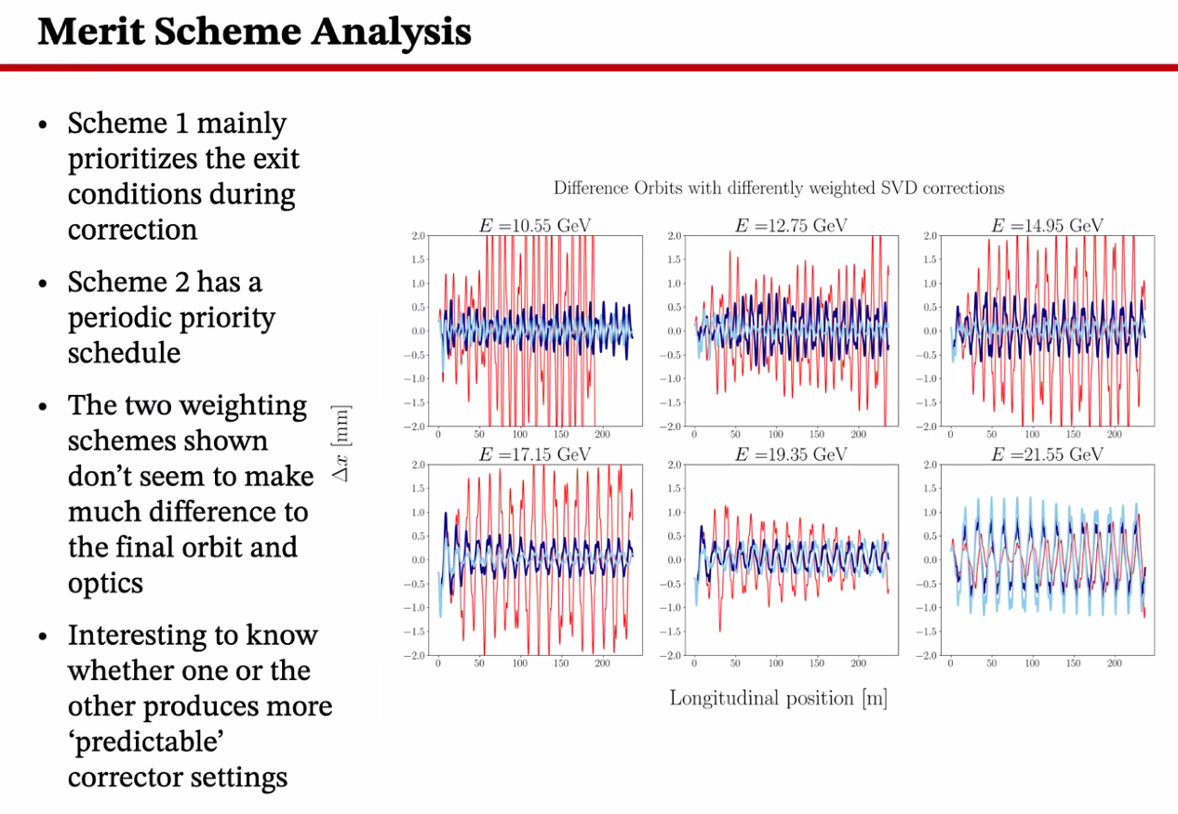
  - Curious if one is more regular/predictable. This would make it easier to train a NN
- 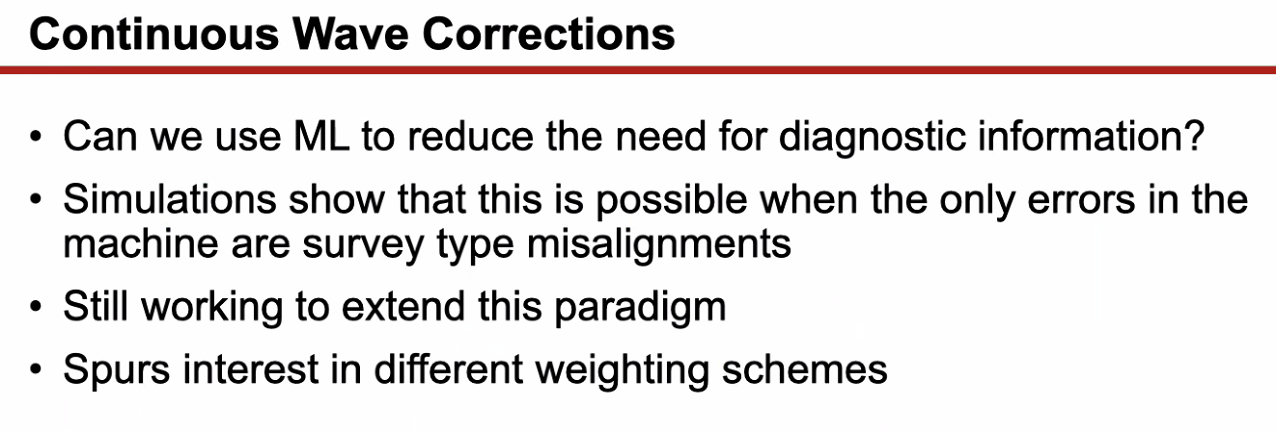
  - Right now, we have to multiplex BPMs
  - Looking at using the “blob” to get good info and train.
  - If only errors are survey related, NN can do ok with this. But when the initial conditions change AND survey errors, the NN algorithm doesn’t do well.
    - NN not learning how to correct as well
    - Can overtrain easily – might just need more data.
- Dejan – when you say survey errors, what do you mean?
  - Misalignments in installation
- Stephen – have you looked at different tunes? This may impact how you can correct different orbits or not
  - Not yet – for now, just using the closed orbits from Bmad
    - Not sure what it’ll look like coming out of splitters, etc…
  - Stephen – might be hard with higher E. Can change the tunes, but might be hard with higher Es
  - AC – might be a great idea
- Salim – what is the main strategy? There are many options. Transfer function from A to B and solve. Now using machine learning. Are you calculating the transfer function from A to B? What kind of correction is this?
  - AC – I’ve been taking the original SVD algorithm, generating many scenarios with inputs and outputs.
    - Train on this data. 6 passes gives 606 values. Combine those into data for each pass, then train supervised learning.
  - How do you set up the strength of the corrector?
    - With the SVD (inspired by CBETA). You take a decomposition of response matrix. Basically a diagonal decomposition. Column matrix vs complex row vectors. SVs in diagonal matrix in the middle. Then you can set correctors to not overcorrect for each other.
- Scott – you *don’t* have to do it this way:
  - SVD works by basically saying “find a solution that minimized the sum of the squares of the errors while simultaneously minimizing the sum of the squares of the corrections”
    - Sometimes it assumes sum of squares is useful, but not always
    - Basically an attempt to remove the non-invertable part of this process.
    - Find cases where you have a small response of the errors to the correctors and remove them (basically)
    - If you decide sum of squares isn’t good, then you have to look in ML and other methods
    - AC – minimize the cost function, which is a sum of squares.
- Alex B – since we’ll have CW, said you developed a way to use the blob. Can you elaborate?
  - It’s less that it’s info about individual passes, but more that you can take “the blob” and a NN can associate the blob with the final corrector settings generated by an SVD that knows all the positions within the blob.
    - Would be amazing to do CW corrections without multiplexing.
- Alex B – other options is to use pulsed mode (tune mode)
  - Can set up with tune mode, then go to CW
- AC – the NN will probably never be *quite* extensible enough to “lose beam and fix it”
  - However, rest of CEBAF is on 1 Hz orbit lock, and the NN in the FFA will be very useful for that.
- Dejan – same idea with ERHIC – always have a bunch mode to use for that
- AB – Nate Rider working on new diagnostics
- Ryan – they’re looking into changing the “shape” of the tune mode beam. Not sure if that’s solved yet.
- Reza – been talking with Nate about an idea about doing this in CW instead of pulsed.
  - Initially, we wanted to see different passes. Had a short pulse (short enough so that when it goes around and comes back to the same position it’s done – shorter than 4.2 ms)
  - Found this out for path length
  - Take this, and say we want CW. If you have a CW beam and put a “notch” on the beam via current (100 mA to 95 mA current)
    - Physics people asked, said it’s ok
    - Can add to CW beam, and now have CW beam that can read different passes
  - AC – maybe not in FFA pipe. The resolution might be too poor.
  - Ryan – still can be doable, but it’ll be noisy in the Arcs. SR loss, etc… - you’d have to set thresholds right.
  - AB – this is promising
- Reza – don’t have to have it “all the time” but maybe you turn in on 5 minutes per hour, for example.
  - Spoke with Doug H as well. Will pursue!
- Ryan – I’ve seen this or something similar somewhere, but can’t recall where. Will try to find it.
- One challenge would be setting the laser properly. No tails, just down/up with right timing.
- Dejan – good job, Alex. And good luck for the defense!
- Reza – you said weighting the end BPMs rather than others didn’t make much difference.
  - In original scheme, every BPM has a small weight. Before correction, last exit BPM has a higher (but not massively higher) weight. After you correct, you then increase the weight so the next pass doesn’t mess with it.
  - Not much difference seen. Trying to see why. If you have deterministic path for the beam, choosing different BPMs (as long as you have enough response), then you should have enough equations and unknowns so it shouldn’t matter.
    - Yes – that is clear. Part of the reason been looking into it, want a more predictable relationship with field at specific BPM and corrector strength, so it’s easier to train NN
- AB – thanks again. Please upload to presentation folder
Action Items | Person responsible | Deadline

Time allotted | 25 mins | Agenda topic AOB | Presenter All
- See in two weeks.
Action Items | Person responsible | Deadline

Special notes

Pathway to Repository: https://jeffersonlab-my.sharepoint.com/:f:/g/personal/tristan_jlab_org/EqZ5MeS-nipCgPfZB5p0oS4B9Is67d3nQb9sLJI3Zyev9g

Next meeting in two weeks. This will persist for summer (every other week).

