FFA@CEBAF Working Group|Minutes

Meeting date | time 07/12/2024 | 11 AM EST | Meeting location https://jlab-org.zoomgov.com/j/1614898082?pwd=TnUzMS81M2sxbDZIbERJU01tYkJCQT09
Meeting called by Alex B  Type of meeting Weekly Meeting  Facilitator Alex B  Note taker Ryan  Timekeeper Alex B | Attendees  Alex B, Ryan, Alex C, Stephen, Scott, Edy, Donish, Dejan, Kirsten, Salim, Tim

Intro Discussion
- Ryan talks about FFA proposal submission
- François retirement announced at ERL seminar by Georg

Agenda topics

Time allotted | 25 mins | Agenda topic New Magnets| Presenter Stephen
- 
  - Work on optimizing FFA arc cells including magnets
  - Muon1 calls magnet design code (pass or fail) – makes a score based on volume of magnet material, etc…
- 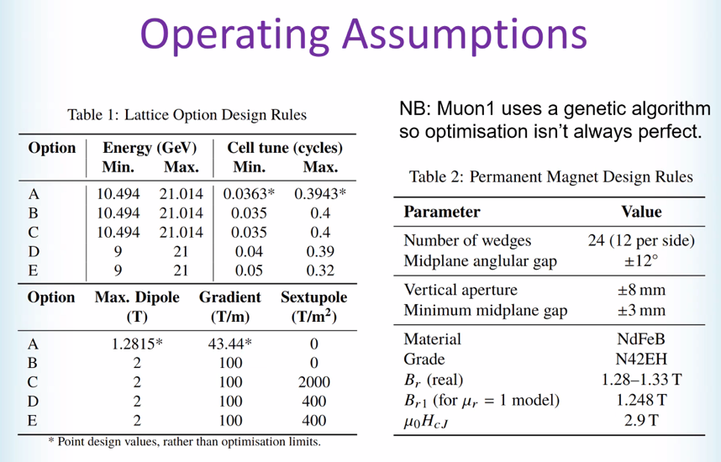
  - Constraints/rules used for designs
  - Energy tunability, mag fields, sextupoles
  - Magnet constraints added (table 2) – similar to light source 2 magnets
  - Using NdFeB N42EH
- 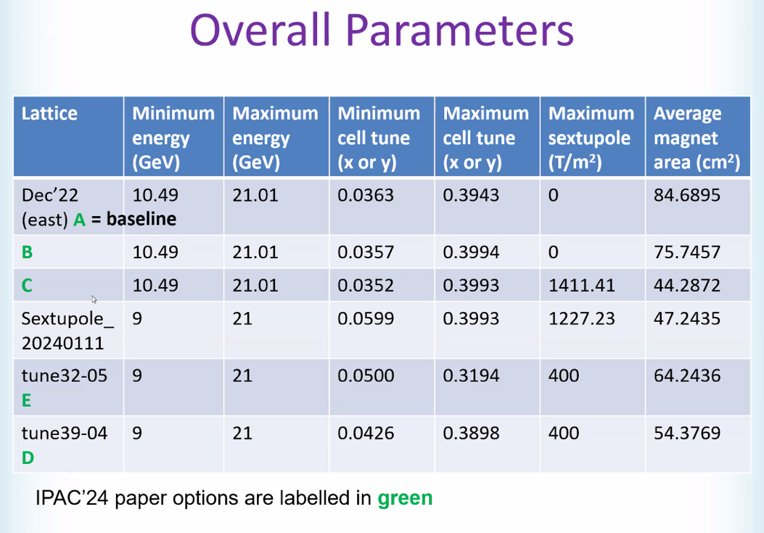
  - Baseline is “A” option
  - Played with tunes, etc…
  - D and E was constrained to 400 – used it all
  - Strong sextupoles are doing excellent for magnet area average
- Alex B – minimum energy range increased by 1.5 GeV
  - Stephen – yes, added on purpose.
  - Just chose “9 GeV” as a number that sounded good
- 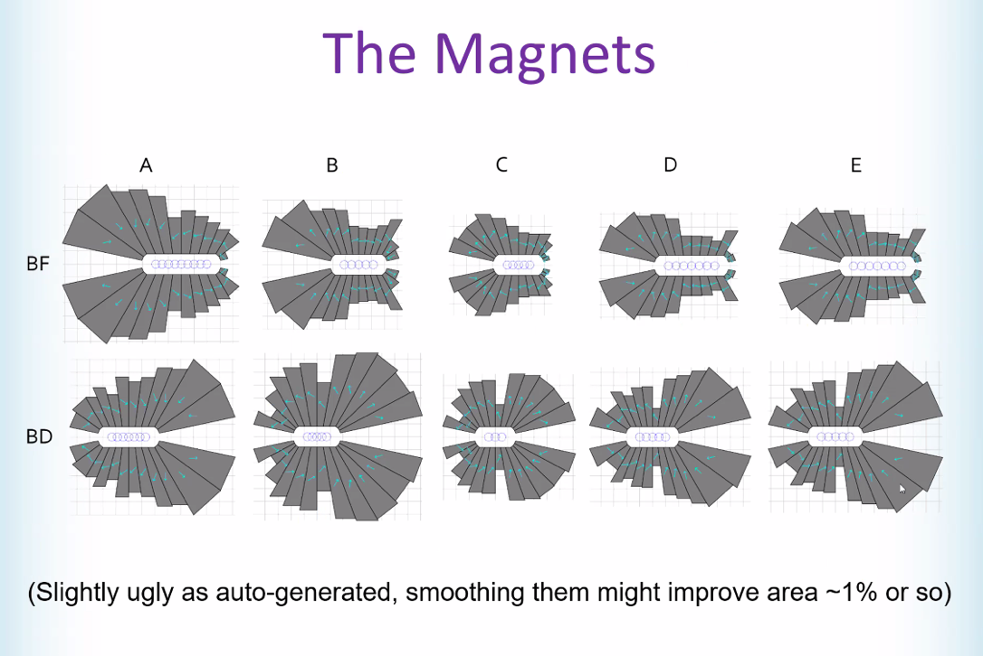
  - These are auto-generated, but can be improved
  - Not final, but gives rough sizes
  - Midplane grows – helpful for vac. Chamber
- Light Source 2 machined out some space
- 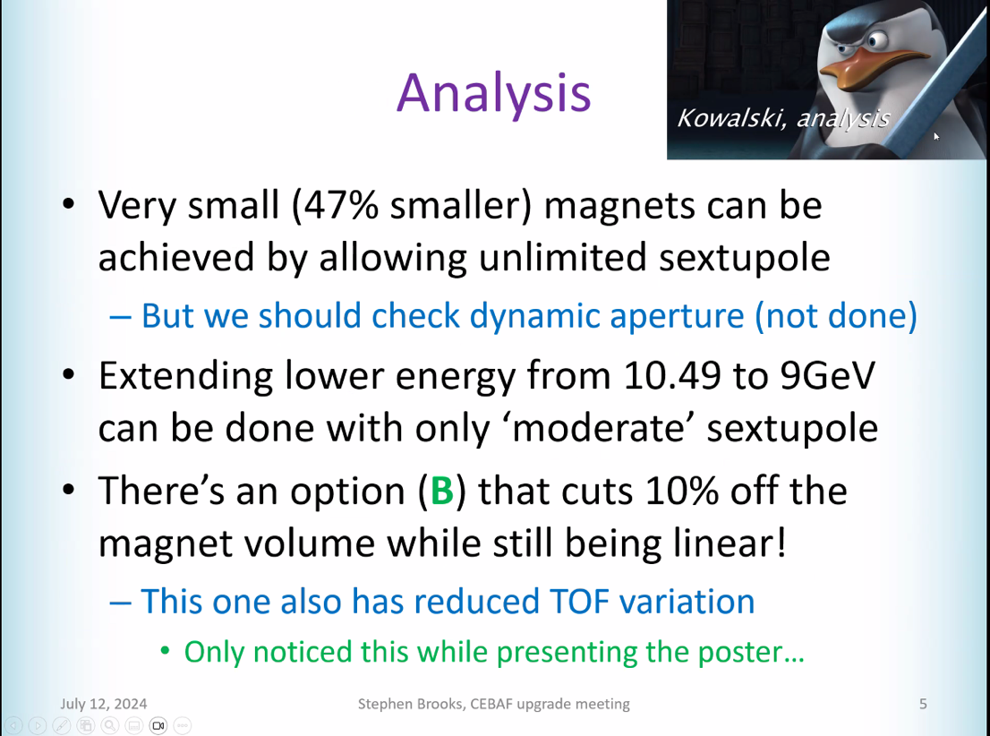
  - Magnets get much smaller by adding sextupoles. This requires checking dynamic aperture
  - Can get lower end with moderate sextupole
- Ryan mentioned ToF being important, so that’s what Stephen looked into
- 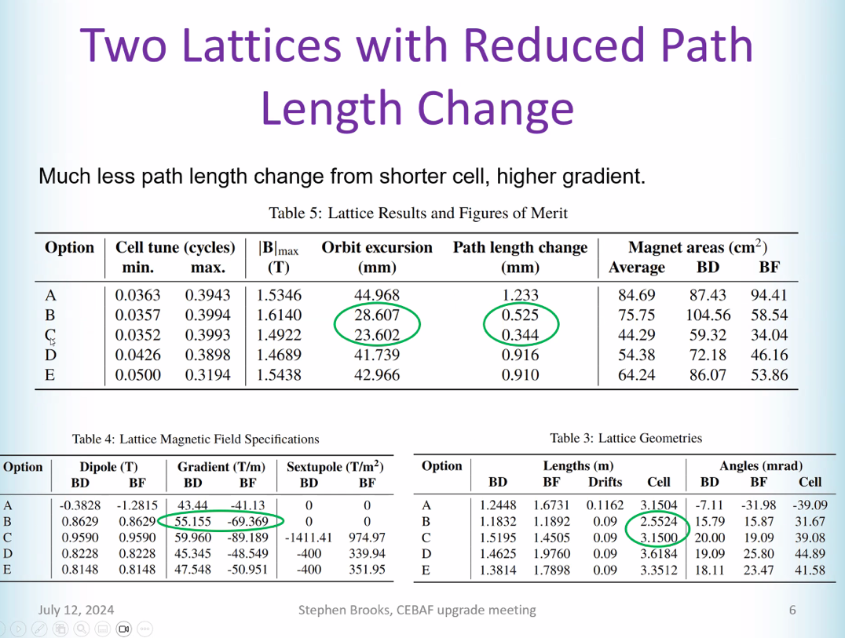
  - Circled options – in case of linear lattice, cell is shorter. Orbit excursions shorter, gradients higher
  - Magnets still reasonable
  - B has interesting direction. Shorter, high gradient, path length shorter
  - C got smaller orbit excursion/path length change, but cell length same
- 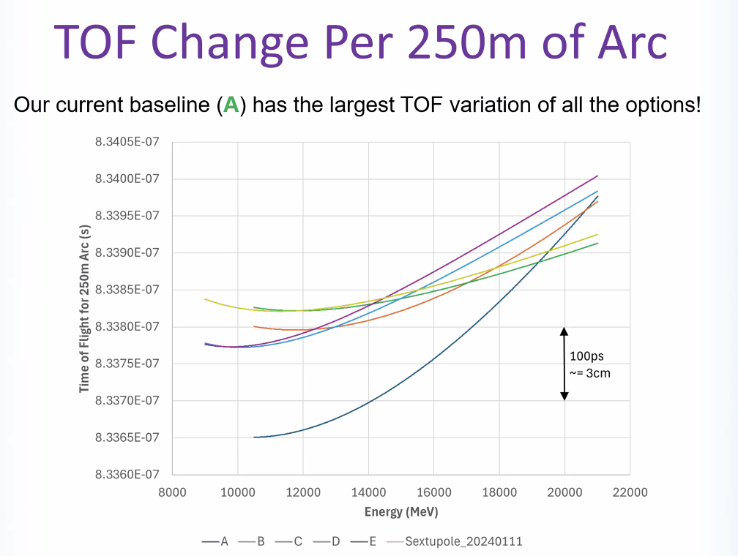
  - Had to normalize b/c different cell lengths
  - A is current baseline – 10 cm of path length
    - Other options is better
  - Yellow/green very goods
- Dejan had a lower value one – but maybe not same normalization
- Ryan – out of the box idea: can we mix these ideas to find something in between what we’re sacrificing?
  - Stephen – we could find solutions between
- Dejan – need to look at dynamic aperture
- Option E keeps the tune below 1/3
- Ryan – how well are these robust for ToF? Can they compensate several cm of variation in the whole CEBAF?
  - Option A might be hard b/c
- 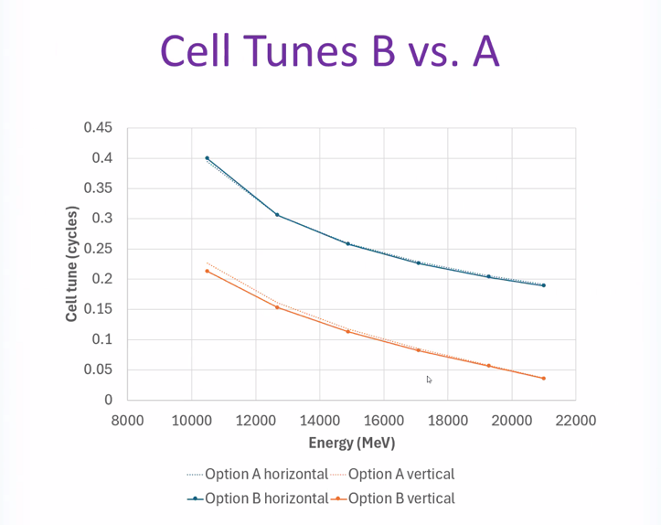
  - B is safe option compared to A
  - Increased gradient might mean more sensitive to position errors
- 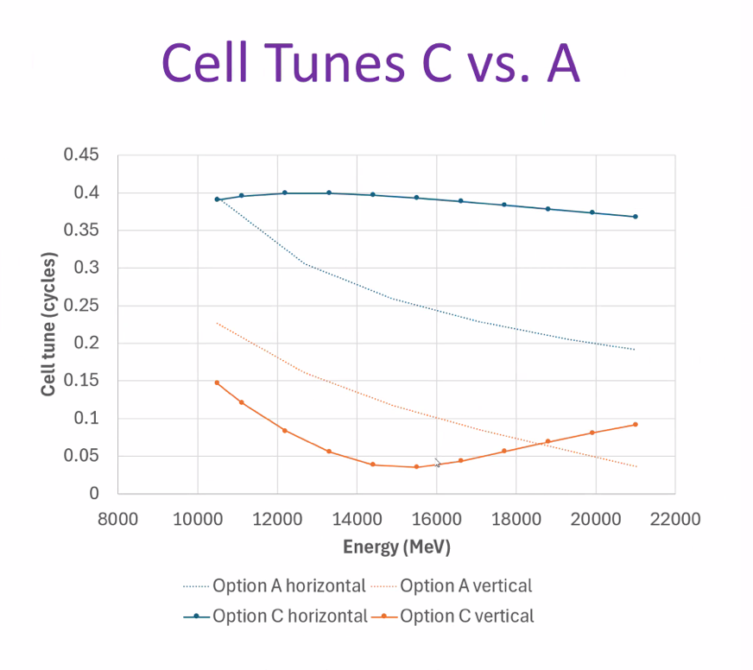
  - Sextupoles do weird things to tune
- 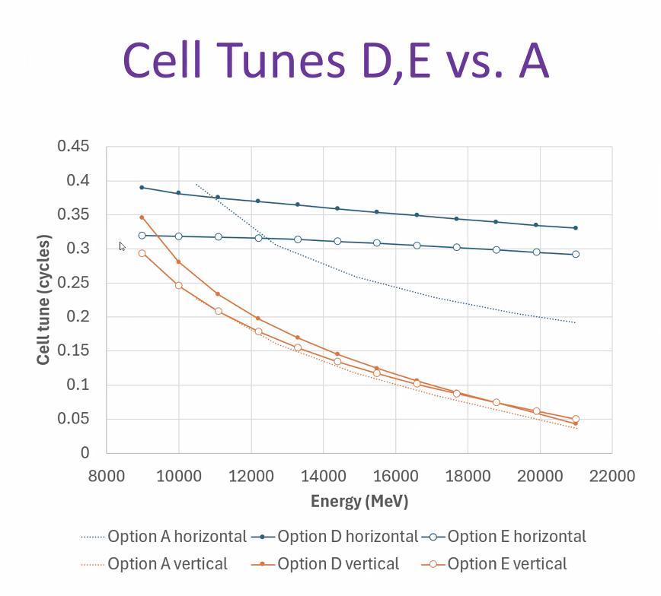
  - Dejan has an option with more of a slope on it
    - Likely want this
- 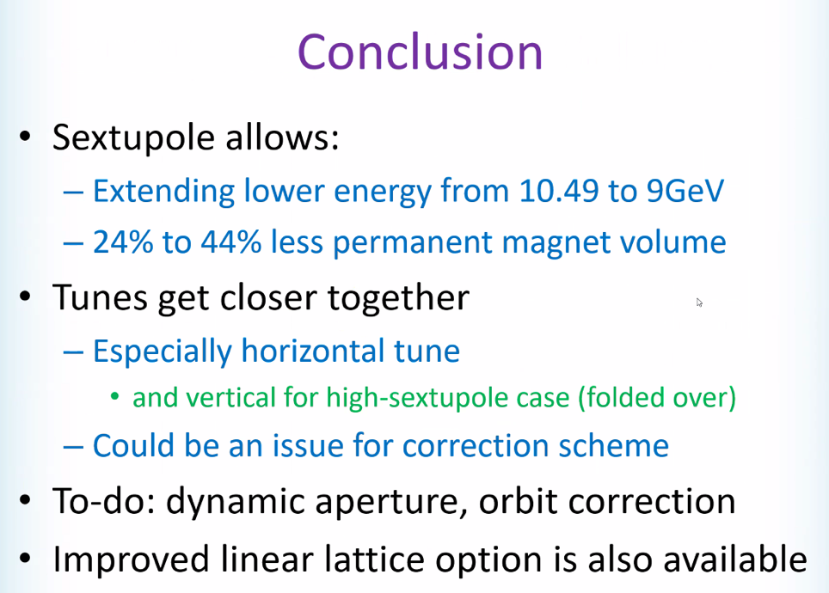
- Dynamic aperture and orbit correction important
- Reduced ToF might help splitter design
- Ryan – as machine expands and contracts (multiple cm a year)
  - Does the new arcs/cells help with this?
  - Alex B – we compensate in the doglegs for that
    - Ryan – no, not in the FFA passes, it has to be in the splitters
  - Scott – you can easily deal with small amounts in the splitters
  - Stephen – are you asking if these will still work if the FFA cells change cms?
    - Ryan - Yes, the correctors can help with some, but not all maybe? That’s what I’m asking
    - Stephen – won’t be a problem per cell. Overall, could probably add that in with what has to be added into the splitters
  - Scott – how much?
    - Ryan - Multiple cm around the year per turn (yes – throughout the year on order of several cm change)
      - This is why we use doglegs daily and throughout the year
      - Can do it in splitters
      - We’re talking about ToF – but asking about robustness
    - Stephen – different energies in splitters have to go a different length. If whole machine grows, not a problem. But if they’re all growing the same, it shouldn’t be too bad
- Scott – in CBETA design of Splitters, path length variation was important for R56, length of splitter lines were constrained by layout/physical constraints
  - At the last minute, added extra wavelength to make magnets fit together
  - Think more in terms of R56 instead of pathlength variation itself
  - Looking at slope of curve is more important
  - Maybe target R56 with designs – avoid large values
- Ryan – we don’t really know our full R56s
  - Have partial information. Spreaders + recombiners, 75 cells FFA arc, Splitter contributions/adjustments, but no transition
  - Transition can be 16 m to 90 degrees in the arc – we really don’t know
  - Scott – less per cell in transition
    - Take max length of regular arc and take half of that R56 for remaining transition it’ll be a pessimistic estimate
  - Ryan – but we don’t know the length. 16 m straight not working.
    - If we cut into the 75 cells, it reduces arc contribution, and has it’s own, it’s really fuzzy. We really don’t know.
  - Stephen – if “bouncing around” in curvature section, can have very strange contributions.
    - Depends if we’re bouncing them around a bit – probably forced to do that b/c lack of longitudinal space
  - Ryan – right – this is what I’m saying. There’s a lot of uncertainty
  - Alex B – we’ll have to keep looking and find out
- Alex B – when we look at tunes how they get deformed from linear case. What’s the FoM? Separation?
  - For correction algorithm yes. First thing do is b/w two energies, how much tune change?
    - get 90 degrees out of phase within a few cells
  - Idea is that two bumps that are the same in one cell, and have a 90 degrees separation in tune later, that’s useful
  - Scott – in some sense, think in terms of low and high E tunes – say going to stay below 1/3 or just push through it and look at those as options
    - Might try with sextupoles – try to flatten out tune curve as function of E
      - Goal: tune difference between each energy step the same. Phase difference between adjacent energies the same, maximize effectiveness of correction
    - Stephen – can set max/min tune, and can also set max difference between max/min tune.
- Alex C comment: multipass corrections will work very well regardless of tunes as long as you have enough cells. Figures out orthogonal knobs for 6 passes (if they exist).
  - If you have enough longitude/cells
  - Alex B – if they’re too close, then you’ll have some degeneracy
  - Scott – think of this as singular values – suggesting you maximize the smallest of first 6 singular values
  - Alex C – experience to date – things only really get weird when you take away correctors
- Dejan:
  - 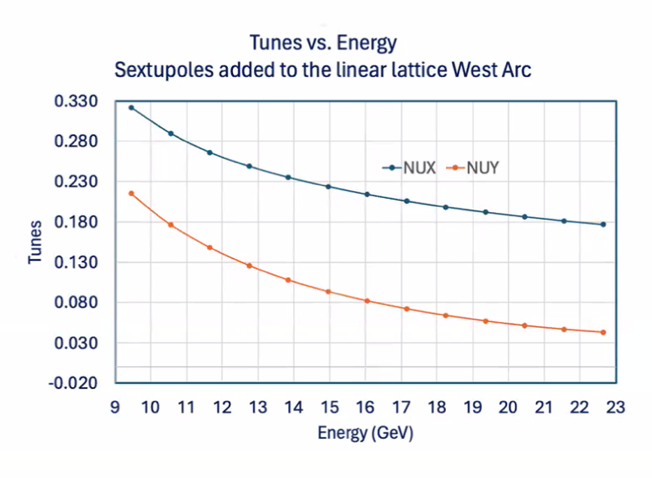
    - 9.3 to 22.5 GeV
    - Looks like good dependence
  - Need to play to get this nice
  - In the end there’s a fixed tune option
- Scott – with sextupoles, don’t get too comfy with 1/3.
  - 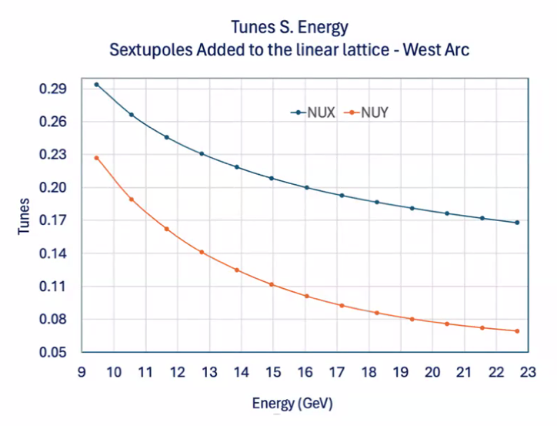
  - This is better
- Scott – with EMMA, could see 1/3 easily
- Alex B – lots of good study cases. Nice way to set stage and see what we can gain
- Dejan:
  - 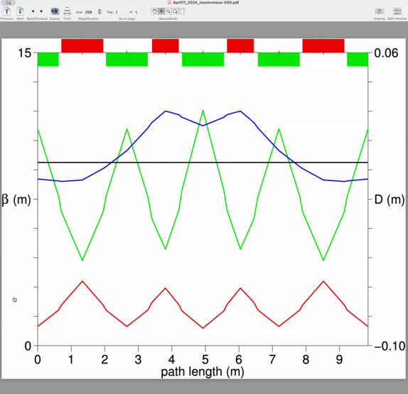
  - Can make tunes be a lot
  - Stephen – difference between what you want and what magnets want to do
- One trick in FFAs is to “hop over” the 1/3. Sometimes with small orbit excursions, etc…
- Dejan – set up reference orbit tunes first, then ask for chromaticity to be a specific number at the reference tunes, then do momentum dependence
  - Adjust sextupole strength to get tune right
- Stephen – if hop over 1/3rd, we’d probably get a gap on where we can run
- Dejan – I’ll provide Donish the lattice (shown above)
  - Similar cell that we have now, but magnets (two central red ones) are stronger
  - Will need to add more sextupoles
- Scott – and you’ll get linear resonances in your space with the design above
- Dejan – this might be just nonsense
  - Stephen – run it with different energies
  - Dejan -did it, but not large energy range.
- Stephen – you’ll get a stop band (like Scott said)
  - Way to design about it, but might then compete with R56 goals
- Scott – back to tune-hopping:
  - Stephen is right, we can hop over 1/3. The scenario we’re worried about is when we lose some energy for whatever reason. We could choose to lose more energy. If cryomodules aren’t up to snuff, we can run lower
  - Can run one linac lower than other
  - We should see how wide the sextupole region really is
  - Danger could be it’s so wide that it covers two energies
- Alex B – how design to narrow stop band – whole industry to do this
Action Items | Person responsible | Deadline

Time allotted | 25 mins | Agenda topic AOB | Presenter All
- Discussion about SBIRs – do they give them to one or multiple companies?
  - Historically one, but maybe exceptions? Should check
  - Prices vs quality
- Discussion with Michelle Shin in April and at IPAC
- Stephen should be leading the efforts with SBIR
- 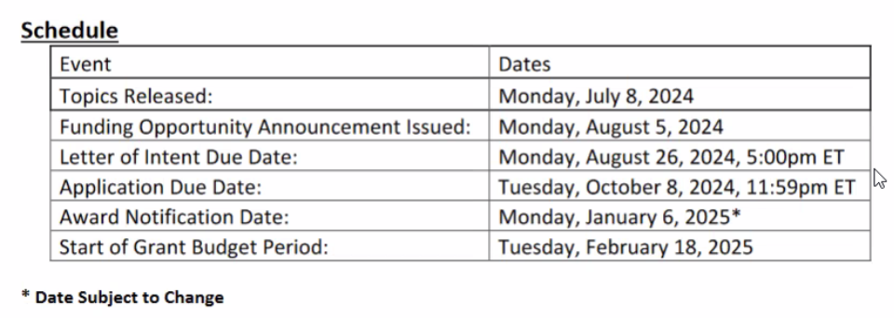

- Scott – ERL 2024 status?
  - Kirsten – approved
  - Ryan – awaiting approval
- Alex B – submitting an LDRD for these studies
Action Items | Person responsible | Deadline

Special notes

Pathway to Repository: https://jeffersonlab-my.sharepoint.com/:f:/g/personal/tristan_jlab_org/EqZ5MeS-nipCgPfZB5p0oS4B9Is67d3nQb9sLJI3Zyev9g

Next meeting in two weeks. This will persist for summer (every other week).

