FFA@CEBAF Working Group|Minutes

Meeting date | time 08/09/2024 | 11 AM EST | Meeting location https://jlab-org.zoomgov.com/j/1614898082?pwd=TnUzMS81M2sxbDZIbERJU01tYkJCQT09
Meeting called by Alex B  Type of meeting Weekly Meeting  Facilitator Alex B  Note taker Ryan  Timekeeper Alex B | Attendees  Alex B, Ryan, Reza, Edith, Salim, Kirsten, Alex C, Dejan, Donish, Stephen,

Intro Discussion
- Tropical Storm chat – bad weather
- Can we do multipass diagnostics? Topic today

Agenda topics

Time allotted | 25 mins | Agenda topic Notched Beam Diagnostics| Presenter Reza
- Quick understanding of general idea
- 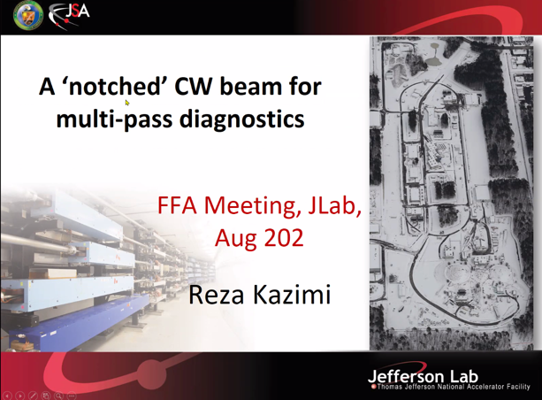
- 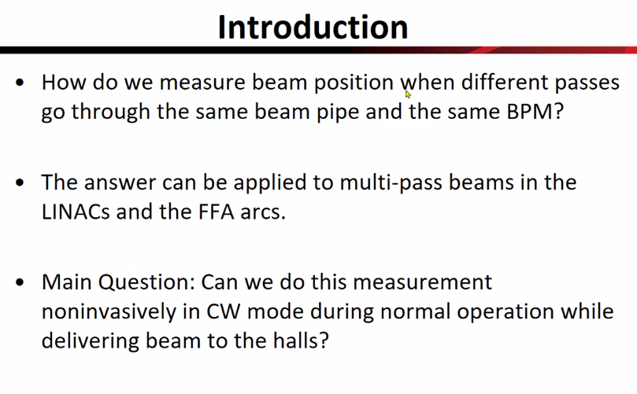
  - NL and SL does this
  - Will need for FFA Arcs
- 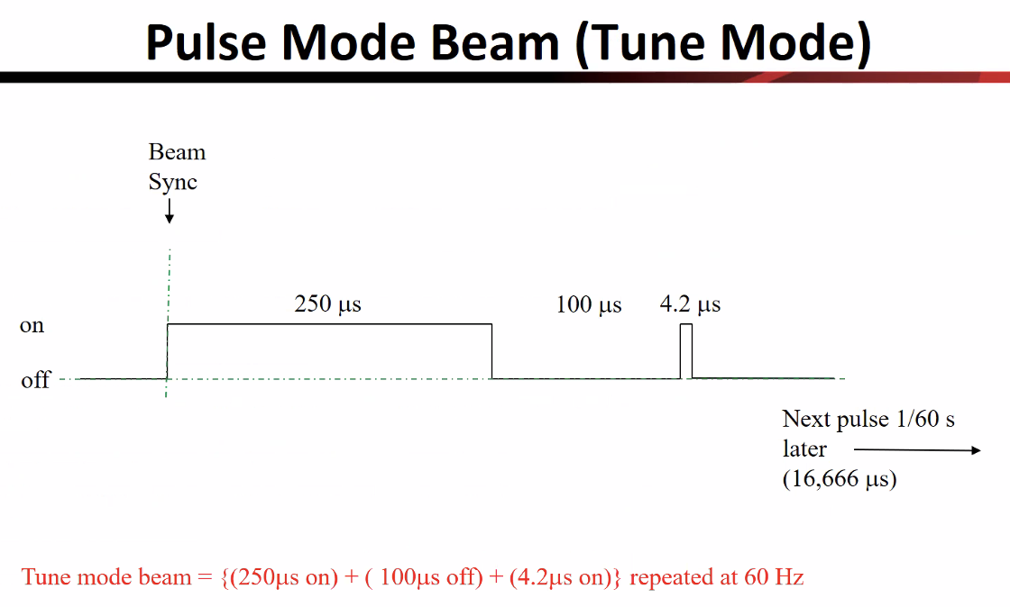
  - Done at 60 and 30 Hz – assume here we’re talking about 60 Hz
  - Why? – first beam through machine, wanted to see the higher passes at the same pickup cavity
    - Two ways: send first then second and add together and find the difference between them
  - Alex B – revolution period is ~ 4 microseconds
- 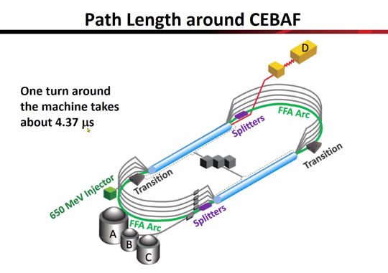
  - If you make the signal slightly shorter, can tell different passes
- 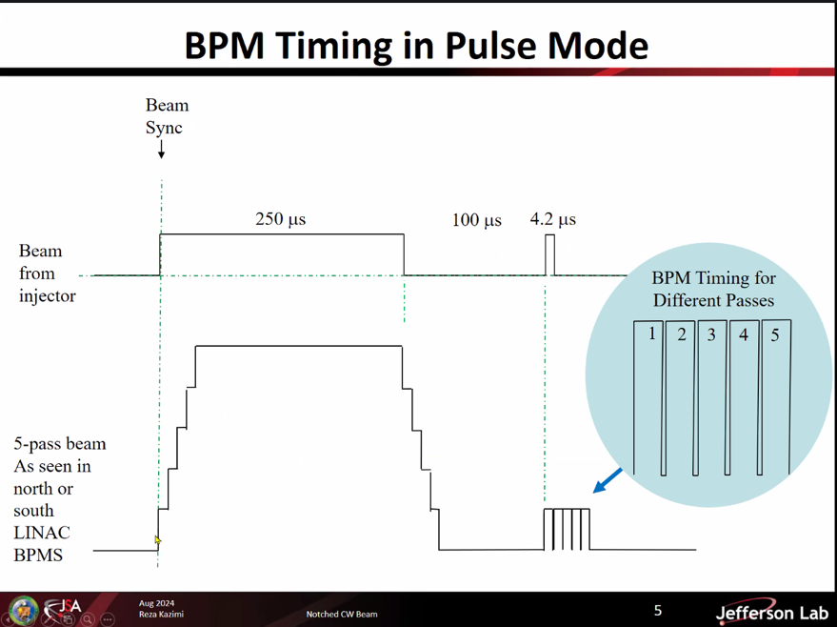
  - Beam adds for 250 us, but at the 4.2 us, separates them out
- 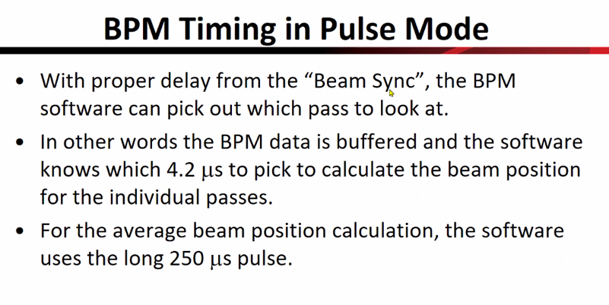
  - Ryan – is this reading wiresum or current?
    - Reza – in the 250, average position of all, in 4.2, each pass – reading position
  - Reza –
    - 4 wires, difference over sum of currents
      - In 250, seeing sum, in 4.2, seeing difference over sum
  - This is NOT CW in this case.
  - Gun at 499 MHz, - that’s CW
- 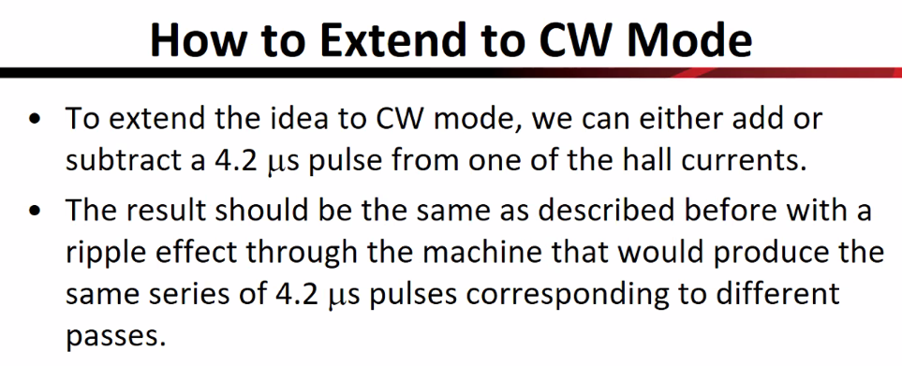
  - All need is that 4.2 pulse added or subtracted from CW
  - Results would be a snake-beam or ripple on system going around at 4.2 or 5.37 us, and would show up as X pulse
  - If subtract from CW, get negative position
- 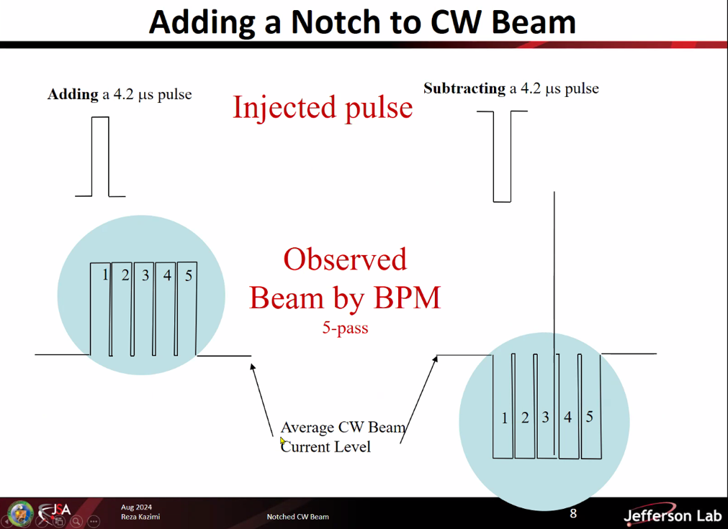
  - Can add or subtract, would get these signals
  - Add or subtract from average
  - Alex B – what frequency would we do that at? 60 Hz?
    - Reza – TBD. Would have to decide the best way to handle this and not interfere with other diagnostics
    - Adjustable – must decide
- Reza – where do you put it in the 60 Hz?
  - Beam sync sets everything else in the machine
  - BPM knows have to go 250+100+4.2+rest of time each cycle
  - Gun group – problem with notch at beam sync, but can put anywhere in 60 Hz pulse
- 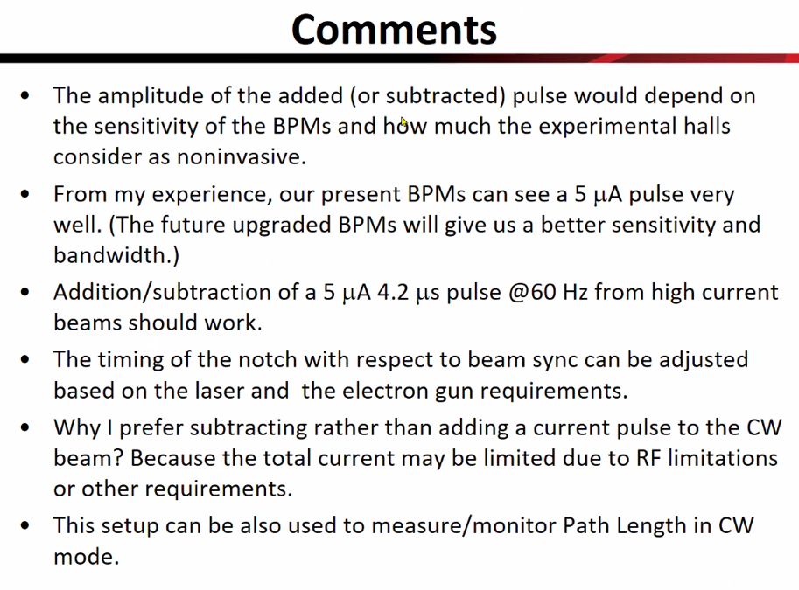
  - If notch too small + or -, BPM may not handle it
    - 5 uA is amount of beam usually for this
    - So if we do current run (let’s say 80 uA for example), could add/subtract 5 uA
    - Timing can be adjusted for laser and gun requirements
    - Prefer subtracting – total current limited due to RF limitations (we often run at the very edge of operations ability)
    - Can also use for measuring/monitoring pathlength in CW
      - Cavity in beam line – measure timing of beam. If the notch/pulse goes through, path length can be determined in CW
    - Should work in NL/SL and FFA arcs
- Ryan – question – our BPMs are super noisy – hard to determine perfect diff/sum or position
  - Could add in wiresum for additional data point to help clean signal
    - Think see notch, but wiresum could help see if it’s noise, or real signal
  - Reza – self-test with wiresum in current BPMs for lock BPMs for example
    - Depends on sensitivity of BPMs
    - New BPMs should be more sensitive
    - Right now, 5 uA of beam in pulse mode, can see it
  - Ryan – adding/subtracting 5 uA on the CW could be lost in noise from the main signal. Doable, but need to consider noise in CW.
    - Sensitivity issue. 60ish uA, then +/- 5uA on that could be hard to read
    - Kirsten – worried about laser modulation? Or noise?
    - Reza – good point
    - Ryan – this is very doable, but have to think of how to clean signals to make sure we’re reading the right thing.
    - Alex B – instrumentation group can probably help with that.
- Alex B – good to get path length – can also get info on momentum compaction
  - Can use a cavity to kick the beam in energy, extract from the timing before/after kick to get momentum compaction
- Reza – yes, all the things we can do in tune mode we should hopefully be able to do live in CW
  - Go to tune mode for machine safety
- Alex B – you spoke to users?
  - Reza – spoke with physics users, the people there said for detector it doesn’t matter, just summing up events.
    - Want to check with more users to make sure
    - If it’s off for a while, then they’re in trouble – trying to make this as short (4.2 us) and limit amplitude just in case
      - Not sure if it’s important, but 10% up/down should be fine probably
- Dejan – when designing eRHIC ERL, we had always assumed there will be a special electron calibration pulse in front of the other beams to use it to remove all the misalignments, etc…
  - In CBETA, wanted to be sure we could see different pulses with same BPMs - was a problem for a while
    - By programming laser at source, can always have special pulse
    - Saw them independently very well in the end – but had problems in the beginning
    - BPMs didn’t need special pulse
  - Kirsten – pilot bunch (never got around), but operationally
    - Basically limited number of bunch pulses per each train so you could have all the trains stacked up without overlapping
      - Made really short trains with almost no gap (tiny)
      - Window the BPM time slot for readings
    - Reza – so you weren’t running “real” CW?
      - Right
  - Pilot bunch was similar idea that you mentioned, but never implemented.
- Reza – in pulse mode, you can either look at steps, or at 4.2 us spot
  - Looking at steps needs some math, and has interactions
  - With just CW, just a line, can’t get information without disturbing CW
- Ryan – you spoke with Nate?
  - Yep, and new BPMs will be better
- Alex B – please put the slides in the folder or send to Alex
- Dejan –
  - Problem we were having:
  - 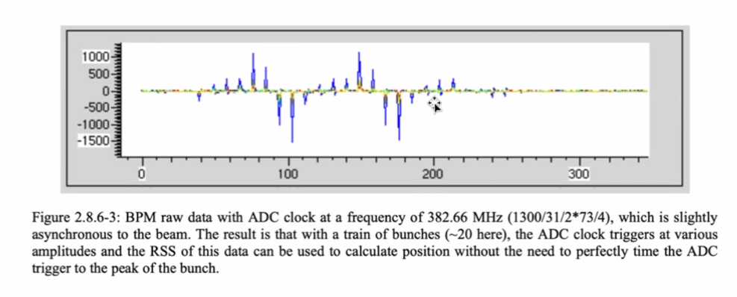
  - 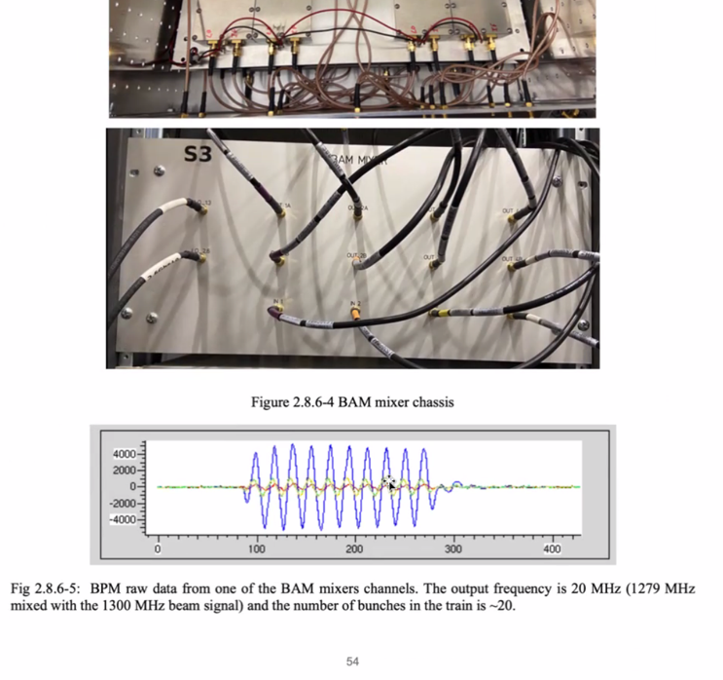
    - Adjust things “in the box”

  - 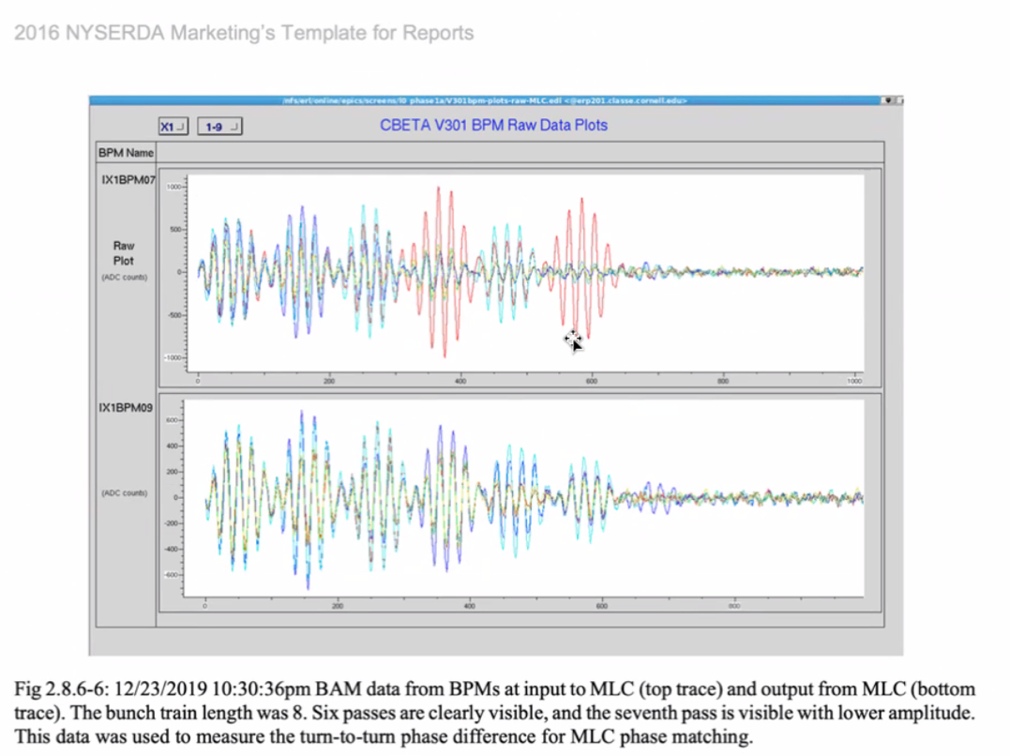
    - Kirsten – each color is a different signal
    - Instead of taking the whole area, you only take the area of the calculation to one of those passes
  - Dejan – couldn’t get last pass – signal was too weak (7th pass)
    - Kirsten – b/c we lost a lot of beam
- Reza – going to ask gun group if they can make this beam, or something similar
  - Then do beam test
Action Items | Person responsible | Deadline

Time allotted | 25 mins | Agenda topic AOB | Presenter All
- Deadline on 27th of August for LOI for SBIR
  - Can go with Saber or other PA company
- Stephen – do we have to pick?
- Dejan – we were discussing
- Competitive bids? Choose company?
- Prepare proposal or LOI with them
- One company merged
- Get JLab to submit proposal with Saber to build magnets
  - Decide on types of magnets
  - When passes by, can get them built and measured – big deal
- Alex B – you have a good track record at BNL – when do you think better to submit? Submit from BNL instead of JLab?
  - Spoke with M. Shinn – need to get the right solicitation
- Alex B – we’ll get the magnets, company will get money
- Dejan – Stephen and Dejan write LOI, send to JLab b/c it’s the CEBAF upgrade
  - See if we all agree on the LOI, we sign it, send it to DOE
  - Alex B – BNL has the expertise, and can guide company
- Alex B – 27th is the LOI deadline? I think we should go for it
  - Will get in touch with Andrei
- Stephen – what has to know what is in it, who to sign, etc…
- Alex – maybe Mike Spata?
- Ryan – have you spoken to Kevin Jordan, who has had tons of these?
- Dejan – last company was horrible. Let them design. If we give design, maybe it’ll be better
- Discussion about companies and options
  - Eligible vs small vs ability, etc…
Action Items | Person responsible | Deadline

Special notes

Pathway to Repository: https://jeffersonlab-my.sharepoint.com/:f:/g/personal/tristan_jlab_org/EqZ5MeS-nipCgPfZB5p0oS4B9Is67d3nQb9sLJI3Zyev9g

Next meeting in two weeks. This will persist for summer (every other week).

